System: Web-Based Supply Chain Management (WBSCM)
Form: FNS Complaints Form
Screenshot as of: 8/15/13

Screenshot #1: WBSCM Complaints Form (Basic Info Form)
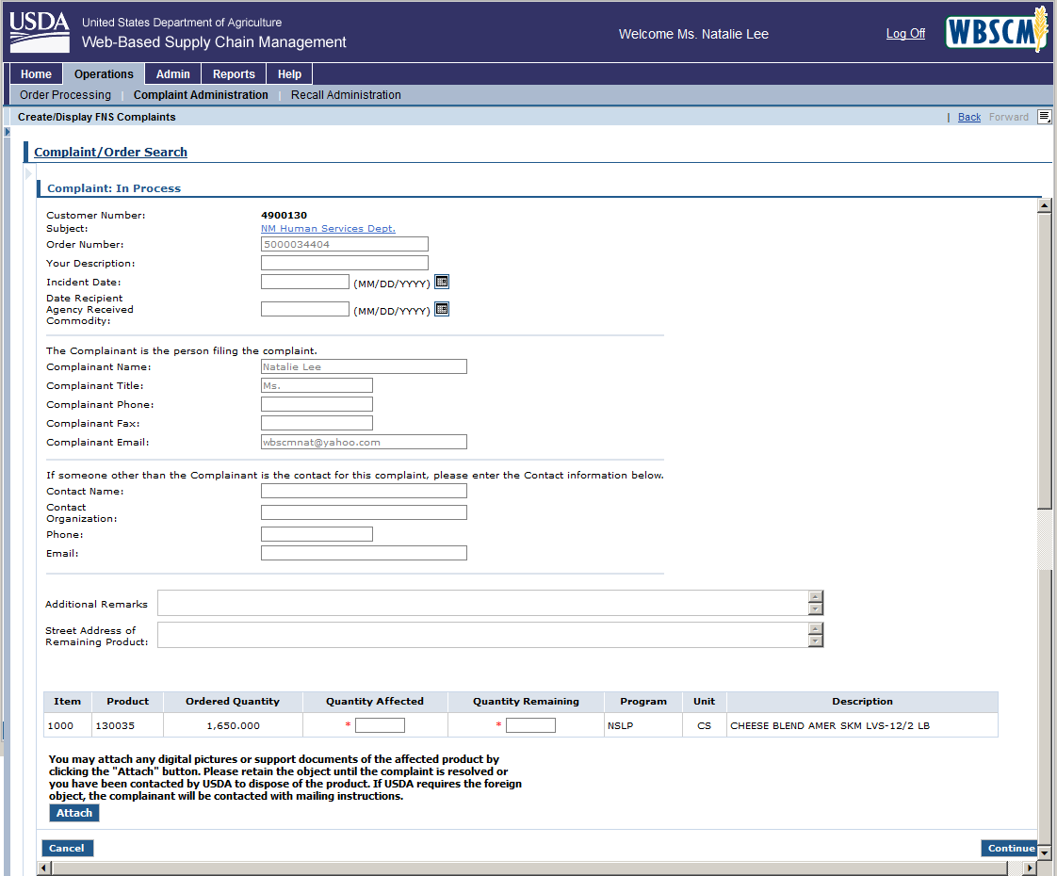

Screenshot #2: WBSCM Complaints Form (Survey Form)
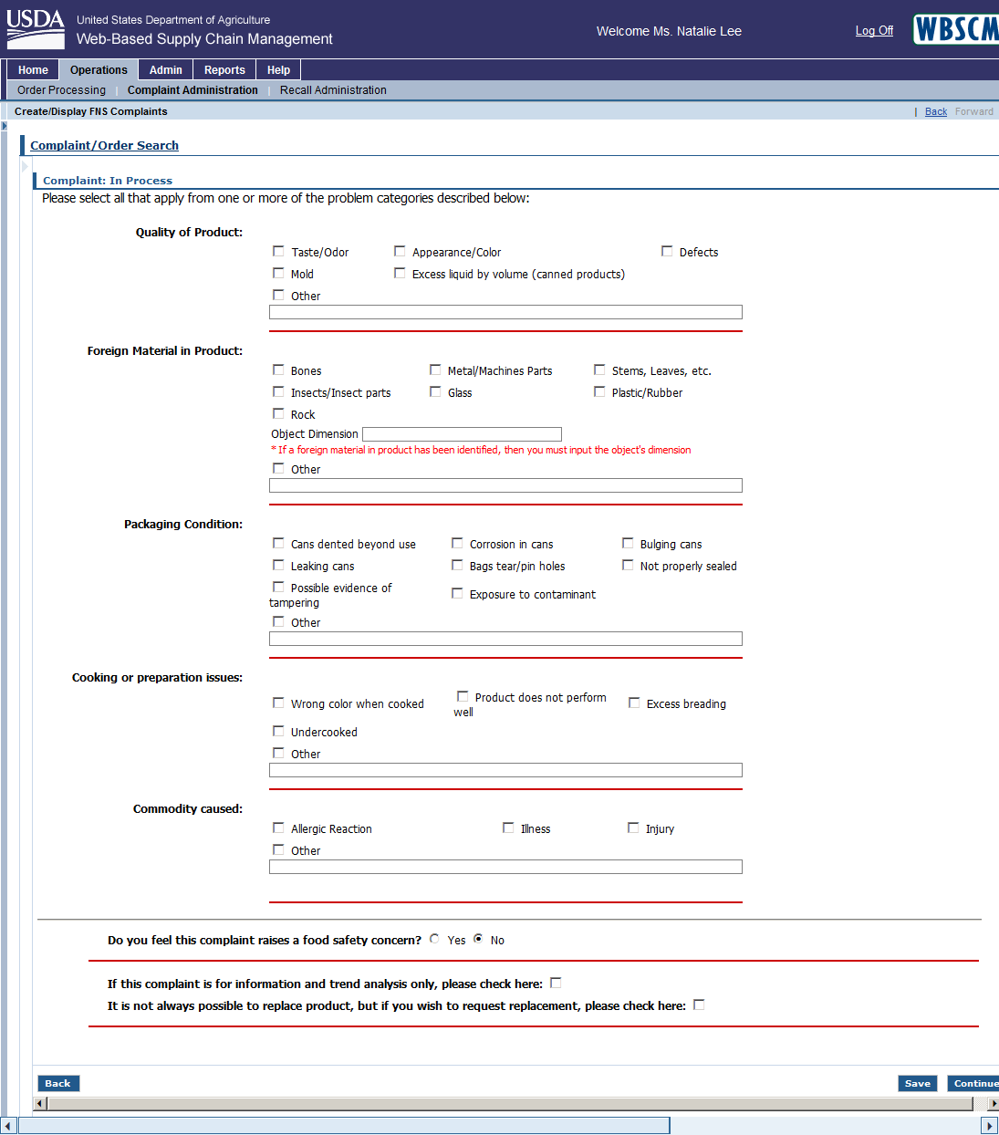

Screenshot #3: WBSCM Complaints Form (Food Safety Info Form)
