Use of this form is optional. Federal HMS dealers are required by NMFS to submit the information marked with an asterisk * as part of their HMS Dealer Landings Reports and this form is provided as a tool to aid them in obtaining this information from the Fishing Vessel. This form is to be completed by fishermen and given to dealers for their reports. A single form should contain no more than one trip’s worth of data.
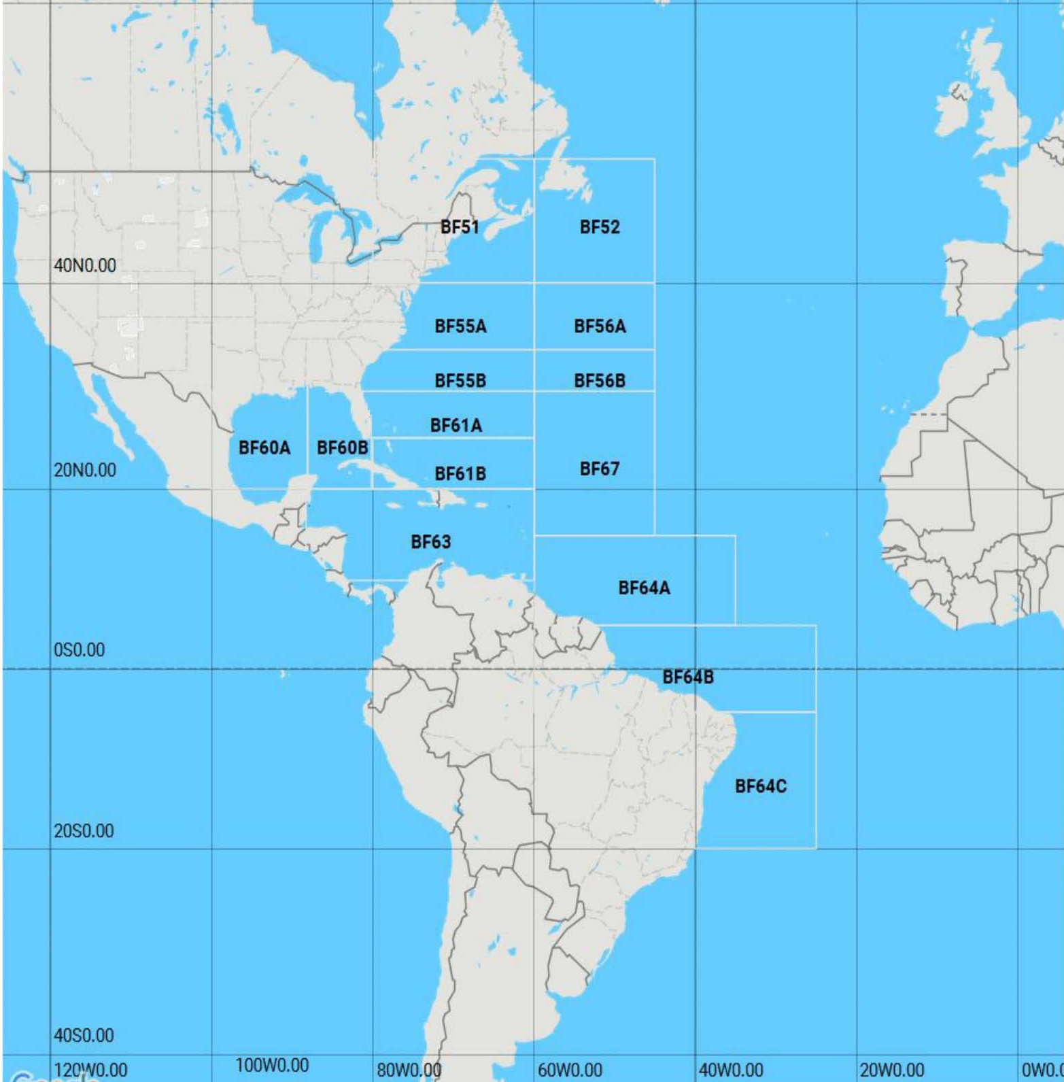

FISHING VESSEL (F/V) TRIP INFORMATION:

F/V Contact Name: __________________________

F/V Contact Phone: __________________________

F/V Contact e-mail:___________________________

*F/V Name: ________________________________

*F/V Registration # or USCG # associated
with HMS permits:_____________________

*Date HMS Offloaded:_____________________

Any Portion of Catch Within Shark Research Fishery?
___Yes* ___No

If Yes, Dealer Must Report SE Observer Logbook ID.
*SE Observer Logbook ID #:___________________

*F/V Logbook ID #:__________________________
CATCH AREAS

*If no FV Logbook, please check the applicable explanation.

  - Sharks caught in state waters and no FV log book required by another permit carried by the FV
  - Tuna caught with a Trap Permit and no FV log book required by another permit carried by the FV
  - HMS caught with General Category Permit and no FV log book required by another permit carried by the FV
  - Tuna caught with Harpoon Permit and no FV log book required by another permit carried by the FV
  - HMS caught with HMS Charter Head Boat Permit and no FV log book required by another permit carried by the FV
  - Explanation described below (Please print legibly)
PAPERWORK REDUCTION ACT NOTICE: Reporting of fishing activity via this form is voluntary. Public reporting burden for this collection of information is estimated to average 15 minutes per response. Send comments regarding this burden estimate or any other aspect of this collection of information, including suggestions for reducing this burden to: NMFS, Highly Migratory Species Management Division (F/SF1), 1315 East-West Highway, Silver Spring, MD 20910. It is NOAA policy to preserve the confidentiality of information submitted under this reporting requirement, except that NMFS may release such information in aggregate or summary form, such that individual identifiers are not disclosed (NAO 216-100). Notwithstanding any other provision of the law, no person is required to respond to, nor shall any person be subject to a penalty for failure to comply with a collection of information subject to the requirements of the Paperwork Reduction Act, unless that collection of information displays a currently valid OMB Control Number. OMB Control #0648-0040 Expires 07/31/2018.
:
*Category / Species  Please check all that were offloaded during this trip |  |  | *Catch Area | *Gear Caught On | Landings From Atlantic Shark Research Fishery? |  | *Category / Species |  | *Catch Area | *Gear Caught On
Example: TUNA (BAYS) – Non Bluefin
X | Bigeye |  | BF60 | 10
SHARKS |  |  |  |  |  |  | SWORDFISH
 | †Basking |  |  |  |  |  |  | Swordfish
 | †Bignose
 | Blacknose |  |  |  |  |  | TUNAS (BAYS) – Non-Bluefin Tuna
 | Blacktip |  |  |  |  |  |  | Bigeye
 | Finetooth |  |  |  |  |  |  | Albacore
 | Blue |  |  |  |  |  |  | Blackfin
 | Bonnethead |  |  |  |  |  |  | Bonito, Atlantic
 | Bull |  |  |  |  |  |  | Skipjack
 | †Dusky |  |  |  |  |  |  | Yellowfin
 | †Galapagos
 | ††Hammerhead, Greater
 | ††Hammerhead, Scalloped
 | ††Hammerhead, Smooth
 | Lemon
 | †Mako, Longfin |  |  |  |  |  | Gear Types
 | Mako, Shortfin |  |  |  |  |  | 1) Bandit Gear
 | †Narrowtooth |  |  |  |  |  | 2) Buoy Gear
 | †Night |  |  |  |  |  | 3) Gill Nets, Float Anchor
 | Nurse |  |  |  |  |  | 4) Gill Nets, Floating Drift
 | ††Oceanic Whitetip |  |  |  |  |  | 5) Gill Nets, Other
 | Porbeagle |  |  |  |  |  | 6) Gill Nets, Runaround
 | †Reef, Caribbean |  |  |  |  |  | 7) Gill Nets, Sink Anchor
 | †Sand Tiger |  |  |  |  |  | 8) Gill Nets, Sink Drift
 | †Sand Tiger, Bigeye |  |  |  |  |  | 9) Green-stick
 | †**Sandbar |  |  |  |  |  | 10) Hand Line
 | †Sevengill |  |  |  |  |  | 11) Harpoons
 | Sharpnose, Atlantic |  |  |  |  |  | 12) Hook & Line
 | †Sharpnose, Caribbean |  |  |  |  |  | 13) Hook & Line, Electric
 | ††Silky |  |  |  |  |  | 14) Hook & Line, Manual
 | †Sixgill |  |  |  |  |  | 15) Hook & Line, Troll
 | †Sixgill, Bigeye |  |  |  |  |  | 16) Long Line, Bottom
 | †Smalltail |  |  |  |  |  | 17) Long Line, Midwater
 | Smooth Dogfish |  |  |  |  |  | 18) Long Line, Surface
 | Smoothhound, FL |  |  |  |  |  | 19) Otter Trawl**
 | Spinner |  |  |  |  |  | 20) Otter Trawl, Bottom**
 | Tiger |  |  |  |  |  | 21) Otter Trawl, Midwater**
 | Thresher, Common |  |  |  |  |  | 22) Pound Net/Fish Weir
 | †Thresher, Bigeye |  |  |  |  |  | 23) Purse Seine
 | †White |  |  |  |  |  | 24) Troll Line, Electric
 | †Whale |  |  |  |  |  | 25) Troll Line, Manual
†prohibited shark species
††prohibited on pelagic longline gear
†**only allowed within Atlantic shark research fishery
**not authorized HMS gear; only limited number of swordfish allowed to be retained with required permits

Privacy Act Statement
Privacy Act Statement

Authority: The collection of this information is authorized under the Magnuson-Stevens Fishery Conservation and Management Act, 16 U.S.C 1801 et seq.

Purpose: The Magnuson-Stevens Act requires that conservation and management measures must prevent overfishing while achieving, on a continuing basis, the optimum yield from each fishery. Vessel logbooks are essential tools in the management of fishery resources. Section 303(a)(5) of the Magnuson-Stevens Act specifically identifies the kinds of data to be collected for fishery management plans (FMPs).

Routine Uses: The Department will use this information for effective fishery management. Disclosure of this information is permitted under the Privacy Act of 1974 (5 U.S.C. Section 552a), to be shared within NMFS offices, in order to coordinate monitoring and management of sustainability of fisheries and protected resources, as well as with the applicable State or Regional Marine Fisheries Commissions and International Organizations. Disclosure of this information is also subject to all of the published routine uses as identified in the
COMMERCE/NOAA-6, Fishermen's Statistical Data.

Disclosure: Submission is mandatory for those persons falling under the requirements of 50 CFR 648.7 (b). If the information is not provided, permit status may be affected.

