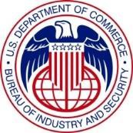
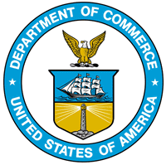
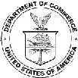
U.S. Department of Commerce, Bureau of Industry and Security

Section 232 National Security Investigation of Imports of

U.S. Automobiles and Automotive Parts

The Bureau of Industry and Security (BIS), Office of Technology Evaluation (OTE), is conducting a survey and assessment of the armored vehicle industry. The survey, requested by the Office of the Secretary of the U.S. Department of Commerce, will be used to support an investigation initiated under Section 232 of the Trade Expansion Act of 1962, as amended. The investigation was requested by the President of the United States.

The principal goal of this survey is to assist the Commerce Department in assessing the domestic armored vehicle industry and the impact of automotive parts imports on armored vehicle industry supply chains, research and development, and labor force, and other factors relevant to Section 232 analysis. Information collected will include facilities and production data, joint ventures, trade flows, supply chain data, sales and demand data, employment information, conditions of competition, research and development information, and government and defense activities. The resulting aggregate data will give the Commerce Department detailed industry information that is otherwise not available and needed to effectively conduct its analysis.

Your organization has been identified as manufacturing armored vehicles at one or more facilities in the United States. Your participation in this survey is vital to ensure a comprehensive dataset for the assessment. BIS has worked in successful partnership with other U.S. industry sectors and we anticipate similar cooperation from your organization on this effort.

To begin, download the Microsoft Excel-formatted survey and corresponding instructions by clicking on the hyperlinked documents below.

Armored Vehicle Survey (Excel)*† │ Armored Vehicle Survey (PDF)†

Complete and submit the Excel version via email to BIS at Autos232@doc.gov. BIS will only accept Excel-formatted survey submissions. The PDF version is only a reference document for your organization's internal use and cannot be submitted in place of a completed Excel survey.

*Note 1: Save a copy of the Excel survey to your computer before you make any inputs to the questionnaire.

†Note 2: If, when clicking on the above links, your computer does not ask if you want to download the file to your computer, right click on the link and select "Save As."

If you have any questions regarding the survey, e-mail Autos232@doc.gov, or contact U.S. Department of Commerce staff at (202) 482-4358. E-mail is the preferred method of contact and will allow for a detailed response to your organization’s questions.

All information submitted to BIS is protected as Business Confidential under provisions of the Defense Production Act (DPA) of 1950, as amended, and will not be published or disclosed, other than in aggregate form. At no time will such reporting identify your specific organization. Such information is also protected from disclosure from Freedom of Information Act (FOIA) requests. Also note that your company is required by federal law (50 U.S.C. Sec. 4555) to complete the survey. You have 30 days from receipt of this letter to respond.

###

