Appendix L: Responding to Comments for RESPECT Social Media Recruitment (RESPECT)

Overview
Social media recruitment for the RESPECT data collection uses two major social media platforms: Facebook and Instagram.
As potential participants scroll through their normal feeds in each of these platforms, advertisements they may be interested in (determined by the targeting features set on the back end) will periodically appear. These ads are distinguished from other social media posts with the use of the word “sponsored” underneath the Facebook page name.
When a potential participant sees an ad, they have the option to (1) click on the ad (and be directed to the screener), (2) like the ad, (3) share the ad with friends, and/or (4) comment on the ad.
Below are examples of how the ads are displayed on Facebook & Instagram.

Facebook
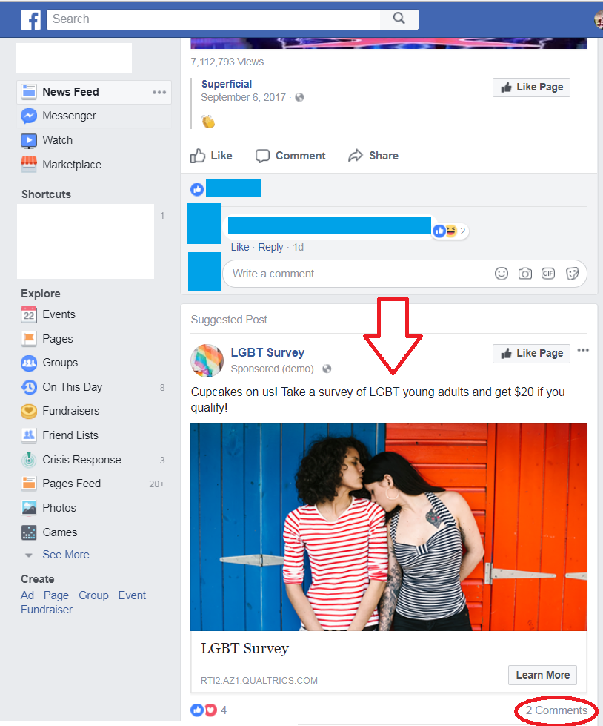

Instagram
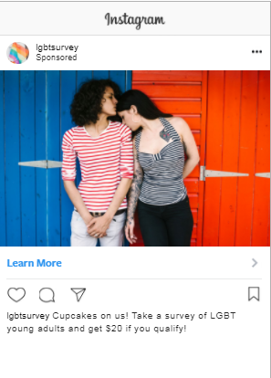
Because Facebook and Instagram are inherently social platforms, the performance of these ads is determined on a variety of engagement factors, which include:
- Likes
- Shares
- Comments
- Feedback (positive or negative)
  - Positive feedback is determined by clicks and successful conversions (e.g., screening in as an eligible participant to complete the survey).
  - Negative feedback is determined by how many people choose to hide the ad or provide negative comments.

If engagement factors are low and/or negative feedback is higher than positive feedback, Facebook/Instagram will stop showing your ads as frequently and ad costs will rise.
In the case of social media ads, potential participants will often comment to ask questions and express grievance about the legitimacy of the study, process of receiving incentives and qualification requirements. If these comments and concerns are left untouched, it can hamper ad performance. However, participants will also comment to tag their friends and let them know about the survey. This doesn’t require a response but is a typical comment that comes up.
Therefore, in order to keep engagement scores high, provide participants with clear information about the survey, maintain legitimacy, and address negative feedback, the social media recruitment manager will start responding to some of these comments by hitting “reply” on the particular comment. Both the comments and responses will be public and can be viewed by anyone else who sees the ad, which allows the commenter and others to benefit from information provided about the survey.
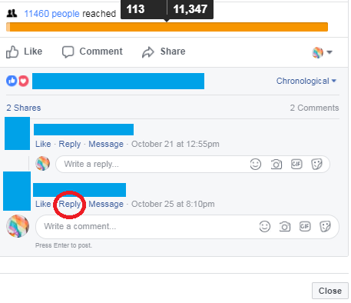

Below are some examples of anticipated comments and our planned responses. Please note that any comments that reveal qualification requirements to screen into the survey as an eligible participant or have vulgar/inappropriate language will simply be deleted.

“Scam” “Fake” “Is this legit?”
We understand your concern. This survey is legitimate and those who qualify to participate and complete the survey in full will receive their incentive.

“Just trying to steal our information”
Responses collected as a part of this study will be used solely for informing programs that help the LGBT community. Any information you provide will be kept private to the fullest extent allowable by law, and nothing you tell us will be reported with your name.

“I didn’t qualify” “Does anyone qualify?”
Thanks so much for taking the time to complete our eligibility screener. People do qualify to participate in this survey, and we’re sorry you didn’t. Be on the lookout for more surveys in the future!

“I took it twice” “I took it multiple times”
Thank you for taking the time to participate in our survey! Please keep in mind that each qualified participant will only receive one incentive per survey, regardless of how many responses they submit.

“I didn’t get my incentive yet” “I never got paid”
As our thank you for participating in our survey, our team is dedicated to ensuring you hear back from us within ____________ (will depend on the survey). If it’s been over ________ and you still haven’t received your incentive, please message us privately and we will look into it. (at this point if they message us, we will direct them to the help desk contact information. See more about private messaging below).

Private Messages on Facebook
On Facebook only, potential participants will also have the option to privately message the Facebook Page. This can be done by clicking on the Sponsor’s name and getting directed to the Facebook Page. Here, there is a button for potential participants to “send message.” These messages can only be viewed by the social media recruitment manager and the person who wrote the message.
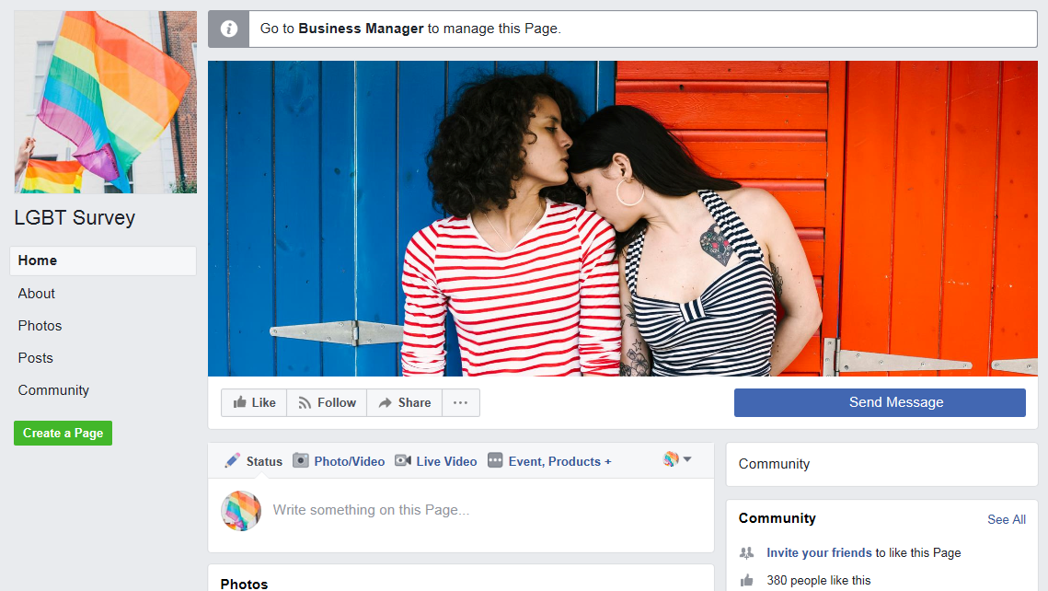

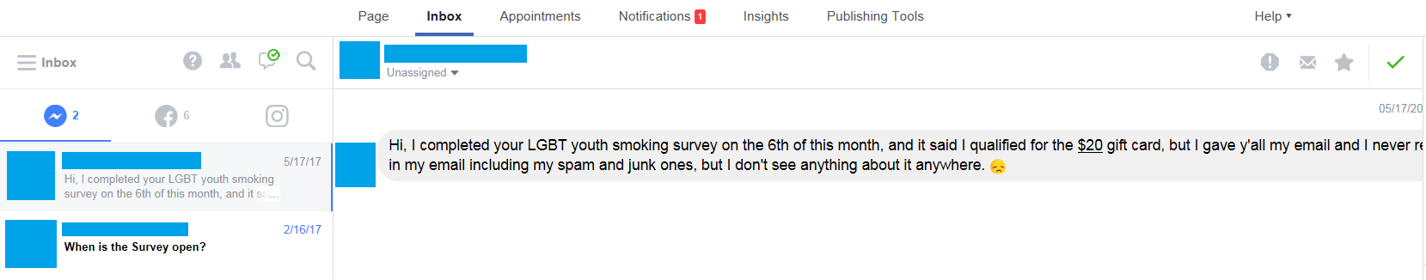
The social media manager can respond to inquiries here, which will also increase credibility to participants.

Responses to inquiries that come in through Facebook Messenger will be consistent with the responses we will provide to public comments. Below are examples of anticipated private messages and our planned response.

“Scam” “Fake” “Is this legit?”
We understand your concern. This survey is legitimate and those who qualify to participate and complete the survey in full will receive their incentive.

“Just trying to steal our information”
Responses collected as a part of this study will be used solely for informing programs that help the LGBT community. Any information you provide will be kept private to the fullest extent allowable by law, and nothing you tell us will be reported with your name.

“I didn’t qualify” “Does anyone qualify?”
Thanks so much for taking the time to complete our eligibility screener. People do qualify to participate in this survey, and we’re sorry you didn’t. Be on the lookout for more surveys in the future!

“I took it twice” “I took it multiple times”
Thank you for taking the time to participate in our survey! Please keep in mind that each qualified participant will only receive one incentive per survey, regardless of how many responses they submit.

“I didn’t get my incentive yet” “I never got paid”
As our thank you for participating in our survey, our team is dedicated to ensuring you hear back from us within ____________ (will depend on the survey). If it’s been over ________ and you still haven’t received your incentive, please message us privately and we will look into it.

