Program Contact

Lee Samuel

National Center for Emerging and Zoonotic Infectious Diseases

Office of Policy

1600 Clifton Rd, C-12

Atlanta GA 30333

Submission Date: July 3, 2018

Circumstances of Change Request for OMB 0920-0666

CDC requests approval to replace five recently approved forms that contain content referencing “*Clostridium difficile*” to be updated and reflect “*Clostridioides difficile.*”

The five forms that are being updated have been previously approved under OMB Control No. 0920-0666; The National Healthcare Safety Network (NHSN).

Form Name:

1. 57.103 Patient Safety Component-Annual Hospital Survey
2. 57.126 MDRO or CDI Infection Form
3. 57.150 Patient Safety Component- Annual Facility Survey for LTAC
4. 57.151 Patient Safety Component-Annual Facility Survey for IRF
5. 57.500 Outpatient Dialysis Center Practices Survey

This is a request to update content in NHSN’s data collection forms that reference “*Clostridium difficile,*” which is scheduled for reclassification to “*Clostridioides difficile”* in August, 2018*.*

The previously approved versions of forms CDC 57.103, 57.126, 57.150, 57.151, and 57.500 are being updated to reflect the proper clinical terminology for *“Clostridioides difficile.”*

Estimates of annualized burden hours for this information collection will not be changed by this request.

|  |  |  |  |  |
| --- | --- | --- | --- | --- |
| **Form Name** | **No. of Respondents** | **No. of responses per respondent** | **Avg. burden per response (hours)** | **Total burden (hours)** |
| Patient Safety Component-Annual Hospital Survey | 5,000 | 1 | 1 | 198,300 |
| MDRO or CDI Infection Form | 6,000 | 72 | 30/60 | 216,000 |
| Patient Safety Component- Annual Facility Survey for LTAC | 400 | 12 | 1 | 400 |
| Patient Safety Component-Annual Facility Survey for IRF | 1,000 | 12 | 1 | 1,000 |
| Outpatient Dialysis Center Practices Survey | 7,000 | 12 | 2 | 14,350 |

Description of Changes

Based on phenotypic, chemotaxonomic, and phylogenetic analyses, novel genus *Clostridioides* gen. nov. is proposed for *Clostridium difficile* as *Clostridioides difficile* gen. nov. comb. nov. and that *Clostridium mangenotii* be transferred to this genus as *Clostridioides mangenotii* comb. nov. The type species of *Clostridioides* is *Clostridioides difficile*.

Due to this reclassification, NHSN has updated all data collection forms containing the previously referenced “*Clostridium difficile”* to its new designation “*Clostridioides difficile.”* We are requesting the replacement of the approved forms with the updated versions.

**Current forms (highlighted areas be change):**

**57.103**

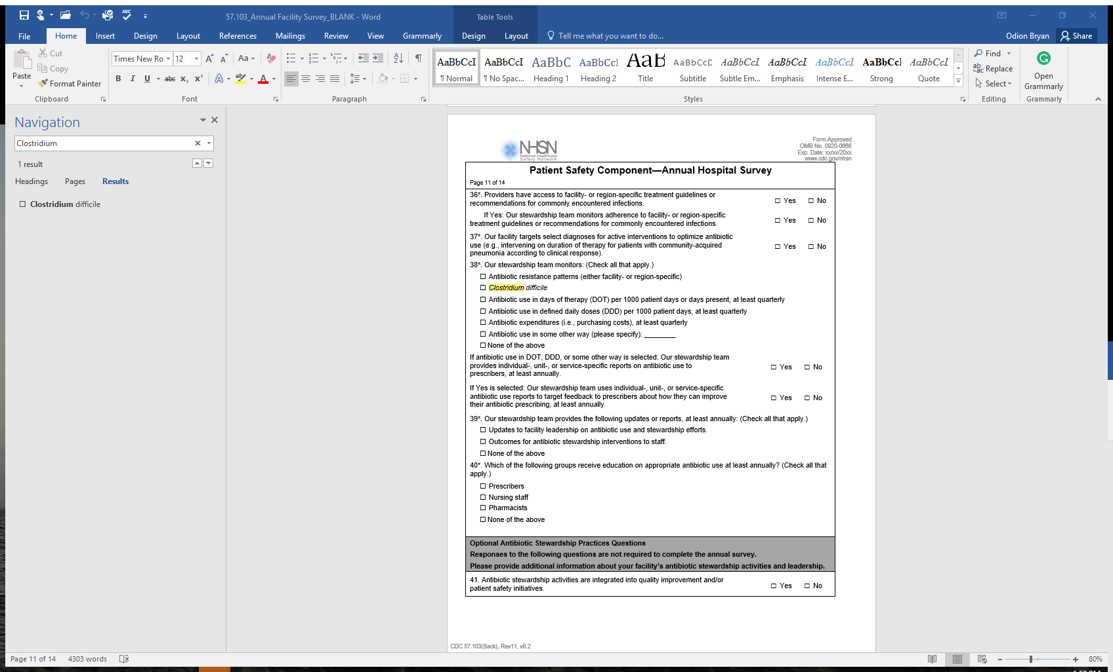

**57.126**

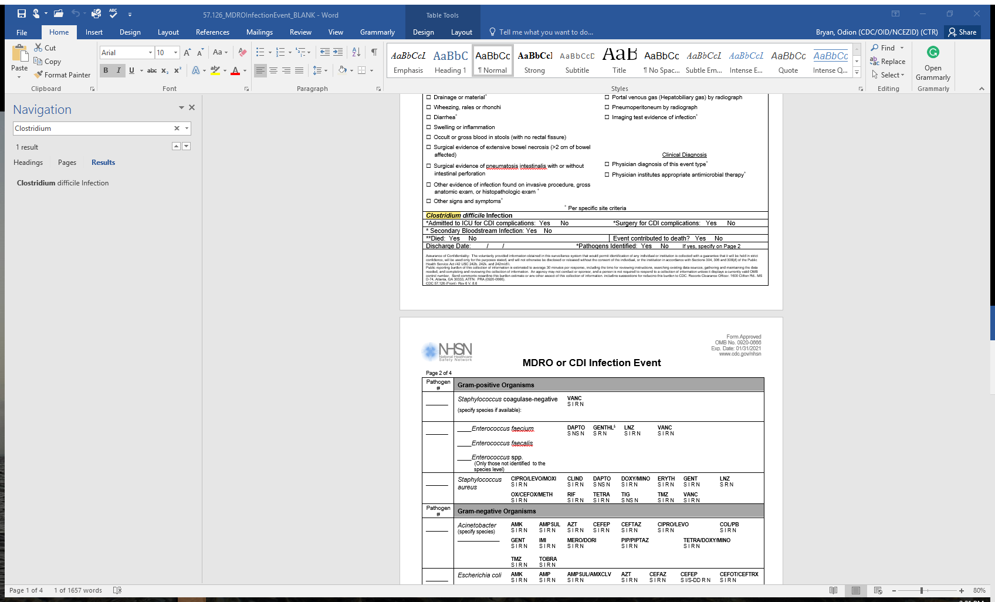

**57.150 & 57.151**

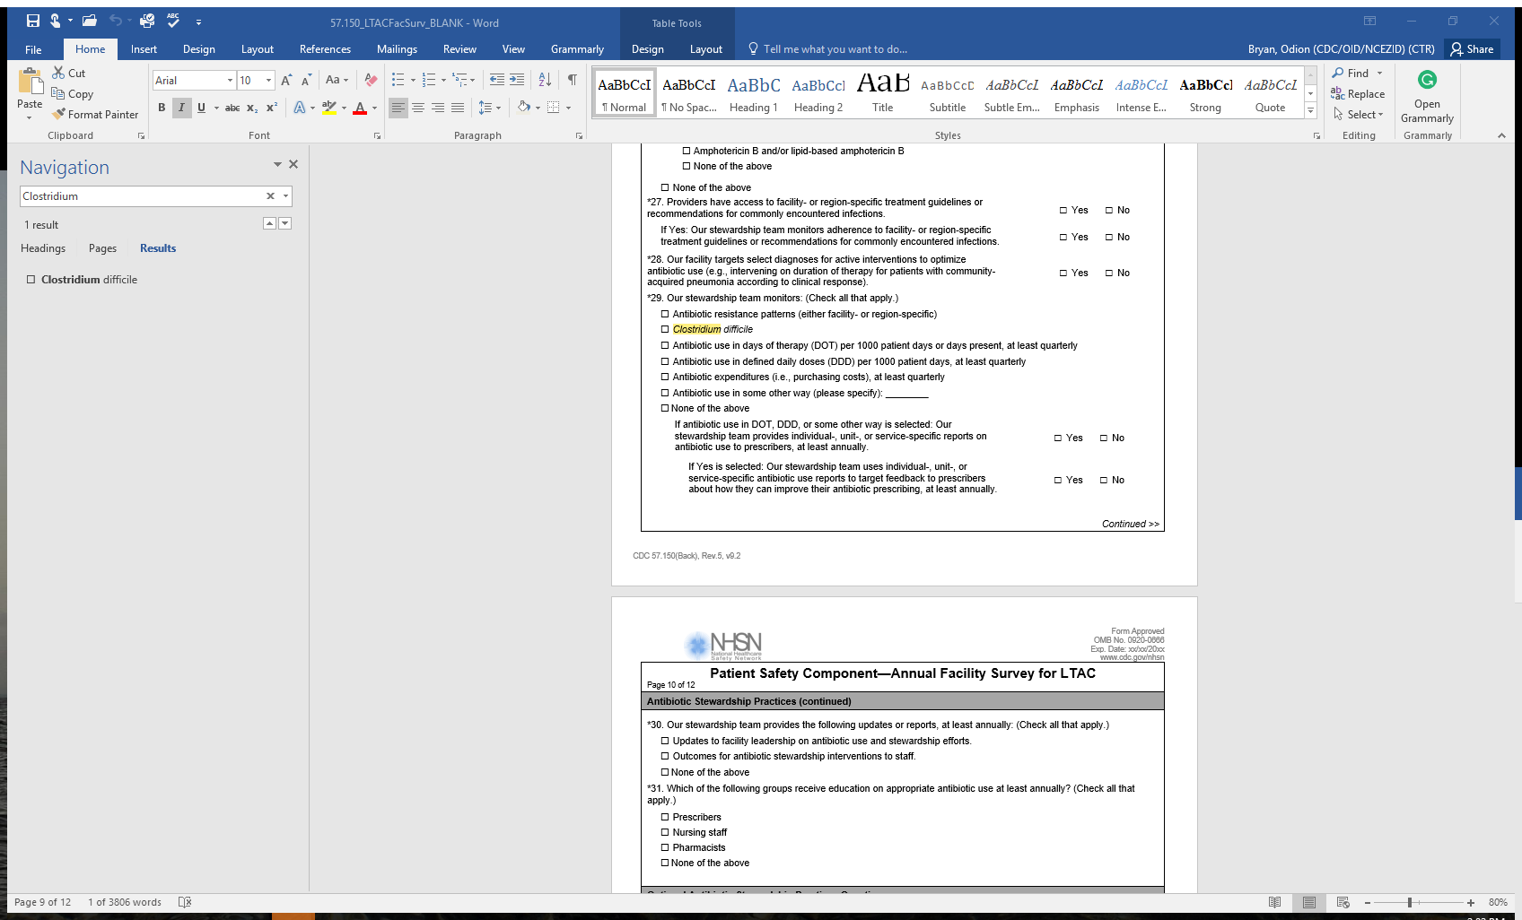

**57.500**

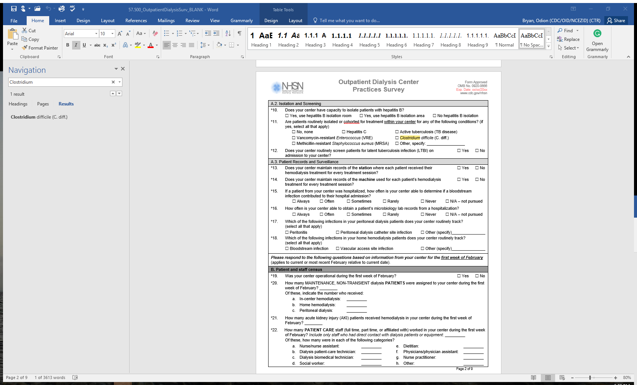

**Requested changes (Highlighted):**

**57.103**

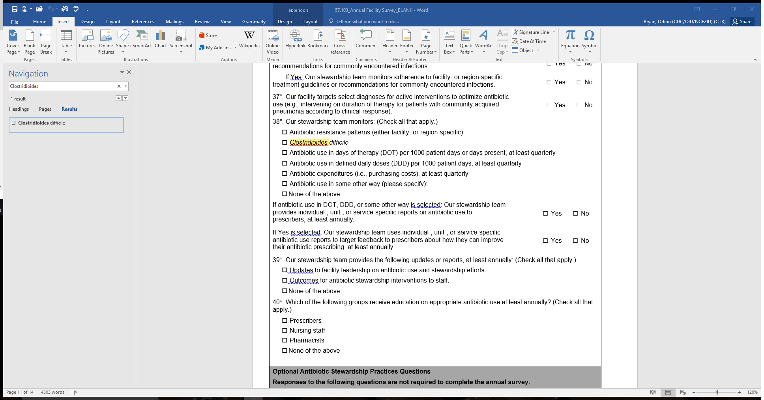

**57.126**

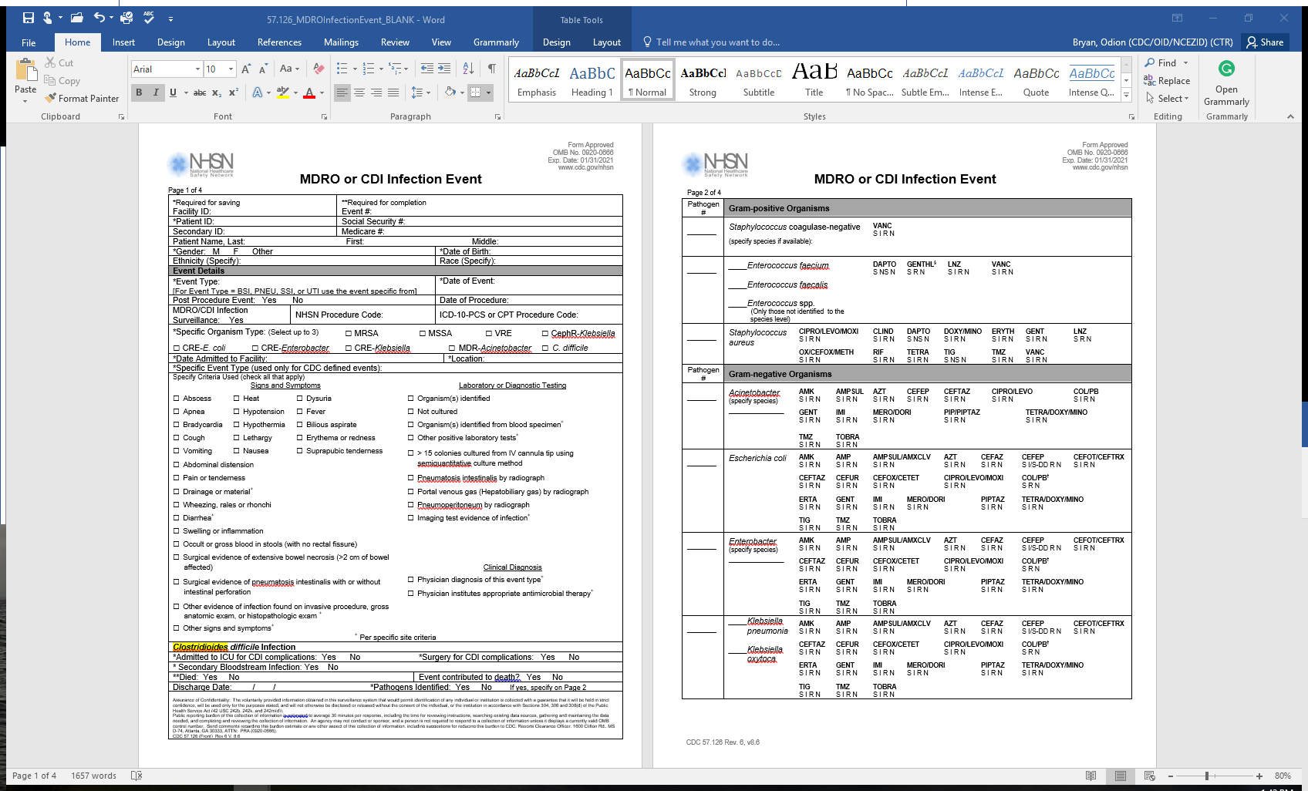

**57.150 & 57.151**

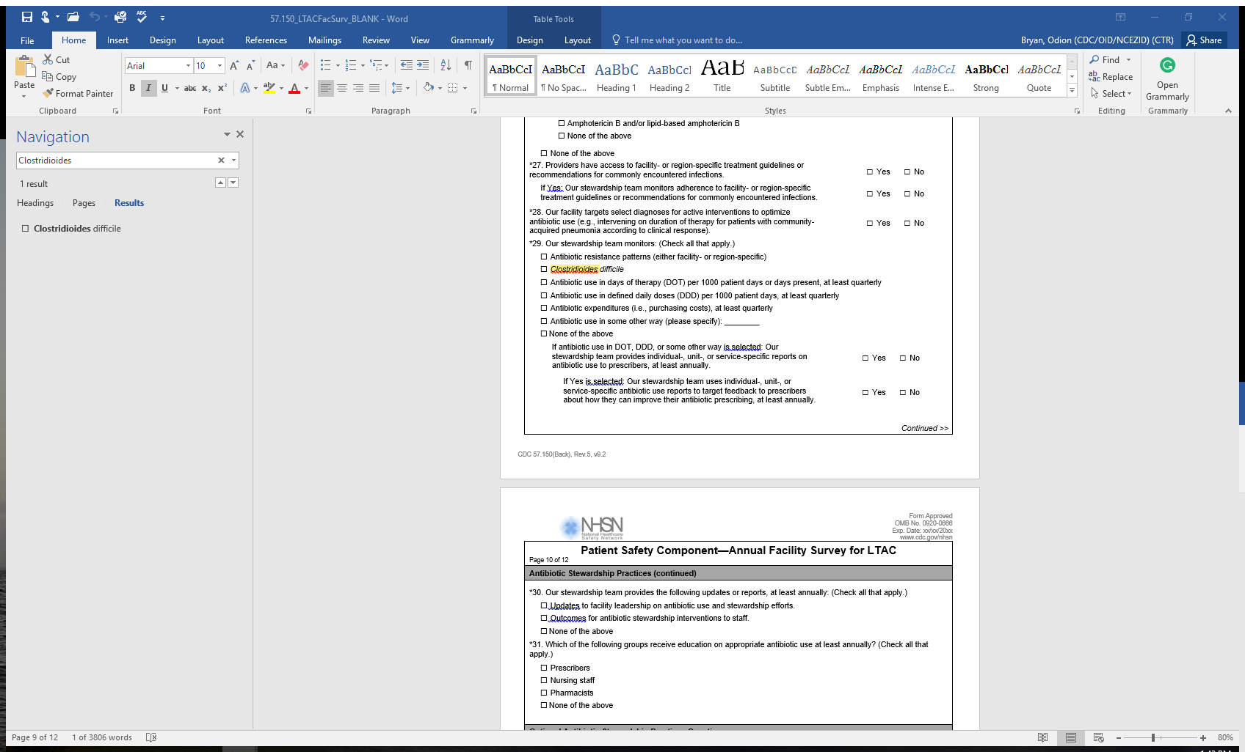

**57.500**

