Attachment 2a: Semi-targeted advertisement [note that only one or more statements within the bracketed section below will be selected at a time, depending on recruiting needs].

**Participants Wanted for Research Study**

The National Center for Health Statistics is looking for persons aged 18 or over who have used complementary or alternative health approaches [such as yoga, chiropractic, massage, acupuncture, music/art therapy, meditation mindfulness or naturopathy or guided relaxation] to answer a variety of health related questions.

The interview will be no longer than 60 minutes and participants will receive $40.

**FOR MORE INFORMATION,**

Call [fill name] at: **301-458-[fill XXXX]**

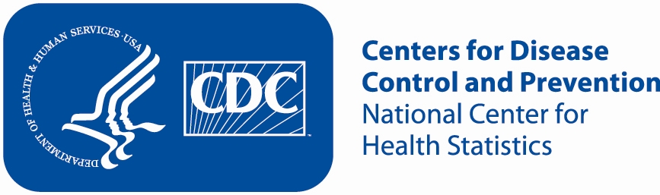

Attachment 2b: Non Specific Advertisement/flyer

**Participants Wanted for Research Study**

The National Center for Health Statistics

is looking for adults aged 18 and over to answer a variety of health questions that may be asked on a national survey. The survey research interview will be no longer than 60 minutes. Participants will receive $40.

**FOR MORE INFORMATION,**

Call [fill name] at: **301-458-[fill XXXX]**

