Attachment 2a: Semi-targeted advertisement/flyer [note that only one or more statements within the bracketed section below will be selected at a time, depending on recruiting needs].

Participants Wanted for Research Study

The National Center for Health Statistics
is looking for mothers (aged 18 and over) with babies 2-12 months old to answer questions that may be used on a national survey. All mothers are welcome, but we are especially interested in mothers who used any of the following prior to or during pregnancy: [Prescription pain relievers, medication for depression or anxiety, or other types of drugs]. The survey research interview will be no longer than 90 minutes and participants will receive $50.

FOR MORE INFORMATION,
Call [fill name] at: 301-458-[fill XXXX]

Centers for Disease Control and Prevention
National Center for Health Statistics
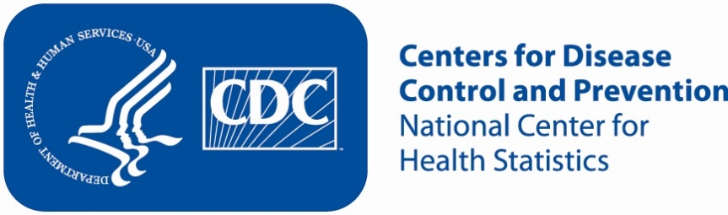
Attachment 2b: Non-Specific Advertisement/flyer

Participants Wanted for Research Study

The National Center for Health Statistics
is looking for mothers (aged 18 and over) with babies 2-12 months old to answer questions that may be used on a national survey. The survey research interview will be no longer than 90 minutes and participants will receive $50.

FOR MORE INFORMATION,
Call [fill name] at: 301-458-[fill XXXX]

Centers for Disease Control and Prevention
National Center for Health Statistics

Attachmdent 2c: Interview conducted with respondents who are affiliated with a center that the CCQDER staff contacted for PRAMS Opioid 2018.

[Center that the CCQDER staff contacted] staff would read the following text to the individual:

If CCQDER staff are at the facility:
“You may be eligible to participate in a research study [today/on specified date] if you would like to do so. Researchers from the National Center for Health Statistics are evaluating questions which may be used on a national survey about mothers with babies 2-12 months old and are offering $50 to those who participate in the study. The researchers are here [specific location in building]. If you are interested in learning more about the study, you can speak with them. You can then decide whether or not you want to participate.”

If CCQDER staff are not at the facility:
“You may be eligible to participate in a research study [today/on specified date] if you would like to do so. Researchers from the National Center for Health Statistics are evaluating questions which may be used on a national survey about mothers with babies 2-12 months old and are offering $50 to those who participate in the study. Here is the researchers’ contact information [pointing to the flyer]. You can contact them to learn more about the study. You can then decide whether or not you want to participate.”

