Attachment 2a: Semi-targeted advertisement/flyer.

Justification for advertisement: This flyer targets new mothers who have used the specific substances that are included in the questions to be tested.

Participants Wanted for Research Study

The National Center for Health Statistics is looking for mothers (aged 18 and over) with babies 3-24 months old to answer questions that may be used on a national survey. All mothers are welcome, but we are especially interested in mothers who have used any of the following after the birth of their baby:

- Prescription pain relievers
- Non-prescription drugs
- Alcohol
- Tobacco products

The survey research interview will be no longer than 90 minutes and participants will receive $50.

FOR MORE INFORMATION,
Call [fill name] at: 301-458-[fill XXXX]

Centers for Disease Control and Prevention
National Center for Health Statistics

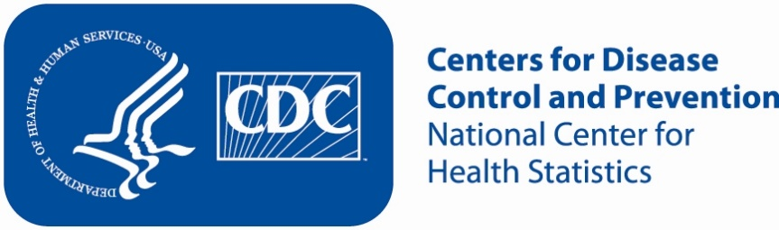
Attachment 2b: Expanded advertisement/flyer

Justification for advertisement: This advertisement expands recruitment to mothers with different kinds of pregnancy and delivery outcomes that may impact experiences with health care providers and hospitals.

Participants Wanted for Research Study

The National Center for Health Statistics
is looking for mothers (aged 18 and over) with babies 3-24 months old to answer questions that may be used on a national survey. All mothers are welcome, but we are especially interested in mothers who:

- had a C-section or
- had a premature baby

The survey research interview will be no longer than 90 minutes and participants will receive $50.

FOR MORE INFORMATION,
Call [fill name] at: 301-458-[fill XXXX]

Centers for Disease Control and Prevention
National Center for Health Statistics

Attachment 2c: Interview conducted with respondents who are affiliated with a center that the CCQDER staff contacted for PRAMS 2019.

[Center that the CCQDER staff contacted] staff would read the following text to the individual:

If CCQDER staff are at the facility:
“You may be eligible to participate in a research study [today/on specified date] if you would like to do so. Researchers from the National Center for Health Statistics are evaluating questions which may be used on a national survey about mothers with babies 3-24 months old and are offering $50 to those who participate in the study. The researchers are here [specific location in building]. If you are interested in learning more about the study, you can speak with them. You can then decide whether or not you want to participate.”

If CCQDER staff are not at the facility:
“You may be eligible to participate in a research study [today/on specified date] if you would like to do so. Researchers from the National Center for Health Statistics are evaluating questions which may be used on a national survey about mothers with babies 3-24 months old and are offering $50 to those who participate in the study. Here is the researchers’ contact information [pointing to the flyer]. You can contact them to learn more about the study. You can then decide whether or not you want to participate.”

