Attachment 2a: Semi-targeted advertisement/flyer [Note that only one or more statements within the bracketed section below will be selected at a time, depending on recruiting needs].

Participants Wanted for Research Study

The National Center for Health Statistics
is looking for adults aged 18 and over to answer a variety of health questions that may be asked on a national survey. We would like to talk to [parents/guardians of children aged 2-17, parents/guardians of children aged 2-17 who have had injuries during the past three months]. The survey research interview will be no longer than 60 minutes and participants will receive $40.

FOR MORE INFORMATION,
Call [fill name] at: 301-458-[XXXX]

Centers for Disease Control and Prevention
National Center for Health Statistics
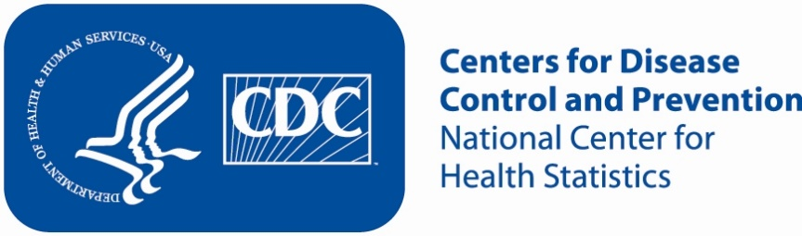
Attachment 2b: Semi-targeted advertisement/flyer [Note that only one or more statements within the bracketed section below will be selected at a time, depending on recruiting needs].

Participants Wanted for Research Study

The National Center for Health Statistics
is looking for adults aged 18 and over to answer a variety of health questions that may be asked on a national survey. We would like to talk to [parents/guardians of children aged 2-17, adults, and/or adults who live with another adult] who has/have difficulties [seeing, hearing, walking, remembering or concentrating, giving self-care, and/or communicating]. The survey research interview will be no longer than 60 minutes and participants will receive $40.

FOR MORE INFORMATION,
Call [fill name] at: 301-458-[XXXX]

Centers for Disease Control and Prevention
National Center for Health Statistics

Attachment 2c: Non Specific Advertisement/flyer

Participants Wanted for Research Study

The National Center for Health Statistics
is looking for adults aged 18 and over to answer a variety of health questions that may be asked on a national survey. The survey research interview will be no longer than 60 minutes. Participants will receive $40.

FOR MORE INFORMATION,
Call [fill name] at: 301-458-[fill XXXX]

Centers for Disease Control and Prevention
National Center for Health Statistics

