Attachment 3a: Semi-targeted advertisement [note that only one or more statements within the bracketed section below will be selected at a time, depending on recruiting needs].

Participants Wanted for Research Study

The National Center for Health Statistics is looking for persons aged 18 or over [who have done temp, shift, contract or gig work, work secured from an online platform or app (lyft, uber, task, rabbit), are self-employed, independent contractors or free-lancers] to answer a variety of employment and health related questions.
The interview will be no longer than 60 minutes and participants will receive $40.

FOR MORE INFORMATION,
Call [fill name] at: 301-458-[fill XXXX]

Centers for Disease Control and Prevention
National Center for Health Statistics
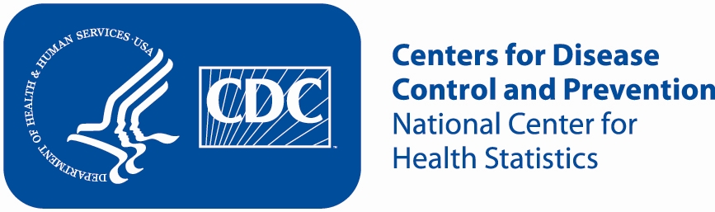
Attachment 3b: Non-Specific Advertisement/flyer

Participants Wanted for Research Study

The National Center for Health Statistics is looking for working adults aged 18 and over to answer a variety of employment and health related questions. The interview will be no longer than 60 minutes and participants will receive $40.

FOR MORE INFORMATION,
Call [fill name] at: 301-458-[fill XXXX]

Centers for Disease Control and Prevention
National Center for Health Statistics

