Attachment 3a: Semi-targeted advertisement [note that only one or more statements within the bracketed section below will be selected at a time, depending on recruiting needs].

Participants Wanted for Research Study

The National Center for Health Statistics is looking for persons aged 18 or over [who have done temp, shift, contract or gig work, work secured from an online platform or app (lyft, uber, task, rabbit), are self-employed, independent contractors or free-lancers] to answer a variety of employment and health related questions.
The research interview will be [through [[Skype/Zoom]] and will be] no longer than 60 minutes. Participants will receive $40.
FOR MORE INFORMATION,
Call [FILL NAME] at: 301-458- [FILL NUMBER]

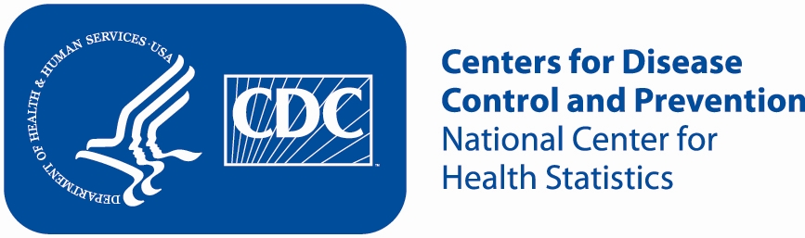
Attachment 3b: Non-Specific Advertisement/flyer

Participants Wanted for Research Study

The National Center for Health Statistics is looking for working adults aged 18 and over to answer a variety of employment and health related questions. The research interview will be [through [[Skype/Zoom]] and will be] no longer than 60 minutes. Participants will receive $40.
FOR MORE INFORMATION,
Call [FILL NAME] at: 301-458- [FILL NUMBER]

