Form Approved
OMB No. 0920-xxxx
Exp. Date xx/xx/201x

How has Tracking made an impact?
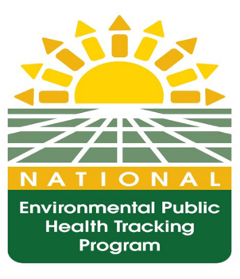
This document is provided by the Environmental Health Tracking Branch (EHTB) to capture the information needed to demonstrate the effectiveness of the National Environmental Public Health Tracking Program (Tracking Program). Awardees will report on interventions and programmatic activities that drive public health action. The Tracking Program provides information to drive public health action and improve health. This process includes not only assessing public health interventions, but demonstrating their impact.
The Public Health Action Report (PHAR) solicitation will be sent out quarterly (January 1st, April 1st, July 1st, and October 1st). Please complete the PHAR and return to your Project Officer by 11/2/2015 for the July 1, 2015 – September 30, 2015 reporting period (FY 2015, Quarter 4). If you have any questions, please contact your Project Officer.

CDC estimates the average public reporting burden for this collection of information as 20 hours per response, including the time for reviewing instructions, searching existing data/information sources, gathering and maintaining the data/information needed, and completing and reviewing the collection of information. An agency may not conduct or sponsor, and a person is not required to respond to a collection of information unless it displays a currently valid OMB control number. Send comments regarding this burden estimate or any other aspect of this collection of information, including suggestions for reducing this burden to CDC/ATSDR Information Collection Review Office, 1600 Clifton Road NE, MS D-74, Atlanta, Georgia 30333; ATTN: PRA (0920-xxxx).

Please report the public health actions taken during this period referencing the guidance below. Include a specific title and a concise description of the action and its impact in the table provided on page 3.
The following are examples of components that could contribute to a public health action:
- Identifying populations at risk;
- Responding to outbreaks, clusters and emerging threats;
- Establishing the relationship between environmental hazards and disease;
- Guiding intervention and prevention strategies;
- Identifying, reducing and preventing harmful environmental risks;
- Improving the public health basis for policymaking;
- Enabling the public’s right to know about health and the environment;
- Informing legislators, policy makers, communities, and/or individuals regarding potential environmental health risks

Public Health Action Title:
- Identify the problem/situation
- Describe your Tracking Program’s involvement
- Demonstrate the impact of your resulting action in addressing the problem/situation
- If possible, quantify the impact of the resulting action on the health of the population

Note: If you have previously reported this information in a past Program Management Tool (PMT) report, please reference the title of the action, fiscal year and quarter.

Total Number of Public Health Actions: _____

# | TITLE | Identify the problem/situation | Describe your Tracking Program’s involvement | Demonstrate the impact of your resulting action in addressing the problem/situation | If possible, quantify the impact of the resulting action on the health of the population
1
2
3
4
5
6
7
8
9
10

