NCI/Office of Communications and Public Liaison
APPENDIX 1A
CUSTOMER SERVICE AND demographic QUESTIONS

Customer Service Questions

The Public Burden statement for the phone demographics is on the workspace:
https://livehelp.cancer.gov/ci/documents/detail/5/1/12/d20f5cee1379622717570b0dd5ba13012e07435c

The VA Demographics share the public burden statement which is on the workspace above, here is the actual VA survey:
https://livehelp.cancer.gov/ci/documents/detail/5/6/12/3d59acc925ccbfd3f780e854ed1be3795a3be5a7

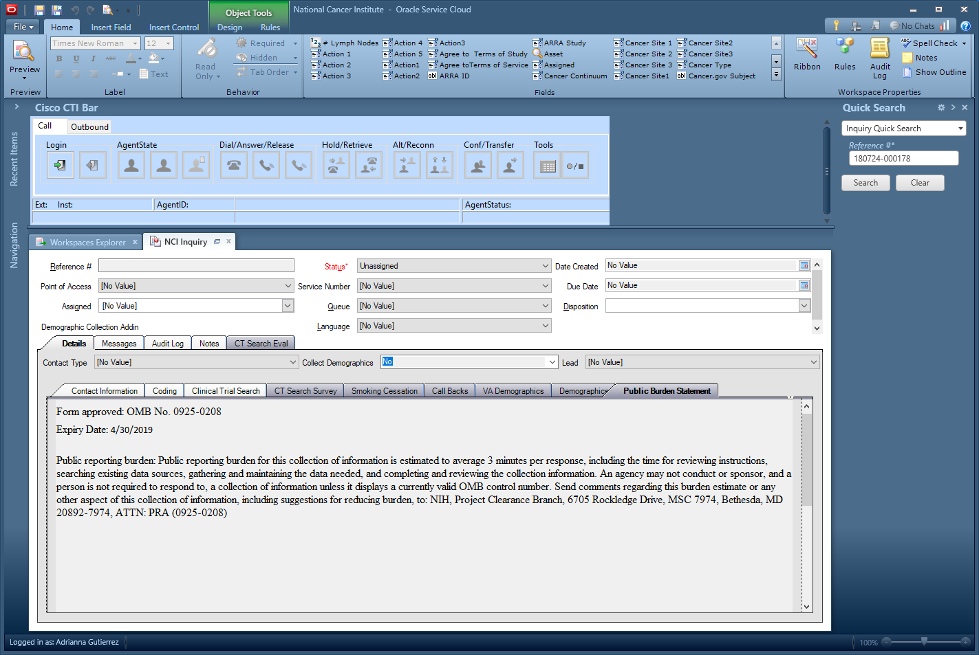

Questions:
- Have you used service before?
- How did you find our Service?
- Zip Code?

Demographic Survey Questions
What is your age?

- Age
- Callers age 96 or older
- Don’t know
- Refusal
- Did not ask

What is your Gender?

- Male
- Female
- Don’t know
- Refusal
- Did not ask

Which of These Categories Best Describes You?

- Hispanic or Latino
- Not Hispanic or Latino
- Don’t know
- Refusal
- Did not ask

Which of These Categories Best Describes You? You can select more than one:

- American Indian or Alaska Native
- Asian
- Black or African American
- Native Hawaiian or Other Pacific Islander
- White
- Don’t know
- Refusal
- Did not ask

What Is the Highest Level of Education You Have Completed?

- Grade school
- Some high school
- High school graduate
- Some college
- College graduate
- Post-graduate
- Not sampled
- Don’t know
- Refusal
- Did not ask

Is There a Place You Usually Go to When You are Sick or Need Advice About Your Health?

- Yes
- No
- Don't Know
- Refused
- Did not ask

What Kind of Place Do You Go Most Often?

- A doctor’s office
- A clinic, health center, or hospital clinic
- The emergency room, or
- Some other place
- No one place
- Valid skip
- Don’t know
- Refused
- Did not ask

In the Last 12 Months, Did You Have Any Kind of Healthcare Coverage, Including Health Insurance, Prepaid Plans Such As HMOs or Government Plans Such as Medicare?

- Yes
- No
- Don’t know
- Refused
- Did not ask

Would You Say You Had This Coverage During All 12 Months or Less Than 12 Months?

- All 12 months
- Less than 12 months
- Valid Skip
- Don’t know
- Refused
- Did not ask

Which Type of Coverage Did You Have?

- Was it public, such as Medicare, Medicaid, or other government plans?
- Was it private, such as an HMO, Blue Cross, Kaiser, Aetna?
- Or, was it both public and private?
- Valid skip
- Don’t know
- Refused
- Did not ask

The final questions are about your family income. I understand that this is sensitive information and I would like to stress again that all of the information you provide is confidential.
What Was Your Total Household Income from All Sources Before Taxes Last Year? Just Stop Me When I Get to the Right Category

- Less than $10,000
- $10,000 to $19,000
- $20,000 to $29,000
- $30,000 to $39,000
- $40,000 to $59,000
- $60,000 to $79,000
- $80,000 or more
- Don’t know
- Refused
- Did not ask

Including Yourself, How Many People Living in Your Household are Supported by This Total Household Income?

- Total People
- Don’t know
- Refused
Did not ask

