Please use this two-page form to provide highlights of your Center’s major achievements in recent months. This form will be used for internal purposes, to: 1) share information with other Centers, 2) share data with NIEHS/EPA staff for internal presentations and/or congressional briefings, and 3) update content on programmatic Web pages. Please provide any relevant website links where necessary, and provide as much detail as possible.

Grant Number:
Please provide the grant number for Center submitting this form:

Related cleared question from OMB No. 0925-0657
Exp. Date 07/31/2018

News & Media:
Please list any recent publicity your Center’s research has received in the news and media (e.g., press releases, podcasts, interviews, etc.)
Related cleared question from OMB No. 0925-0657
Exp. Date 07/31/2018

Knowledge Transfer Output | Check all that apply: |  | Provide a brief description.
Alternative/  Informal Dissemination |  | Research study is referred to or cited in a blog, tweet, wiki or other alternative mode of dissemination.
Mass Media |  | Mass media publication refers to the research study.
Dissemination Outputs
Please indicate which of the following mechanisms you have used to disseminate related knowledge and products stemming from your research. (Please check all that apply).
- Published in peer-reviewed journals
- Presented at scientific conferences
- Participated in grantee meetings
- Developed and disseminated curricula
- Developed and disseminated interventions
- Participated in the development of clinical guidelines
- Developed and disseminated research tools and methods
- Participated in workshops or trainings disseminating your research
- Provided scientific testimony and briefings to legislators
- Developed and published websites
- Presented research in community forums
- Developed fact sheets and pamphlets
- Provided information for press releases
- Other, please specify:_______________________________________________

Awards:
Please list any recent awards that Center personnel, trainees, or students have received below.
Related cleared question from OMB No. 0925-0657
Exp. Date 07/31/2018
We do not have a question currently cleared for the survey that asks about awards. We could potentially include that as a possible “other” dissemination output that we ask about. See box on previous page.

Community Outreach & Engagement:
Please describe any noteworthy outreach projects that have resulted in the collection of data and/or creation of educational materials. Provide links where necessary.
Related cleared question from OMB No. 0925-0657
Exp. Date 07/31/2018

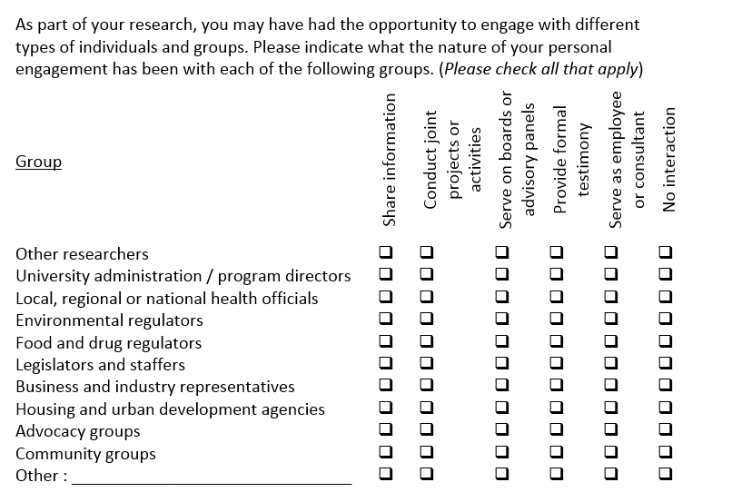

Community Partnership Outputs
Describe any community outreach outputs produced by your project, such as Outreach visits, interventions, curriculums, etc.: ________________________________________
Describe the target audience (include specific numbers of people reached if possible):
______________________________________________________________________
Describe the goal of the community partnership: _______________________________
Describe the ways community partners participated in the project: ________________
Describe any leadership roles community partners had in the project: ______________

Publications:
Please list recent high-impact publications. (Please consider limiting the list to 5-6 recent hihg-impact publications).
Related cleared question from OMB No. 0925-0657
Exp. Date 07/31/2018

Dissemination Outputs
Please indicate which of the following mechanisms you have used to disseminate related knowledge and products stemming from your research. (Please check all that apply).
- Published in peer-reviewed journals

IMPACTS
We are interested in assessing whether you think your research will have effects on long term outcomes (now or in the near future) through a variety of pathways, including clinical practice changes, reduced exposure to environmental hazards, or changes in public behavior and advocacy. For each of the following items, please mark the ’current’ box if you believe your research has already affected change in this area and the ‘future potential’ box if you believe it has the potential to affect change in the next 10 years.
Impact Area | Impact Timing
- My research has led to greater understanding of selected science portfolio disease mechanisms  Describe impact: | Current Future potential
- My research has led to greater understanding of individual, social, and environmental factors associated with selected science portfolio  Describe impact: | Current Future potential
- My research has led to improved environmental measurement techniques  Describe impact: | Current Future potential
- My research has led to increased evidence regarding effective interventions  Describe impact: | Current Future potential
- My research has led to improved environmental control techniques  Describe impact: | Current Future potential
- My research has led to changes in education outcomes for clinical/public health students  Describe impact: | Current Future potential
- My research has led to changes in education outcomes for K-12 or families  Describe impact: | Current Future potential
- My research has led to changes in business practices regarding selected science portfolio  Describe impact: | Current Future potential
Impact Area | Impact Timing
- My research has led to changes in environmental standards or regulations for change to reflect selected science portfolio  Describe impact: | Current Future potential
- My research has led to changes in environmental policies for selected science portfolio  Describe impact: | Current Future potential
- My research has led to changes in clinical practice relevant to selected science portfolio  Describe impact: | Current Future potential
- My research has led to changes in public knowledge and practices related to selected science portfolio prevention and control  Describe impact: | Current Future potential
- My research has led to increased public advocacy for selected science portfolio prevention and control  Describe impact: | Current Future potential
- My research has led to changes in behavior related to the field of selected science portfolio | Current Future potential

- My research has led to improved environmental control techniques  Describe impact: | Current Future potential
- My research has led to changes in education outcomes for clinical/public health students  Describe impact: | Current Future potential
- My research has led to changes in education outcomes for K-12 or families  Describe impact: | Current Future potential
- My research has led to changes in business practices regarding selected science portfolio  Describe impact: | Current Future potential
- My research has led to changes in environmental standards or regulations for change to reflect selected science portfolio  Describe impact: | Current Future potential
- My research has led to changes in environmental policies for selected science portfolio  Describe impact: | Current Future potential
- My research has led to changes in clinical practice relevant to selected science portfolio  Describe impact: | Current Future potential
- My research has led to changes in public knowledge and practices related to selected science portfolio prevention and control  Describe impact: | Current Future potential
- My research has led to increased public advocacy for selected science portfolio prevention and control  Describe impact: | Current Future potential
- My research has led to changes in behavior related to the field of selected science portfolio | Current Future potential

Career Development Highlights:
Please describe recent accomplishments of trainees.

Related cleared question from OMB No. 0925-0657
Exp. Date 07/31/2018

Career Development Outputs
Career Development Output | Check all that apply: |  | Provide a brief description.
University Leadership Positions |  | Serve as Center Director, Department Chair, or other university leadership position
Organizational/  Conference Leadership Position |  | Serve as conference chair, organizational leader (Society of Toxicology, International Society of Environmental Epidemiology, etc.)
Nominated for Membership in Prestigious Organization |  | Nominated for membership in prestigious organization such as Institute of Medicine, American Association for Advancement of Science, etc.
Employment Promotion |  | Received promotion to higher level of employment, such as next level of professor, or scientist
Obtained Tenure Status |  | Obtained tenure status for research or teaching position
Trained or Mentored Students |  | Served as a mentor or trained students in the field of selected science portfolio
Additional Training or Certification Received |  | Obtained additional training (K awards) or certifications within the field of environmental health science

Additional Highlights:
Please use the space below to list or describe any noteworthy highlights that have not already been addressed above.

On behalf of NIEHS, thank you for taking the time to provide this information.

