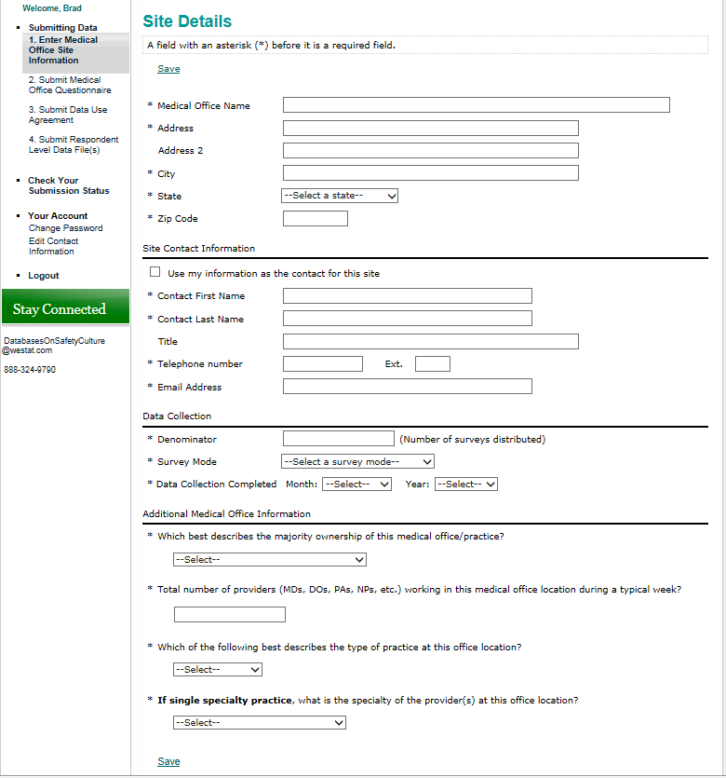
Response options for Specialties (separated by semi-colons):
Allergy/Immunology; Anesthesiology; Cardiology; Child & Adolescent Psychiatry; Dermatology; Diagnostic Radiology; Emergency Medicine; Endocrinology/ Metabolism; Family Practice/Family Medicine; Forensic Pathology; Gastroenterology; General Practice

Response options for Practice Type:
- Single specialty
- Multispecialty

Response options for Majority Ownership:
- Provider(s) and/or Physician(s)
- Hospital or Health System
- University or Academic Medical Center
- Community Health Center
- Federal, state, or local government
- Other

Response options for Survey Mode:
- Paper
- Web
- Mixed mode (paper & web)
- Other

Public reporting burden for this collection of information is estimated to average 5 minutes per response, the estimated time required to complete the survey. An agency may not conduct or sponsor, and a person is not required to respond to, a collection of information unless it displays a currently valid OMB control number. Send comments regarding this burden estimate or any other aspect of this collection of information, including suggestions for reducing this burden, to: AHRQ Reports Clearance Officer Attention: PRA, Paperwork Reduction Project (0935-XXXX) AHRQ, 540 Gaither Road, Room # 5036, Rockville, MD 20850.

