ATTACHMENT F:
MULTI-SITE IMPLEMENTATION EVALUATION OF TRIBAL HOME VISITING (MUSE)
CAREGIVER INFORMATIONAL FLYER
An agency may not conduct or sponsor, and a person is not required to respond to, a collection of information unless it displays a currently valid OMB control number. The OMB number for the described information collection is 0970-0XXX and the expiration date is XX/XX/XXXX.

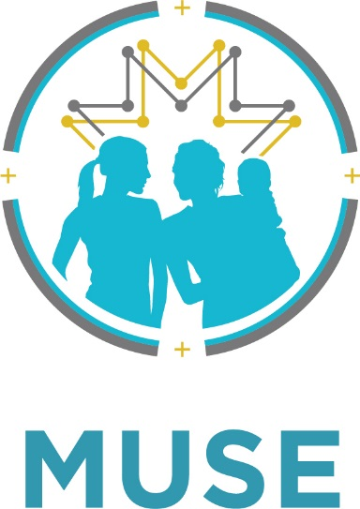
Multisite Implementation Evaluation of Tribal Home Visiting (MUSE) Research Study
Replace w/ Local Program Logo

Program name is a partner in the Multisite Implementation Evaluation of Tribal Home Visiting (MUSE). MUSE is a 5-year research study. The MUSE study is an effort to learn about tribal home visiting programs and the families they serve. We are one of 17 tribal organizations partnering on MUSE.

Your home visitor will ask you if you want to be in the MUSE study. The study will ask you about your experiences in our program. This flyer shares some information about MUSE so that you can think about taking part.

Principal Investigator

Nancy Rumbaugh Whitesell, Professor, Centers for American Indian and Alaska Native Health (CAIANH), Colorado School of Public Health
COMIRB—18-0109

MUSE Study Team

Kate Lyon, JBA
Tess Abrahamson-Richards, JBA
Melina Salvador, JBA
Michelle Sarche, CAIANH
Amy Stiffarm, JBA

Why is Program Name partnering with the MUSE study team?

Program Name wants to learn more about what is working well in tribal home visiting programs and how services can be improved for families in our community and nationwide. By joining the study, Program Name is also helping make sure the national MUSE study respects local tribal practices and culture.



Thank you for thinking about being in the study!

If you decide to be in the study, you may be asked to—
- Take up to 3 surveys about you and your experiences with Program name.
- Take a 5-minute questionnaire after a few of your home visits.
- Allow Program name to share some information about you and your child with the MUSE study.
- Complete an in-person interview with a MUSE researcher.

You will get details about each study activity before you are asked to do anything. Taking part in the study is voluntary, meaning you can say “yes” or “no” to being in the study. If you choose not to be in the study, you can still receive home visiting services.
What happens next?

Sometime soon, your home visitor will ask you if you want to be in the study. If you have questions, you can ask your home visitor or contact MUSE directly.
Program name Contact: Name
XXX-XXX-XXXX
Email address

MUSE Contact: Tess Abrahamson-Richards
206-719-8313
Abrahamson-Richards@jbassoc.com

What will we ask you to do?

