Draft HPP Partner Survey Questions – February 2019

Note that text in brackets [ ] are notes for programming in SurveyMonkey and should not be included in the distributed version.

Survey Purpose
The purpose of this survey is to gather information from the Hospital Preparedness Program’s partner community on the value of the HPP partner meetings and various activities, resources, and communications materials put forth by ASPR and HPP. Information collected from this survey will help HPP measure how well the program is meeting its strategy and mission, as well as help improve and refine the program’s engagement priorities.
Survey Questions
Questions related to background information
- Please provide your name, organization, and preferred contact information. [open responses]

Questions regarding the HPP Partner Community Meetings, various activities and resources, and communications materials
- How valuable are the HPP Partner Meetings to you and your organization, on a scale of 1-5? [sliding scale ranking 1-5]

- Which of the following activities or resources benefit your understanding of HPP? Check all that apply. [check boxes]
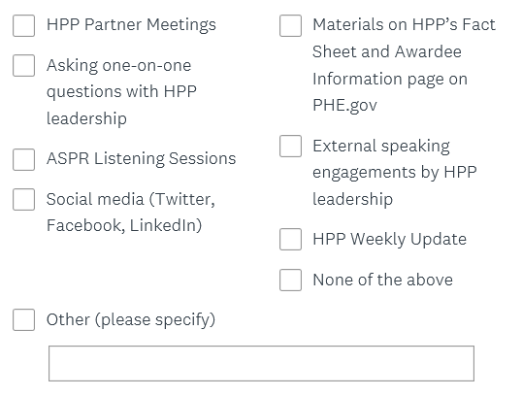

- Have you used any of these communications materials on HPP’s Fact Sheet and Awardee Information page on PHE.gov in the last six months? Check the ones you have used: [check boxes]

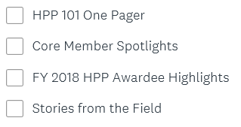

- As a result of HPP Partner Meetings, these various activities and resources, and communications materials, how confident are you in your ability to communicate HPP’s mission and impact to other audiences, on a scale of 1-5? [sliding scale 1-5]

- Is information missing from these communications materials that would benefit your organization? If so, what additional information should HPP include? [open response]

Questions related to feedback on HPP’s strategy, mission, and engagement priorities
- As a program, what does HPP do well? [multiple choice]
- What can HPP improve on? [multiple choice]
Questions regarding HPP’s engagment priorities
- Are there any conferences that HPP should present at to reach a broader health care audience? [open response]

- Please list any additional organizations that you think would be interested in attending HPP Partner Community meetings or receiving information regularly from HPP and include the organization and point of contact. [open response]

