**IMAGE # 1: BBS HOMEPAGE**

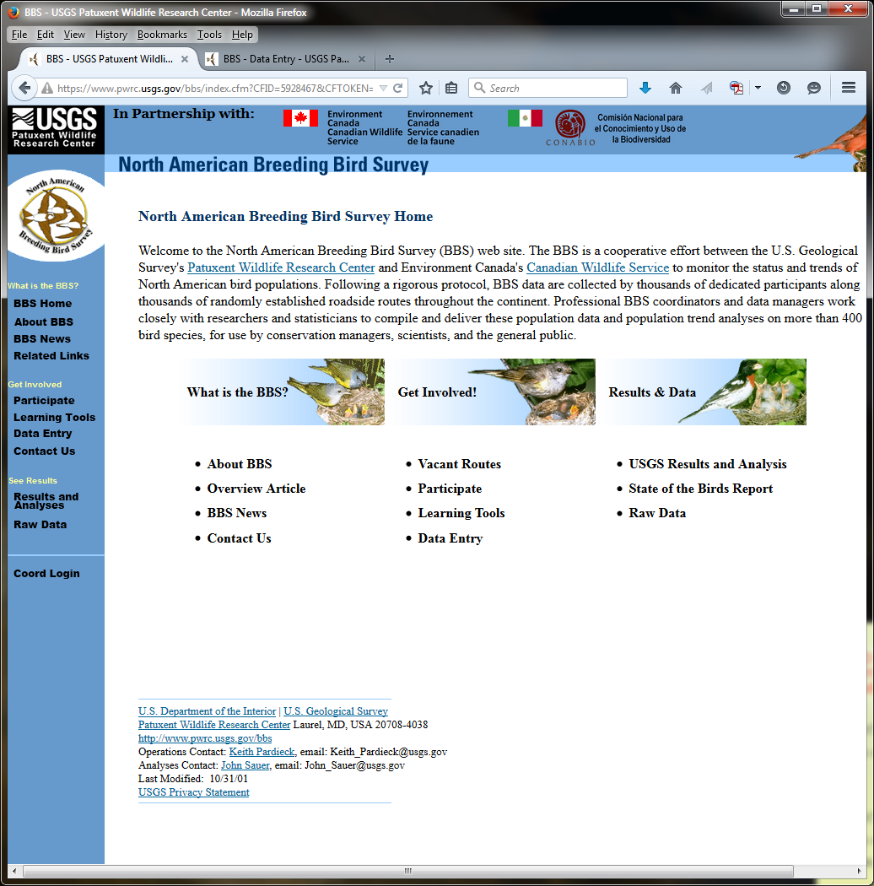

**IMAGE #2: DATA ENTRY (PAGE 1)**

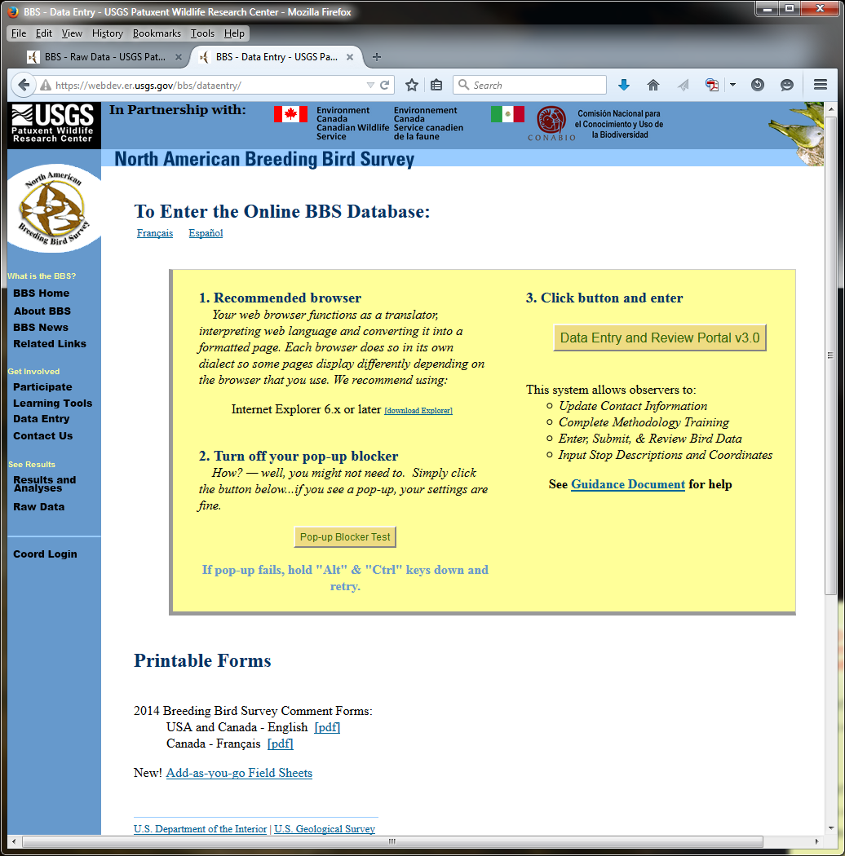

**IMAGE #3: DATA ENTRY LOGIN (PAGE 2)**

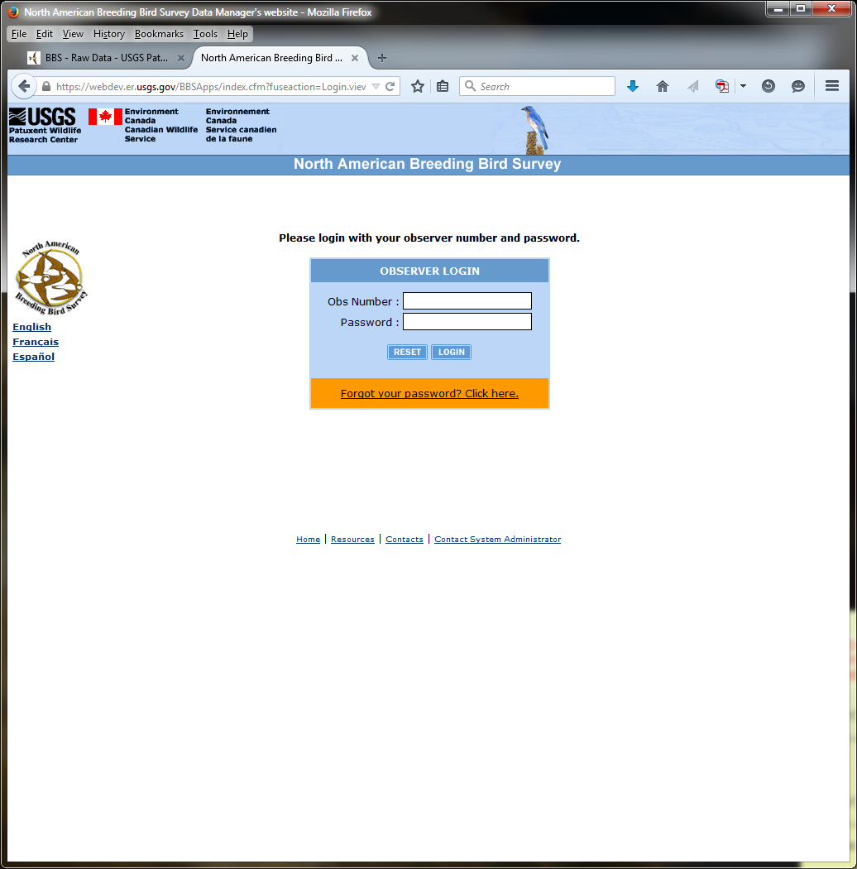

**IMAGE #4: DATA ENTRY (PAGE 3)**

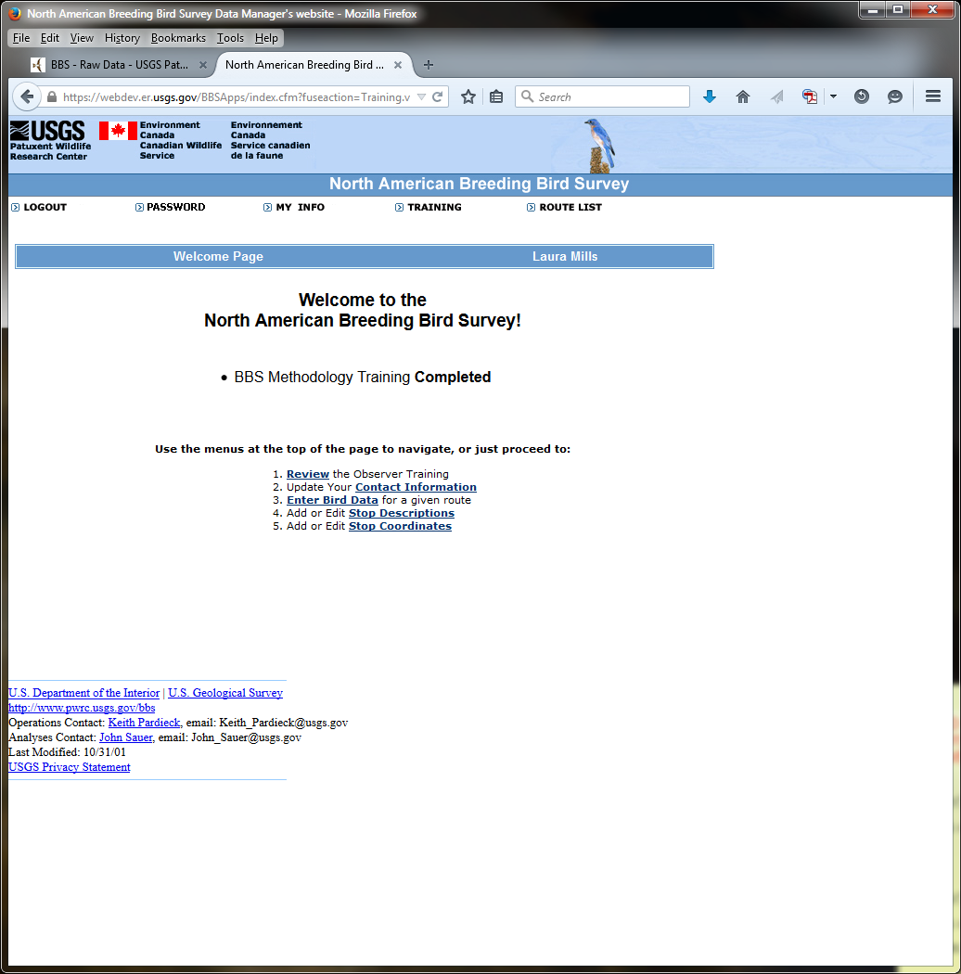

**IMAGE #5: DATA ENTRY (PAGE 4)**

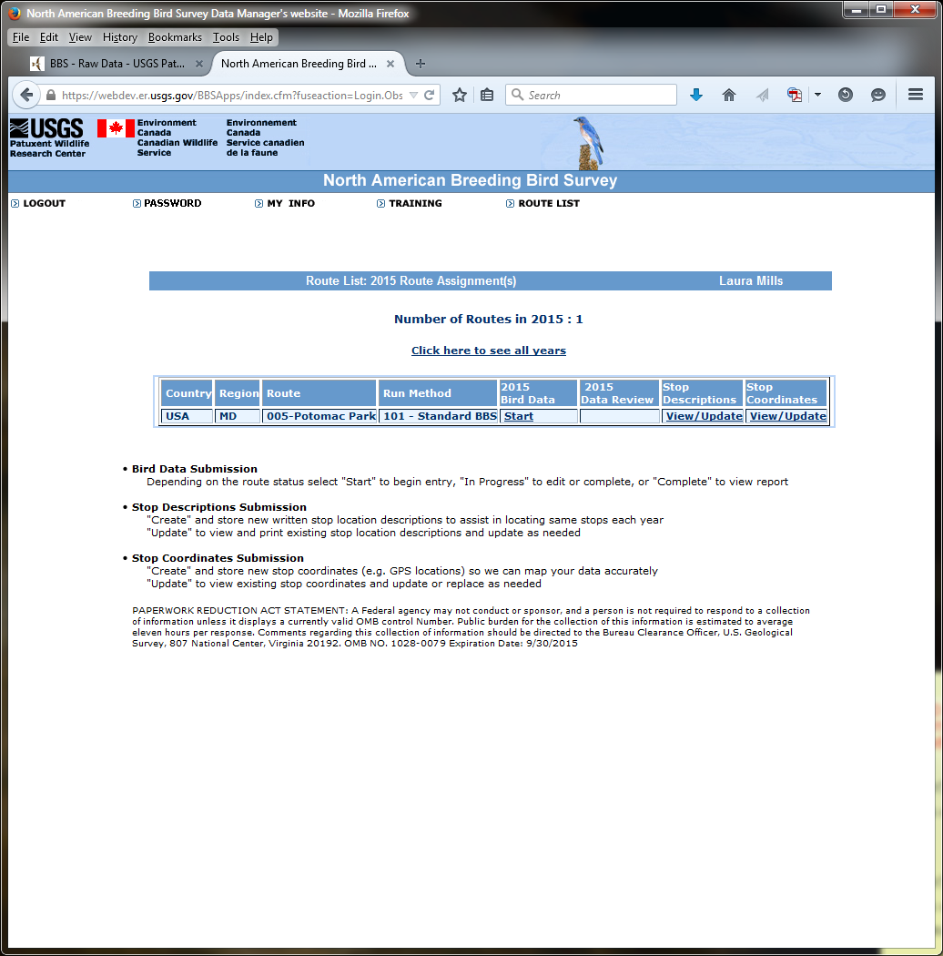

**IMAGE #6: DATA ENTRY (PAGE 5)**

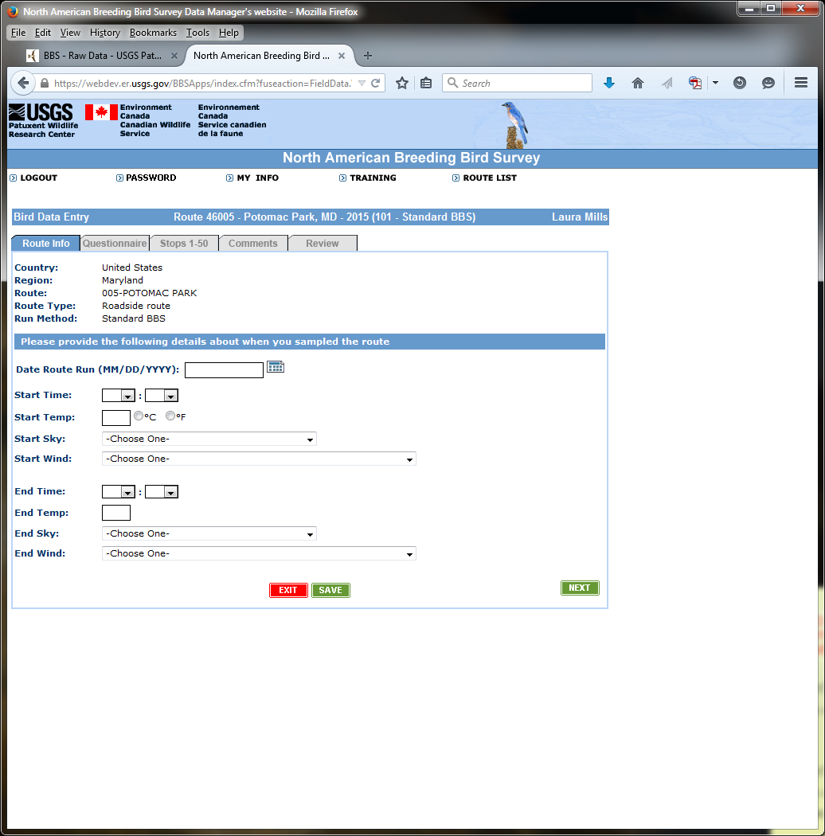

**IMAGE #7: DATA ENTRY (PAGE 6)**

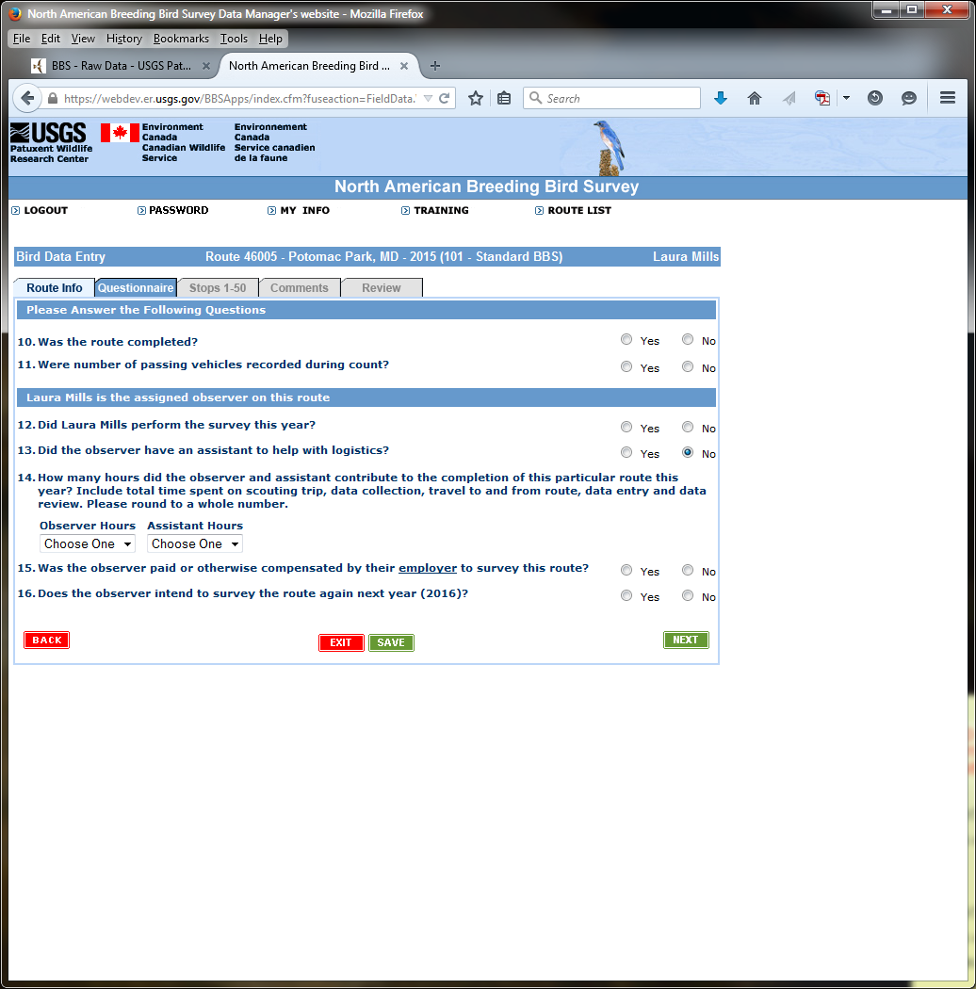

**IMAGE #8: DATA ENTRY (PAGE 7)**

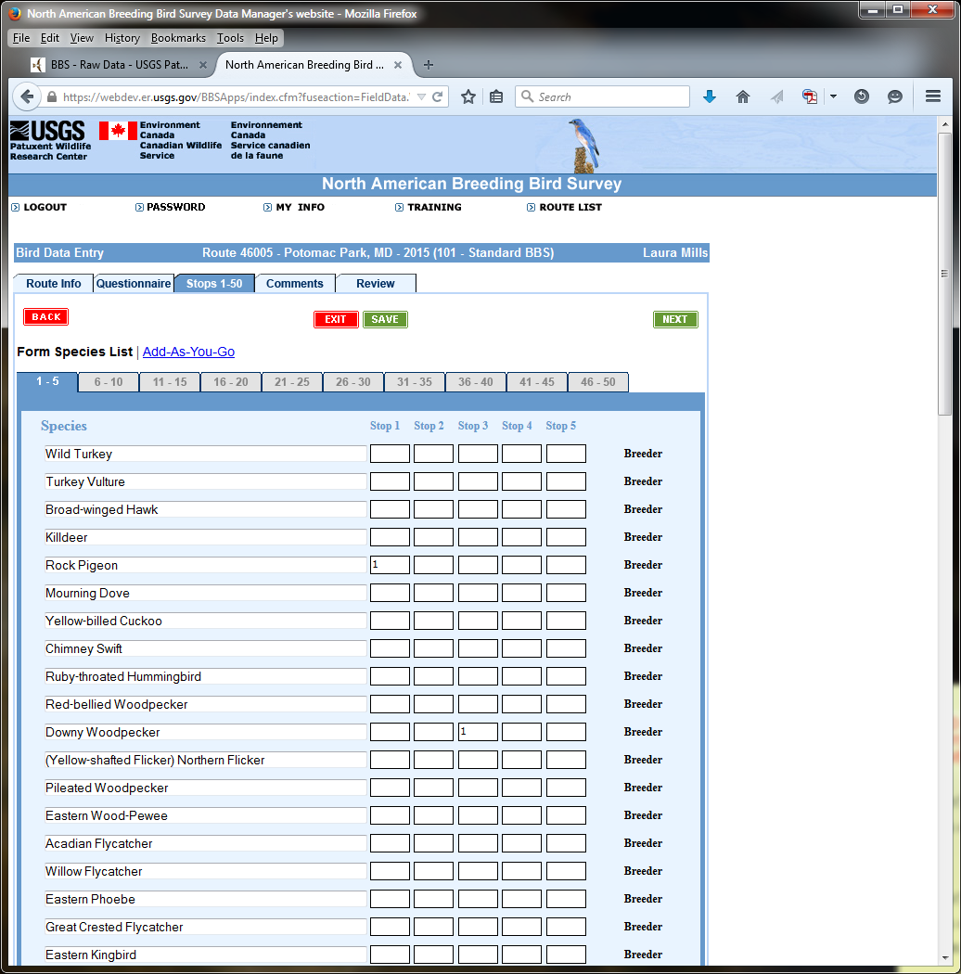

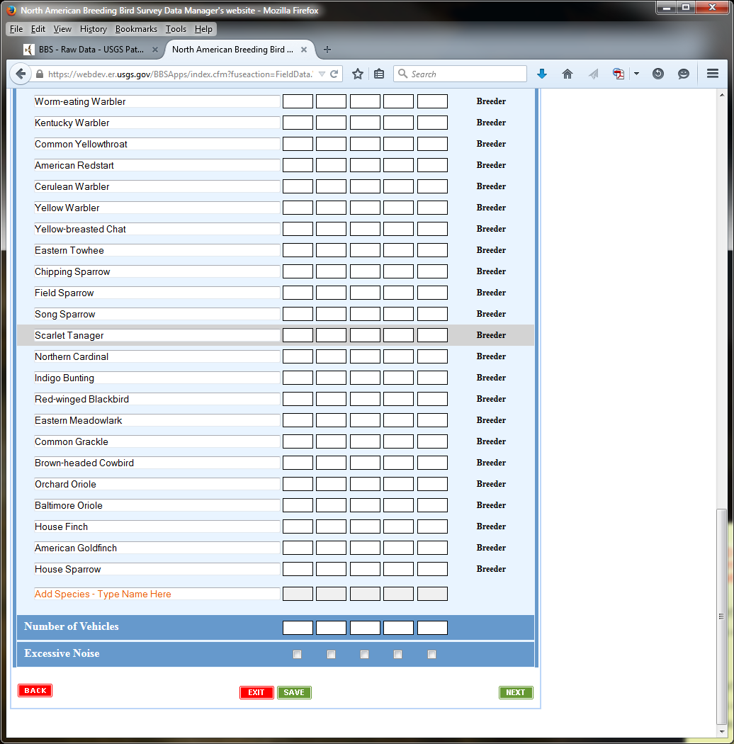

**IMAGE #9: DATA ENTRY (PAGE 8)**

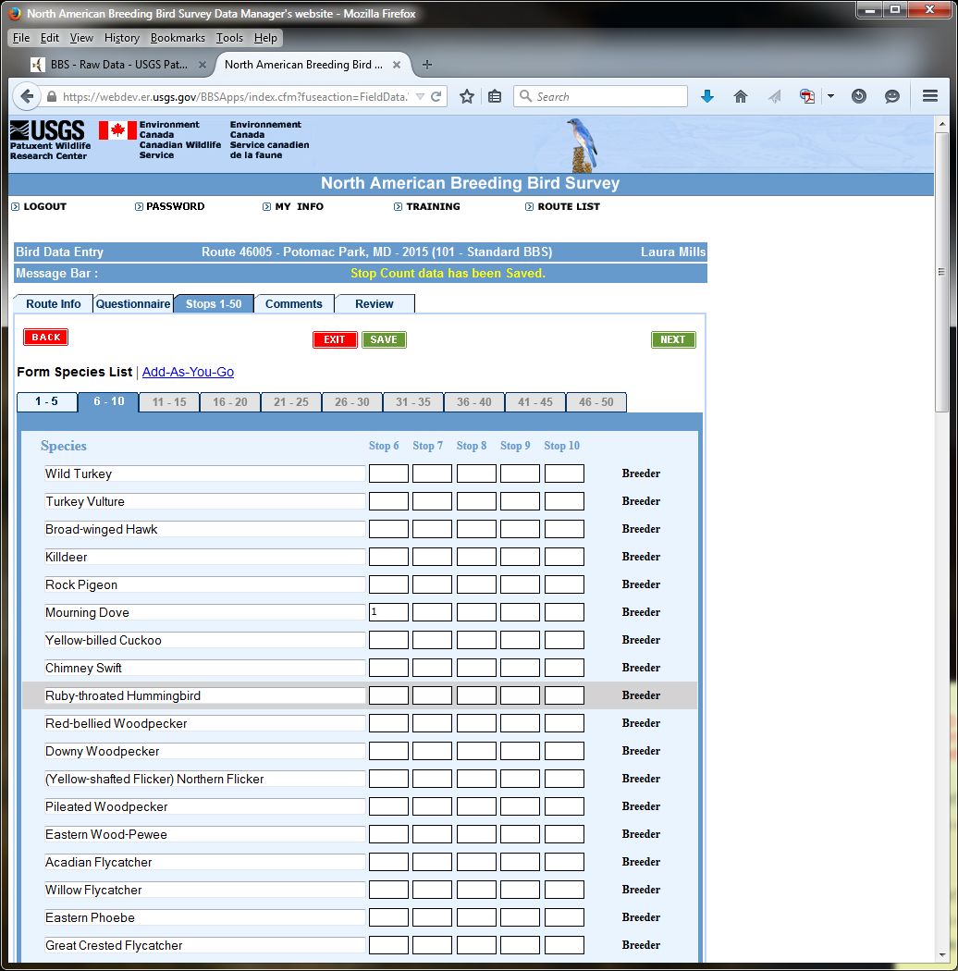

**IMAGE #10: DATA ENTRY (PAGE 9)**

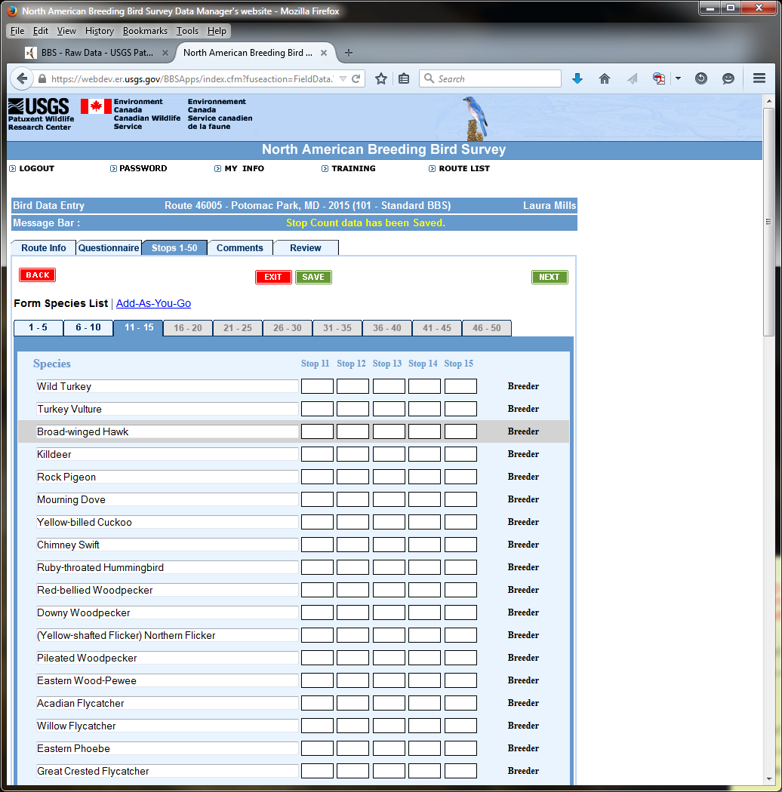

**IMAGE #11: DATA ENTRY (PAGE 10)**

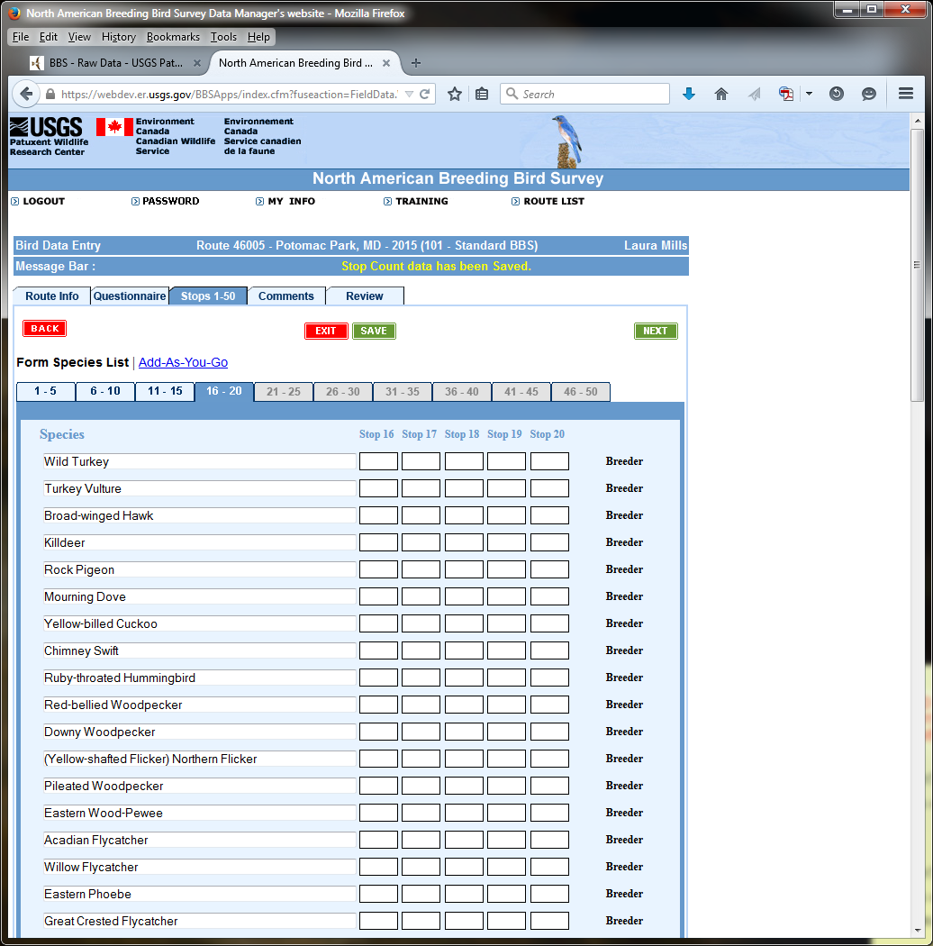

**IMAGE # 12: DATA ENTRY (PAGE 11)**

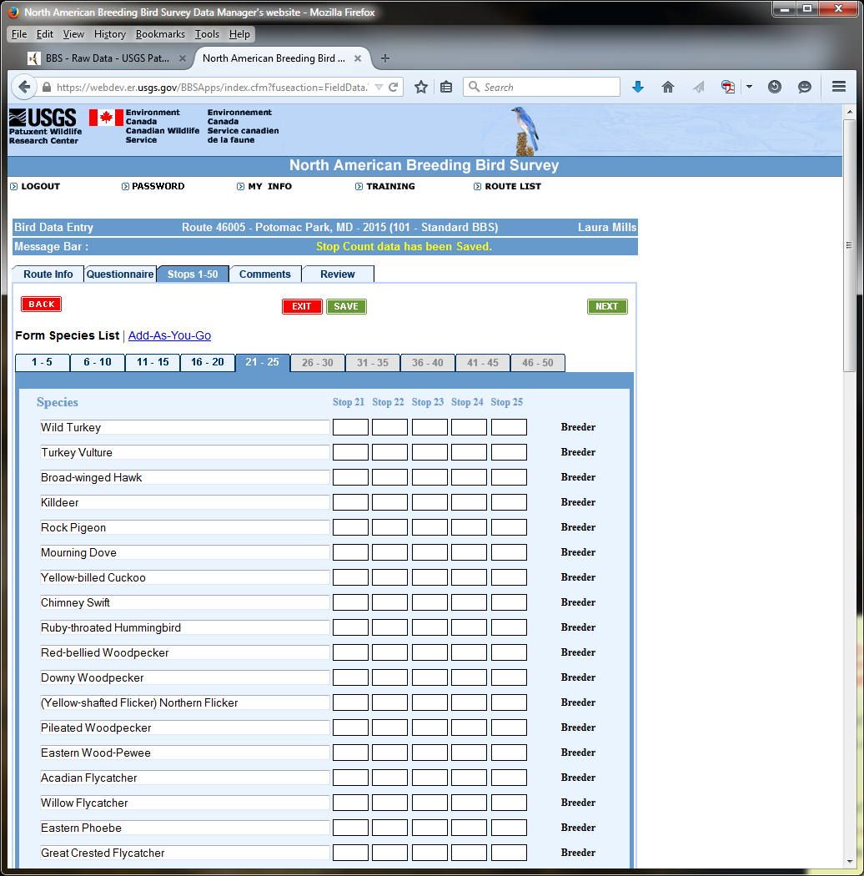

**IMAGE #13: DATA ENTRY (PAGE 12)**

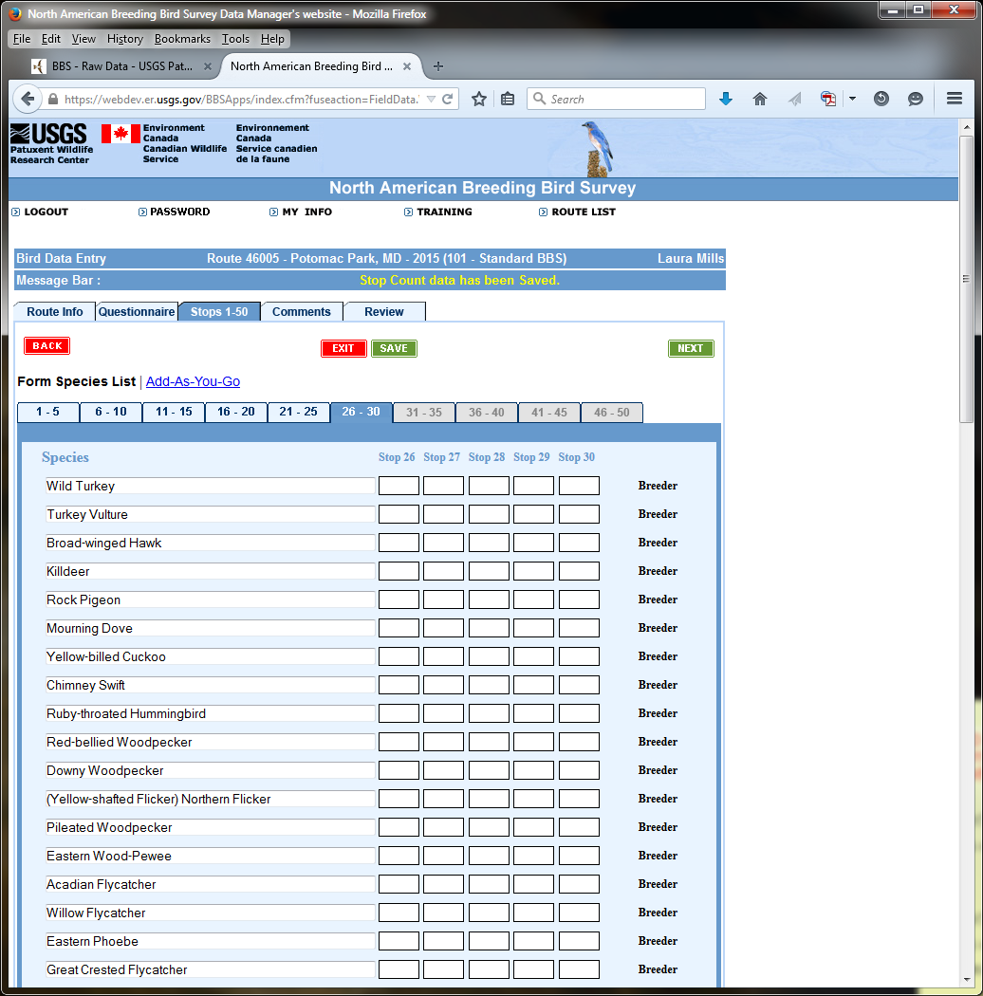

**IMAGE #14: DATA ENTRY (PAGE 13)**

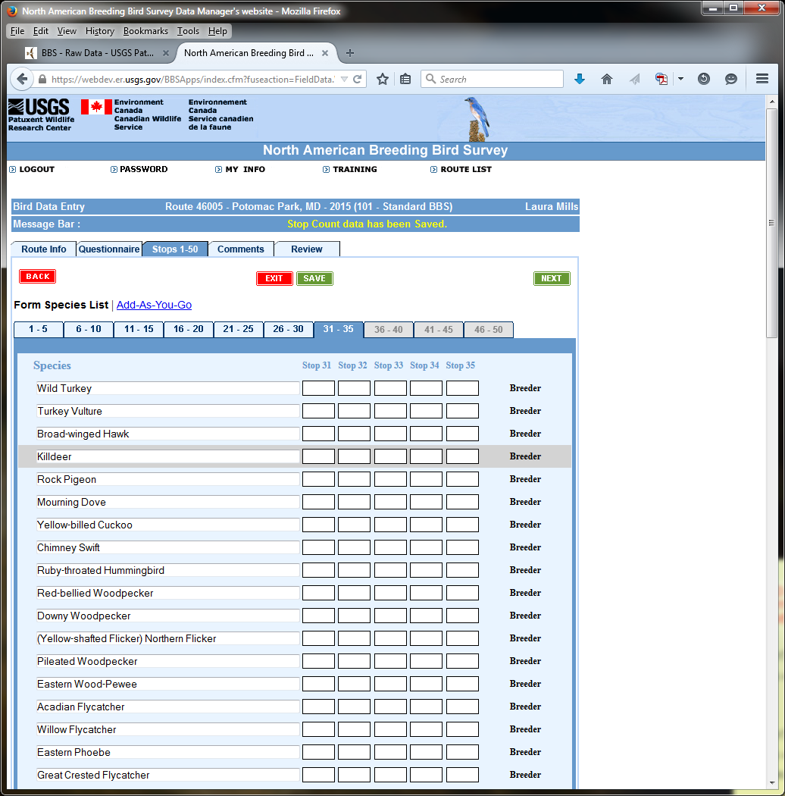

**IMAGE #15: DATA ENTRY (PAGE 14)**

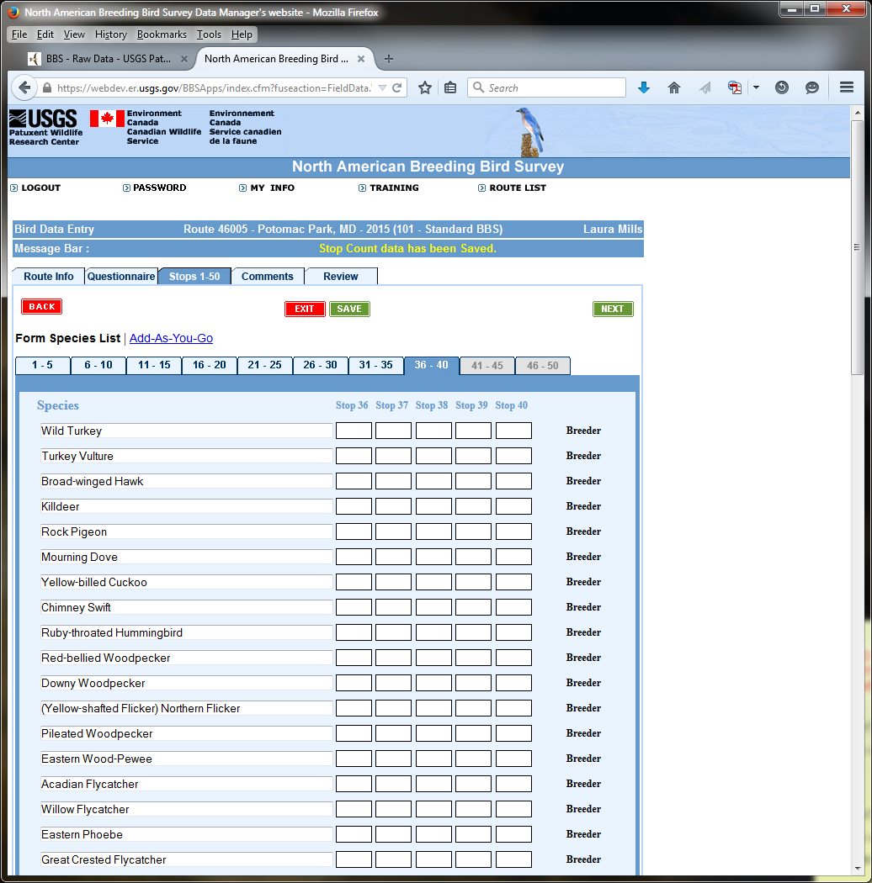

**IMAGE #16: DATA ENTRY (PAGE 15)**

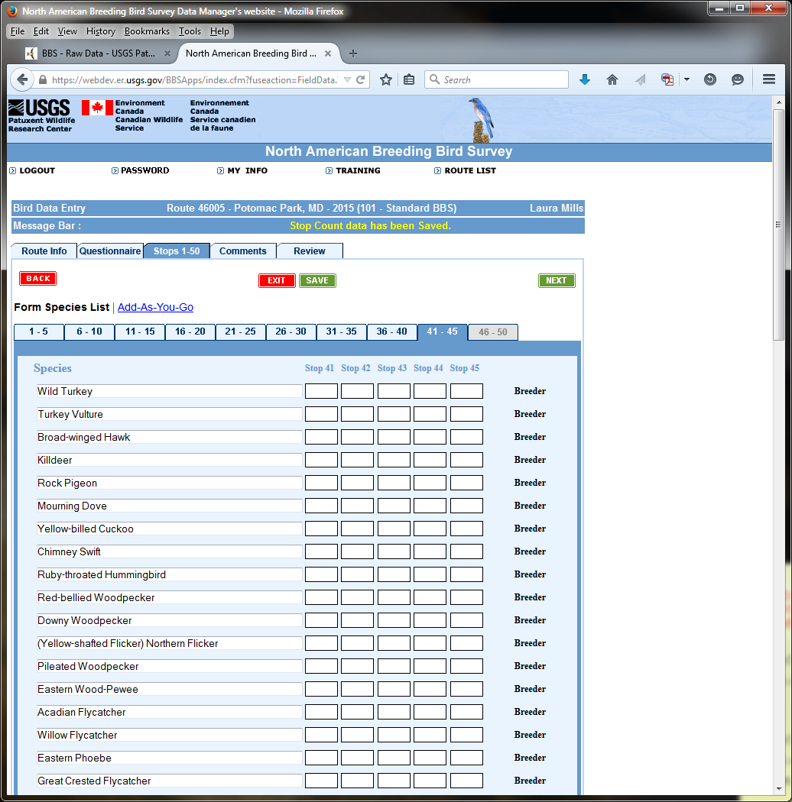

**IMAGE #17: DATA ENTRY (PAGE 16)**

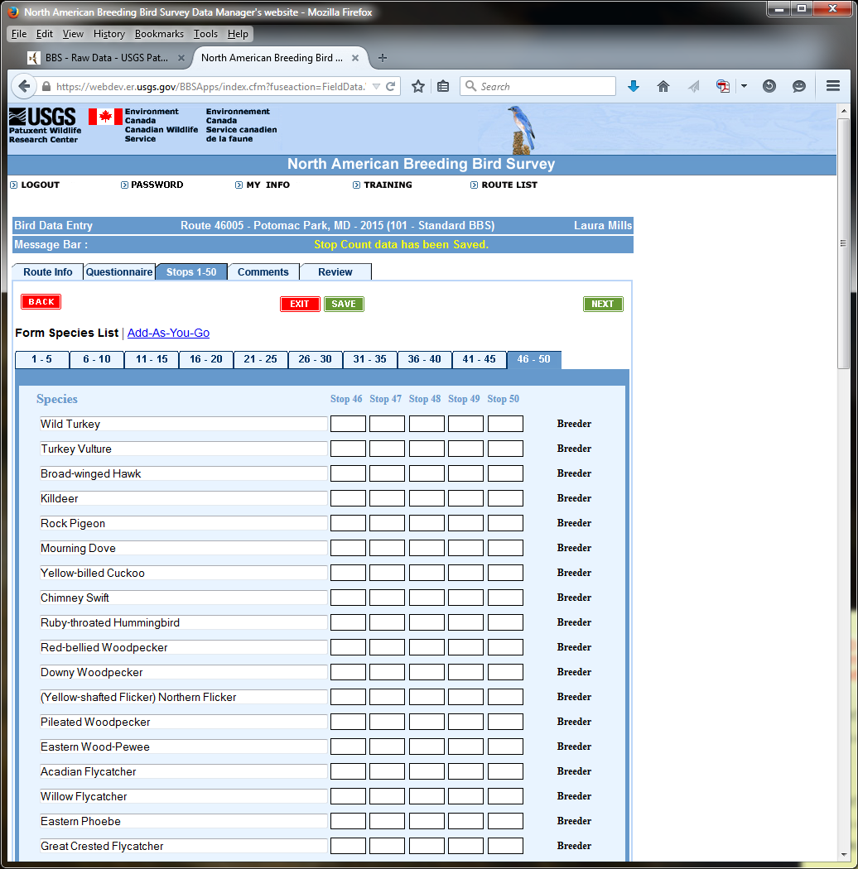

**IMAGE #18: DATA ENTRY (PAGE 17)**

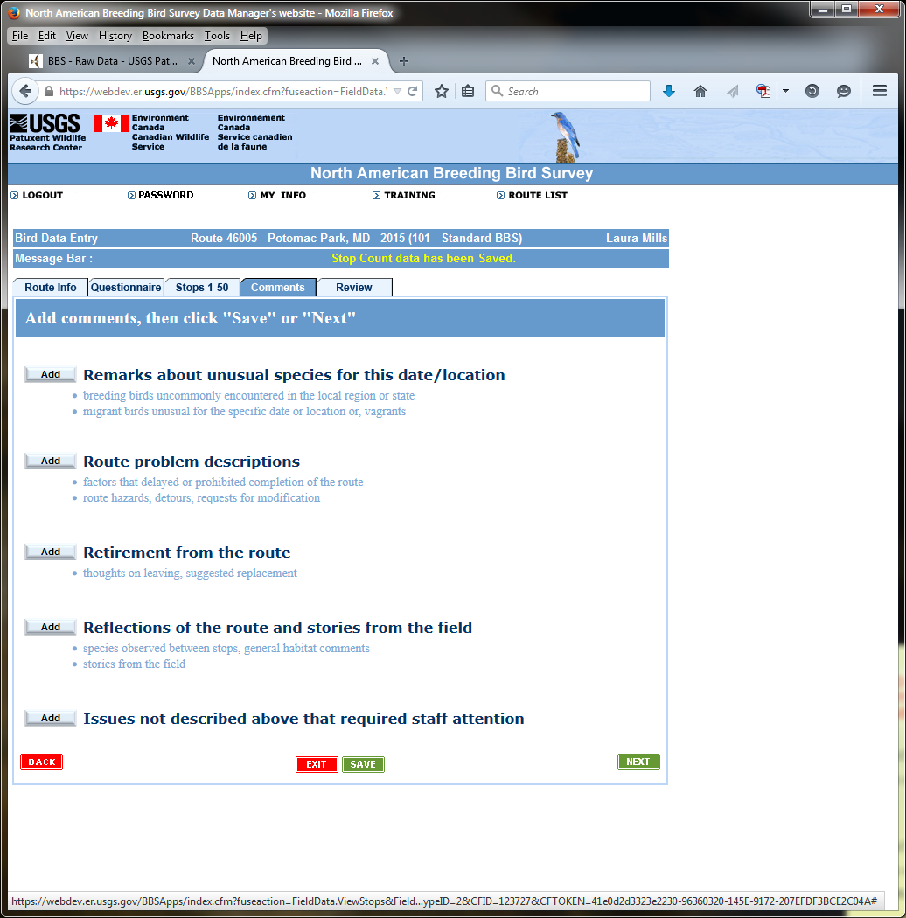

**IMAGE #19: DATA ENTRY (PAGE 18)**

