IMAGE # 1: BBS HOMEPAGE

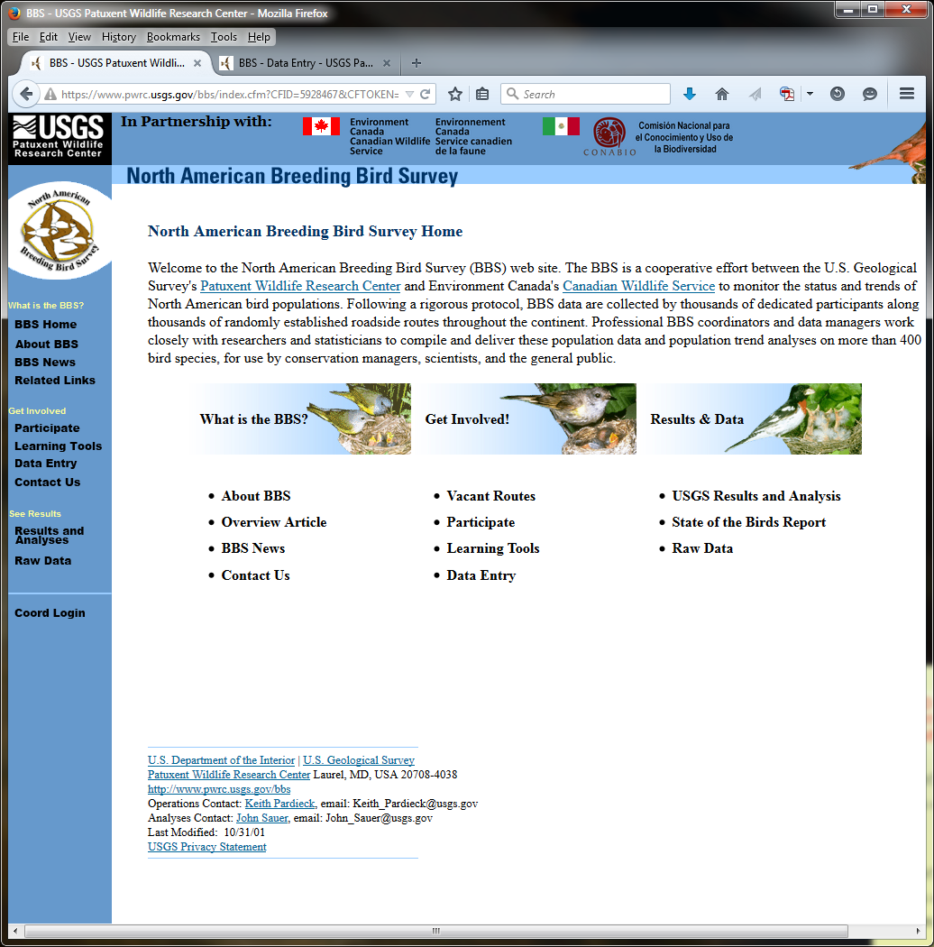

IMAGE #2: DATA ENTRY (PAGE 1)
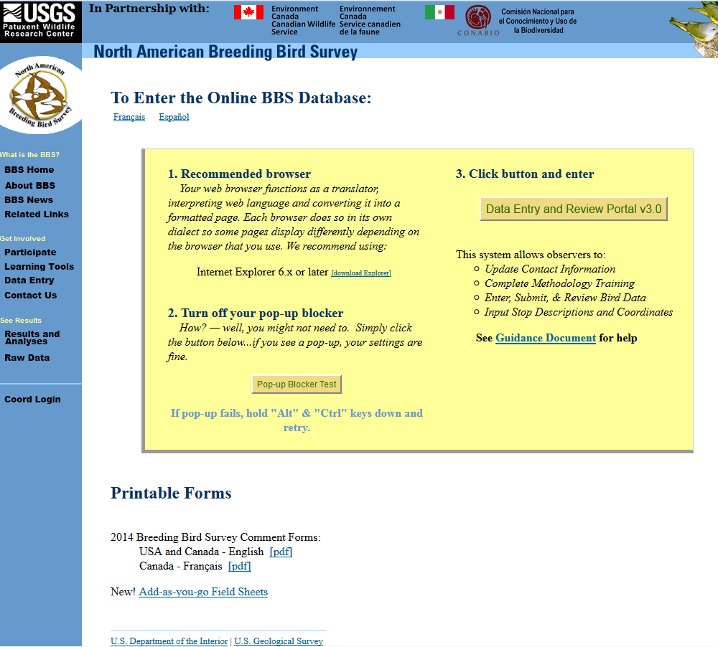

IMAGE #3: DATA ENTRY LOGIN (PAGE 2)
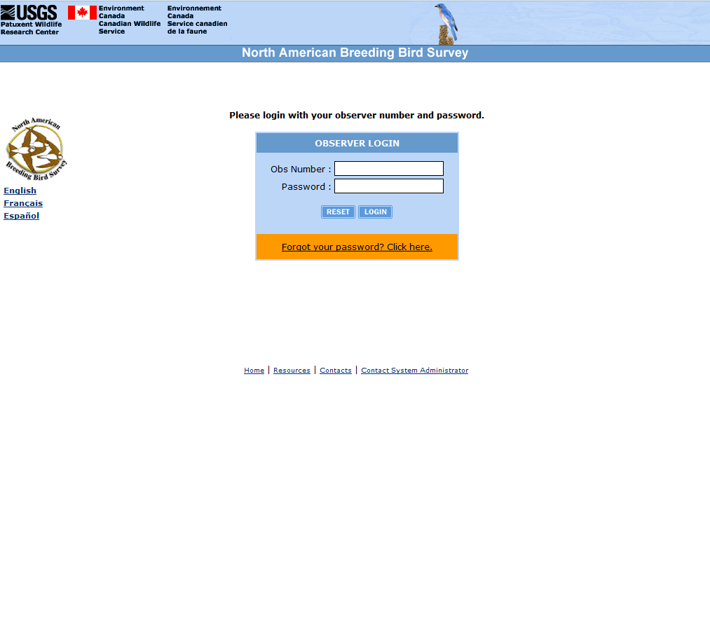

IMAGE #4: DATA ENTRY (PAGE 3)
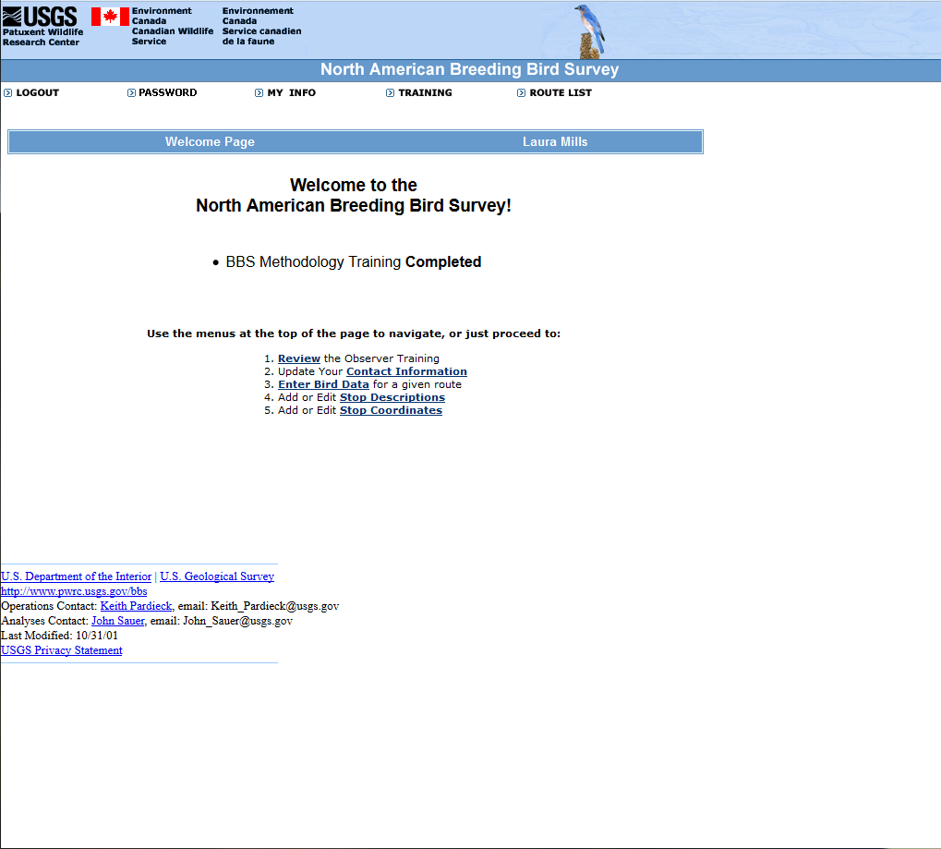

IMAGE #5: DATA ENTRY (PAGE 4)
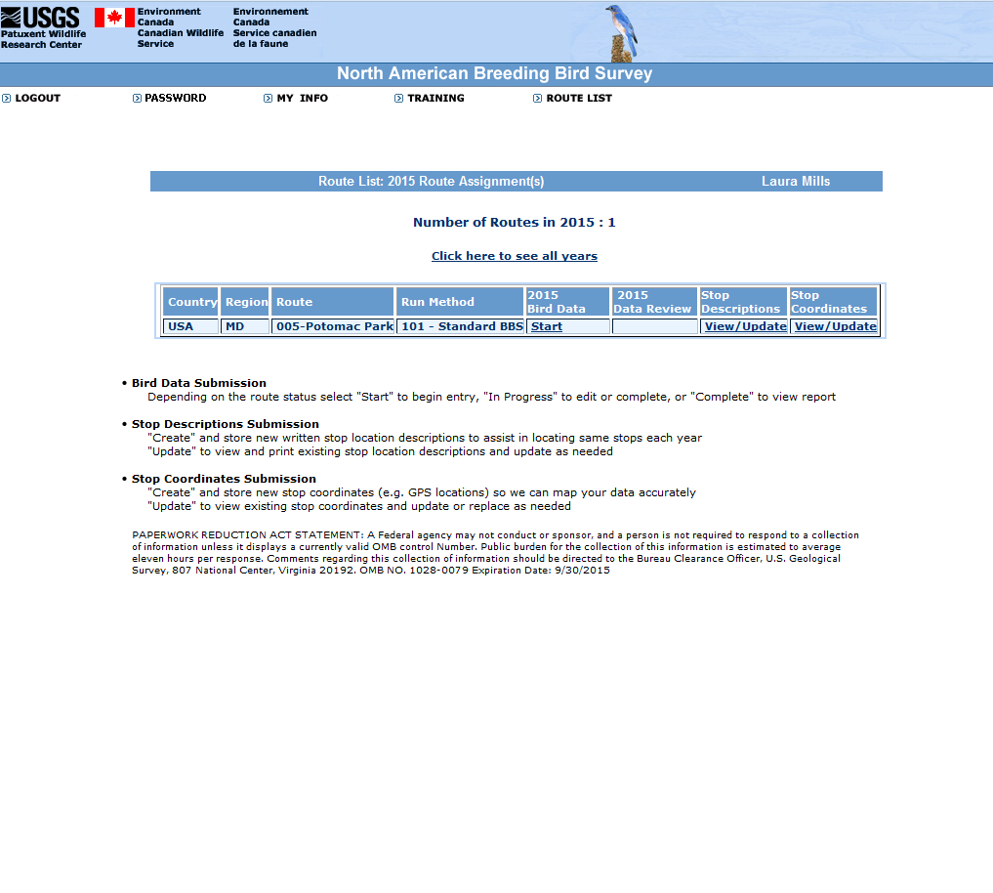

IMAGE #6: DATA ENTRY (PAGE 5)
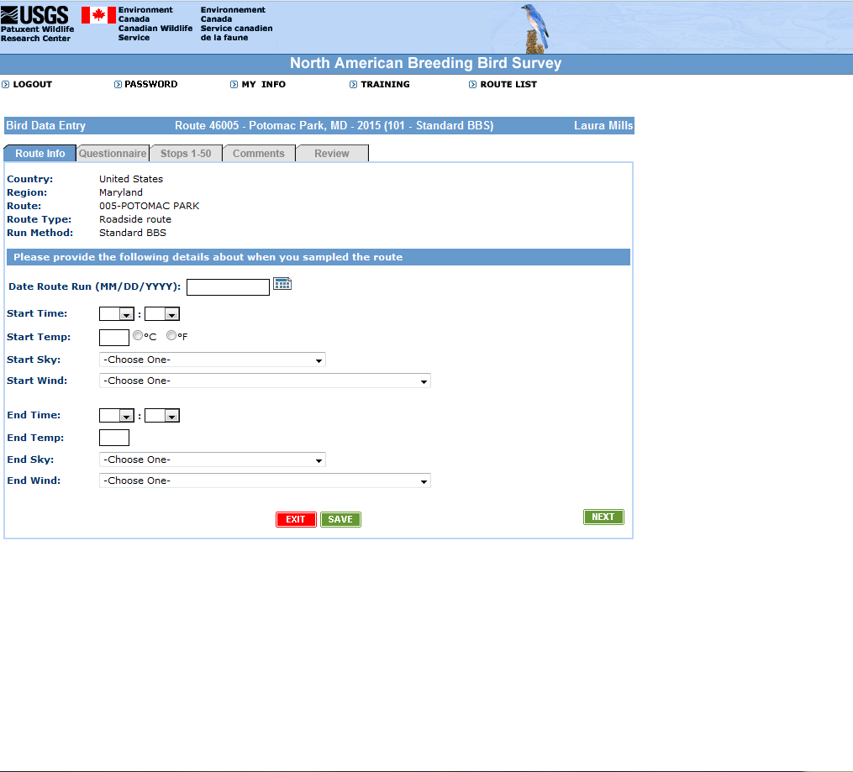

IMAGE #7: DATA ENTRY (PAGE 6)
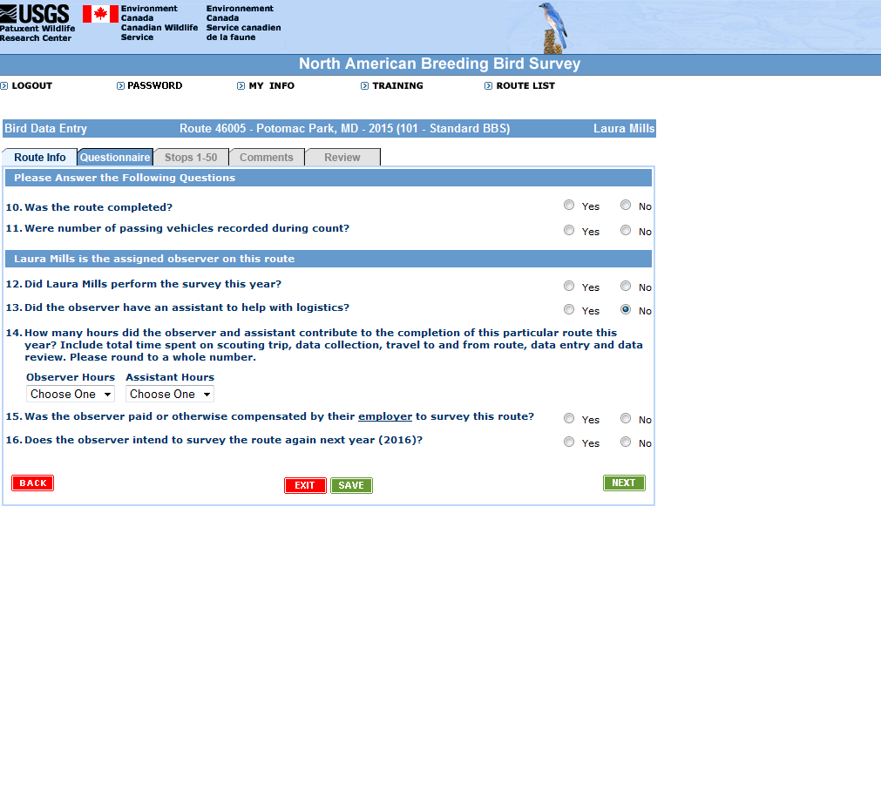

IMAGE #8: DATA ENTRY (PAGE 7)
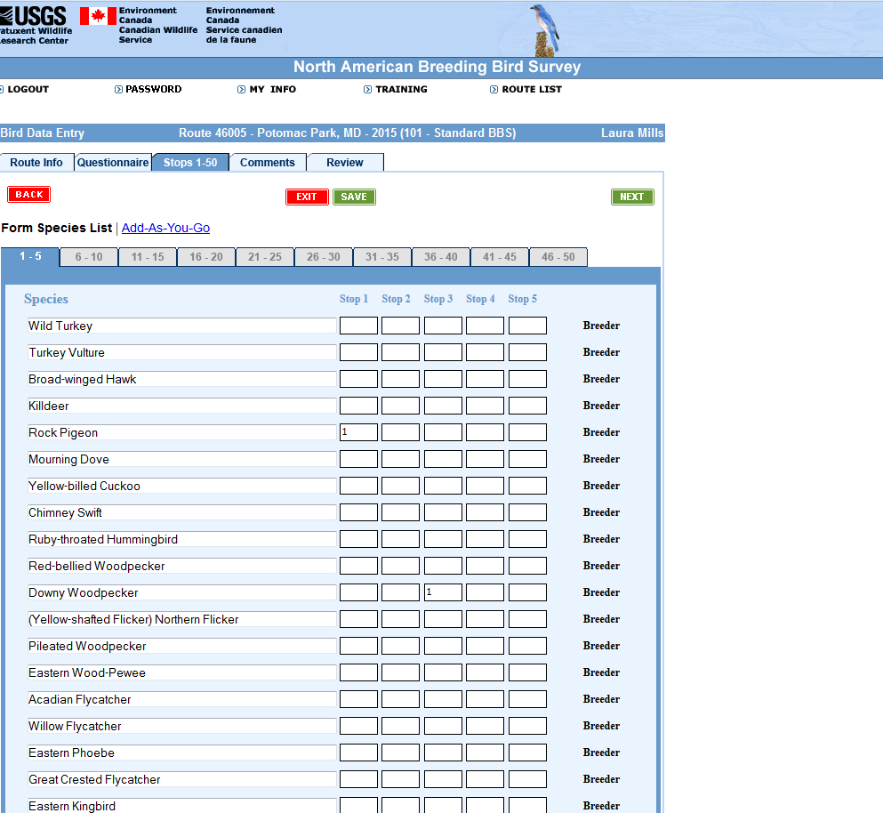
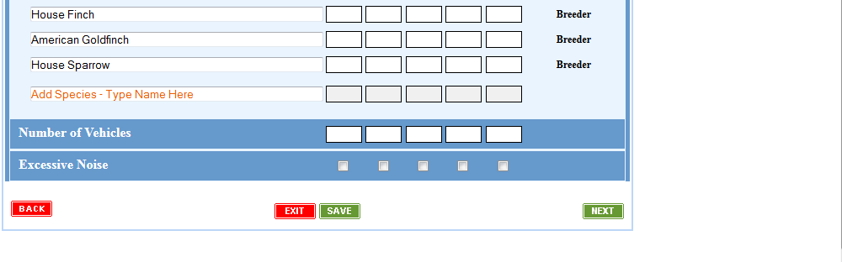
IMAGE #9: DATA ENTRY (PAGE 8)
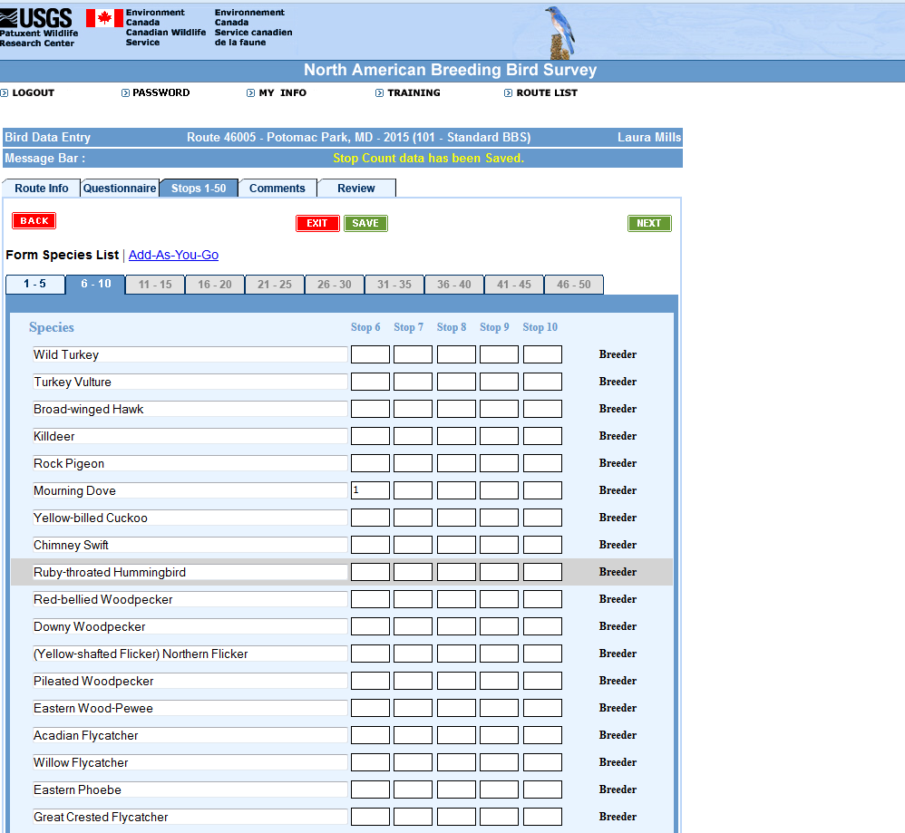

IMAGE #10: DATA ENTRY (PAGE 9)
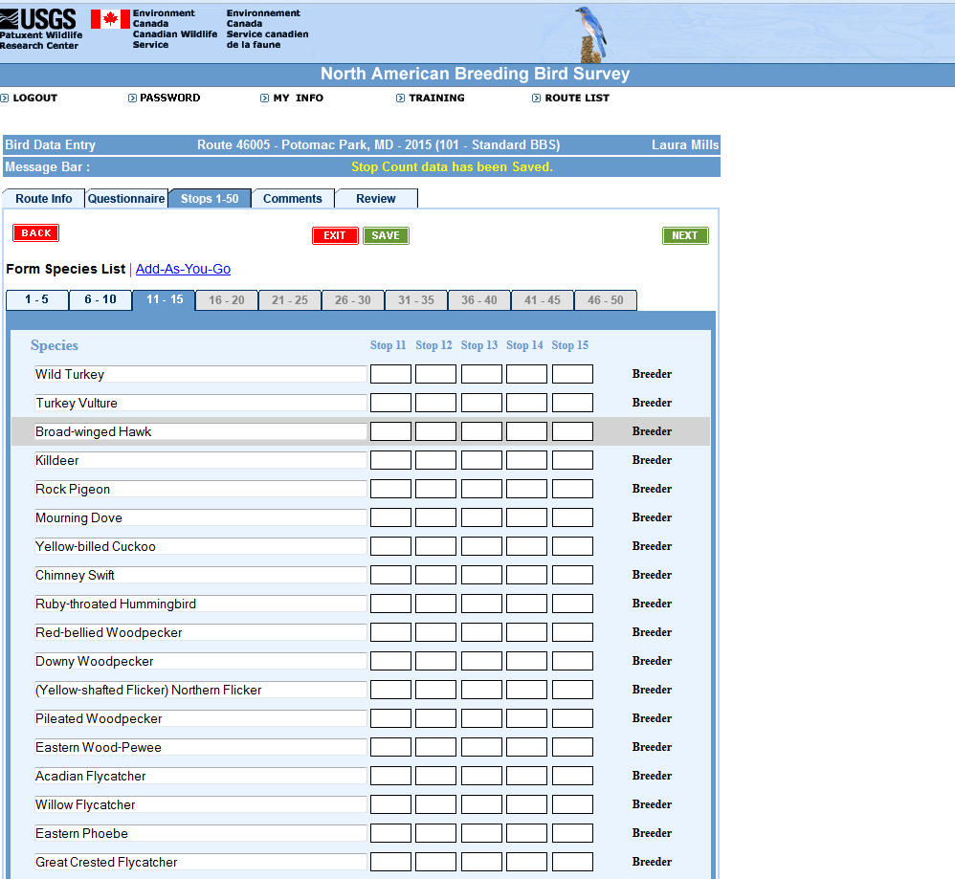

IMAGE #11: DATA ENTRY (PAGE 10)
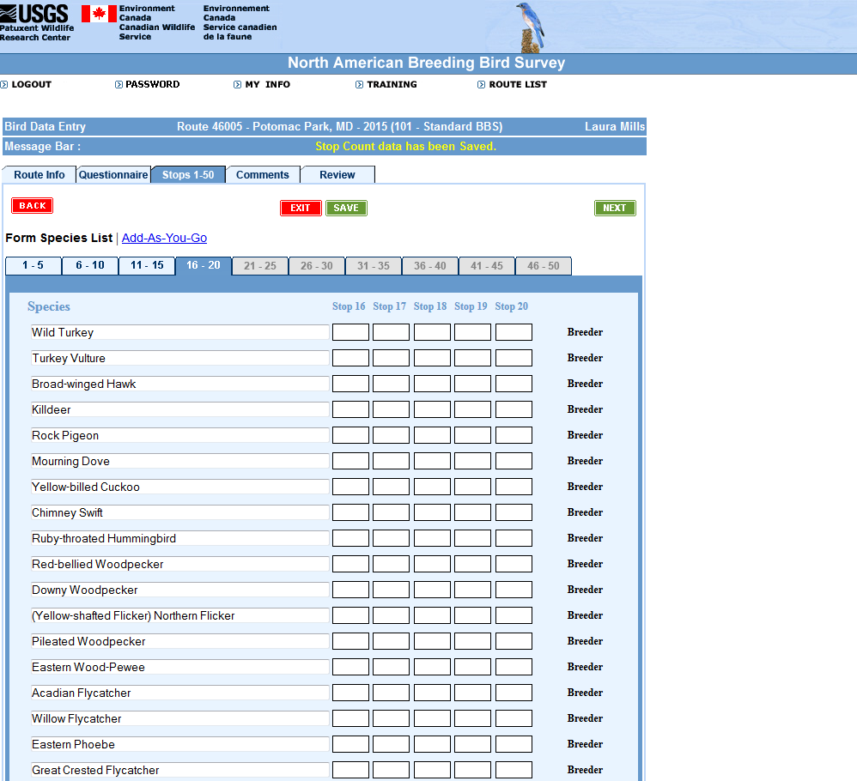

IMAGE # 12: DATA ENTRY (PAGE 11)
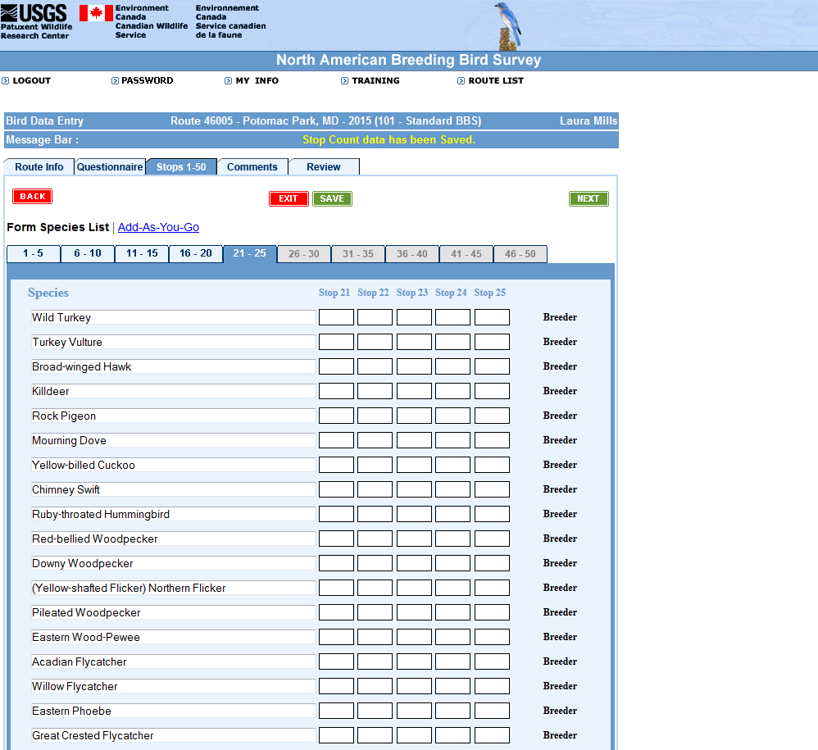

IMAGE #13: DATA ENTRY (PAGE 12)
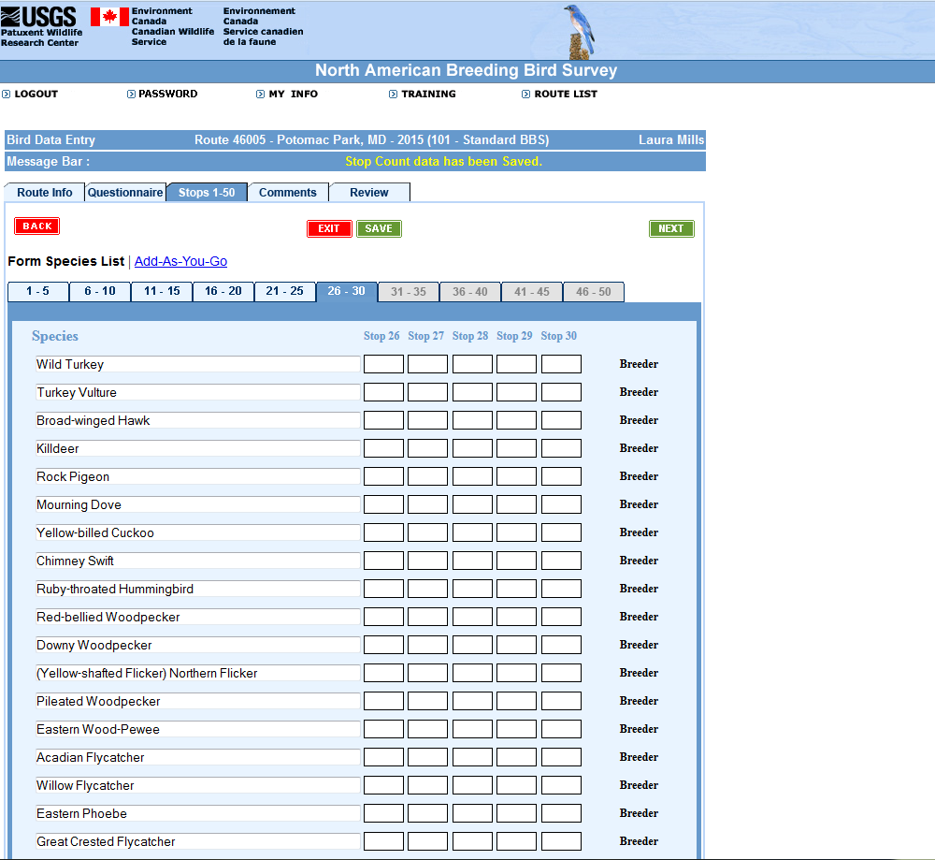

IMAGE #14: DATA ENTRY (PAGE 13)
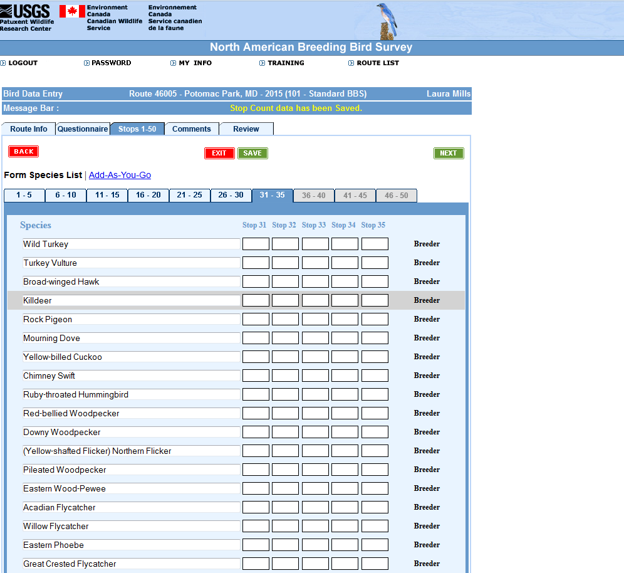

IMAGE #15: DATA ENTRY (PAGE 14)
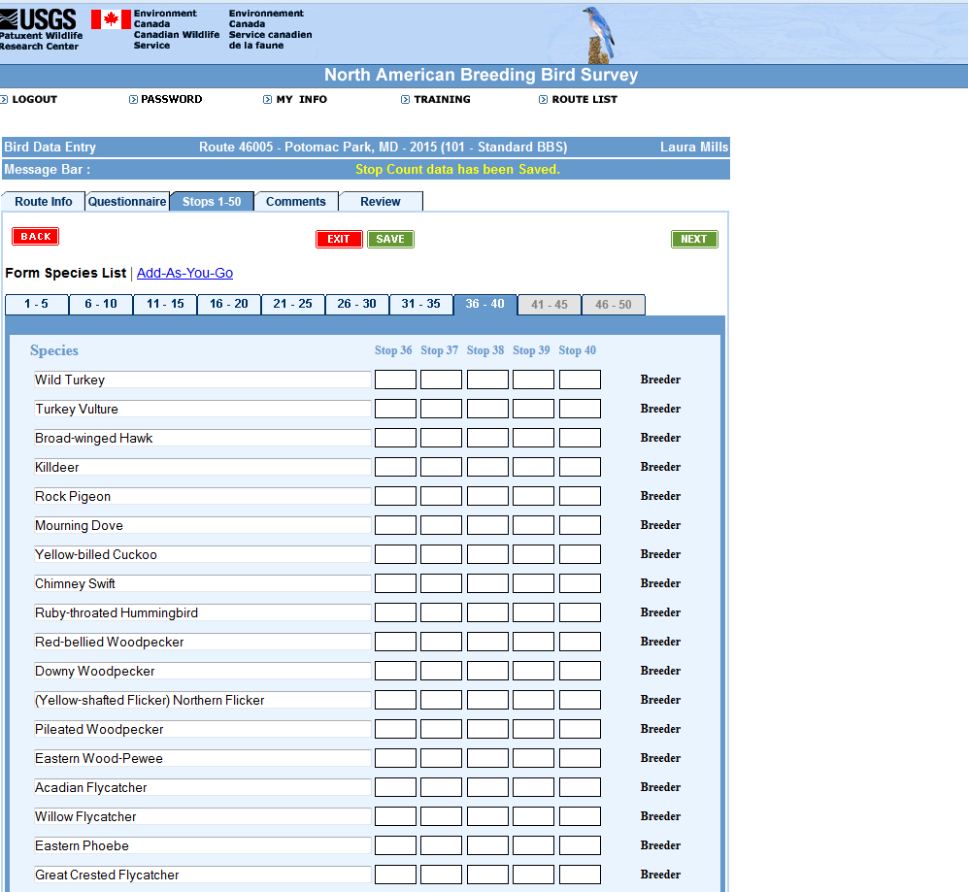

IMAGE #16: DATA ENTRY (PAGE 15)
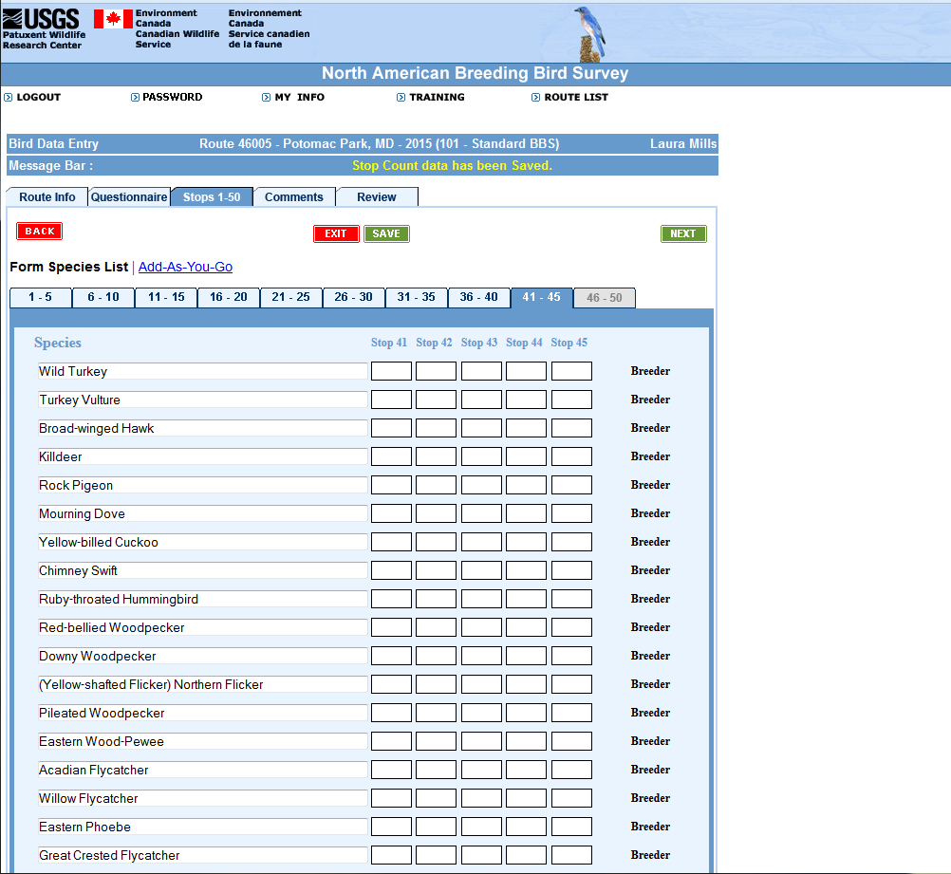

IMAGE #17: DATA ENTRY (PAGE 16)
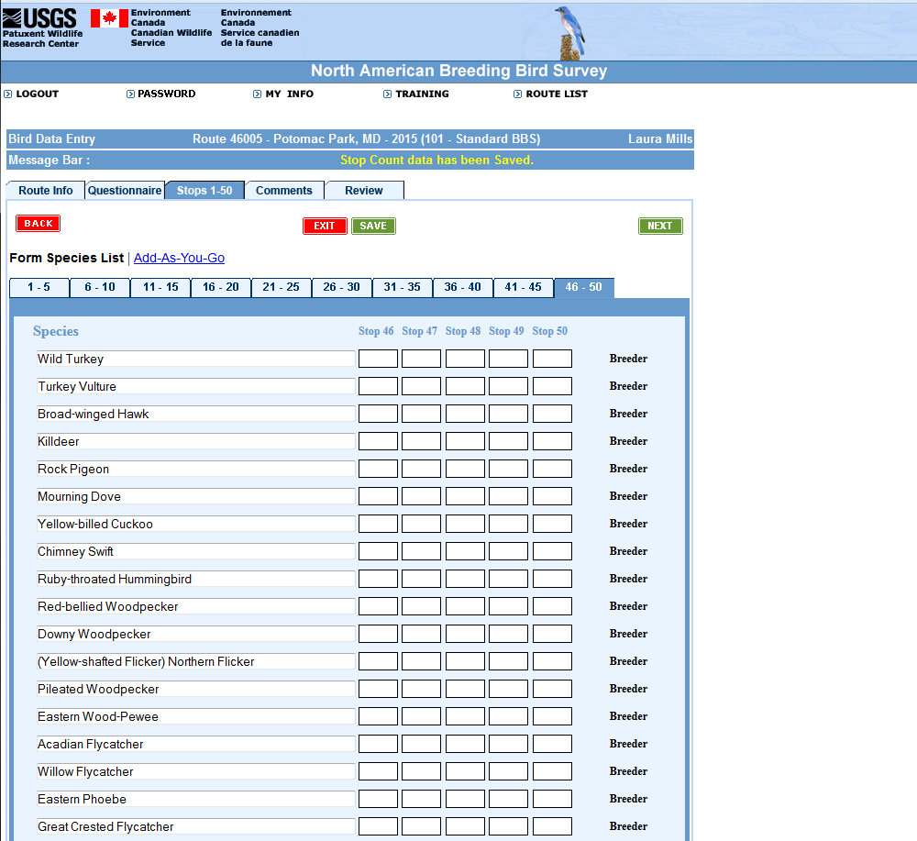

IMAGE #18: DATA ENTRY (PAGE 17)
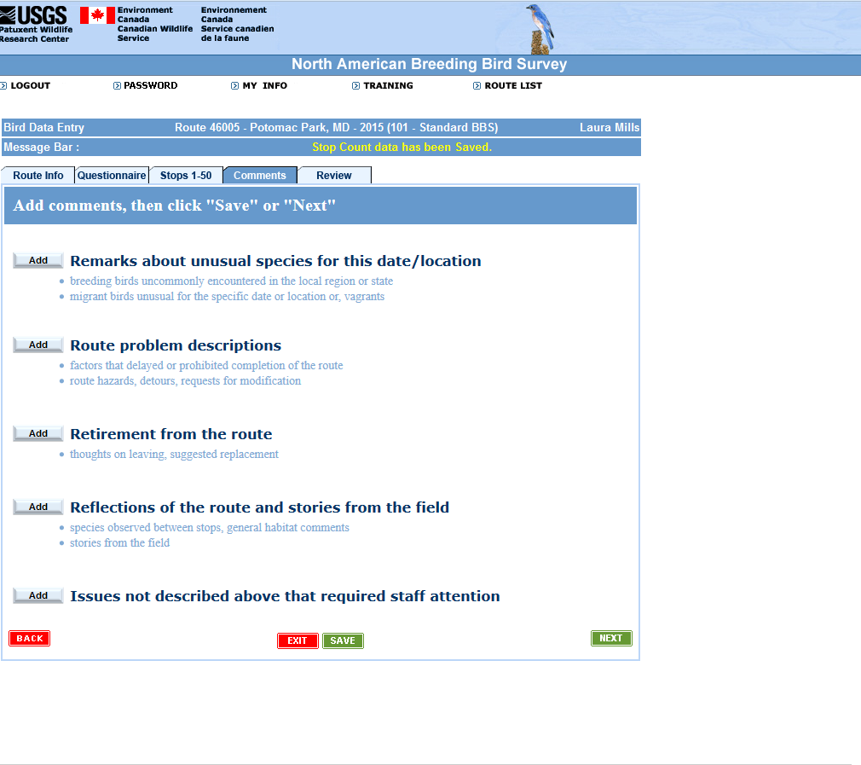

IMAGE #19: DATA ENTRY (PAGE 18)
