**Script for OSTEM Equity Plan Focus Groups**

**Desired Outcome of Focus Groups:**

To solicit input, recommendations and feedback directly from the OSTEM Community to OSTEM leadership about tangible actions to improve OSTEM’s culture of inclusion.

**Scope:** Internal focus - OSTEM HQ and Centers representing those who officially report to Agency OSTEM management.

**Ground Rules:**

* Consider this to be safe space.
* Participate actively.
* Speak one at a time.
* Treat everyone's ideas with respect.
* Stay focused on the topic or question.

**Key Questions:** (*Ideally no more than 4-6 open ended questions that focus on the most critical areas. Proposing:*

1. **In what ways is OSTEM welcoming and inclusive?** 
   1. What is an example of OSTEM being welcoming and inclusive?
   2. Do you feel a sense of belonging at OSTEM? Why?
2. **Are there barriers to OSTEM establishing an inclusive environment?** 
   1. If so, what are they and what ideas do you have to address them?
   2. Where are opportunities for OSTEM to fill gaps?
3. **There are many dimensions of diversity (reference the diversity wheel). Diversity representation on our OSTEM team is important.** 
   1. Where opportunities for OSTEM to improve its diversity representation
   2. What are your ideas to improve our diversity?
4. **If you were AA of OSTEM , what is the one change you would make?**

*The Diversity Wheel is away to visualize aspects of diversity in an organization.

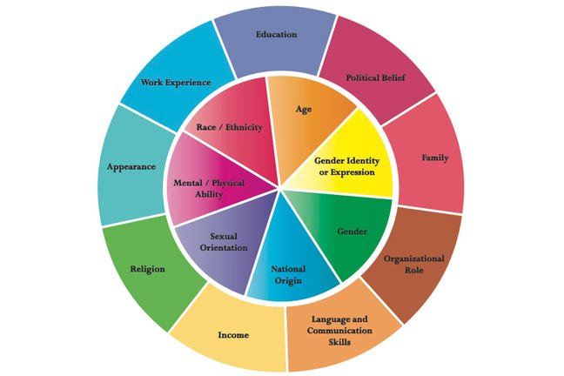

Source: John Hopkins Diversity Wheel from http://web.jhu.edu/dlc/resources/diversity_wheel/

**Additional Questions**

**(Inclusion)**

1. In what ways is OSTEM welcoming and inclusive?
2. What is an example of OSTEM being welcoming and inclusive?
3. In what ways is OSTEM not welcoming?
4. Are there barriers to establishing an inclusive environment? If so, what are they?
5. Does OSTEM have equitable opportunities?
6. Do you feel that you have sufficient support to develop your skills and progress your career?

**(Diversity)**

1. What do you wish that OSTEM leadership understood about your own group?
2. How can we better value team members’ your unique attributes, traits, characteristics, skills, experience and background?
3. What do you think that OSTEM could do to get the best from everyone?

**Ending Questions**

1. Of the diversity, inclusion, and equity issues which is the most important to you?
2. Is there anything regarding inclusion, diversity, and equity in OSTEM that we should have talked about today during the focus group, but didn’t?
3. If you could tell Mike Kincaid one thing that you would want him to fix about OSTEM, re: Diversity and Inclusion, what would it be?