**United States Department of Agriculture**

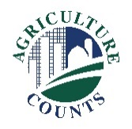

National Agricultural Statistics Service

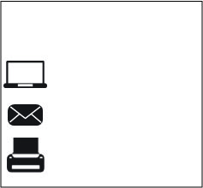

**What should I do next?**

Complete your survey in one of the following ways:

**Online** at [www.agcounts.usda.gov](http://www.agcounts.usda.gov) beginning on Monday, October 15, 2018. ***Online reporting is fast, cost-effective, and secure.*** All you need is the 17-digit survey code on the enclosed form to begin.

By **mail or fax**. Complete the survey questionnaire and mail it back in the return envelope provided or fax it to (855) 415-3687.

October 10, 2018

**Why am I getting this letter?**

Enclosed is your Cost of Pollination Survey. Please complete the questionnaire at your earliest convenience. Your information is important.

**How will the data be used?**

Survey responses help producers and beekeepers monitor and react to changes in production costs. Pollination expenditures are a necessary part of the crop industry and are directly tied to the health of the honey bee industry.

If we do not hear from you by Monday, October 22, 2018, we

may attempt to contact you by telephone or in person to conduct an interview.

The results of this survey will be kept confidential and available in aggregate form only, ensuring that no individual operation or producer can be identified, as required by federal law. We will publish the survey findings in the annual *Cost of Pollination* report, to be released Friday, December 21, 2018.

Thank you for participating and for your support of our programs and U.S. agriculture. If you have any questions, please feel free to contact us at (888) 424-7828.

|  |
| --- |
| H:\Shared\OAPAO\Public Affairs\Survey Publicity\Survey Specific Marketing Items\Bee and Honey Production and Loss Inquiry\Bee Icons\Bees.pngH:\Shared\OAPAO\Public Affairs\Survey Publicity\Survey Specific Marketing Items\Bee and Honey Production and Loss Inquiry\Bee Icons\Bees.png**Release Date for the Cost of Pollination Survey** |
| *Cost of Pollination:* December 21, 2018  To view other publications please go to [www.nass.usda.gov](http://www.nass.usda.gov). |

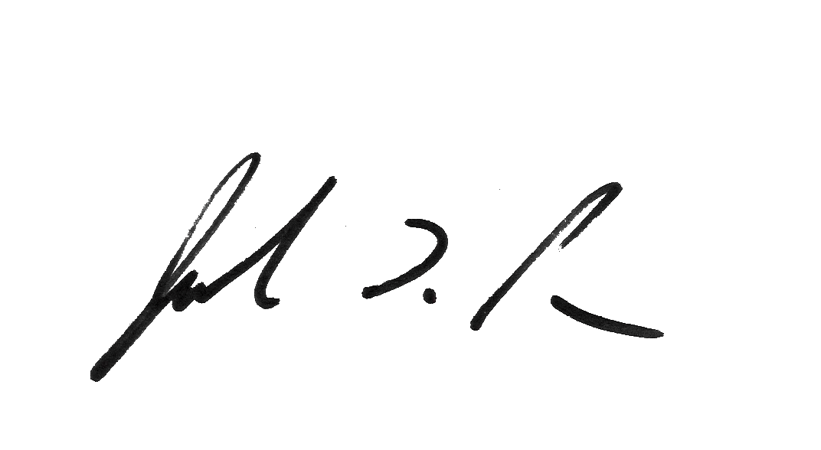

Sincerely,

Joseph L. Parsons

Chair, Agricultural Statistics Board

Enclosure