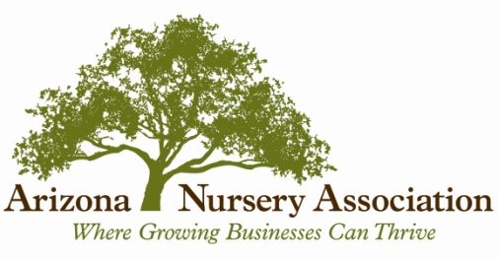
January 17, 2019
DRAFT
Dear Arizona Green Industry Member:
The Arizona Nursery Association and the Arizona Landscape Contractors Association have asked the USDAs National Agriculture Statistics Service, Arizona Field Office to conduct the 2018 Arizona Green Survey.
The Green Industry has been one of the fastest growing agricultural segments over the last couple of decades. In 2008, total sales associated with the Green Industry totaled $1.68 billion. In 1998, total sales were $947 million. This growth has spurred dramatic interest in the industry’s size and economic importance. A comprehensive study of the entire Green Industry has not been conducted since 2007.
The 2018 Green Industry Survey will provide comprehensive data about the ever-changing industry throughout Arizona. Industry statistics are crucial in obtaining state and local government support on various issues.
Enclosed you will find the 2018 Arizona Green Survey which contains questions relating to gross sales by type of operation, labor, expenditures, area used for production, shipping destinations, and other factors affecting the growth of the industry.
There are several benefits from completing this survey including informing Arizona residents about the size and importance of the Green Industry in Arizona. The Survey helps supply useful information to Arizona lawmakers and lobbyists in support of legislation that recognizes the benefits of the Green Industry. It also supplies extension agents with information for use in professional development and data to justify grants for research and other activities. The Survey provides trade and producer associations the information to evaluate changes within the industry and explains to all that the Green Industry is a very important part of Arizona agriculture.
We realize your time is valuable and appreciate your support in helping to build a reliable picture of the size and importance of Arizona’s Green Industry. Please take the time to contribute this essential information that will help in so many ways. Participation is voluntary, however your help with this survey is appreciated.
Please be assured that NASS will not disclose any information about an individual’s report and has legal authority to safeguard the privacy of individual responses. All the information you provide will be used only for statistical purposes and combined with other reports to produce state-level information. Feel free to contact me or Cheryl Goar with any questions.
Dave DeWalt, State Statistician Cheryl Goar, Executive Director
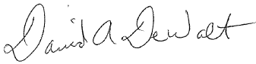
USDA NASS Arizona Field Office Arizona Nursery Association
1-800-645-7286 480.966.1610
dave.dewalt@nass.usda.gov cgoar@azna.org
Enclosures

