Boundary and Annexation Survey (BAS) Respondent Guide: Paper
Instructions for Participating in the Boundary and Annexation Survey
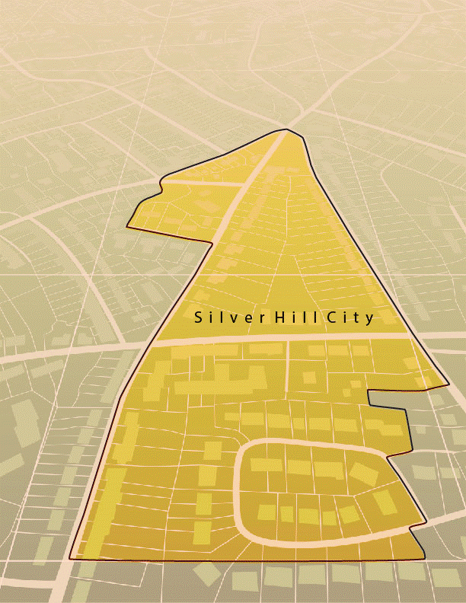
Revised as of February 26, 2018

U.S. Department of Commerce
Economic and Statistics Administration
U.S. CENSUS BUREAU
census.gov

This page intentionally left blank

Table of Contents
Introduction v
A. The Boundary and Annexation Survey v
B. What’s New for the BAS? v
C. Key Dates for BAS Respondents v
D. BAS State Agreements vi
E. Legal Disputes vi
F. Respondent Guide Organization vi
Part 1: Completing the BAS Forms 1
1.1 Forms Included in the BAS Package 1
1.2 Name or Type Changes 1
1.3 Contact information 1
1.4 Legal Boundary Changes 1
1.5 Other Changes 1
Part 2: Reviewing and Updating the BAS Maps 2
2.1 Maps Included in the BAS package 2
2.2 Requesting Additional Maps 2
2.3 General Guidelines for Reviewing and Updating BAS Maps 2
2.4 Census Bureau Geocoding 3
2.5 Legal Boundary Changes 5
Part 3: Delineating New Tribal Subdivisions 10
3.1 Tribal Subdivision Program Procedures 10
3.2 Updating Existing Tribal Subdivisions 10
3.3 Tribal Subdivision Documentation 11
3.4 Feature Modifications 11
3.5 Modifying Locations of Streets 11
3.6 Annotating Address Range 15
3.7 Point Landmarks 16
3.8 Area Landmarks 16
3.9 Geographic Corridors and Offsets 17
3.10 County Review and Consolidations 20
3.11 Public Land Survey System 21
3.12 New Incorporations 21
3.13 Disincorporations 21
Part 4: Signing Updated Maps and Returning BAS Materials 22
Appendices 23
Appendix A Additional Documentation of Changes Forms A-1
A1 Places A-1
A2 Counties and Equivalent Areas A-2
A3 Minor Civil Divisions A-3
A4 Reservations and Off-Reservation Trust Land A-4
Appendix B MTFCC Descriptions B-1
Appendix C Reading A Map C-1
C1 Scales C-1
C2 Compass Rose C-2
C3 Legend C-2
C4 Index Maps C-3
C5 Inset Maps C-4
C6 Parent Maps C-5

LIST OF FIGURES
Figure 1. Shared Boundary 2
Figure 2. MSP Method of Geocoding 3
Figure 3. Address Range Method of Geocoding 4
Figure 4. Correctly Annotating a Legal Boundary Change 5
Figure 5. Correctly Annotating an AIA Trust Land 6
Figure 6. Annotating a Legal Boundary Change 7
Figure 7. Annotating a Legal Change to an Incorporated Place 7
Figure 8. Annotating a Boundary Correction to an Incorporated Place Boundary 8
Figure 9. Recording New Tribal Subdivision Information 10
Figure 10. Modifying a Street Feature No Boundary Movement 11
Figure 11. Modifying a Street Feature with Boundary Movement 12
Figure 12. Adding an MTFCC Code When Adding a New Street 12
Figure 13. Correcting a Street Name. 13
Figure 14. Adding Street Name Features in a Congested Area When Deleting Streets 13
Figure 15. Deleting a Street Feature 14
Figure 16. Adding Unnamed Road Features 14
Figure 17. Adding Cul-de-sac and Circle Features 15
Figure 18. Adding Street Feature/Annotating with Name and Address Breaks 15
Figure 19. Adding a Point Landmark 16
Figure 20. Adding an Area Landmark 17
Figure 21. Geographic Offset and Geographic Corridor 17
Figure 22. Where the Right-of-way Belongs in the Unincorporated Area 18
Figure 23. Housing Units in the Unincorporated Area 18
Figure 24. Indicating a Geographic Corridor by Using a Red Pencil 19
Figure 25. The Place Boundary is Along the Front Lot Line 20
Figure 26. The Place Boundary is on the Rear Lot Line 20
Figure 27. Depicting a Geographic Offset on a Paper Submission 20
Figure 28. BAS Paper Map Signature Box 22
Figure 29. Bar Scale……………… C-1
Figure 30. Large Scale Map…………. C-1
Figure 31. Compass Rose………………….. C-2
Figure 32. Legend Describing What Each Symbol Means C-2
Figure 33. Map Depicting Multiple Features Concurrently C-3
Figure 34. Index Map……………………. C-4
Figure 35. An Inset Map as it is Displayed on the Index Map C-5
Figure 36. Inset Maps……………………………………….. C-5
Figure 37. The Parent Map………………………………….. C-6
Figure 38. The Key to Adjacent Sheets C-6
Figure 39. The Sheet Location within Entity key C-7

Introduction
- The Boundary and Annexation Survey
The U.S. Census Bureau (Census Bureau) conducts an annual survey called the Boundary and Annexation Survey (BAS) to collect information about selected legally defined geographic areas, such as counties (and equivalent areas), incorporated places, minor civil divisions (MCDs), federally recognized American Indian Areas (AIAs) — including reservations, off-reservation trust lands and tribal subdivisions, Hawaiian Homelands, and Alaska Native Regional Corporations (ANRC). BAS also provides an opportunity for participants to review the names and geographic relationships for these areas. Title 13, U.S.C., Section 6, authorizes this survey.
The Census Bureau uses the boundary information collected during the BAS to tabulate data for the decennial and economic censuses, and to support the Population Estimates Program (PEP) and the American Community Survey (ACS). Maintaining correct boundaries and boundary-to-feature relationships through the BAS helps ensure that the Census Bureau assigns the appropriate population to each governmental unit (GU).
In compliance with the Office of Management and Budget Circular A-16, the BAS supports the Census Bureau’s spatial data steward responsibilities for the Federal Geographic Data Committee (FGDC) and the Geospatial One-Stop by updating the inventory and boundaries of GUs.
In addition, the BAS is the source of up-to-date information on changes to the boundaries, codes and names of incorporated places, MCDs, counties (and equivalent areas), Hawaiian Homelands, ANRC, and federally recognized AIAs, which include reservations and off-reservation trust lands used by the U.S. Geological Survey’s (USGS), the National Map, and the Geographic Names Information System (GNIS).
Please visit the BAS program Web site at <https://www.census.gov/programs-surveys/bas.html>.
For more information on the BAS, please view the “Introduction to BAS” video series on the Census Bureau’s BAS Web site at <https://www.census.gov/programs-surveys/bas/library/videos/bas-intro.html>
- What’s New for the BAS?
- The Geographic Partnership Support Desk (GPSD) is now fully functional and available to assist with any questions respondents may have regarding BAS.
- Redistricting data contacts participating in the Voting District Project (VTD) may submit boundary updates for reconciliation with BAS contacts.
- Key Dates for BAS Respondents
January 1— All boundary changes must be legally in effect on or before this date to be reported in the current survey year.
March 1— BAS submission date deadline for boundary updates to be reflected in the ACS and PEP published data. Boundary submissions received by this date are also reflected in next year’s BAS materials.
May 31— BAS boundary updates submitted by this date will be reflected in next year’s BAS materials.
- BAS State Agreements
The Census Bureau has established a number of agreements with states for reporting boundary changes. Please visit the BAS State Agreements webpage within the BAS program Web site at <https://www.census.gov/programs-surveys/bas/information/state-agreements.html> or call (800) 972-5651 for information regarding state agreements.
Note: The Census Bureau can only establish BAS state agreements for states that require local governments to report boundary changes to a state agency.
- Legal Disputes
If the Census Bureau discovers that an area of land is in dispute between two or more jurisdictions, the Census Bureau will not make any boundary corrections until the parties come to a written agreement, or there is a documented final court decision regarding the dispute.
If you have questions concerning this, please contact the Census Bureau Legal Office at
301-763-9844.
For disputes involving tribal areas, the Census Bureau must defer to the Office of the Solicitor at the Department of the Interior for a legal opinion. Often complicated land issues require an extended period of time for resolution, and in those cases, the Census Bureau will retain the current boundary in the database until a legal opinion is issued by the Solicitor’s office.
- Respondent Guide Organization
This guide has been created for those who choose to participate in the survey using paper maps.
This guide contains four parts:
Part 1: Provides an Overview of BAS. It specifies the:
- Forms used to verify legal names, status, contact information, and previous legal boundary changes for BAS;
- BAS-1 for Incorporated Places
- BAS-2 for Counties and Equivalent Areas
- BAS-3 for Minor Civil Divisions (MCD)
- BAS-5 for American Indian Reservations and Off-Reservation Trust Land

Part 2: Provides Information on Reviewing and Updating BAS Maps:
- Request Additional Maps
- Guidelines for Reviewing and Updating BAS Maps;
- Census Bureau Geocoding;
- Legal Boundary Changes (How to Draw, Changes Involving Coincident Features, Boundary Corrections; Tribal Subdivisions)

Part 3: Describes the Procedures for Delineating New Tribal Subdivisions:
- Tribal Subdivision Program Procedures;
- Updating Existing Tribal Subdivisions;
- Tribal Subdivision Documentation;
- Feature Modifications;
- Modify Locations of Streets (Adding, Deleting, Naming);
- Correcting Street Names;
- Annotating Address Range (Adding Address Ranges);
- Point Landmarks and Area Landmarks;
- Geographic Corridors and Offsets;
- County Review and Consolidations;
- Public Land Survey System;
- New Incorporations; and
- Disincorporations

Part 4: Describes the Procedures for Returning BAS Materials

- Completing the BAS Forms
- Forms Included in the BAS Package
The forms in the BAS package should be used to verify legal names, legal status, contact information, previous legal boundary changes submitted to the Census Bureau, and to document any recent or missing legal boundary changes. There are four types of forms:
- BAS-1 for Incorporated Places
- BAS-2 for Counties and Equivalent Areas
- BAS-3 for Minor Civil Divisions (MCD)
- BAS-5 for American Indian Reservations and Off-Reservation Trust Land
- Name or Type Changes
Please verify that the legal names and legal status of the GU or AIA are accurate. Make any necessary corrections by crossing out the error and clearly printing the correct information. Provide an effective date for name, type, or status changes. County participants should verify the list of active and inactive entities within their counties.
- Contact information
Please verify that the Census Bureau has the most recent BAS, HEO, or TC contact information for the GU or AIA. Fill in any missing or incorrect information, especially blank emails. If the primary address of the BAS contact, HEO, or TC is a PO Box, provide the Census Bureau with a physical address that can be used for the delivery of maps. Contact changes or updates may also be provided to the Census Bureau throughout the year by email to geo.bas@census.gov.
- Legal Boundary Changes
Please record all legal boundary changes in the Documentation of Changes section of the BAS form. Include legal boundary changes that occurred prior to January 1 of the current survey year if they do not appear on the current BAS maps. Please include legal authorization, such as a local ordinance or resolution number, and the effective date of the legal action. If additional pages are needed to record legal changes, a copy of the Documentation of Changes is provided in the appendix.
- Other Changes
Please indicate if there are any boundary corrections or feature updates that need to be made on the BAS maps. This will assist the Census Bureau in identifying and accounting for any updates made to the maps.
- Reviewing and Updating the BAS Maps
- Maps Included in the BAS package
The Census Bureau mails an index map showing the entire GU or AIA, along with more detailed individual map sheets. Index maps are provided as a reference to help locate a map sheet. GUs and AIAs with more than 30 map sheets receive only an index map and the map sheets that show the legal boundary. Entities that require more than 30 boundary ring map sheets receive only the index map.
- Requesting Additional Maps
If you only received an index map for a county, incorporated place, MCD, or AIA where boundary changes or feature updates need to be made, call (800) 972-5651 or email geo.bas@census.gov to request an individual map sheet or a full set of maps. Do not make updates on the index map.
- General Guidelines for Reviewing and Updating BAS Maps
- Colored pencils are provided in the package. The red pencil should be used to indicate legal boundary changes and non-legal boundary corrections for all counties, places, MCDs, and AIAs. The purple pencil should be used to indicate feature changes or corrections. The blue pencil should be used by AIAs to add or modify tribal subdivisions.
- Compare the BAS maps to a local source for an entity (e.g., a local plat map, or a county assessor’s dataset). Update the map(s) if the boundaries shown do not correctly depict the boundaries in effect as of January 1st of the survey year.
- You may also provide annexations and deannexations from previous years in addition to providing updates as of January 1st. However, the Census Bureau does require legal documentation when submitting these vintage legal updates.
- The maps show boundaries for multiple legal and statistical boundaries. If an entity’s legal boundaries are coextensive with another boundary, the symbols on the map will alternate. In the figure below, the county shares a boundary with an incorporated place and Census Designated Place (CDP); therefore, the symbols on the map alternate between county, incorporated place, and CDP.

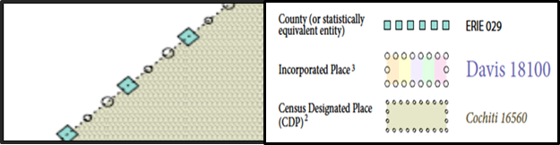

Figure 1. Shared Boundary
The combined line represents a county, incorporated place and CDP boundary.

- Census Bureau Geocoding
Geocoding is how the Census Bureau codes population to geographic entities. There are two primary methods of geocoding used by the Census Bureau. Both of these involve coding an address to a spatial polygon, but one uses Global Positioning System (GPS) technology, while the other uses address ranges.
- GPS Physical Location Geocoding
A field worker stands in front of a house or living quarters, and records the physical location with a GPS device (Figure 2). Usually, the GPS point should fall very close to the front door of the house. However, since this is a field operation, real-world obstacles like locked fences, poor satellite reception, or even aggressive dogs might sometimes prevent the worker from gaining access to the front door. In these circumstances, the worker may have to take the GPS coordinate from the sidewalk or side of the road.
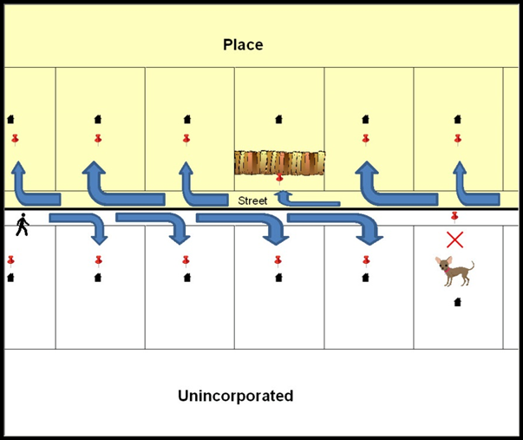
Figure 2. MSP Method of Geocoding
Notice in Figure 2. MSP Method of Geocoding that it is occasionally not possible for the field worker to go all the way to the front door, due to unforeseen circumstances, like the fence or the dog shown above. Thus, the MSP (represented here in Figure 2 by the red pins) can sometimes fall within the road or the road right-of-way.

- Address Range Geocoding
When no Master Address File (MAF) structure point (MSP) is available, the Census Bureau codes houses and living quarters according to a potential range of addresses associated with the adjacent stretch of road (Figure 3).
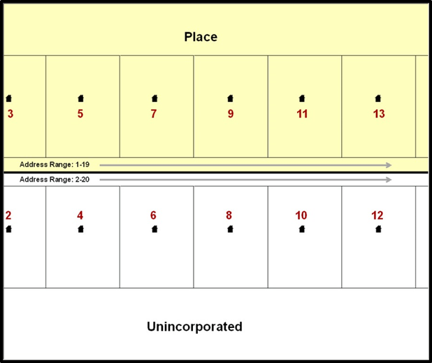
Figure 3. Address Range Method of Geocoding
When it is not possible to collect an MSP, houses are geocoded according to their placement along a range of potential addresses along that road. Since the address has a relationship with the road, boundaries placed on front lot lines will lead to mis-geocoding unless an offset flag is used.

While the two methods of geocoding differ greatly, both rely heavily on the integrated nature of the MAF/Topologically Integrated Geographic encoding and Referencing (TIGER) System. The representation of streets and boundaries relative to one another impacts these geocoding methods. This interdependence between streets, boundaries, and geocoding means that Census Bureau representations of legal boundaries occasionally differ from other representations (e.g., in local or state GIS). This is especially true regarding geographic corridors and offsets that follow road right of ways (or the front lot lines of parcels). In both of the examples above, delineating a boundary along the front lot line will tend to increase the risk of incorrect geocoding. Using the road centerline as a boundary eliminates these potential errors, improving accuracy.
- Completing a BAS Submission Using the Centerline of the Road
When completing a BAS submission in which a road or road right-of-way is owned or maintained by a place or AIA but the adjacent housing is not, the respondent should use the centerline of the road (not the front lot-line) as the boundary whenever possible. If local or state law requires the use of the front lot line boundary, the respondent must explicitly designate the polygon(s) between the road centerline and the front-lot boundary as a corridor or an offset (see Section 3.9 of this document for more details).
- Legal Boundary Changes
Legal boundary changes are the result of legal actions (e.g., annexations), and documenting such changes is the primary goal of the BAS. AIA legal documentation (e.g., statute, federal court decision, trust deed) must accompany all AIA legal boundary changes, while legal boundary change submissions from incorporated places, MCDs, and counties must provide an authorization number, such as a resolution or ordinance number.
- How to Draw Legal Boundary Changes
The following figures illustrate the correct way to draw legal boundary changes on BAS maps.
- Using the red pencil provided, cross out the portion of the boundary that is no longer current with a string of “Xs”.
- Draw the new boundary line(s) ensuring the boundary is closed.
- Add the ordinance number or other legal identifier of the action authorizing the change, along with the effective date of each annexation or de-annexation that is drawn on the map.
- Record all legal changes in the Documentation of Changes section of the BAS form.

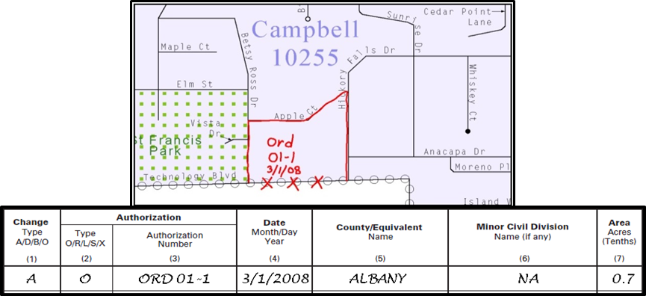
Figure 4. Correctly Annotating a Legal Boundary Change
With the red pencil and record the changes in the Documentation of Changes section of the BAS form.

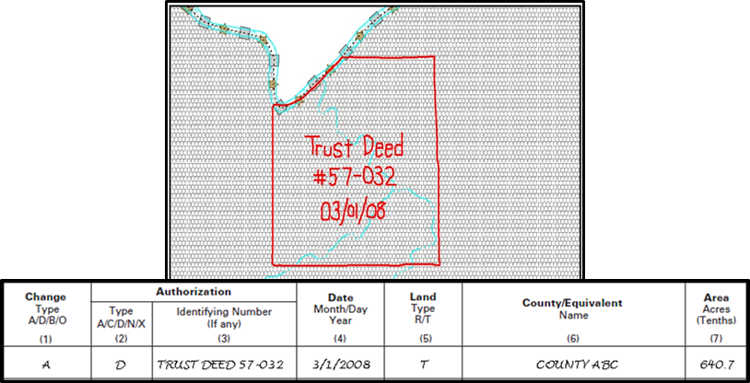
Figure 5. Correctly Annotating an AIA Trust Land
Correctly annotate an AIA trust land and record the change in the Documentation of Changes section of the BAS form. The original reservation is not deleted and therefore does not require a string of X’s.
- Boundary Changes Involving Coincident Features
The following figures illustrate how to adjust a boundary that is coincident with
(i.e., follows exactly) a feature, such as a river or street. In this case, the feature location is correct, but the boundary location is incorrect.
- Using the red pencil, cross out the portion of the boundary that is no longer current using a string of “Xs” inside circles.
- Draw the updated boundary.
- Add the authorization number or other identifier of the action authorizing the change along with the effective date of each addition or deletion.
- Record all legal changes in the Documentation of Changes section of the BAS form.
If both the boundary and feature need to be moved, cross out the incorrect boundary with a string of red “Xs” and then draw a red line representing the new location of the boundary and road.
Figure 6, Figure 7, and Figure 8 below illustrate how to make a correction to the boundary where an associated feature moves along with the boundary. If these changes are the result of an annexation or deannexation, include the authorization number and effective date.

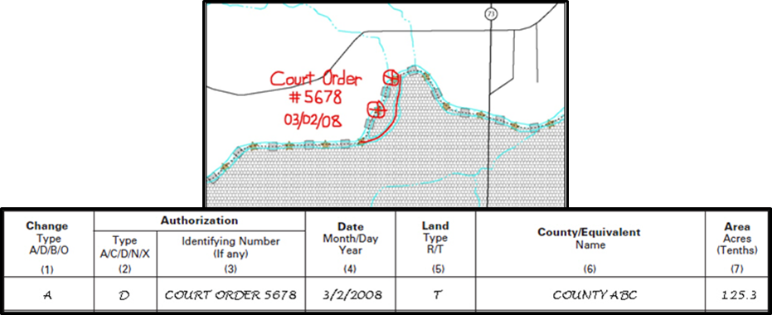
Figure 6. Annotating a Legal Boundary Change
Annotating a legal boundary change coincident with a river feature, where the river location does not change, but the boundary does. The legal change is also recorded in the Documentation of Changes.

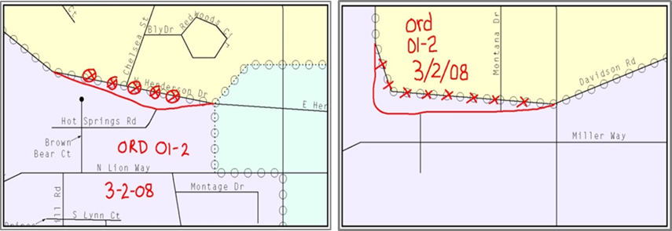
Figure 7. Annotating a Legal Change to an Incorporated Place
Annotating a legal change to an incorporated place boundary coincident with a road feature, where only the boundary moves to the new location. The street feature location is correct, but the boundary location is incorrect.

- Boundary Corrections
A boundary correction is the adjustment of a boundary to correct an error in how the Census Bureau depicts an existing boundary. Boundary corrections should follow the general shape of the existing boundary. Legal documentation is not required when submitting a boundary correction to the Census Bureau. Boundary corrections also do not need to be reported on the BAS form.
Figure 8 illustrates how to complete a boundary correction.
- Using the red pencil, cross out the incorrect boundary with a string of “X”s.
- Add a line showing the correct boundary.
- Print the letters BC inside the change to identify the update as a boundary correction rather than a legal change.

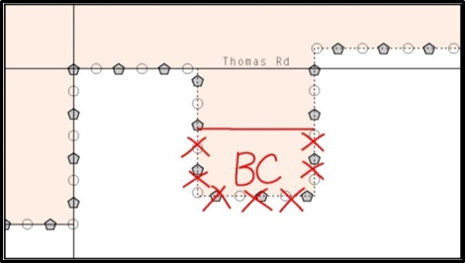
Figure 8. Annotating a Boundary Correction to an Incorporated Place Boundary
- Tribal Subdivisions
The Census Bureau considers any type of unit of self-government or administration in tribal areas as a tribal subdivision. A tribe may submit only one type of subdivision, even if it has more than one type of distinct administrative area that could qualify as a tribal subdivision
(e.g., tribal election districts, tribal water districts, or health service areas with different boundaries). The Census Bureau recognizes two types of tribal subdivisions, active (A) or inactive (I):
- Active subdivisions are defined as having a functioning government, with elected officials, that provides programs and services.
- Inactive subdivisions have no functioning government or elected officials and receive services solely from the tribe.
- Some examples of areas submitted as tribal subdivisions are:
- Areas used by a tribe for the election of tribal government officials (e.g., districts or precincts used for the election of tribal council members).
- Areas used by a tribal government for tax purposes.
- Areas used by a tribal government for the provision of general services or specified services, such as:
  - Water districts;
  - Health service areas;
  - Emergency service delivery areas (911, fire, and/or police); or
  - Grazing districts or range units.
  - Historical or traditional areas recognized by a tribal government.
  - Sub-reservation tribal community governments.
- Keep the following criteria in mind when defining tribal subdivisions:
- Tribal subdivisions should cover all, or most, of a tribe’s land base.
- The delineation of tribal subdivisions is restricted to the area contained within reservations and/or associated off-reservation trust lands.
- There is no minimum population threshold for a tribal subdivision.
- A tribal subdivision may be noncontiguous.
- Tribes may designate only one type of tribal subdivision. If a tribe has more than one level of tribal subdivision within its land base, the Census Bureau recommends delineating subdivisions corresponding to the lowest geographic level (those geographic areas containing the smallest area) of the tribe’s administrative hierarchy.
- Tribal subdivisions should not be based solely on land ownership or other cadastral areas, nor should they consist of divisions based on the U.S. public land survey system of townships, ranges, and sections, if these areas have no governmental or administrative function for a tribe.
- The following descriptions can be appended to chosen subdivision names (e.g., Red Rock Community):
  - District.
  - Community.
  - Area.
  - Chapter.
  - Segment.
  - Administrative Area.
  - Addition.
  - County District.

- Delineating New Tribal Subdivisions
- Tribal Subdivision Program Procedures
If this is the first time that tribal subdivisions are being provided to Census:
- Using the blue pencil, please add the boundaries on the BAS map(s).
Note: If a full set of BAS maps has not been sent, please request them by calling the Census Buraus’s BAS team at (800) 972-5651.
- Please note: each tribal subdivision must be labeled on each map sheet with its name (e.g., “District 3,” “Arlee District,” “White Rock Chapter,” “Parmelee Community”).
- Record the names, type, and status of each subdivision in the Tribal Names and Status Documentation section of the BAS-5 form.
- If a tribal subdivision boundary follows a visible feature such as a stream, road, or fence line, please be sure to indicate that on the BAS map. Add the visible feature the boundary follows if it is not already shown on the map.

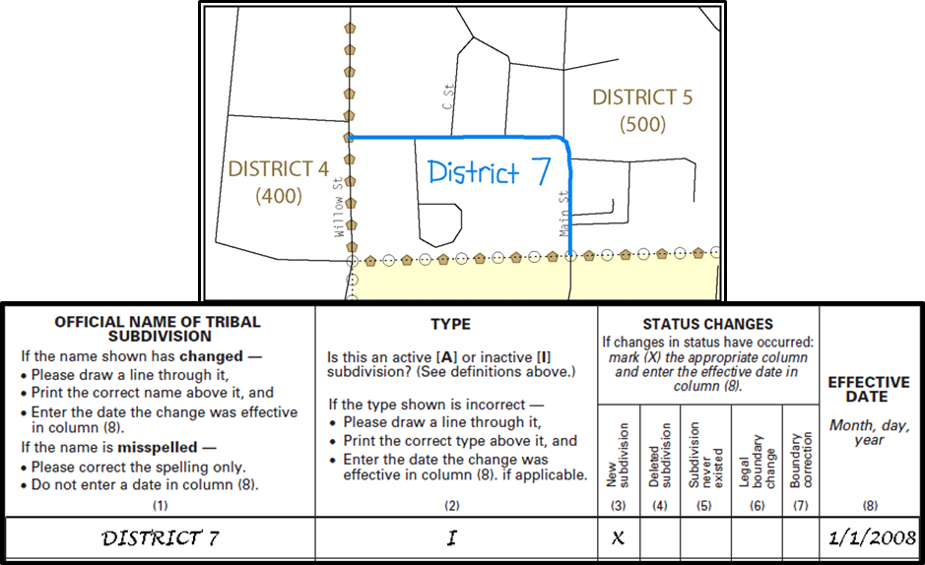
Figure 9. Recording New Tribal Subdivision Information
Depicting a new tribal subdivision and recording the information in the Tribal Names and Status Documentation section of the BAS form.
- Updating Existing Tribal Subdivisions
If tribal subdivisions were delineated during a prior survey, they are symbolized on the enclosed BAS maps by a dashed pentagon-shaped gold line.
Before adding/or revising tribal subdivision boundaries on the enclosed map(s):
- Using the red pencil, please note any changes to the boundary of the land base on the map(s).
- Using the blue pencil, please add and/or revise the boundaries of the tribal subdivisions on the enclosed BAS map(s).
Note: The names and types (active or inactive) of tribal subdivisions are listed in the Tribal Names and Status Documentation section of the BAS-5 form. This information should be reviewed and updated.
- Tribal Subdivision Documentation
New tribal subdivisions and name changes to existing tribal subdivisions require documentation, regardless of whether they are being delineated for the first time, or being added to those previously reported. This documentation should be in the form of a tribal resolution or a tribal constitution. Include a copy of this documentation with your BAS maps and BAS-5 form when returning these materials to the Census Bureau.
Corrections to the Census Bureau’s depiction of tribal subdivision boundaries or names do not require documentation.
If there are any questions or if additional maps are needed, please contact the Census Bureau’s BAS team at the telephone number shown on the enclosed BAS-5 form.
- Feature Modifications
The primary purpose of the BAS is to collect legal boundary information. However, please also submit feature (e.g. streets, rivers) updates and modifications occurring near or coincident with a legal boundary through the BAS. Feature modifications that are internal to the boundary of an incorporated place, county or MCD will be accepted, but are not required as part of the BAS.
- Modifying Locations of Streets
The following figures illustrate how to correct the location of a street feature:
- Using the purple pencil, please cross out the incorrect feature location with “Xs”.
- Please draw the feature in the correct location.
- Please print the name of the feature along the length of the feature (as shown in the Figure 10 and Figure 11).

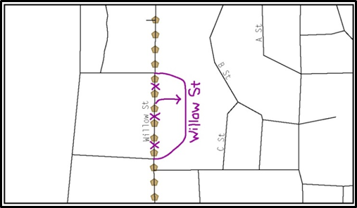
Figure 10. Modifying a Street Feature No Boundary Movement
In this example the street location moves, but the boundary does not.
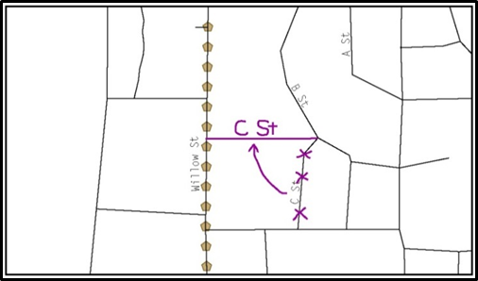
Figure 11. Modifying a Street Feature with Boundary Movement
In this example both the street location and the boundary move.

The Census Bureau recently completed a nationwide program to improve the positional accuracy of all streets and other features that appear in the Census Bureau’s MAF/TIGER System. It is not necessary to make small positional corrections on the BAS maps; correct only those streets that are incorrectly located, mislabeled or distorted. Additionally, new streets may be added, and nonexistent streets may be deleted.
- Adding, Deleting, and Naming Streets
When adding missing streets, new streets, and alternate street names:
- Please use the purple pencil to draw the feature and its name on the map.
- Where possible, please provide the address range for any new streets.
- Please provide the MAF/TIGER Feature Class Code (MTFCC) (Appendix B) for all new streets (Figure 12).
- Alternate street names may be written in parentheses below the primary street name.

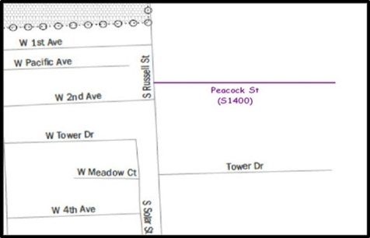
Figure 12. Adding an MTFCC Code When Adding a New Street

Note: Due to the difficulty of showing multiple names for the same street, only the primary street name is shown on BAS maps. Please note that, even though alternate street names are not shown on the maps, they do exist in our database. For example, US Hwy 30 may be locally known as Main St., but on the BAS map, only US Hwy 30 will be displayed; however, within our MAF/TIGER System, both names are listed. If you have reported an alternate street name in the past, you do not have to report it to us again.
- When Correcting Street Names:
- Using the purple pencil, please draw a line through the incorrect street name.
- Please print the correct street name along the feature.

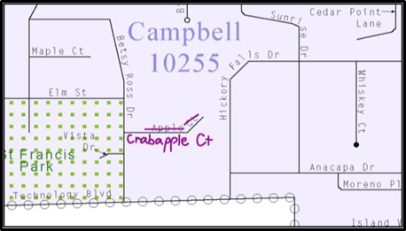
Figure 13. Correcting a Street Name.

Note: If an area of the map is too congested to add all feature names, please number each feature and list this number and the corresponding feature name in the map margin or in an uncongested spot close to the feature’s actual location (Figure 14). Do not repeat numbers on a map sheet.

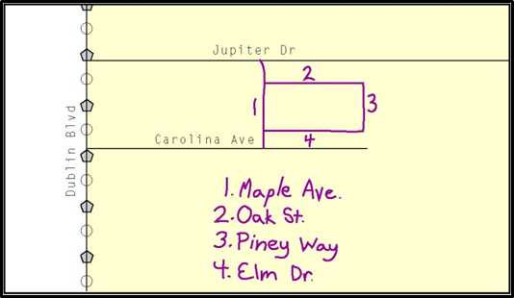
Figure 14. Adding Street Name Features in a Congested Area When Deleting Streets

Note: Delete street features only if they are nonexistent, or impassable. Do not delete a street because the local jurisdiction is not responsible for maintaining it.

- Using the purple pencil, please mark the beginning and end of the base feature to be deleted with hatch (//) marks perpendicular to the feature as shown below.
- Cross-out what is to be removed using a string of “Xs”.

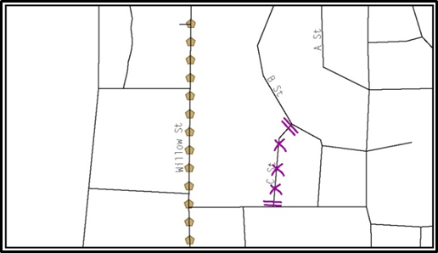
Figure 15. Deleting a Street Feature
- When Naming Streets:
- Using the purple pencil, please label any unnamed streets on the maps.
  - Label any unnamed private roads with PR; and
  - Examples of private roads are driveways and unnamed roads in commercial or industrial parks.

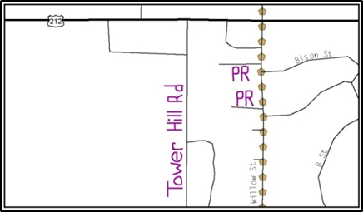
Figure 16. Adding Unnamed Road Features
- Adding a Cul-De-Sac or Circle
When adding a cul-de-sac or circle:
- Using the purple pencil, please draw the feature.
  - Cul-de-sacs are entirely paved, and should be drawn as a solid dot; and
  - Circles have an area of unpaved ground within them, and should be drawn as an unfilled circle.
- Print the name of the associated street leading to the cul-de-sac or circle.

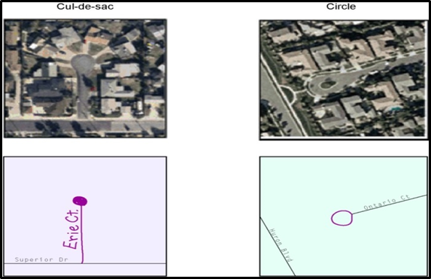
Figure 17. Adding Cul-de-sac and Circle Features
- Annotating Address Range
Addresses are stored in the Census Bureau spatial database as potential address ranges. The BAS maps show the break in the potential address range created where a street is bisected by a boundary. These address range breaks are shown because it is important that the Census Bureau assign the correct addresses to each governmental unit.
Note: Some streets on the BAS maps do not display address breaks due to space considerations.
Add address ranges on both ends of the street only if one of the following circumstances exists:
- A road where house numbers, street names and/or addresses were added or deleted;
- A street was added that crosses a boundary; or
- The address ranges created by a boundary are incorrect on the map.
- When Adding Address Ranges:
Using the purple pencil, please add in the address ranges, providing the lowest and/or highest possible addresses where the road intersects a boundary (Figure 18).
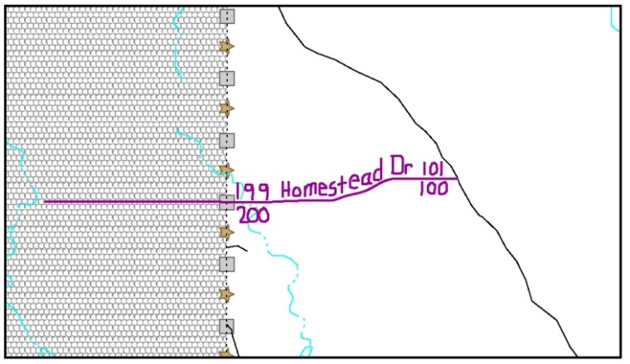
Figure 18. Adding Street Feature/Annotating with Name and Address Breaks

- Point Landmarks
BAS maps display a select number of point landmarks (e.g., mountain peaks). Point landmarks can be updated through the BAS, but are not required.
Acceptable point landmark feature updates include mountain peaks or summits, libraries, city halls, community centers and police stations. Airports, parks, schools, golf courses, museums, and cemeteries may be submitted as point landmarks or area landmarks.
Features that contain residences or private business should not be added as point landmarks or area features (e.g. hotels, campgrounds, retirement homes, farms).
The BAS maps also include select point landmarks (e.g. airports, cemeteries, summits) taken from USGS topography maps and the USGS Geographic Names Information System. These landmarks represent the official federally recognized name and will not be removed or updated without USGS verification.
When adding a point landmark:
- Using the purple pencil, place a solid dot at the location of the point landmark.
- Print the name of the landmark next to the dot.

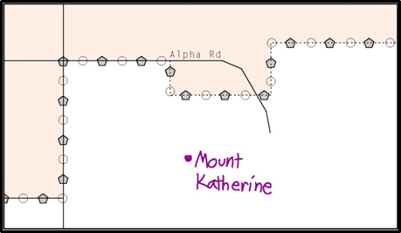
Figure 19. Adding a Point Landmark
- Area Landmarks
The BAS maps display a select number of area landmarks (e.g., lakes). Like point landmarks, area features can be updated through the BAS, but are not required.
Acceptable area landmark updates include water bodies, swamps, quarries, national parks or forests. Airports, parks, schools, golf courses, museums, and cemeteries may be submitted as area landmarks or point landmarks.
Features that contain residences or private business should not be added as point landmarks or area features (e.g. hotels, campgrounds, retirement homes, farms).
When adding an area landmark:
- Using the purple pencil, draw the area landmark boundary in the correct location.
- Print the name of the landmark inside or next to the feature.

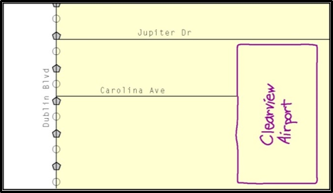
Figure 20. Adding an Area Landmark
- Geographic Corridors and Offsets
A geographic corridor is an area that only includes road surface and right-of-way and does not contain any structures addressed to either side of the street. A geographic offset is an area claimed by a geographic entity that is only on one side of a road and does not include structures addressed to that side of the road.
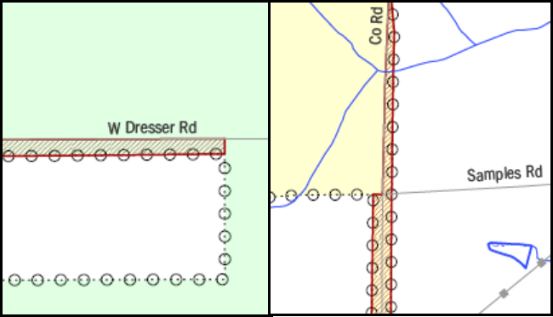
Figure 21. Geographic Offset and Geographic Corridor
The image on the left illustrates a geographic offset, designated by red diagonal lines. The offset is part of the incorporated place (green area). However, the dwelling units are counted outside of the incorporated place. The image on the right illustrates a geographic corridor (Co Rd, south of Samples Rd) and a geographic offset (Co Rd, north of Samples Rd). The geographic corridor and offset are both part of the incorporated place (yellow area), but dwelling units are not.

- Geographic Corridors
Figure 21 shows a corridor that has been created where the incorporated place or AIA owns the right-of-way, and wishes for that ownership to be displayed on the Census Bureau’s maps, but the housing units are not included in the incorporated place or AIA (shown in color). Without a corridor, the housing units along this road would be incorrectly geocoded into the incorporated place or AIA. Thus, if it is important to the place or AIA that its ownership and/or maintenance of the road and/or its rights-of-way be displayed on Census’ maps, a geographic corridor should be created. However, the Census does not require places and AIAs to report rights-of-way:
maintaining geographic corridors in a nationwide database is not essential to the mission of the Census Bureau and the right-of-way should only be included if it is crucial to the place or AIA, or if state or local laws require it.
Figure 22 below shows a case where the right-of-way belongs in the unincorporated area, while the housing units in Figure 23 are included in the incorporated place (shown in color). While depicting this corridor may be important for local purposes, it is not relevant for Census Bureau tabulations because no house can be built in a road right-of-way. This type of corridor should not be included in a BAS response.
Please note that the Census Bureau does not require places or AIAs to display rights-of-way or road maintenance corridors that do not contain or potentially contain housing or population. If local or state law does not require depiction of these geographic features, the Census Bureau prefers that they be left off BAS submissions. If it is necessary for the place or AIA to depict them, they must be submitted as a geographic corridor.
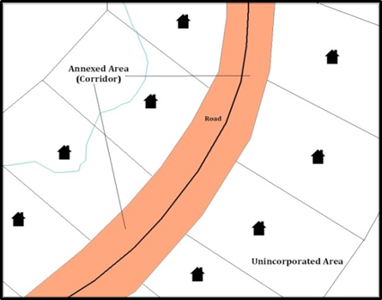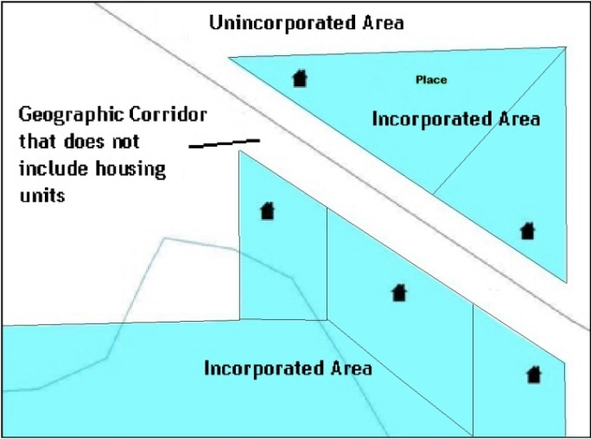
Figure 22. Where the Right-of-way Belongs in the Unincorporated Area
Figure 23. Housing Units in the Unincorporated Area

Geographic corridors can be provided to the Census Bureau if the centerline representation results in addresses being assigned to the wrong entity. However, geographic corridors should only be created if the addresses along the street do not belong to your governmental unit. To indicate a geographic corridor on your map, use the red pencil to draw a line on each side of the road. Mark the beginning and end of each line with perpendicular hatch marks. Write the letters “GC” beside each line (Figure 24). To remove a geographic corridor or offset, use the red pencil to mark the beginning and end of the corridor or offset with perpendicular hatch marks and write “remove GC.”
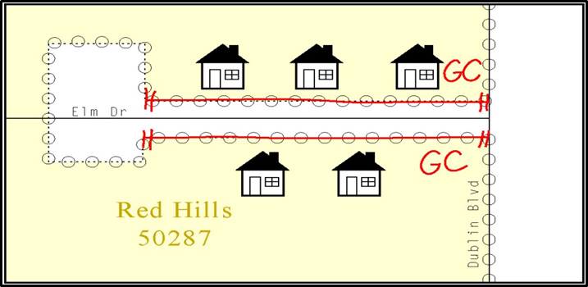
Figure 24. Indicating a Geographic Corridor by Using a Red Pencil
To indicate a geographic corridor on your BAS return, use the red pencil to draw a line on each side of the road. Mark the beginning and end of each line with perpendicular hatch marks. Write the letters “GC” beside each line.
- Geographic Offsets
The Census Bureau is aware that many governments base their legal boundaries on cadastral (parcel-based) right-of-way mapping. The Census Bureau bases their maps on spatial data that is topologically integrated. This makes the maintenance of geographic offsets inefficient. Delineating an entity boundary on the centerline wherever applicable will help to establish more accurate population counts. If a boundary is on the front lot line adjacent to a road on the map, the Census Bureau strongly prefers that the boundary be delineated on the road centerline already shown on the map. If a boundary is on the rear or side lot line, then it should be depicted as such. If it is unclear whether a particular line is a front lot line or something else, please contact the BAS team for assistance. Generally, if a house or other building could not conceivably be built in the area between the potential line and the centerline of the road, then the line can be considered a front lot line.
Figure 25 shows a situation in which the place boundary is along the front lot line. In this example, the respondent must either delineate the boundary on the road centerline, or create an offset. In Figure 26, the place boundary is on the rear lot line, so the respondent should not delineate it on the road centerline or create an offset; instead, the respondent should delineate a new edge that actually follows the rear lot line.
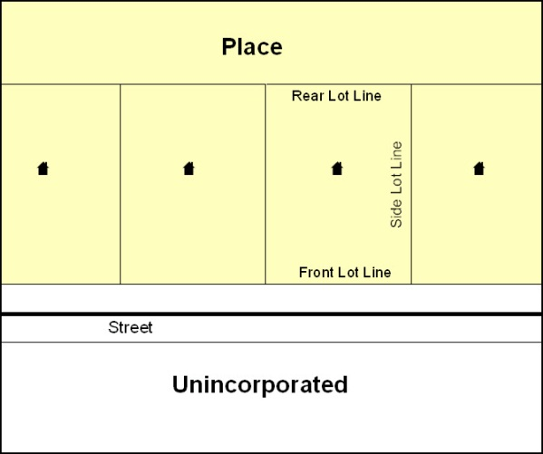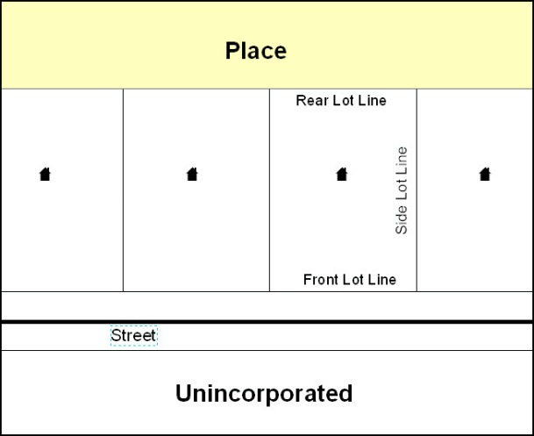
Figure 25. The Place Boundary is Along the Front Lot Line
Figure 26. The Place Boundary is on the Rear Lot Line
To indicate a geographic offset on your map, use the red pencil to draw a line parallel to the road, along which you want the offset to be created. Mark the beginning and end of the line with perpendicular hatch marks. Write the letters “OFF” on the side of the road where the geographic offset exists (Figure 27).

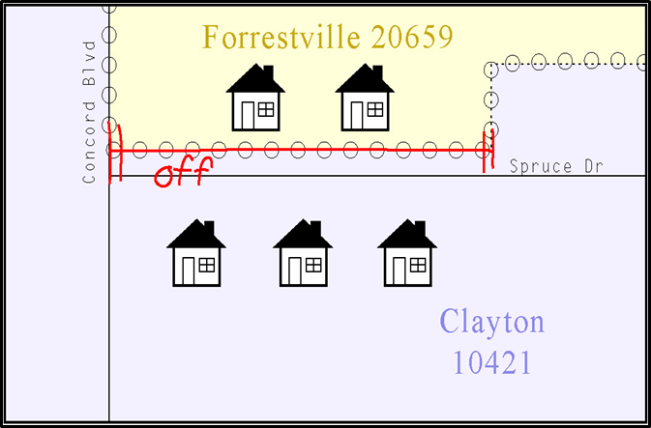
Figure 27. Depicting a Geographic Offset on a Paper Submission
- County Review and Consolidations
Counties receive boundary information from the Census Bureau for all governmental units within their county boundary. Counties should review the names and legal status of active and inactive incorporated places and MCDs found on page 3 of the BAS-2 form.
- Active entities are defined as having a functioning government, with elected officials, that provides programs and services.
- Inactive entities have no functioning government or elected officials, receive services solely from the county, and should be reviewed by the county during BAS.
Although it is not required, counties may update boundaries for incorporated places and MCDs on the county BAS maps. The Census Bureau encourages counties to establish Consolidated BAS agreements with local governments in order to consolidate resources, reduce the burden on local governments, and avoid duplication of work. Under a Consolidated BAS agreement, the county is responsible for reporting boundary changes to the Census Bureau. Participating local governments would no longer receive an annual BAS package. One hundred percent participation is not required and governments may opt out of the agreement at any time. Contact the Census Bureau at <geo.bas@census.gov> for more information on participating in a Consolidated BAS (CBAS) agreement or visit the Consolidated BAS website at <https://www.census.gov/programs-surveys/bas/information/consolidated-bas.html>
- Public Land Survey System
Boundaries are often based on nonvisible features, such as Public Land Survey System (PLSS) lines (i.e. township, section, range lines, etc.). The Census Bureau is currently working on a program through which PLSS lines can be incorporated into the MAF/TIGER System. If any of your entity’s existing or new boundaries are known to follow PLSS lines, you should designate that on your BAS submission by writing “PLSS” in red pencil next to (and parallel to) the appropriate boundary segments. In areas where the Census Bureau has obtained accurate PLSS shapefiles, we will then be able to compare these lines to those shapefiles and ensure accurate placement of the boundary.
- New Incorporations
Newly incorporated places should provide the Census Bureau with:
- A copy of the official new incorporation papers, including date of incorporation;
- A map indicating the boundaries of the new incorporation; and
- Contact information for the highest elected official and a contact for the BAS.
- Disincorporations
Disincorporated entities should provide the Census Bureau with a copy of the official papers of disincorporation, including the effective date.
- Signing Updated Maps and Returning BAS Materials
For each map sheet that has changes, fill in the Signature Box on one copy of the map:
- Print your name, your position, your telephone number, and the date; and
- Sign your name in the Signature area.

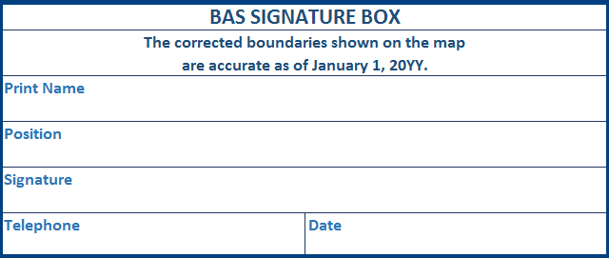
Figure 28. BAS Paper Map Signature Box
Use the postage-paid envelope to return the set of signed maps and the BAS form to the Census Bureau. You may also send an email to geo.bas@census.gov or fill out the Annual Response form located at the following address <http://www.census.gov/geo/partnership/bas/bas_ar_form.html>.

Appendices

Additional Documentation of Changes Forms
- Places
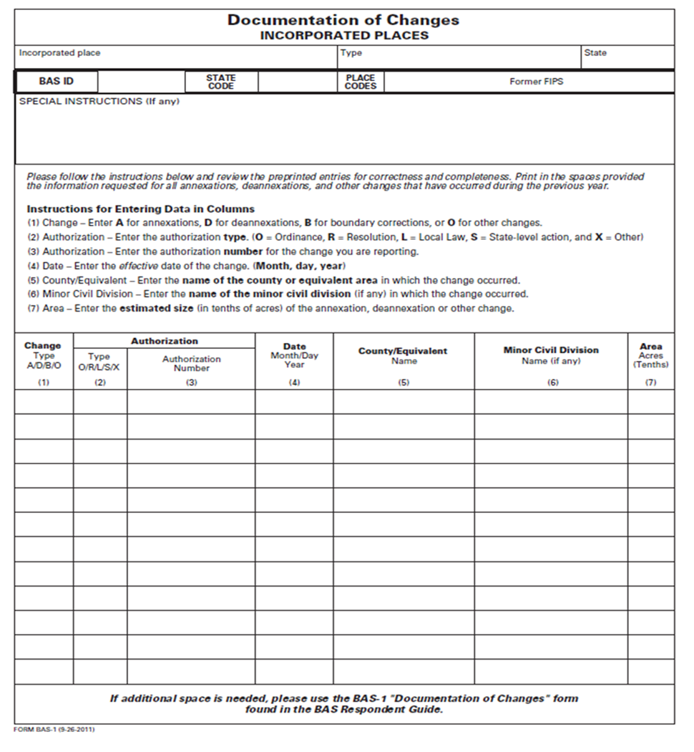
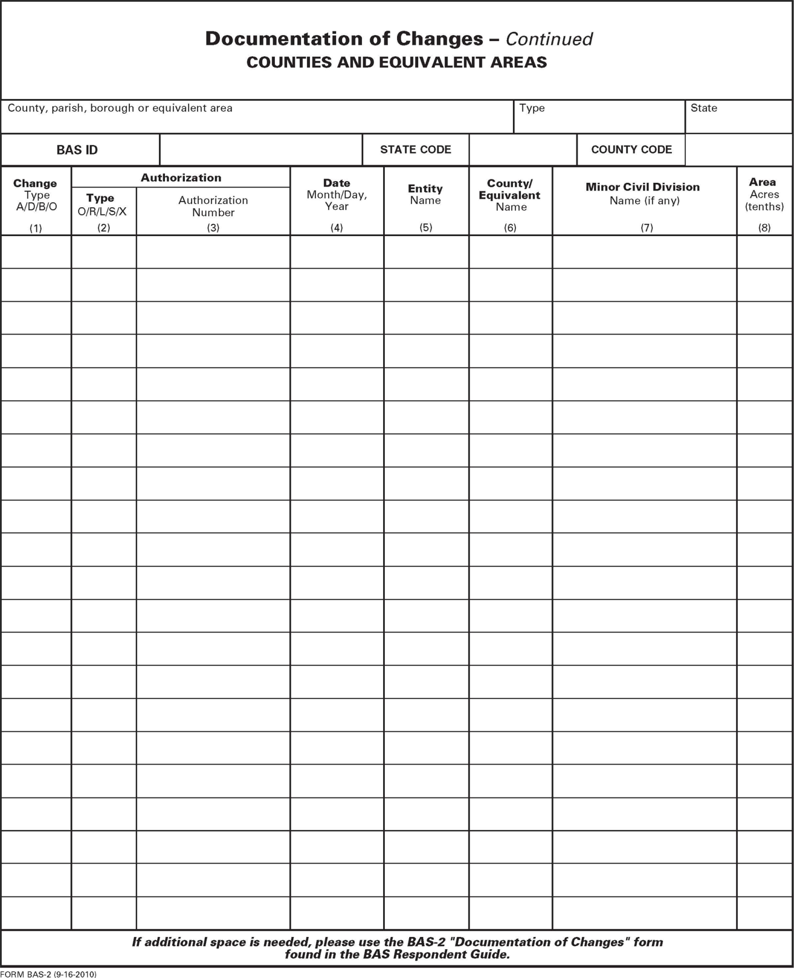
- Counties and Equivalent Areas
- Minor Civil Divisions
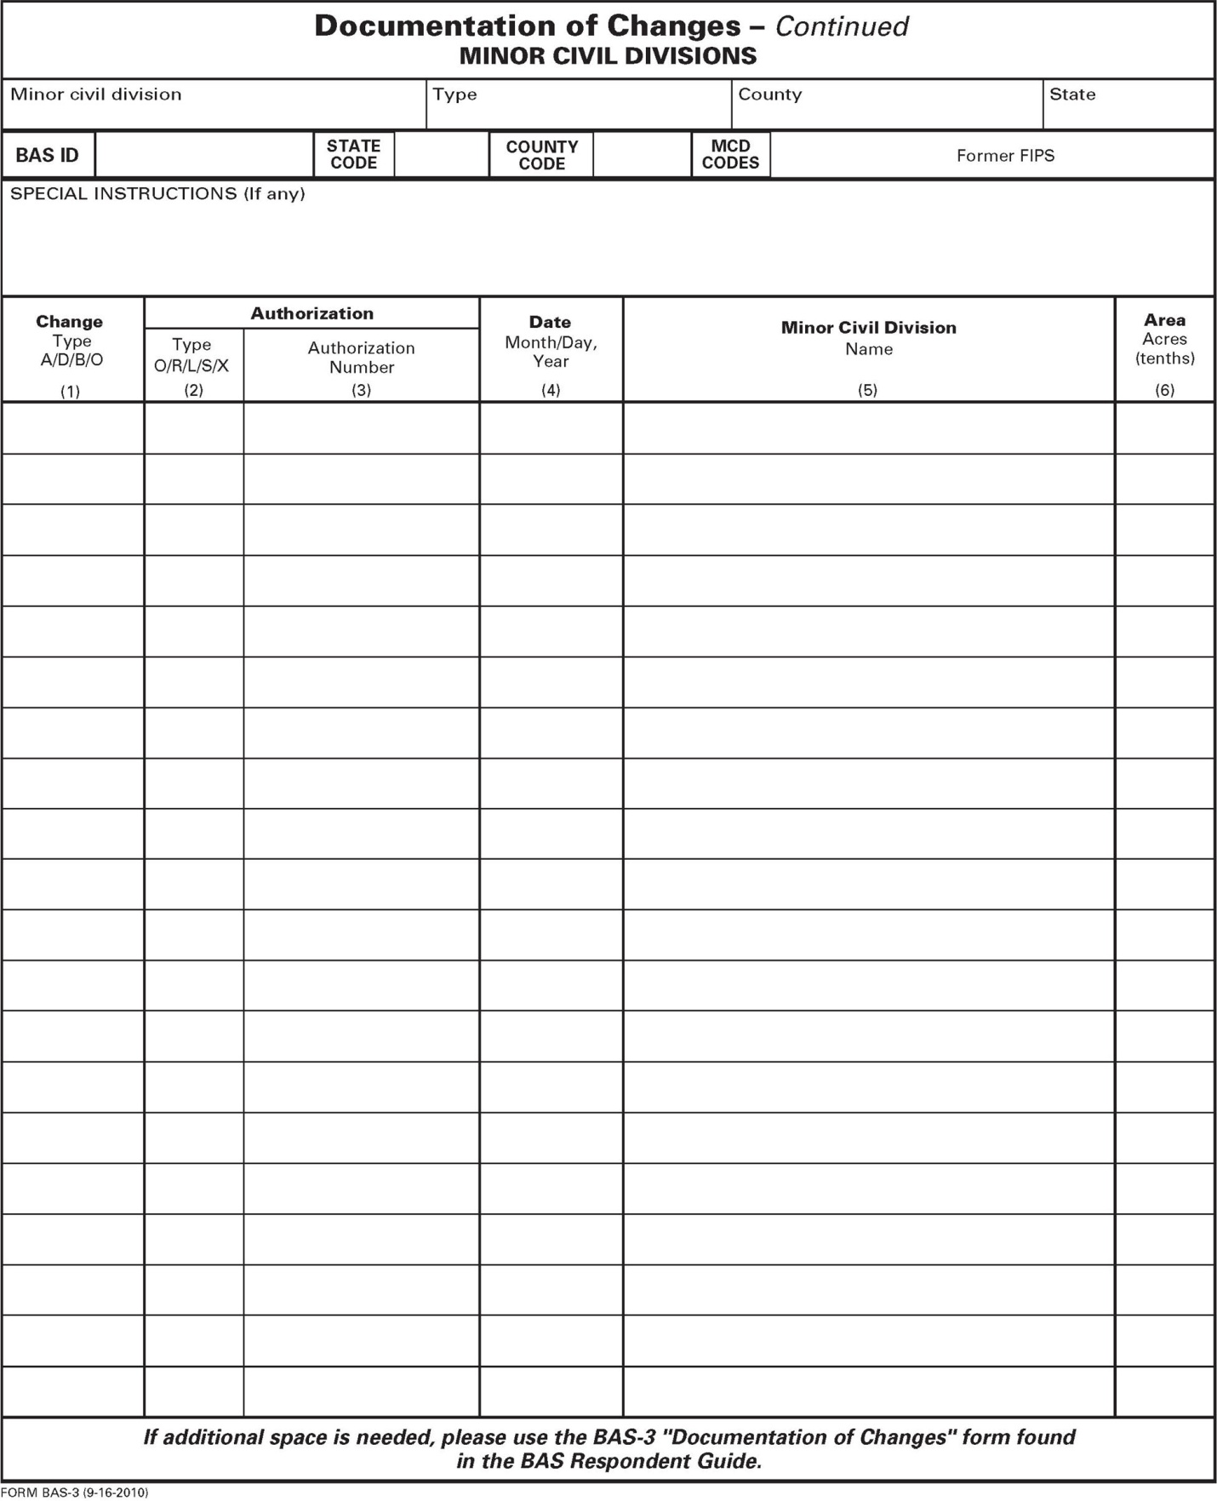
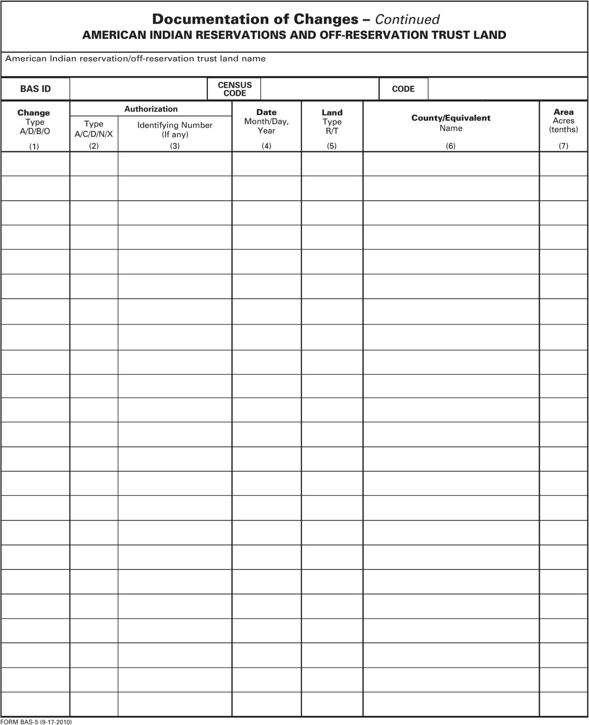
- Reservations and Off-Reservation Trust Land

MTFCC Descriptions
The MAF/TIGER Feature Classification Code (MTFCC) is a 5-digit code assigned by the Census Bureau to classify and describe geographic objects or features in Census Bureau MAF/TIGER products.
MTFCC | Feature Class | Feature Class Description
C3022 | Mountain Peak or Summit | A prominent elevation rising above the surrounding level of the Earth’s surface.
C3023 | Island | An area of dry or relatively dry land surrounded by water or low wetland [including archipelago, atoll, cay, hammock, hummock, isla, isle, key, moku and rock].
C3024 | Levee | An embankment flanking a stream or other flowing water feature to prevent overflow.
C3026 | Quarry (not water-filled), Open Pit Mine or Mine | An area from which commercial minerals are or were removed from the Earth; not including an oilfield or gas field.
C3027 | Dam | A barrier built across the course of a stream to impound water and/or control water flow.
C3061 | Cul-de-sac | An expanded paved area at the end of a street used by vehicles for turning around. For mapping purposes, the Census Bureau maps it only as a point feature.
C3062 | Traffic Circle | A circular intersection allowing for continuous movement of traffic at the meeting of roadways.
C3066 | Gate | A movable barrier across a road.
C3067 | Toll Booth | A structure or barrier where a fee is collected for using a road.
C3071 | Lookout Tower | A manmade structure, higher than its diameter, used for observation.
C3074 | Lighthouse Beacon | A manmade structure, higher than its diameter, used for transmission of light and possibly sound generally to aid in navigation.
C3075 | Tank/Tank Farm | One or more manmade structures, each higher than its diameter, used for liquid (other than water) or gas storage or for distribution activities.
C3076 | Windmill Farm | One or more manmade structures used to generate power from the wind.
C3077 | Solar Farm | One or more manmade structures used to generate power from the sun.
C3078 | Monument or Memorial | A manmade structure to educate, commemorate, or memorialize an event, person, or feature.
C3079 | Boundary Monument Point | A material object placed on or near a boundary line to preserve and identify the location of the boundary line on the ground.
C3080 | Survey Control Point | A point on the ground whose position (horizontal or vertical) is known and can be used as a base for additional survey work.
C3081 | Locality Point | A point that identifies the location and name of an unbounded locality (e.g., crossroad, community, populated place or locale).
C3085 | Alaska Native Village Official Point | A point that serves as the core of an Alaska Native village and is used in defining Alaska Native village statistical areas.
G2100 | American Indian Area | A legally defined state- or federally recognized reservation and/or off-reservation trust land (excludes statistical American Indian areas).
G2120 | Hawaiian Home Land | A legal area held in trust for the benefit of Native Hawaiians.
G2130 | Alaska Native Village Statistical Area | A statistical geographic entity that represents the residences, permanent and/or seasonal, for Alaska Natives who are members of or receiving governmental services from the defining legal Alaska Native Village corporation.
G2140 | Oklahoma Tribal Statistical Area | A statistical entity identified and delineated by the Census Bureau in consultation with federally recognized American Indian tribes that have no current reservation, but had a former reservation in Oklahoma.
G2150 | State-designated Tribal Statistical Area | A statistical geographic entity identified and delineated for the Census Bureau by a state-appointed liaison for a state-recognized American Indian tribe that does not currently have a reservation and/or lands in trust.
G2160 | Tribal Designated Statistical Area | A statistical geographic entity identified and delineated for the Census Bureau by a federally recognized American Indian tribe that does not currently have a reservation and/or off-reservation trust land.
G2170 | American Indian Joint Use Area | An area administered jointly and/or claimed by two or more American Indian tribes.
G2200 | Alaska Native Regional Corporation | Corporate entities established to conduct both business and nonprofit affairs of Alaska Natives pursuant to the Alaska Native Claims Settlement Act of 1972 (Public Law 92-203). There are twelve geographically defined ANRCs and they are all within and cover most of the State of Alaska (the Annette Island Reserve-an American Indian reservation-is excluded from any ANRC). The boundaries of ANRCs have been legally established.
G2300 | Tribal Subdivision | Administrative subdivisions of federally recognized American Indian reservations, off-reservation trust lands, or Oklahoma tribal statistical areas (OTSAs). These entities are internal units of self-government or administration that serve social, cultural, and/or economic purposes for the American Indians on the reservations, off-reservation trust lands, or OTSAs.
G2400 | Tribal Census Tract | A relatively small and permanent statistical subdivision of a federally recognized American Indian reservation and/or off-reservation trust land, delineated by American Indian tribal participants or the Census Bureau for the purpose of presenting demographic data.
G2410 | Tribal Block Group | A cluster of census blocks within a single tribal census tract delineated by American Indian tribal participants or the Census Bureau for the purpose of presenting demographic data.
G3100 | Combined Statistical Area | A grouping of adjacent metropolitan and/or micropolitan statistical areas that have a degree of economic and social integration, as measured by commuting.
G3110 | Metropolitan and Micropolitan Statistical Area | An area containing a substantial population nucleus together with adjacent communities having a high degree of economic and social integration with that core, as measured by commuting. Defined using whole counties and equivalents.
G3120 | Metropolitan Division | A county or grouping of counties that is a subdivision of a Metropolitan Statistical Area containing an urbanized area with a population of 2.5 million or more.
G3200 | Combined New England City and Town Area | A grouping of adjacent New England city and town areas that have a degree of economic and social integration, as measured by commuting.
G3210 | New England City and Town Metropolitan and Micropolitan Statistical Area | An area containing a substantial population nucleus together with adjacent communities having a high degree of economic and social integration with that core, as measured by commuting. Defined using Minor Civil Divisions (MCDs) in New England.
G3220 | New England City and Town Division | A grouping of cities and towns in New England that is a subdivision of a New England City and Town Area containing an urbanized area with a population of 2.5 million or more.
G3500 | Urban Area | Densely settled territory that contains at least 2,500 people. The subtypes of this feature are Urbanized Area (UA), which consists of 50,000 + people and Urban Cluster, which ranges between 2,500 and 49,999 people.
G4000 | State or Equivalent Feature | The primary governmental divisions of the United States. The District of Columbia is treated as a statistical equivalent of a state for census purposes, as is Puerto Rico.
G4020 | County or Equivalent Feature | The primary division of a state or state equivalent area. The primary divisions of 48 states are termed County, but other terms are used such as Borough in Alaska, Parish in Louisiana, and Municipio in Puerto Rico. This feature includes independent cities, which are incorporated places that are not part of any county.
G4040 | County Subdivision | The primary divisions of counties and equivalent features for the reporting of Census Bureau data. The subtypes of this feature are Minor Civil Division, Census County Division/Census Subarea, and Unorganized Territory. This feature includes independent places, which are incorporated places that are not part of any county subdivision.
G4050 | Estate | Estates are subdivisions of the three major islands in the United States Virgin Islands (USVI).
G4060 | Subbarrio (Subminor Civil Division) | Legally defined divisions (subbarrios) of minor civil divisions (barrios-pueblo and barrios) in Puerto Rico.
G4110 | Incorporated Place | A legal entity incorporated under state law to provide general-purpose governmental services to a concentration of population. Incorporated places are generally designated as a city, borough, municipality, town, village, or, in a few instances, have no legal description.
G4120 | Consolidated City | An incorporated place that has merged governmentally with a county or minor civil division, but one or more of the incorporated places continues to function within the consolidation. It is a place that contains additional separately incorporated places.
G4210 | Census Designated Place | A statistical area defined for a named concentration of population and the statistical counterpart of an incorporated place.
G4300 | Economic Census Place | The lowest level of geographic area for presentation of some types of Economic Census data. It includes incorporated places, consolidated cities, census designated places (CDPs), minor civil divisions (MCDs) in selected states, and balances of MCDs or counties. An incorporated place, CDP, MCD, or balance of MCD qualifies as an economic census place if it contains 5,000 or more residents, or 5,000 or more jobs, according to the most current data available.
G5020 | Census Tract | Relatively permanent statistical subdivisions of a County or equivalent feature delineated by local participants as part of the Census Bureau’s Participant Statistical Areas Program.
G5030 | Block Group | A cluster of census blocks having the same first digit of their four-digit identifying numbers within a Census Tract. For example, block group 3 (BG 3) within a Census Tract includes all blocks numbered from 3000 to 3999.
G5035 | Block Area Grouping | A user-defined group of islands forming a single census tabulation block. A BAG must: (1) consist of two or more islands, (2) have a perimeter entirely over water, (3) not overlap, and (4) not cross the boundary of other tabulation geographies, such as county or incorporated place boundaries.
G5040 | Tabulation Block | The lowest-order census defined statistical area. It is an area, such as a city block, bounded primarily by physical features but sometimes by invisible city or property boundaries. A tabulation block boundary does not cross the boundary of any other geographic area for which the Census Bureau tabulates data. The subtypes of this feature are Count Question Resolution (CQR), current, and census.
G5200 | Congressional District | The 435 areas from which people are elected to the U.S. House of Representatives. Additional equivalent features exist for state equivalents with nonvoting delegates or no representative. The subtypes of this feature are 106th, 107th, 108th, 109th, and 111th Congressional Districts, plus subsequent Congresses.
G5210 | State Legislative District (Upper Chamber | Areas established by a state or equivalent government from which members are elected to the upper or unicameral chamber of a state governing body. The upper chamber is the senate in a bicameral legislature, and the unicameral case is a single house legislature (Nebraska).
G5220 | State Legislative District (Lower Chamber) | Areas established by a state or equivalent government from which members are elected to the lower chamber of a state governing body. The lower chamber is the House of Representatives in a bicameral legislature.
G5240 | Voting District | The generic name for the geographic features, such as precincts, wards, and election districts, established by state, local, and tribal governments for the purpose of conducting elections.
G5400 | Elementary School District | A geographic area within which officials provide public elementary grade-level educational services for residents.
G5410 | Secondary School District | A geographic area within which officials provide public secondary grade-level educational services for residents.
G5420 | Unified School District | A geographic area within which officials provide public educational services for all grade levels for residents.
G6120 | Public-Use Microdata Area | A decennial census area with a population of at least 100,000 or more persons for which the Census Bureau provides selected extracts of household-level data that are screened to protect confidentiality.
G6300 | Traffic Analysis District | An area delineated by Metropolitan Planning Organizations (MPOs) and state Departments of Transportation (DOTs) for tabulating journey-to-work and place-of-work data. A Traffic Analysis District (TAD) consists of one or more Traffic Analysis Zones (TAZs).
G6320 | Traffic Analysis Zone | An area delineated by Metropolitan Planning Organizations (MPOs) and state Departments of Transportation (DOTs) for tabulating journey-to-work and place-of-work data.
G6330 | Urban Growth Area | An area defined under state authority to manage urbanization that the Census Bureau includes in the MAF/TIGER® System in agreement with the state.
G6350 | ZIP Code Tabulation Area (Five-Digit) | An approximate statistical-area representation of a U.S. Postal Service (USPS) 5-digit ZIP Code service area.
G6400 | Commercial Region | For the purpose of presenting economic statistical data, municipios in Puerto Rico are grouped into commercial regions.
H1100 | Connector | A known, but nonspecific, hydrographic connection between two nonadjacent water features.
H2025 | Swamp/Marsh | A poorly drained wetland, fresh or saltwater, wooded or grassy, possibly covered with open water [includes bog, cienega, marais and pocosin].
H2030 | Lake/Pond | A standing body of water that is surrounded by land.
H2040 | Reservoir | An artificially impounded body of water.
H2041 | Treatment Pond | An artificial body of water built to treat fouled water.
H2051 | Bay/Estuary/Gulf/Sound | A body of water partly surrounded by land [includes arm, bight, cove and inlet].
H2053 | Ocean/Sea | The great body of salt water that covers much of the earth.
H2060 | Gravel Pit/Quarry filled with water | A body of water in a place or area from which commercial minerals were removed from the Earth.
H2081 | Glacier | A body of ice moving outward and down slope from an area of accumulation; an area of relatively permanent snow or ice on the top or side of a mountain or mountainous area [includes ice field and ice patch].
H3010 | Stream/River | A natural flowing waterway [includes anabranch, awawa, branch, brook, creek, distributary, fork, kill, pup, rio, and run].
H3013 | Braided Stream | A natural flowing waterway with an intricate network of interlacing channels.
H3020 | Canal, Ditch or Aqueduct | An artificial waterway constructed to transport water, to irrigate or drain land, to connect two or more bodies of water, or to serve as a waterway for watercraft [includes lateral].
K1225 | Crew-of-Vessel Location | A point or area in which the population of military or merchant marine vessels at sea are assigned, usually being at or near the home port pier.
K1231 | Hospital/Hospice/Urgent Care Facility | One or more structures where the sick or injured may receive medical or surgical attention [including infirmary].
K1235 | Juvenile Institution | A facility (correctional and non-correctional) where groups of juveniles reside; this includes training schools, detention centers, residential treatment centers and orphanages.
K1236 | Local Jail or Detention Center | One or more structures that serve as a place for the confinement of adult persons in lawful detention, administered by a local (county, municipal, etc.) government.
K1237 | Federal Penitentiary, State Prison, or Prison Farm | An institution that serves as a place for the confinement of adult persons in lawful detention, administered by the federal government or a state government.
K1238 | Other Correctional Institution | One or more structures that serve as a place for the confinement of adult persons in lawful detention, not elsewhere classified or administered by a government of unknown jurisdiction.
K1239 | Convent, Monastery, Rectory, Other Religious Group Quarters | One or more structures intended for use as a residence for those having a religious vocation.
K1246 | Community Center | Community Center.
K2110 | Military Installation | An area owned and/or occupied by the Department of Defense for use by a branch of the armed forces (such as the Army, Navy, Air Force, Marines, or Coast Guard), or a state owned area for the use of the National Guard.
K2165 | Government Center | A place used by members of government (either federal, state, local, or tribal) for administration and public business.
K2167 | Convention Center | An exhibition hall or conference center with enough open space to host public and private business and social events.
K2180 | Park | Parkland defined and administered by federal, state, and local governments.
K2181 | National Park Service Land | Area—National parks, National Monuments, and so forth—under the jurisdiction of the National Park Service.
K2182 | National Forest or Other Federal Land | Land under the management and jurisdiction of the federal government, specifically including areas designated as National Forest, and excluding areas under the jurisdiction of the National Park Service.
K2183 | Tribal Park, Forest, or Recreation Area | A place or area set aside for recreation or preservation of a cultural or natural resource and under the administration of an American Indian tribe.
K2184 | State Park, Forest, or Recreation Area | A place or area set aside for recreation or preservation of a cultural or natural resource and under the administration of a state government.
K2185 | Regional Park, Forest, or Recreation Area | A place or area set aside for recreation or preservation of a cultural or natural resource and under the administration of a regional government.
K2186 | County Park, Forest, or Recreation Area | A place or area set aside for recreation or preservation of a cultural or natural resource and under the administration of a county government.
K2187 | County Subdivision Park, Forest, or Recreation Area | A place or area set aside for recreation or preservation of a cultural or natural resource and under the administration of a minor civil division (town/township) government.
K2188 | Incorporated Place Park, Forest, or Recreation Area | A place or area set aside for recreation or preservation of a cultural or natural resource and under the administration of a municipal government.
K2189 | Private Park, Forest, or Recreation Area | A privately owned place or area set aside for recreation or preservation of a cultural or natural resource.
K2190 | Other Park, Forest, or Recreation Area (quasi-public, independent park, commission, etc.) | A place or area set aside for recreation or preservation of a cultural or natural resource and under the administration of some other type of government or agency such as an independent park authority or commission.
K2191 | Post Office | An official facility of the U.S. Postal Service used for processing and distributing mail and other postal material.
K2193 | Fire Department | Fire Department.
K2194 | Police Station | Police Station.
K2195 | Library | Library.
K2196 | City/Town Hall | City/Town Hall.
K2400 | Transportation Terminal | A facility where one or more modes of transportation can be accessed by people or for the shipment of goods; examples of such a facility include marine terminal, bus station, train station, airport and truck warehouse.
K2424 | Marina | A place where privately owned, light-craft are moored.
K2432 | Pier/Dock | A platform built out from the shore into the water and supported by piles. This platform may provide access to ships and boats, or it may be used for recreational purposes.
K2451 | Airport or Airfield | A manmade facility maintained for the use of aircraft [including airstrip, landing field and landing strip].
K2452 | Train Station, Trolley or Mass Transit Rail Station | A place where travelers can board and exit rail transit lines, including associated ticketing, freight, and other commercial offices.
K2453 | Bus Terminal | A place where travelers can board and exit mass motor vehicle transit, including associated ticketing, freight, and other commercial offices.
K2454 | Marine Terminal | A place where travelers can board and exit water transit or where cargo is handled, including associated ticketing, freight, and other commercial offices.
K2455 | Seaplane Anchorage | A place where an airplane equipped with floats for landing on or taking off from a body of water can debark and load.
K2456 | Airport—Intermodal Transportation Hub/Terminal | A major air transportation facility where travelers can board and exit airplanes and connect with other (i.e. non-air) modes of transportation.
K2457 | Airport—Statistical Representation | The area of an airport adjusted to include whole 2000 census blocks used for the delineation of urban areas
K2458 | Park and Ride Facility/Parking Lot | A place where motorists can park their cars and transfer to other modes of transportation.
K2459 | Runway/Taxiway | A fairly level and usually paved expanse used by airplanes for taking off and landing at an airport.
K2460 | Helicopter Landing Pad | A fairly level and usually paved expanse used by helicopters for taking off and landing.
K2540 | University or College | A building or group of buildings used as an institution for post-secondary study, teaching, and learning [including seminary].
K2543 | School or Academy | A building or group of buildings used as an institution for preschool, elementary or secondary study, teaching, and learning [including elementary school and high school].
K2545 | Museum, Visitor Center, Cultural Center, or Tourist Attraction | An attraction of historical, cultural, educational or other interest that provides information or displays artifacts.
K2561 | Golf Course | A place designed for playing golf.
K2582 | Cemetery | A place or area for burying the dead [including burying ground and memorial garden].
K2586 | Zoo | A facility in which terrestrial and/or marine animals are confined within enclosures and displayed to the public for educational, preservation, and research purposes.
K3544 | Place of Worship | A sanctified place or structure where people gather for religious worship; examples include church, synagogue, temple, and mosque.
L4010 | Pipeline | A long tubular conduit or series of pipes, often underground, with pumps and valves for flow control, used to transport fluid (e.g., crude oil, natural gas), especially over great distances.
L4020 | Powerline | One or more wires, often on elevated towers, used for conducting high-voltage electric power.
L4031 | Aerial Tramway/Ski Lift | A conveyance that transports passengers or freight in carriers suspended from cables and supported by a series of towers.
L4110 | Fence Line | A man-made barrier enclosing or bordering a field, yard, etc., usually made of posts and wire or wood, used to prevent entrance, to confine, or to mark a boundary.
L4121 | Ridge Line | The line of highest elevation along a ridge.
L4125 | Cliff/Escarpment | A very steep or vertical slope [including bluff, crag, head, headland, nose, palisades, precipice, promontory, rim and rimrock].
L4130 | Point-to-Point Line | A line defined as beginning at one location point and ending at another, both of which are in sight.
L4140 | Property/Parcel Line (Including PLSS) | This feature class may denote a nonvisible boundary of either public or private lands (e.g., a park boundary) or it may denote a Public Land Survey System or equivalent survey line.
L4150 | Coastline | The line that separates either land or Inland water from Coastal, Territorial or Great Lakes water. Where land directly borders Coastal, Territorial or Great Lakes water, the shoreline represents the Coastline. Where Inland water (such as a river) flows into Coastal, Territorial or Great Lakes water, the closure line separating the Inland water from the other class of water represents the Coastline.
L4165 | Ferry Crossing | The route used to carry or convey people or cargo back and forth over a waterbody in a boat.
P0001 | Nonvisible Linear Legal/Statistical Boundary | A legal/statistical boundary line that does not correspond to a shoreline or other visible feature on the ground.
P0002 | Perennial Shoreline | The more-or-less permanent boundary between land and water for a water feature that exists year-round.
P0003 | Intermittent Shoreline | The boundary between land and water (when water is present) for a water feature that does not exist year-round.
P0004 | Other non-visible bounding Edge (e.g., Census water boundary, boundary of an areal feature) | A bounding Edge that does not represent a legal/statistical boundary, and does not correspond to a shoreline or other visible feature on the ground. Many such Edges bound area landmarks, while many others separate water features from each other (e.g., where a bay meets the ocean).
R1011 | Railroad Feature (Main, Spur, or Yard) | A line of fixed rails or tracks that carries mainstream railroad traffic. Such a rail line can be a main line or spur line, or part of a rail yard.
R1051 | Carline, Streetcar Track, Monorail, Other Mass Transit | Mass transit rail lines (including lines for rapid transit, monorails, streetcars, light rail, etc.) that are typically inaccessible to mainstream railroad traffic and whose tracks are not part of a road right-of-way.
R1052 | Cog Rail Line, Incline Rail Line, Tram | A special purpose rail line for climbing steep grades that is typically inaccessible to mainstream railroad traffic. Note that aerial tramways and streetcars (which may also be called “trams”) are accounted for by other MTFCCs and do not belong in R1052.
S1100 | Primary Road | Primary roads are generally divided, limited-access highways within the interstate highway system or under state management, and are distinguished by the presence of interchanges. These highways are accessible by ramps and may include some toll highways.
S1200 | Secondary Road | Secondary roads are main arteries, usually in the U.S. Highway, State Highway or County Highway system. These roads have one or more lanes of traffic in each direction, may or may not be divided, and usually have at-grade intersections with many other roads and driveways. They often have both a local name and a route number.
S1400 | Local Neighborhood Road, Rural Road, City Street | Generally a paved non-arterial street, road, or byway that usually has a single lane of traffic in each direction. Roads in this feature class may be privately or publicly maintained. Scenic park roads would be included in this feature class, as would (depending on the region of the country) some unpaved roads.
S1500 | Vehicular Trail (4WD) | An unpaved dirt trail where a four-wheel drive vehicle is required. These vehicular trails are found almost exclusively in very rural areas. Minor, unpaved roads usable by ordinary cars and trucks belong in the S1400 category.
S1630 | Ramp | A road that allows controlled access from adjacent roads onto a limited access highway, often in the form of a cloverleaf interchange. These roads are unaddressable and do not carry a name in the MAF/TIGER System.
S1640 | Service Drive usually along a limited access highway | A road, usually paralleling a limited access highway, that provides access to structures along the highway. These roads can be named and may intersect with other roads.
S1710 | Walkway/Pedestrian Trail | A path that is used for walking, being either too narrow for or legally restricted from vehicular traffic.
S1720 | Stairway | A pedestrian passageway from one level to another by a series of steps.
S1730 | Alley | A service road that does not generally have associated addressed structures and is usually unnamed. It is located at the rear of buildings and properties and is used for deliveries.
S1740 | Private Road for service vehicles (logging, oil fields, ranches, etc.) | A road within private property that is privately maintained for service, extractive, or other purposes. These roads are often unnamed.
S1750 | Internal U.S. Census Bureau use | Internal U.S. Census Bureau use.
S1780 | Parking Lot Road | The main travel route for vehicles through a paved parking area.
S1820 | Bike Path or Trail | A path that is used for manual or small, motorized bicycles, being either too narrow for or legally restricted from vehicular traffic.
S1830 | Bridle Path | A path that is used for horses, being either too narrow for or legally restricted from vehicular traffic.
S2000 | Road Median | The unpaved area or barrier between the carriageways of a divided road.
Note: The information in this table was last updated in November 2017.

Reading A Map
- Scales
A map is a paper or digital representation of an area. Naturally, the map is always smaller than the area it represents, so nearly all maps are equipped with a scale, which depicts the ratio of distance on the map to the actual distance on land. The scale can be designed any number of ways, but two of the most common scales are ratio scales (Figure C1), which describe a ratio between the map and the real world (e.g., 1: 24,000), and bar scales, which depict that relationship graphically by displaying how much a certain distance on the map represents in the real world (Figure C1). In other words, if a map has a ratio scale of 1: 24,000, it means that one inch on the map represents 24,000 inches on the ground. (This works with any unit of measurement, so long as the unit being used on the map is the same as – or properly converted from – the unit being depicted on the ground.) Often a map will have both types of scale.

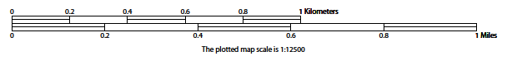
Figure 29. Bar Scale
The map from which this scale was taken has a ratio scale of 1:15,000. The bar scale shows distances in kilometers and miles.
A bar scale will often be a set length (e.g., one inch), and/or represent a set distance (e.g., one mile). You can use the bar scale to determine distance on your map by using a ruler. Simply place the ruler on the map to determine the distance on the map; then place the ruler along the bar scale, which will show how much that distance represents on the ground.
Maps that display a small area, but with a relatively large amount of detail, are considered large-scale maps (see Figure C2). A map that displays a large area, but shows less detail, is called a small-scale map (see Figure C3). This is because the representative fraction of a large-scale map (e.g., 1/7,500 or 1:7,500) is a larger fraction than that of a small-scale map (e.g., 1/250,000 or 1:250,000).
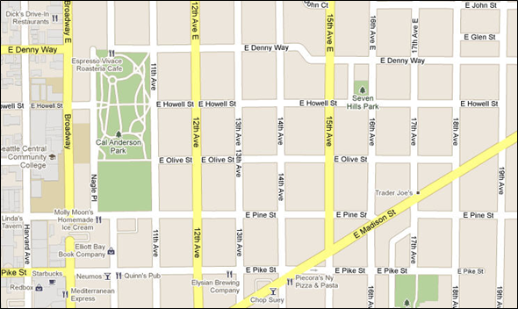
Figure 30. Large Scale Map
A large-scale map shows a greater amount of detail; this example displays streets, parks, churches and restaurants.
- Compass Rose
All maps should have some sort of diagram depicting at least one – but sometimes all – of the cardinal directions (north, south, east, and west) that the map reader can use to orient the map. This diagram is sometimes called a compass rose (see Figure C4). A compass rose can have any number of designs, and north can be shown in any direction on the map, but most maps are oriented with north at the top of the map. It is important to check the compass rose when beginning to read a map, in order to determine the direction in which the map is oriented (i.e., which direction is at the top of the map).
Figure 31. Compass Rose
- Legend
Because a map is a graphic representation of a real-world area, naturally, it is necessary, and convenient, to symbolize real world features with representative symbols. These symbols can take any form, so long as they are consistent within any individual map. In order to describe what each symbol means, most maps have a legend (see Figure C5). The legend is typically located on the side or bottom of the map – they can be anywhere, so long as they do not obstruct the integral parts of the map. Typically, the legend will have a small example of each symbol (e.g. a line, or a picture of a tent), and next to the symbol, in text, a brief description of what is being depicted (e.g. “road”, or “campground”).
Figure 32. Legend Describing What Each Symbol Means
Sometimes a map needs to depict multiple features concurrently. This is because some lines are the boundaries of multiple geographies at the same time (i.e. a county boundary can also be a city boundary, a voting district boundary, and even a highway or river). Such instances can be depicted in various ways, but Census Bureau maps depict coincident lines by alternating the symbols for each type of line as shown in Figure C6 below. In other words, if a line is both a county boundary (symbolized by a series of squares) and a city boundary (a series of circles), that boundary will be depicted as a series of alternating squares and circles for the length of the concurrency.
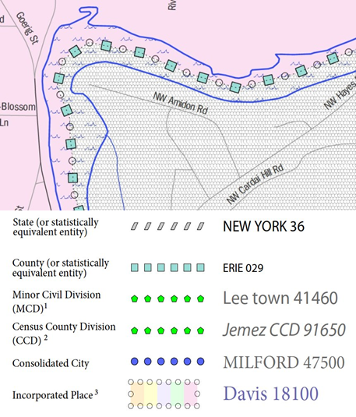
Figure 33. Map Depicting Multiple Features Concurrently
In this case, the city and the county boundaries are coincident, and run through the middle of the river.

In situations where higher-level geographies (e.g. national, state, county, or county subdivisions) coincide, the Census Bureau’s maps display only the symbol of the highest-ranking of these boundaries. In other words, if a particular boundary is shared by both a state and county, only the symbol representing the state boundary will be displayed.
- Index Maps
In order to decide which map you need to use for your BAS submission, it is necessary to view the entity as a whole, and choose the correct parent map sheet based on its location within the entity. You can do this by referring to the index map (Figure 34), a relatively small-scale map that shows the entire entity, and the location and number of all parent map sheets within that entity. Each parent map sheet has a numerical locator which differentiates it from the other parent map sheets associated with that entity. The numbering begins with the northern and western-most parent map sheets, and continues left-to-right, in much the same pattern as words in a book. By referring to the index map, you can then determine which parent map sheet(s) you need to use for your BAS submission, and then access it based on its number on the index map.
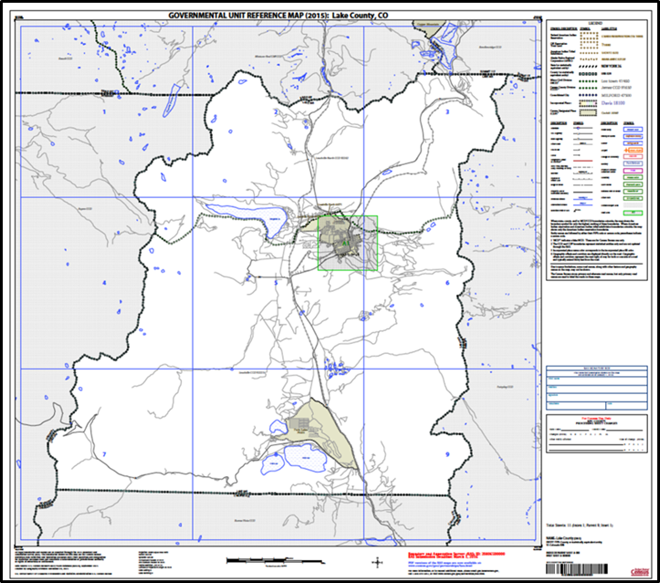
Figure 34. Index Map
The Index Map sheet shows the location of all parent map sheets and inset map sheets within an entity.

The index map is not appropriate for BAS submissions. Its purpose is as a reference or index of parent maps, and it will not be accepted as a BAS submission.
- Inset Maps
In some instances, in highly congested areas, even a parent map sheet provides insufficient detail for BAS purposes. In such cases, rather than using a parent map, the area is depicted within an inset map (Figure 36). This refers to a map with a very large scale, so that it displays a smaller area than the parent map sheet, but with greater detail. On the index map, an inset map is represented by a green outline, and is assigned a number preceded by a letter (i.e. A1, A2, B1, etc.), as shown in Figure 35 on the next page. Inset maps are only found in areas with a large number of features, and as such are used less often than parent maps.
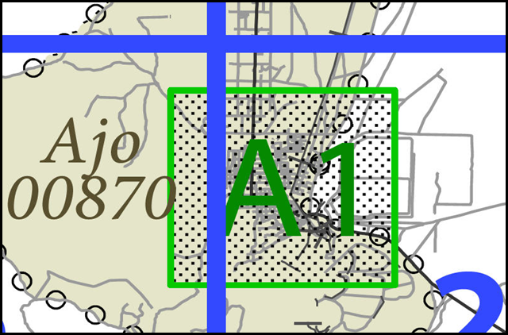
Figure 35. An Inset Map as it is Displayed on the Index Map

Figure 36. Inset Maps
Inset maps show areas of relative congestion at a large scale, allowing a greater amount of detail.

- Parent Maps
Many entities, such as incorporated places and counties, are too large to be shown on a single map; that is, the scale is too small to allow the necessary details for BAS updates. Thus, it is necessary to separate the entity into sections, each of which has its own map, called the parent map sheet (Figure 37). Thus, a single entity is often represented with numerous map sheets, with each parent map sheet showing a small section of the entity. Each parent map is assigned a number, beginning with the number one and increasing progressively for each additional parent map sheet (i.e. 1, 2, 3, 4, etc.). In this way, viewing and editing map sheets becomes more manageable, and it becomes possible to depict an area with the level of detail necessary to make changes or challenges. In most instances, the parent map is the one that should be used for BAS submissions.
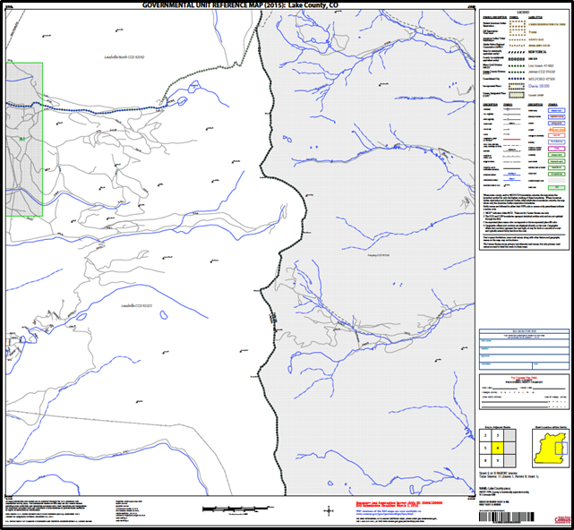
Figure 37. The Parent Map
The parent map sheet shows a section of an entity at a relatively large scale.
In the bottom right-hand corner of the parent map sheet, there is a key to the parent map sheet’s location in relation to adjacent map sheets as shown in Figure 37 above. A larger example of this key is shown in Figure 39. This way, if you need to refer to an adjacent map sheet, you can quickly determine which one you will need.
2 | 3
5 | 6
8 | 9

Figure 38. The Key to Adjacent Sheets
The key to adjacent sheets shows where the parent map sheet lies in relation to adjacent sheets.
Next to the key to adjacent sheets, there is a small outline of the entire entity (the inside of which is colored yellow), and a blue outline of the parent map sheet. This key displays the location of the map sheet in relation to the entity as a whole as is shown in Figure 39 below.
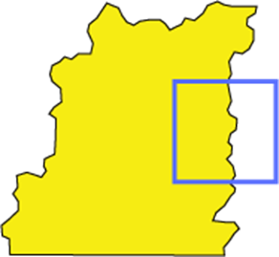
Figure 39. The Sheet Location within Entity key
The sheet location with entity key shows where the parent map sheet is located within the entity to which it belongs.

Legal boundary changes from the State of Georgia are the exception: a state statute requires participants to include acreage, and the Census requests that the respondent includes an authorization number.
Entity refers to any local governmental unit, e.g. a county, incorporated place, or minor civil division.
Within the scope of BAS, the terms ‘map’ and ‘map sheet’ have the same meaning, and they are used interchangeably throughout this document.

