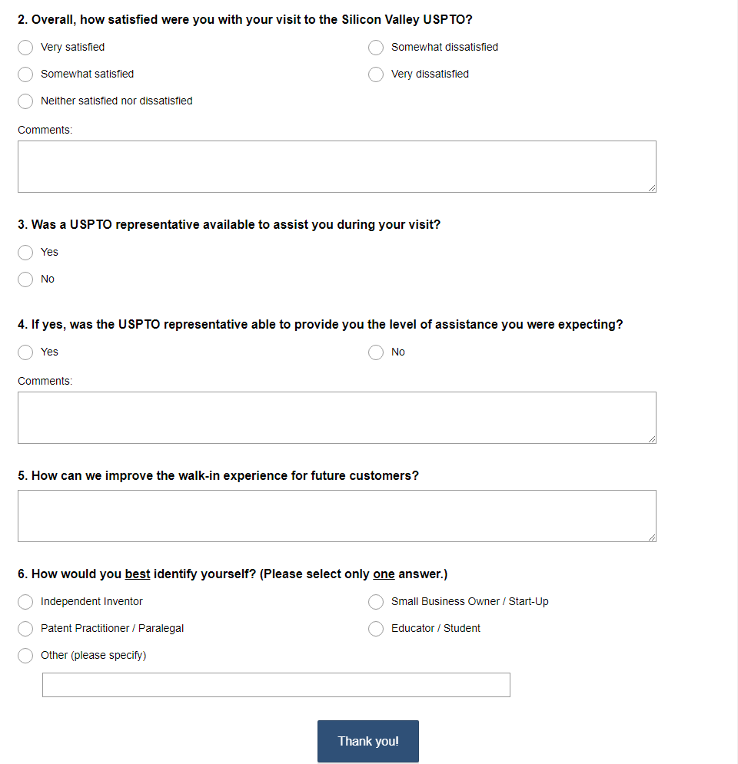
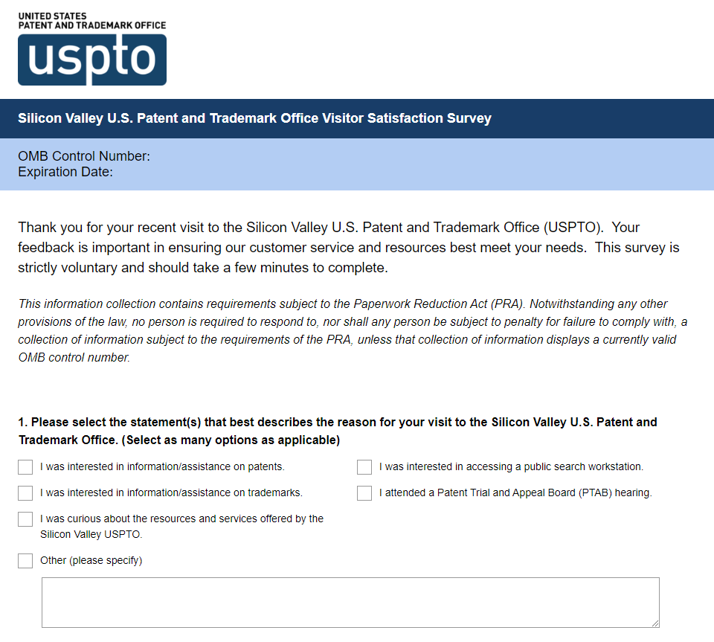

The United States Patent and Trademark Office (USPTO) is conducting this survey to gather feedback about the USPTO Silicon Valley office. This survey is strictly voluntary, includes 6 questions and should take approximately 5 minutes to complete. This information collection contains requirements subject to the Paperwork Reduction Act (PRA). Notwithstanding any other provisions of the law, no person is required to respond to, nor shall any person be subject to penalty for failure to comply with, a collection of information subject to the requirements of the PRA, unless that collection of information displays a currently valid OMB control number.

