United States Patent and Trademark Office
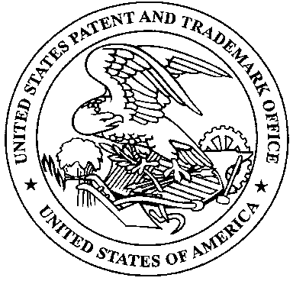
Commissioner for Patents
United States Patent and Trademark Office
P.O. Box 1450
Alexandria, VA 22313-1450
www.uspto.gov

Pro Se Survey Participation Request

The Pro Se Pilot, which includes the Pro Se Assistance Program and the Pro Se Art Unit, were established in 2014 in response to a White House Executive Action to provide more assistance to unrepresented applicants. One evaluation metric to assess the effectiveness of the pilot program is this survey of applicants who filed a non-provisional utility patent application without legal representation. If you are an attorney, there is a survey question directed to you also, and we are interested in your feedback as well.

By volunteering your time and providing feedback regarding your experiences with the United States Patent and Trademark Office (USPTO) patenting process and any assistance you received from the USPTO, you are instrumental in assisting the USPTO with monitoring and improving patent performance of pro se inventors and the examiners that work with them.

Your voluntary response will be combined with all other responses and analyzed in aggregated format only. The survey is designed to measure your opinion about the services that the USPTO provides for you as an applicant filing without legal representation. The results from this voluntary survey will assist us in guiding improvements and enhancements in the future.
The survey should take no more than 10 minutes to complete. For general questions regarding the purpose of the survey, contact Darnell Jayne (darnell.jayne@uspto.gov). If you encounter any problems with the survey instrument, contact Michael Easdale (michael.easdale@uspto.gov).

Link to Survey: [enter unique link]
For control group: https://www.surveymonkey.com/r/ProSe2019CTR
For pilot group: https://www.surveymonkey.com/r/ProSe2019PLT

If you have provided an email address in your patent application, you will receive email notification of this survey as well.

You may also contact the USPTO by telephone at ###-###-#### or by email at ProSeSurvey@uspto.gov, if you would like a USPTO representative to call you and administer the survey verbally over the phone.

