OMB Control Number 0651-0080
Expiration Date: 09/30/2021
System Usability Scale
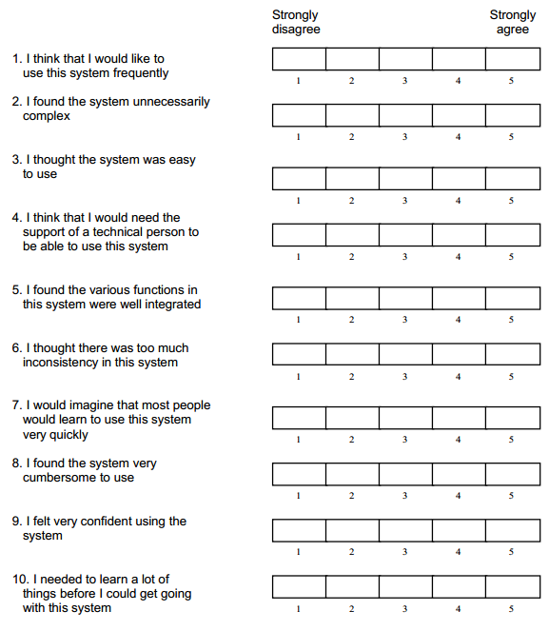
Additional information, including scoring, may be retrieved from: http://hell.meiert.org/core/pdf/sus.pdf

This information collection contains requirements subject to the Paperwork Reduction Act (PRA). Notwithstanding any other provisions of the law, no person is required to respond to, nor shall any person be subject to penalty for failure to comply with, a collection of information subject to the requirements of the PRA, unless that collection of information displays a currently valid OMB Control Number. The estimated response time for this collection is two hours. The response time includes the time for reviewing instructions, searching existing data sources, gathering and maintaining the data needed, and completing and reviewing the collection of information.

