Attachment 5 – FMS Host Site Module

Fellowship Management System (FMS)

FMS Host Site Module | 2014
Public Health Associate Program (PHAP) Host Site Example

Privacy Act and Public Burden Information
Privacy Act Information
The Privacy Act applies to this information collection. Information collected will be kept private as noted in the System of Records Notice is 09-20-0112, Fellowship Program and Guest Researcher Records.

Public Burden Information
Form Approved
OMB No. 0920-0765
Exp. Date 04/30/2018

Public reporting burden of this collection of information takes an estimated average of 90 minutes per response, including the time for reviewing instructions, searching existing data sources, gathering and maintaining the data needed, and completing and reviewing the collection of information. An agency may not conduct or sponsor, and a person is not required to respond to a collection of information unless it displays a currently valid OMB control number. Send comments regarding this burden estimate or any other aspect of this collection of information, including suggestions for reducing this burden to CDC/ATSDR Reports Clearance Officer; 1600 Clifton Road NE, MS D-74, Atlanta, Georgia 30333; ATTN: PRA (0920-0765).

Table of Contents
1 Introduction 1
1.1 Document Structure 1
2 Login and Registration Pages 3
2.1 Login Page 3
2.2 Registration Page (For New Users) 4
2.2.1 Additional Fields for Specific Types of Public Health Agency 5
2.3 Forgot Your E-mail? Page 9
2.4 Forgot Your Password? Page 10
2.5 Reset Password Page 11
3 Application Home Page 12
4 Application Instructions page 13
4.1 Application Instructions 13
5 Application Status Page 15
5.1 Application Status Page 15
5.2 Track Your Application Page 15
5.3 Application Submission Section 16
5.4 Application Withdrawal Section 16
6 My Profile Page 17
6.1 My Profile Section 17
7 Public Health Agency Details Page 18
7.1 Contact Information Section 18
7.2 Description Section 20
7.3 Partnerships Section 21
8 Public Health Agency Statement Page 22
8.1 Public Health Agency Statement Section 22
9 Assignment Details Page 23
9.1 Assignment Details Home Page 23
9.2 Program Information Section 24
9.3 Activities Section 27
9.3.1 Competencies Sub-Section for Both Year 1 and 2 29
9.4 Special Requirements 33
9.5 Planned Trainings 34
9.6 Supervisor Section 35
10 Appendix A – E-mails 39
10.1 Applicant Registration Confirmation 39
10.2 Applicant Reset Password Information 39
10.3 Application Submission Confirmation 40
11 Appendix B – Example Agreement to Detail 41
12 Appendix C – List Of Values 46

Introduction
The purpose of this document is to list all the data elements of the host site application collected online through the Fellowship Management System (FMS). The FMS online host site assignment module is a streamlined mechanism for agencies, who are interested in hosting fellows of the Centers for Disease Control and Prevention (CDC) fellowships to submit their assignment proposals online and track statuses of the application processes. The FMS is a robust flexible framework and is successfully tailored for various CDC fellowships. The following fellowships use the FMS Host Site Application module to collect applications from federal and non-federal public health agencies and organizations:
- Epidemic Intelligence Service (EIS)
- Public Health Associate Program (PHAP)
- Preventive Medicine Residency and Fellowship (PMR/F)
The following fellowships currently use the FMS Host Site Application module only to collect host site applications from federal agencies (e.g., placements within the CDC). They currently do not collect applications from nonfederal agencies.
- Public Health Informatics Fellowship (PHIF)
- CDC-Hubert Global Health Fellowship (Hubert)
The CDC Epidemiology Elective Program for senior medical and veterinary students (Epi-Elect) and Prevention Effectiveness Fellowship (PEF) currently do not use the FMS Host Site Application module to collect applications from federal host sites (i.e., CDC).

Document Structure
This document is broken down by the major pages of the FMS Host Site Application. In this document, each page of the FMS Host Site Application has sections and some sub-sections. In addition, application instructions, login, and registration pages are included. Appendix A provides examples of emails generated by the FMS for the PHAP host site application and Appendix B is an example of agreement with CDC to detail staff to host sites. The instructions and emails provided in this document are examples from PHAP; instructions and emails in the FMS Host Site Application are tailored to each CDC fellowship’s requirements, eligibility criteria, information, and timeline.

The main screenshots of the Host Site Application pages, sections, or subsections are from PHAP with additional screenshots of additional data elements collected by other CDC fellowships.

Following the screenshots in each section is a table that shows the status of the collection of data elements by each CDC fellowships. The following labels indicate the status of the collection:

- “Yes” indicates that the fellowship collects the information and that applicants are required to submit this information.
- “Opt” indicates that the fellowship collects the information and that it is optional for applicants to submit this information.
- “-” indicates that the fellowship does not collect this information.

In addition, the table shows the data values of each data element, and for ones that have a list of dropdown values, the data value category is hyperlinked to its list located in Appendix C.

The following table (Table 1.1-a) provides an overview of the major pages and sections in the FMS Host Site Application module used by each fellowship program. The “Yes” indicates that the fellowship uses the page or section, whereas, the “-” indicates that the fellowship does not use the page or section.

Table 1.1-a. FMS Host Site Application Page and Section used by Fellowship Programs
Section | EIS | PHIF | Hubert | Epi-Elect | PEF | PMR/F | PHAP
Login Page | Yes | Yes | Yes | - | - | Yes | Yes
Registration Page | Yes | Yes | Yes | - | - | Yes | Yes
Forgot Email Page | Yes | Yes | Yes | - | - | Yes | Yes
Forgot Password Page | Yes | Yes | Yes | - | - | Yes | Yes
Application Instructions Page | Yes | Yes | Yes | - | - | Yes | Yes
Application Status Page | Yes | Yes | Yes | - | - | Yes | Yes
Application Submission Section | Yes | Yes | Yes | - | - | Yes | Yes
Application Withdrawal Section | Yes | Yes | Yes | - | - | Yes | Yes
Track Your Application Section | Yes | Yes | Yes | - | - | Yes | Yes
My Profile Page | Yes | Yes | Yes | - | - | Yes | Yes
Public Health Agency Details Page | Yes | Yes | - | - | - | Yes | Yes
Contact Information | Yes | Yes | Yes | - | - | Yes | Yes
Description Section | Yes | Yes | Yes | - | - | Yes | -
Partnerships Section | - | Yes | - | - | - | - | -
Public Health Agency Statement Page | Yes | Yes | Yes | - | - | Yes | Yes
Assignment Details Page | Yes | Yes | Yes | - | - | Yes | Yes
Program Information Section | Yes | Yes | Yes | - | - | Yes | Yes
Specific Types of Agencies | Yes | Yes | Yes | - | - | Yes | Yes
Activities Section | Yes | Yes | Yes | - | - | Yes | Yes
Competencies Sub-Section | Yes | Yes | - | - | - | Yes | -
Special Requirements | Yes | Yes | Yes | - | - | Yes | Yes
Planned Trainings | Yes | Yes | - | - | - | Yes | -
Supervisor Section | Yes | Yes | Yes | - | - | Yes | Yes

Login and Registration Pages

Login Page

Figure 2.1-a. Login Page
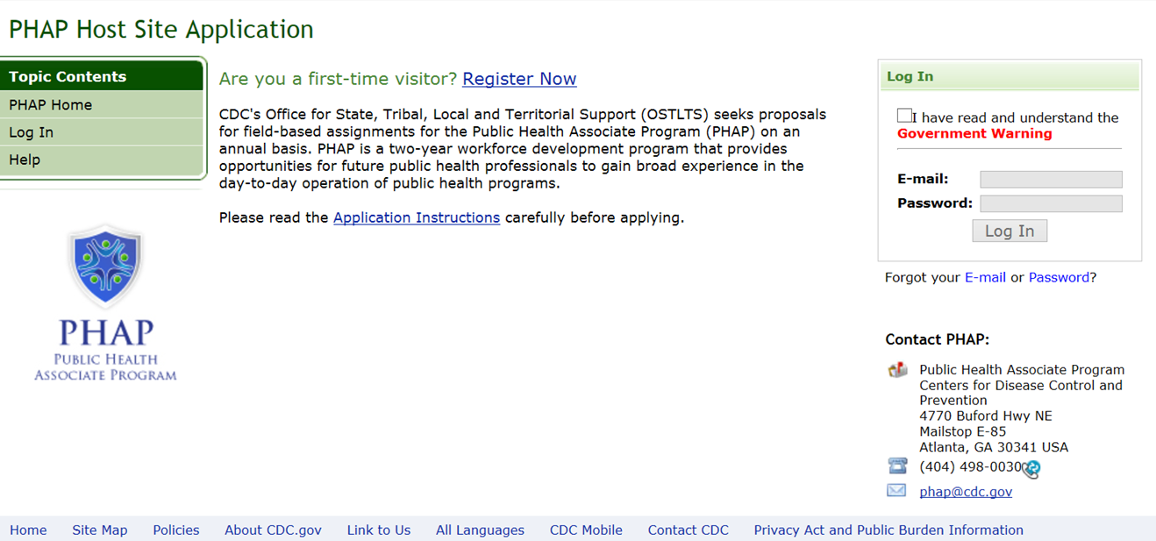

Figure 2.1-b. Privacy Act and Public Burden Information
Privacy Act and Public Burden Information
Privacy Act Information
The Privacy Act applies to this information collection. Information collected will be kept private as noted in the System of Records Notice is 09-20-0112, Fellowship Program and Guest Researcher Records.

Public Burden Information
Form Approved
OMB No. 0920-0765
Exp. Date 04/30/2018

Public reporting burden of this collection of information takes an estimated average of 90 minutes per response, including the time for reviewing instructions, searching existing data sources, gathering and maintaining the data needed, and completing and reviewing the collection of information. An agency may not conduct or sponsor, and a person is not required to respond to a collection of information unless it displays a currently valid OMB control number. Send comments regarding this burden estimate or any other aspect of this collection of information, including suggestions for reducing this burden to CDC/ATSDR Reports Clearance Officer; 1600 Clifton Road NE, MS D-74, Atlanta, Georgia 30333; ATTN: PRA (0920-0765).

Table 2.1-a. Login Page Data Elements
Data Elements | Data Values | EIS | PHIF | Hubert | Epi-Elect | PEF | PMR/F | PHAP
Government Warning | Checkbox | Yes | Yes | Yes | - | - | Yes | Yes
E-Mail | Alphanumeric | Yes | Yes | Yes | - | - | Yes | Yes
Password | Alphanumeric | Yes | Yes | Yes | - | - | Yes | Yes

Registration Page (For New Users)
Figure 2.2-a. Registration Page
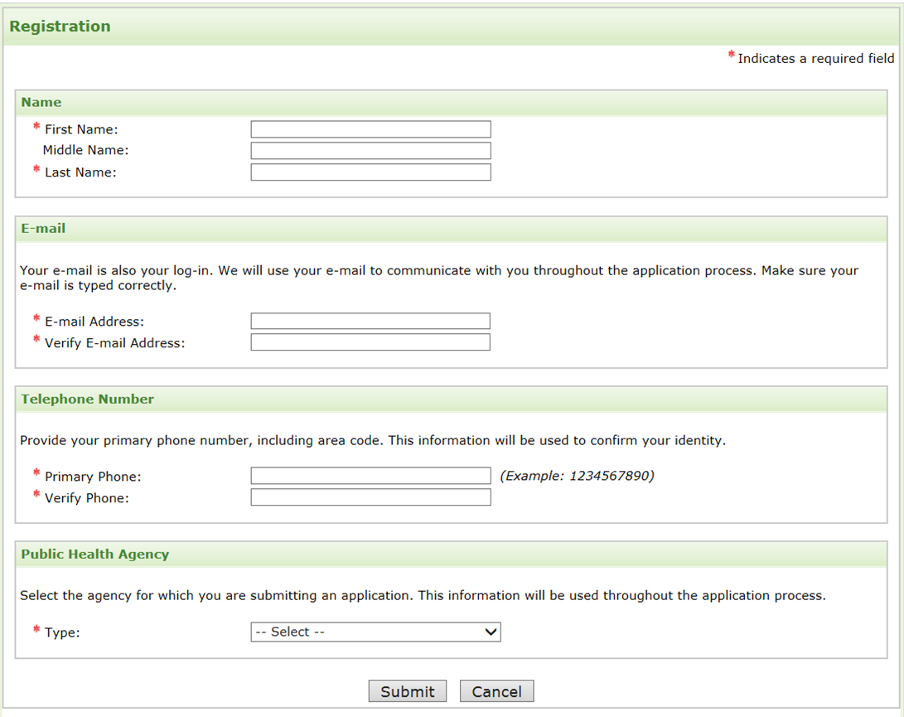

Figure 2.2-b. Registration Successful

Table 2.2-a. Registration Page Data Elements
Data Elements | Data Values | EIS | PHIF | Hubert | Epi-Elect | PEF | PMR/F | PHAP
First Name | Text | Yes | Yes | Yes | - | - | Yes | Yes
Middle Name | Text | Opt | Opt | Opt | - | - | Opt | Opt
Last Name | Text | Yes | Yes | Yes | - | - | Yes | Yes
E-mail Address | Alphanumeric | Yes | Yes | Yes | - | - | Yes | Yes
Verify E-mail Address | Alphanumeric | Yes | Yes | Yes | - | - | Yes | Yes
Primary Phone | Numeric | Yes | Yes | Yes | - | - | Yes | Yes
Verify Phone | Numeric | Yes | Yes | Yes | - | - | Yes | Yes
Public Health Agency Type | Agency Types | Yes | Yes | Yes | - | - | Yes | Yes

Additional Fields for Specific Types of Public Health Agency

Figure 2.2-c. Public Health Agency: CDC
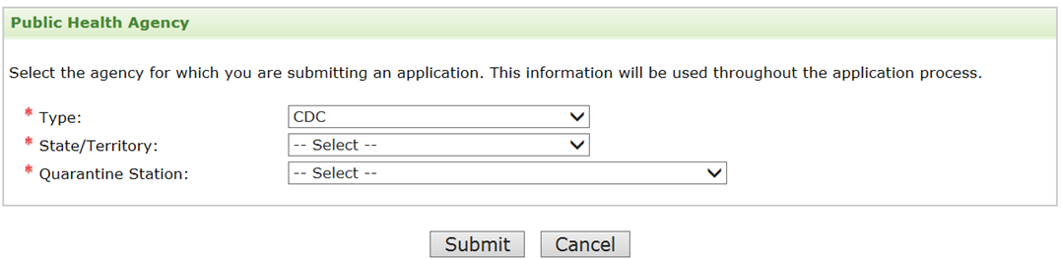

Figure 2.2-d. Public Health Agency: Other Federal Government
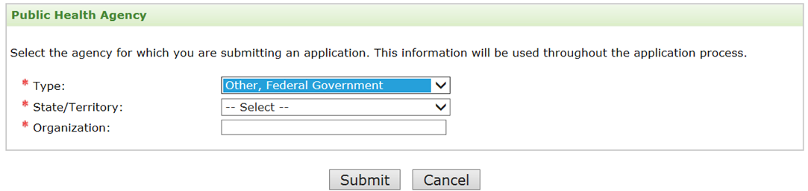

Figure 2.2-e. Public Health Agency: State
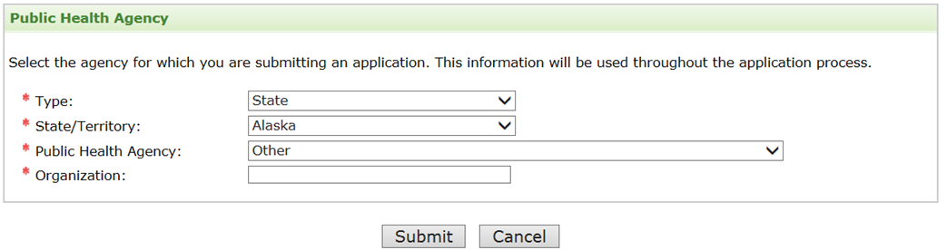
Figure 2.2-f. Public Health Agency: Local
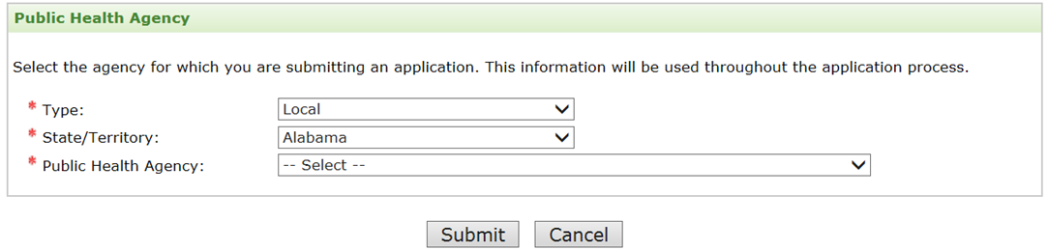

Figure 2.2-g. Public Health Agency: Territorial
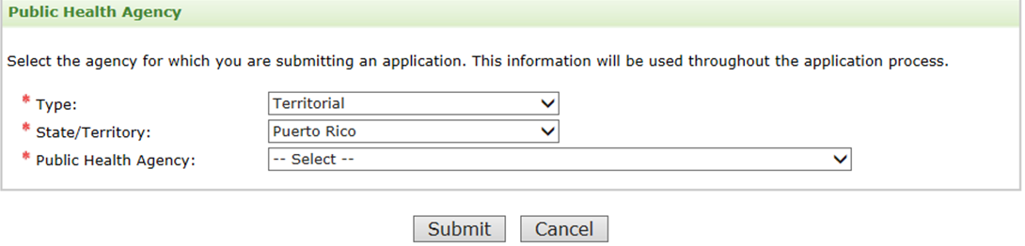

Figure 2.2-h. Public Health Agency: Tribal
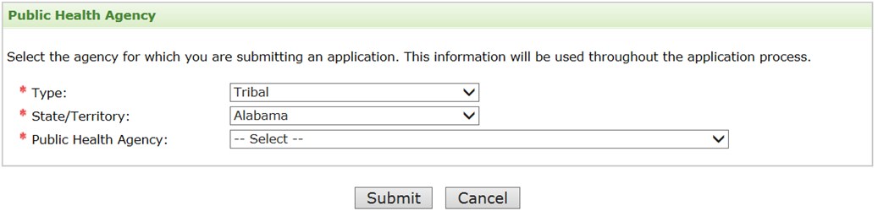

Figure 2.2-i. Public Health Agency: Other
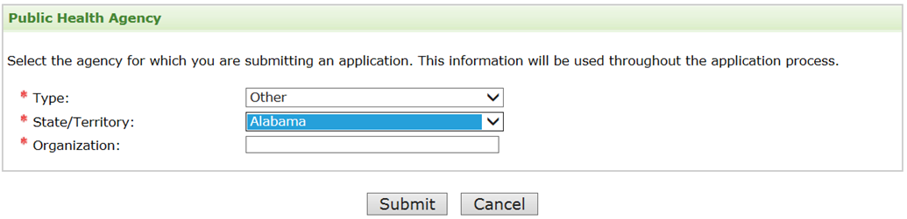

Figure 2.2-j. Public Health Agency: Community-based Organization
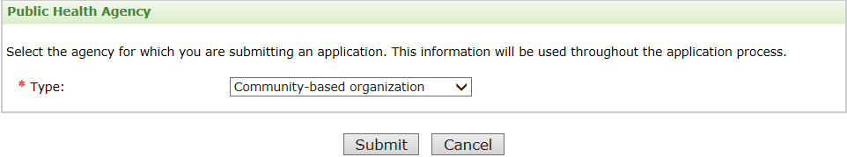
Figure 2.2-k. Public Health Agency: Indian Health Service area offices
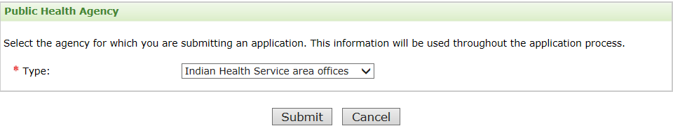

Figure 2.2-l. Public Health Agency: University or other academia
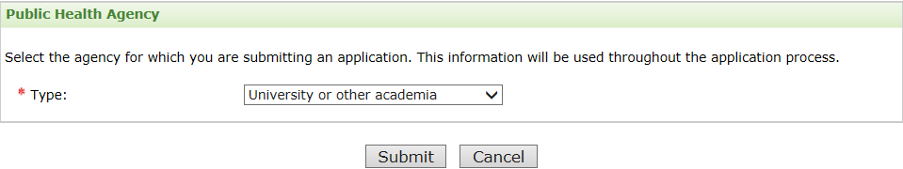

Figure 2.2-m. Public Health Agency: Private public health organization
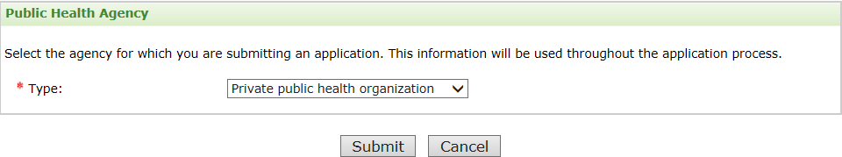

Table 2.2-b. Public Health Agency Section Data Elements
Data Elements | Data Values | EIS | PHIF | Hubert | Epi-Elect | PEF | PMR/F | PHAP
State/Territory | States | Yes | Yes | - | - | - | Yes | Yes
CDC Quarantine Station | CDC Quarantine Stations | Yes | Yes | - | - | - | Yes | Yes
Public Health Agency | Public Health Agencies | Yes | Yes | Yes | - | - | Yes | Yes
Organization | Text | Yes | Yes | - | - | - | Yes | Yes
Country | Countries | - | Yes | Yes | - | - | - | -

Forgot Your E-mail? Page

Figure 2.3-a. Forgot your Email? Contact Information
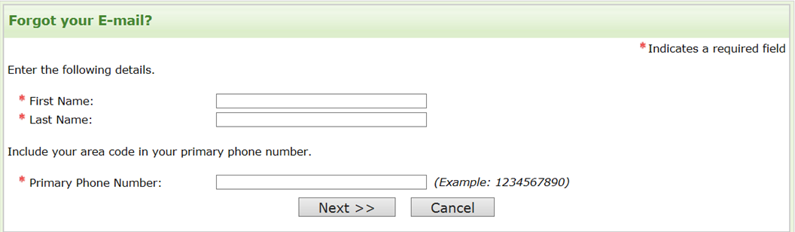

Figure 2.3-b. Forgot your Email? Secret Question
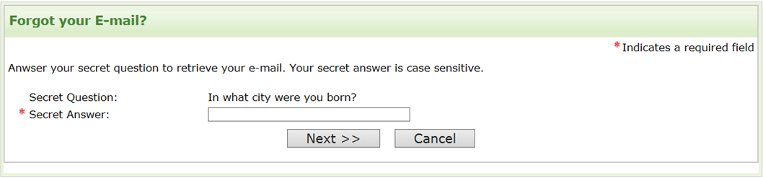

Figure 2.3-c. Forgot your Email? Email Display

Table 2.3-a. Forgot your E-mail? Page Data Elements
Data Elements | Data Values | EIS | PHIF | Hubert | Epi-Elect | PEF | PMR/F | PHAP
First Name | Text | Yes | Yes | Yes | - | - | Yes | Yes
Last Name | Text | Yes | Yes | Yes | - | - | Yes | Yes
Primary Phone | Numeric | Yes | Yes | Yes | - | - | Yes | Yes
Secret Question | Selected Secret Question | Yes | Yes | Yes | - | - | Yes | Yes
Secret Answer | Alphanumeric | Yes | Yes | Yes | - | - | Yes | Yes

Forgot Your Password? Page

Figure 2.4-a. Forgot your Password? Contact Information
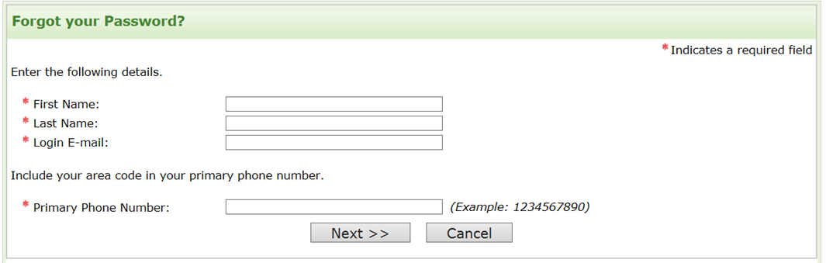

Figure 2.4-b. Forgot your Password? Secret Question
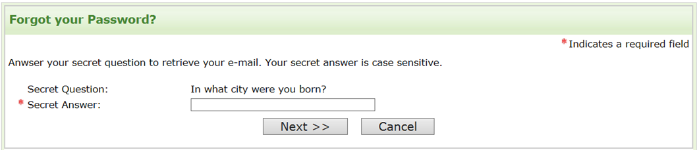

Figure 2.4-c. Forgot your Password? New Password
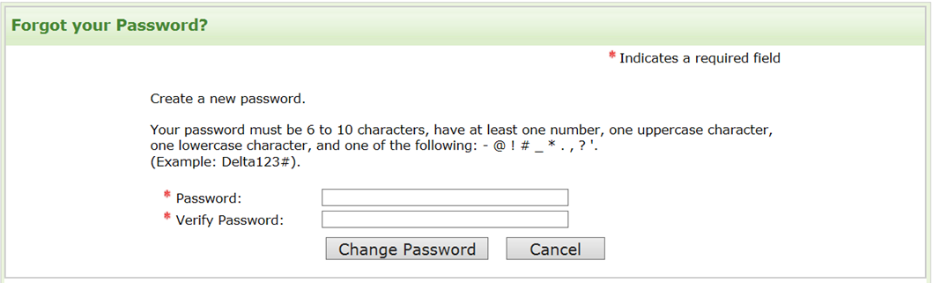

Figure 2.4-d. Forgot your Password? Password Changed

Table 2.4-a. Forgot your Password Page Data Elements
Data Elements | Data Values | EIS | PHIF | Hubert | Epi-Elect | PEF | PMR/F | PHAP
First Name | Text | Yes | Yes | Yes | - | - | Yes | Yes
Last Name | Text | Yes | Yes | Yes | - | - | Yes | Yes
Login E-mail | Alphanumeric | Yes | Yes | Yes | - | - | Yes | Yes
Primary Phone | Numeric | Yes | Yes | Yes | - | - | Yes | Yes
Secret Question | Selected Secret Question | Yes | Yes | Yes | - | - | Yes | Yes
Secret Answer | Alphanumeric | Yes | Yes | Yes | - | - | Yes | Yes
New Password | Alphanumeric | Yes | Yes | Yes | - | - | Yes | Yes
Verify Password | Alphanumeric | Yes | Yes | Yes | - | - | Yes | Yes

Reset Password Page

Figure 2.5-a. Reset Password
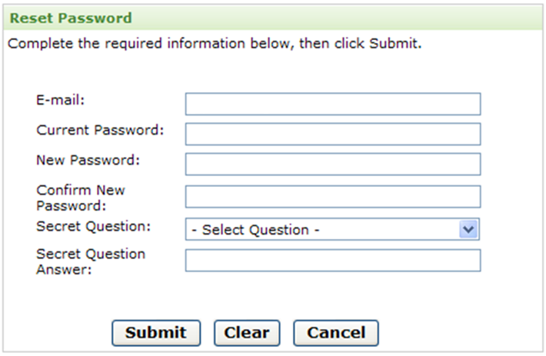

Table 2.5-a. Reset Password Data Elements
Data Elements | Data Values | EIS | PHIF | Hubert | Epi-Elect | PEF | PMR/F | PHAP
E-mail | Alphanumeric | Yes | Yes | Yes | - | - | Yes | Yes
Current Password | Alphanumeric | Yes | Yes | Yes | - | - | Yes | Yes
New Password | Alphanumeric | Yes | Yes | Yes | - | - | Yes | Yes
Verify Password | Alphanumeric | Yes | Yes | Yes | - | - | Yes | Yes
Secret Question | Secret Questions | Yes | Yes | Yes | - | - | Yes | Yes
Secret Answer | Alphanumeric | Yes | Yes | Yes | - | - | Yes | Yes

Application Home Page
Figure 2.5-a. Home Page
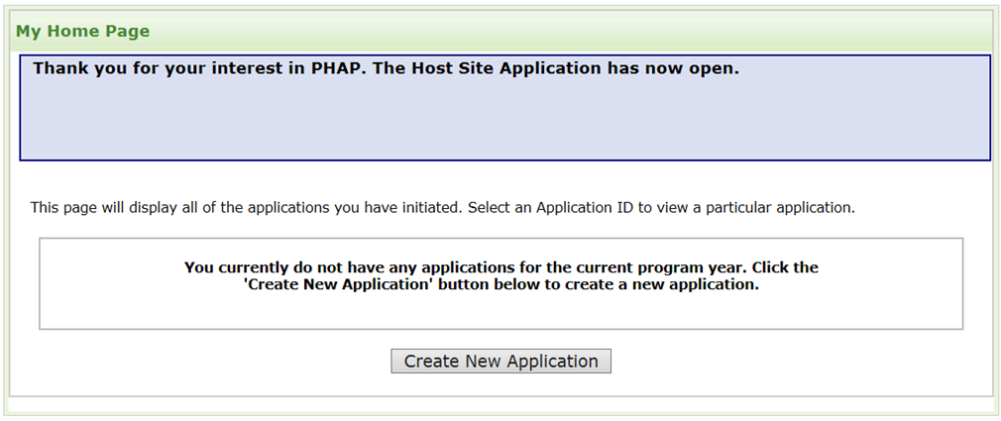

Figure 2.5-b. Create New Application
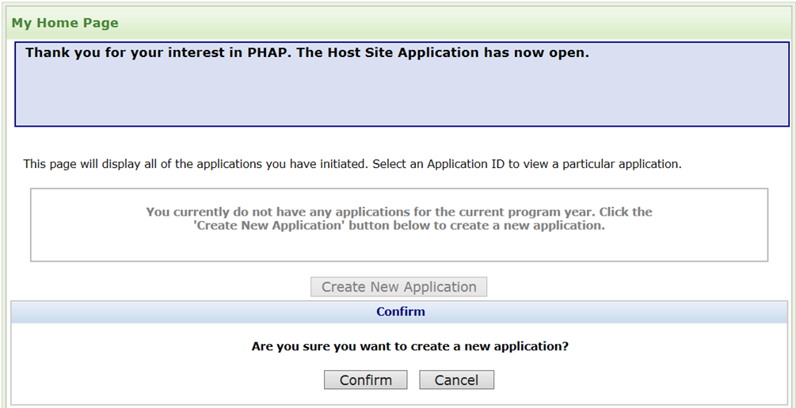

Figure 2.5-c. Home Page Application Submitted
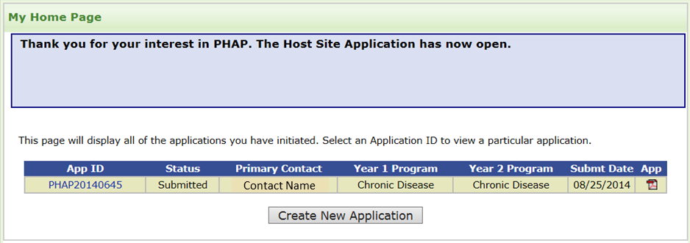

Application Instructions page

Application Instructions
Figure 4.1-a. Application Eligibility and Finalization Example from PHAP*
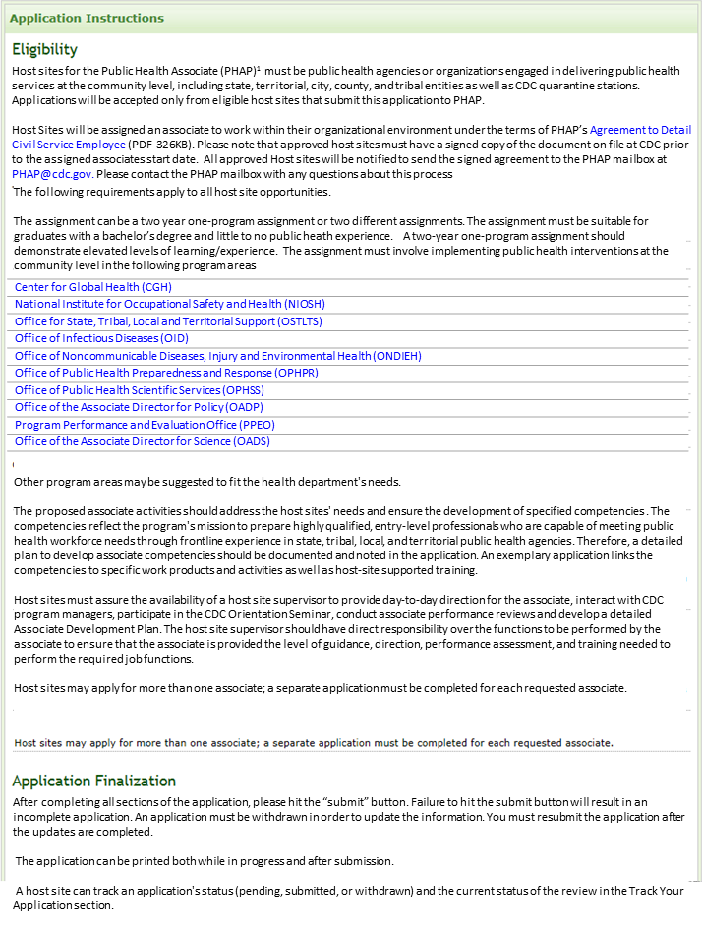
*Note: Instructions and information are tailored to each fellowship program’s information.

Figure 4.1-b. Application Submission and Evaluation Criteria Example from PHAP*
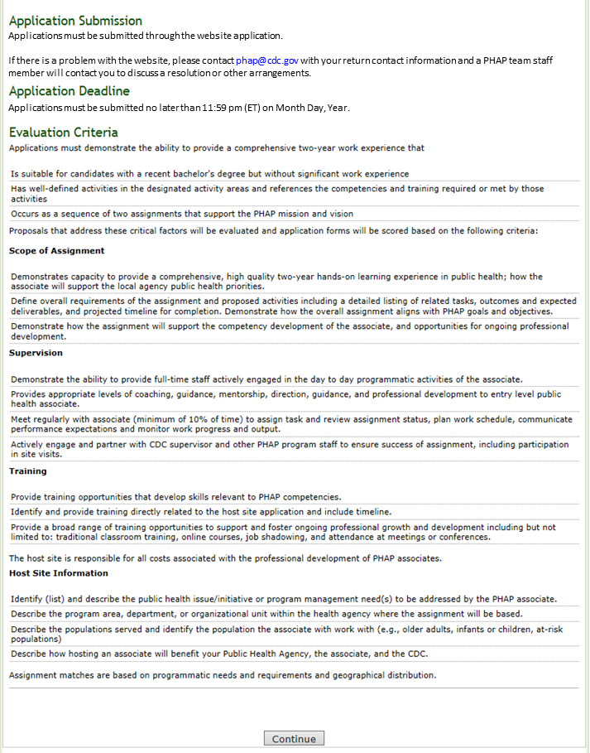
*Note: Instructions and information are tailored to each fellowship program’s information.

Application Status Page

Application Status Page
Figure 5.1-a. Application Status Page
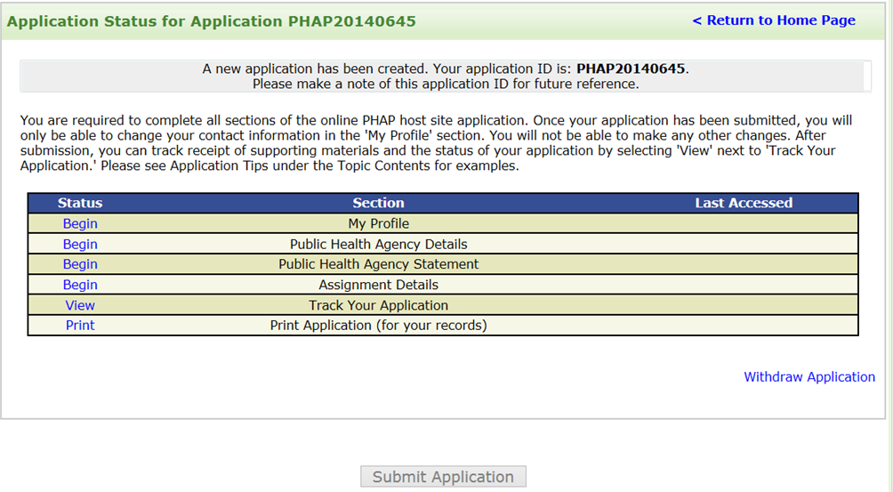

Track Your Application Page
Figure 5.2-a. Track Your Application Page
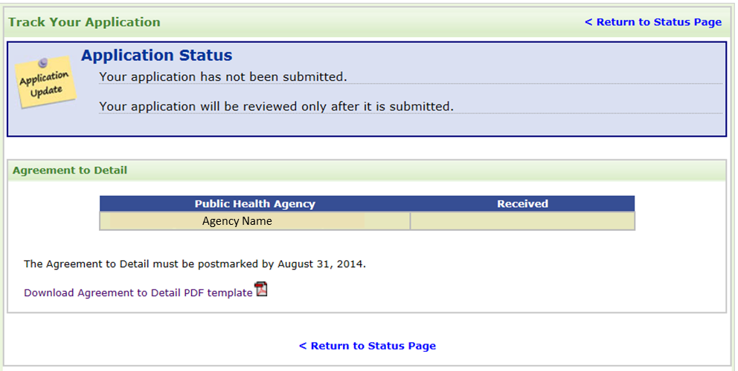

Application Submission Section

Figure 5.3-a. Submit Confirmation

Figure 5.3-b. Application Certification
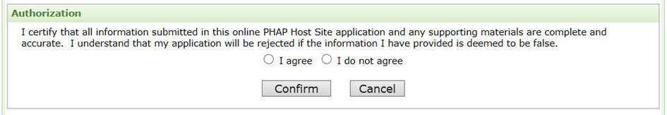

Table 5.3-a. Application Submission Section Data Elements
Data Elements | Data Values | EIS | PHIF | Hubert | Epi-Elect | PEF | PMR/F | PHAP
Submit Application | Submit Button | Yes | Yes | Yes | - | - | Yes | Yes
Application Certification | I agree/ do not agree | Yes | Yes | Yes | - | - | Yes | Yes

Application Withdrawal Section

Figure 5.4-a. Withdraw Application*
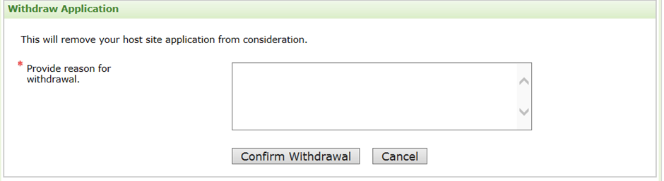
*Note: Only collected from applicants who wish to withdraw their applications.

Table 5.4-a. Application Withdrawal Section Data Elements
Data Elements | Data Values | EIS | PHIF | Hubert | Epi-Elect | PEF | PMR/F | PHAP
Reasons for Withdrawal | Text | Yes | Yes | Yes | - | - | Yes | Yes

My Profile Page

My Profile Section

Figure 6.1-a. My Profile Section
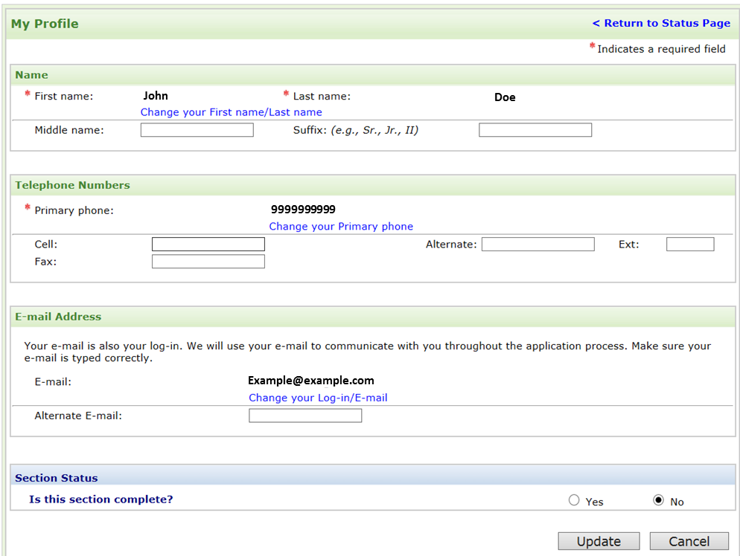

Table 6.1-a. My Profile Section Data Elements
Data Elements | Data Values | EIS | PHIF | Hubert | Epi-Elect | PEF | PMR/F | PHAP
First Name | Already Populated | Yes | Yes | Yes | - | - | Yes | Yes
Last Name | Already Populated | Yes | Yes | Yes | - | - | Yes | Yes
Middle Name | Text | Opt | Opt | Opt | - | - | Opt | Opt
Suffix | Text | Opt | Opt | Opt | - | - | Opt | Opt
Primary Phone | Already Populated | Yes | Yes | Yes | - | - | Yes | Yes
Cell Phone | Numeric | Opt | Opt | Opt | - | - | Opt | Opt
Alternate Phone | Numeric | Opt | Opt | Opt | - | - | Opt | Opt
Extension | Numeric | Opt | Opt | Opt | - | - | Opt | Opt
Fax Number | Numeric | Opt | Opt | Opt | - | - | Opt | Opt
E-mail | Already Populated | Yes | Yes | Yes | - | - | Yes | Yes
Alternate E-mail | Alphanumeric | Opt | Opt | Opt | - | - | Opt | Opt
Section Complete | Yes/No Choice | Yes | Yes | Yes | - | - | Yes | Yes

Public Health Agency Details Page

Contact Information Section

Figure 7.1-a. Contact Information*
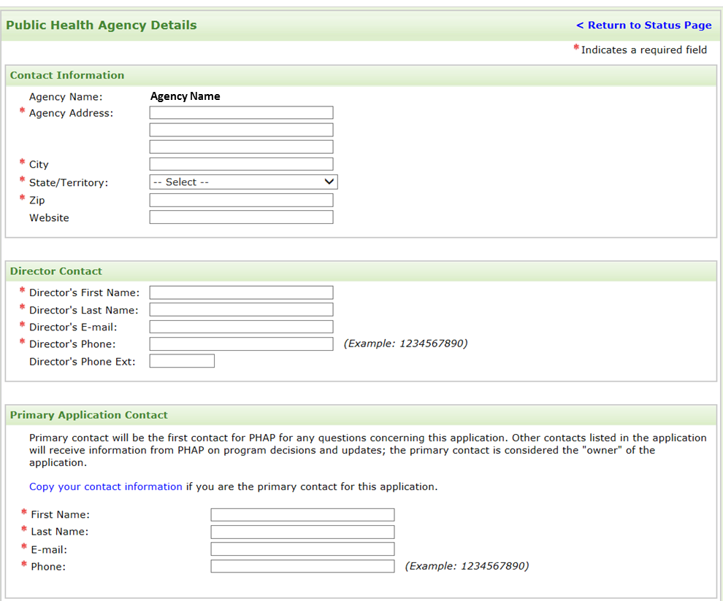
*Note: Primary Application Contact Data Elements are only collected if the primary contact differs from account holder.

Table 7.1-a. Contact Information Section Data Elements
Data Elements | Data Values | EIS | PHIF | Hubert | Epi-Elect | PEF | PMR/F | PHAP
Agency Name | Already Populated | Yes | Yes | Yes | - | - | Yes | Yes
Agency Address Line 1 | Text | Yes | Yes | - | - | - | Yes | Yes
Agency Address Line 2 | Text | Opt | Opt | - | - | - | Opt | Opt
Agency Address Line 3 | Text | Opt | Opt | - | - | - | Opt | Opt
State/Province | States | Yes | Yes | - | - | - | Yes | Yes
City | Text | Yes | Yes | - | - | - | Yes | Yes
Zip | Numeric | Yes | Yes | - | - | - | Yes | Yes
Website | Text | Opt | Opt | - | - | - | Opt | Opt
Director’s First Name | Text | Yes | Yes | - | - | - | Yes | Yes
Director’s Last Name | Text | Yes | Yes | - | - | - | Yes | Yes
Director’s E-mail | Alphanumeric | Yes | Yes | - | - | - | Yes | Yes
Director’s Phone | Numeric | Yes | Yes | - | - | - | Yes | Yes
Director’s Ext | Numeric | Opt | Opt | - | - | - | Opt | Opt
Primary Contact First Name | Text | Yes | Yes | Yes | - | - | Yes | Yes
Primary Contact Last Name | Text | Yes | Yes | Yes | - | - | Yes | Yes
Primary Contact E-mail | Alphanumeric | Yes | Yes | Yes | - | - | Yes | Yes
Primary Contact Phone | Numeric | Yes | Yes | Yes | - | - | Yes | Yes

Description Section

Figure 7.2-a. Description Section
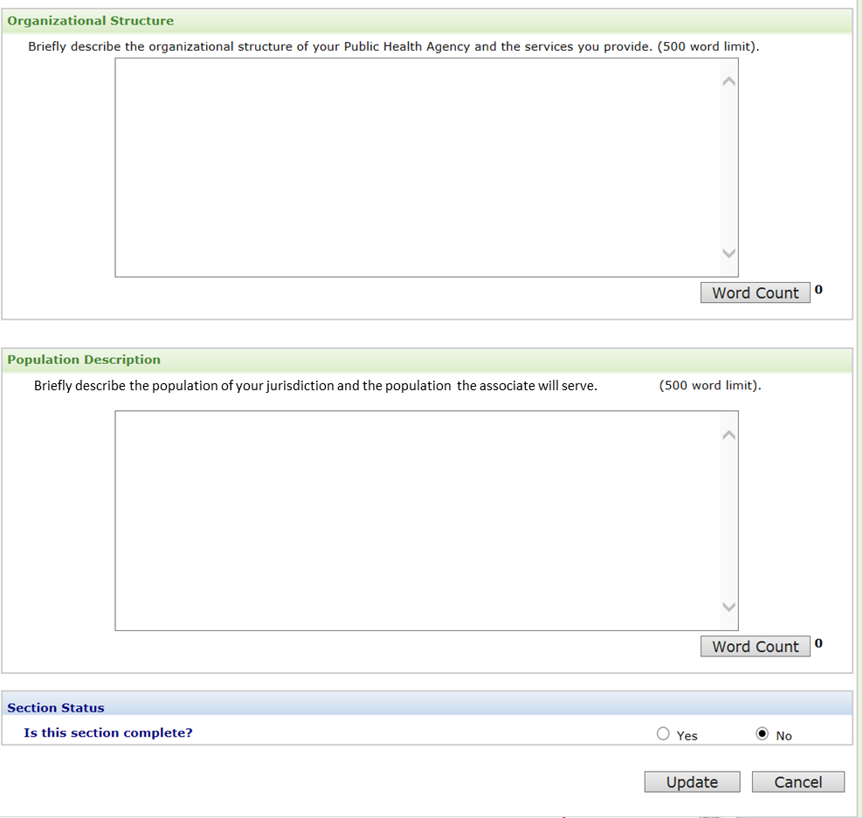

Table 7.2-a. Description Section Data Elements
Data Elements | Data Values | EIS | PHIF | Hubert | Epi-Elect | PEF | PMR/F | PHAP
Organizational Structure | Text (500 words) | Yes | Yes | - | - | - | Yes | Yes
Population Description | Text (500 words) | Yes | Yes | - | - | - | Yes | Yes
Section Complete | Yes/No Choice | Yes | Yes | - | - | - | Yes | Yes

Partnerships Section

Figure 7.3-a. Partnerships Section*
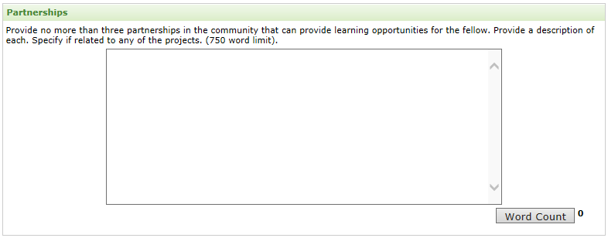
*Note: Only collected by Public Health Informatics Fellowship Program (PHIF).

Table 7.3-a. Partnerships Section Data Elements
Data Elements | Data Values | EIS | PHIF | Hubert | Epi-Elect | PEF | PMR/F | PHAP
Partnership | Text (750 Words) | - | Yes | - | - | - | - | -

Public Health Agency Statement Page

Public Health Agency Statement Section
Figure 8.1-a. Public Health Agency Statement Page
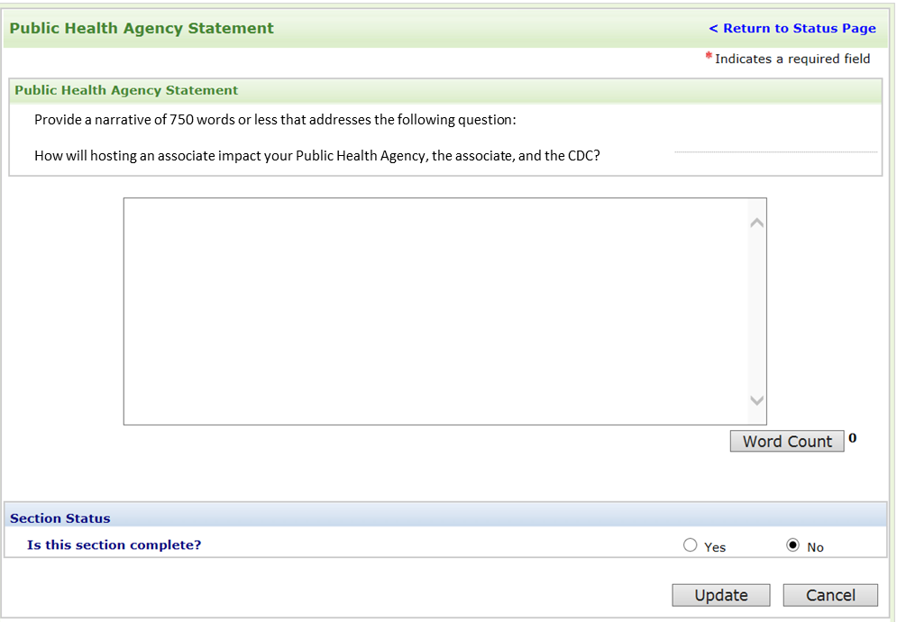

Table 8.1-a. 8.1 Public Health Agency Statement Page Data Elements
Data Elements | Data Values | EIS | PHIF | Hubert | Epi-Elect | PEF | PMR/F | PHAP
Public Health Agency Statement | Text (750 words) | Yes | Yes | - | - | - | Yes | Yes
Section Complete | Yes/No Choice | Yes | Yes | - | - | - | Yes | Yes

Assignment Details Page

Assignment Details Home Page
Figure 9.1-a. Assignment Details Home Page
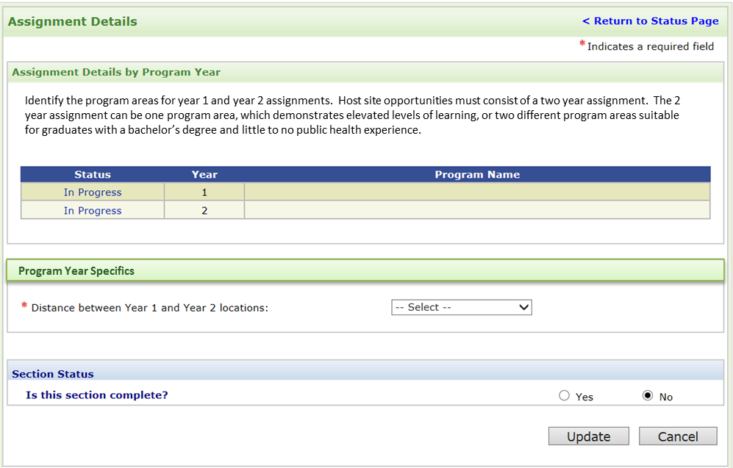

Table 9.1-a. Assignment Details Home Page Data Elements
Data Elements | Data Values | EIS | PHIF | Hubert | Epi-Elect | PEF | PMR/F | PHAP
Distance | Distances | - | - | - | - | - | - | Yes
Section Complete | Yes/No Choice | Yes | Yes | Yes | - | - | Yes | Yes

Program Information Section
Figure 9.2-a. Program Information*
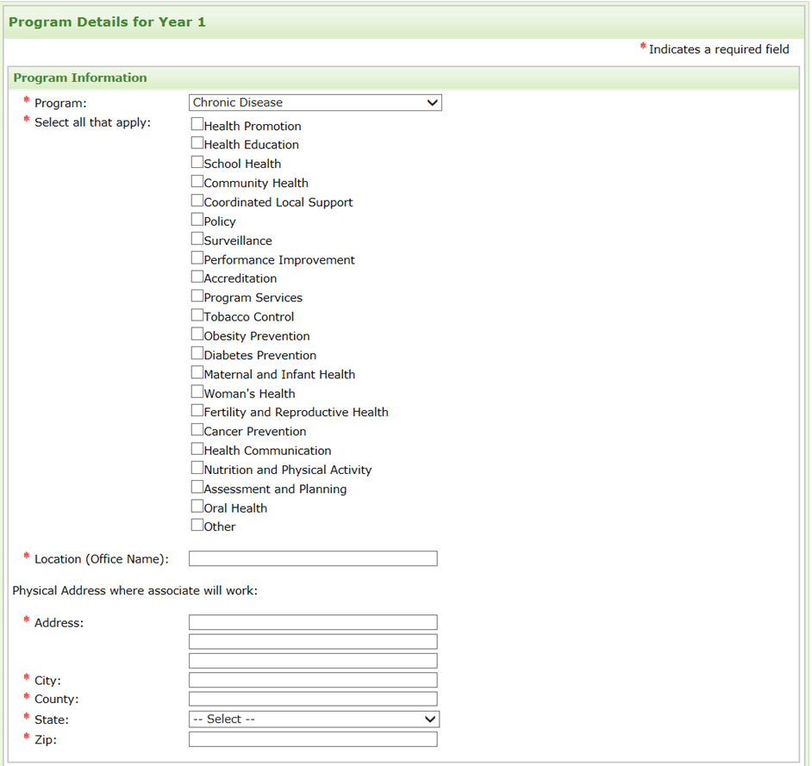
*Note: Same information collected for both year 1 and 2. Only Public Health Associate Program (PHAP) collects year 2 information.

Figure 9.2-b. Additional Position Details*
*Note: Only collected by Public Health Informatics Fellowship (PHIF) program.

Figure 9.2-c. Additional Position Details for EIS*
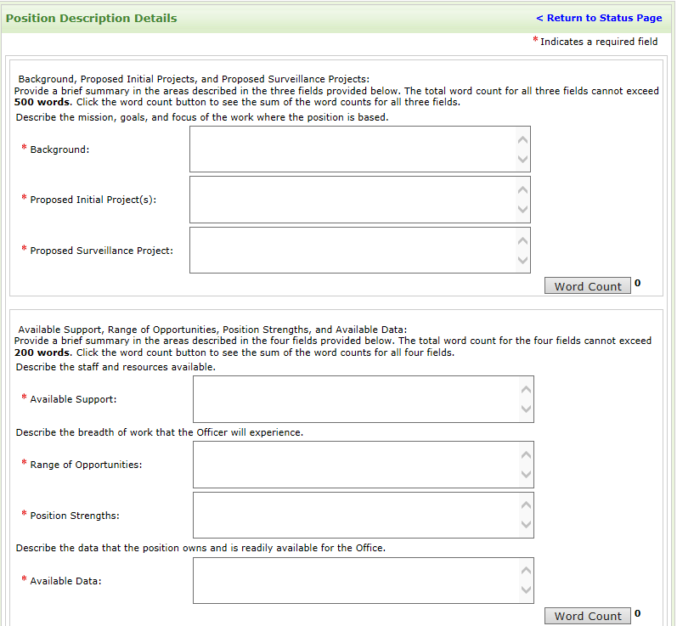
*Note: Only collected by Epidemic Intelligence Service (EIS) program.

Table 9.2-a. Program Information Section Data Elements
Data Elements | Data Values | EIS | PHIF | Hubert | Epi-Elect | PEF | PMR/F | PHAP
Program | Programs | Yes | Yes | - | - | - | Yes | Yes
Program Focus | Topic Domains | Yes | Yes | - | - | - | Yes | Yes
Location (Office Name) | Text | Yes | Yes | - | - | - | Yes | Yes
Physical Address Line 1 | Text | Yes | Yes | - | - | - | Yes | Yes
Physical Address Line 2 | Text | Opt | Opt | - | - | - | Opt | Opt
Physical Address Line 3 | Text | Opt | Opt | - | - | - | Opt | Opt
State | States | Yes | Yes | - | - | - | Yes | Yes
City | Text | Yes | Yes | - | - | - | Yes | Yes
Zip | Numeric | Yes | Yes | - | - | - | Yes | Yes
Countries | Countries | - | Yes | Yes | - | - | - | -
Background of Work | Text (500 words) | Yes | Yes | - | - | - | Yes | -
Proposed Initial Projects | Text (500 words) | Yes | Yes | - | - | - | Yes | -
Proposed Surveillance Projects | Text (500 words) | Yes | - | - | - | - | Yes | -
Available Support | Text (200 Words) | Yes | Yes | - | - | - | Yes | -
Range of Opportunities | Text (200 Words) | Yes | Yes | - | - | - | Yes | -
Position Strengths | Text (200 Words) | Yes | - | - | - | - | Yes | -
Available Data | Text (200 Words) | Yes | - | - | - | - | Yes | -
New or Existing Project | New/Existing Choices | - | - | - | - | - | - | -
Project Phase | Project Phases | - | Yes | - | - | - | - | -
Program Topic Domains | Topic Domains | - |  | - | - | - | - | -
Fellow’s Role | Fellow’s Roles | - | Yes | - | - | - | - | -
Project Title | Text |  | Yes | Yes | - | - | - | -
Fellow Requested Year | Fellow Years | - | - | Yes | - | - | - | -
Fellow Requested Type | Fellow Types | - | - | Yes | - | - | - | -
Project Durations | Number of Weeks | - | - | Yes | - | - | - | -
Project Availability between September and June | Text | - | - | Yes | - | - | - | -
Fellows Required Skills | Text | - | Yes | Yes | - | - | - | -
Project Descriptions | Text | - | Yes | Yes | - | - | - | -
Project Objectives | Text | - | Yes | Yes | - | - | - | -
Project Design | Text | - | - | Yes | - | - | - | -

Activities Section
Figure 9.3-a. Activities Section*
*Note: Same information collected for both year 1 and 2. Only Public Health Associate Program (PHAP) collects year 2 information.

Figure 9.3-b. Activity*
*Note: Same information collected for both year 1 and 2. Only Public Health Associate Program (PHAP) collects year 2 information.

9.3-c. Additional Activities for PHAP*
*Note: Same information collected for both year 1 and 2. Only Public Health Associate Program (PHAP) collects this information and year 2 information.

Figure 9.3-d. Deliverable Timeline for PHAP*
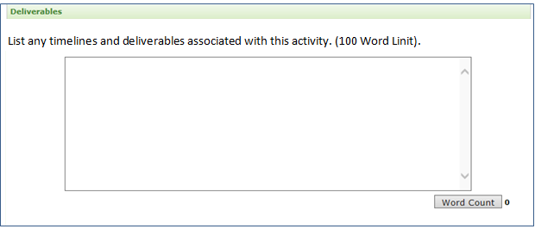
*Note: Same information collected for both year 1 and 2. Only Public Health Associate Program (PHAP) collects this information and year 2 information.

Figure 9.3-e. Deliverables for all other fellowships*
*Note: Public Health Associate Program (PHAP) does not collect this information.

Table 9.3-a. Program Activities Section Data Elements
Data Elements | Data Values | EIS | PHIF | Hubert | Epi-Elect | PEF | PMR/F | PHAP
Activity Description | Text (100 words) | Yes | Yes | Yes | - | - | Yes | Yes
Activity Type | Activity Types | - | - | - | - | - | - | Yes
Deliverable Timeline | Text | - | - | - | - | - | - | Yes
Deliverables | Checkboxes | Yes | Yes | - | - | - | Yes | Yes

Competencies Sub-Section for Both Year 1 and 2

Figure 9.3-f. Competency Categories for PHAP*
*Note: Same information collected for both year 1 and 2. Only Public Health Associate Program (PHAP) collects this information and year 2 information.

Figure 9.3-g. Competencies Categories Sub-Section for all other fellowships

Figure 9.3-h. Analytic Assessment Skills*
*Note: Public Health Associate Program (PHAP) does not collect this detailed information.

Figure 9.3-i. Program Planning Skills*
*Note: Public Health Associate Program (PHAP) does not collect this detailed information.

Figure 9.3-j. Communications Skills*
*Note: Public Health Associate Program (PHAP) does not collect this detailed information.

Figure 9.3-k. Cultural Competency Skills*
*Note: Public Health Associate Program (PHAP) does not collect this detailed information.

Figure 9.3-l. Partnership and Collaboration Skills*
*Note: Public Health Associate Program (PHAP) does not collect this detailed information.

Figure 9.3-m. Public Health Practice and Knowledge Skills*
*Note: Public Health Associate Program (PHAP) does not collect this detailed information.

Figure 9.3-n. Financial Planning Skills*
*Note: Public Health Associate Program (PHAP) does not collect this detailed information.

Figure 9.3-o. Leadership and Systems Thinking Skills*
*Note: Public Health Associate Program (PHAP) does not collect this detailed information.

Table 9.3-b. Competencies Sub-Section Data Elements
Data Elements | Data Values | EIS | PHIF | Hubert | Epi-Elect | PEF | PMR/F | PHAP
Competencies | Checkboxes | - | - | - | - | - | - | Yes
Analytic and Assessment Skills | Checkboxes | Yes | Yes | - | - | - | Yes | -
Program Planning Skills | Checkboxes | Yes | Yes | - | - | - | Yes | -
Communication Skills | Checkboxes | Yes | Yes | - | - | - | Yes | -
Cultural Competency Skills | Checkboxes | Yes | Yes | - | - | - | Yes | -
Partnership and Collaboration Skills | Checkboxes | Yes | Yes | - | - | - | Yes | -
Public Health Practice and Knowledge Skills | Checkboxes | Yes | Yes | - | - | - | Yes | -
Financial Planning Skills | Checkboxes | Yes | Yes | - | - | - | Yes | -
Leadership and Systems Thinking Skills | Checkboxes | Yes | Yes | - | - | - | Yes | -

Special Requirements

Figure 9.4-a. Special Requirements
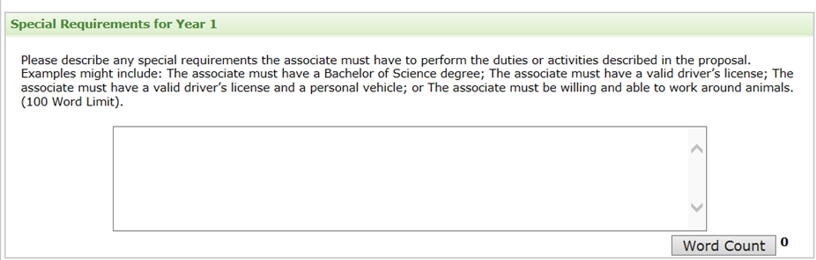

Figure 9.4-b. Specific Special Requirements for PHAP*
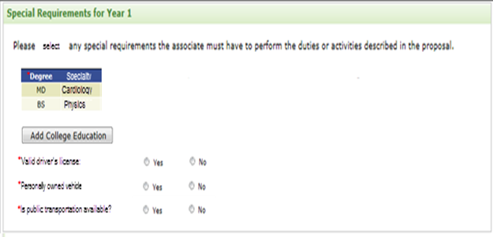
*Note: Same information collected for both year 1 and 2. Only Public Health Associate Program (PHAP) collects this information.

Figure 9.4-c. Language Skills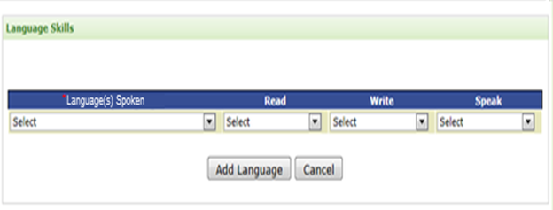

Table 9.4-a. Special Requirements Section Data Elements
Data Elements | Data Values | EIS | PHIF | Hubert | Epi-Elect | PEF | PMR/F | PHAP
Special Requirements | Text | Yes | Yes | Yes | - | - | Yes | Yes
Driver’s License | Yes/No Choice | - | - | - | - | - | - | Yes
Personal Vehicle | Yes/No Choice | - | - | - | - | - | - | Yes
Public Transportation | Yes/No Choice | - | - | - | - | - | - | Yes
College Degree | Degrees | - | - | - | - | - | - | Yes
College Specialty | Text | - | - | - | - | - | - | Yes
Language | Languages | Yes | Yes | Yes | - | - | Yes | Yes
Language - Read | Proficiencies | Opt | Opt | - | - | - | Opt | Yes
Language - Write | Proficiencies | Opt | Opt | - | - | - | Opt | Yes
Language - Speak | Proficiencies | Opt | Opt | - | - | - | Opt | Yes

Planned Trainings

Figure 9.5-a. Planned Trainings*
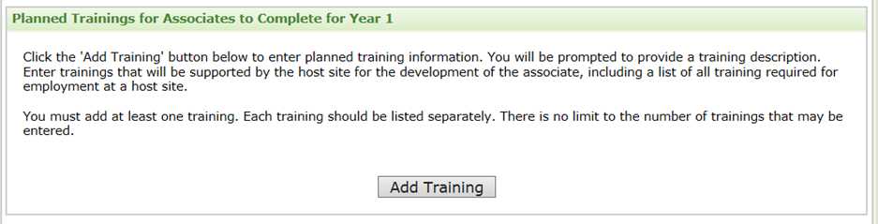
*Note: Same information collected for both year 1 and 2. Only Public Health Associate Program (PHAP) collects year 2 information.

Figure 9.5-b. Training*
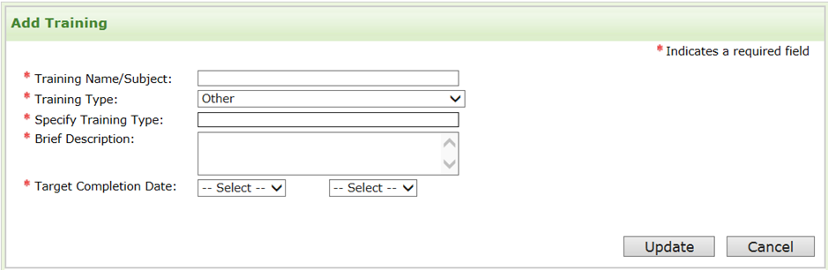
*Note: Same information collected for both year 1 and 2. Only Public Health Associate Program (PHAP) collects year 2 information.

Table 9.5-a. Program Training Section Data Elements
Data Elements | Data Values | EIS | PHIF | Hubert | Epi-Elect | PEF | PMR/F | PHAP
Training Name/Subject | Text | Yes | Yes | - | - | - | Yes | Yes
Training Type | Training Types | Yes | Yes | - | - | - | Yes | Yes
Brief Description | Text | Yes | Yes | - | - | - | Yes | Yes
Target Completion Month | Months | Yes | Yes | - | - | - | Yes | Yes
Target Completion  Year | Years | Yes | Yes | - | - | - | Yes | Yes

Supervisor Section

Figure 9.6-a. Supervisor Section*
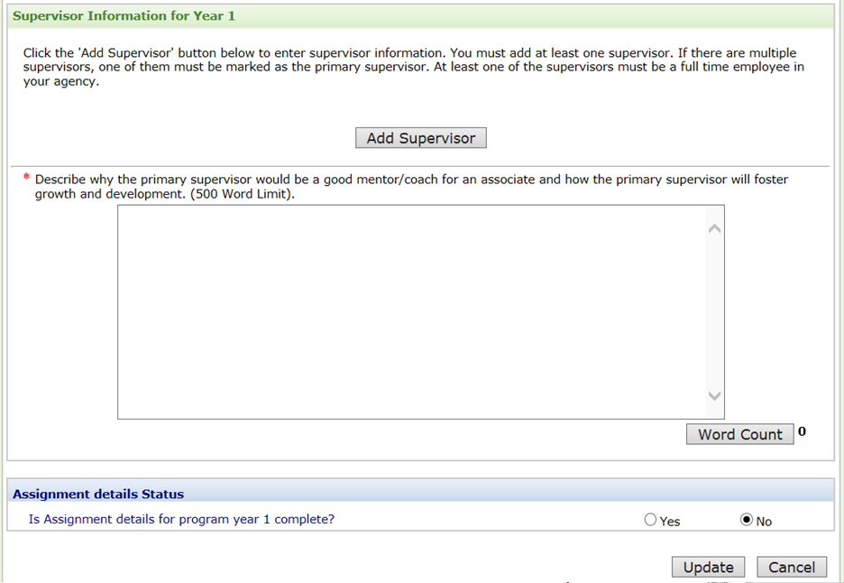
*Note: Same information collected for both year 1 and 2. Only Public Health Associate Program (PHAP) collects year 2 information.

Figure 9.6-b. Supervisor Information*
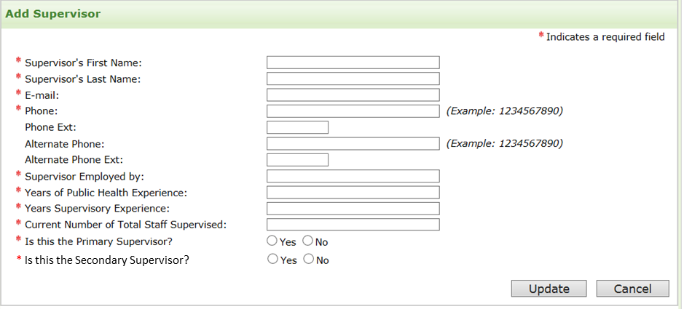
*Note: Same information collected for both year 1 and 2. See next figure for option to copy from year 1. Only Public Health Associate Program (PHAP) collects year 2 information.

Figure 9.6-c. Year 2 Supervisor Copy from Year 1*
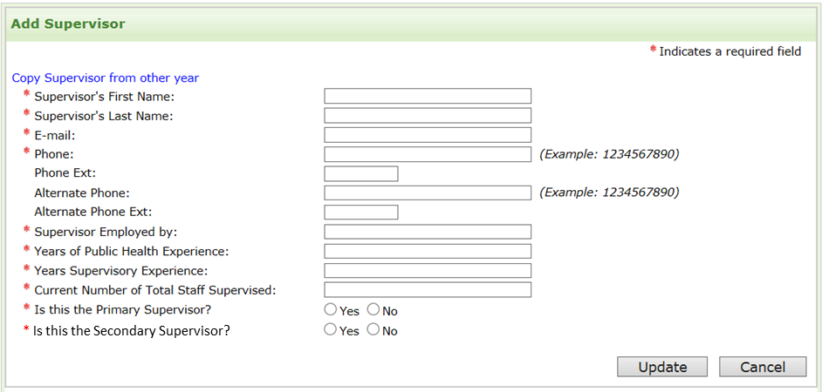
*Note: Only collecting new information if supervisor for year 2 differs from year 1. If the same, applicant could select to copy from previous year. Only Public Health Associate Program (PHAP) collects year 2 information.

Figure 9.6-d. Additional Supervisor Information*
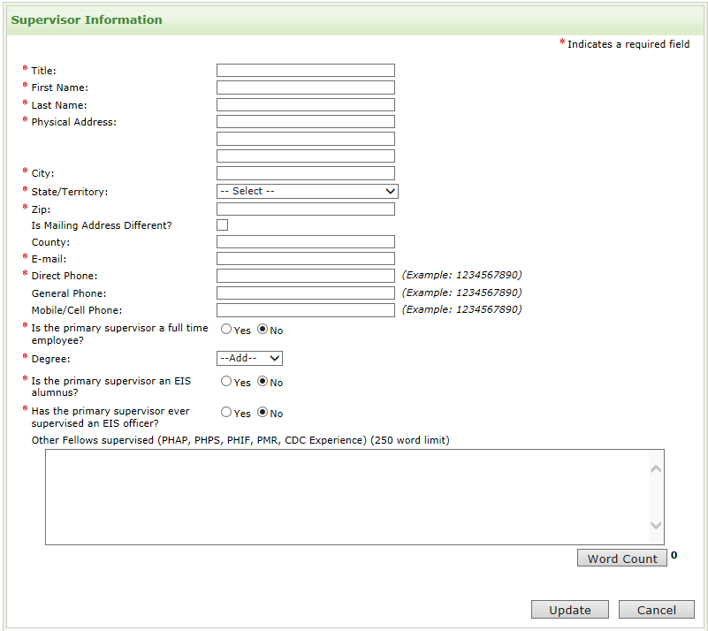
*Note: Only Epidemic Intelligence Service, Public Health Informatics Fellowship, and Preventive Medicine Residency and Fellowship programs collect this information.

Table 9.6-a. Supervisor Section Data Elements
Data Elements | Data Values | EIS | PHIF | Hubert | Epi-Elect | PEF | PMR/F | PHAP
First Name | Text | Yes | Yes | Yes | - | - | Yes | Yes
Last Name | Text | Yes | Yes | Yes | - | - | Yes | Yes
Degree | Degrees | - | Yes | Yes | - | - | - | -
Title | Text | - | Yes | Yes | - | - | - | -
E-mail | Alphanumeric | Yes | Yes | Yes | - | - | Yes | Yes
(Direct) Phone | Numeric | Yes | Yes | - | - | - | Yes | Yes
Alternate (General) Phone | Numeric | Opt | Opt | - | - | - | Opt | Opt
Supervisor Employed by | Text | Yes | Yes | - | - | - | Yes | Yes
Years of Public Health Experience | Numeric | Yes | Yes | - | - | - | Yes | Yes
Years of Supervisory Experience | Numeric | Yes | Yes | - | - | - | Yes | Yes
Current Number of Total Staff Supervised | Numeric | Yes | Yes | - | - | - | Yes | Yes
Primary Supervisor | Yes/No Choice | Yes | Yes | Yes | - | - | Yes | Yes
Secondary Supervisor | Yes/No Choice | - | Yes | Yes | - | - | - | Yes
Copy from Year 1 | Select Button | Yes | Yes | - | - | - | - | Yes
Title | Text | Yes | Yes | - | - | - | Yes | -
Physical Address Line 1 | Text | Yes | Yes | - | - | - | Yes | -
Physical Address Line 2 | Text | Yes | Yes | - | - | - | Yes | -
Physical Address Line 3 | Text | Yes | Yes | - | - | - | Yes | -
Physical State/Province | States | Yes | Yes | - | - | - | Yes | -
Physical Zip | Numeric | Yes | Yes | - | - | - | Yes | -
Mailing Address Different | Yes/No | Opt | Opt | - | - | - | Opt | -
Physical County | Text | Opt | Opt | - | - | - | Opt | -
Mobile/Cell Phone | Numeric | Opt | Opt | - | - | - | Opt | -
Primary Supervisor alumnus | Yes/No | Yes | Yes | - | - | - | Yes | -
Supervisor Degree | Degrees | Yes | Yes | Yes | - | - | Yes | -
Ever supervised Fellow | Yes/No | Yes | Yes | - | - | - | Yes | -
Other Fellows Supervised | Text (250 words) | Opt | Opt | - | - | - | Opt | -

Appendix A – E-mails

Applicant Registration Confirmation
Dear $strFname$ $strLname$:
You are successfully registered as an applicant for $strAddressText$. Below is the login information for you to login:
Your log-in:
E-mail: $strEmail$
Temporary password: $pw$
$strAddressText$: $strAddress$
Please do not reply to this e-mail. This e-mail address is not monitored.
CONFIDENTIALITY NOTICE: This electronic mail may contain information that is privileged, confidential, or otherwise protected from disclosure to anyone other than its intended recipients. Any dissemination or use of this electronic mail or its contents by persons other than the intended recipients is strictly prohibited. If you have received this communication in error, please delete the original message.

Applicant Reset Password Information
Dear $strFname$ $strLname$:
This e-mail provides your $strProgramName$ login information.
E-mail: $strEmail$
Temporary password: $pw$
$strProgramName$: $strAddress$
Please do not reply to this e-mail. This e-mail address is not monitored.
CONFIDENTIALITY NOTICE: This electronic mail may contain information that is privileged, confidential, or otherwise protected from disclosure to anyone other than its intended recipients. Any dissemination or use of this electronic mail or its contents by persons other than the intended recipients is strictly prohibited. If you have received this communication in error, please delete the original message.

Application Submission Confirmation
Dear strFname strLname,
Thank you for submitting your host site application for the Public Health Associate Program (PHAP). We have received your application and must receive the supporting document (Agreement to Detail) by strSubmissionDate. Host sites must have a signed copy of this document on file at CDC prior to the start date of the assigned Associate.
You may track receipt of documents and the status of your application online at: InternetWebAddress.

Please have your supporting documents mailed directly to:

Public Health Associate Program
ATTN: PHAP Application
Centers for Disease Control and Prevention
4770 Buford Highway, NE, MS E-85
Atlanta, GA 30341
CONFIDENTIALITY NOTICE: This electronic mail may contain information that is privileged, confidential, or otherwise protected from disclosure to anyone other than its intended recipients. Any dissemination or use of this electronic mail or its contents by persons other than the intended recipients is strictly prohibited. If you have received this communication in error, please delete the original message.

Appendix B – Example Agreement to Detail
AGREEMENT TO DETAIL
FEDERAL CIVIL SERVICE PERSONNEL
PUBLIC HEALTH ASSOCIATE PROGRAM (PHAP)
To State, Tribal, Local, or Territorial Host Agency

Pursuant to section 214 of the Public Health Service Act (42 U.S.C. § 215), the Centers for Disease Control and Prevention (hereinafter CDC) hereby agrees to the request for detail of CDC civil service personnel (hereinafter associate) to state and local public health agencies (hereinafter “host agency”) as specified below. This agreement is for the Public Health Associate Program (PHAP).

I. JUSTIFICATION FOR DETAIL ASSIGNMENT

A. The detail of CDC civil service personnel will assist CDC and host agency in carrying out disease prevention, health promotion and protection, and other public health activities.

B. Associate(s) will provide assistance to host agency in developing, implementing, and evaluating public health programs.

C. Associate(s) will promote and enhance state, tribal, local and territorial capacity.

II. OBJECTIVES FOR DETAIL ASSIGNMENT

A. To provide opportunities to expand and enhance the skills and development of CDC associates assigned to host agency.

B. To contribute to overall state, tribal, local and territorial health goals in support of national health.

C. To reduce the incidence of disease and injury, disability and death.

D. To strengthen federal, state and local capacity to prepare for, detect, report, respond to, contain and recover from public health effects of terrorism and other public health emergencies.

III. POSITION DATA AND SUPERVISION

CDC is responsible for the selection and supervision of associates in accordance with CDC recruitment, hiring, and merit promotion policies, regulations, and requirements.
A. The host agency shall provide a work environment free of verbal, written, or physical conduct that has the purpose or effect of unreasonably interfering with the associate’s performance or that creates an intimidating, hostile, or offensive environment. The host agency shall abide by all federal laws and regulations applicable to workplace conduct.

B. The host agency will provide the associate(s) with work space equipped with resources and materials that will provide the associate(s) with access to communications equipment (e.g., computers, electronic mail, telephone and facsimile machines) to allow them to maintain regular contact with CDC and for routine business purposes. This includes ensuring that associates have access to CDC secure systems through the host site computer network/firewall.

C. The host agency will immediately report any workplace incident to the CDC PHAP Supervisor. This includes associate exposure or injury, breach of security policies, or IT security issue.

D. Associates will have the same rights, responsibilities, and supervision as comparably situated employees of the host agency including receiving reimbursement for local travel expenses, participating in host site training, and receiving technical direction and mentoring from host site employees.

E. CDC will provide broad guidance, technical consultation, and official supervision to associate(s). Furthermore:

1. Each associate’s performance will be formally assessed by CDC in accordance with established CDC performance management systems for civil service employees. In completing an associate’s evaluations (both at end-of-year and at mid-year) CDC will solicit input from appropriate host agency staff regarding the associate’s performance. Performance evaluations will include an assessment of the associate’s achievement of required program competencies.

2. Host agency officials may make recommendations to CDC officials regarding any formal recognition that the employee would be eligible to receive based on performance or contributions to the program in accordance with the federal compensation guidelines.

3. Any publication that includes the name of a CDC associate must be submitted for and receive CDC clearance prior to submission for publication. The publication should include the associate’s CDC affiliation as well as local affiliation with his/her name. Standard CDC guidelines for authorship should be followed when determining whether a CDC associate’s name should be included as an author on a publication (General Administration No. CDC-69).

4. Any request by an associate for approval of work outside his/her current job and assignment must be submitted in writing through both the associate’s host agency supervisor and his/her most immediate CDC supervisor to the appropriate
management level at CDC.

5. The CDC will ultimately be responsible for rendering any appropriate disciplinary action that host agency proposes against an associate.

6. The host agency supervisor will work closely with associate to resolve any routine questions or issues that arise regarding the assignment or the associate’s performance.

7. The host agency will promptly advise CDC of any serious performance or behavioral concerns about an associate. In these cases, host agency and CDC staff will work together to attempt to resolve such concerns with the associate, either informally or formally, depending upon the nature of the concern. Other CDC resources may be called upon by the immediate supervisor to help resolve the issues.

8. If informal and/or formal efforts fail to resolve a problem, the host agency may request the removal of an associate. Such request must be forwarded, in writing, through the senior management of the host agency to the CDC PHAP Director and must state: 1) a substantive basis for the request, 2) efforts taken by host agency otherwise resolve the problem, and 3) the proposed date for the removal (not less than 90 days from the date of the request). Upon receipt of such a request, CDC will take appropriate action in consultation with host agency and the associate.

9. CDC may mobilize an associate during an emergency response to act as a CDC responder, either in the field or a CDC-site. During these emergency responses, CDC will inform the host agency of the activation of the associate for the emergency response, the anticipated duration of the associate to the emergency response efforts and will be responsible for all supervision, training and travel costs related to CDC emergency response mobilization.

a. This section does not apply to situations where an associate is acting for the host site in an emergency response situation.

b. CDC may supersede a host agency in mobilizing an associate for emergency response in a state or with a host agency.

IV. COSTS

A. Projected costs for associate(s)’ salary, fringe benefits, and related expenses will be budgeted annually by CDC.
B. Expenses incident to the associate(s)’ employment and travel will be paid as follows:

1. Pay and allowances will include, but will not be limited to, premium pay (e.g., holiday and overtime pay, see #3 below), CDC’s share of costs for health benefits, group life insurance, and civil service or social security retirement coverage, and any out-of-state travel by any associate, or any in-state travel required by CDC.

2. An associate’s salary will be paid on a biweekly basis. Payment for Civil Service employees will be dependent on the timely receipt of the appropriate time and attendance reports associate is required to submit to his/her CDC timekeeper. Payment will be issued by the CDC in accordance with federal rules and procedures.

3. Premium pay for overtime worked by Civil Service must be approved in advance by the appropriate management staff within CDC. Associate(s) must complete and submit the necessary paperwork in advance of the overtime before any payment will be authorized.

4. Individual performance ratings will serve as the basis for recommending with-in grade salary increases and merit pay increases for Civil Service employees. A year one associate with a minimum of a fully successful (or equivalent) rating, will receive a promotion in year 2.

5. Any in-state or local travel by an associate that is required by host agency will be paid by host agency. This includes reimbursement for expenses related to host site required or sponsored training. CDC required training will be supported by CDC.

V. LEAVE AND HOURS OF DUTY

A. Civil Service associate(s) are required to work an 80-hour pay period. Hours of duty will be determined by host agency. Associate(s) are allowed federal holidays only.

B. On all Federal holidays that are not also holidays at the host agency, the host site should determine whether the associate(s) is performing essential duties that require him/her to report for duty. If the host site determines that the associate needs to work on a federal holiday, the associate should request prior approval from their CDC PHAP Supervisor. Associates working on a federal holiday will receive premium pay, therefore, this option should be used with discretion due to the financial impact.

C. On any Local holiday that is not a Federal holiday (as per the Federal Holiday schedule), Associate(s) are required to do one of the following:
a. The Associate(s) may take leave, with proper approval, on the Local holiday;

b. The Associate(s) may work a modified schedule during the 80-hour work period to “make up” the Local Holiday day (e.g. – associate would have the local holiday but work additional hours during the two week federal pay period to fulfill the 80 hour requirement);

c. The Associate(s) may complete PHAP required tasks (online training, assist CDC PHAP team with projects) or other local agency work on a telework basis.

d. Either choice would be reviewed with the Associate’s CDC supervisor. Prior written approval must be given by the associate’s federal supervisor.

D. Associate(s) will be entitled to use annual and sick leave in accordance with Federal laws, regulations, and procedures. Associates may also earn or use overtime, compensatory time, or credit time in accordance with Federal laws, regulations, and procedures, but approval of such must be consistent with local pay and leave management policies and procedures of the host agency.
A request for leave should be reviewed and initialed by an associate’s on-site supervisor

Final written approval for leave (signature on leave slips) is the responsibility of the associate’s Federal supervisor. Each associate’s leave records will be maintained by his/her Federal supervisor.

VI. APPLICABILITY OF RULES, REGULATIONS, AND POLICIES

A. Rules and policies of the host agency shall apply to associate(s) except in cases where this agreement provides otherwise.

B. Where there is a conflict between the rules, regulations, and policies of host agency and/or the locality regarding the legal status and/or rights of associate and the rules, regulations, and policies of CDC or the Federal government regarding the same issue, the CDC or Federal standards will prevail.

C. Associate(s) may not engage in any political activities prohibited for Federal employees by the Hatch Act, 5 U.S.C. § 7321 et. seq., or that may be criminal offenses under title 18 of the U.S. Code (18 U.S.C. §§ 210, 211, 594, 595, 600, 601-607, 610).

D. The Standards of Conduct for Federal employees (5 CFR § 2635), HHS Supplemental Standards of Ethical Conduct (5 CFR § 5501), HHS Residual Standards of conduct (45 CFR § 73.735) and those for employees of host agency will both apply to associate(s), except as noted in item B, above.

VII. TRAINING

A. Associate(s) will be permitted to attend CDC-required programmatic and career development training, meetings, seminars and conferences (including national seminars and regional staff conferences). Absences for purposes of optional training or professional development will occur only with the mutual consent of the parties to this agreement.

B. The host agency may, at its discretion and expense, make available to associate(s) any training opportunities sponsored by the State or locality and made available to other host agency staff.

VIII. PERIOD OF DETAIL

A. The field assignments addressed by this agreement shall be of two year duration.

B. This agreement may be modified or terminated by mutual consent of the parties upon 90 days notice in writing by either party of its intent to modify or terminate the agreement.

C. The continuation of each associate’s detail is contingent upon the availability of funds to support the detail.

IX. APPROVAL

A. The Undersigned represents CDC and is authorized to grant the detail or assignment for the purposes stated herein:
_____________ [Signature] ____________________ Date: _______________

________[Title – CDC Director or Designee]_______

B. The Undersigned represents the host agency and is authorized to request the detail of associate(s) for the purposes stated herein.

_________ _ ____________________ Date: ________________
Host Site Signee

Appendix C – List Of Values

Secret Questions
- In what city were you born?
- In what city was your mother born?
- In what city was your father born?
- What was the name of your first pet?
- What was your high school mascot?
- What is your favorite color?

Distances
- 0-49 mi
- 50-100 mi
- Greater than 100 mi

Agency Types
- CDC
- Other, Federal Government
- State
- Local
- Territorial
- Tribal
- Other

Months
- January
- February
- March
- April
- May
- June
- July
- August
- September
- October
- November
- December

Years
- 2014
- 2015
- 2016
- 2017
- 2018

Programs
- ATSDR  - Birth Defects and Disabilities  - Chronic Disease  - Environmental health  - HIV  - Immunization  - Injury Prevention Maternal/Child Health | - Other Communicable Diseases  - Public Health Preparedness  - Quarantine  - STD  - TB  - Other

Topic Domains
Birth Defects and Disabilities  - Prevention and Protection  - Health Tracking  - Fetal Alcohol  - Human Development and Disabilities  - Health Promotion and Outreach  - Birth Defects and Development Disabilities | - Child Development and Disabilities  - Disability and Health  - Surveillance and Laboratory  - Prevention, research and Informatics  - Other
Chronic Disease  - Health Promotion  - Health Education  - School health  - Community Health  - Coordinated Local Support  - Policy  - Surveillance  - Performance Improvement  - Accreditation  - Program Services  - Tobacco Control | - Obesity Prevention  - Diabetes Prevention  - Maternal and Infant Health  - Women’s Health  - Fertility and Reproductive Health  - Cancer Prevention  - Health Communication  - Nutrition and Physical Activity  - Assessment and Planning  - Oral Health
Environmental Health  - Air Pollution and Respiratory Health  - Environmental Health Tracking  - Vessel Sanitation  - Food Sanitation and Investigations  - Emergency Response  - Tobacco and Volatiles  - Nutritional Bio-markers  - Inorganic and Radiation Analytical Toxicology  - Public Health Assessment  - Surveillance | - Toxic Substance and Incidence  - Assessment Plan and evaluation  - Education and Outreach  - Healthy Homes and Lead  - Community Health Investigations  - Environmental Hazards  - Health Affects  - Health Protection  - Other
HIV  - Health Promotion  - Health Education  - School Health  - Community Health  - Disease Control and Prevention | - Policy  - Surveillance  - Performance Improvement  - Hepatitis  - Other
Immunization  - Health Promotion  - Health Education  - School Health  - Community Health  - Disease Control and Prevention | - Policy  - Surveillance  - Performance Improvement  - Other

Injury Prevention  - Policy Development  - Outreach and Education  - Unintentional Injury  - Employee Wellness  - Occupational Health  - Violence Prevention | - Health Tracking  - Surveillance  - Heart/Stroke Prevention  - Arthritis, Epilepsy, and Well being  - Other
Maternal/Child Health  - Women Health  - Infant Health  - Children Health  - Program Services | - Health Promotion and Outreach  - Policy  - Surveillance and Tracking  - Other
Public Health Preparedness  - Readiness and Response  - Applied Science and Evaluation  - Planning  - Program Services | - Emergency and Risk Communications  - Training and Outreach  - Other
STD  - Health Promotion  - Health Education  - School Health  - Community Health  - Disease Control and Prevention | - Policy  - Surveillance  - Performance Improvement  - Hepatitis  - Other
TB  - Health Promotion  - Health Education  - School Health  - Community Health  - Disease Control and Prevention | - Policy  - Surveillance  - Performance Improvement  - Other
Informatics  - Policy Development  - Evaluation and Assessment of Information Systems/Applications  - Information Security | - Information Needs Assessment  - Interoperability  - Other

Competencies

Analytic and Assessment Skills
- Monitors community health risks
- Investigates community health problems
- Performs surveillance activities including data collection and analysis (e.g., collecting morbidity reports, NEDSS, NEPS, cancer registries)
- Uses technological information systems for public health application
- Disseminates information that is evidence-based and from professional sources
- Adheres to ethical principles in the collection, maintenance, use and dissemination of data and information

Program Planning Skills
- Identifies information required in the program planning process (e.g., expresses the problem statement)
- Gathers information for use by program officials to inform program planning decisions
- Participates in program planning processes (e.g., assists in the development of goals and objectives, timelines, resource needs, evaluations)
- Applies planning and program-specific implementation strategies to address public health needs (e.g., community blood screening, development of youth activity programs)
- Describes the public health laws and regulations governing public health programs

Communication Skills
- Demonstrates active listening skills
- Communicates in writing and orally to target audiences with linguistic and cultural proficiency
- Addresses sensitive issues with decorum, tact and diplomacy
- Responds to electronic, written, verbal and non-verbal communications with courtesy and respect
- Communicates information that is clear, current and factual
- Communicate strategies in forums or community meetings
- Applies communication and group dynamic techniques (e.g., principled negotiation, conflict resolution and risk communication) in interactions with individuals and groups

Cultural Competency Skills
- Recognizes the role of cultural, social and behavioral factors in the accessibility, availability, acceptability and delivery of public health services
- Uses colleagues diverse experiences as a resource to serve targeted populations
- Uses cultural and social aspects to increase an interventions effectiveness

Partnership and Collaboration Skills
- Identifies stakeholders, community assets and resources
- Educates community groups on health issues and solutions for public health initiatives (e.g., TB prevention practices, STD/HIV testing information)
- Develops working relationships with team members and colleagues within the public and private sectors for the purpose of improving public health
- Collaborates with community partners to promote the health of the population
- Describes the partnership between governmental, inter-governmental and non-governmental organizations in the delivery of community health services

Public Health Practice and Knowledge Skills
- Defines the roles, responsibilities and contributions of various organizations and agencies to specific federal, state, tribal, local and territorial public health programs
- Adheres to laws, regulations, policies and procedures for ethical public health practice (e.g., HIPAA, restaurant inspection policies, administrative codes)
- Identifies how work activities and skills relate to the Core Public Health Functions and Ten Essential Services of Public Health
- Describes the basic public health sciences (e.g., laboratory, biostatistics, epidemiology, environmental health sciences, health services administration and social and behavioral health sciences)

Financial Planning Skills
- Describes components of a budget
- Describes federal public health funding mechanisms

Leadership and Systems Thinking Skills
- Uses individual, team and organizational learning opportunities for personal and professional development
- Uses feedback received during peer review, mentoring and coaching opportunities for skill development
- Examines professional development plans on an ongoing basis with assigned supervisors to track knowledge increase and skill development
- Uses the chain of command at CDC and in the field to address issues or concerns
- Describes how public health operates within a larger system (e.g., political, health care)
- Describes how changes in the public health system in the larger social, political and economic environment impact organizational practices

Training Types
- One-on-One  - E-Learning Non-CDC  - Classroom: HD | - Classroom: Outside Sponsor  - E-learning CDC

Countries
- Afghanistan  - Albania  - Algeria  - Andorra  - Angola  - Anguilla (U.K.)  - Antigua and Barbuda  - Argentina  - Armenia  - Aruba  - Australia  - Austria  - Azerbaijan  - Azores  - Bahamas, The  - Bahrain  - Bangladesh  - Barbados  - Belarus  - Belgium  - Belize  - Benin  - Bermuda (U.K.)  - Bhutan  - Bolivia  - Bosnia and Herzegovina  - Botswana  - Brazil  - British Indian Ocean Territory (U.K.)  - British Virgin Islands  - Brunei  - Bulgaria  - Burkina Faso  - Burma (Myanmar)  - Burundi  - Cambodia  - Cameroon  - Canada  - Canary Islands (Spain)  - Cape Verde  - Cayman Islands (U.K.)  - Central African Republic  - Chad  - Chile  - China  - Christmas Island (Australia)  - Cocos (Keeling) Islands (Australia)  - Colombia | - Comoros  - Congo, Democratic Republic of the  - Congo, Republic of the  - Cook Islands (New Zealand)  - Costa Rica  - Côte d'Ivoire  - Croatia  - Cuba  - Cyprus  - Czech Republic  - Denmark  - Djibouti  - Dominica  - Dominican Republic  - Easter Island (Chile)  - Ecuador  - Egypt  - El Salvador  - Equatorial Guinea  - Eritrea  - Estonia  - Ethiopia  - Falkland Islands (Malvinas)  - Falkland Islands (U.K.)  - Faroe Islands (Denmark)  - Fiji  - Finland  - France  - French Guiana (France)  - French Polynesia (France)  - Gabon  - Gambia, The  - Georgia  - Germany  - Ghana  - Gibraltar (U.K.)  - Greece  - Greenland (Denmark)  - Grenada  - Guadeloupe  - Guatemala  - Guinea  - Guinea-Bissau  - Guyana  - Haiti  - Honduras  - Hong Kong SAR (China)  - Hungary | - Iceland  - India  - Indonesia  - Iran  - Iraq  - Ireland  - Israel  - Italy  - Jamaica  - Japan  - Jordan  - Kazakhstan  - Kenya  - Kiribati  - Korea, North  - Korea, South  - Kosovo  - Kuwait  - Kyrgyzstan  - Laos  - Latvia  - Lebanon  - Lesotho  - Liberia  - Libya  - Liechtenstein  - Lithuania  - Luxembourg  - Macau SAR (China)  - Macedonia  - Madagascar  - Madeira Islands (Portugal)  - Malawi  - Malaysia  - Maldives  - Mali  - Malta  - Marshall Islands  - Martinique (France)  - Mauritania  - Mauritius  - Mayotte (France)  - Mexico  - Moldova  - Monaco  - Mongolia  - Montenegro  - Montserrat (U.K.)  - Morocco  - Mozambique | - Namibia  - Nauru  - Nepal  - Netherlands Antilles  - Netherlands, The  - New Caledonia (France)  - New Zealand  - Nicaragua  - Niger  - Nigeria  - Niue (New Zealand)  - Northfolk Island (Australia)  - Northern Mariana Islands (U.S.)  - Norway  - Oman  - Other  - Pakistan  - Palau  - Panama  - Papua New Guinea  - Paraguay  - Peru  - Philippines  - Pitcairn Islands (U.K.)  - Poland  - Portugal  - Qatar  - Réunion (France)  - Romania  - Russia  - Rwanda  - Saint Helena (U.K.)  - Saint Kitts and Nevis  - Saint Lucia  - Saint Pierre and Miquelon (France)  - Saint Vincent and the Grenadines  - Samoa  - San Marino  - São Tomé and Príncipe  - Saudi Arabia  - Senegal  - Serbia  - Seychelles  - Sierra Leone  - Singapore | - Slovakia  - Slovenia  - Solomon Islands  - Somalia  - South Africa  - Spain  - Sri Lanka  - Sudan  - Suriname  - Swaziland  - Sweden  - Switzerland  - Syria  - Taiwan  - Tajikistan  - Tanzania  - Thailand  - Timor-Leste (East Timor)  - Togo  - Tokelau (New Zealand)  - Tonga  - Trinidad and Tobago  - Tunisia  - Turkey  - Turkmenistan  - Turks and Caicos Islands (U.K.)  - Tuvalu  - Uganda  - Ukraine  - United Arab Emirates  - United Kingdom  - United States  - Uruguay  - Uzbekistan  - Vanuatu  - Venezuela  - Vietnam  - Western Sahara  - Yemen  - Zambia  - Zimbabwe

States
- Alabama  - Alaska  - Arizona  - Arkansas  - California  - Colorado  - Connecticut  - Delaware  - Washington, DC  - Florida  - Georgia  - Hawaii  - Idaho  - Illinois  - Indiana  - Iowa  - Kansas  - Kentucky  - Louisiana  - Maine  - Maryland  - Massachusetts  - Michigan  - Minnesota  - Mississippi  - Missouri  - Montana  - Nebraska  - Nevada | - New Hampshire  - New Jersey  - New Mexico  - New York  - North Carolina  - North Dakota  - Ohio  - Oklahoma  - Oregon  - Pennsylvania  - Rhode Island  - South Carolina  - South Dakota  - Tennessee  - Texas  - Utah  - Vermont  - Virginia  - Washington  - West Virginia  - Wisconsin  - Wyoming  - Puerto Rico  - Guam  - American Samoa  - U.S. Virgin Islands  - Alberta  - British Columbia  - Manitoba | - New Brunswick  - Newfoundland and Labrador  - Nova Scotia  - Nunavut  - N.W.T.  - Ontario  - Quebec  - Saskatchewan  - Yukon  - Australian Capital Territory  - New South Wales  - Northern Territory  - Queensland  - South Australia  - Tasmania  - Victoria  - Western Australia  - Andra Pradesh  - Arunachal Pradesh  - Assam  - Bihar  - Chhattisgarh  - Goa  - Gujarat  - Haryana  - Himachal Pradesh | - Jammu and Kashmir  - Jharkhand  - Karnataka  - Kerala  - Madya Pradesh  - Maharashtra  - Manipur  - Meghalaya  - Mizoram  - Nagaland  - Orissa  - Punjab  - Rajasthan  - Sikkim  - Tamil Nadu  - TripuraUttaranchal  - Uttar Pradesh  - West Bengal  - Andaman and Nicobar Islands  - Chandigarh  - Dadar and Nagar Haveli  - Daman and Diu  - Delhi  - Lakshadeep  - Pondicherry

Degrees
- AA  - AAS  - AB  - AD  - ADN  - AM  - AS  - ASN  - BA  - BAC  - BBA  - BCE  - BDS  - BEng  - BFA  - BHB  - BIE  - BM  - BMBS  - BMed  - BNSc  - BNurs  - BPharm  - BS  - BS/BA | - BSc  - BSChE  - BScN  - BSE  - BSEE  - BSFS  - BSJ  - BSME  - BSPH  - BSN  - BVS  - BVSc  - DCH  - DDS  - DHA  - DHS  - DHSc  - DMD  - DNSc  - DO  - DPA  - DPE  - DPH  - DPhil  - DPM | - DPT  - DrPH  - DrS  - DrSc  - DSc  - DScD  - DScH  - DScVM  - DVM  - EdD  - JD  - LLB  - LLD  - MA  - MAS  - MAT  - MB  - MBA  - MBBCh  - MBBS  - MBChB  - MCPS  - MD  - MDCM  - MDiv | - MEd  - MFA  - MHA  - MHS  - MHSc  - MHSE  - MMS  - MN  - MNS  - MOH  - MOT  - MPA  - MPAS  - MPH  - MPharm  - MPhil  - MPHTM  - MPP  - MPVM  - MRP  - MS  - MSVPH  - MSc  - MScPH  - MSD | - MSHSA  - MSM  - MSN  - MSPH  - MSPM  - MSW  - MTM&H  - MUS  - MVSc  - OD  - PA  - PharmD  - PhB  - PhD  - PNP  - PsyD  - RN  - SB  - ScB  - ScD  - ScM  - SM  - SMHyg  - VMD

Project Phases
- Initiation  - Planning | - Implementation  - Evaluation

Program Topic Domains
- Policy Development  - Evaluation and Assessment of Information Systems/Applications  - Information Security | - Information Needs Assessment  - Interoperability  - Other

Fellow’s Roles
- Leadership
- Team Member

Fellow Years
- Third Year
- Fourth Year
- Both

Fellow Types
- Medical Student
- Veterinary Student
- Both

Number of Weeks
- 1  - 2  - 3  - 4  - 5  - 6  - 7  - 8  - 9  - 10 | - 11  - 12  - 13  - 14  - 15  - 16  - 17  - 18  - 20

Deliverables
- Written surveillance report
- Record of interview and case results
- Meeting documentation including action plan and consensus document
- Description of need and proposed solution and proposed or approved copy of revised process, operation or policy
- Live presentation and copy of agenda, slides, handouts, etc.
- Health information deliverable (e.g. presentation, website, brochure)
- Documented Written Contribution option to non-federal grant application or other funding mechanisms
- Actual work products and written plan

Activity Types
- Case Management
- Presentation/Outreach
- Communications
- Problem solving/critical thinking

Languages
- Afrikaans  - Albanian  - Amharic  - Arabic (Egyptian)  - Aramaic  - Armenian  - Assamese  - Aymara  - Azerbaijani  - Basque  - Belarusian  - Bengali  - Bislama  - Bosnian  - Bulgarian  - Burmese  - Catalan  - Cebuano  - Cherokee  - Mandarin  - Croatian  - Czech  - Danish  - Dutch  - Egyptian | - English Estonian Finnish  - French  - Georgian  - German  - Greek  - Guarani  - Gujarati  - Creole (Haitian)  - Hausa  - Hawaiian  - Hebrew  - Hindi  - Hungarian  - Icelandic  - Irish  - Italian  - Japanese  - Javanese  - Kannada  - Kazakh  - Khmer  - Korean  - Lao  - Latvian | - Lithuanian  - Macedonian Malagasy Malayalam  - Marathi  - Mongolian  - Nahuatl  - Navajo  - Nepali  - Norwegian  - Oriya  - Oromo  - Farsi  - Polish  - Portuguese  - Punjabi  - Pashto  - Romanian  - Romany  - Russian  - Sanskrit  - Serbian  - Slovak  - Slovenian  - Somali  - Spanish | - Swahili  - Swedish  - Tagalog  - Tajik  - Tamil Telugu  - Thai  - Tibetan  - Tok Pisin  - Turkish  - Turkmen  - Ukrainian  - Urdu  - Uzbek  - Vietnamese  - Welsh  - Xhosa  - Yiddish  - Yoruba  - Zapotec  - Zulu  - Arabic (Levantine)  - Arabic (Modern Standard)  - Arabic (Moroccan) | - Indonesian (Not Specified)  - Bahasa Melayu  - Balochi  - Berber  - Cantonese  - Dari  - Ilokano  - Inuit  - Kurdi  - Kyrgyz  - Lakota  - Ojibwa  - Quechua  - Quiche  - Uyghur  - Yucatec Maya  - Arabic (Not Specified)  - Chinese (Not Specified)  - Creole (Not Specified)  - Malay

Language Proficiencies
- Poor
- Fair
- Good
- Excellent

Quarantine Stations
- CDC Anchorage Quarantine Station  - CDC Atlanta Quarantine Station  - CDC Boston Quarantine Station  - CDC Dallas/Ft. Worth Quarantine Station  - CDC Detroit Quarantine Station  - CDC El Paso Quarantine Station  - CDC Honolulu Quarantine Station  - CDC Houston Quarantine Station  - CDC Los Angeles Quarantine Station  - CDC Miami Quarantine Station | - CDC Minneapolis Quarantine Station  - CDC Newark Quarantine Station  - CDC New York Quarantine Station  - CDC Philadelphia Quarantine Station  - CDC San Diego Quarantine Station  - CDC San Francisco Quarantine Station  - CDC San Juan Quarantine Station  - CDC Seattle Quarantine Station  - CDC Washington Quarantine Station

Public Health Agencies

Alabama
- Poarch Band of Creek Indians  - Autauga County Health Department  - Baldwin County Health Department  - Barbour County Health Department  - Bibb County Health Department  - Blount County Health Department  - Bullock County Health Department  - Butler County Health Department  - Calhoun County Health Department  - Chambers County Health Department  - Cherokee County Health Department  - Chilton County Health Department  - Choctaw County Health Department  - Clarke County Health Department  - Clay County Health Department  - Cleburne County Health Department  - Coffee County Health Department  - Colbert County Health Department  - Conecuh County Health Department  - Coosa County Health Department  - Covington Health Department  - Crenshaw County Health Department  - Cullman County Health Department  - Dale County Health Department  - Dallas County Health Department  - DeKalb County Health Department  - Alabama Public Health Area 3  - Elmore County Health Department  - Escambia County Health Department  - Etowah County Health Department  - Fayette County Health Department  - Franklin County Health Department  - Geneva County Health Department  - Greene County Health Department  - Hale County Health Department  - Henry County Health Department  - Houston County Health Department  - Jackson County Health Department  - Jefferson County Department of Health/Alabama Public Health Area 4  - Lamar County Health Department | - Lauderdale County Health Department  - Lawrence County Health Department  - Lee County Health Department  - Limestone County Health Department  - Lowndes County Health Department  - Macon County Health Department  - Madison County Health Department  - Marengo County Health Department  - Marion County Health Department  - Marshall County Health Department  - Mobile County Health Department/Alabama Public Health Area 11  - Monroe County Health Department  - Montgomery County Health Department  - Alabama Public Health Area 2  - Alabama Public Health Area 5  - Perry County Health Department  - Pickens County Health Department  - Pike County Health Department  - Randolph County Health Department  - Russell County Health Department  - Shelby County Department of Health  - St. Clair County Health Department  - Sumter County Health Department  - Talladega County Health Department  - Tallapoosa County Health Department  - Tuscaloosa County Health Department  - Walker County Health Department  - Washington County Health Department  - Wilcox County Health Department  - Winston County Health Department  - Alabama Public Health Area 8  - Alabama Public Health Area 1  - Alabama Public Health Area 6  - Alabama Public Health Area 7  - Alabama Public Health Area 9  - Alabama Public Health Area 10  - Morgan County Health Department  - Alabama Department of Public Health

Public Health Agencies Continued

Alaska
- Alaska Department of Health and Social Services  - Municipality of Anchorage/Department of Health and Human Services  - Nome Health Center, Norton-Sound Health Corporation  - Juneau Public Health Center  - North Slope Borough Health and Social Services Agency  - Maniilaq Association  - Aleutian Pribilof Islands Association  - Arctic Slope Native Association  - Chickaloon Native Village  - Kodiak Area Native Association  - Native Village of Eklutna  - Southcentral Foundation  - Tanana Chiefs Conference  - Yukon-Kuskokwin Health  - Alaska Native Tribal Health Consortium  - Bethel Center and Itinerant Nursing Services  - Cordova Public Health Center South Central Region  - Craig Public Health Center  - Delta Junction Public Health Center  - Dillingham Public Health Center  - Fairbanks Regional Public Health Center Interior Region  - Fort Yukon Public Health Center  - Galena Public Health Center Interior Region  - Haines Public Health Center  - Homer Public Health Center  - Kenai Public Health Center  - Ketchikan Public Health Center  - Kodiak Public Health Center  - Matanuska-Susitna (Mat-Su) Public Health Center  - Petersburg Public Health Center  - Seward Public Health Center  - Sitka Public Helath Center  - Tok Public Health Center  - Valdez Public Health Center  - Wrangell Public Health Center  - South Central Region  - Southwest Region | - Interior Region  - Alaska Native Tribal Health Consortium  - Southeast Region  - CDC Anchorage Quarantine Station  - Native Village of Tyonek  - Searhc Mt. Edgecumbe Hospital  - Metlakatla Indian Community  - Fairbanks Native Association  - Mount Sanford Tribal Consortium  - Arctic Slope Native Association  - Bristol Bay Area Health Corporation  - Ukpeagvik Inupiat Corporation  - Maniilaq Association  - Searhc Juneau Medical Center  - Akiachak Native Community  - Southcentral Foundation  - Chickaloon Native Village  - SouthEast Alaska Regional Health Consortium  - Valdez Native Tribe  - Alaska Native Medical Center  - Tanana Chiefs Conference  - North Slope Borough Health Corp  - Chief Andrew Isaac Health Center  - Ninilchik Traditional Council  - Ketchikan Indian Corporation  - Eastern Aleutian Tribes, Inc  - Native Village of Kwinhagak  - St. George Community Council  - Cook Inlet Tribal Council, Inc.  - Yukon-Kuskokwim Regional Health Corporation  - Kenaitze Indian Tribe  - Aleutian Pribilof Islands Association, Inc.  - Norton Sound Health Corporation  - Copper River Native Association  - Council of Athabascan Tribal Governments  - Tanana Tribal Council  - Kodiak Area Native Association

American Samoa
- American Samoa Dept of Health

Public Health Agencies Continued

Arizona
- San Juan Southern Paiute Tribe  - Health & Social Svcs Committee  - Tsaile PHS Indian Health Center  - Tuba City Regional Hlth Care Corp.  - Winslow Indian Hlth. Care Ctr., Inc.  - Navajo Division of Social Services  - Navajo Division of Health  - Navajo Division of EMS  - Inscription House Health Center  - Cibecue PHS Indian Health Ctr  - Bylas Health Center  - AZ Assoc. of Community Hlth Ctr  - Fort McDowell - Wassaja Memorial Health Center  - Gila River Indian Community  - Yavapai-Prescott Tribe  - Apache County Health Department  - Cochise County Health Department  - Coconino County Public Health Services District  - Gila River Indian Community Department of Public Health  - Graham County Health Department  - Greenlee County Health Department  - La Paz County Health Department  - Maricopa County Department of Public Health  - Mohave County Department of Public Health  - Navajo County Public Health Services District  - Pima County Health Department  - Pinal County Health Department  - Santa Cruz County Health Department  - Yavapai County Community Health Services  - Yuma County Health Department  - Gila County Health Department | - White Mountain Apache Health Authority  - Fort McDowell Indian Community/Wassaja Memorial Health Center  - Inter-Tribal Health Care Center  - Pascua Yaqui Health Department  - San Carlos Apache Tribe  - Tohono O'Odham Health Department  - Arizona Department of Health Services  - San Xavier PHS Indian Hlth Ctr  - Pascua Yaqui Tribe Health Services Division  - Tohono O'odham Nation  - Santa Rosa Clinic  - Tonto Apache Tribe  - Quechan Tribal Council  - White Mountain Apache Tribe  - Phoenix Indian Center  - Hualapai Tribe  - Fort Mojave Indian Tribe  - Havasupai Tribe  - Ak-Chin Indian Community  - Cocopah Tribe  - Colorado River Indian Community  - Salt River Indian Community  - Salt River Indian Community  - Hopi Health Care Center  - Tohono O'odham, San Lucy District  - Desert Visions Youth Wellness Center  - Yavapai-Apache Nation  - Kaibab-Paiute Tribe  - Peach Springs Health Center  San Carlos Apache Tribe

Public Health Agencies Continued

Alaska
- Ashley County Health Unit - Crossett  - Baxter County Health Unit  - Benton County Health Unit - Bentonville  - Boone County Health Department  - Bradley County Health Unit  - Calhoun County Health Unit  - Carroll County Health Unit  - Chicot County Health Unit - Lake Village  - Clark County Health Unit  - Clay County Health Unit - Piggott  - Cleburne County Health Unit  - Cleveland County Health Unit  - Columbia County Health Unit  - Conway County Health Unit  - Craighead County Health Unit  - Crawford County Health Unit  - Crittenden County Health Unit - West Memphis  - Cross County Health Unit  - Dallas County Health Unit  - Desha County Health Unit - McGehee  - Drew County Health Unit  - Faulkner County Health Unit  - Fulton County Health Unit  - Garland County Health Unit  - Grant County Health Unit  - Greene County Health Unit  - Hempstead County Health Unit  - Hot Spring County Health Unit  - Howard County Health Unit  - Independence County Health Unit  - Izard County Health Unit  - Jackson County Health Unit  - Jefferson County Health Unit  - Johnson County Health Unit  - Lafayette County Health Unit  - Lawrence County Health Unit  - Lee County Health Unit  - Lincoln County Health Unit  - Little River County Health Unit  - Logan County Health Unit - Paris  - Lonoke County Health Unit - Lonoke | - Madison County Health Unit  - Marion County Health Unit  - Miller County Health Unit  - Mississippi County Health Unit - Blytheville  - Monroe County Health Unit  - Montgomery County Health Unit  - Nevada County Health Unit  - Newton County Health Unit  - Ouachita County Health Unit  - Perry County Health Unit  - Phillips County Health Unit  - Pike County Health Unit  - Poinsett County Health Unit - Harrisburg  - Polk County Health Unit  - Pope County Health Unit  - Prairie County Health Unit  - Pulaski Health Unit - Central Little Rock  - Randolph County Health Unit  - Saline County Health Unit  - Scott County Health Unit  - Searcy County Health Unit  - Sebastian County Health Unit  - Sevier County Health Unit  - Sharp County Health Unit  - St. Francis County Health Unit - Forrest City  - Stone County Health Unit  - Union County Health Unit  - Van Buren County Health Unit  - Washington County Health Unit  - White County Health Unit - Searcy  - Woodruff County Health Unit  - Yell County Health Unit - Dardanelle  - Franklin County Health Unit  - Central Public Health Region  - Northeast Region Office  - Northwest Region Office  - Southeast Region Office  - SouthWest Region Office  - Pulaski County Health Unit - Southwest Little Rock  - Pulaski County Health Unit - North Little Rock  - Pulaski County Health Unit - Jacksonville

Public Health Agencies Continued

California
- Alameda County Public Health Department  - Alpine County Health and Human Services  - Amador County, Health and Human Services Agency  - Berkeley City Public Health Department  - Butte County Department of Public Health  - Calaveras County Public Health Department  - Colusa County Health Department  - Contra Costa Health Services  - Del Norte County Public Health  - El Dorado County Health Department  - Fresno County Department of Public Health  - Glenn County Health Department  - Humboldt County Department of Health and Human Services  - Imperial County Health Department  - Inyo County Health Department  - Kern County Health Department  - Kings County Health Department  - Lake County Department of Health Services  - Lassen County Department of Health and Social Services  - Long Beach City Department of Health and Human Services  - Madera County Public Health  - Marin County Health and Human Services  - Mariposa County Health Department  - Mendocino County Dept of Public Health  - Merced County Department of Public Health  - Modoc County Public Health Department  - Mono County Health Department  - Monterey County Health Department  - Napa County Health and Human Services Agency  - Nevada County Public Health Department  - Orange County Health Care Agency/Public Health  - City of Pasadena Public Health Department  - Placer County Health and Human Services  - Plumas County Public Health Agency  - Riverside County Department of Health  - Sacramento Department of Health and Human Services  - San Benito County Health and Human Services  - San Bernardino County Department of Public Health  - County of San Diego HHS and Public Health Services  - San Francisco Department of Public Health | - San Joaquin County Public Health Services  - San Luis Obispo County Health Department  - San Mateo County Health Service Department  - Los Angeles County Public Health Department  - Santa Clara County Public Health Department  - Santa Cruz County Health Services Agency  - Shasta County Public Health  - Sierra County Health Department  - Siskiyou County Public Health Department  - Solano County Health and Social Services Dept. - Public Health  - Sonoma County Department of Health Services  - Stanislaus County Public Health Department  - Sutter County Health Department  - Tehama County Health Services Agency  - Trinity County Health and Human Services  - Tulare County Health and Human Services  - Tuolumne County Health Department  - Ventura County Health Department  - Vernon City Health Department  - Yolo County Health Department  - Yuba County Health Department  - Santa Barbara County Public Health Department  - San Diego Department of Environmental Health  - Cold Springs Rancheria Health Services  - Hoopa Valley Tribe - Kima Medical Center  - Indian Health Council, Inc.  - Scotts Valley Health and Social Services  - Southern Indian Health Council, Inc.  - Toiyabe Indian Health  - United Indian Health Services  - El Dorado County Environmental Management  - Lone Pine Indian Health Clinic  - Table Mountain Rancheria  - Cabazon Band of Mission Indians  - Colusa Indian Community Council  - Greenville Rancheria of Maidu Indians  - Tule River Indian Health Center, Inc.  - Cold Springs Rancheria of Mono Indians | - Shingle Springs Tribal Health Programs  - Hopland Band of Pomo Indians  - Susanville Indian Health Center  - Chapa-De Indian Health Program, Inc.  - Sycuan Band of the Kumeyaay Nation  - Sherwood Valley Band of Pomo Indians  - Central Valley Indian Health, Inc.  - Santa Rosa Rancheria  - Consolidated Tribal Health Project, Inc.  - Guidiville Indian Rancheria  - Soboba Indian Health Clinic  - Indian Health Center of Santa Clara Valley  - Feather River Tribal Health Inc.  - Southern Indian Health Council  - Tuolumne Me-Wuk Indian Hlth Ctr  - Northern Valley Indian Health  - Toiyabe Indian Health Project  - Indian Health Council, Inc.  - Sonoma County Indian Health (CRIHB)  - Coyote Valley Tribal Council  - Lytton Rancheria  - Santa Ynez Band of Chumash Mission Indians  - Lake County Tribal Health Consortium  - Quartz Valley Indian Reservation  - Sierra Tribal Consortium  - M.A.C.T. Health Board, Inc.  - Round Valley Indian Health Center  - Warner Mountain Indian Hlth Project  - Karuk Tribe  - United Indian Health Services  - Redding Rancheria Health Clinic  - Hoopa Valley Tribe  - Pinoleville Band of Pomo Indians  - Pit River Health Services, Inc.  - Scotts Valley Band of Pomo Indians  - CDC Los Angeles Quarantine Station  - CDC San Francisco Quarantine Station  - California Health and Human Services  - Chemehuevi Tribe

Public Health Agencies Continued

Colorado
- Colorado Department of Public Health and Environment  - Towaoc PHS Indian Health Center  - Ignacio PHS Indian Health Center  - Southern Ute Health Program  - Ute Mountain Ute Health Program  - Alamosa County Public Health Department  - Community Health Services, Inc.  - Pitkin County Environmental Health Department  - City and County of Broomfield Department of Health and Human Services  - Bent County Public Health Agency  - Boulder County Public Health  - Chaffee County Public Health Department  - Cheyenne County Public Health  - Clear Creek County Public & Environmental Health  - Conejos County Public Health and Nursing Service  - Costilla County Public Health Agency  - Hinsdale County Public Health Agency  - Custer County Public Health Agency  - Delta County Department of Health and Human Services  - Denver Department of Environmental Health  - Dolores County Public Health Agency  - Eagle County Health and Human Services Department  - El Paso County Public Health  - Elbert County Public Health Nursing Service  - Fremont County Public Health Agency  - Fremont County Environmental Health Department  - Garfield County Public Health Nursing Service  - Gilpin County Public Health Agency  - Grand County Public Health  - Gunnison County Public Health  - Jackson County Public Health Agency  - Jefferson County Public Health  - Kiowa County Public Health Agency  - Kit Carson County Public Health Nursing Service  - Larimer County Department of Health and Environment  - Las Animas-Huerfano County Health and Environment  - Lincoln County Public Health Nursing Service | - Mesa County Health Department  - Mineral County Public Health Nursing Service  - Montezuma County Health Department  - Montrose County Health & Human Services  - Northeast Colorado Health Department  - Northwest Colorado Visiting Nurse Association and Hospice  - Otero County Department of Health  - Ouray County Public Health Nursing Service  - Park County Environmental Health Department  - Prowers County Public Health  - Pueblo City-County Health Department  - Rio Grande County Public Health Nursing Service  - Routt County Environmental Health Department  - Saguache County Public Health Nursing Service  - San Juan Basin Health Department  - San Juan County Public Health Nursing Service  - San Miguel County Public Health Nursing Service  - Summit County Public Health Nursing Service  - Summit County Environmental Health Department  - Teller County Public Health  - Teller County Environmental Health Department  - Tri-County Health Department  - Weld County Health Department of Public Health and Environment  - Rio Blanco County Public Health Nursing Service  - Clear Creek County Environmental Health Department  - Eagle County Environmental Health Department  - Kit Carson County Environmental Health Department  - Park County Public Health Nursing Service  - Southeastern Land and Environment  - San Miguel County Environmental Health Department  - Town of Vail Environmental Health  - Baca County Public Health Nursing Service  - Aspen City Environmental Health Department  - Crowley County Public Health Nursing Service  - Denver Health and Hospital Authority  - Lake County Public Health Nursing Service

Public Health Agencies Continued

Connecticut
- Chatham Health District  - Bethel Health Department  - West Hartford-Bloomfield Health District  - Bridgeport Health Department  - Bristol-Burlington Health District  - Brookfield Town Health Department  - Chesprocott Health District  - Colchester Health Department  - Lebanon Health Department  - Cromwell Health Department  - Danbury Health Department  - Darien Health Department  - Durham Health Department  - East Hartford Health Department  - East Shore District Health Department  - Easton Health Department  - Essex Health Department  - Fairfield Health Department  - Farmington Valley Health District  - Franklin Health Department  - Glastonbury Health Department  - Greenwich Department of Health  - Griswold Health Department  - Guilford Health Department  - Haddam Health Department  - Hartford Health Department  - Killingworth Health Department  - Ledge Light Health District  - Madison Health Department  - Manchester Health Department  - Eastern Highlands Health District  - Meriden Department of Health and Human Services  - Middlebury Department of Health  - Middlefield Health Department  - Middletown Health Department  - Milford Health Department  - Trumbull-Monroe Health District  - Naugatuck Valley Health District  - New Britain Health Department  - New Canaan Health Department  - New Fairfield Health Department  - New Haven Health Department  - New Milford Department of Health | - Newtown Health District  - North Central Health District  - Northeast District Department of Health  - Norwalk Health Department  - Old Lyme Health Department  - Connecticut River Area Health District  - Orange Health Department  - Pomperaug Health District  - Preston Health Department  - Quinnipiack Valley Health District  - Redding Health Department  - Ridgefield Health Department  - Salem Health Department  - Sharon Health Department  - Sherman Health Department  - Somers Health Department  - South Windsor Health Department  - Stamford City Health Department  - Stonington Health Department  - Stratford Health Department  - Torrington Area Health District  - Uncas Health District  - Wallingford Health Department  - Washington Health Department  - Waterbury Department of Public Health  - West Haven Health Department  - Westbrook Health Department  - Westport-Weston Health District  - Central Connecticut Health District  - Wilton Health Department  - Windsor Health Department  - Mohegan Tribal Health Department  - North Stonington Health Office  - Chester Health Department  - Lisbon Health Department  - Lyme Health Department  - Voluntown Health Department  - Mashantucket Pequot Health Department  - Plainville-Southington Regional Health District  - Mashantucket Pequot Health Dept  - Mohegan Tribe of Indians of CT  - Connecticut Department of Public Health

Delaware
- Delaware Division of Public Health
- Delaware Department of Health, Northern Health Services
- Delaware Department of Health, Southern Health Services

Public Health Agencies Continued

Florida
- Duval County Health Department  - Alachua County Health Department  - Baker County Public Health Department  - Bay County Health Department  - Bradford County Health Department  - Brevard County Health Department  - Broward County Health Department  - Calhoun County Public Health Department  - Charlotte County Health Department  - Citrus County Health Department  - Clay County Health Department  - Collier County Health Department  - Columbia County Public Health Department  - Miami-Dade County Health Department  - DeSoto County Health Department  - Dixie County Health Department  - Escambia County Health Department  - Flagler County Health Department  - Gadsden County Health Department  - Gilchrist County Health Department  - Gulf County Health Department  - Hamilton County Health Department  - Hardee County Health Department  - Hendry County Health Department  - Hernando County Health Department  - Highlands County Health Department  - Holmes County Health Department  - Indian River County Health Department  - Jackson County Health Department  - Jefferson County Health Department  - Lafayette County Health Department  - Lake County Health Department  - Lee County Health Department  - Leon County Health Department  - Levy County Health Department  - Liberty County Health Department  - Madison County Health Department | - Manatee County Health Department  - Marion County Health Department  - Martin County Health Department  - Monroe County Health Department  - Nassau County Health Department  - Okaloosa County Health Department  - Okeechobee County Health Department  - Orange County Health Department  - Osceola County Health Department  - Pasco County Health Department  - Pinellas County Health Department  - Polk County Health Department  - Putnam County Health Department  - Santa Rosa County Health Department  - Sarasota County Health Department  - Seminole County Health Department  - St. Johns County Public Health Department  - St. Lucie County Health Department  - Sumter County Health Department  - Suwannee County Health Department  - Taylor County Health Department  - Union County Health Department  - Volusia County Department of Health  - Wakulla County Health Department  - Walton County Health Department  - Washington County Health Department  - Glades County Health Department  - Miccosukee Tribe of Indians of Florida  - Big Cypress IHS Center  - Brighton Health Center  - Seminole Tribe of FL - Hth. Admin.  - CDC Miami Quarantine Station  - CDC San Diego Quarantine Station  - Hillsborough County Health Department  - Palm Beach County Health Department  - Florida Department of Health

Georgia
- Georgia Department of Community Health  - District 2: North Health District  - CDC Atlanta Quarantine Station  - Appling County Health Department  - Atkinson County Health Department  - Bacon County Health Department  - Baker County Health Department  - Baldwin County Health Department  - Banks County Health Department  - Barrow County Health Department  - Bartow County Health Department  - Ben Hill County Health Department  - Berrien County Health Department  - Bibb County Health Department  - Bleckley County Health Department  - Brantley County Health Department  - Brooks County Health Department  - Bryan County Health Department  - Bulloch County Health Department  - Burke County Health Department  - Butts County Health Department  - Calhoun County Health Department  - Camden County Health Department  - Candler County Health Department  - Carroll County Health Department  - Catoosa County Health Department  - Charlton County Health Department  - Chatham County Health Department  - Chattahoochee County Health Department  - Chattooga County Health Department  - Cherokee County Health Department  - Clarke County Health Department  - Clay County Health Department  - Clinch County Health Department  - Cobb County Board of Health  - Coffee County Health Department  - Colquitt County Health Department  - Columbia County Health Department  - Cook County Health Department  - Coweta County Health Department  - Crawford County Health Department  - Crisp County Health Department  - Dade County Health Department  - Dawson County Health Department  - District 3, Unit 5: DeKalb Health District  - Decatur County Health Department  - Floyd County Health Department  - District 1, Unit 1: Northwest District  - Gwinnett County Health Department  - Dodge County Health Department  - Dooly County Health Department  - Dougherty County Health Department  - Douglas County Board of Health  - Early County Health Department  - Echols County Health Department  - Effingham County Health Department  - Elbert County Health Department  - Emanuel County Health Department  - Evans County Health Department  - Fannin County Health Center  - Fayette County Health Department | - Forsyth County Health Department  - Franklin County Health Department  - District 3, Unit 2: Fulton County Health District  - Gilmer County Health Department  - Glascock County Health Department  - Glynn County Health Department  - Gordon County Health Department  - Grady County Health Department  - Greene County Health Department  - District 3, Unit 4: East Metro Health District  - Habersham County Health Department  - Hall County Health Department  - Hancock County Health Department  - Haralson Community Health Services  - Harris County Health Department  - Hart County Health Department  - District 8, Unit 2, Southwest Health District  - Heard County Health Department  - Henry County Health Department  - Houston County Health Department  - Irwin County Health Department  - Jackson County Health Department  - Jasper County Health Department  - Jeff Davis County Health Department  - Jefferson County Board of Health  - Jenkins County Health Department  - Johnson County Health Department  - Jones County Health Department  - Lamar County Health Department  - Lanier County Health Department  - Laurens County Health Department  - Lee County Health Department  - Liberty County Health Department  - Lincoln County Health Department  - Long County Health Department  - Lowndes County Health Department  - Lumpkin County Health Department  - Macon County Health Department  - Madison County Health Department  - Marion County Health Department  - McDuffie County Health Department  - McIntosh County Health Department  - Meriwether County Health Department  - Miller County Health Department  - Mitchell County Health Department  - Monroe County Health Department  - Montgomery County Health Department  - Morgan County Health Department  - Murray County Health Department  - Newton County Health Department  - Oconee County Health Department  - Oglethorpe County Health Department  - Paulding County Health Department  - Peach County Health Department  - Pickens County Health Department  - Pierce County Health Department  - Pike County Health Department  - Polk County Health Department  - Pulaski County Health Department  - Putnam County Health Department  - Quitman County Health Department; District 7-0 | - Rabun County Health Department  - Randolph County Health Department  - Richmond County Health Department  - Rockdale County Health Department  - Schley County Health Department  - Seminole County Health Department  - District 5, Unit 1: South Central District  - Spalding County Health Department  - Stephens County Health Department  - Stewart County Health Department  - Sumter County Health Department  - Talbot County Health Department  - Taliaferro County Health Department  - Tattnall County Health Department  - Taylor County Health Department  - Telfair County Health Department  - Terrell County Health Department  - Thomas County Health Department  - Tift County Health Department  - Toombs County Health Department  - Towns County Health Department  - Treutlen County Health Department  - Troup County Health Department  - Turner County Health Department  - Twiggs County Health Department  - Union County Health Department  - Upson County Health Department  - Walker County Health Department  - Walton County Health Department  - Ware County Health Department  - Warren County Health Department  - Washington County Health Department  - Wayne County Health Department  - Webster County Health Department  - Wheeler County Health Department  - White County Health Department  - Whitfield County Health Department  - Wilcox County Health Department  - Wilkes County Health Department  - Wilkinson County Health Department  - Worth County Health Department  - Screven County Health Department  - District 4: LaGrange Health District  - District 1, Unit 2: North Georgia Health District  - District 3, Unit 1: Cobb-Douglas Health District  - District 3, Unit 3: Clayton County Health District  - District 5, Unit 2: North Central District  - District 6: East Central Health District  - District 7: West Central District  - District 8, Unit 1: South Health District  - District 9, Unit 1: Coastal Health District  - District 9, Unit 2: Southeast Health District  - District 10: Northeast Health District

Public Health Agencies Continued

Guam
- Guam Dept Pub Health & Soc Serv

Hawaii
- CDC Honolulu Quarantine Station  - Hawaii District Health Office  - Kauai District Health Office | - Maui District Health Office  - Honolulu Department of Health | - Kalawao District Health Office  - Hawaii State Department of Health

Idaho
- Idaho Department of Health and Welfare  - Shoshone-Bannock Tribe  - Nimiipuu Health  - Kootenai Tribal Health Clinic  - Niimiipuu Health Center | - Central District Health Department (Region 4)Eastern Idaho Public Health District (Region 7)  - North Central District Health Department (Region 2)  - Panhandle Health District (Region 1) | - Southwest District Health Department (Region 3)  - South Central Public Health District (PHD 5)  - Southeastern District Health Department (Region 6)

Illinois
- Adams County Health Department  - Bond County Health Department  - Boone County Department of Public Health  - Brown County Health Department  - Bureau County Health Department  - Calhoun County Health Department  - Cass County Health Department  - Champaign-Urbana Public Health District  - Chicago Department of Public Health  - Christian County Health Department  - Clay County Health Department  - Coles County Health Department  - Cook County Department of Public Health  - Cumberland County Health Department  - DeKalb County Health Department  - DeWitt-Piatt Bi County Health Department  - Douglas County Health Department  - DuPage County Health Department  - East Side Health District  - Effingham County Health Department  - Egyptian Health Department  - Evanston Department of Health and Human Services  - Fayette County Health Department  - Ford-Iroquois Public Health Department  - Franklin-Williamson Bi-County Health Department  - Fulton County Health Department  - Greene County Health Department  - Grundy County Health Department  - Hamilton County Health Department  - Hancock County Health Department  - Henderson County Health Department | - Henry and Stark County Health Department Jackson County Health Department  - Jasper County Health Department  - Jefferson County Health Department  - Jersey County Health Department  - Jo Daviess County Health Department  - Kane County Health Department  - Kankakee County Health Department  - Kendall County Health Department  - Knox County Health Department  - LaSalle County Health Department  - Lake County Health Department  - Lawrence County Health Department  - Lee County Health Department  - Livingston County Health Department  - Logan County Department of Public Health  - Macon County Health Department  - Macoupin County Health Department  - Peoria City/County Health Department  - Mason County Health Department  - McDonough County Health Department  - McHenry County Department of Health  - McLean County Health Department  - Menard County Health Department  - Mercer County Health Department  - Randolph County Health Department  - Montgomery County Health Department  - Morgan County Health Department  - Oak Park Department of Public Health  - Ogle County Health Department  - Clark County Health Department  - Perry County Health Department  - Carroll County Health Department  - Pike County Health Department  - Putnam County Health Department  - Rock Island County Health Department  - Sangamon County Health Department  - Schuyler County Health Department | - Shelby County Health Department  - Skokie Health Department  - Southern Seven Health Department  - St. Clair County Health Department  - Stephenson County Health Department  - Stickney Public Health District  - Tazewell County Health Department  - Vermilion County Health Department  - Wabash County Health Department  - Wayne County Health Department  - Whiteside County Health Department  - Will County Health Department  - Winnebago County Health Department  - Woodford County Health Department  - Clinton County Health Department  - Crawford County Health Department  - Edgar County Public Health Department  - Madison County Health Department  - Marion County Health Department  - Washington County Health Department  - Moultrie County Health Department  - Scott County Health Department  - Chicago Regional Office/Illinois Department of Health  - Edwardsville Regional Office/Illinois Department of Public Health  - Marion Regional Office/Illinois Department of Public Health  - Peoria Regional Office/Illinois Department of Public Health  - Rockford Regional Office/Illinois Department of Public Health  - West Chicago Regional Office/Illinois Dept. of Public Health  - Warren County Health Department  - Stark County Health Department  - Monroe County Health Department  - Illinois Department of Public Health

Public Health Agencies Continued

Indiana
- Indiana Department of Health  - Adams County Health Department  - Fort Wayne - Allen County Health Department  - Bartholomew County Health Department  - Benton County Health Department  - Blackford County Health Department  - Boone County Health Department  - Brown County Health Department  - Carroll County Health Department  - Cass County Health Department  - Clark County Health Department  - Clay County Health Department  - Clinton County Health Department  - Crawford County Health Department  - Daviess County Health Department  - DeKalb County Health Department  - Dearborn County Health Department  - Decatur County Health Department  - Delaware County Health Department  - Dubois County Health Department  - East Chicago City Health Department  - Elkhart County Health Department  - Fayette County Health Department  - Floyd County Health Department  - Fountain-Warren County Health Department  - Franklin County Health Department  - Fulton County Health Department  - Gary City Health Department  - Gibson County Health Department  - Grant County Health Department | - Greene County Health Department  - Hamilton County Health Department  - Lake County Health Department  - Hancock County Health Department  - Harrison County Health Department  - Hendricks County Health Department  - Henry County Health Department  - Howard County Health Department  - Huntington County Health Department  - Jackson County Health Department  - Jasper County Health Department  - Jay County Health Center  - Jefferson County Health Department  - Jennings County Health Department  - Johnson County Health Department  - Knox County Health Department  - Kosciusko County Health Department  - LaGrange County Health Department  - LaPorte County Health Department  - Lawrence County Health Department  - Madison County Health Department  - Marion County Public Health Department  - Marshall County Health Department  - Martin County Health Department  - Miami County Health Department  - Monroe County Health Department  - Montgomery County Health Department  - Morgan County Health Department  - Newton County Health Department  - Noble County Health Department  - Ohio County Health Department  - Orange County Health Department  - Owen County Health Department | - Parke County Health Department  - Perry County Health Department  - Pike County Health Department  - Porter County Health Department  - Posey County Health Department  - Pulaski County Health Department  - Putnam County Health Department  - Randolph County Health Department  - Ripley County Health Department  - Rush County Health Department  - Scott County Health Department  - Shelby County Health Department  - Spencer County Health Department  - St. Joseph County Health Department  - Starke County Health Department  - Steuben County Health Department  - Sullivan County Health Department  - Switzerland County Health Department  - Tippecanoe County Health Department  - Tipton County Health Department  - Union County Health Department  - Vanderburgh County Health Department  - Vermillion County Health Department  - Vigo County Health Department  - Wabash County Health Department  - Warrick County Health Department  - Washington County Health Department  - Wayne County Health Department  - Wells County Health Department  - White County Health Department  - Whitley County Health Department  - Miami Nation of Indiana

Public Health Agencies Continued

Iowa
- Linn County Public Health Department  - Sac & Fox Tribe of the Mississippi in Iowa  - Adair County Home Care  - Adams County/Alegent Health Family Home Care  - Allamakee County / Veterans Memorial Hospital Community and Home Care  - Appanoose County Public Health Nursing Service  - Audubon County Public Health Nursing Service  - Benton County / Virginia Gay Hospital Home Health Agency  - Black Hawk County Health Department  - Boone County / Hospital Home Care Services  - Henry County Public Health/Health Center  - Buchanan County Public Health Department  - Buena Vista County Public Health and Home Care  - Butler County Public Health  - Calhoun County Public Health  - Cass County / CCMH Home Care/Hospice  - Cedar County Public Health Nursing Service  - Cerro Gordo County Public Health Department  - Cherokee County Home Choice/Hospice/Public Health  - Chickasaw County Public Health  - Clarke County Public Health Department  - Clay County / Spencer Hospital Public Health  - Clayton County Visiting Nurses Association  - Clinton County / Genesis Visiting Nurses Association & Hospice  - Council Bluffs City Health Department  - Jones County / Community Health of Jones County  - Crawford County Home Health and Hospice Agency  - Dallas County Public Health Nursing Service  - Davis County Hospital Home and Community Health  - Decatur County Public Health and Home Care  - Delaware County Public Health  - Des Moines County Public Health | - Dickinson County / Lakes Regional Healthcare  - City of Dubuque Health Services Department  - Dubuque County Health Department  - Madison County Public Health  - Emmet County Public Health  - Fayette County / Palmer Home Agency  - Webster County Public Health Agency  - Franklin County Public Health Nursing Service  - Greene County Medical Center Public Health  - Grundy County Public Health  - Guthrie County Public Health Nursing Service  - Hancock County Public Health Services  - Hardin County / Greenbelt Home Care  - Howard County / Regional Health Service of Howard County  - Ida County / Horn Memorial Hospital Community Health Services  - Iowa County Health Department  - Jefferson County Public Health  - Johnson County Public Health  - Keokuk County Public Health  - Kossuth County Regional Health Center/Community Health  - Lee County Health Department, Community Nursing and EH Services  - Louisa County Public Health  - Lucas County Public Health Nursing Service  - Lyon County Health Services  - Mahaska County Partnership Community Health  - Marion County / Community Health Services of Marion County  - Mills County Public Health Department  - Monona County Public Health Nursing Service  - Monroe County Public Health  - Muscatine County/Unity Health Care  - O'Brien County Public Health  - Osceola County Health Service  - City of Ottumwa Health Department  - Page County Public Health Service  - Palo Alto County Community Health Service  - Pocahontas County Nursing and Health Service  - Polk County Health Department  - Pottawattamie County/Visiting Nurse Association  - Ringgold County Public Health Nursing Agency  - Sac County Public Health Nursing  - Scott County Health Department  - Sioux County/Community Health Partners | - Woodbury County/Siouxland District Health Department  - HOMEWARD, Story County - Mary Greely Medical Center  - Tama County Public Health and Home Care  - Taylor County Public Health Agency  - Van Buren County Public Health Nursing Service  - Wapello County Public Health  - Washington County Public Health and Home Care  - Wayne County Public Health  - Winnebago County Public Health Nursing Service  - Winneshiek County Public Health Nursing Service  - Worth County Public Health  - Wright County Public Health Nursing Service/Hospice for Wright County  - Hamilton County Public Health  - Jackson County Regional Health Center  - Floyd County Public Health/Home Health Care  - Union County/Greater Community Hospital Outreach Services  - Harrison County Public Health  - Mitchell County Home Health Care  - Southwest Iowa Home Health  - Carroll County / St. Anthony Home Health Agency  - Bremer County Home Care  - Marshall Medical and Surgical Center Home Care Plus  - Montgomery County Public Health Nursing Service  - Floyd Valley Community Health Service  - Poweshiek County/Grinnell Regional Home Care  - Shelby County/Myrtue Memorial Hospital Home and Public Health  - Warren County Health Services  - Region 6/Iowa Department of Public Health  - Region 4/Iowa Department of Public Health  - Region 5/Iowa Department of Public Health  - Region 3/Iowa Department of Public Health  - Region 2/Iowa Department of Public Health  - Region 1/Iowa Department of Public Health  - Jasper County Home Care Aides  - Unity Public Health  - Iowa Department of Public Health

Public Health Agencies Continued

Kansas
- Kansas Department of Health and Environment  - Kickapoo Health Center  - Kickapoo Tribe in Kansas  - Sac & Fox Nation of Missouri  - Prairie Band Potawatomi Tribe  - Iowa Tribe of Kansas & Nebraska  - Barber County Public Health Department  - Barton County Health Department  - Butler County Health Department  - Chase County Health Department  - Chautauqua Health Department  - Cherokee County Health Department  - Cheyenne County Health Department  - Clark County Health Department  - Clay County Health Department  - Cloud County Health Department  - Coffey County Health Department  - Comanche County Health Department  - City-Cowley County Health Department  - Crawford County Health Department  - Decatur Health Department  - Dickinson County Health Department  - Doniphan County Health Department  - Edwards County Health Department  - Elk County Health Department  - Ellis County Health Department  - Ellsworth County Health Department  - Finney County Health Department  - Ford County Health Department  - Franklin County Health Department  - Gove County Health Department  - Graham County Health Department  - Grant County Health Department  - Gray County Health Department  - Greeley County Health Department  - Hamilton County Health Department  - Harper County Health Department and Home Health Agency  - Harvey County Health Department  - Hodgeman County Health Department  - Jefferson County Health Department  - Jewell County Health Department  - Johnson County Public Health  - Junction City Geary County Health Department  - Kearny County Health Department  - Kingman County Health Department  - Kiowa County Health Department | - Labette County Health Department  - Lane County Health Department  - Lawrence-Douglas County Health Department  - Leavenworth County Health Department  - Seward County Health Department  - Lincoln County Health Department  - Logan County Health Department  - Lyon County Health Dept./Flint Hills Community Health Center  - Marion County Health Department  - Marshall County Health Department  - McPherson County Health Department  - Meade County Health Department  - Miami County Health Department  - Mitchell County Health Department  - Montgomery County Health Department  - Morris County Health Department  - Morton County Health Department  - NEK Multi-County Health Department  - Nemaha County Community Health Services  - Neosho County Health Department  - Ness County Health Department  - Norton County Health Department  - Osage County Health Department  - Osborne County Health Department  - Ottawa County Health Department/Hospice  - Pawnee County Health Department  - Phillips County Health Department  - Pottawatomie County Health Department  - Pratt County Health Department  - Rawlins County Health Department  - Reno County Health Department  - Republic County Health Department  - Rice County Health Department  - Riley County-Manhattan Health Department  - Rooks County Health Department  - Rush County Health Department  - Russell County Health Department  - Allen SEK Multi-County Health Department  - Salina-Saline County Health Department  - Scott County Health Department  - Sheridan County Public Health Department | - Sherman County Health Department  - Smith County Health Department  - Stafford County Health Department  - Stanton County Health Department  - Sumner County Health Department  - Thomas County Health Department  - Shawnee County Health Agency  - Trego County Health Department  - Wabaunsee County Health Department  - Wallace County Health Department  - Washington County Health Department  - Wichita County Health Department  - Sedgwick County Health Department  - Wilson County Health Department  - Unified Government of Wyandotte County Public Health Department  - Haskell County Health Department  - Anderson SEK-Multi County Health Department  - Atchison NEK-Multi County Health Department  - Bourbon SEK-Multi County Health Department  - Jackson NEK-Multi County Health Department  - Linn County Health Department  - Woodson SEK-Multi County Health Department  - Stevens County Health Department  - Northwest District Office/KDHE  - Southwest District Office/KDHE  - North Central District Office/KDHE  - South Central District Office/KDHE  - Northeast District Office/KDHE  - Southeast District Office/KDHE  - West Central Public Health Initiative  - Sumner County Planning-Zoning-Environmental Health

Public Health Agencies Continued

Kentucky
- Anderson County Health Department  - Barren River District Health Department  - Bourbon County Health Department  - Boyle County Health Department  - Breathitt County Health Department  - Buffalo Trace District Health Department  - Bullitt County Health Department  - Christian County Health Department  - Clark County Health Department  - Cumberland Valley District Health Department  - Estill County Health Department  - Ashland-Boyd County Health Department  - Fleming County Health Department  - Floyd County Health Department  - Franklin County Health Department  - Gateway District Health Department  - Green River District Health Department  - Greenup County Health Department  - Hopkins County Health Department  - Jessamine County Health Department  - Johnson County Health Department  - Kentucky River District Health Department  - Knox County Health Department  - Lake Cumberland District Health Department  - Laurel County Health Department  - Lewis County Health Department  - Lexington-Fayette County Health Department  - Lincoln County Health Department  - Lincoln Trail District Health Department  - Little Sandy District Health Department  - Louisville Metro Department of Public Health and Wellness  - Madison County Health Department  - Magoffin County Health Department  - Marshall County Health Department  - Martin County Health Department  - Monroe County Health Department  - Muhlenberg County Health Department  - North Central District Health Department  - Northern Kentucky Independent District Health Department  - Oldham County Health Department  - Pennyrile District Health Department  - Pike County Health Department  - Powell County Health Department | - Purchase District Health Department  - Three Rivers District Health Department  - Todd County Health Department Wedco District Health Department  - Whitley County Health Department  - Woodford County Health Department  - Montgomery County Health Department  - Allen County Health Department  - Bracken County Health Department  - Mercer County Health Department  - Garrard County Health Department  - Breckinridge County Health Department  - Barren County Center  - Butler County Center  - Edmonson County Center  - Hart County Center  - Logan County Center  - Metcalfe County Center  - Simpson County Center  - Bowling Green - Warren County Center  - Mason County Center  - Robertson County Center  - Bell County Center  - Clay County Center  - Harlan County Center  - Jackson County Center  - Rockcastle County Center  - Lawrence County Health Department  - Bath County Center  - Menifee County Center  - Morgan County Center  - Rowan County Center  - Daviess County Center - Owensboro  - Hancock County Center  - Henderson County Center  - McLean County Center  - Ohio County Center  - Union County Center  - Webster County Center  - Knott County Center  - Lee County Health Center  - Leslie County Center  - Letcher County Center  - Owsley County Center  - Perry County Health Center  - Wolfe County Center  - Adair County Center  - Casey County Center  - Clinton County Center  - Cumberland County Center  - Green County Center  - McCreary County Center  - Pulaski County Center  - Russell County Center | - Taylor County Center  - Wayne County Center  - Breckinridge County Home Health  - Grayson County Center  - Hardin County Center  - Larue County Center  - Marion County Center  - Meade County Health Department Nelson County Center  - Washington County Center  - Carter County Center  - Elliott County Center  - Henry County Center  - Shelby County Center  - Spencer County Center  - Trimble County Center  - Caldwell County Health Department  - Crittenden County Health Department  - Livingston County Health Department  - Lyon County Health Department  - Trigg County Health Department  - Ballard County Center  - Calloway County Center  - Carlisle County Center  - Fulton County Center - West  - Graves County Health Department  - Hickman County Center  - Paducah - McCracken County Center  - Carroll County Center  - Gallatin County Center  - Owen County Center  - Pendleton County Center  - Harrison County Center  - Nicholas County Center  - Scott County Center  - Kentucky Department of Public Health

Public Health Agencies Continued

Louisiana
- Louisiana Department of Health and Hospitals  - Acadia Parish Health Unit  - Allen Parish Health Unit  - Ascension Parish Health Unit  - Assumption Parish Health Unit  - Avoyelles Parish Health Unit  - Beauregard Parish Health Unit  - Bienville Parish Health Unit  - Bossier Parish Health Unit  - Caddo Parish Health Unit  - Calcasieu Parish Health Unit  - Caldwell Parish Health Unit  - Cameron Parish Health Unit  - Catahoula Parish Health Unit  - Claiborne Parish Health Unit  - Concordia Parish Health Unit  - Region 4 (Acadian Regional Office)  - Region 2 (Capitol Regional Office)  - Region 6 (Central Regional Office)  - Region 9 (Southeast Regional Office)  - Region 1 (Metro Regional Office)  - Region 8 (Northeast Regional Office)  - Region 7 (Northwest Regional Office)  - Region 5 (Southwest Regional Office)  - Desoto Parish Health Unit  - East Baton Rouge Parish Health Unit  - East Carroll Parish Health Unit | - East Feliciana Parish Health Unit Evangeline Parish Health Unit  - Franklin Parish Health Unit  - Grant Parish Health Unit  - Iberia Parish Health Unit  - Iberville Parish Health Unit  - Jackson Parish Health Unit  - Jefferson Davis Parish Health Unit  - Lafayette Parish Health Unit  - Region 3 (Office of Public Health)  - Lasalle Parish Health Unit  - Lincoln Parish Health Unit  - Livingston Parish Health Unit  - Madison Parish Health Unit  - Natchitoches Parish Health Unit  - City of New Orleans Department of Health  - Ouachita Parish Health Unit  - Plaquemines Parish Health Department  - Pointe Coupee Parish Health Unit  - Rapides Parish Health Unit  - Red River Parish Health Unit  - Richland Parish Health Unit  - Sabine Parish Health Unit  - St. Bernard Parish Health Unit  - St. Charles Parish Community Health Center | - St. Landry Parish Health Unit  - St. Martin Parish Health Unit  - St. Mary Parish Health Unit  - St. Tammany Parish Health Unit  - Tangipahoa Parish Health Unit  - Tensas Parish Health Unit  - Terrebonne Parish Health Unit  - Union Parish Health Unit  - Vermilion Parish Health Unit  - Vernon Parish Health Unit  - Washington Parish Health Unit  - Webster Parish Health Unit  - West Baton Rouge Parish Health Unit  - West Carroll Parish Health Unit  - West Feliciana Parish Health Unit  - Winn Parish Health Unit  - Jefferson Parish Health Unit  - Lafourche Parish Health Unit  - Morehouse Parish Health Unit  - Chitimacha Tribe of Louisiana  - Tunica-Biloxi Indian Tribe of Louisiana  - Jena Band of Choctaw Indians  - Coushatta Tribe of Louisiana  - St. Helena Parish Health Unit  - St. James Parish Health Unit  - St. John Parish Health Unit

Maine
- Aroostook Band of Micmac Indians  - Houlton Band of Maliseet Indians Hlth Dept  - Penobscot Nation Health Department  - Passamaquoddy Indian Township Hlth Ctr  - Passamaquoddy Pleasant Point Hlth Center  - Maine DHS/Augusta  - Bangor City Health Department  - Maine DHS/Bangor  - Downeast District PublicHealth | - City of Portland Public Health Division  - Maine DHS/Rockland  - Maine DHS/Biddeford  - Maine DHS/Calais  - Maine DHS/Ellsworth  - Maine DHS/Farmington  - Maine DHS/Fort Kent  - Maine DHS/Portland  - Maine DHS/Sanford  - Maine DHS/Skowhegan  - Maine DHS/Caribou  - Maine DHS/South Paris  - Aroostook Band of MICMAC | - Houlton Band of Maliseet Indians of Maine  - Passamaquoddy Indian Township of Maine Health Center  - Passamaquoddy Pleasant Point  - Penobscot Indian Health  - Maine DHS/Dover Foxcroft  - Maine DHS/Lewiston  - Town of Lubec  - Penquis District Public Health Unit  - Maine Centers for Disease Control and Prevention

Maryland
- Department of Health and Mental Hygiene  - Allegany County Health Department  - Anne Arundel County Department of Health  - Baltimore City Health Department  - Baltimore County Department of Health  - Calvert County Health Department  - Caroline County Health Department  - Carroll County Health Department  - Cecil County Health Department  - Charles County Health Department | - Dorchester County Health Department  - Frederick County Health Department  - Garrett County Health Department  - Harford County Health Department  - Howard County Health Department  - Kent County Health Department  - Montgomery County Department of Health and Human Services  - Prince George's County Health Department  - Queen Anne's County Health Department  - Somerset County Health Department  - St. Mary's County Health Department | - Talbot County Health Department  - Washington County Health Department  - Wicomico County Health Department  - Worcester County Health Department

Public Health Agencies Continued

Massachusetts
- Massachusetts Department of Public Health  - Wampanoag Tribe of Gay Head  - Mashpee Wampanoag Tribe  - CDC Boston Quarantine Station  - Abington Board of Health  - Acton Health Department  - Agawam Health Department  - Alford Board of Health  - Amesbury Health Department  - Amherst Health Department  - Andover Health Department  - Arlington Board of Health  - Athol Board of Health  - Attleboro Health Department  - Auburn Health Department  - Avon Board of Health  - Barnstable County Health/Environmental Department  - Barnstable Town Health Department  - Barre Board of Health/Health Department  - Becket Board of Health  - Bedford Board of Health  - Bellingham Board of Health  - Belmont Health Department  - Berkley Health Department  - Bernardston Health Department  - Billerica Health Department  - Boston Public Health Commission  - Bourne Health Department  - Boxford Health Department  - Boylston Board of Health  - Braintree Board of Health  - Brewster Health Department  - Bridgewater Board of Health  - Brimfield Health Department  - Brockton Health Department  - Brookfield Health Department  - Brookline Department of Public Health  - Buckland Health Department  - Burlington Board of Health  - Cambridge Public Health Department  - Canton Board of Health  - Carlisle Health Department  - Carver Health Department  - Charlemont Board of Health  - Charlton Board of Health  - Chatham Board of Health  - Chelmsford Board of Health  - Chelsea Department of Health and Human Services  - Cheshire Board of Health  - Chester Health Department  - Chicopee Health Department  - Chilmark Board of Health  - Everett Board of Health | - Newburyport Health Department  - Holden Board of Health  - Pelham Board of Health  - Shutesbury Board of Health  - Stockbridge Board of Health  - Ware Board of Health Cohasset Board of Health  - Colrain Board of Health  - Concord Board of Health  - Cummington Health Department  - Dalton Health Department  - Danvers Board of Health  - Dartmouth Board of Health  - Dedham Board of Health  - Deerfield Health Department  - Town of Dennis  - Dighton Health Department  - Douglas Board of Health  - Dover Board of Health  - Dracut Health Department  - Dudley Board of Health  - Duxbury Board of Health  - East Bridgewater Board of Health  - East Brookfield Health Department  - East Longmeadow Health Department  - Eastern Franklin County Health District  - Eastham Board of Health  - Easthampton Health Department  - Easton Board of Health  - Edgartown Board of Health  - Egremont Health Department  - Essex Board of Health  - Fairhaven Board of Health  - Fall River Health Department  - Falmouth Health Department  - Fitchburg Health Department  - Florida Health Department  - Foothills Health District  - Foxborough Health Department  - Framingham Health Department  - Freetown Health Department  - Gardner Health Department/Board of Health  - Aquinnah Board of Health  - Georgetown Board of Health  - Gill Board of Health  - Gloucester Health Department  - Gosnold Health Department  - Grafton Health Department  - Granby Board of Health  - Granville Health Department  - Great Barrington Health Department  - Greenfield Health Department  - Groveland Health Department  - Hadley Board of Health  - Halifax Board of Health  - Hamilton Health Department  - Hampden Health Department | - Hancock Health Department  - Hanover Board of Health  - Hanson Health Department/Board of Health  - Hardwick Board of Health  - Harwich Health Department  - Hatfield Health Department  - Haverhill Health and Inspectional Services  - Winchester Board of Health  - Hawley Board of Health  - Windsor Health Department  - Heath Health Department  - Winthrop Health Department  - Hingham Health Department  - Woburn Health Department  - Hinsdale Board of Health  - Worthington Health Department  - Holbrook Board of Health  - Wrentham Board of Health  - Holland Board of Health  - Yarmouth Health Department  - Holliston Board of Health  - Holyoke Health Department  - Hopedale Board of Health  - Hopkinton Health Department  - Hubbardston Health Department  - Hudson Board of Health  - Hull Board of Health  - Huntington Health Department  - Ipswich Board of Health  - Kingston Health Department  - Lakeville Board of Health  - Lanesborough Health Department  - Lawrence Health Department  - Leicester Health Department  - Leominster Health Department  - Lexington Board of Health  - Lincoln Health Department  - Longmeadow Board of Health  - City of Lowell Health Department  - Ludlow Board of Health  - Lynn Health Department  - Lynnfield Board of Health  - Malden Board of Health  - Manchester-by-the-Sea Board of Health  - Mansfield Board of Health  - Marblehead Health Department  - Marlborough Health Department  - Marshfield Health Department  - Mashpee Health Department  - Mattapoisett Health Department  - Maynard Board of Health  - Medfield Board of Health  - Medford Department of Public Health  - Medway Board of Health  - Melrose Health Department  - Mendon Board of Health

Public Health Agencies Continued

Massachusetts
- Mendon Board of Health  - Merrimac Board of Health  - Methuen Health Department  - Middleborough Health Department  - Middlefield Health Department  - Middleton Board of Health  - Milford Board of Health  - Millbury Health Department  - Millis Board of Health  - Millville Board of Health  - Milton Health Department  - Monroe Board of Health  - Monson Board of Health  - Monterey Board of Health  - Montgomery Health Department  - Mount Washington Health Department  - Nahant Board of Health  - Nantucket Health Department  - Nashoba Associated Boards of Health  - Natick Board of Health  - Needham Health Department  - New Ashford Health Department  - New Bedford Health Department  - New Braintree Health Department  - New Marlborough Board of Health  - Newbury Board of Health  - Newton Health Department  - Norfolk Health Department  - North Adams Health Department  - North Andover Board of Health  - North Attleboro Health Department  - North Brookfield Health Department  - North Reading Board of Health  - Northborough Health Department  - Northbridge Health Department  - Northampton Board of Health  - Norton Health Department  - Norwell Health Department  - Rockport Health Department  - Norwood Board of Health  - Oak Bluffs Board of Health  - Oakham Board of Health  - Orange Board of Health  - Orleans Health Department  - Otis Health Department | - Oxford Board of Health  - Palmer Health Department  - Paxton Health Department  - City of Peabody  - Pembroke Board of Health  - Pepperell Health Department  - Peru Health Department  - Petersham Health Department  - Phillipston Board of Health  - Pittsfield Health Department  - Plainville Health Department  - Plymouth Health Department  - Plympton Board of Health  - Princeton Health Department  - Provincetown Health Department  - Quabbin Health District  - Quincy Health Department  - Randolph Health Department  - Raynham Health Department  - Reading Health Department  - Rehoboth Health Department  - Revere Health Department  - Richmond Health Department  - Rockland Board of Health  - Rowe Board of Health  - Rowley Health Department  - Royalston Board Health Department  - Russell Health Department  - Rutland Board of Health  - Salem Board of Health  - Salisbury Health Department  - Sandisfield Health Department  - Sandwich Health Department  - Saugus Health Department  - Savoy Health Department  - Scituate Health Department  - Seekonk Health Department  - Sharon Health Department  - Sheffield Health Department  - Sherborn Health Department  - Shrewsbury Health Department  - Somerset Board of Health  - Somerville Health Department  - South Hadley Health Department | - Southborough Health Department  - Southbridge Health Department  - Southampton Health Department  - Southwick Board of Health  - Spencer Board of Health  - Springfield Department of Health and Human Services  - Sterling Board of Health  - Stoughton Health Department and Visiting Nurses Association  - Stow Health Department  - Sturbridge Board of Health  - Sudbury Health Department  - Sunderland Board of Health  - Sutton Health Department  - Swampscott Health Department  - Swansea Board of Health  - Taunton Board of Health  - Templeton Health Department  - Tewksbury Board of Health  - Tisbury Board of Health  - Tolland Health Department  - Topsfield Board of Health  - Tri-Town Health District  - Truro Health Department  - Tyngsborough Board of Health  - Tyringham Board of Health  - Upton Health Department  - Uxbridge Health Department  - Wakefield Health Department  - Walpole Health Department  - Waltham Department of Health  - Wareham Health Department  - Warren Health Department  - Warwick Board of Health  - Washington Health Department  - Watertown Health Department  - Wayland Health Department  - Webster Health Department  - Weston Health Department  - Wellfleet Health Department  - Wendell Health Department

Public Health Agencies Continued

Michigan
- CDC Detroit Quarantine Station  - Michigan Department of Community Health  - Little River Band of Ottawa Indians  - Grand Traverse Ottawa & Chippewa  - Sault Ste. Marie HHS  - Match-E-Be-Nash-She-Wish Pottawatomi  - Lac Vieux Desert Band  - Inter-Tribal Council of Michigan, Inc.  - Ellen Marshall Memorial Center  - Keweenaw Bay Indian Community  - Huron Potawatomi, Inc.  - Nimkee Memorial Wellness Center  - Pokagon Potawatomi Health Services  - Hannahville Health Center  - Little Traverse Bay Band of Odawa  - Allegan County Health Department  - Barry-Eaton District Health Department  - Bay County Health Department  - Benzie-Leelanau District Health Department  - Berrien County Health Department  - Branch-Hillsdale-St. Joseph Community Health Agency  - Calhoun County Health Department | - Huron County Health Department  - Central Michigan District Health Department  - Chippewa County Health Department  - Public Health Delta-Menominee Counties  - Detroit Health Department  - Dickinson-Iron District Health Department  - Health Department of Northwest Michigan  - District Health Department 4  - District Health Department 10  - District Health Department #2  - Genesee County Health Department  - Grand Traverse County Health Department  - Ingham County Health Department  - Ionia County Health Department  - Jackson County Health Department  - Kalamazoo County Health and Community Services  - Kent County Health Department  - LMAS District Health Department  - Lapeer County Health Department  - Lenawee County Health Department  - Livingston County Department of Public Health  - Macomb County Health Department | - Marquette County Health Department  - Mid-Michigan District Health Department  - Midland County Department of Public Health  - Monroe County Health Department  - Public Health Muskegon County  - Oakland County Health Division  - Ottawa County Health Department  - Saginaw County Department of Public Health  - Sanilac County Health Department  - Shiawassee County Health Department  - St. Clair County Health Department  - Tuscola County Health Department  - Van Buren/Cass District Health Department  - Washtenaw County Public Health Department  - Wayne County Health Department  - Western U.P. District Health Department  - Dearborn Health Department  - Bay Mills Indian Community  - Keweenaw Bay Indian Community/Environmental Services  - Sault Ste. Marie Health and Human Services

Minnesota
- Aitkin-Itasca-Koochiching Community Health Board  - Wilkin County Public Health  - City of Bloomington Division of Public Health  - Blue Earth County Public Health Nursing Service  - Brown County Public Health  - Carver County Public Health  - Carlton County Public Health  - Chisago County Health and Human Service Departments  - Clay County Public Health Department  - St. Louis County Health Department  - Cottonwood-Jackson CHS  - Countryside Public Health  - Crow Wing County Health Services  - Dakota County Public Health Department  - Steele Community Health Services/Public Health Nursing  - Douglas County Public Health  - Edina Health Department  - Human Services of Faribault and Martin County  - Fillmore County Public Health  - Freeborn County Public Health  - Goodhue County Public Health Services  - Stevens-Traverse-Grant Public Health  - Hennepin County Human Services and Public Health  - Cook County Public Health  - Isanti County Public Health Services  - Kandiyohi County Public Health  - Lincoln-Lyon-Murray-Pipestone Public Services  - Meeker-McLeod-Sibley Community Health Services Board  - Mille Lacs County Public Health | - Minneapolis Department, Health and Family Support  - Becker County Human Services  - Mower County Public Health Nursing Service  - Dodge County Public Health  - Nobles-Rock Community Health Service  - Olmsted County Public Health Services  - Otter Tail County Public Health  - Houston County Public Health  - Polk County Public Health  - Pope County Health Department  - Quin County Board of Health  - St. Paul-Ramsey County Public Health Department  - Redwood-Renville Public Health Services  - Rice County Community Health Service  - Scott County Public Health  - Sherburne County HHS/Public Health Unit  - Le Sueur County Public Health Nursing Service  - Stearns County Public Health Division  - Washington County Department of Public Health and Environment  - Watonwan County Community Health Services  - Winona Community Health Services Agency  - Wright County Human Services  - Norman/Mahnomen Public Health  - Sibley County Public Health  - Kanabec County Public Health  - Lake County Health Department  - Carlton-Cook-Lake-St. Louis Community Health Board  - LakeWood Nursing Service  - Nicollet County Public Health Nursing Service  - Todd County Public Health  - Wabasha Community Health Service  - Red Lake Comprehensive Health Services  - Waseca County Public Health Services | - McLeod County Public Health Nursing Service  - Meeker County Public Health Department  - Kittson Memorial Home Healthcare  - Marshall County Public Health Nursing Service  - Roseau County Home Health Care/LifeCare Public Health  - Inter-County Public Health Nursing  - Redwood County Public Health Services  - Benton County Human Services  - Pine County Public Health  - Beltrami County Public Health Nursing Service  - Clearwater County Nursing Service  - St. Joseph's Area Health Services  - Morrison County Public Health  - Wadena County Public Health  - Cass County Health Services  - Aitkin County Health and Human Services  - Itasca County Health and Human Services  - Koochiching County Community Health  - Brown-Nicollet Community Health Services  - Morrison-Todd-Wadena Community Health Board  - Upper Sioux Community  - Fond du Lac Min-No-Aya-Win Clinic  - Lower Sioux Community Council  - Grand Portage Band Tribal Office  - Mille Lacs Band Ne-Ia-Shing Clinic  - Prairie Island Family Health Clinic  - Shakopee Mdewakanton Business Council  - White Earth Band Health Division  - Leech Lake Band of Chippewa Indians  - Minnesota Chippewa Tribe  - Bois Forte Tribal Clinic  - Red Lake Comprehensive Hlth Svc  - CDC Minneapolis Quarantine Station  - Minnesota Department of Health

Public Health Agencies Continued

Mississippi
- Mississippi State Department of Health  - Choctaw Health Center  - Adams County Health Department  - Alcorn County Health Department  - Amite County Health Department  - Benton County Health Department  - Bolivar County Health Department  - Calhoun County Health Department  - Carroll County Health Department  - Chickasaw County Health Department  - Choctaw County Health Department  - Claiborne County Health Department  - Clarke County Health Department  - Clay County Health Department  - Coahoma County Health Department  - Public Health District 9 - Coastal/Plains / Mississippi Department of Health  - Copiah County Health Department  - Covington County Health Department  - DeSoto County Health Department  - Forrest County Health Department  - Franklin County Health Department  - George County Health Department  - Greene County Health Department  - Grenada County Health Department  - Hancock County Health Department  - Harrison County Health Department  - Public Health District 3 - Delta/Hills / Mississippi Department of Health  - Hinds County Health Department  - Holmes County Health Department  - Humphreys County Health Department  - Sharkey/Issaquena County Health Department  - Itawamba County Health Department | - Jackson County Health Department  - Jasper County Health Department Jefferson Davis County Health Department  - Jefferson County Health Department Jones County Health Department  - Kemper County Health Department  - Lafayette County Health Department  - Lamar County Health Department  - Lawrence County Health Department  - Leake County Health Department  - Lee County Health Department  - Leflore County Health Department  - Lincoln County Health Department  - Lowndes County Health Department  - Madison County Health Department  - Marion County Health Department  - Marshall County Health Department  - Monroe County Health Department  - Montgomery County Health Department  - Neshoba County Health Department  - Newton County Health Department  - Noxubee County Health Department  - Oktibbeha County Health Department  - Panola County Health Department  - Pearl River County Health Department  - Perry County Health Department  - Pike County Health Department  - Pontotoc County Health Department  - Prentiss County Health Department  - Quitman County Health Department  - Rankin County Health Department  - Scott County Health Department  - Simpson County Health Department  - Smith County Health Department | - Stone County Health Department  - Sunflower County Health Department  - Tallahatchie County Health Department  - Tate County Health Department Tippah County Health Department  - Tishomingo County Health Department  - Tunica County Health Department  - Union County Health Department  - Walthall County Health Department Warren County Health Department  - Washington County Health Department  - Wayne County Health Department  - Webster County Health Department  - Wilkinson County Health Department  - Winston County Health Department  - Yalobusha County Health Department  - Yazoo County Health Department  - Attala County Health Department  - Lauderdale County Health Department  - Public Health District 6 - East Central/Mississippi Department of Health  - Public Health District 2 - Northeast/Mississippi Department of Health  - Public Health District 1 - Northwest/Mississippi Department of Health  - Public Health District 8 - Southeast/Mississippi Department of Health  - Public Health District 7 - Southwest/Mississippi Department of Health  - Public Health District 4 - Tombigbee/Mississippi Department of Health  - Public Health District 5 - West Central/Mississippi Department of Health

Public Health Agencies Continued

Missouri
- Adair County Health Department/Home Health Agency  - Andrew County Health Department  - Atchison County Health Department  - Audrain City-County Health Unit  - Barry County Health Department  - Barton County Health Department  - Bates County Health Center  - Benton County Health Department  - Bollinger County Health Department  - Butler County Health Department  - Caldwell County Health Department  - Callaway County Health Department  - Camden County Health Department  - Cape Girardeau County Public Health Center  - Carroll County Health Department  - Carter County Health Center  - Cass County Health Department  - Chariton County Health Center  - Christian County Health Department  - Clark County Health Department  - Clay County Public Health Center  - Clinton County Health Department  - Cole County Health Department  - Columbia/Boone County Health Department  - Cooper County Public Health Center  - Crawford County Nursing Service/Health Department  - Dade County Health Department  - Dallas County Health Department  - Daviess County Health Department  - Dent County Health Center  - Douglas County Health Department  - Dunklin County Health Department  - Franklin County Department of Health  - Gasconade County Health Department  - Grundy County Health Department  - Harrison County Health Department  - Henry County Health Center  - Hickory County Health Department  - Holt County Health Department  - Howard County Health Department  - Independence City Health Department  - Iron County Health Department  - Jackson County Health Department  - Jasper County Health Department  - Jefferson County Health Department | - Johnson County Community Health Services  - Joplin City Health Department Kansas City Health Department  - Knox County Health Department  - Laclede County Health Department  - Lafayette County Health Department  - Lawrence County Health Department  - Lewis County Home Health Agency  - Lincoln County Health Department  - Linn County Health Center  - Livingston County Health Center  - Macon County Health Department  - Madison County Health Department  - Marion County Health Department and Home Health Agency  - McDonald County Health Department  - Mercer County Health Department  - Miller County Health Department  - Mississippi County Health Department  - Moniteau County Health Center  - Monroe County Health Department  - Montgomery County Health Department  - Morgan County Health Department  - New Madrid County Health Department  - Newton County Health Department  - Nodaway County Health Department  - Oregon County Health Department  - Ozark County Health Center  - Pemiscot County Health Department  - Perry County Health Department  - Pettis County Health Center  - Phelps/Maries County Health Department  - Pike County Nursing Service  - Platte County Health Department  - Polk County Health Center  - Pulaski County Health Department  - Putnam County Health Department  - Ralls County Health Department and Home Health Agency  - Randolph County Health Department  - Ray County Health Department  - Reynolds County Health Center  - Ripley County Public Health Center  - Saline County Health Department  - Schuyler County Health Department  - Scotland County Health Department | - Shannon County Health Department  - Shelby County Health Department  - Springfield-Greene County Health Department  - St. Charles County Health Department  - Scott County Health Department  - Ste. Genevieve County Health Department  - St. Joseph-Buchanan County Health Department  - St. Louis City Department of Health  - St. Louis County Department of Health  - Stoddard County Public Health Center  - Stone County Health Department  - Sullivan County Health Department  - Taney County Health Department  - Texas County Health Department  - Tri-County Health Department  - Vernon County Health Department  - Washington County Health Department  - Wayne County Health Center  - St. Francois County Health Center  - Webster County Health Unit  - Wright County Health Department  - Cedar County Health Department  - Warren County Health Department  - St. Clair County Health Department  - Cameron Area Health Office/Missouri Department of Health  - Cape Girardeau Area Health Office/Missouri Department of Health  - Eastern District Health Office/Missouri Department of Health  - Northeastern District Health Office/Missouri Department of Health  - Northwestern District Health Office/Missouri Dept. of Health  - Southeastern District Health Office/Missouri Dept. of Health  - Southwestern District Health Office/Missouri Dept. of Health  - Howell County Health Department  - Columbia Area Health Office  - Osage County Health Department  - Eastern Shawnee Tribe  - Missouri Department of Health and Senior Services

Public Health Agencies Continued

Montana
- Montana Department of Public Health  - Rocky Boy Tribal Health Dept.  - Blackfeet Tribal Health Department  - Wolf Point Clinic  - Lodge Grass Clinic  - Heart Butte Clinic  - Hays Clinic  - Fort Belknap Tribal Health Dept.  - Flathead Tribal Hlth & Human Svcs Dept.  - Crow Tribal Health Department  - Fort Peck Tribal Health Project  - Northern Cheyenne Tribal Health Dept.  - Beaverhead County Public Health Department  - Big Horn County Health Department  - Blaine County Health Department  - Broadwater County Health Department  - Silver Bow-Butte City-County Health Department  - Carbon County Health Department  - Carter County Health Department  - Cascade City-County Health Department  - Chouteau County Health Department  - Custer County Health Department  - Daniels County  - Dawson County Health Department | - Deer Lodge County Health Department  - Fallon County Health Department  - Central Montana Health District/Fergus County Health Department  - Flathead City-County Health Department  - Gallatin City-County Health Department  - Garfield County Health Department  - Glacier County Health Department  - Granite County Health Department  - Hill County Health Department  - Jefferson County Health Department  - Lake County Health Department  - Lewis and Clark City-County Health Department  - Liberty County Health Department  - Lincoln County Health Department  - Madison County Health Department  - McCone County Health Department  - Meagher County Health Department  - Mineral County Health Department  - Missoula City-County Health Department  - Park County Health Department  - Phillips County Health Department  - Pondera County Health Department  - Powder River County Health Department  - Powell County Health Department  - Prairie County Health Department | - Ravalli County Public Health Nursing Department  - Richland County Health Department  - Roosevelt County Health Department  - Rosebud County Health Department  - Sanders County Health Department  - Sheridan County Health Department  - Stillwater County Health Department - Columbus Clinic  - Sweet Grass County Health Department  - Teton County Health Department  - Toole County Health Department  - Valley County Health Department  - Wibaux County Health Department  - RiverStone Health  - Treasure County Health Department  - Blackfeet Tribal Health Department  - Crow Tribal Health Department  - Confederated Salish and Kootenai Tribal Health  - Fort Belknap Tribal Health Department  - Fort Peck Tribal Health  - Northern Cheyenne Tribal Health Department  - Rocky Boy Tribal Health Department

Nebraska
- Clay County Health Department  - Dakota County Health Department  - Douglas County Health Department  - Central District Health Department  - Elkhorn Logan Valley Health Department  - Lincoln-Lancaster County Health Department  - Southeast District Health Department  - Four Corners Health Department  - Polk County Health Department  - Red Willow County Health Department  - Sandhills District Health Department  - Three Rivers District Health Department | - Scotts Bluff County Health Department  - South Heartland District Health Department  - East Central District Health Department  - Northeast Nebraska Public Health Department  - Loup Basin Public Health Department  - North Central District Health Department (NCDHD)  - Panhandle Public Health District  - Public Health Solutions District Health Department  - Sarpy/Cass Department of Health | - and Wellness  - Southwest Nebraska Public Health Department  - Two Rivers Public Health Department  - West Central District Health Department  - Winnebago Tribe of Nebraska Health Dept  - Santee Sioux Nation  - Winnebago Tribe of Nebraska  - Omaha Tribe of Nebraska  - Ponca Tribe of Nebraska  - Nebraska Department of Health and Human Services

Nevada
- Nevada Department of Health and Human Services  - Fort McDermitt Tribe  - Pyramid Lake Paiute Tribe  - Washoe Tribal Health Center  - Battle Mountain Band  - Duck Valley Shoshone Tribe  - Las Vegas Paiute Tribe  - South Fork Band Council  - Las Vegas Indian Center  - Moapa Band of Paiutes  - Walker River Paiute Tribe  - Yerington Paiute Tribe  - Wells Band Council  - Fallon Health Center  - Lovelock Paiute Tribe | - Elko Band Council  - Te-Moak Tribe of Western Shoshone  - Duckwater Shoshone Tribe  - Moapa Health Clinic  - Ely Shoshone Tribe  - Reno-Sparks Tribal Health Center  - Southern Nevada Health District  - Washoe County District Health Department  - Fallon Paiute Shoshone Tribal Health Station  - Las Vegas Paiute Tribe Health and Human Services  - Carson City Health and Human Services  - State of Nevada Department of Health & Human Services, State Health Division  - Churchill County Health Center  - Douglas County Clinic | - Elko County Clinic  - Humboldt County Clinic  - Lander County Clinic  - Lincoln County Clinic  - Lyon County Clinic  - Mineral County Public Health Nurses Office  - Nye County Clinic  - Nye and Esmeralda Counties Clinic  - Pershing County Clinic  - White Pine County Clinic  - Lyon County/Dayton Clinic  - Lyon County/Yerington Clinic  - Reno Sparks Tribal Health Center  - Yerington Paiute Tribal Clinic  - Yomba Shoshone Tribe

New Hampshire
- Amherst Health Department  - Berlin Health Department  - Claremont Health Department  - Concord Health Department  - Derry Health Department  - Dover Health Department  - Keene Health Department  - Manchester Health Department  - Merrimack Health Department  - Nashua Division of Public Health and Community Services  - Plaistow Health Department  - Portsmouth Health Department  - Salem Health Department  - Somersworth Health Department  - Lebanon Health Department  - Acworth Health Department  - Albany Health Department  - Alexandria Health Department  - Allenstown Health Department  - Alstead Health Department  - Alton Health Department  - Andover Health Department  - Antrim Health Department  - Ashland Health Department  - Atkinson Health Department  - Auburn Health Department  - Barnstead Health Department  - Barrington Health Department  - Bartlett Health Department  - Belmont Health Department  - Bennington Health Department  - Benton Health Department  - Bethlehem Health Department  - Bow Health Department  - Bradford Health Department  - Brentwood Health Department  - Bridgewater Health Department  - Bristol Health Department  - Brookfield Health Department  - Brookline Health Department  - Campton Health Department  - Canaan Health Department  - Candia Health Department  - Canterbury Health Department  - Carroll Health Department  - Center Harbor Health Department  - Charlestown Health Department  - Chatham Health Department  - Chester Health Department  - Chesterfield Health Department  - Chichester Health Department  - Clarksville Health Department  - Colebrook Health Department  - Columbia Health Department  - Conway Health Department  - Cornish Health Department  - Croydon Health Department  - Dalton Health Department  - Danbury Health Department  - Danville Health Department  - Deerfield Health Department  - Deering Health Department  - Dorchester Health Department  - Dublin Health Department | - Dummer Health Department  - Dunbarton Health Department  - Durham Health Department  - East Kingston Health Department  - Easton Health Department  - Eaton Health Department  - Effingham Health Department  - Ellsworth Health Department  - Enfield Health Department  - Epping Health Department  - Epsom Health Department  - Errol Health Department  - Exeter Health Department  - Farmington Health Department  - Fitzwilliam Health Department  - Francestown Health Department  - Franconia Health Department  - Franklin Health Department  - Freedom Health Department  - Fremont Health Department  - Gilford Health Department  - Gilmanton Health Department  - Gilsum Health Department  - Goffstown Health Department  - Gorham Health Department  - Goshen Health Department  - Grafton Health Department  - Grantham Health Department  - Greenfield Health Department  - Greenland Health Department  - Greenville Health Department  - Groton Health Department  - Hampstead Health Department  - Hampton Health Department  - Hampton Falls  - Hancock Health Department  - Hanover Health Department  - Harrisville Health Department  - Haverhill Health Department  - Hebron Health Department  - Henniker Health Department  - Hill Health Department  - Hillsborough Health Department  - Hinsdale Health Department  - Holderness Health Department  - Hollis Health Department  - Hooksett Health Department  - Hopkinton Health Department  - Hudson Health Department  - Jackson Health Department  - Jaffrey Health Department  - Jefferson Health Department  - Kensington Health Department  - Kingston Health Department  - Laconia Health Department  - Lancaster Health Department  - Landaff Health Department  - Langdon Health Department  - Lee Health Department  - Lempster Health Department  - Lincoln Health Department | - Lisbon Health Department  - Litchfield Health Department  - Littleton Health Department  - Londonderry Health Department  - Loudon Health Department  - Lyman Health Department  - Lyme Health Department  - Lyndeborough Health Department  - Madbury Health Department  - Madison Health Department  - Marlborough Health Department  - Marlow Health Department  - Mason Health Department  - Meredith Health Department  - Middleton Health Department  - Milan Health Department  - Milford Health Department  - Milton Health Department  - Monroe Health Department  - Mont Vernon Health Department  - Moultonborough Health Department  - Nelson Health Department  - New Boston Health Department  - New Castle Health Department  - New Durham Health Department  - New Hampton Health Department  - New Ipswich Health Department  - New London Health Department  - Newbury Health Department  - Newfields Health Department  - Newington Health Department  - Newmarket Health Department  - Newport Health Department  - Newton Health Department  - North Hampton Health Department  - Northfield Health Department  - Northumberland Health Department  - Northwood Health Department  - Nottingham Health Department  - Orange Health Department  - Orford Health Department  - Ossipee Health Department  - Pelham Health Department  - Pembroke Health Department  - Peterborough Health Department  - Piermont Health Department  - Pittsburg Health Department  - Pittsfield Health Department  - Plainfield Health Department  - Plymouth Health Department  - Randolph Health Department | - Raymond Health Department  - Richmond Health Department  - Rindge Health Department  - Rollinsford Health Department  - Roxbury Health Department  - Rumney Health Department  - Rye Health Department  - Salisbury Health Department  - Sanbornton Health Department  - Sandown Health Department  - Sandwich Health Department  - Seabrook Health Department  - Sharon Health Department  - Shelburne Health Department  - South Hampton Health Department  - Springfield Health Department  - Stark Health Department  - Stewartstown Health Department  - Stoddard Health Department  - Strafford Health Department  - Stratford Health Department  - Stratham Health Department  - Sugar Hill Health Department  - Sullivan Health Department  - Sunapee Health Department  - Surry Health Department  - Sutton Health Department  - Swanzey Health Department  - Tamworth Health Department  - Temple Health Department  - Thornton Health Department  - Tilton Health Department  - Troy Health Department  - Tuftonboro Health Department  - Unity Health Department  - Wakefield Health Department  - Walpole Health Department  - Warner Health Department  - Warren Health Department  - Washington Health Department  - Waterville Valley Health Department  - Weare Health Department  - Webster Health Department  - Wentworth Health Department  - Westmoreland Health Department  - Whitefield Health Department  - Wilmot Health Department  - Wilton Health Department  - Winchester Health Department  - Windham Health Department  - Windsor Health Department  - Wolfeboro Health Department  - Woodstock Health Department  - Bedford Health Department  - Boscawen Health Department  - Bath City Health Department  - New Hampshire Department of Health and Human Services

New Jersey
- New Jersey Department of Health and Senior Services  - Mercer County Division of Public Health  - Atlantic County Division of Public Health  - Bayonne Health Department  - Morris County Office of Health Management  - Bergen County Department of Health Services  - Bergenfield Health Department  - Bernards Township Health Department  - Bloomfield Health Department  - Branchburg Township Health Department  - Bridgewater Township Division of Health  - Burlington County Health Department  - Camden County Department of Health and Human Services  - Cape May County Health Department  - Clifton Health Department  - Closter Boro Board of Health  - Colts Neck Township Health Department  - Cranford Board of Health  - South Orange Health Department  - Denville Township Health Department  - Dover Health Department  - Union County Office of Health Management  - East Hanover Township Health Department  - East Orange Health Department  - Borough of Roselle  - Edison Department of Health and Human Resources  - Elizabeth Department of Health and Human Services  - Elmwood Park Department of Health  - City of Englewood Department of Health  - Ewing Township Health Department  - Fair Lawn Health Department  - Essex County Health Department  - Fort Lee Department of Health  - Freehold Township Health Department  - Gloucester County Department of Health  - Hackensack Department of Health  - Hamilton Township Department of Health  - Hanover Township Health Department  - Harrison Health Department  - Hillsborough Township Board of Health  - Hoboken Health Department  - Hopatcong Board of Health | - Hunterdon County Health Department  - Irvington Health Department  - Jefferson Township Health Department  - Jersey City Division of Health  - Kearny Health Department  - Lincoln Park Health Department  - Linden Board of Health  - Livingston Health Department  - Long Beach Island Health Department  - Long Branch Department of Health  - Madison Boro Board of Health  - Manalapan Township Board of Health  - Township of Maplewood Health Department  - Mid-Bergen Regional Health Commission  - Middle-Brook Regional Health Commission  - Middlesex County Public Health Department  - Middletown Township Health Department  - Monmouth County Regional Health Commission #1  - Montclair Department of Health and Human Services  - Montgomery Township Health Department  - Montville Township Health Department  - Morristown Division of Health  - Mount Olive Township Health Department  - North West Bergen Regional Health Commission  - City of Newark Department of Child & Family Well-Being  - Ocean County Board of Health  - Palisades Park Health Department  - Paramus Board of Health  - Parsippany Health Department  - City of Passaic Health Department  - Passaic County Health Department  - Paterson Division of Health  - Lawrence Township Health Department  - Pequannock Township Board of Health  - Princeton Regional Health Commission  - Rahway Health Department | - Rockaway Township Health Department  - Roxbury Township Health Department  - Cumberland/Salem County Department of Health  - South Brunswick Township Health Department  - Sussex County Department of Environmental and Public Health  - Teaneck Department of Health and Human Services  - City of Trenton Department of Health  - Township of Union Department of Health  - Vineland Department of Health  - Warren County Health Department  - Township of Washington Local Health Agency  - West Caldwell Health Department  - West Milford Health Department  - West Orange Health Department  - Westfield Regional Health Department  - Woodbridge Township Department of Health and Human Services  - Somerset County Health Department  - Hopewell Township Health Department  - Atlantic City Health Department  - North Bergen Health Department  - Clark Health Department  - Plainfield Health Department  - West New York Health Department  - Washington Township Health Department  - Monmouth County Health Department  - West Windsor Health Department  - Hudson Regional Health Commission  - Essex Regional Health Commission  - Westwood Board of Health  - Wayne Health Department  - City of Orange Township  - CDC Newark Quarantine Station  - Randolph Township Board of Health  - Ringwood Health Department

New Mexico
- Santa Fe PHS Indian Hospital  - Isleta Health Center  - Santa Clara PHS Indian Hlth Ctr  - Tribal Human Services  - Zuni Health Program  - San Ildefonso Pueblo Health Program  - Alamo Navajo School Board  - Zia Pueblo Health Program  - Ramah Navajo School Board, Inc.  - Kewa Pueblo Health Program  - Jemez Dept of Health & Human Svcs  - San Felipe Health Program  - Santa Ana Health Clinic  - Zia Health Clinic  - Santa Clara Pueblo Health Program  - Taos CHR Program  - Tesuque Pueblo Health Program  - Pine Hill Indian Health Center  - Alamo Navajo Health Station  - Jicarilla Apache Tribe  - San Juan Pueblo Health Program  - Santa Ana Pueblo Health Program  - Five Sandoval Indian Pueblos, Inc.  - Eight Northern Indian Pueblos, Inc. Hlth Prog.  - Sandia Health Program  - Dzilth-Na-O-Dith-Hle-PHS Indian Hlth Ctr  - Tohatchi PHS Indian Health Center  - Catron County Public Health Office  - Chaves County - Dexter Public Health Office  - Chaves County - Roswell Health Office  - Cibola County Public Health Office  - Colfax County Public Health Office  - Curry County Public Health Office  - De Baca County Public Health Office  - Dona Ana County - Anthony Public Health Office  - Dona Ana County - Chaparral Public Health Office  - Dona Ana County - Las Cruces Central Public Health Office | - Eddy County Public Health Office Eddy County - Carlsbad Public Health Office  - Grant County Public Health Office  - Guadalupe County Public Health Office  - Harding County Public Health Office  - Hidalgo County Public Health Office  - Lea County - Hobbs Public Health Office  - Lea County - Lovington Public Health Office  - Lincoln County Health Office  - Los Alamos County Public Health Office  - Luna County Public Health Office  - Mora County Public Health Office  - Otero County Public Health Office  - Rio Arriba North Public Health Office  - Roosevelt County Public Health Office  - San Juan County Public Health Office  - San Miguel County Public Health Office  - Sandoval County - Cuba Public Health Office  - Sandoval Commons Public Health Office  - Santa Fe County Health Office  - Sierra County Public Health Office  - Socorro County Health Office  - Taos County Public Health Office  - Torrance County Public Health Office  - Union County Public Health Office  - Valencia County - Belen Public Health Office  - Valencia County - Los Lunas Public Health Office  - Bernalillo County - Southeast Public Health Office  - Albuquerque City Environmental Health Department  - Bernalillo County Environmental Health Department  - McKinley County Public Health Office | - San Juan County - Bloomfield Public Health Office  - Pueblo of Jemez  - Bernalillo County - Northeast Heights Public Health Office  - Bernalillo County - North Valley Public Health Office  - Bernalillo County - Southwest Public Health Office  - Bernalillo County - Stanford Public Health Office  - Dona Ana County - Dona Ana Village Public Health Office  - Dona Ana County - East Mesa Public Health Office  - Dona Ana County - Hatch Public Health Office  - Dona Ana County - Las Cruces West Public Health Office  - Dona Ana County - Sunland Park Public Health Office  - McKinley County - Crown Point Healthcare Facility  - Otero County - Holloman Public Health Office  - Otero County - Tularosa Public Health Office  - Rio Arriba South Public Health Office  - Torrance County - Moriarty Public Health Office  - New Mexico Department of Health, Northern Region  - New Mexico Department of Health, Southern Region  - Tri-County Partnership of Chaves, Curry and Roosevelt Counties  - New Mexico Department of Health

New York
- New York Department of Health  - Albany County Department of Health  - Allegany County Health Department  - Broome County Health Department  - Cattaraugus County Health Department  - Cayuga County Department of Health and Human Services  - Chautauqua County Health Department  - Chemung County Health Department  - Chenango County Public Health  - Clinton County Department of Public Health  - Columbia County Department of Health  - Cortland County Health Department  - Delaware County Public Health  - Dutchess County Department of Health  - Erie County Department of Health  - Essex County Public Health Department  - Franklin County Public Health Services  - Fulton County Public Health Department  - Genesee County Health Department  - Greene County Public Health Nursing Service  - Hamilton County Public Health Nursing Service  - Herkimer County Public Health Nursing Service  - Jefferson County Public Health Service | - Lewis County Public Health Agency Livingston County Department of Health  - Madison County Health Department  - Monroe County Department of Public Health  - Montgomery County Public Health  - Nassau County Department of Health  - New York City Department of Health and Mental Hygiene  - Niagara County Health Department  - Oneida County Health Department  - Onondaga County Health Department  - Ontario County Public Health  - Orleans County Health Department  - Otsego County Department of Health  - Oswego County Health Department  - Putnam County Health Department  - Rensselaer County Health Department  - Rockland County Department of Health  - Saratoga County Public Health Nursing Services  - Schenectady County Public Health Services  - Schoharie County Health Department  - Schuyler County Public Health | - Seneca County Health Department  - St. Lawrence County Health Department Steuben County Public Health and Nursing Services  - Suffolk County Department of Health Services  - Sullivan County Public Health Services  - Tioga County Health Department  - Tompkins County Health Department  - Ulster County Health Department  - Warren County Health Services  - Washington County Public Health Department  - Wayne County Public Health Service  - Westchester County Health Department  - Wyoming County Health Department  - Yates County Public Health Department  - Orange County Department of Health  - Seneca Nation of Indians (New York) Health Department  - Oneida Nation of NY Health Program  - Cattaraugus Indian Reservation Hlth Ctr  - St. Regis Mohawk Health Services  - Lionel R. John Health Center  - CDC New York Quarantine Station

North Carolina
- UNITY Healing Center  - Alamance County Health Department  - Alexander County Health Department  - Anson County Health Department  - Appalachian District Health Department  - Beaufort County Health Department  - Bladen County Health Department  - Brunswick County Health Department  - Buncombe County Health Department  - Burke County Health Department  - Public Health Authority of Cabarrus County  - Caldwell County Health Department  - Carteret County Health Department  - Catawba County Health Department  - Chatham County Public Health Department  - Cherokee County Health Department  - Clay County Health Department  - Cleveland County Health Department  - Columbus County Health Department  - Craven County Health Department  - Cumberland County Health Department  - Davidson County Health Department  - Davie County Health Department  - Duplin County Health Department  - Durham County Health Department  - Edgecombe County Health Department  - Forsyth County Department of Public Health  - Franklin County Health Department  - Gaston County Health Department  - Dare County Health Department | - Granville-Vance District Health Department  - Greene County Health Department  - Guilford County Department of Public Health  - Halifax County Department of Health  - Harnett County Health Department  - Haywood County Health Department  - Henderson County Health Department  - Hertford Health Department  - Hoke County Health Center  - Hyde County Health Department  - Iredell County Health Department  - Jackson County Department of Public Health  - Johnston County Health Department  - Jones County Health Department  - Lee County Health Department  - Lenoir County Health Department  - Lincoln County Health Department  - Macon County Public Health Center  - Madison County Health Department  - Martin Tyrrell Washington District  - Mecklenburg County Health Department  - Montgomery County Health Department  - Moore County Health Department  - Nash County Health Department  - New Hanover County Health Department  - Northampton County Health Department  - Onslow County Health Department  - Orange County Health Department | - Pamlico County Health Department  - Pender County Health Department  - Person County Health Department  - Pitt County Public Health Center  - Randolph County Health Department  - Richmond County Health Department  - Robeson County Health Department  - Rockingham County Health Department  - Rowan County Health Department  - Rutherford-Polk-McDowell District  - Sampson County Health Department  - Scotland County Health Department  - Stanly County Health Department  - Stokes Family Health Center  - Surry County Health and Nutrition Center  - Toe River District  - Transylvania County Health Department  - Union County Health Department  - Wake County Human Services  - Warren County Health Department  - Wayne County Health Department  - Wilson County Department of Pubic Health  - Yadkin County Health Department  - Caswell County Health Department  - Swain County Health Department  - Graham County Health Department  - Albemarle Regional Health Services  - NC Department of Health and Human Services

North Dakota
- North Dakota Department of Health  - Bismarck-Burleigh Public Health  - Central Valley Health District  - City-County Health District  - Custer District Health Unit  - Emmons County Public Health  - Fargo/Cass Public Health  - First District Health Unit  - Foster County Community Health Department  - Grand Forks City County Public Health Department  - Kidder District Health Unit  - Lake Region District Health Unit  - McIntosh District Health Unit  - Nelson-Griggs District Health Unit | - Pembina County Health Department  - Ransom County Public Health  - Richland County Health Department  - Sargent County District Health Unit  - Southwestern District Health Unit  - Steele County Public Health  - Traill District Health Unit  - Upper Missouri District Health Unit  - Walsh County Health Department  - Wells County District Health Unit  - Cavalier County Health District  - Dickey County Health District  - Rolette County Public Health District | - Towner County Public Health District  - LaMoure County Public Health Department  - Spirit Lake Tribal Health Program  - Standing Rock Tribal Health  - Three Affiliated Tribes - Minne Tohe Health Center  - Trenton Indian Service Area - Trenton Community Clinic  - Turtle Mountain Chippewa  - Three Affiliated Tribes  - Turtle Mountain Band of Chippewa  - Spirit Lake Tribe  - Trenton Indian Service Area  - Standing Rock Sioux Tribe

Ohio
- Ohio Department of Health  - Adams County Health District  - Akron City Health Department  - Allen County Health Department  - Alliance City Health Department  - Ashland County/City Health Department  - Ashtabula County Health District  - Ashtabula City Health District  - Athens County Health Department  - Auglaize County Health District  - Barberton City Health District  - Belmont County Health Department  - Belpre City Health Department  - Brown County Health Department  - Butler County Health Department  - Canton City Health District  - Carroll County Health District  - Champaign County Health District  - Cincinnati Health Department  - Shaker Heights City Health District  - Clark County Combined Health District  - Clermont County Health District  - Cleveland City Department of Public Health  - Clinton County Health District  - Columbiana County Health District  - Columbus Public Health  - Conneaut City Health District  - Coshocton City Health Department  - Crawford County General Health District  - Cuyahoga County Board of Health  - Darke County Health District  - Defiance County General Health District  - Delaware General Health District  - East Liverpool City Health District  - East Palestine City Health District  - Elyria City Health District  - Erie County Health District  - Fairfield County Health District  - Fayette County Health Department  - City of Findlay Health District  - Franklin County Health District  - Fulton County Health Department  - City of Galion Health District  - Gallia County Health District  - Geauga County Health District | - City of Girard Health District  - Greene County Combined Health District Cambridge-Guernsey County Health District  - City of Hamilton Health Department  - Hamilton County General Health District  - Hancock County Health Department  - Harrison County Health Department  - Henry County Health Department  - Highland County Health District  - Holmes County Health District  - Huron County General Health District  - City of Ironton Health District  - Jackson County Health Department  - Jefferson County General Health District  - Kent City Health District  - Kenton-Hardin County Health District  - Knox County Health Department  - Lake County Health District  - Lawrence County Health District  - Licking County Health District  - Logan County Health District  - Logan-Hocking County Health Department  - Lorain City Health District  - Lorain County Health District  - Toledo-Lucas County Health Department  - Madison County-London City Health District  - District Board of Health Mahoning County  - Mansfield/Ontario/Richland County Health Department  - City of Marietta Health District  - Massillon City Health District  - Medina County Health District  - Meigs County Health Department  - Mercer County-Celina City Health Department  - Miami County Health District  - Middletown City Health District  - Monroe County Health Department  - Public Health-Dayton and Montgomery County  - City of Salem Health Department  - Morgan County Health District  - Morrow County Health Department  - New Philadelphia City Health | - Niles City Health District  - Noble County Health Department  - Oakwood City Health District  - Ottawa County Health Department  - Paulding County Health District  - Perry County Health Department  - Pickaway County Health District  - Pike County Health District  - Piqua City Health District  - Portage County Health District  - Portsmouth City Health District  - Preble County Health District  - Putnam County Health Department  - Ravenna City Health District  - Ross County Health District  - Scioto County Health District  - Seneca County Health District  - Sharonville City Health District  - Sidney-Shelby County Health Department  - Springdale City Health District  - St. Bernard City Health District  - Stark County Combined General Health District  - Steubenville City Health Department  - Summit County Health District  - Trumbull County Health Department  - Tuscarawas County Health District  - Union County Health District  - Van Wert County Health District  - Vinton County Health District  - Warren County Combined Health District  - Warren City Health District  - Washington County Health Department  - Wayne County Health District  - Williams County Health District  - Wood County Health District  - Wyandot County Health District  - Youngstown City Health District  - Zanesville-Muskingum County Health Department  - Struthers City Health Department  - Coshocton County Health Department  - Marion Public Health Department

Oklahoma
- Adair County Health Department  - Atoka County Health Department  - Beaver County Health Department  - Beckham County Health Department  - Blaine County Health Department  - Bryan County Health Department  - Canadian County Health Department  - Carter County Health Department  - Cherokee County Health Department  - Choctaw County Health Department  - Cleveland County Health Department  - Coal County Health Department  - Comanche County Health Department  - Cotton County Health Department  - Craig County Health Department  - Creek County Health Department  - Custer County Health Department  - Delaware County Health Department  - Garfield County Health Department  - Garvin County Health Department  - Grady County Health Department  - Grant County Health Department  - Greer County Health Department  - Harmon County Health Department  - Haskell County Health Department  - Hughes County Health Department  - Jackson County Health Department  - Jefferson County Health Department  - Johnston County Health Department  - Kay County Health Department  - Kingfisher County Health Department  - Kiowa County Health Department  - Latimer County Health Department  - LeFlore County Health Department  - Lincoln County Health Department  - Logan County Health Department  - Love County Health Department  - Major County Health Department  - Marshall County Health Department  - Mayes County Health Department  - McClain County Health Department  - McCurtain County Health Department  - McIntosh County Health Department  - Murray County Health Department  - Muskogee County Health Department  - Noble County Health Department  - Harper County Health Department | - Wagoner County Health Department  - Okfuskee County Health Department  - Oklahoma City-County Health Department  - Okmulgee County Health Department  - Ottawa County Health Department  - Pawnee County Health Department  - Payne County Health Department  - Pittsburg County Health Department  - Pontotoc County Health Department  - Pottawatomie County Health Department  - Pushmataha County Health Department  - Rogers County Health Department  - Seminole County Health Department  - Sequoyah County Health Department  - Stephens County Health Department  - Texas County Health Department  - Tillman County Health Department  - Tulsa City-County Health Department  - Washington County Health Department  - Woods County Health Department  - Woodward County Health Department  - Broken Bow-Choctaw Nation Health Center  - Choctaw Nation Health Care Center  - Hugo-Choctaw Nation Indian Health Clinic  - McAlester-Choctaw Nation Indian Health Clinic  - Osage County Health Department  - Cimarron County Health Department  - Oklahoma State Department of Health  - Carl Albert Indian Hospital  - Sam Hider Jay Community Clinic  - Pawhuska PHS Indian Hlth Ctr  - Sapulpa Health Center  - Carnegie Indian Health Center  - Fort Sill Apache Tribe  - Cherokee Nation of Oklahoma  - Citizen Potawatomi Nation Hlth Clinic  - Anadarko PHS Indian Hlth Ctr  - Eufaula Health Center  - Osage Nation  - Choctaw Nation of Oklahoma  - Ardmore Chickasaw Health Clinic  - Choctaw Nation Health Care Center | - Otoe-Missouria Tribe  - El Reno PHS Indian Hlth Clinic  - Kanza Health Clinic  - Muskogee Indian Health Center  - Seminole Nation of Oklahoma  - Wyandotte Tribe of Oklahoma  - Northeastern Tribal Health System  - Modoc Tribal Council  - Redbird Smith Health Center  - Tishomingo Chickasaw Health Center  - Bearskin Health Center  - Miami Tribe of Oklahoma  - Delaware Nation  - Choctaw Nation Indian Health Clinic  - Quapaw Tribe of Oklahoma  - Choctaw Nation Indian Health Clinic  - Apache Tribe of Oklahoma  - Ottawa Tribe of Oklahoma  - Iowa Tribe of Oklahoma  - Choctaw Nation Health Clinic  - Cheyenne & Arapaho Tribes  - Choctaw Nation Indian Hlth Clinic  - Muscogee (Creek) Nation Div. of Hlth. Adm.  - Diabetes Treatment Center  - White Eagle Indian Health Center  - Absentee Shawnee Tribal Clinic  - Kickapoo Tribe of Oklahoma  - Watonga IHS Clinic  - Black Hawk Health Center  - Peoria Tribe of Oklahoma  - Caddo Nation of Oklahoma  - Salina Community Clinic  - Kickapoo Tribal Health Center  - Okemah Indian Health Center  - Tonkawa Tribe of Oklahoma  - Cherokee Nation Health Clinic  - Delaware Tribe of Indians (Eastern Oklahoma)  - Durant Health Center  - Pawnee Nation of Oklahoma  - Seneca-Cayuga Tribe of Oklahoma  - Comanche Tribe of Oklahoma

Oregon
- Marion County Health Department  - Burns-Paiute Health Clinic  - Klamath Tribal Health Center  - Yellowhawk Tribal Hlth Ctr  - Siletz Community Health Clinic  - Cow Creek Tribal Clinic  - Oregon Department of Human Services  - Coquille Tribal Health Center  - Wadatika Health Center  - Grand Ronde Health & Wellness Center  - Baker County Health Department  - Benton County Health Department  - Clackamas County Community Health Division  - Clatsop County Health and Human Services Department  - Columbia Health District  - Coos County Health Department | - Crook County Health Department Curry County Health Department  - Deschutes County Health Department  - Douglas County Health and Social Services  - Grant County Health Office  - Harney County Health Department  - Hood River County Health Department  - Jefferson County Health Department  - Josephine County Public Health Department  - Klamath County Department of Public Health  - Lake County Public Health Department  - Lane County Public Health Department  - Lincoln County Health and Human Services  - Linn County Health Department | - Morrow County Health Department  - Multnomah County Health Department  - Polk County Public Health Tillamook County Health Department  - Umatilla County Public Health Department  - Union County Health Department  - Wallowa County Health Department  - Washington County Department of Health and Human Services  - Wheeler County Health Department  - Yamhill County HandH Serv-Public Health  - Malheur County Health Department  - Jackson County Health and Human Services  - Klamath Tribal Health and Family Services  - North Central Public Health District

Pennsylvania
- Allegheny County Health Department  - Allentown City Bureau of Health  - Bethlehem City Bureau of Health  - Bucks County Department of Health  - Chester County Health Department  - Cumberland County State Health Center  - Erie County Department of Health  - Forest County State Health Center  - Lancaster County State Health Center  - Lebanon County State Health Center  - Montgomery County Department of Health  - Northcentral District Office  - Wilkes-Barre City Health Department  - Northwest District Office  - Philadelphia Department of Public Health  - Southcentral District Office  - Southeast District Offiice  - Southwest District Office  - York City Bureau of Health  - Adams County State Health Center  - Armstrong County State Health Center  - Beaver County State Health Center  - Bedford County State Health Center  - Blair County State Health Center  - Bradford County State Health Center  - Cambria County State Health Center  - Carbon County State Health Center  - Centre County State Health Center | - Clarion County State Health Center  - Clearfield County State Health Center  - Clinton County State Health Center  - Columbia County State Health Center  - Crawford County State Health Center  - Dauphin County State Health Center  - Delaware County State Health Center  - Elk County State Health Center  - Fayette County State Health Center  - Franklin County State Health Center  - Fulton County State Health Center  - Greene County State Health Center  - Huntingdon County State Health Center  - Indiana County State Health Center  - Jefferson County State Health Center  - Juniata County State Health Center  - Lackawanna County State Health Center  - Lawrence County State Health Center  - Lehigh County State Health Center  - Luzerne County State Health Center  - Lycoming County State Health Center  - McKean County State Health Center  - Mercer County State Health Center  - Mifflin County State Health Center  - Monroe County State Health Center  - Montour County State Health Center  - Northampton County State Health Center | - Northumberland County State Health Center  - Northeast District Office  - Perry County State Health Center  - Pike County State Health Center  - Potter County State Health Center  - Schuylkill County State Health Center  - Snyder County State Health Center  - Somerset County State Health Center  - Susquehanna County State Health Center  - Tioga County State Health Center  - Union County State Health Center  - Venango County State Health Center  - Warren County State Health Center  - Washington County State Health Center  - Wayne County State Health Center  - Westmoreland County State Health Center  - Wyoming County State Health Center  - Springfield Township  - Northampton County Board of Health  - Berks County Community Health Project - Berks Visiting Nurse Association  - York County State Health Center  - Pennsylvania Department of Health  - CDC Philadelphia Quarantine Station

Puerto Rico
- CDC San Juan Quarantine Station
- Puerto Rico Departamento de Salud

Rhode Island
- Narragansett Indian Tribe Health Program
- Rhode Island Department of Health
- Narragansett Indian Tribe

South Carolina
- Region 1 - Public Health Regional Office  - Region 2 - Public Health Regional Office  - Region 5 - Public Health Regional Office  - Region 3 - Public Health Regional Office | - Region 8 - Public Health Regional Office  - Region 7 - Public Health Regional Office  - Region 6 - Public Health Regional Office  - Region 4 - Public Health Regional Office | - SC Department of Health and Environmental Control  - Catawba Indian Nation

South Dakota
- Lower Brule Sioux Tribe  - Rosebud Sioux Tribe  - Crow Creek Sioux Tribe  - Sisseton-Wahpeton Oyate of the Lake Traverse Reservation  - Flandreau Santee Sioux Tribe  - Yankton Sioux Tribe  - Cheyenne River Sioux Tribe  - Oglala Sioux Tribe  - South Dakota Department of Health  - Lake County Health Department  - Sioux Falls City Health Department  - Flandreau Santee Sioux Tribe Health Clinic  - Miner County  - Edmunds County Public Health Services  - Tripp County Public Health Services  - Hand County Public Health Services  - Meade County  - Harding County, Buffalo Regional Medical Clinic  - Perkins County  - Butte County  - Lawrence County  - Ziebach County  - Dewey County  - Clay County  - Brown County Community Health Center  - Faulk County  - Spink County  - Beadle County  - Day County  - Marshall County  - Kingsbury County | - Jerauld County  - Sanborn County  - Brule County  - Aurora County  - Davison County  - Hanson County  - Douglas County Memorial Hospital  - Hutchinson County Public Health Services  - Gregory County  - Charles Mix County  - Bon Homme County  - Turner County Public Health Services  - Lyman County  - Jones County  - Haakon County  - Stanley County  - Hughes County  - Potter County  - Roberts County  - Lincoln County  - Grant County  - Codington County  - McCook County  - McPherson County Public Health Services  - Clark County  - Hamlin County  - Deuel County Community Memorial Services  - Minnehaha County  - Brookings County  - Moody County Public  - Health Services | - Pennington County  - Jackson County  - Bennett County  - Shannon County Public Health Service Hospital  - Fall River County  - Custer County  - Union County  - Walworth County Public Health Services  - Yankton County  - Sully County - Onida Clinic  - Buffalo County Office (Indian Health Service Clinic)  - Campbell County Clinic  - Charles Mix County - Platte Clinic  - Corson County Clinic  - Lawrence County - Spearfish Community Health Clinic  - Meade County - Faith Community Health Services  - Mellette County Health Clinic  - Perkins County - Lemmon Community Health Services  - DBA Mission Medical Clinic  - South Dakota Region 6 - Mitchell  - South Dakota Region 4 - Watertown  - South Dakota Region 1 - Sturgis  - Region 2 Pierre  - Region 3 Aberdeen  - South Dakota Region 5 - Sioux Falls  - South Dakota Region 7 - Rapid City  - Black Hills Center American Indian Health

Tennessee
- Anderson County Health Department  - Bedford County Health Department  - Benton County Health Department  - Bledsoe County Health Department  - Blount County Health Department  - Bradley County Health Department  - Campbell County Health Department  - Cannon County Health Department  - Carroll County Health Department  - Carter County Health Department  - Chattanooga-Hamilton County Health Department  - Cheatham County Health Department  - Chester County Health Department  - Claiborne County Health Department  - Clay County Health Department  - Cocke County Health Department  - Coffee County Health Department  - Crockett County Health Center  - Cumberland County Health Department  - Metro Public Health Department  - Decatur County Health Department  - Dekalb County Health Department  - Dickson County Health Department  - Hawkins County Health Department / Church Hill Office  - Dyer County Health Department  - East Region, Tennessee Department of Health  - Fayette County Health Department  - Fentress County Health Department  - Franklin County Health Department  - Gibson County Health Department  - Giles County Health Department  - Grainger County Health Department  - Greene County Health Department  - Grundy County Health Department  - Hamblen County Health Department  - Hancock County Health Department  - Hardeman County Health Department | - Hardin County Health Department  - Hawkins County Health Department  - Haywood County Health Department  - Henderson County Health Department  - Henry County Health Department  - Hickman County Health Department  - Houston County Health Department  - Humphreys County Health Department  - Jackson County Health Department  - Jackson - Madison County Health Department  - Jefferson County Health Department  - Johnson County Health Department  - Knox County Health Department  - Lake County Health Department  - Lauderdale County Health Department  - Lawrence County Health Department  - Lewis County Health District  - Lincoln County Health Department  - Loudon County Health Department  - Macon County Health Department  - Marion County Health Department  - Marshall County Health Department  - Maury County Health Department  - McMinn County Health Department  - McNairy County Health Department  - Meigs County Health Department  - Shelby County Health Department  - Monroe County Health Department  - Montgomery County Health Department  - Moore County Health Department  - Morgan County Health Department  - Obion County Health Department  - Overton County Health Department  - Perry County Health Department  - Pickett County Health Department  - Polk County Health Department  - Putnam County Health Department  - Rhea County Health Department | - Roane County Health Department  - Robertson County Health Department  - Rutherford County Health Department  - Scott County Health Department  - Sequatchie County Health Department  - Sevier County Health Department  - Smith County Health Department  - Stewart County Health Department  - Sullivan County Regional Health Department  - Sumner County Health Department  - Tipton County Health Department  - Trousdale County Health Department  - Unicoi County Health Department  - Union County Health Department  - Van Buren County Health Department  - Warren County Health Department  - Washington County Health Department  - Wayne County Health Department  - Weakley County Health Department  - White County Health Department  - Williamson County Health Department  - Wilson County Health Department  - Northeast Region, Tennessee Department of Health  - Southeast Region, Tennessee Department of Health  - Upper Cumberland Region, Tennessee Department of Health  - Mid-Cumberland Region, Tennessee Department of Health  - South Central Region, Tennessee Department of Health  - West Tennessee Region, Tennessee Department of Health  - Tennessee Department of Health

Texas
- Texas Department of State Health Services  - Abilene-Taylor County Public Health District  - Andrews County Health Department  - Angelina County/Cities Health District  - Arlington Environmental Health Department  - Austin/Travis County Health and Human Services  - Beaumont City Health Department  - Bell County Public Health District  - Town of Pampa Department of Sanitation  - Frisco City Health Department  - Garland City Health Department  - Rowlett City Health Department  - Mesquite City Health Department  - Farmers Branch City Health Department  - Coppell City Health Department  - City of the Colony Health Department  - Lake Dallas Health Department  - Town of Flower Mound Health Department  - Ellis County Human Services Department  - Ennis City Health Department  - Waxahachie City Health Department  - Granbury City - Code Enforcement  - Cleburne City - Code Enforcement  - Rockwall City - Code Enforcement  - Euless City - Code Enforcement  - Gregg County Health Department  - City of Deer Park Family Clinic  - Hedwig Village Health Department  - Llano County Department of Natural Resources  - City of Brenham  - Bandera County Permits and Inspections Courthouse  - Seguin City Health Inspections  - Real County Department of Sanitation  - City of Big Lake  - Ward County Health Officer  - Bee County Health Department  - Kingsville City-Kleberg County Health Unit  - Brazoria County Health Department  - Brazos County Health District  - Brownwood-Brown County Health Department  - Calhoun County Health Department  - Cameron County Health Department  - Cass County Health Department  - Chambers County Health Department  - Cherokee County Health Department  - Collin County Health Department  - Comal County Health Department  - Corpus Christi-Nueces County Health Department  - Corsicana-Navarro County Public Health Department  - Cuero-Dewitt County Health Department  - Denton County Health Department  - Ector County Health Department  - City of El Paso Department of Public Health  - Fort Bend County Health Department  - Galveston County Health District  - Grayson County Health Department | - Greenville-Hunt County Health Department  - Hardin County Health Department  - Harris County Public Health and Environmental Services  - Hidalgo County Health Department  - Houston Department of Health and Human Services  - Irving Public Health and Environmental Services  - Jackson County Health Department  - Jasper-Newton County Public Health District  - Jefferson County Health and Welfare Department  - Kaufman County Health Department  - Laredo City Health Department  - Live Oak County Health Department  - Lubbock City Health Department  - Marshall-Harrison County Health District  - Medina County Health Department  - Midland County Health Department  - Milam County Health Department  - Montgomery County Public Health Department  - Orange County Health Department  - Paris-Lamar County Health Department  - Pecos County Health Department  - Plainview-Hale County Health Department  - Plano Environmental Health Department  - Port Arthur City Health Department  - Richardson Health Department  - San Angelo-Tom Green County Health Department  - San Antonio Metropolitan Health District  - Hays County Health Department  - San Patricio County Department of Public Health  - Scurry County Health Unit  - South Plains Public Health District  - Sweetwater-Nolan County Health Department  - Texarkana-Bowie County Health Department  - Northeast Texas Public Health District  - Uvalde County Health Department  - Victoria City-County Health Department  - Waco-McLennan County Public Health District  - Wichita Falls-Wichita County Public Health District  - Williamson County and Cities Health District  - Wilson County Public Health and Safety  - Wood County Health Department  - Amarillo Bi-City County Health District  - Dallas County Health and Human Services  - Addison City Health Department  - City of Baytown Health Department  - Allen City Environmental Health Department | - McCulloch County Health Department  - Burleson City Environmental Health Department  - Carrollton City Health Department  - DeSoto City Health Department  - Falfurrias City Health Department  - Health Department of Gainseville  - Mills County Judge  - Hood County Health Department  - Duncanville City Health Department  - Brooks County Welfare Clinic  - Gillespie County  - Gainesville City Health Department  - Graham City Health Department  - Harlingen City Health Department  - Upper Guadalupe River Authority  - Fayette County Department of Sanitation  - Lewisville Health and Code Enforcement  - Lockhart City Health Department  - Luling City Health Department  - McAllen Health Department  - Pasadena Health Department  - Lampasas County Health Department  - Caldwell County Sanitation Department  - Madison County Courthouse  - Mineral Wells City Health Department  - North Richland Hills Health Department  - Parker County Health Department  - Guadalupe County Environmental Health  - Weatherford City Health Department  - Tarrant County Public Health Department  - Texas Department of Health/Region 1  - Texas Department of Health/Regions 2 and 3  - Texas Department of Health/Regions 4 and 5 North  - Texas Department of Health/Regions 6 and 5 South  - Texas Department of Health/Region 7  - Texas Department of Health/Region 8  - Texas Department of Health/Regions 9 and 10  - Texas Department of Health/Region 11  - Willacy County Health Department  - City of South Padre Island Health Department  - Brownsville Health Department  - City of Longview Health Department  - Public Health/Sheppard Air Force Base  - CDC El Paso Quarantine Station  - CDC Houston Quarantine Station  - CDC Dallas/Ft. Worth Quarantine Station  - Ysleta del Sur Pueblo  - Alabama-Coushatta Tribe of Texas  - Kickapoo Traditional Tribe of Texas

U.S. Virgin Islands
- Virgin Islands Department of Health

Utah
- Utah Navajo Hlth System, Inc.  - Bear River Health Department  - Central Utah Public Health Department  - Utah County Health Department  - Davis County Department of Health  - Southeastern Utah District Health Department | - Salt Lake Valley Health Department  - Southwest Utah Public Health Department  - Summit County Public Health Department  - Tooele County Health Department  - Tri-County Health Department | - Wasatch County Health Department  - Weber-Morgan Health Department  - Utah Department of Health  - Goshute Tribe  - Paiute Indian Tribe of Utah  - Ute Indian Tribe

Vermont
- Bennington Vermont Department of Health  - Brattleboro Vermont Department of Health  - Burlington Vermont Department of Health  - St. Albans Vermont Department of Health | - Barre and Morrisville Vermont Department of Health  - Middlebury and Rutland Vermont Department of Health | - Newport and St. Johnsbury Vermont Department of Health  - Springfield and White River Junction Vermont Department of Health  - Vermont Department of Health

Virginia
- Virginia Department of Health  - Eastern Shore Health District  - Albemarle/Charlottesville Health Department  - Alexandria Health Department/Alexandria Health District  - Alleghany County / Covington Health Department  - Amelia County Health Department  - Amherst County Health Department  - Appomattox County Health Department  - Arlington Health District  - Augusta-Staunton Health Department  - Bath County Health Department  - Bedford County Health Department  - Bland County Health Department  - Alleghany Health District  - Bristol City Health Department  - Brunswick County Health Department  - Buchanan County Health Department  - Buckingham County Health Department  - Buena Vista City Health Department  - Campbell County Health Department  - Caroline County Health Department  - Carroll County Health Department  - Charles City County Health Department  - Charlotte County Health Department  - Chesapeake Health District  - Chesterfield Health District  - Clarke County Health Department  - Clifton Forge City Health Department  - Colonial Heights City Health Department  - Craig County Health Department  - Cumberland Plateau Health District  - Danville City Health Department  - Dickenson County Health Department  - Dinwiddie County Health Department  - Fairfax County Health Department  - Fauquier County Health Department  - Floyd County Health Department  - Fluvanna County Health Department  - Franklin City Health Department  - Frederick County/Winchester Health Department  - Fredericksburg City Health Department  - Galax City Health Department  - Chickahominy Health District  - Gloucester County Health Department  - Goochland County Health Department  - Grayson County Health Department  - Greene County Health Department | - Isle of Wight County Health Department  - Halifax County Health Department  - Hampton City Health District  - King William County Health Department  - Lancaster County Health Department  - Lee County Health Department  - Loudoun County Health District  - Louisa County Health Department  - Lunenburg County Health Department  - Lynchburg City Health Department  - Madison County Health Department  - Mathews County Health Department  - Mecklenburg County Health Department  - Middlesex County Health Department  - New River Health District  - Nelson County Health Department  - New Kent County Health Department  - Norfolk City Health District  - Lord Fairfax Health District  - Northumberland County Health Department  - Nottoway County Health Department  - Orange County Health Department  - Page County Health Department  - Petersburg City Health Department  - Pittsylvania/Danville Health District  - Portsmouth Health District  - Powhatan County Health Department  - Prince Edward County Health Department  - Prince George County Health Department  - Prince William Health District  - Rappahannock Health District  - Rappahannock/Rapidan Health District  - Richmond City Health Department  - Richmond County Health Department  - Roanoke County/Salem Health Department  - Roanoke County/Vinton Health Department  - Rockbridge/Lexington Health Department  - Rockingham/Harrisonburg Health Department  - Russell County Health Department  - Scott County Health Department  - Shenandoah County Health Department  - Smyth County Health Department  - South Hampton County Health Department  - Spotsylvania County Health Department  - Stafford County Health Department  - Western Tidewater Health District  - Surry County Health Department | - Warren County Health Department  - Sussex County Health Department  - Tazewell County Health Department  - Virginia Beach City Health District  - Washington County Health Department  - Waynesboro City Health Department  - Westmoreland County Health Department  - Peninsula Health District  - Wise/Norton Health Department  - Wythe County Health Department  - York/Denbigh Health Department  - Three Rivers Health District  - Southside Health District  - Henrico Health District  - Henry/Martinsville Health Department  - Highland County Health Department  - Hopewell City Health Department  - Greensville/Emporia Health Department  - King and Queen County Health Department  - King George County Health Department  - Pulaski County Health Department  - Roanoke City Health District  - Central Shenandoah Health District  - Central Virginia Health District  - Crater Health District  - Lenowisco Health District  - Mount Rogers Health District  - Piedmont Health District  - Thomas Jefferson Health District  - West Piedmont Health District  - Botetourt County Health Department  - Accomack County Health Department  - Northampton County Health Department  - Hanover County Health Department  - Newport News City Health Department  - Williamsburg City Health Department  - Cumberland County Health Department  - Pittsylvania County Health Department  - Culpeper County Health Department  - Rappahannock County Health Department  - Essex County Health Department  - Suffolk City Health Department  - Prince William Health District

Washington
- Shoalwater Bay Health Clinic  - CDC Seattle Quarantine Station  - Washington State Department of Health  - White Swan Clinic  - Suquamish Tribe  - Nisqually Health Clinic  - Lower Elwha Health Clinic  - Indian Tribal Consortium  - Samish Tribal Health  - Skokomish Health Clinic  - Adams County Health Department  - Asotin County Health District  - Benton-Franklin Health District  - Kitsap County Health District  - Chelan-Douglas Health District  - Clallam County Health and Human Services  - Columbia County Public Health Department  - Cowlitz County Health Department  - Garfield County Health District  - Grant County Health District  - Grays Harbor County Public Health and Social Services  - Island County Health Department  - Jefferson County Public Health  - Kittitas County Health Department  - Lewis County Public Health Department | - Lincoln County Health Department  - Mason County Department of Health Services  - Northeast Tri-County Health District  - Okanogan County Public Health  - Pacific County Health and Human Services Department  - San Juan County Health and Community Services  - Public Health - Seattle and King County  - Skagit County Health Department  - Snohomish Health District  - Clark County Public Health  - Spokane Regional Health District  - Tacoma-Pierce County Health Department  - Thurston County Public Health and Social Services Department  - Wahkiakum County Health Department  - Walla Walla County Health Department  - Whatcom County Health Department  - Whitman County Department of Health  - Yakima County Health District  - Klickitat County Health Department  - Lummi Tribal Health Center  - Port Gamble S'Klallam Tribal Health Clinic  - Quinault Nation Tribal Health Facility | - Skamania County Health Department  - Inchelium Health Clinic  - Omak Clinic  - Chehalis Tribal Clinic  - Makah Health Center  - Lummi Indian Health Center  - Nooksack Tribal Health Center  - Tulalip Clinic  - Puyallup Tribal Health Authority  - Stillaguamish Tribal Clinic  - Port Gamble S'Klallam Tribal Clinic  - Swinomish Health Clinic  - Quileute Clinic  - Quinault Indian Nation  - Jamestown S'Klallam Tribe  - Kalispel Tribe  - Squaxin Island Health Center  - Cowlitz Tribe  - Muckleshoot Health & Wellness Center  - Roger Saux Health Center  - Spokane Tribe  - Sauk-Suiattle Health Clinic  - Upper Skagit Tribal Clinic  - Healing Lodge of Seven Nations  - Hoh Tribe

Washington, DC
- District of Columbia Department of Health  - CDC Washington Quarantine Station | - National Indian Education Association | - Government of the District of Columbia Department of Health

West Virginia
- West Virginia Department of Health and Human Resources  - Barbour County Health Department  - Beckley-Raleigh County Health Department  - Boone County Health Department  - Braxton County Health Department  - Brooke County Health Department  - Cabell-Huntington Health Department  - Clay County Health Department  - Doddridge County Health Department  - Fayette County Health Department  - Gilmer County Health Department  - Grant County Health Department  - Greenbrier County Health Department  - Hampshire County Health Department  - Hancock County Health Department  - Hardy County Health Department  - Harrison-Clarksburg Health Department | - Jackson County Health Department  - Jefferson County Health Department  - Kanawha-Charleston Health Department  - Lewis County Health Department  - Logan County Health Department  - Marion County Health Department  - Marshall County Health Department  - Mason County Health Department  - McDowell County Health Department  - Mercer County Health Department  - Mid-Ohio Valley Health Department  - Mineral County Health Department  - Mingo County Health Department  - Monongalia County Health Department  - Monroe County Health Department  - Morgan County Health Department  - Nicholas County Health Department | - Pendleton County Health Department  - Pocahontas County Health Department  - Preston County Health Department  - Putnam County Health Department  - Berkeley County Health Department  - Randolph-Elkins Health Department  - Summers County Health Department  - Grafton-Taylor County Health Department  - Tucker County Health Department  - Upshur-Buckhannon Health Department  - Wayne County Health Department  - Webster County Health Department  - Wetzel-Tyler County Health Department  - Wheeling-Ohio County Health Department  - Wyoming County Health Department  - Lincoln County Health Department

Wisconsin
- Adams County Health & Human Services Department  - Appleton City Health Department  - Ashland County Health Department  - Barron County Health and Human Services Department  - Bayfield County Health Department  - Brown County Health Department  - Caledonia/Mt. Pleasant Health Department  - Buffalo County Department of Health and Human Services  - Burnett County Department of Health and Human Services  - Calumet County Health Department  - Chippewa County Department of Public Health  - Clark County Health Department  - Columbia County Health Department  - Crawford County Public Health  - Cudahy Health Department  - DePere Department of Public Health  - Dodge County Human Services and Health Department  - Door County Public Health Department  - Douglas County Health and Human Services  - Dunn County Health Department  - Eau Claire City-County Health Department  - Florence County Health Department  - Fond du Lac County Health Department  - Forest County Health Department  - Franklin Health Department  - Grant County Health Department  - Green County Health Department  - Green Lake County Human Services - Health Unit  - Greendale Health Department  - Greenfield Health Department  - Hales Corners Health Department  - Iowa County Health Department  - Iron County Health Department  - Jackson County Public Health Department  - Jefferson County Health Department  - Juneau County Health Department  - Kenosha County Division of Health  - Kewaunee County Public Health Office  - La Crosse County Health Department  - Lafayette County Health Department  - Lincoln County Health Department  - Public Health - Madison and Dane County  - Manitowoc County Health Department | - Marathon County Health Department  - Marinette County Health and Human Services Department  - Marquette County Health Department  - Menasha Health Department  - Menominee Tribal Clinic  - Menominee County Human Services  - Milwaukee City Health Department  - Monroe County Health Agency  - Neenah Department of Public Health  - Oak Creek Health Department  - Oconto County Public Health Division  - Oneida County Health Department  - City of Oshkosh Health Services Division  - Outagamie County DHHS, Public Health Division  - Ozaukee County Public Health Department  - Pepin County Health Department  - Pierce County Public Health Department  - Polk County Health Department  - Portage County Health and Human Services  - Price County Health Department  - Racine City Health Department  - Richland County Health Department  - Rock County Health Department - North Office  - Rusk County Department of Health & Human Services  - Sauk County Health Department  - Sawyer County Health and Human Services  - Shawano County Health Department  - Sheboygan County Division of Public Health  - Shorewood/Whitefish Bay Health Department  - South Milwaukee Health Department  - St. Francis Health Department  - St. Croix County Dept. of Human and Health Services - Public Health  - Stockbridge-Munsee Health and Wellness Center  - Taylor County Health Department  - Trempealeau County Public Health Department  - Vernon County Health Department  - Vilas County Public Health Department  - Walworth County Health and Human Services | - Washburn County Health  - Washington County Health Department  - Watertown Department of Public Health  - Waukesha County Public Health Division  - Waupaca County Health Services Division  - Waushara County Health Department  - Wauwatosa Health Department  - West Allis Health Department  - Winnebago County Health Department  - Wood County Health Department  - Langlade County Health Department  - Western Racine County Health Department  - North Shore Health Department  - Bad River Tribal Health Services  - Forest County Potawatomi Health and Wellness Center  - Ho-Chunk Nation Health Department  - Lac Courte Oreilles Community Health Center  - Oneida Community Health Center  - Peter Christensen Health Center  - Red Cliff Community Health Center  - St. Croix Tribal Health Center  - Sokaogon Chippewa Health Clinic  - Wisconsin Department of Health Services  - Bad River Health Services  - Ho-Chunk Nation Health Dept  - Oneida Community Health Center  - Red Cliff Health Services  - Lac Courte Oreilles Comm Hlth Ctr  - Potawatomi Health & Wellness Center  - Great Lake Inter-Tribal Council  - Lac du Flambeau - Pete Christensen Hlth Ctr  - Stockbridge-Munsee Tribal Health Center  - St. Croix Tribal Health Dept.  - Sokaogon Chippewa Indian Community  - Menominee Tribal Clinic

Wyoming
- Arapaho Clinic  - Northern Arapaho Tribal Health Dept.  - Shoshone Tribal Health Department  - Wyoming Department of Health  - Big Horn County Public Health Nursing Service  - Campbell County Health Department  - Carbon County Public Health Nursing  - City of Casper-Natrona County Health Department  - Cheyenne-Laramie County Health Department  - Converse County Public Health  - Crook County Public Health Nursing Service  - Fremont County Public Health Nursing | - Goshen County Public Health Nursing Service  - Hot Springs County Public Health Nursing Service  - Johnson County Health Department  - Lincoln County Health Department  - Niobrara County Public Health Nurse Services  - Park County Public Health Nursing  - Platte County Public Health Nursing Service  - Sheridan County Public Health  - Sublette County Public Health Nursing Service | - Sweetwater County Community Nursing Services  - Teton County Public Health  - Uinta County Public Health Nursing  - Washakie County Public Health Nursing  - Weston County Public Health Nursing  - Albany County Public Health Nursing  - Northern Arapaho Tribal Health Department  - Shoshone Tribal Health Department

