Attachment 1 – Screen Shots for Modifications and Additions to the Existing FMS Application Module
OMB CONTROL NUMBER 0920-0765
FELLOWSHIP MANAGEMENT SYSTEM
NON-SUBSTANTIVE CHANGE REQUEST

PROPOSED MODIFICATIONS FOR CDC EPIDEMIC INTELLIGENCE SERVICE (EIS) FELLOWSHIP
FMS APPLICATION MODULE
DATE SUBMITTED: August 8, 2018
No Changes will be made to sections 1.1–11.1 or 12.1-17
Change is reflected in section 11.1b-d

11. Personal Statement Section
Figure 11.1-b Timed Personal Statement – Prompt A Page
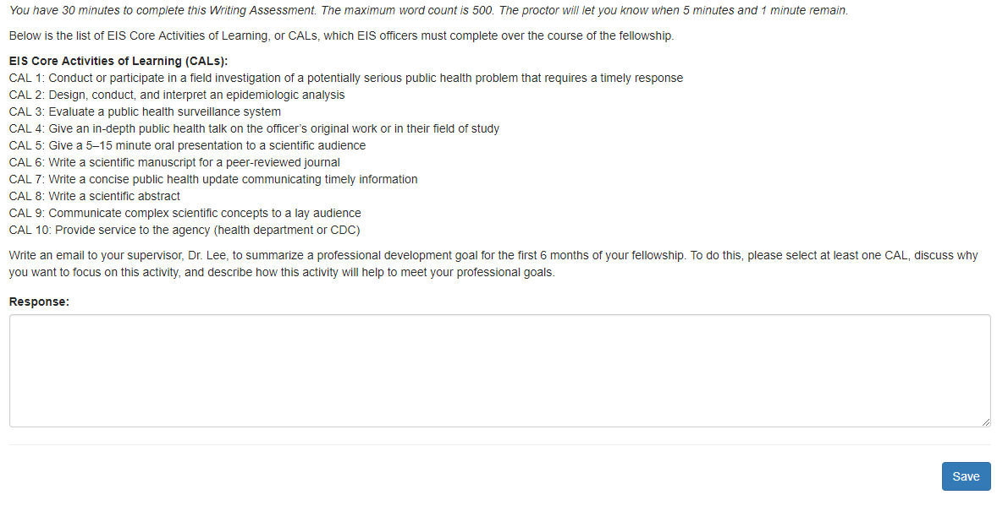

Figure 11.1-c Timed Personal Statement – Prompt B Page
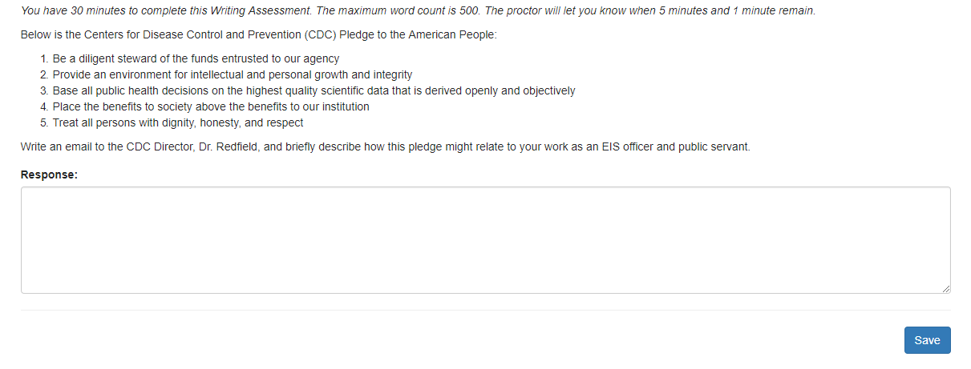

Figure 11.1-d Timed Personal Statement – Prompt C Page
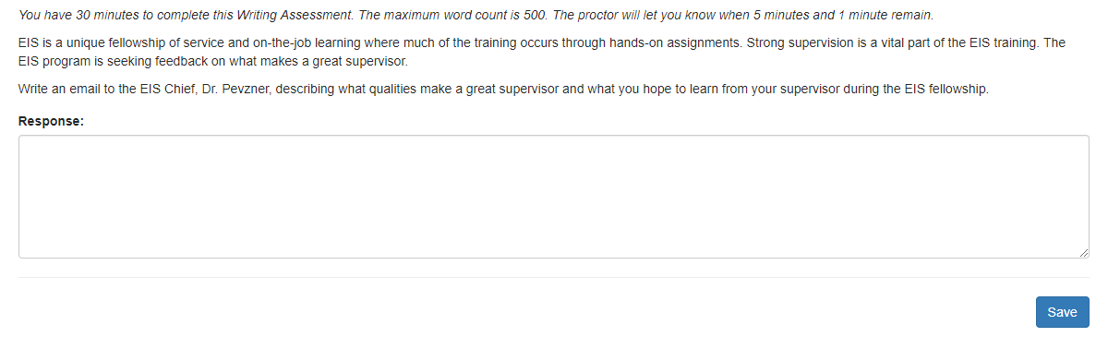
Table 11.1-a. Personal Statement Page Data Elements
Data Elements | Data Values | EIS | PHIF | Hubert | Epi-Elect | PEF | PMR/F | PHAP | SA
Personal Statement | Text | Yes  750 words limit | Yes  750 words limit | Yes  750 words limit | Yes  300 words limit | Yes  1000 words limit | Yes  1000 words limit | Yes  750 words limit | Yes  500 words limit
Timed Personal Statement | Text | Yes  500  words  limit | No | No | No | No | No | No | No
Section Complete | Yes/No Choice | Yes | Yes | Yes | Yes | Yes | Yes | Yes | Yes

