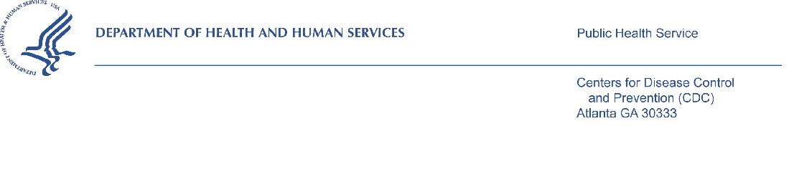
DATE

«FirstName» «LastName» «Credentials»
«Company»
«Address1»
«City», «State» «PostalCode»

Dear «FirstName» «LastName»:

Recently one of our staff contacted your hospital about participating in the 2018 CDC National Survey of Maternity Practices in Infant Nutrition and Care (mPINC). You were identified as the person most knowledgeable about these practices at your hospital. We are asking you to use the log in information below to complete the survey using a secure web server. Your participation is completely voluntary and it takes approximately 30 minutes to complete the survey.

The mPINC survey asks about day-to-day practices in mother-baby care at your hospital, and focuses on infant nutrition care including breastfeeding, use of formula by healthy newborns, and feeding routines. Since you are completing the survey on behalf of your hospital, you may find that the experience or knowledge of other staff within your hospital may be needed to answer some of the survey questions. As you complete the mPINC survey, please feel free to seek input from these colleagues.

This research study is being conducted by the Centers for Disease Control and Prevention (CDC) to assess infant feeding practices at maternity care hospitals in the United States and Territories. It was first administered in 2007 and has been administered every two years, allowing the monitoring of infant feeding practices trends over time. All hospitals in the United States and Territories identified as providing maternity care are being asked to participate in the survey, whether or not they participated in the previous surveys. We are using the American Hospital Association’s Annual Survey to identify these hospitals.

Once data collection and analysis are complete, we will send you an individualized report that will enable you to compare your hospital with other similar hospitals on indicators of infant feeding practices and policies. In addition, anonymous results from all hospitals will be summarized overall and for each state.

Public reporting burden of this collection of information is estimated to average 30 minutes per response, including the time for reviewing instructions, searching existing data sources, gathering and maintaining the data needed, and completing and reviewing the collection of information. An agency may not conduct or sponsor, and a person is not required to respond to a collection of information unless it displays a currently valid OMB control number. Send comments regarding this burden estimate or any other aspect of this collection of information, including suggestions for reducing this burden to CDC, Reports Clearance Officer, 1600 Clifton Road, MS D-74, Atlanta, GA 30329, ATTN: PRA (0920-0743). Do not send the completed form to this address.

Hospital of Interest
If your hospital has more than one location that provides maternity care, please complete the questionnaire only for the location identified below.

Hospital Name: <facility name>
Address: <address>
<city, state, zip>

If maternity care is no longer provided at your hospital, please email CDCMPINCSURVEY@battelle.org or call 1-866-826-4176.

Your responses will be treated in a secure manner and will not be disclosed unless required by law. Your name, hospital name, and any other personal identifiers will not appear when we present in oral or written presentation of study results. Providing your name, position, and official hospital email address is voluntary and will be used to send an electronic version of your hospital’s results; results will be mailed if you do not provide an email address.

Web Survey Security
Please use your internet browser to go to the home page at [insert website here]. Only authorized users may complete the survey and your unique username and password are provided below. Every precaution has been made to reduce the risk that unauthorized users could view your answers. The web survey is conducted from a "secure" https (SSL) server using the same type of internet security as is used for handling credit card transactions.

Use this unique username and password below to access the survey.

Your username is: <username>
Your password is: <password>

If you have any questions regarding this study, please call Robyn Sagatov, PhD, MHS, RD, Task Leader, Battelle, toll free at 1-866-826-4176. If you have any questions regarding your rights as a study subject, please contact the Battelle Institutional Review Board, at 1-877-810-9530, ext. 500.

The web survey will close at 11:59 PM on [insert date DD/MM/YYYY]. Please note, if you do not submit your survey responses by the deadline, your hospital’s information will not be included in the mPINC analysis and your hospital will not receive a benchmark report.

Thank you in advance for your time and participation in this important research endeavor.

Sincerely,

Rafael C. Flores-Ayala, DrPH, MApStat
Chief, Nutrition Branch
Division of Nutrition, Physical Activity, and Obesity
National Center for Chronic Disease Prevention and Health Promotion
Centers for Disease Control and Prevention

