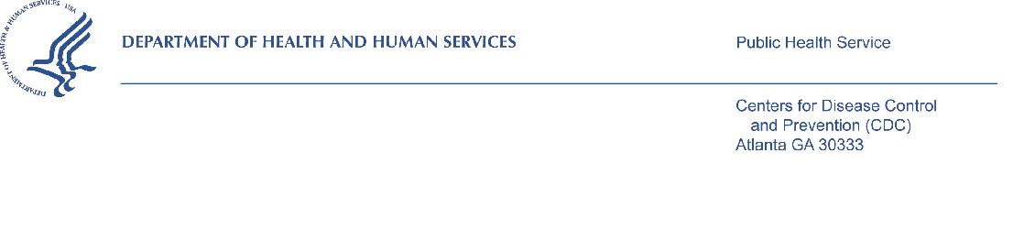
DATE
«FirstName» «LastName» «Credentials»
«Company»
«Address1»
«City», «State» «PostalCode»

Dear «FirstName» «LastName»:
We are following up with you because we received a paper copy of your completed CDC National Survey of Maternity Practices in Infant Nutrition and Care (mPINC) via mail. If you have already completed your survey on the web, please disregard this letter and thank you very much for taking the time to complete the survey. While, in past cycles of the mPINC survey, we have accepted paper copies of surveys, for this and future survey cycles, we are only able to accept surveys submitted online through our website.
If you wish to complete the web survey, use your internet browser to go to the home page at [insert website here]. Only authorized users may complete the survey and your unique username and password are provided below. Every precaution has been made to reduce the risk that unauthorized users could view your answers. The web survey is conducted from a "secure" https (SSL) server using the same type of internet security as is used for handling credit card transactions.

Use this unique username and password below to access the survey.

Your username is: <username>

Your password is: <password>

In order to have an accurate understanding of infant feeding practices at maternity care hospitals in all States and Territories, we want to emphasize the importance of having every hospital that provides maternity care complete the survey. Your participation is completely voluntary and it takes approximately 30 minutes to complete the survey.
In case you have misplaced your survey or information about the survey, we are requesting your participation in the CDC National Survey of Maternity Practices in Infant Nutrition and Care (mPINC). This research study is being conducted by the Centers for Disease Control and Prevention (CDC) to assess infant feeding practices at maternity care hospitals in the United States and Territories. All hospitals in the United States and Territories we identify as providing maternity care are being asked to participate in the survey. We are using the American Hospital Association’s Annual Survey to identify these facilities. Once data collection and analysis are complete, we will send you an individualized report that will enable you to compare your facility with other similar facilities on indicators of infant feeding practices and policies. In addition, anonymous results from all facilities will be summarized overall and for each state.

Public reporting burden of this collection of information is estimated to average 30 minutes per response, including the time for reviewing instructions, searching existing data sources, gathering and maintaining the data needed, and completing and reviewing the collection of information. An agency may not conduct or sponsor, and a person is not required to respond to a collection of information unless it displays a currently valid OMB control number. Send comments regarding this burden estimate or any other aspect of this collection of information, including suggestions for reducing this burden to CDC, Reports Clearance Officer, 1600 Clifton Road, MS D-74, Atlanta, GA 30329, ATTN: PRA (0920-0743). Do not send the completed form to this address.

Hospital of Interest

If your hospital has more than one location that provides maternity care, please complete the questionnaire only for the location identified below.

Hospital Name: <facility name>
Address: <address>
<city, state, zip>

If maternity care is no longer provided at your facility, please e-mail CDCMPINCSURVEY@battelle.org or call 1-866-826-4176.
Your responses will be treated in a secure manner and will not be disclosed unless required by law. Your name, facility name, and any other personal identifiers will not appear in oral or written presentations of study results. Access to documents and electronic files is restricted to the research staff working on the study. Providing your name, position, and official hospital email address is voluntary and will be used to send an electronic version of your hospital’s results; results will be mailed if you do not provide an email address.

If you have any questions regarding this study please call Robyn Sagatov, PhD, MHS, RD, Task Leader, Battelle, toll free at 1-866-826-4176. If you have any questions regarding your rights as a study subject, please contact the Battelle Institutional Review Board, at 1-877-810-9530, ext. 500.

The web survey will close at 11:59 PM on [insert date DD/MM/YYYY]. Please note, if you do not submit your survey responses by the deadline, your hospital’s information will not be included in the mPINC analysis and your hospital will not receive a benchmark report.

Thank you in advance for your time and participation in this important research endeavor.

Sincerely,

Rafael C. Flores-Ayala, DrPH, MApStat
Chief, Nutrition Branch

Division of Nutrition, Physical Activity, and Obesity

National Center for Chronic Disease Prevention and Health Promotion

Centers for Disease Control and Prevention

