**APPENDIX E: In-depth Interview (IDI) Semi-Structured Guide and Showcards**

**OMB # 0920-1091**

**Expiration Date: 09/30/2021**

|  |
| --- |
| Public reporting burden of this collection of information is estimated to average 60 minutes per response, including the time for reviewing instructions, searching existing data sources, gathering and maintaining the data needed, and completing and reviewing the collection of information. An agency may not conduct or sponsor, and a person is not required to respond to a collection of information unless it displays a currently valid OMB control number. Send comments regarding this burden estimate or any other aspect of this collection of information, including suggestions for reducing this burden to CDC/ATSDR Reports Clearance Officer; 1600 Clifton Road NE, MS D-74, Atlanta, Georgia 30333; ATTN: PRA (0920-1091). |

|  |
| --- |
| **INTRODUCTION** |

Thank you for agreeing to take part in this interview. Because there will be a lot of information that I will not be able to remember in detail or write down, I would like to audio record this interview. Your name will not be linked to any of your responses. If you should mention your own or another person’s name during the interview, we will omit the name(s) from the transcript.

There are no right or wrong answers to any of the questions that I will be asking you. I really am interested in learning about how you see things and what your experiences have been. I would like you to be as honest as you are comfortable being so that we can get the best information possible. Please remember that your participation is voluntary. You do not have to answer any questions that you do not wish to answer, and you are free to leave/stop interview at any time. There will be time after the interview to address any questions or comments that you might have.

I will begin audio-recording the interview now. Is that okay?

|  |
| --- |
| **INSTRUCTIONS TO THE INTERVIEWER:**   1. **Turn on tape recorder and ask for verbal consent to record the interview** 2. **Verbally label audio file with the case ID, locale code, date, and your staff ID** |

Let’s start by talking about contraception. To make sure that we are on the same page, I am talking about methods used by sexually active women to avoid getting pregnant. I am asking questions in terms of your personal thoughts, behaviors, and feelings. However, if you are more comfortable talking about what other women, such as friends or family, think or do, please do so.

What do you think about when considering a birth control method?

* 1. What has been most important to you in selecting a birth control method?
  2. What types of birth control methods would you not consider using?
     1. What makes this a/these method(s) no-go(es) for you?
  3. In your opinion, what is the most difficult part of using birth control?

1. Tell me about any discussions that you have had with a doctor or nurse about pregnancy prevention.
2. If you were talking to other women you know, such as family, friends or co-workers, how would you explain what the term “reproductive health” means?
3. How would your description of reproductive health compare to an explanation that you might give them about “sexual health”?

For the purposes of this study, think of sexual health broadly in terms of physical, emotional, mental and social well-being as it relates to your sexuality.

1. How do you think women usually get information on sexual health?
   1. In general, how useful do you think the information that women receive is?
   2. What types of information would be more useful to women?
2. Describe sexual health services that you have used.
   1. (If R cannot describe “sexual health services”) What about women’s health services?

Now, I would like to talk about infections that might be due to sexual activity.

1. What steps, if any, do you take to protect yourself against STDs or sexually transmitted diseases?

*(Optional) If no steps are taken, ask:*

*Please tell me what makes you <not at risk>/<not take any steps>.” or*

*What steps do you think other women who at risk for STDs or sexually transmitted diseases might take?”*

1. How are these steps possibly related to steps taken to avoid pregnancy?
2. Tell me about any discussions that you have had with a doctor or nurse about preventing STDS or sexually transmitted diseases, including HIV.

Now, I would like to talk about HIV.

1. What steps, if any, do you take to protect yourself against HIV?

We are now going to talk about products for preventing HIV. These would be products that were developed by a drug company and eventually made available to women by a doctor, a pharmacy, or drug store.

1. First, please tell me what you have heard about a pill that is taken daily to prevent HIV infection. This pill is referred to as oral PrEP.

|  |
| --- |
| **VIEWS ON HIV PREVENTION BIOMEDICAL TECHNOLOGIES** |

Next, I am going to tell you a little bit about 3 products to help prevent HIV among women. These products are either in early phases of development or they are being tested in human trials. One of these products may also be used to prevent pregnancy. I will ask you the same set of questions about each of the products.

For each product, I will first give you some quick facts and ask for your first impression. Next, I will show the product to you and ask again for your initial reaction. Finally, I will give you some more information about the product and how it would work.

Before I begin telling you about the first product, I would like to cover things that are similar for all three.

|  |
| --- |
| **Present and Read Showcard #0. Products' Common Characteristics to participant** |

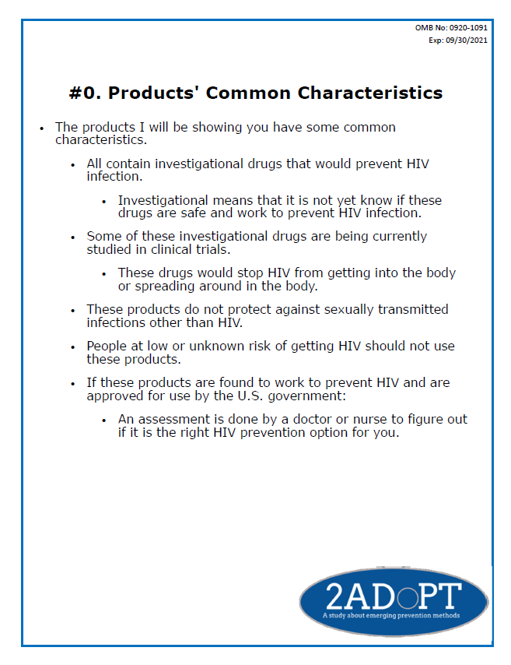

|  |
| --- |
| **PROTOTYPE PRODUCT #1: LONG-ACTING INJECTABLE QUICK FACTS** |

**Interviewer read:**

* The first product is a long-acting injection.
  + An injection is also referred to as a shot, so we will use the word shot instead
* The shot would be given into a muscle in the butt or upper thigh.
* The shot can be used by both women and men.
* A shot with an investigational HIV-prevention drug is being currently studied.

1. What first comes to mind in hearing about this long-acting shot? **(Do not probe. Take notes and follow-up when presenting the three prototype-related questions if necessary)**

|  |
| --- |
| **Show Long-acting Injectable Prototype to participant**  **Ask question 13 at the same time that you show the prototype to the participant** |

1. What first comes to mind now that you are actually seeing this long-acting shot? **(Do not probe. Take notes and follow-up when presenting the three prototype-related questions if necessary)**

|  |
| --- |
| **Present and Read Showcard #1. Long-acting Injectable Prototype to participant**   * **Present prototype related components as you mention them** * **After all information is read, put away components and leave only showcard** |

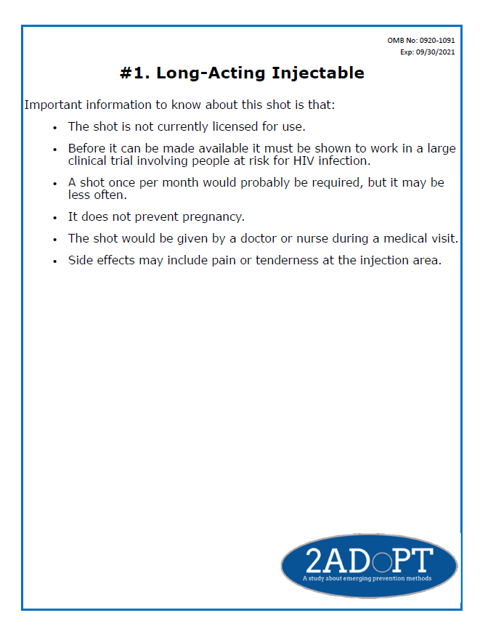

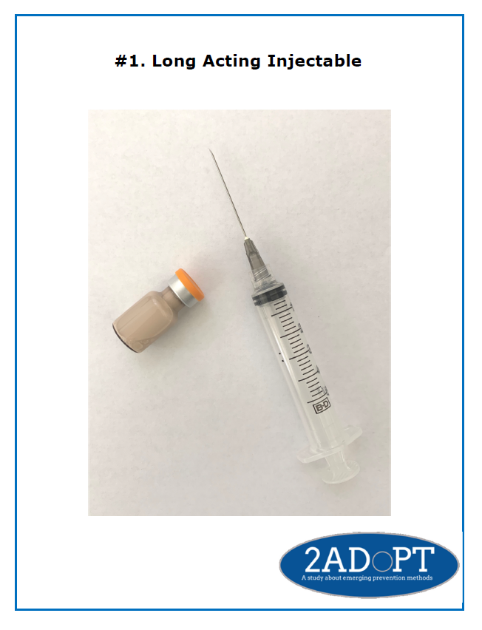

* 1. What could affect whether or note you would consider using this long-acting shot?
  2. What could affect whether or not other women would consider using this long-acting shot?
  3. What challenges might one face when using a method like this long-acting shot?

|  |
| --- |
| **PROTOTYPE PRODUCT #2: IMPLANT QUICK FACTS** |

**Interviewer read**:

* The second product is a thin tube inserted beneath the skin.
  + This tube is called an implant, so we will use the word implant.
* The implant is usually inserted inside the upper arm.
* The implant can be used by both women and men.

1. What first comes to mind in hearing about this implant? **(Do not probe. Take notes and follow-up when presenting the three prototype-related questions as necessary)**

|  |
| --- |
| **Show implant prototype to participant (only small plastic implant)**   * **ask question 15 at the same time that you show the prototype to the participant** |

1. What first comes to mind now that you are actually seeing this implant? **(Do not probe. Take notes and follow-up when presenting the three prototype-related questions as necessary)**

|  |
| --- |
| **Present and Read Showcard #2. Implant to participant**   * **present prototype related components as you mention them** * **after all information is read, put away components and leave only showcard** |

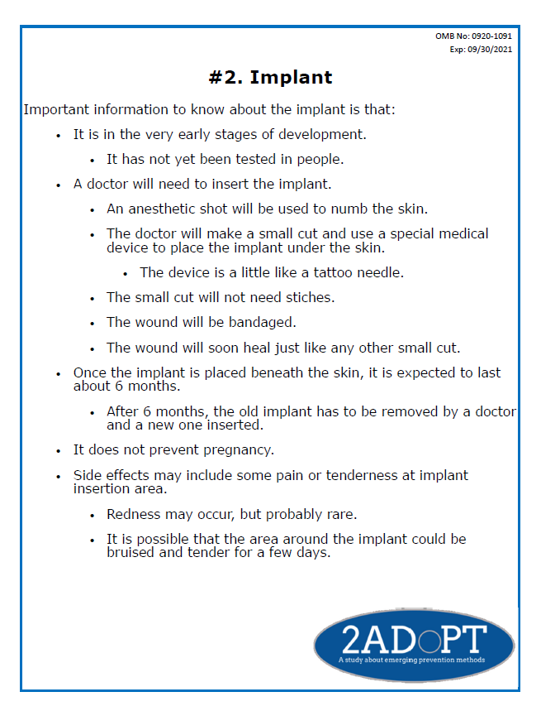

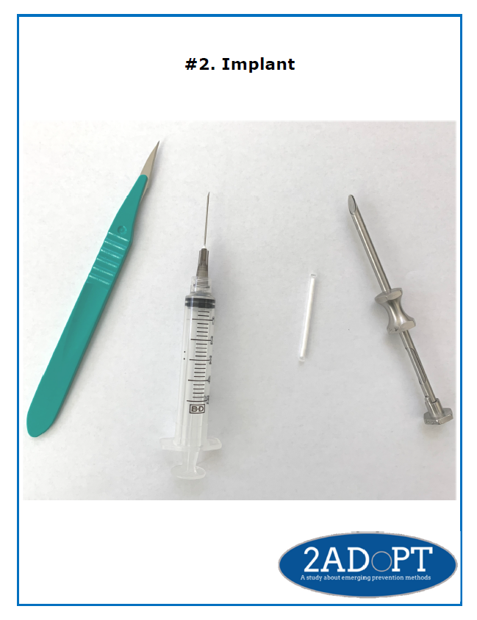

15a. What could affect whether or not you would consider using this implant?

15b. What could affect whether or not other women would consider using this implant?

15c. What challenges might one face when using a method like this implant?

|  |
| --- |
| **PROTOTYPE PRODUCT** **#3****: INTRAVAGINAL RING QUICK FACTS** |

**Interviewer read:**

* The third product is a flexible intravaginal ring
  + We will refer to the intravaginal ring as the ring.
* The ring, which is inserted into the vagina for one month or longer, prevents both HIV and pregnancy.
* The ring is only to be used by women.

1. What first comes to mind in hearing about this ring? **(Do not probe. Take notes and follow-up when presenting the three prototype-related questions if necessary)**

|  |
| --- |
| **Show intravaginal ring prototype to participant** |
| * **Ask question 17 at the same time that you show the prototype to the participant** |

1. What first comes to mind now that you are actually seeing this ring? **(Do not probe. Take notes and follow-up when presenting the three prototype-related questions if necessary)**

|  |
| --- |
| **Present and Read Showcard #3. Intravaginal Ring to participant** |
| * **Present prototype related components as you mention them** |
| * **After all information is read, put away components and leave only showcard** |

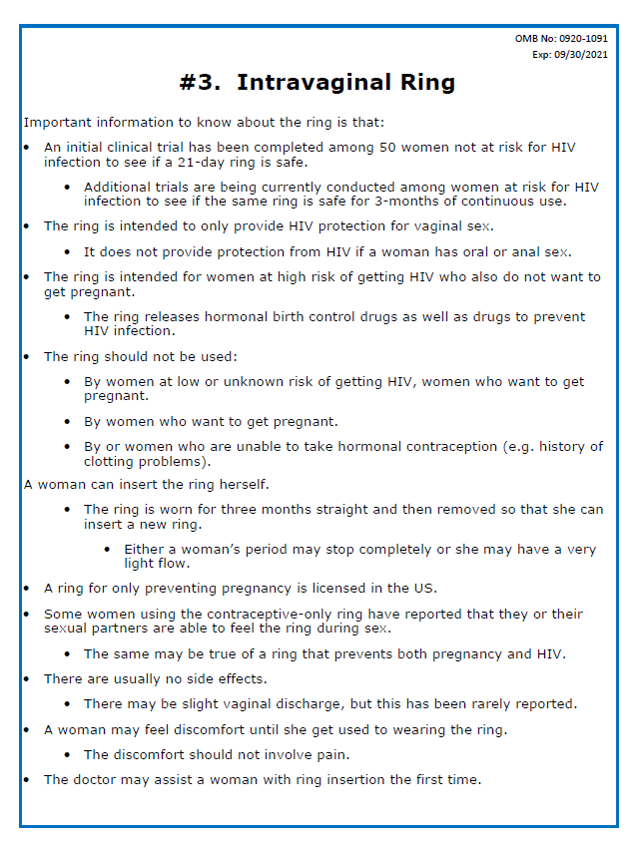

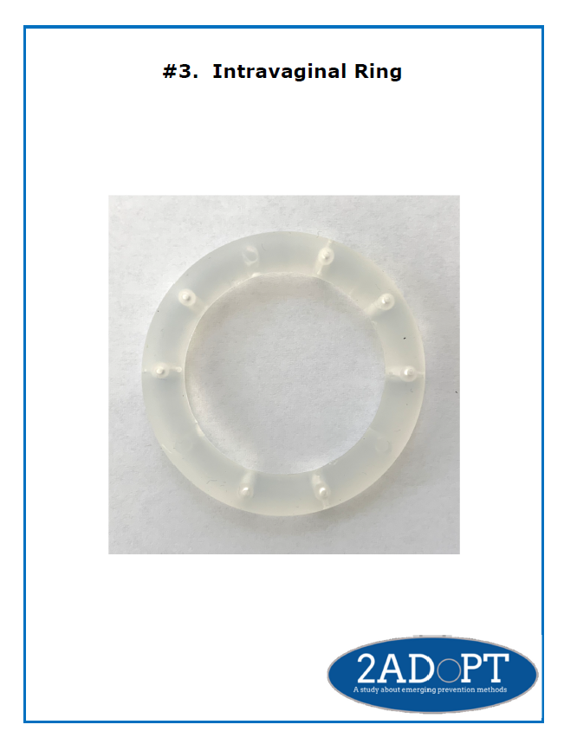

* 1. What could affect whether or not other women would consider using this ring?
  2. What challenges might one face when using a method like this ring?

Now I would like to talk about things that would help women actually using these products in their everyday lives. Using your own experiences or those of others, what would be needed for women to adopt these 3 products?

1. If you had to pick from these 3 products for yourself, which one would you pick and why?
   1. Which one(s), if any, would you automatically say no to?
   2. What are the reasons that you would not be interested in this/these products?

Thank you for your thoughtful responses. I have a few questions to ask you, and then I’ll give you your $40 incentive, and we will be all done.

|  |
| --- |
| **INSTRUCTION TO THE INTERVIEWER: Turn off audio recorder(s) and administer Demographic and Behavioral CAPI.** |