Attachment 97

Medical Expenditure Panel Survey

Medical Provider Component

Other Respondent Materials

Used for Home Care, Office-Based Doctors, Separately Billing Doctors, Hospital, and Institution Providers

**Template 1a (First contact when unable to reach by phone, non-SBD provider)**

Dear [POC Name]:

I was given your name as the point of contact for supplying medical/billing records for [fill in with doctor or provider’s name].

I am contacting you regarding the Medical Expenditure Panel Survey – Medical Provider Component (MEPS-MPC). This study is sponsored by the U.S. Department of Health and Human Services (DHHS) and provides government policymakers and private researchers accurate information about the rapidly changing health care situation in this country. *One or more of your patients has given us written authorization to request information from you regarding their medical and billing records for the year 2017*.

To follow through with your patient(s)’s request, we need your help to gather information for this important study. The information we need includes determining the actual dates of service, the diagnoses/conditions, the services provided, the amount that was charged, the amount that was paid, and the sources of payment for services provided in 2017.

**In order to remain HIPAA compliant, it is critical that you do not include any personally identifiable information and protected health information throughout this email communication.**

Please contact us toll-free at 1-866-800-9203 or feel free to email me at [insert email address] so we can send you the study materials and copies of the authorization forms your patient(s) signed. The information we are requesting from you is vital to this nationally important study.

Sincerely,  
QCS/DCS Name

**Template 1b (Initial Contact for SBD provider)**

Dear [POC Name]:

I was given your name as the point of contact for billing and payment records for professional fees associated with [fill in with Provider or Billing Service Name] for doctors who specialize in [insert specialties].

I am contacting you regarding the Medical Expenditure Panel Survey – Medical Provider Component (MEPS-MPC).  This study is sponsored by the U.S. Department of Health and Human Services (DHHS) and provides government policymakers and private researchers accurate information about the rapidly changing health care situation in this country.   One or more of your patients has given us written authorization to request information from you regarding their billing and payment records for the year 2017.

To follow through with your patient(s)’s request, we need your help to gather information for this important study.  The information we need includes determining the actual dates of service, the services provided, the amount that was charged, the amount that was paid, and the sources of payment for services provided in 2017.

We will reimburse your hospital for the expense of providing records to us, and we are eager to proceed in a manner that is most convenient for you (collecting the billing and payment records through secure email, FTP, electronic portal, fax, mail, over the phone, or through transfer of a data file).

Please contact me toll-free at 1-866-800-9203 or feel free to email me at [[insert](mailto:CWilliams_83020@ccs.rti.org) email address]so we can arrange to send you the study materials and copies of the authorization forms your patient(s) signed organized in a manner that is most convenient for you.

Thank you,

QCS/DCS Name

**Template 2- Thank you (After initial contact)**

Dear [POC Name]:

Thank you for your participation in the MEPS-MPC and taking the time to speak with me today. We look forward to receiving the ***[medical/billing records]*** from your ***[fill in provider type]***

As you know, the MEPS-MPC sponsored by the U.S. Department of Health and Human Services (DHHS), provides government policymakers and private researchers accurate information about the rapidly changing health care situation in this country. The records we receive from you are very important part of the MEPS-MPC study.

**In order to remain HIPAA compliant, it is critical that you do not include any personally identifiable information and protected health information throughout this email communication.**

Thanks again for your help and if you have any questions, please contact me at 1-866-800-9203.

Sincerely,

QCS/DCS Name

**Template 3- Thank you (After AFs are confirmed)**

Dear [POC Name]:

Thank you for your participation in the MEPS MPC and taking the time to speak with me today. We look forward to receiving the ***[medical/billing records]*** from your hospital.

As you know, the MEPS MPC sponsored by the U.S. Department of Health and Human Services (DHHS), provides government policymakers and private researchers accurate information about the rapidly changing health care situation in this country. The records we receive from you are very important part of the MEPS MPC study.

Thanks again for your help and if you have any questions, please contact me at 1-866-800-9203.

Sincerely,

QCS/DCS Name

DATE

POC NAME

ADDRESS

CITY/STATE/ZIP

Dear PROVIDER NAME:

We have been trying to reach you for several weeks to speak with you about the Medical Expenditure Panel Survey (MEPS MPC). The MEPS MPC is sponsored by the U.S. Department of Health and Human Services (DHHS) and is conducted annually. The study helps provide accurate information to government policymakers and private researchers about the rapidly changing health care situation in this country. Over the past couple of years many important changes have taken place in the way people choose their providers of medical care, the way in which health care is paid for and the kinds of health insurance plans and services covered by those plans. Because of these changes, it is important to have the most up to date information on the types of health care your patients obtain and how it is paid for.

[FILL IN NUMBER OF PATIENTS] patients that received services at your hospital have given us written authorization to request information from you regarding their medical and billing records for the year 2017. Your participation and collecting your patient’s information is critical to the success of the MEPS MPC. Our records show that your hospital last gave information for MEPS in [FILL IN YEAR]. We would appreciate your help in providing the MEPS MPC information again this year.

Data collection for the 2017 MEPS MPC started in February of this year and ends in October. Last year, we automated the data collection process by programming our forms for electronic administration to make the process more efficient and easier for you. Because of the changes, we expect a continued reduction in the number of calls back to providers for clarification. We also expect a reduction in human error and are relying less on editors whose review may generate calls to providers later in the data collection period, often times causing unnecessary confusion.

FOR EACH PATIENT EVENT WE NEED THE FOLLOWING:

✓ Date of Service in 2017

✓ Services Provided in 2017 (e.g., CPT-4, DRG, revenue code, HCPCS, or description, etc.)

✓ Diagnoses or Conditions (e.g., ICD-10 Codes, or descriptions, etc.)

✓ All Names, Roles, Specialties, and Contacting Information for All Doctors Who May Have Billed

Separately for These Dates of Service

We will accept this information in a method that is convenient for you. Given the number of patients associated with your hospital, it may be easier for you to provide the information hardcopy via fax, mail or electronically. We will reimburse your hospital for the expense of providing records to us. Your participation is what allows the MEPS MPC to collect thorough and accurate information about health and health care costs in the United States. Thank you for your consideration.

If you have any questions or need additional information, please do not hesitate to contact me directly at (919) 541-6262.

Sincerely,



Kathryn Dowd

MEPS MPC Project Director

DATE

## POC NAME

ADDRESS

## CITY/STATE/ZIP

Dear PROVIDER NAME:

Thank you for speaking with my colleague [NAME] on the Medical Expenditure Panel Survey Medical Provider Component (MEPS MPC) about the information and patient authorization forms we sent you. At that time, you indicated that you would be sending us [FILL IN MEDICAL OR BILLING RECORDS] for patients that received services at your hospital and gave written permission to release records for participation in the MEPS MPC.

We have not received the [FILL IN MEDICAL OR BILLING RECORDS] yet and wanted to follow up with you. As the materials we sent you explain, the MEPS MPC is sponsored by the U.S. Department of Health and Human Services (DHHS) and is conducted annually. The study helps provide accurate information to government policymakers and private researchers about the rapidly changing health care situation in this country. Over the past couple of years many important changes have taken place in the way people choose their providers of medical care, the way in which health care is paid for and the kinds of health insurance plans and services covered by those plans. Because of these changes, it is important to have the most up to date information on the types of health care your patients obtain and how it is paid for.

[FILL IN NUMBER OF PATIENTS] patients that received services at your hospital have given us written authorization to request information from you regarding their medical and billing records for the year 2017. Your participation and collecting your patient’s information is critical to the success of the MEPS MPC. Our records show that your hospital last gave information for MEPS in [FILL IN YEAR]. We would appreciate your help in providing the MEPS MPC information again this year.  
FOR EACH PATIENT EVENT WE NEED THE FOLLOWING:

* Date of Service in 2017
* Services Provided in 2017 (e.g., CPT-4, DRG, revenue code, HCPCS, or description, etc.)
* Diagnoses or Conditions (e.g., ICD-10 Codes, or descriptions, etc.)
* All Names, Roles, Specialties, and Contacting Information for All Doctors Who May Have Billed

Separately for These Dates of Service

We will accept this information in a method that is convenient for you. Given the number of patients associated with your hospital, it may be easier for you to provide the information hardcopy via fax, mail or electronically. We will reimburse your hospital for the expense of providing records to us. Your participation is what allows the MEPS MPC to collect thorough and accurate information about health and health care costs in the United States. Thank you for your consideration.

If you have any questions or need additional information, please do not hesitate to contact me directly at (919) 541-6262.

Sincerely,

  
  
Kathryn Dowd  
MEPS MPC Project Director

**MEPS Messaging to POCs:**

**Initial contact**:

Hi POC. I hope you have been doing well since we were last in touch a few months ago. Thank you again for honoring your customers’ wishes in releasing their prescription profiles for MEPS, our yearly research study on how health care is used and paid for.

I’m back in touch with you because we have once again a number of your customers who would like their YEAR records released to us. If that is okay with you, I will send the authorization forms to you as I did last year [DESCRIBE PREVIOUSLY NEGOTIATED AGREEMENT]. However if your preferences have changed or there is someone else I should be working with this year, please point me in the right direction.

Many thanks.

**Reminder prompt:**

Hi POC. I hope you are doing well. Just wanted to check in with you to find out whether you have had a chance to begin working on our request for the release of YEAR prescription records for those customers who are asking for their release for our research study. Please let me know if this is still doable for you and if not, let me know what adjustments we can make to make this easier for you. It would be great if we could get the profiles by DATE but we work within your time frame so let me know whether that timeline works.

Thanks again for all your help.



February 16, 2018

Dear

We’d like to thank you for your assistance over the last year with providing 2016 patient records for the Medical Expenditure Panel Survey- Medical Provider Component (MEPS MPS) and alert you to the start of our cycle for requesting 2017 records. The MEPS MPC is sponsored by the U.S. Department of Health and Human Services (DHHS) and is conducted annually. The study helps provide accurate information to government policymakers and private researchers about the rapidly changing health care situation in this country. Over the past couple of years many important changes have taken place in the way people choose their providers of medical care, the way in which health care is paid for and the kinds of health insurance plans and services covered by those plans. Because of these changes, it is important to have the most up to date information on the types of health care your patients obtain and how it is paid for. We are grateful for your continued participation.

We have assigned _________________ to be the primary point of contact with you this year. ____ will reach out to you in the coming week to discuss next steps. We strive to make records transfer as convenient as possible for you. We will accept data or records in a method that is convenient for you including secure email or FTP of a data file or images of records, via third party platforms (i.e. Ciox Health, Chartswap, IOD, Incorporated, etc.) or the project’s electronic portal, faxed records, mailed records, or a mailed CD containing images of records or a data file. _________ can discuss each of these options with you in more detail.

We are also willing to reimburse your hospital for the expense of providing records to us, and if there is anything else we can do to facilitate this process, please let ________know.

Your participation is what allows the MEPS MPC to collect thorough and accurate information about health and health care costs in the United States. Thank you again for your participation.

Sincerely,



Kathryn Dowd

MEPS MPC Project Director

DATE, 2

CEO CONTACT INFO

Dear xxxx,

You may have heard of our research study MEPS which is **authorized yearly by your patients to obtain their medical and billing records.** We are again attempting to honor your patients’ wishes to release their records for our research on how people use and pay for health care in the U.S.

There are a number of XX facilities in our yearly sample and through your staff’s feedback regarding what makes participation difficult for them; we have made a number of adjustments we hope will centralize our requests for records. However, in order to carry out this more efficient process we need your help in **identifying a point of contact we can work with who can receive the signed patient authorization forms and subsequently release the medical and billing records to us**.

We work with many large providers like XX with whom we have efficiently centralized requests. Following are options that may accommodate your staff’s participation needs:

* ***We pay a fee per record*** released to cover your staff labor or cover temp labor you assign to our requests
* We provide a consolidated spreadsheet (sample enclosed) with all patient names, identifiers and locations where patients received services.
* HIPAA compliant authorization forms (samples enclosed) and spreadsheets can be loaded on a disc for ease. Some facilities do a data import directly on a disc and return that to us instead of paper.
* Records can be quickly uploaded via our electronic portal.
* If you use any 3rd party companies to release records on your behalf, we have arrangements to receive the records through them with your approval.
* If a data agreement or other business agreements need to be signed, we are familiar with that process.

Please consider these options and let me know what works best. I’ve included my contact information on the letter for ease in follow up.

Thanking you in advance for your consideration!



Negotiator Name Kathryn Dowd

MEPS-MPC Negotiator MEPS MPC Project Director

Negotiator Phone Number

Negotiator Email

DATE

## POC NAME

ADDRESS

## CITY/STATE/ZIP

Dear [POC Name]:

One of our specialists has been trying to reach you regarding the Medical Expenditure Panel Survey Medical Provider Component (MEPS MPC). This study is sponsored by the U.S. Department of Health and Human Services (DHHS) and helps provide accurate information to government policymakers and private researchers about the rapidly changing health care situation in this country.

*One or more of your patients has given us written authorization to request information from you regarding their medical and billing records for the year 2017*. To follow through with your patient(s)’s request, we need your help to gather information for this important study. The information we need includes determining the actual dates of service, the diagnoses/conditions, the services provided, the amount that was charged, the amount that was paid, and the sources of payment for services provided in 2017.

Please contact us toll-free at **1-866-800-9203** so we can send you the study materials and copies of the authorization forms your patient(s) signed. The information we are requesting from you is vital to this nationally important study.

This call will only take a few minutes of your time and we can contact you at your convenience. We offer options to provide the information by phone, fax, mail, or electronic portal. If you have any questions or would like to speak with someone about the study or this request, again please call us toll-free at **1-866-800-9203**.

Thank you very much for your time and cooperation.

Sincerely,

  
  
Kathryn Dowd  
MEPS-MPC Project Director

DATE

## POC NAME

ADDRESS

## CITY/STATE/ZIP

Dear [POC Name]:

One of our representatives recently spoke to you about the Medical Expenditure Panel Survey Medical Provider Component (MEPS MPC). This study is sponsored by the U.S. Department of Health and Human Services (DHHS) and is an important research study that provides accurate information to government policymakers and private researchers about the rapidly changing health care situation in this country.

One or more of your patients has given us written authorization to request information from you regarding their medical and billing records for the year 2017. To follow through with your patient(s)’s request, we need your help to gather information for this important study. The information we need includes determining the actual dates of service, the diagnoses/conditions, the services provided, the amount that was charged, the amount that was paid, and the sources of payment for services provided in 2017.

To accomplish this goal, we need your help. Last time we contacted you, it was not a convenient time for you. We understand you are busy and this call will only take a few minutes of your time and we can contact you at your convenience. We also offer options to provide the information we are requesting by phone, fax, mail, or electronic portal. The information we are requesting is not available from anyone else, and therefore, it is *very important* that we speak with you to obtain it.

If you have any questions or would like to speak with someone, please call us toll-free at **1-866-800-9203**.

Thank you very much for your time and cooperation.

Sincerely,

  
  
Kathryn Dowd  
MEPS MPC Project Director

[DATE] MEPS ID#: 1XXXXXX

[Provider Name]

[Provider Address]

[Provider City/State/zip]

Attn: To Whom It May Concern

Thank you for your participation in the Medical Expenditure Panel Survey - Medical Provider Component (MEPS-MPC). We appreciate your assistance in providing information for this very important study.

Enclosed you will find the payment you require for providing billing records for participation in the MEPS-MPC.

The following patient(s) information is requested:

Patient’s Name

Patient’s Name

Patient’s Name

The information we need to confirm for each patient:

* Date of Service
* Services Provided
* Diagnoses/Conditions
* Payments and who made them (private insurance, Medicare, Medicaid, out-of-pocket, etc.)
* Charges for each service provided and total charges

Your participation enables the MEPS-MPC to report thorough and accurate information about health and health care costs in the United States.

If you have any questions, please contact us at 1-866-800-9203.

Thank you in advance for your time and assistance.

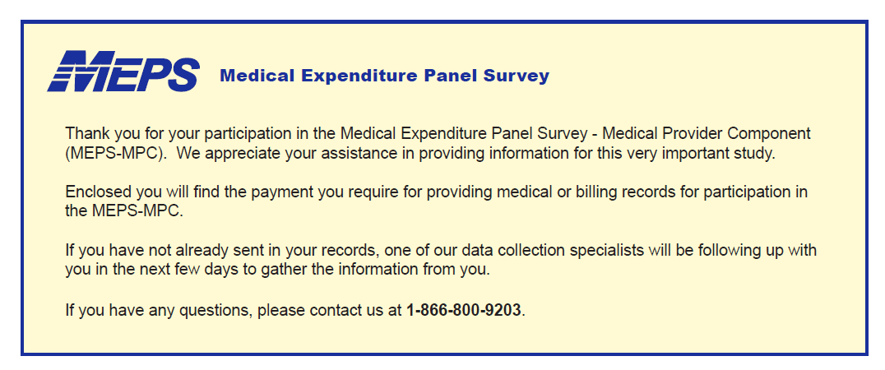

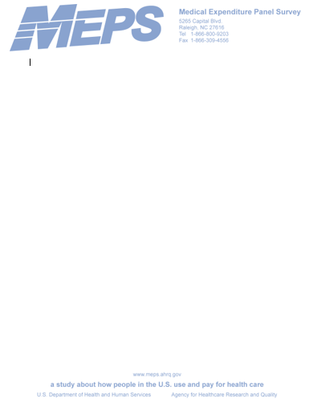

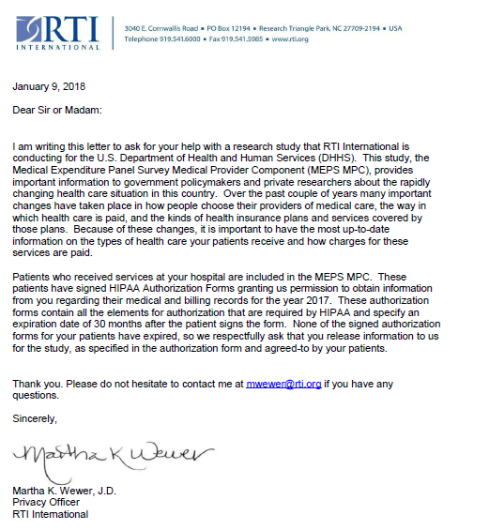



**Template for POCs who choose to upload records via the electronic portal**

Dear [POC Name]:

You recently requested patient authorization forms from the Medical Expenditure Panel Survey (MEPS) team. This email provides instructions for accessing the portal site where you can download and open the encrypted PDF file containing these authorization forms. Please remember that these PDF files are only available for the next 7 days. If you cannot access them until after 7 days, you will need to call staff to have them recreate the PDFs.

To access the site and open the file, you will need the password that our data collection staff provided to you during your phone call. If you do not remember your password, or did not receive one, please call us at {{tollFreeNumber}} and we will be happy to assist you. When calling with questions, use reference <insert GID>.

To access the patient authorization forms, you will need to log into our provider portal site at {{portalSiteURL}}. Your username will be {{portalUserName}}. Unless you have accessed the site previously and changed your password, your password will be the portal password provided to you by the MEPS staff during your call.

Once you log into the portal site, click the link to the file downloads area. Here you will see any files currently available for download, as well as a list of archived files you may have downloaded previously. Click on the file named {{filename}} to see the PDF file we prepared for your request. Once you download the file, you will be prompted to enter a password to view it. Please note that the password to view the file is the one provided by the MEPS staff and this password is customized for each file and is different than your portal password. You can change your portal password at any time. The PDF password will always be the one provided during your phone call and will not change.

Sincerely,  
MEPS Data Collection Staff