Figure 1: Submit Data Use Agreement (DUA) and Link DUA to Medical Office(s)
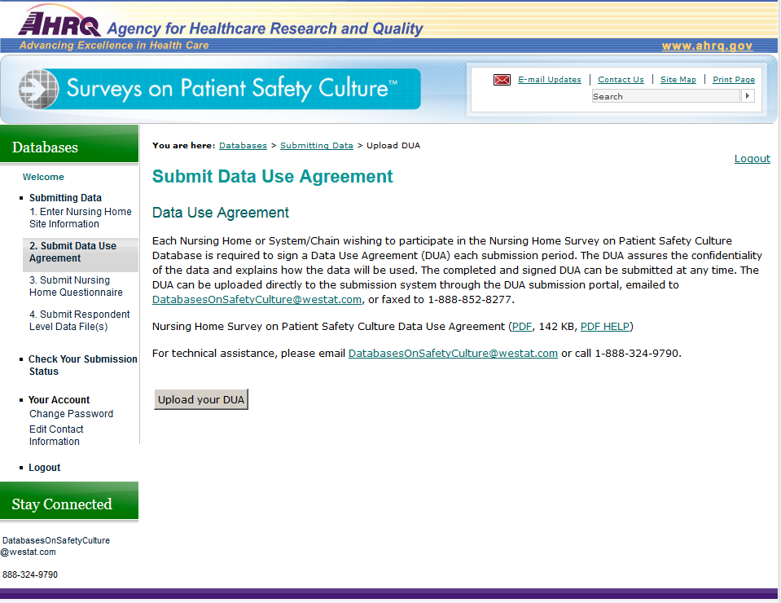

Figure 1: Submit Data Use Agreement (DUA) and Link DUA to Medical Office(s), continued
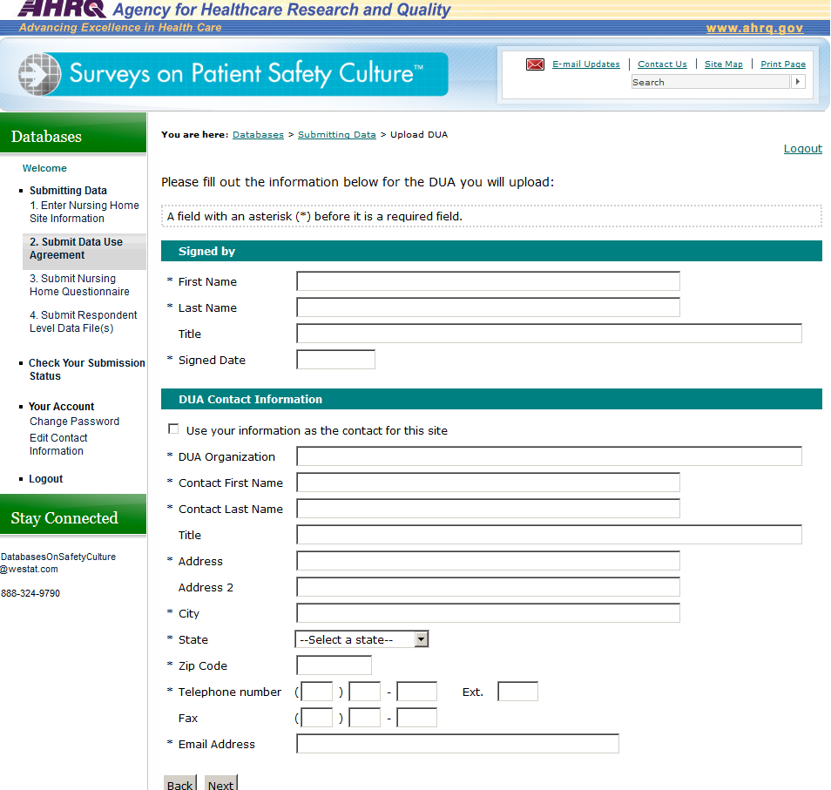
Figure 1: Submit Data Use Agreement (DUA) and Link DUA to Medical Office(s), continued
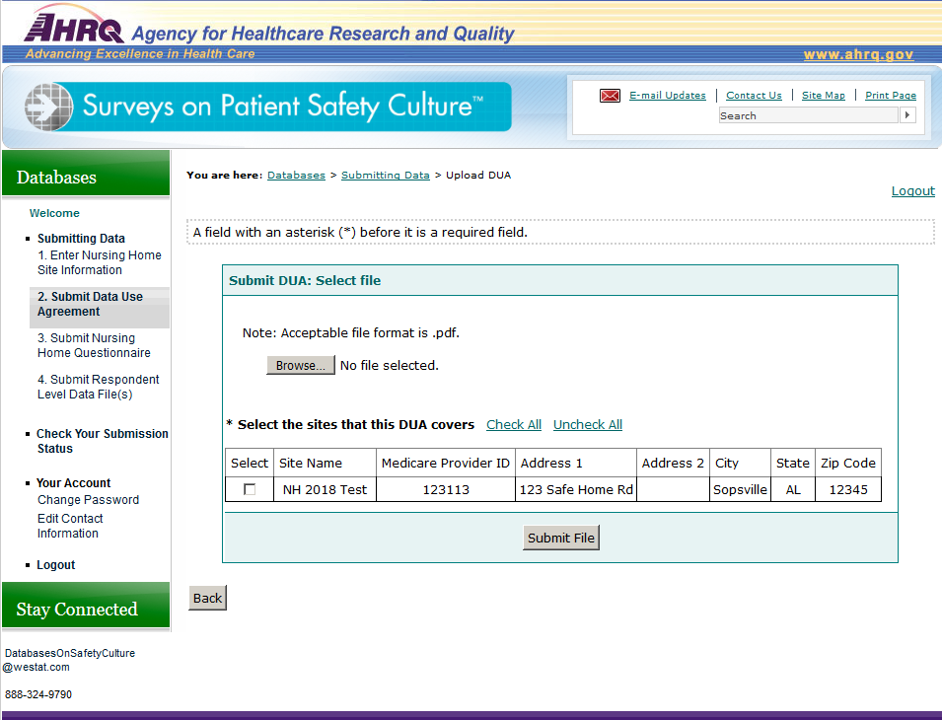
Figure 2: Submit Questionnaire and Link Questionnaire to Nursing Home(s)
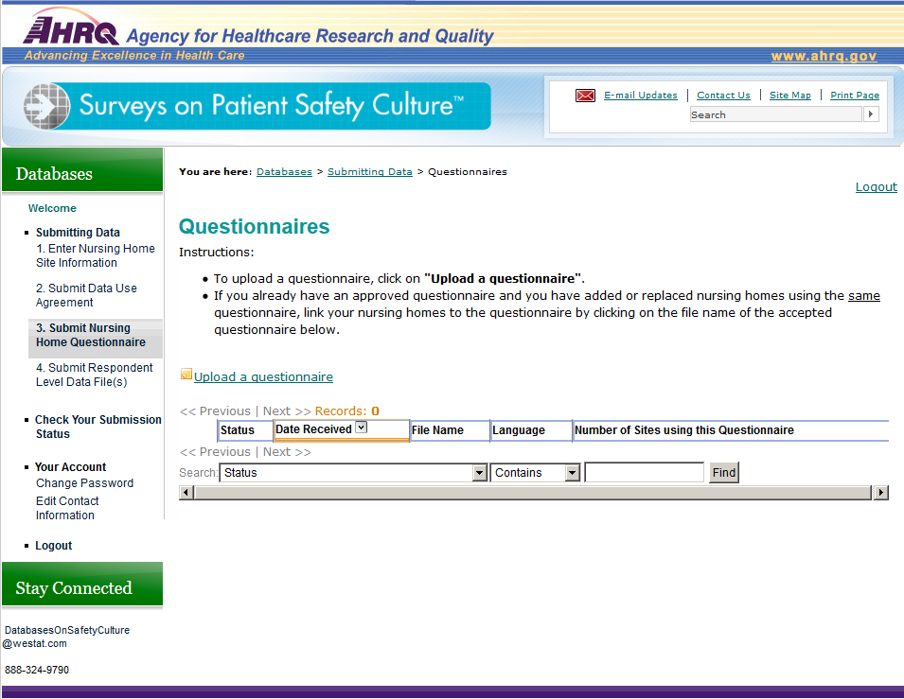

Figure 2: Submit Questionnaire and Link Questionnaire to Nursing Home(s), continued
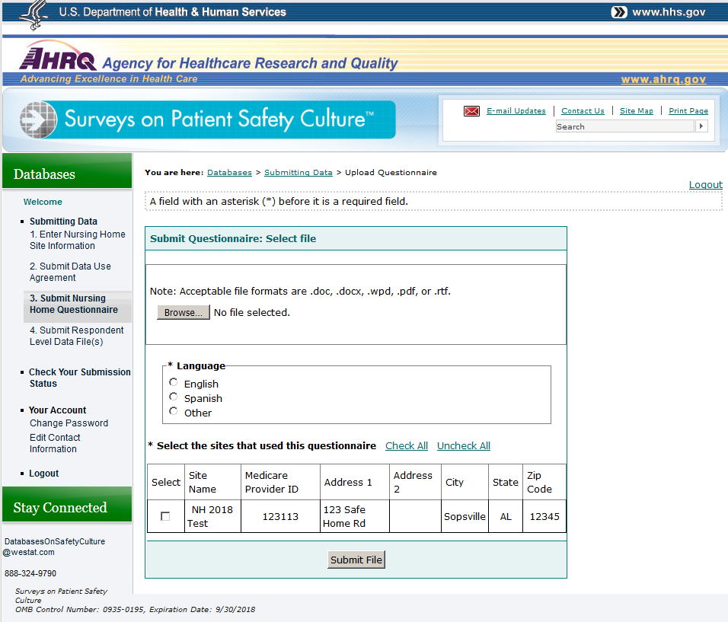

Figure 3: Upload Data File for Each Participating Nursing Home
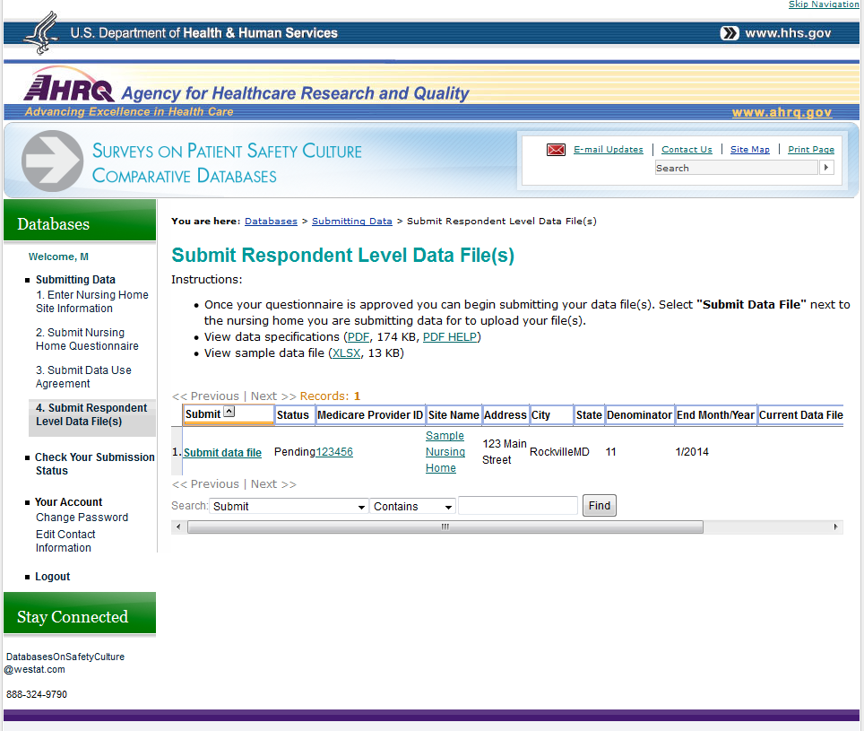

Figure 3: Upload Data File for Each Participating Nursing Home, continued
