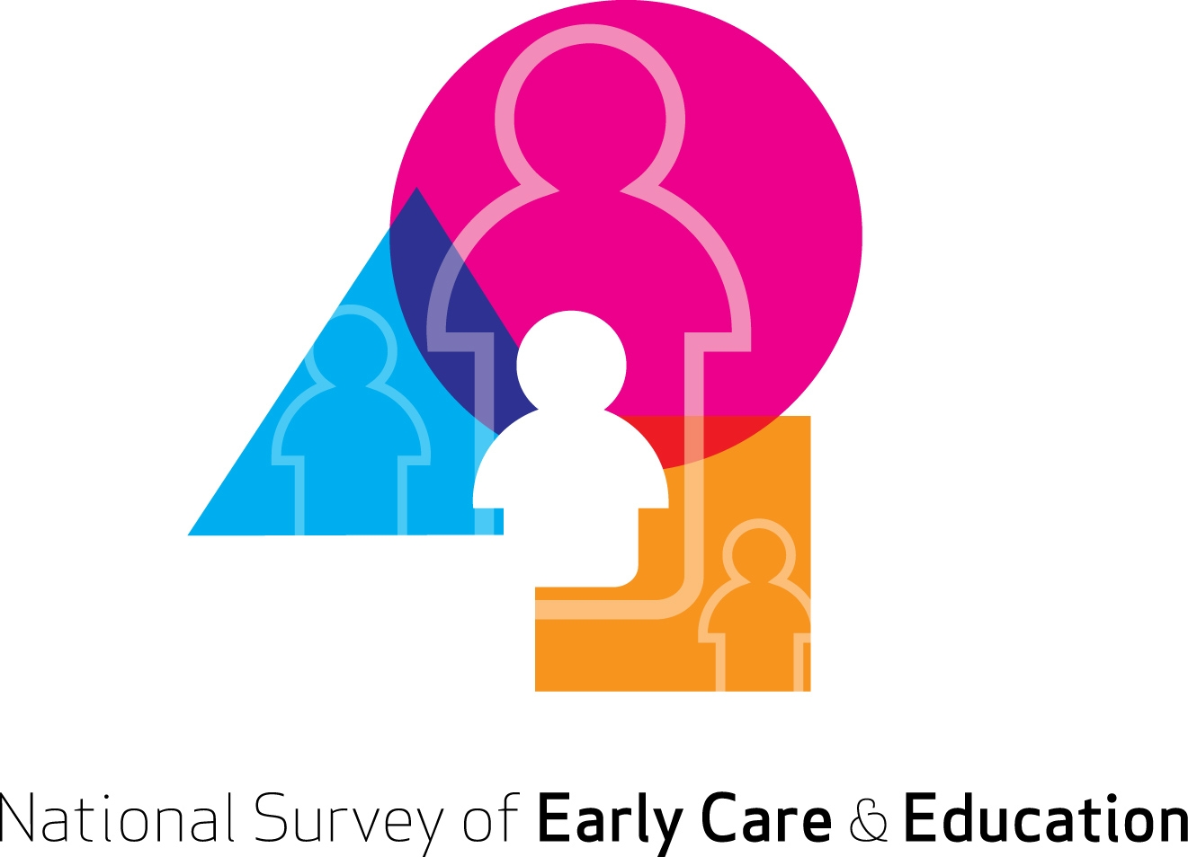


Household Screener
CAPI Household Screener
S_INTRO. Hello, my name is [NAME] and I’m from NORC at the University of Chicago. We’re conducting a study sponsored by the U.S. Department of Health and Human Services about social and educational services in your community. May I speak to someone living in this household who is 18 years or older and is knowledgeable about the household?
1. Knowledgeable person 18 years or older available to talk→GO TO S1
2. Knowledgeable person 18 years or older, but not available now →MAKE APPOINTMENT TO CALLBACK
3. No one in the household is 18 years or older→TERMINATE
4. DK/REF→MAKE AN APPOINTMENT TO CALLBACK

S1. First, I’d like to know how many children under 13 years of age are living in your household?
Number of children under 13:______________

S1_2. Do you regularly look after any children under age 13 who are not your own? IF NEEDED: By regularly I mean five hours a week or more.
1 Yes
2 No

S1_3. Does any other adult 18 years or older living in this household regularly look after any children under age 13 who are not his or her own? IF NEEDED: By regularly I mean five hours a week or more.
1 Yes
2 No

S1_4. [IF YES TO S1_2 AND/OR S1_3] Are children being looked after in someone’s home or in a school or child-care center?
1 Home
2 School or Center
3 BOTH

S1_5.
[IF S1_4 = 1 OR 3 and s1_3=1 (YES)] Please tell me the names of individuals 18 years or older living in this household who regularly look after children under age 13 who are not their own. IF NEEDED: I am only interested in people looking after children in someone's home, not in a center or school.

[IF S1_4 = 1 OR 3 and s1_3=2 (NO/Blank)] What is your name?

a._______________
b._______________
c._______________

IF 0 TO s1 AND (NO PERSON MENTIONED IN S1_5), THEN END: We are looking for households with young children and people who provide home-based care to young children. Thanks very much for your time.

IF TELEPHONE INTERVIEW AND:
IF S1>0 OR IF( S1=0 BUT PERSONS MENTIONED IN S1_5), THEN ASK S1_6.

IF PERSONAL INTERVIEW, GO TO INSTRUCTION BEFORE S2A.

S1_6. May I verify that you live on (SAMPLE ADDRESS)?
- YES→GO TO INSTRUCTIONS ABOVE S2A
- NO→GO TO S1_7
- DON’T KNOW/REFUSED→GO TO S1_7

S1_7. May I know your street address?
_________________________________________________

IF S1>0, ASK S2a.
IF S1=0 AND IF PERSONS MENTIONED IN S1_5 AND:
IF ADDRESS FLAGGED TO BE IN THE ADMINISTRATIVE LIST (PROVIDER SAMPLING FRAME), GO TO S5_3 AND TERMINATE. BUT DO NOT SPAWN FOR HOME-BASED QUESTIONNAIRE.
IF ADDRESS NOT FLAGGED TO BE IN THE ADMINISTRATIVE LIST, AND IF (S1_4 = 1 OR 3 and s1_3=2 (NO/Blank)), DISPOSITION SCREENER TO BE COMPLETE AND CONTINUE WITH HOME-BASED QUESTIONNAIRE.
IF ADDRESS NOT FLAGGED TO BE IN THE ADMINISTRATIVE LIST, AND IF (S1_4=1 OR 3, AND S1_3=1 (YES)), RANDOMLY SELECT ONE HOME-BASED PROVIDER IN HOUSEHOLD THEN GO TO S5.

S2a. Is the mother of the youngest child in the household at least 18 years of age?
1. YES→GO TO S2.
2. NO→GO TO S3
3. MOTHER DOES NOT LIVE IN HOUSEHOLD→GO TO S3
4. DK/REF →GO TO S3

S2. May I speak to the mother of the youngest child in the household?
ALREADY SPEAKING WITH MOTHER ->GO TO C_INTRO
MOTHER AVAILABLE ->GO TO C_INTRO
MOTHER LIVES IN HOUSEHOLD, NOT AVAILABLE AT THIS TIME->CALL BACK
MOTHER NOT AVAILABLE DURING SURVEY PERIOD →GO TO S3
MOTHER DOES NOT LIVE IN HOUSEHOLD →GO TO S3
DON’T KNOW →GO TO S3
REFUSED →GO TO S3

S3. Is there anyone available at this time who is 18 years or older and knows how the youngest child spends his or her day?
YES →GO TO S4
NO, NOT AVAILABLE ->MAKE AN APPOINTMENT TO CALL BACK
DON’T KNOW/REF ->MAKE AN APPOINTMENT TO CALL BACK

S4. May I speak with him/her please?
YES-> GO TO HOUSEHOLD (DEMAND) QUESTIONNAIRE
NO ->CALL BACK TO CONDUCT HOUSEHOLD QUESTIONNAIRE
DON’T KNOW/REF ->CALL BACK TO CONDUCT HOUSEHOLD QUESTIONNAIRE

S5. May I speak to [SELECTED FFNN PROVIDER]?
1. YES, R AVAILABLE→GO TO HOME-BASED QUESTIONNAIRE
2. NO, R NOT AVAILABLE AT THIS TIME→MAKE AN APPOINTMENT TO CALL BACK
3. NO, R NOT AVAILABLE DURING SURVEY PERIOD→SELECT ANOTHER FFNN PROVIDER IF MORE THAN ONE PERSON IS MENTIONED IN S1_5 AND ASK S5 AGAIN. OTHERWISE, GO TO S5_2 AND TERMINATE.
S5_2. Thank you very much for your time. That is all I have. TERMINATE (COMPLETED SCREENER)
S5_3. Thank you very much for your time. That is all I have. TERMINATE AND DO NOT SPAWN FOR HOME-BASED QUESTIONNAIRE (COMPLETED SCREENER)
Mail Household Screener [not formatted]
National Survey of Early Care and Education

If you have any questions, please call 1-877-369-3240
The U.S. Department of Health and Human Services (DHHS) is conducting an important study to learn about young children in your community and who cares for them when they are not with their parents. This information will help inform state and federal agencies in their efforts to improve access to quality child care for all children. Please have an adult (18 years or older) who lives in this household answer the following questions. Your information will be kept private and used only for statistical purposes. If you have any questions or would prefer to answer these questions by phone, please call toll-free at 1-877-369-3240.

Q1. First, how many adults (18 years and older) live in this household?
__________________NUMBER OF ADULTS

Q2. How many children under the age of 6, including babies, live in this household?
_________________NUMBER OF CHILDREN

Q2a. How many children between 6 and 13 years old live in this household?
_________________NUMBER OF CHILDREN

Q3. Is anyone in this household expecting to have a baby in the next three months?
1 YES
2 NO

Q4. Do you regularly look after any children under age 13 who are not your own for 5 hours a week or more?
1 YES
2 NO → Go To Q6

Q5. Do you look after those children in someone’s home or in a school or child-care center?
1 Home
2 School or center
3 Both

Q6. Thinking about the next three months, how likely are you to start regularly looking after children under age 13 who are not your own, for 5 hours a week or more? Would you say you…?
1 Definitely will,
2 Probably will,
3 Might or might not,
4 Probably will not, or
4 Definitely will not

Q7. Does any other adult in the household regularly look after any children under age 13 who are not his or her own, for 5 hours a week or more?
1 YES
2 NO → Go To Q9

Q8. Does he/she look after children in someone’s home or in a school or child-care center?
1 Home
2 School or center
3 Both

Q9. Again, thinking about the next three months, how likely do you think any other adult in the household is to start regularly looking after any children under age 13 who are not their own, for 5 hours a week or more? Would you say they…?
1 Definitely will,
2 Probably will,
3 Might or might not,
4 Probably will not, or
4 Definitely will not

Q10. In general, how do you feel about the quality and cost of child care and early education available to families with children in your community? Do you feel..
1 Very satisfied
2 Somewhat satisfied
3 Not satisfied at all
4 Or do you not have an opinion?

Q11. What is the best phone number to reach you if we have any questions about your survey?
Name or Initial: ___________________________
Phone: _ _ _ -_ _ _ -_ _ __

Thank you very much for your participation! Please return this form in the postage-paid envelope provided or mail it to:

National Survey of Early Care and Education
NORC at the University of Chicago
1 North State Street,
Chicago, IL 60602
Toll-free number: 1-877-369-3240.

