PONL Application Data Fields for OMB Control No. 1513–0023, Environmental Information and Supplemental Information on Water Quality Consideration under 31 U.S.C. 1341(a).
The Alcohol and Tobacco Tax and Trade Bureau (TTB) has established the “Permits Online” (PONL) system to allow alcohol and tobacco-related TTB permit applicants to complete, sign, and submit such applications to TTB electronically via the TTB website. Information, registration for, and user access to PONL may be found on the TTB website at https://www.ttb.gov/ponl/permits-online.shtml.

The PONL system consists of various OMB-approved information collections, and PONL replaces the paper forms associated with those collections. Included among the information collections contained in PONL is OMB Control No. 1513–0023, Environmental Information and Supplemental Information on Water Quality Consideration under 31 U.S.C. 1341(a). The PONL data fields related to OMB Control No. 1513–0023 replace forms TTB F 5000.29, Environmental Information, and TTB F 5000.30, Supplemental Information on Water Quality Consideration under 31 U.S.C. 1341(a). The data fields for OMB Control No. 1513–0023 are the same for each type of alcohol and tobacco permit application available in PONL.

PONL data fields related to the applicant’s name, contact, and other identifying information, and the applicant’s business name and location, are approved under the OMB control numbers for the specific type of alcohol or tobacco permit applied for.

Specific to this information collection request, OMB Control No. 1513–0023, are the PONL data fields shown below, unless otherwise noted.

Welcome Page
This page is displayed when the user goes to the Permits Online website. This page includes the links to the Privacy Act Statement, Privacy Impact Assessment and Paperwork Reduction Act Notice. OMB Control No. 1513–0023 is not subject to the Privacy Act, and the Privacy Act Statement and Privacy Impact Assessment for PONL is therefore not shown here. The Paperwork Reduction Act notice shown below covers all the information collections contained in PONL.
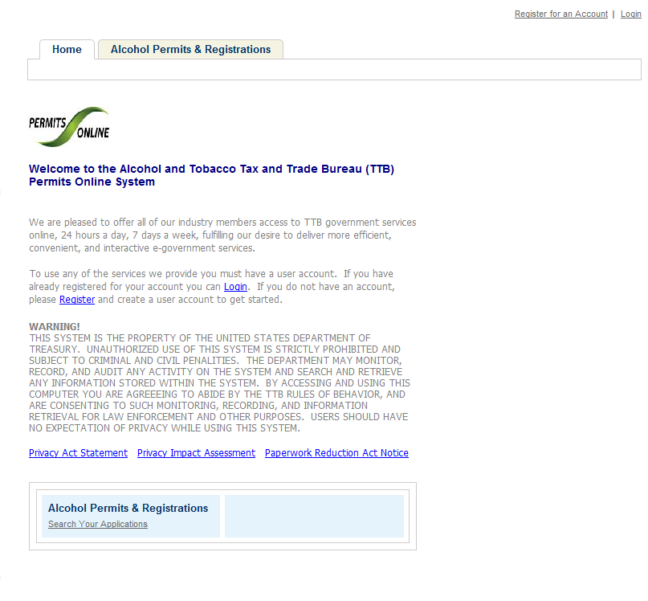

Paperwork Reduction Act Notice Page
This page displays the Paperwork Reduction Act Notice for the Permits Online application, including those for the two forms contained in OMB Control No. 1513–0023:
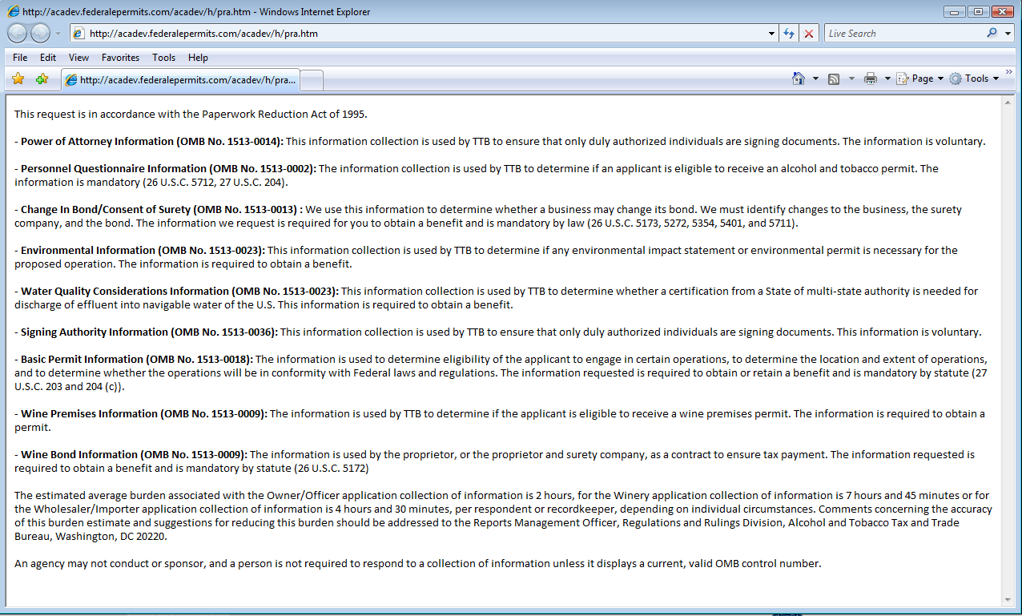

Information collection data fields specific to OMB Control No. 1513–0023, and equivalent to those on form TTB F 5000.29, Environmental Information, and TTB F 5000.30, Supplemental Information on Water Quality Consideration under 31 U.S.C. 1341(a), are shown below:
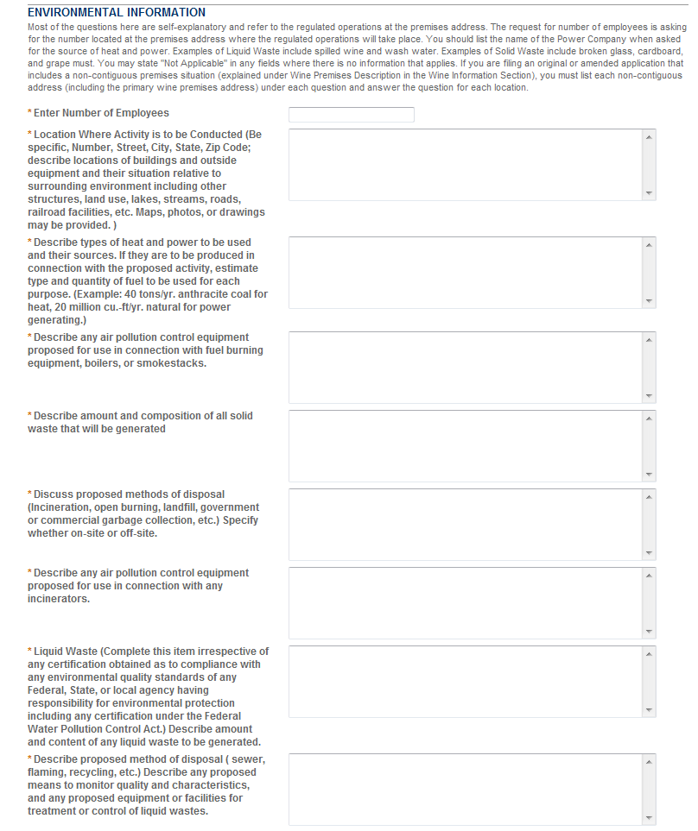

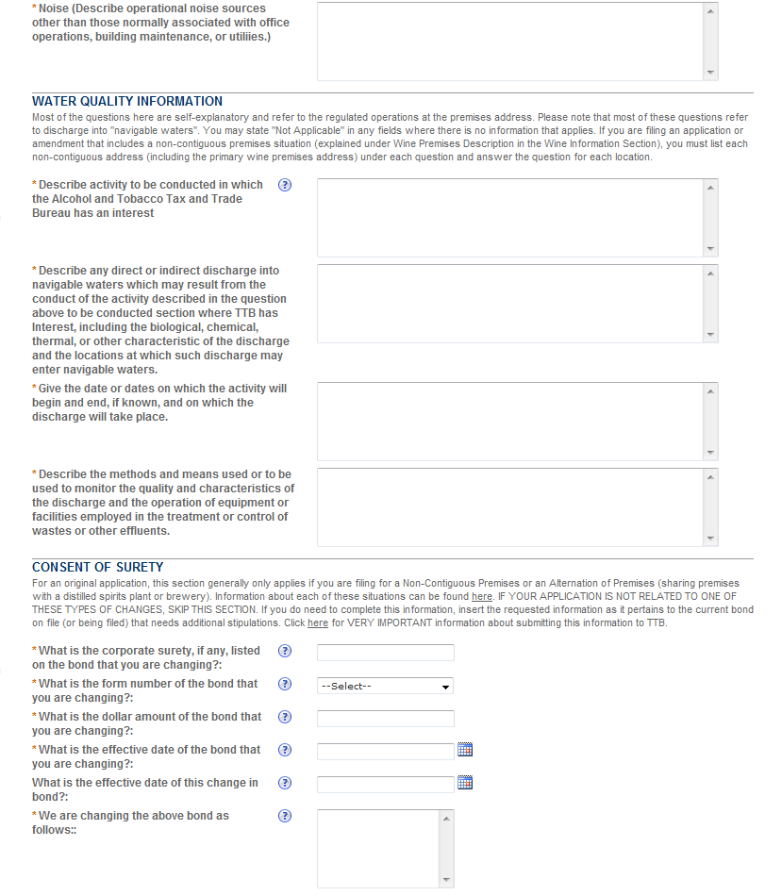
End of data fields related to OMB Control No. 1513–0023, and equivalent to those on form TTB F 5000.29, Environmental Information, and TTB F 5000.30, Supplemental Information on Water Quality Consideration under 31 U.S.C. 1341(a).

Once the application is submitted, the Record Submittal page appears indicating the Application Tracking Number and Penalty of Perjury statement.
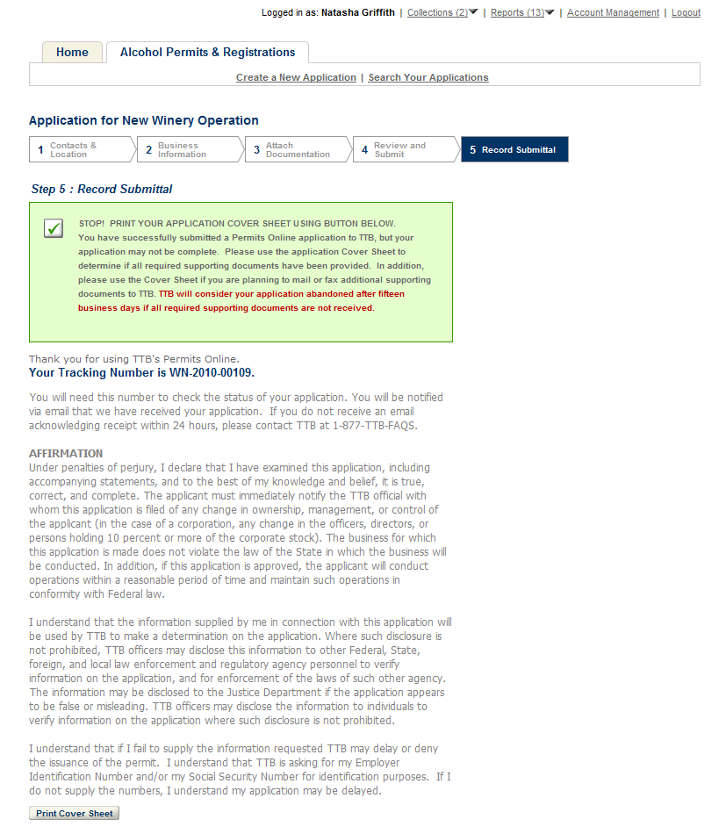
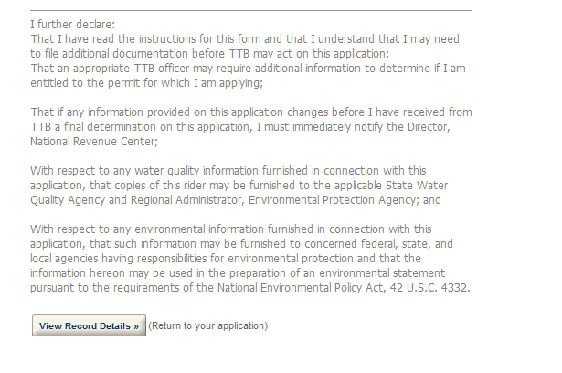
END OF PONL.

