**Formulas Online (FONL) — Nonbeverage Drawback Formula and Process**

**Approval Application**

Log-in Screen

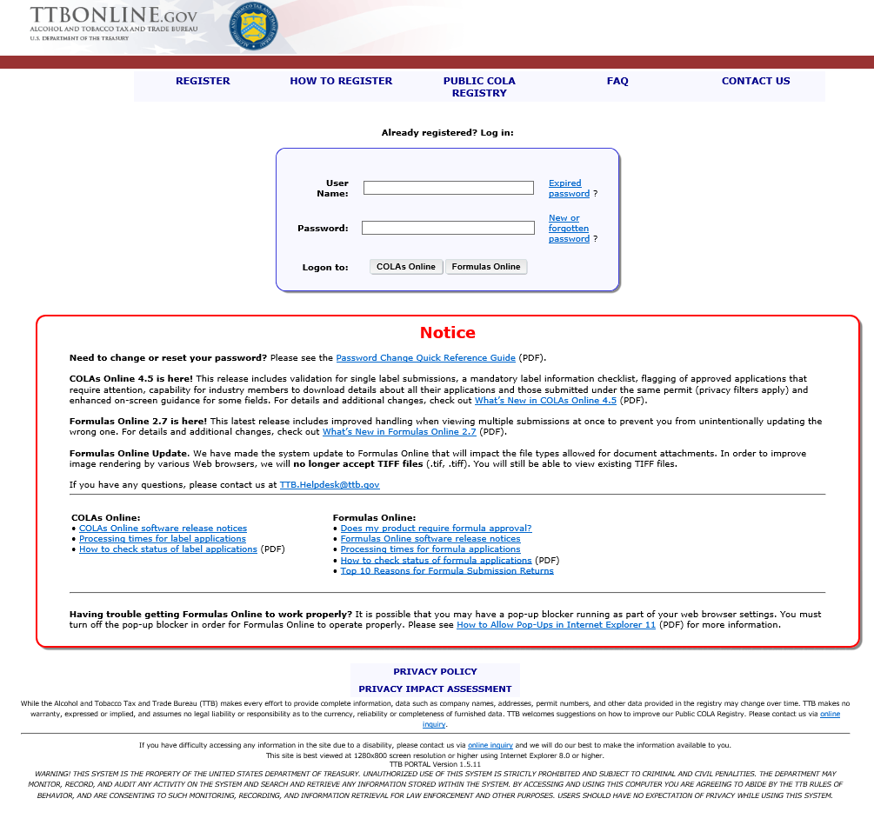

This application is a collection instrument, approved under 1513–0021, and is equivalent to TTB F 5154.1)

Create New Formula pop-up – to enter company code

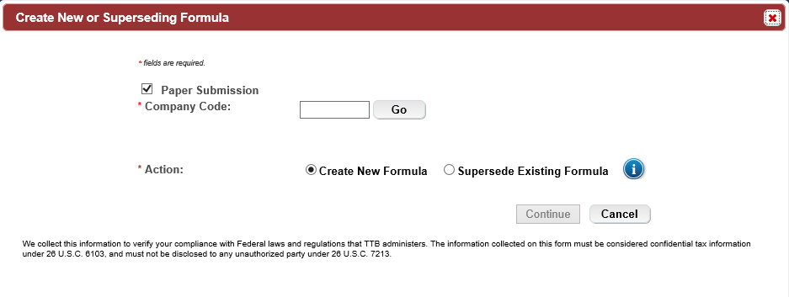

Main Tab

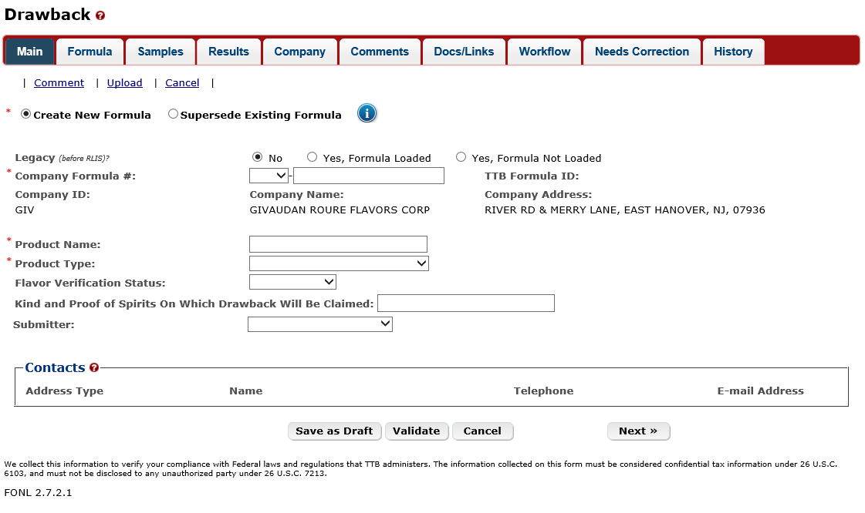

Formula Tab – part 1 – for Product Type of Flavor/Flavoring Extract, Food Product, Medicine/Medicinal Preparation and Perfume

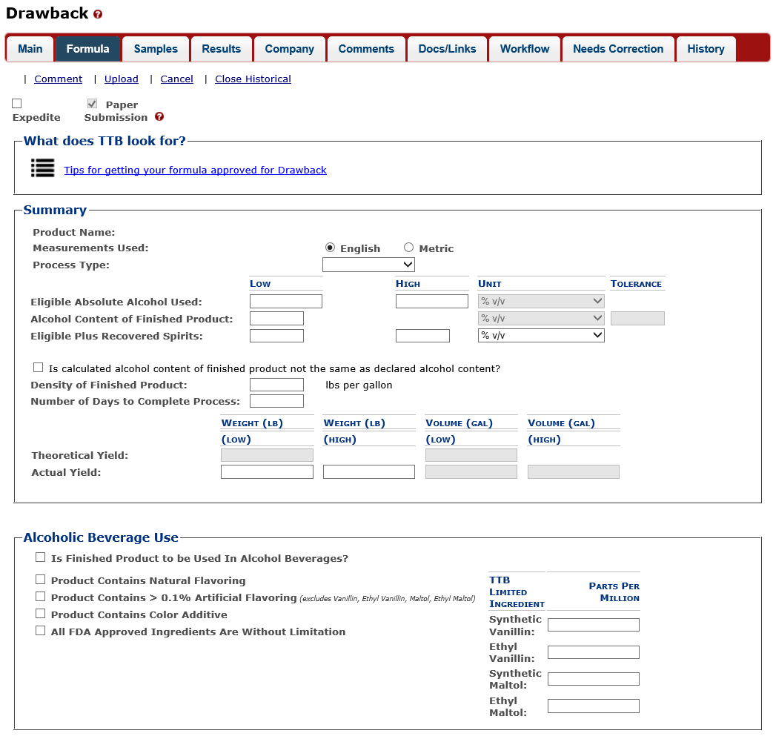

Formula Tab – continued

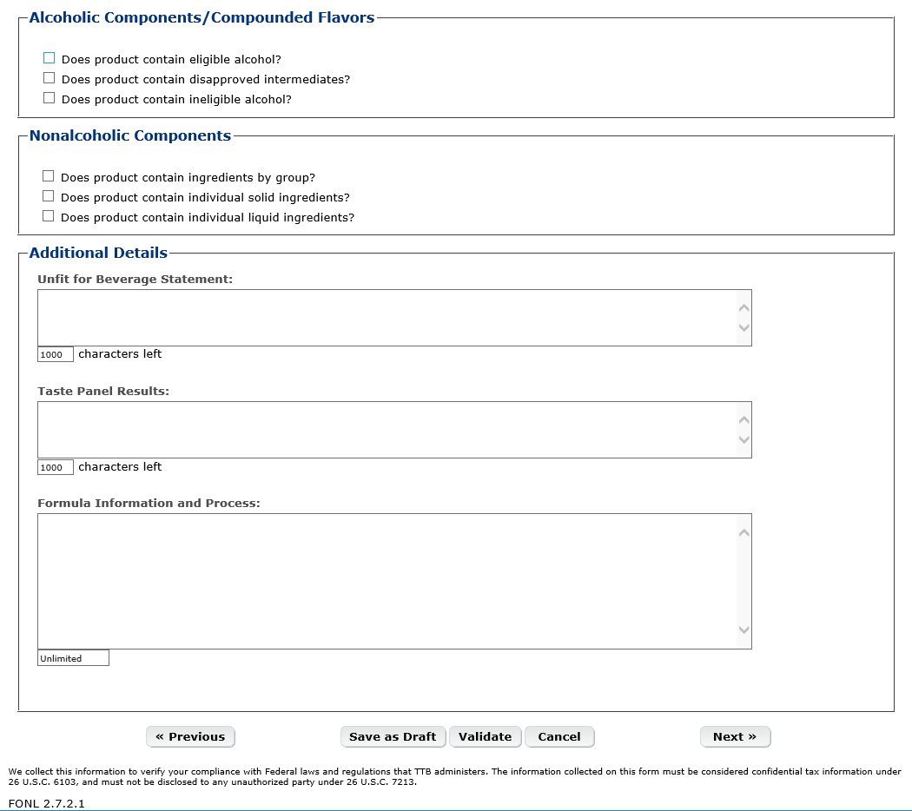

Formula Tab – Alcoholic Components – Eligible Alcohol

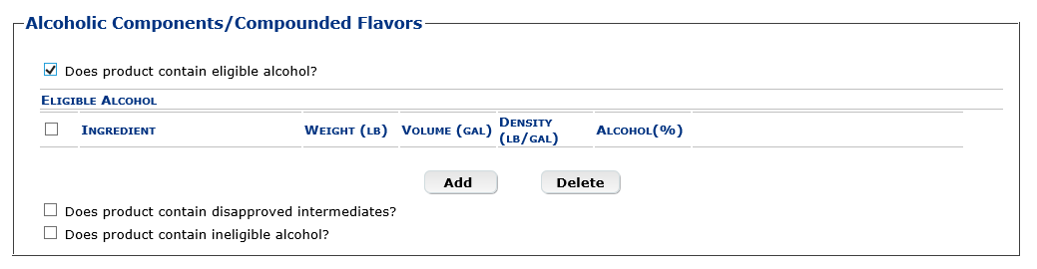

Formula Tab – Eligible Alcohol pop-up window

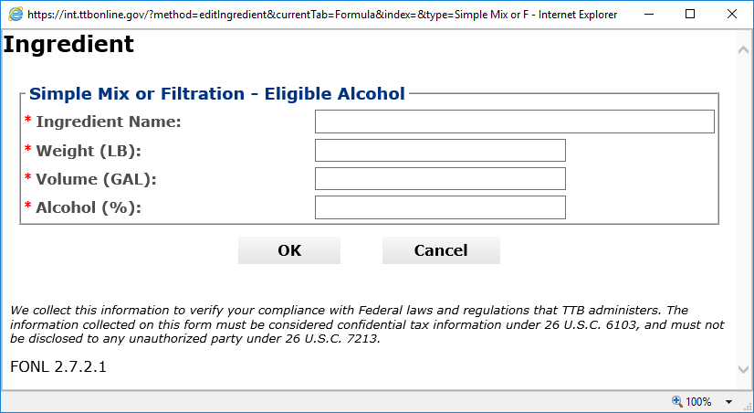

Formula Tab – Alcoholic Components – Disapproved Intermediates

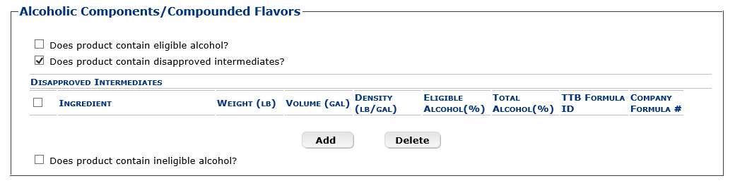

Formula Tab – Disapproved Intermediates pop-up window

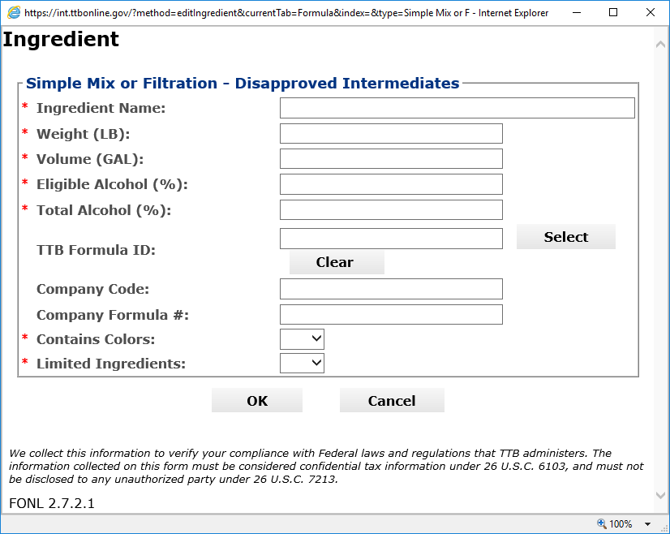

Formula Tab – Alcoholic Components – Ineligible Alcohol

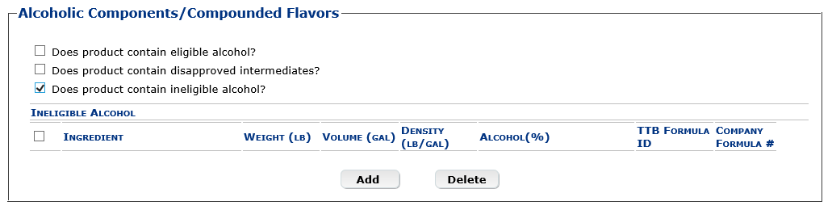

Formula Tab – Ineligible Alcohol pop-up window

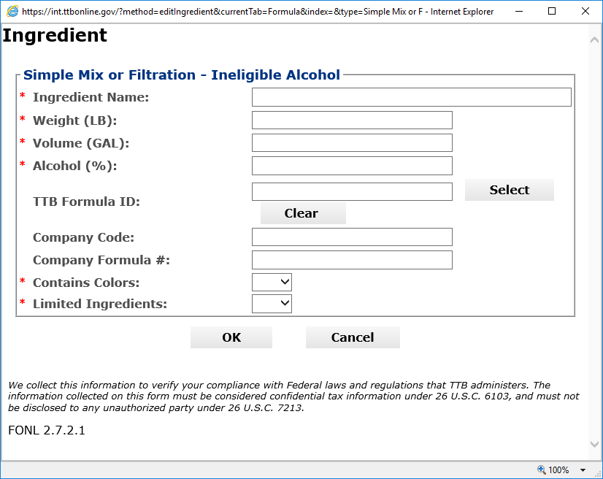

Formula Tab – Nonalcoholic Components – Ingredients by Group

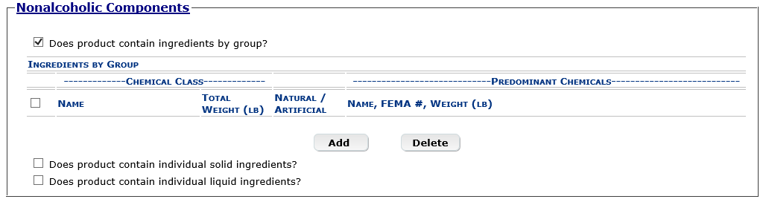

Formula Tab – Ingredients by Group pop-up window

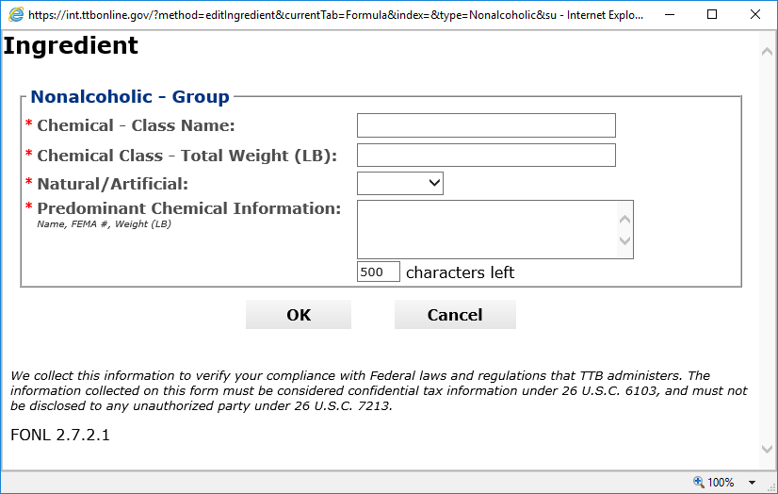

Formula Tab – Nonalcoholic Components – Solid Ingredients

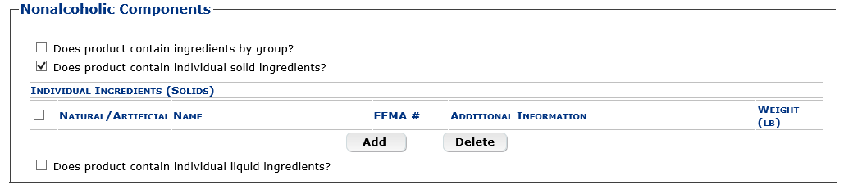

Formula Tab – Solid Ingredients pop-up window

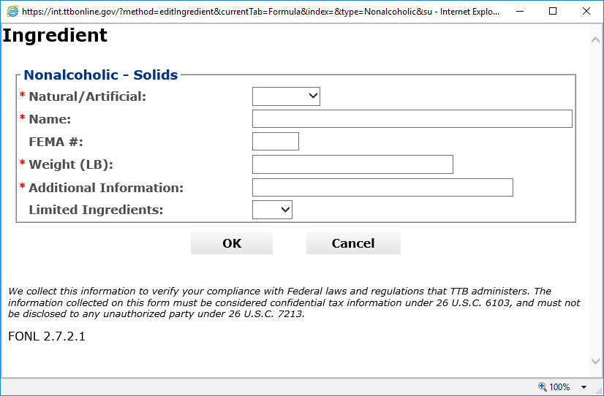

Formula Tab – Nonalcoholic Components – Liquid Ingredients

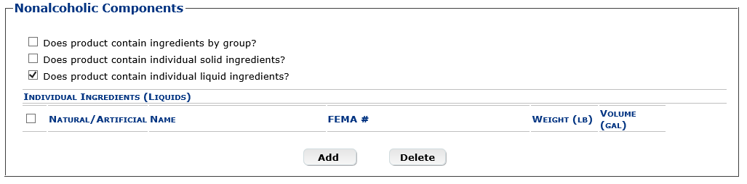

Formula Tab – Liquid Ingredients pop-up window

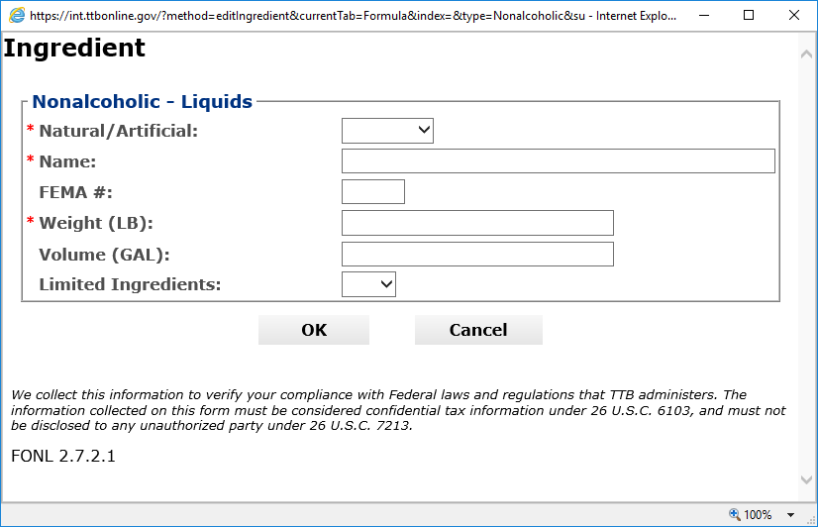

Formula Tab – for Product Type of Dietary Supplement (top half the same as other product types)

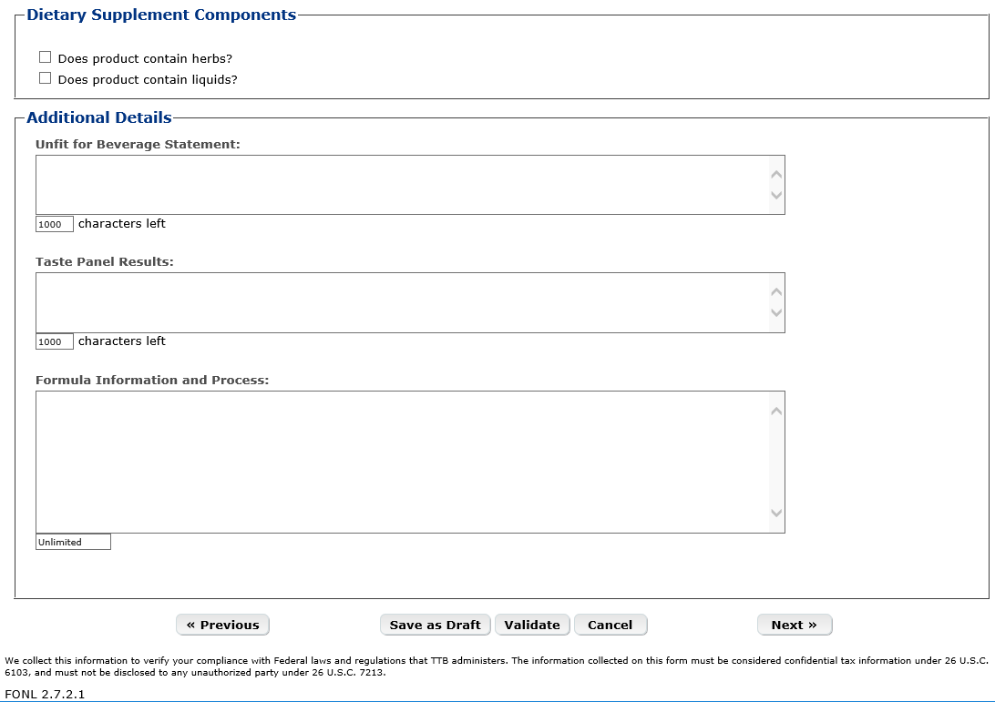

Formula Tab – Dietary Supplement Components – Herbs

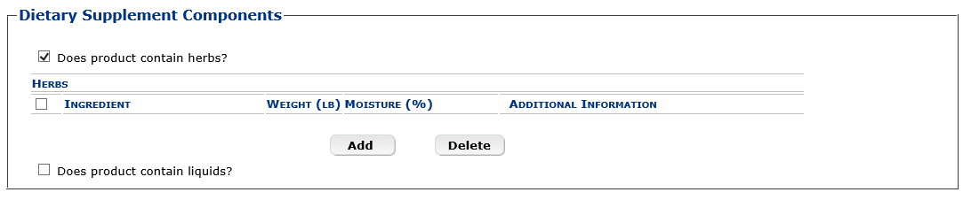

Formula Tab – Herbs pop-up window

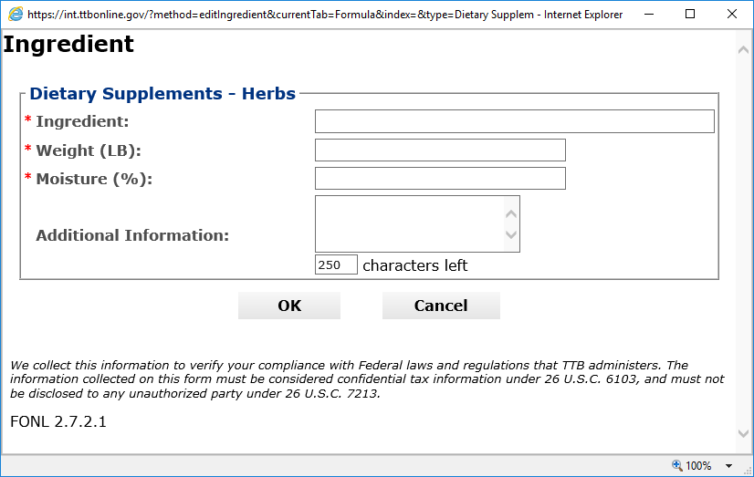

Formula Tab – Dietary Supplement Components – Liquids

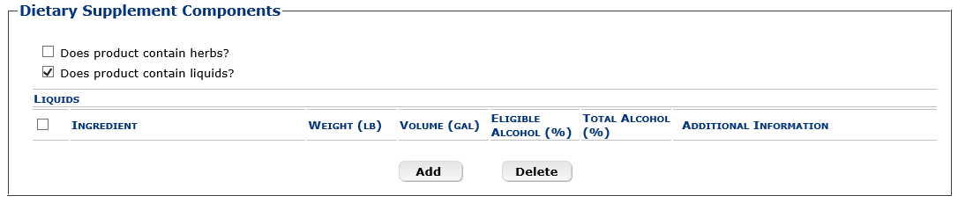

Formula Tab – Liquids pop-up windo

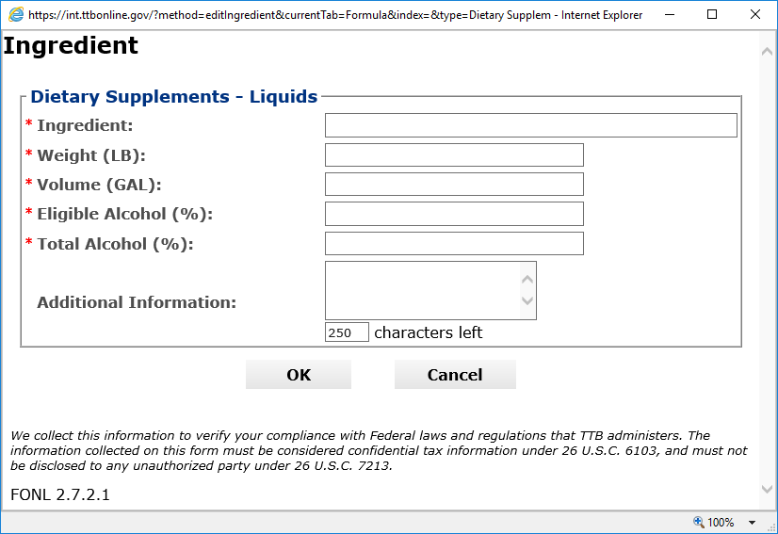

Samples Tab

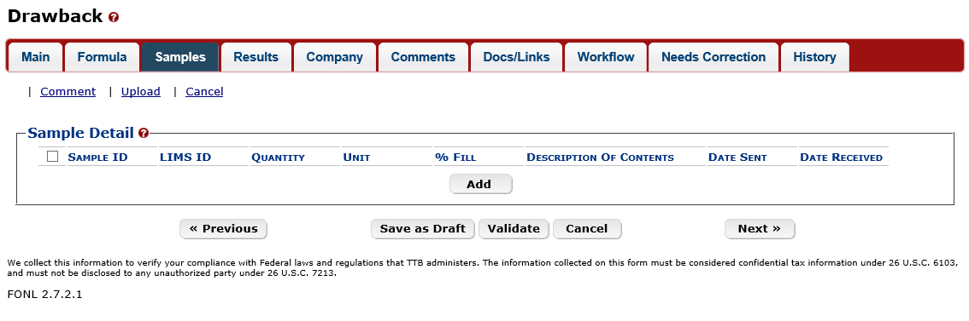

Samples Tab – Add Sample pop-up window

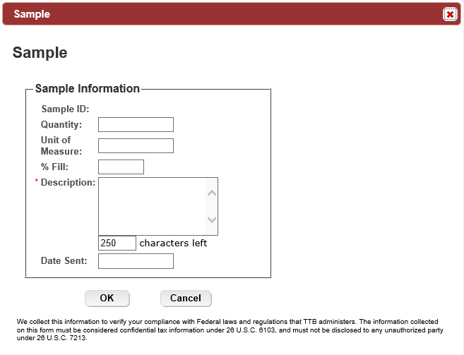

Company Tab

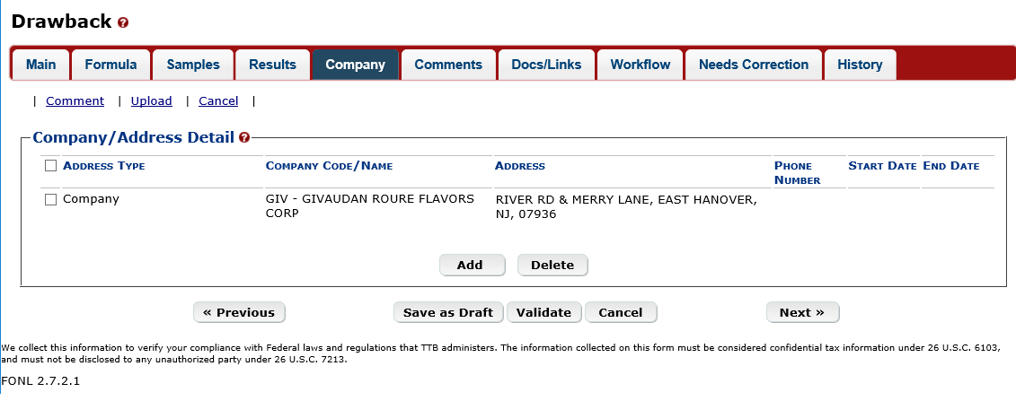

Company Tab – Add Address pop-up window

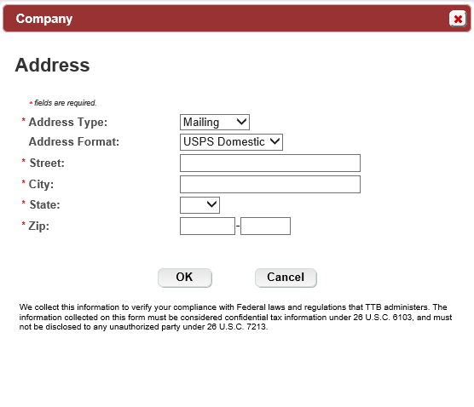

Comments Tab

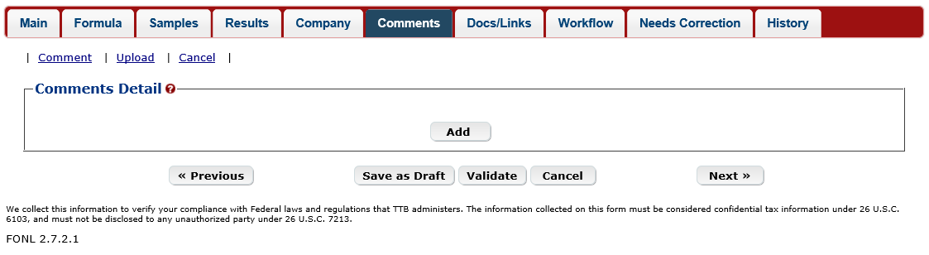

Comments Tab – Add pop-up window

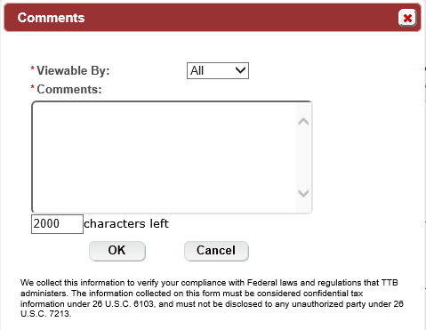

Docs/Links Tab

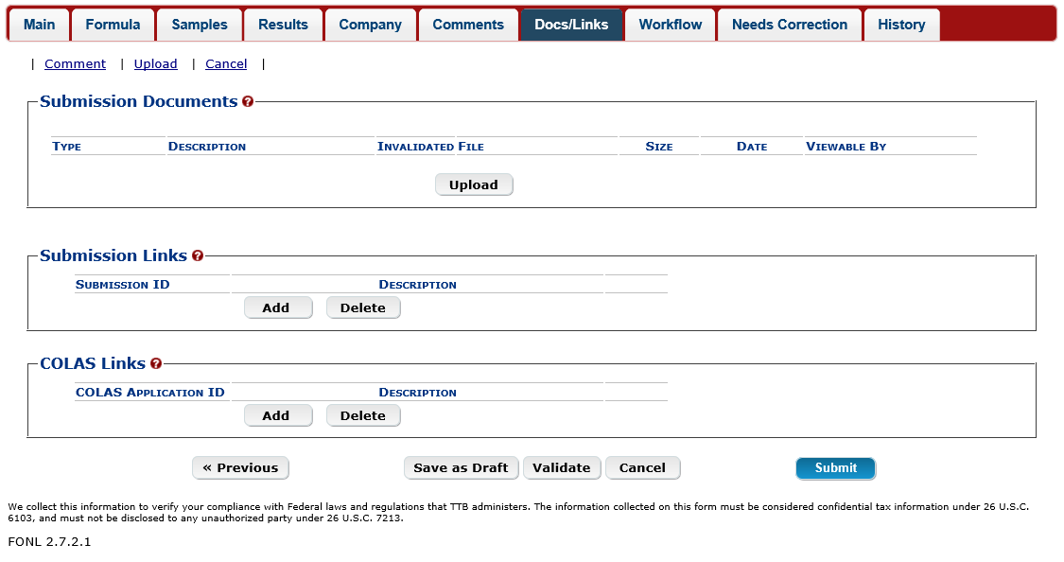

Docs/Links Tab – Upload pop-up

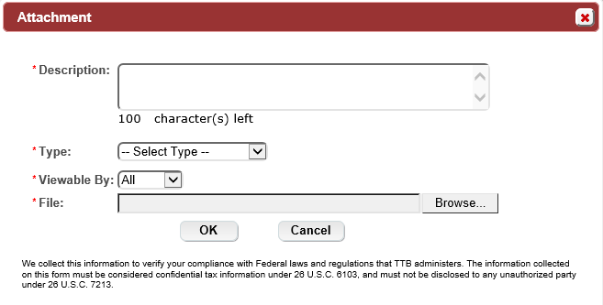

Docs/Links Tab – Submission Link pop-up window

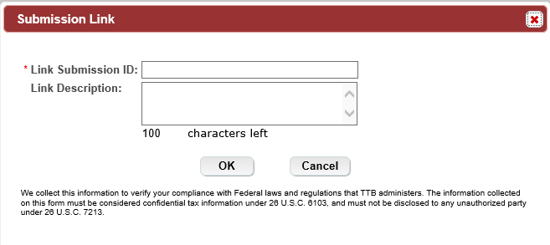

Docs/Links Tab – COLAS Link

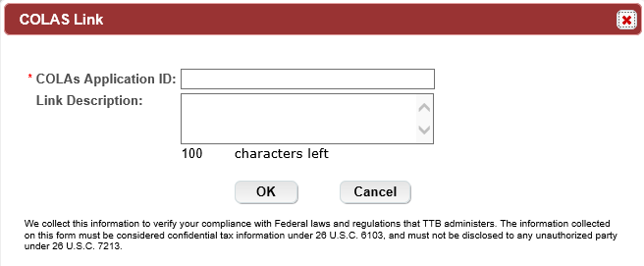

Perjury Statement

