Permits Online (PONL), New Distilled Spirits or Bonded Wine Premises Applications — for OMB Control No. 1513–0018, Application for Basic Permit under the Federal Alcohol Administration Act).

This PONL application is equivalent to TTB F 5100.24, Application for Basic Permit under the Federal Alcohol Administration Act, for new beverage Distilled Spirits Plants and Bonded Wine Premises applications on that form. New Winery application used as example; application for new Distilled Spirits Plant collects the same data.

PONL Log-in Screen:

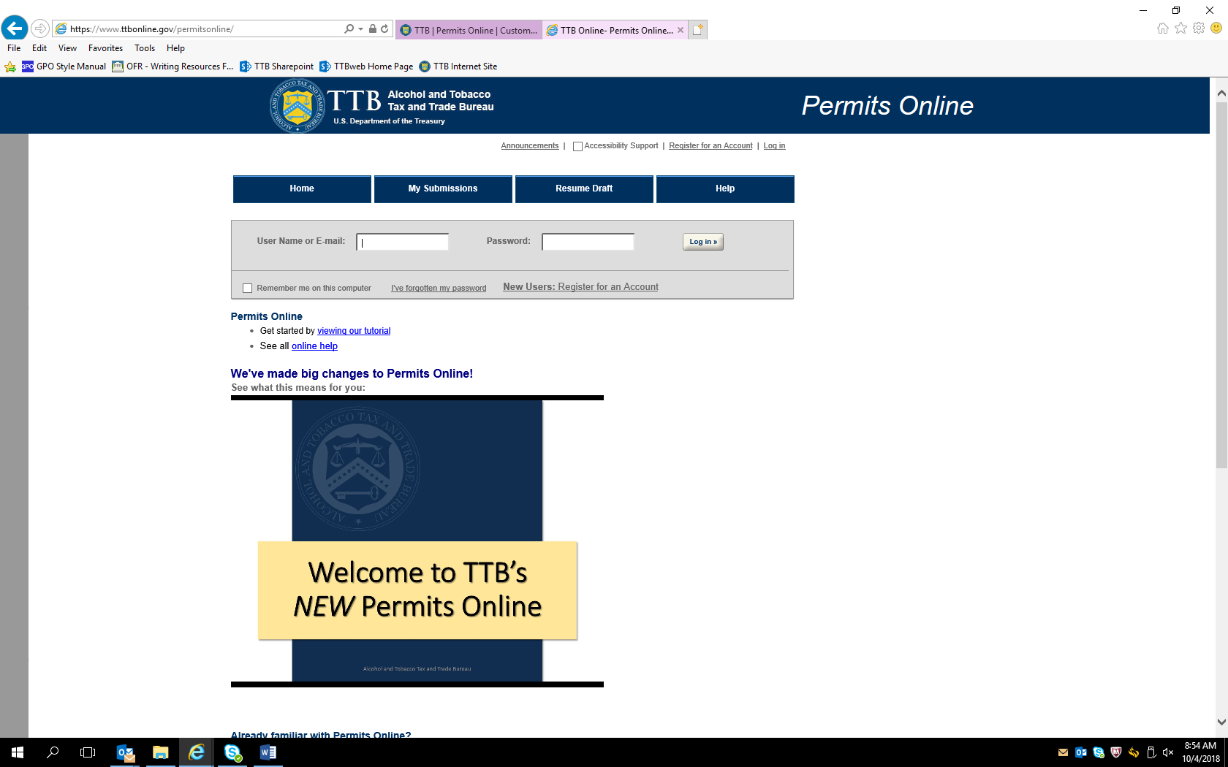

PONL Log-in Screen (continued):

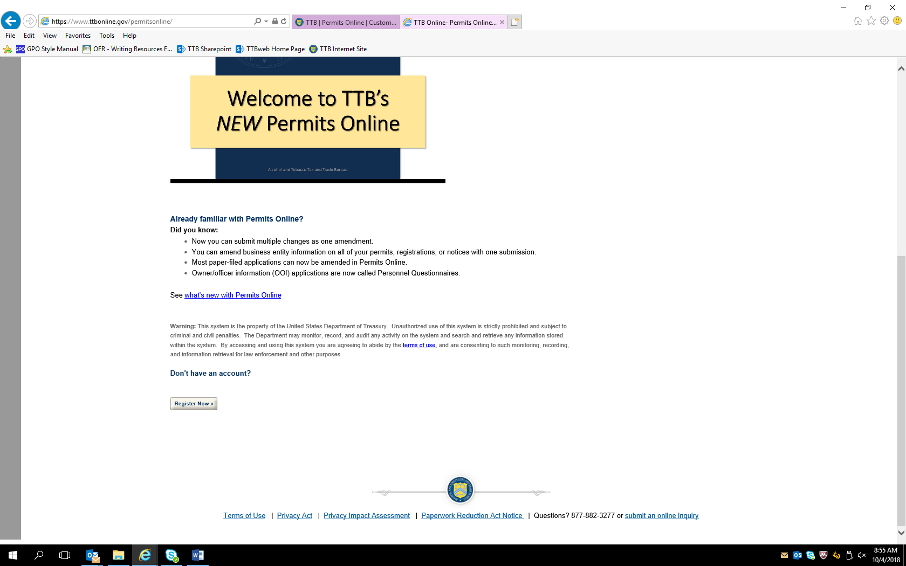

Screen shown after successful log-in:

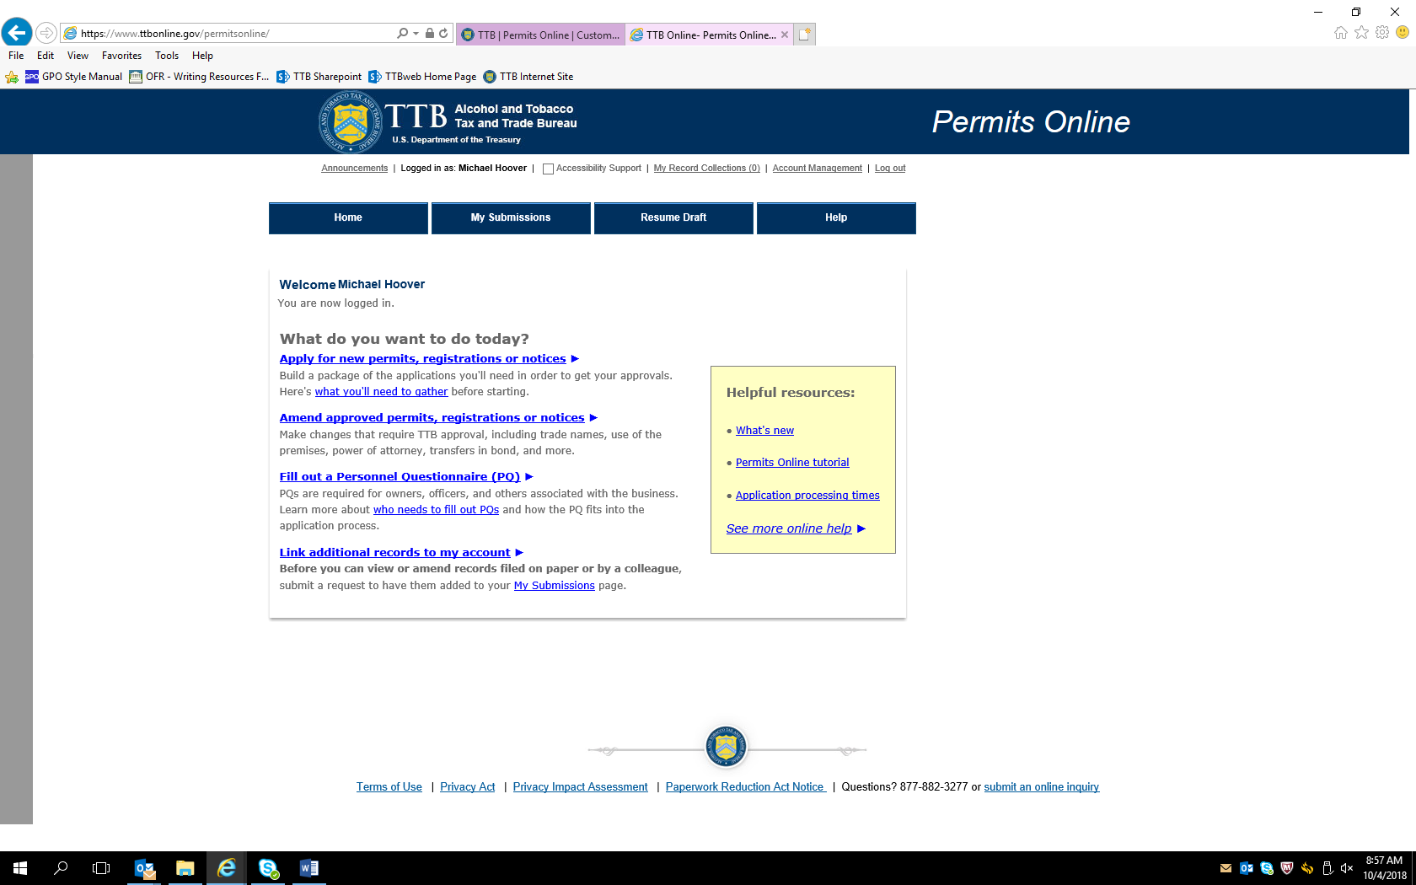

After clicking appropriate “What do you want to do today?” link, the Penalty of Perjury screen appears:

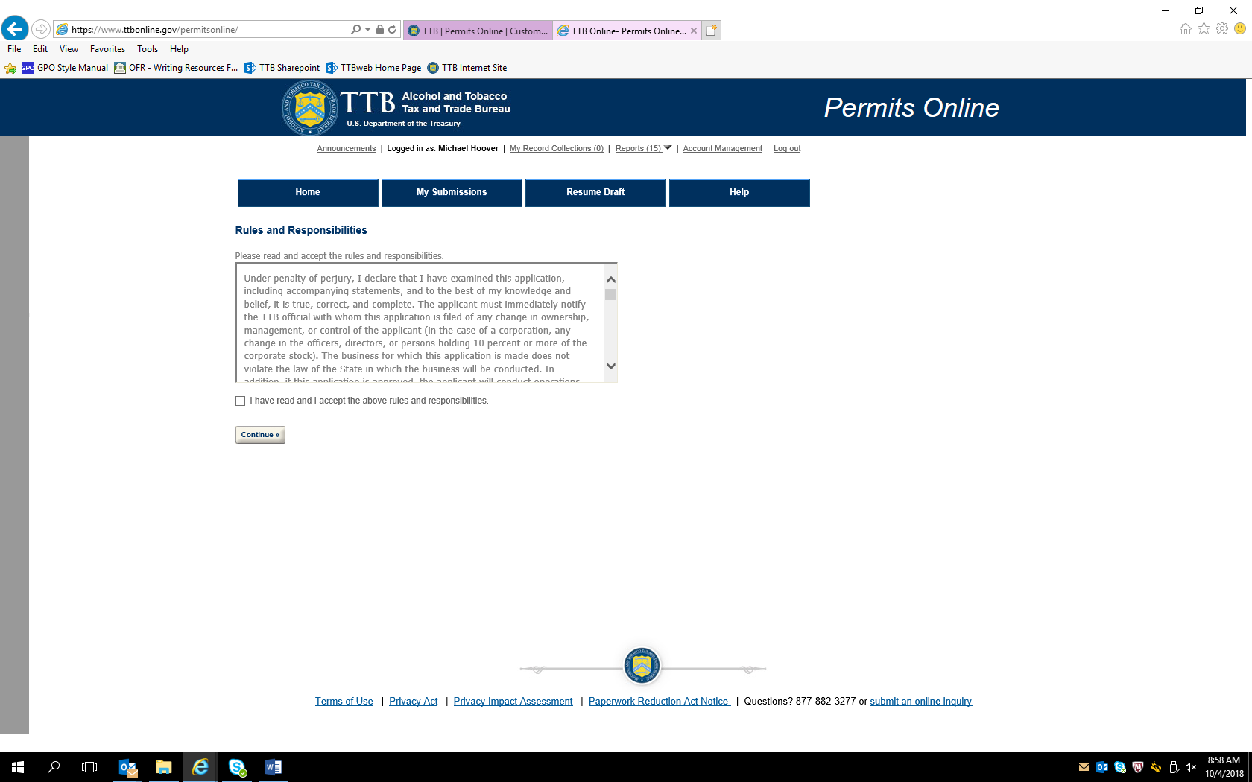

After accepting perjury statement, the New Applications wizard screen appears. The Application Contact information auto fills from PONL registration information:

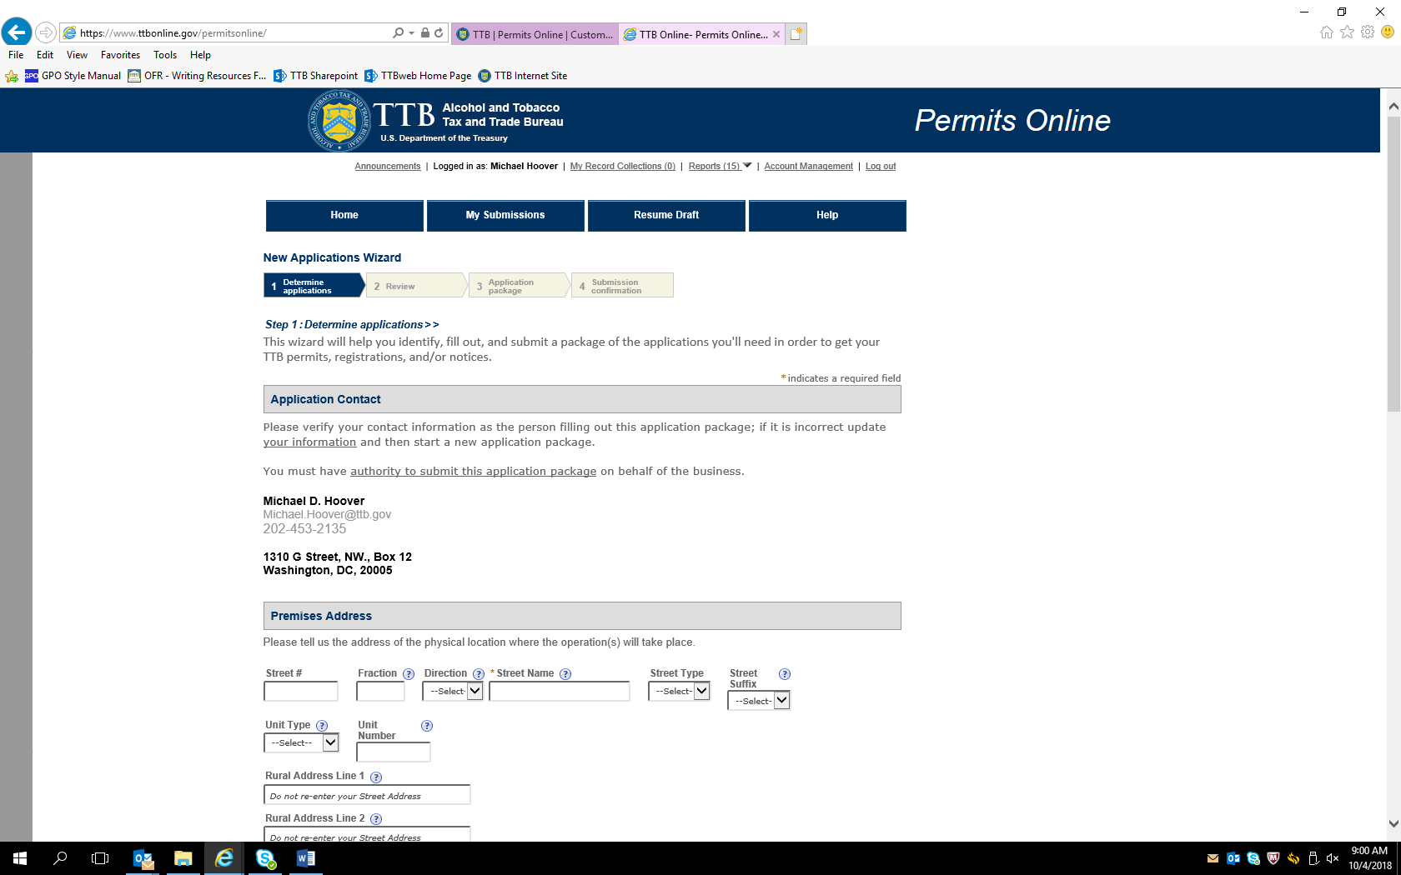

New Application Wizard screen continued:

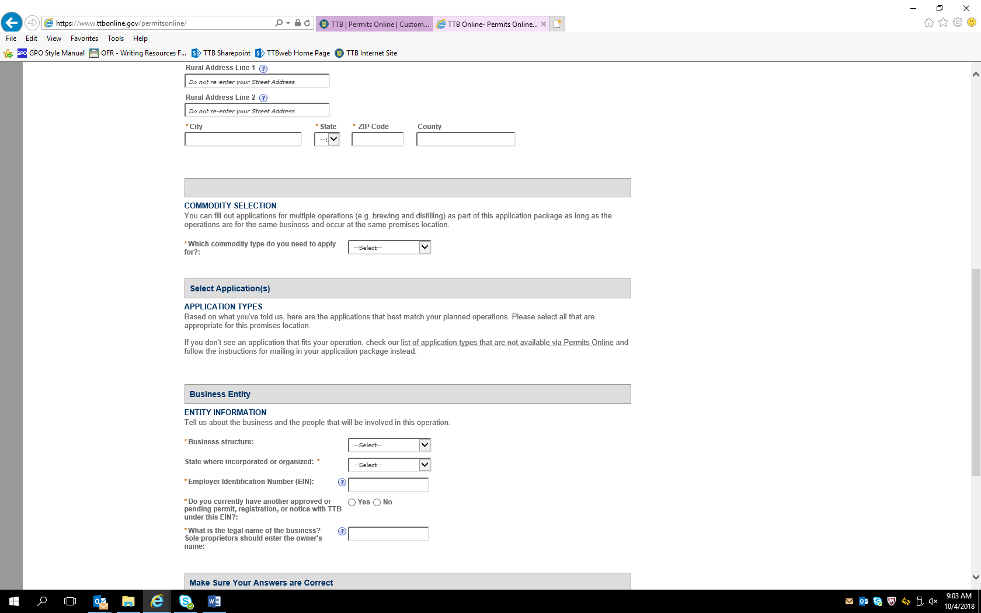

New Application Wizard screen continued:

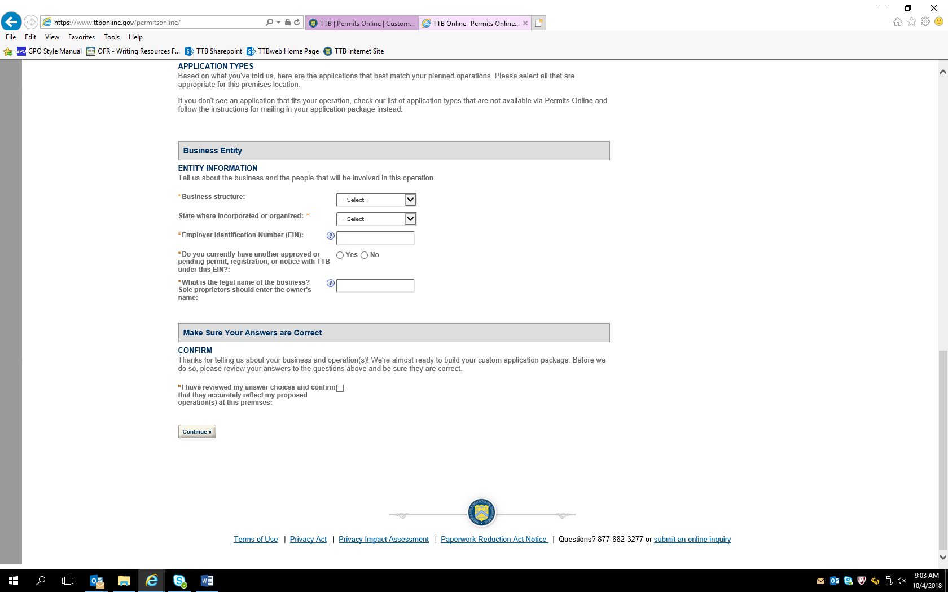

Selecting “Alcohol” and “Winery” in the Commodity Selection section, then “Bonded Winery – Full Operations” in the “Application Types” section results in these addition data fields appearing (similar data fields appear for the equivalent new Distilled Spirits Plant (beverage) selection):

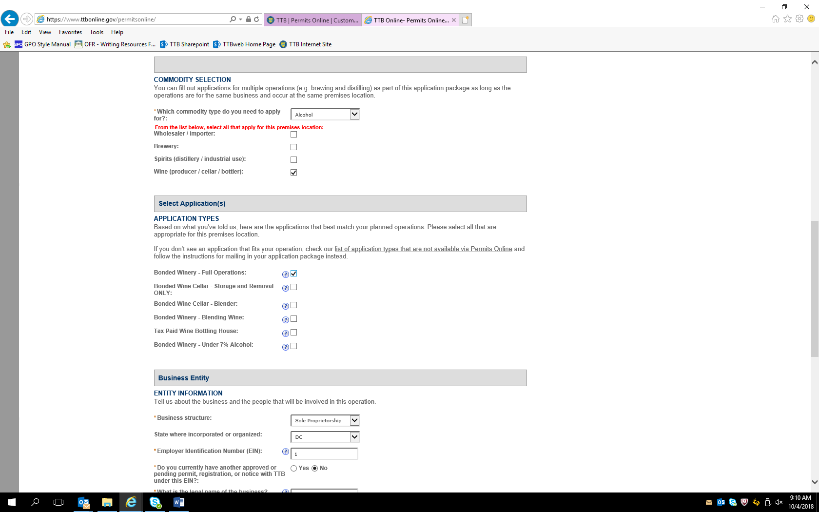

Selecting “Sole Proprietorship” in the Business Entity section, leads to this screen, including a confirmation statement:

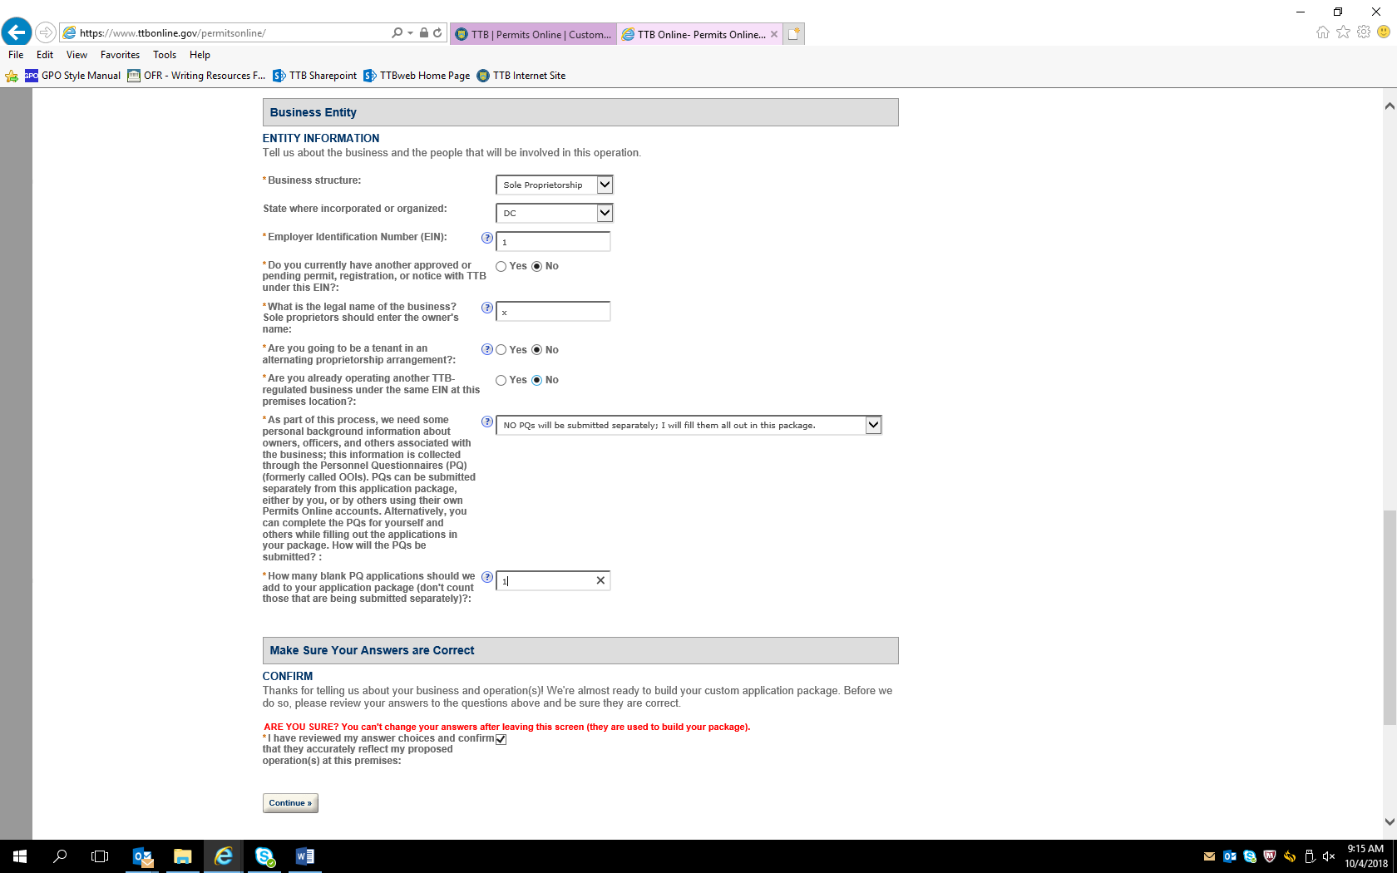

After confirmation is made, the next screen allows the applicant to review the information submitted to this point in the PONL application:

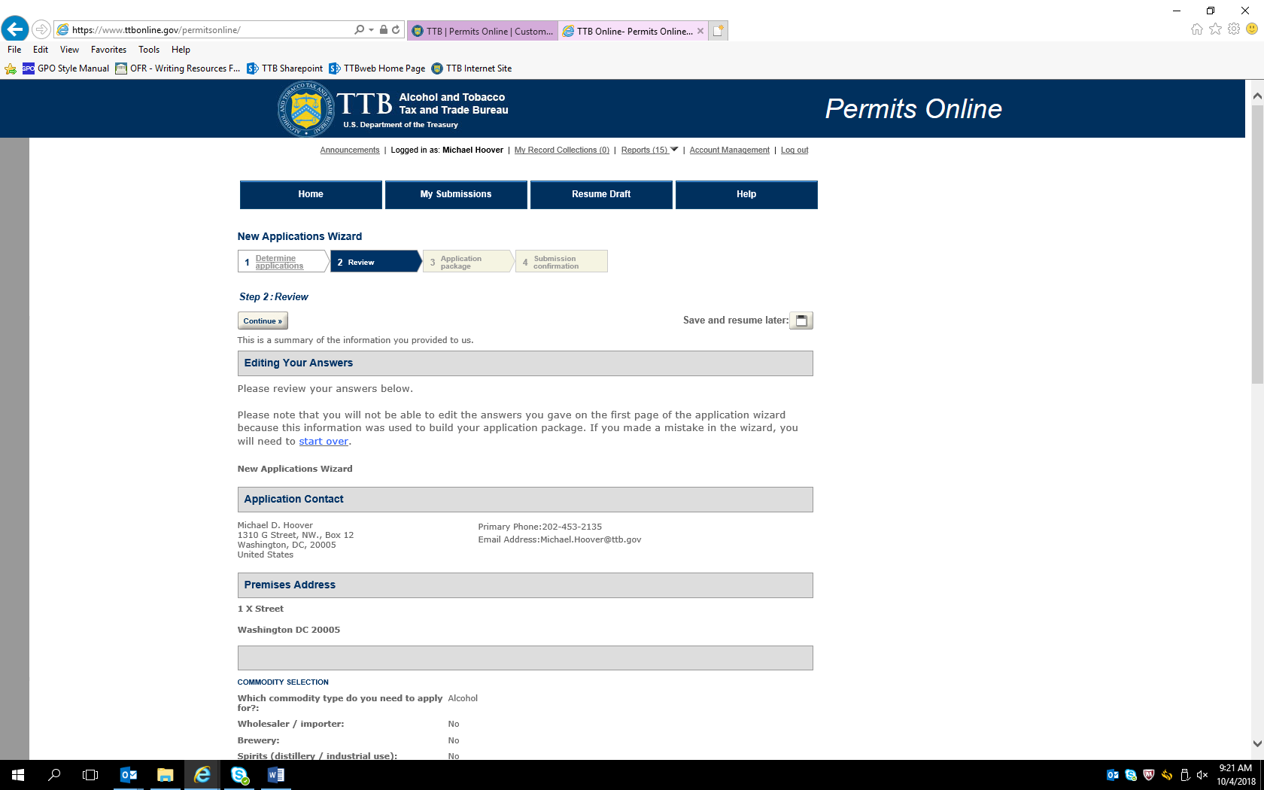

Review screen continued:

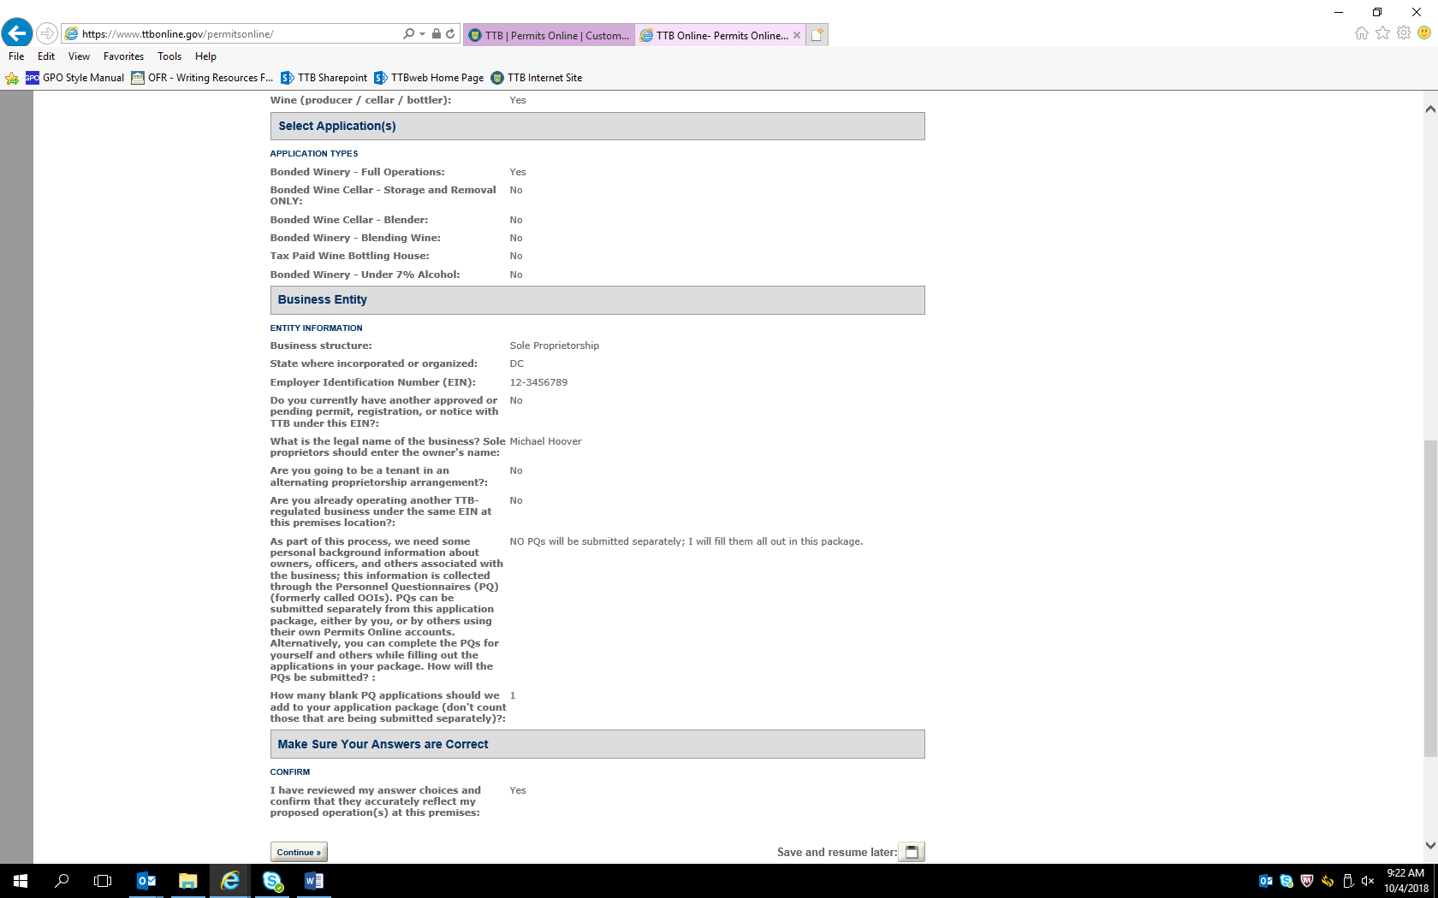

Based on the initial information provided, the PONL wizard then selects the appropriate applications to be completed by the applicant:

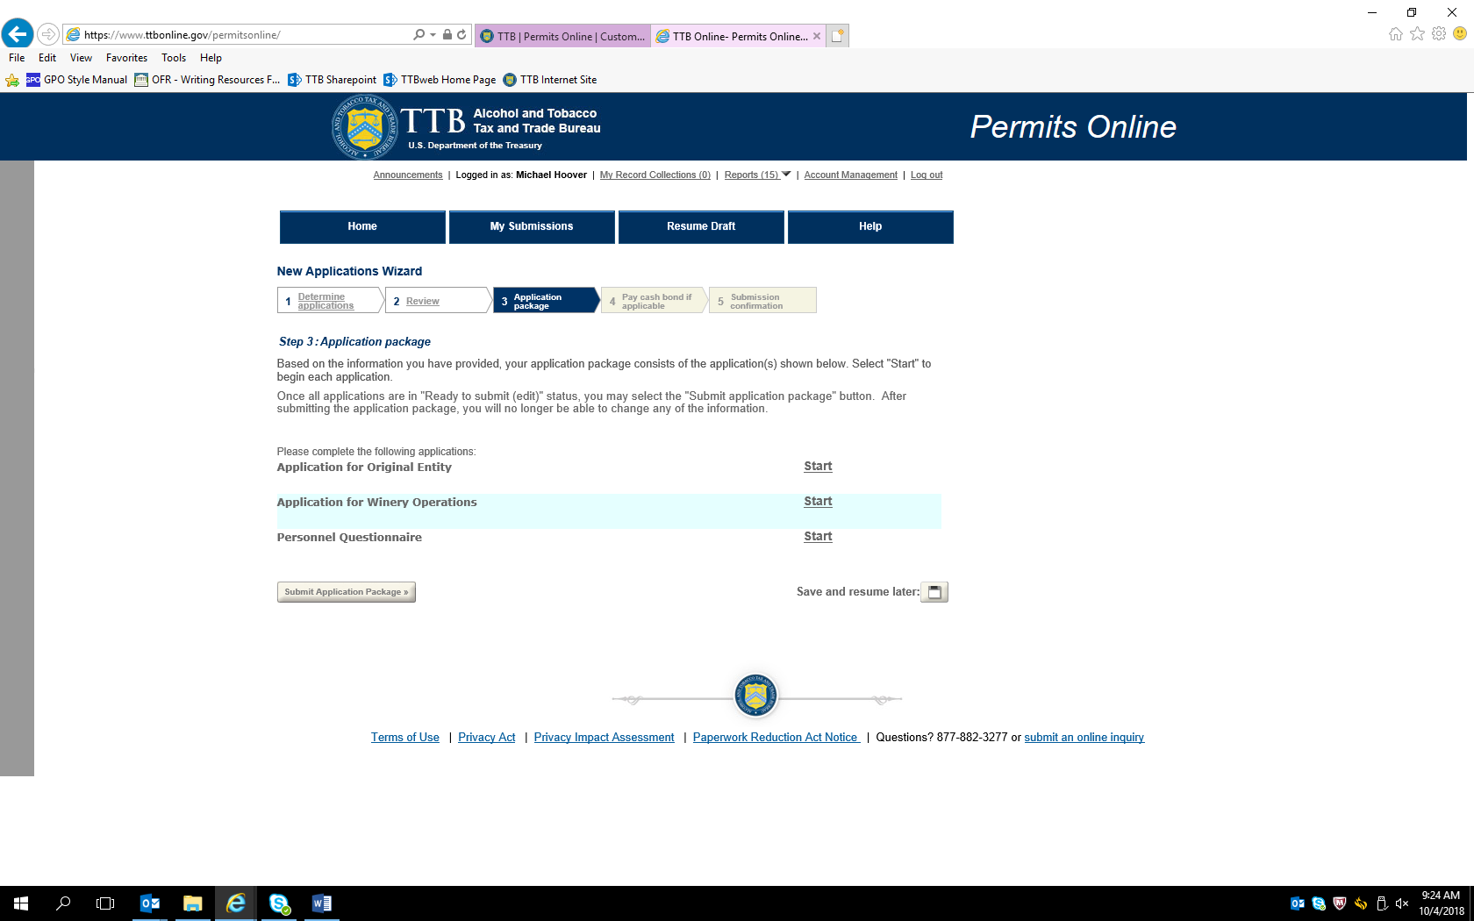

Application for Original Entity

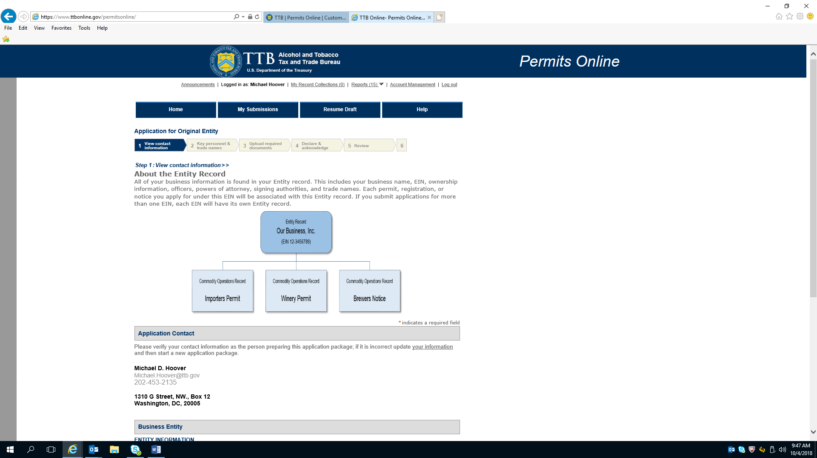

Continuation of Application for Original Entity initial page

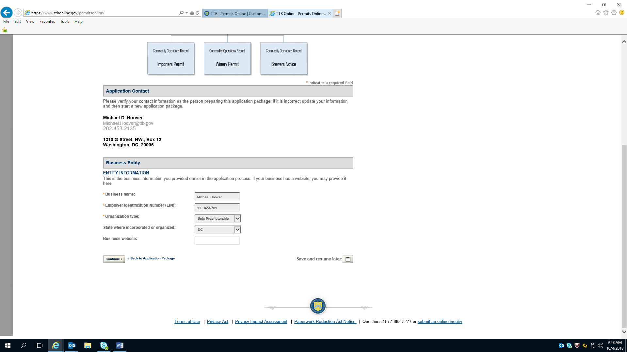

Application for Original Entity—Officer/Ownership Information

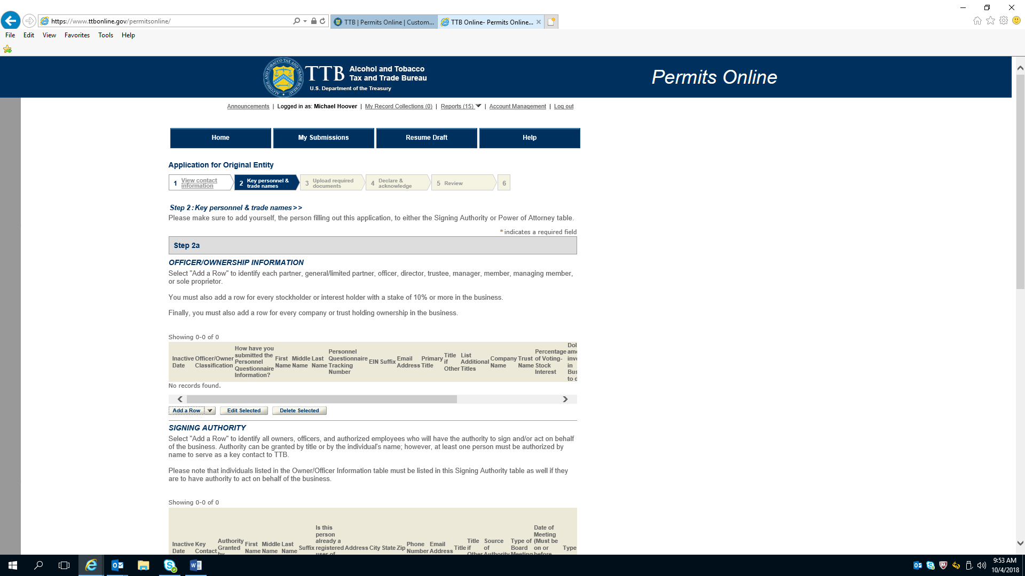

Application for Original Entity—Officer/Ownership Information (continued)

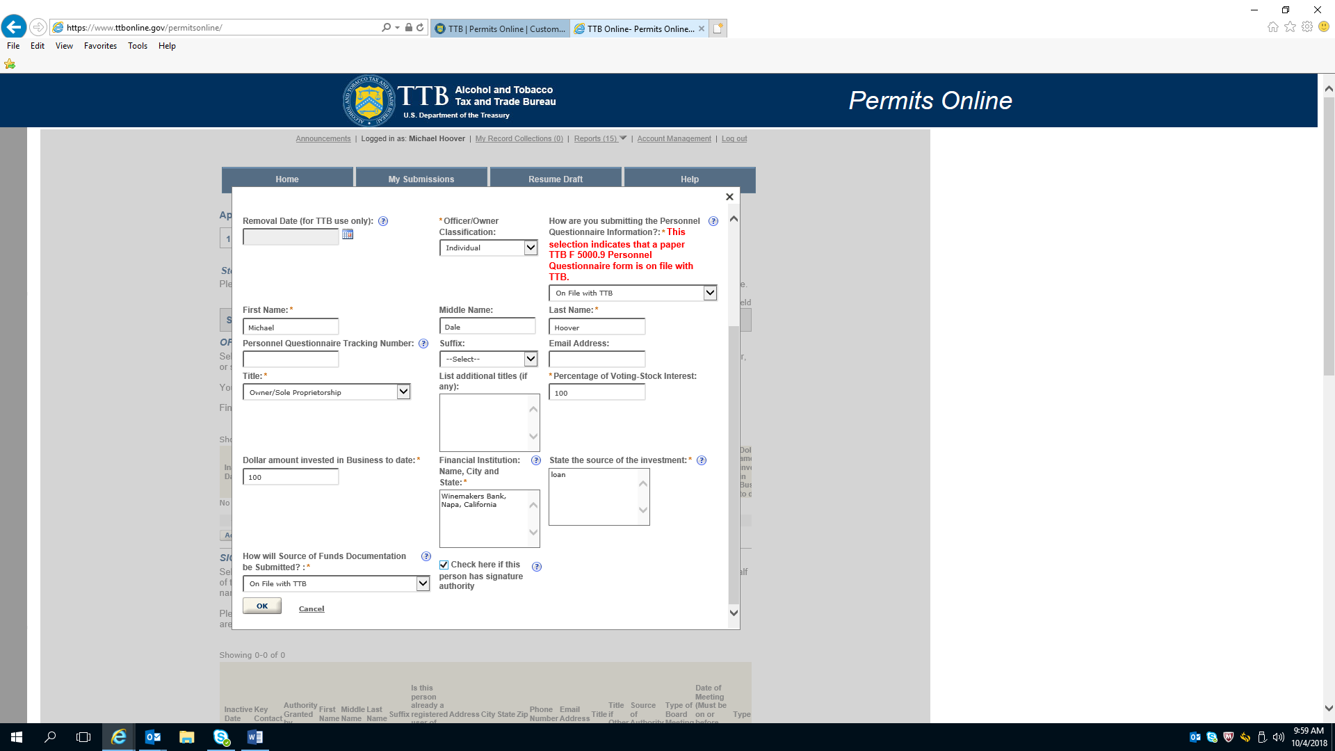

Application for Original Entity---Signing Authority

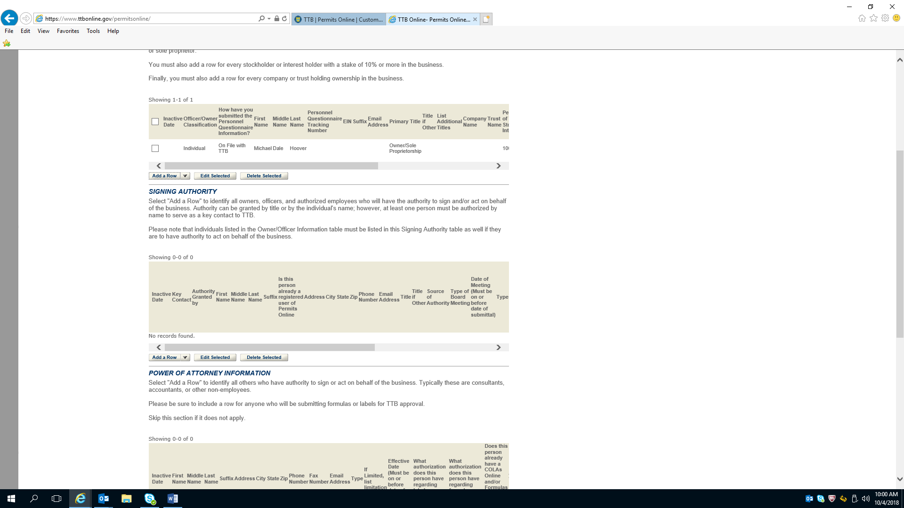

Application for Original Entity---Signing Authority (continued)

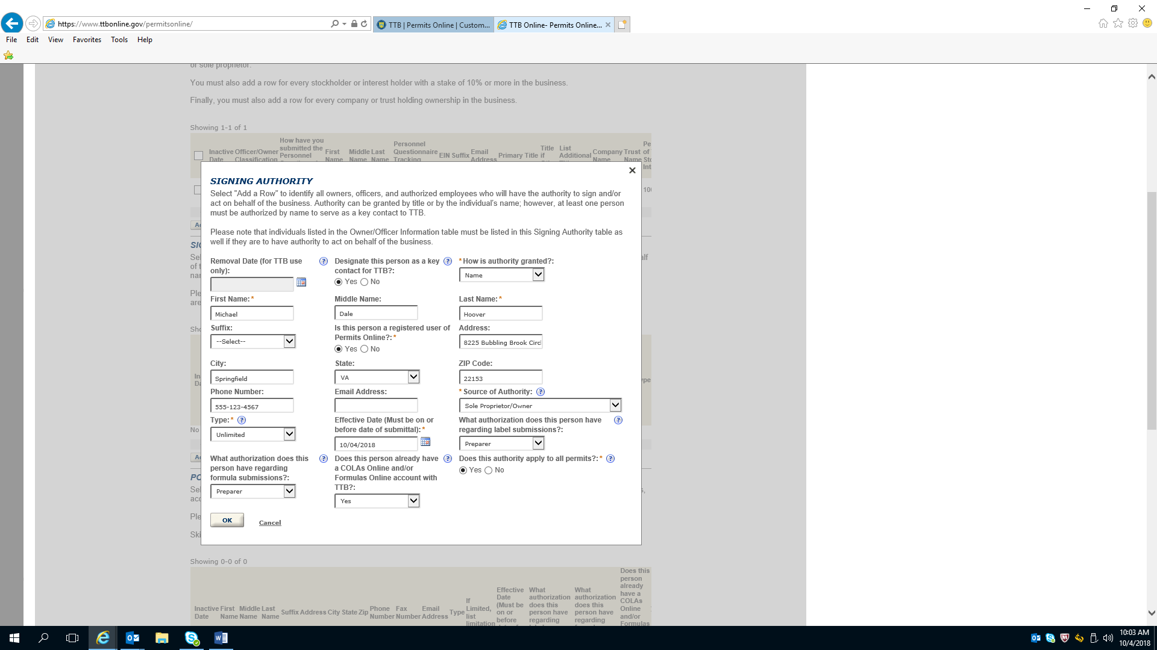

Application for Original Entity---Power of Attorney Information

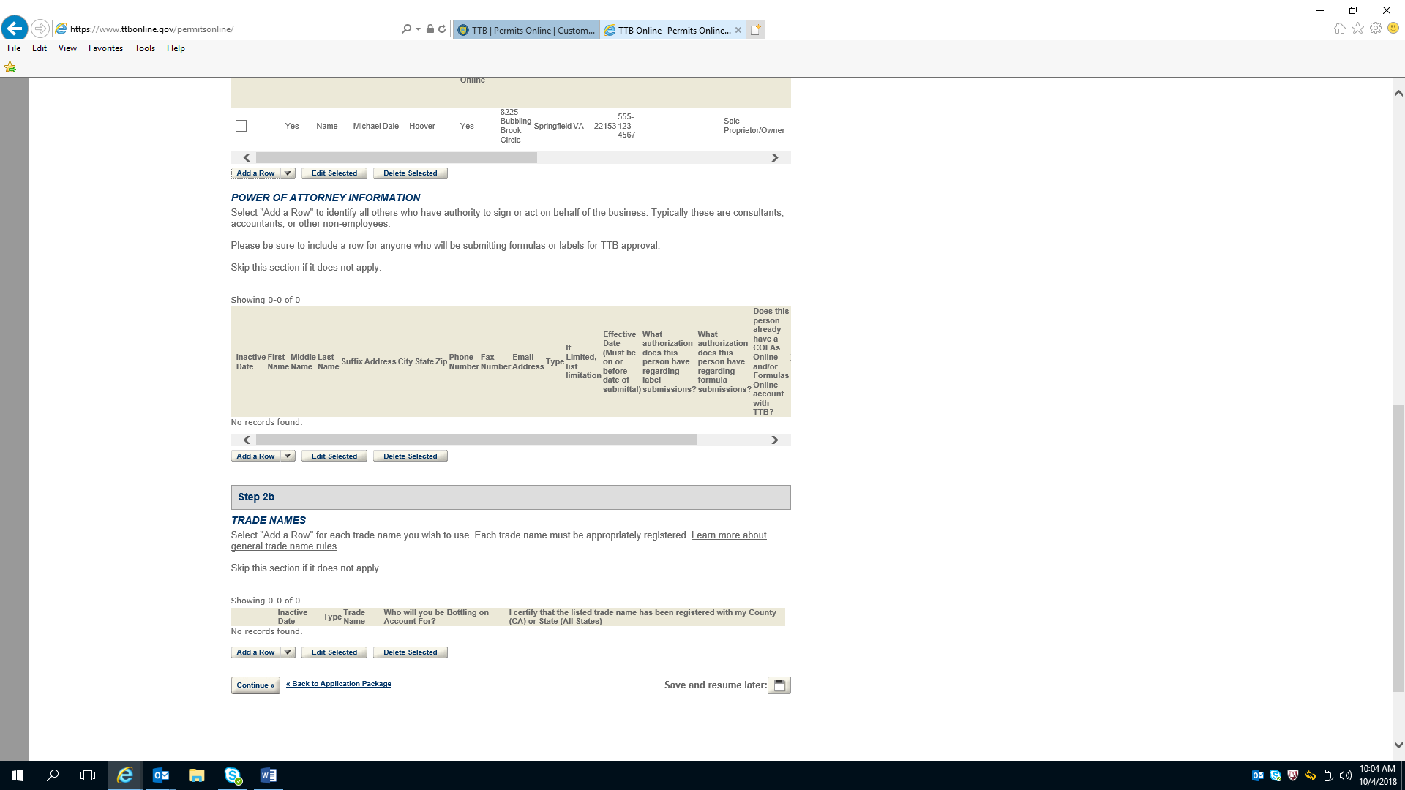

Application for Original Entity---Power of Attorney Information (continued)

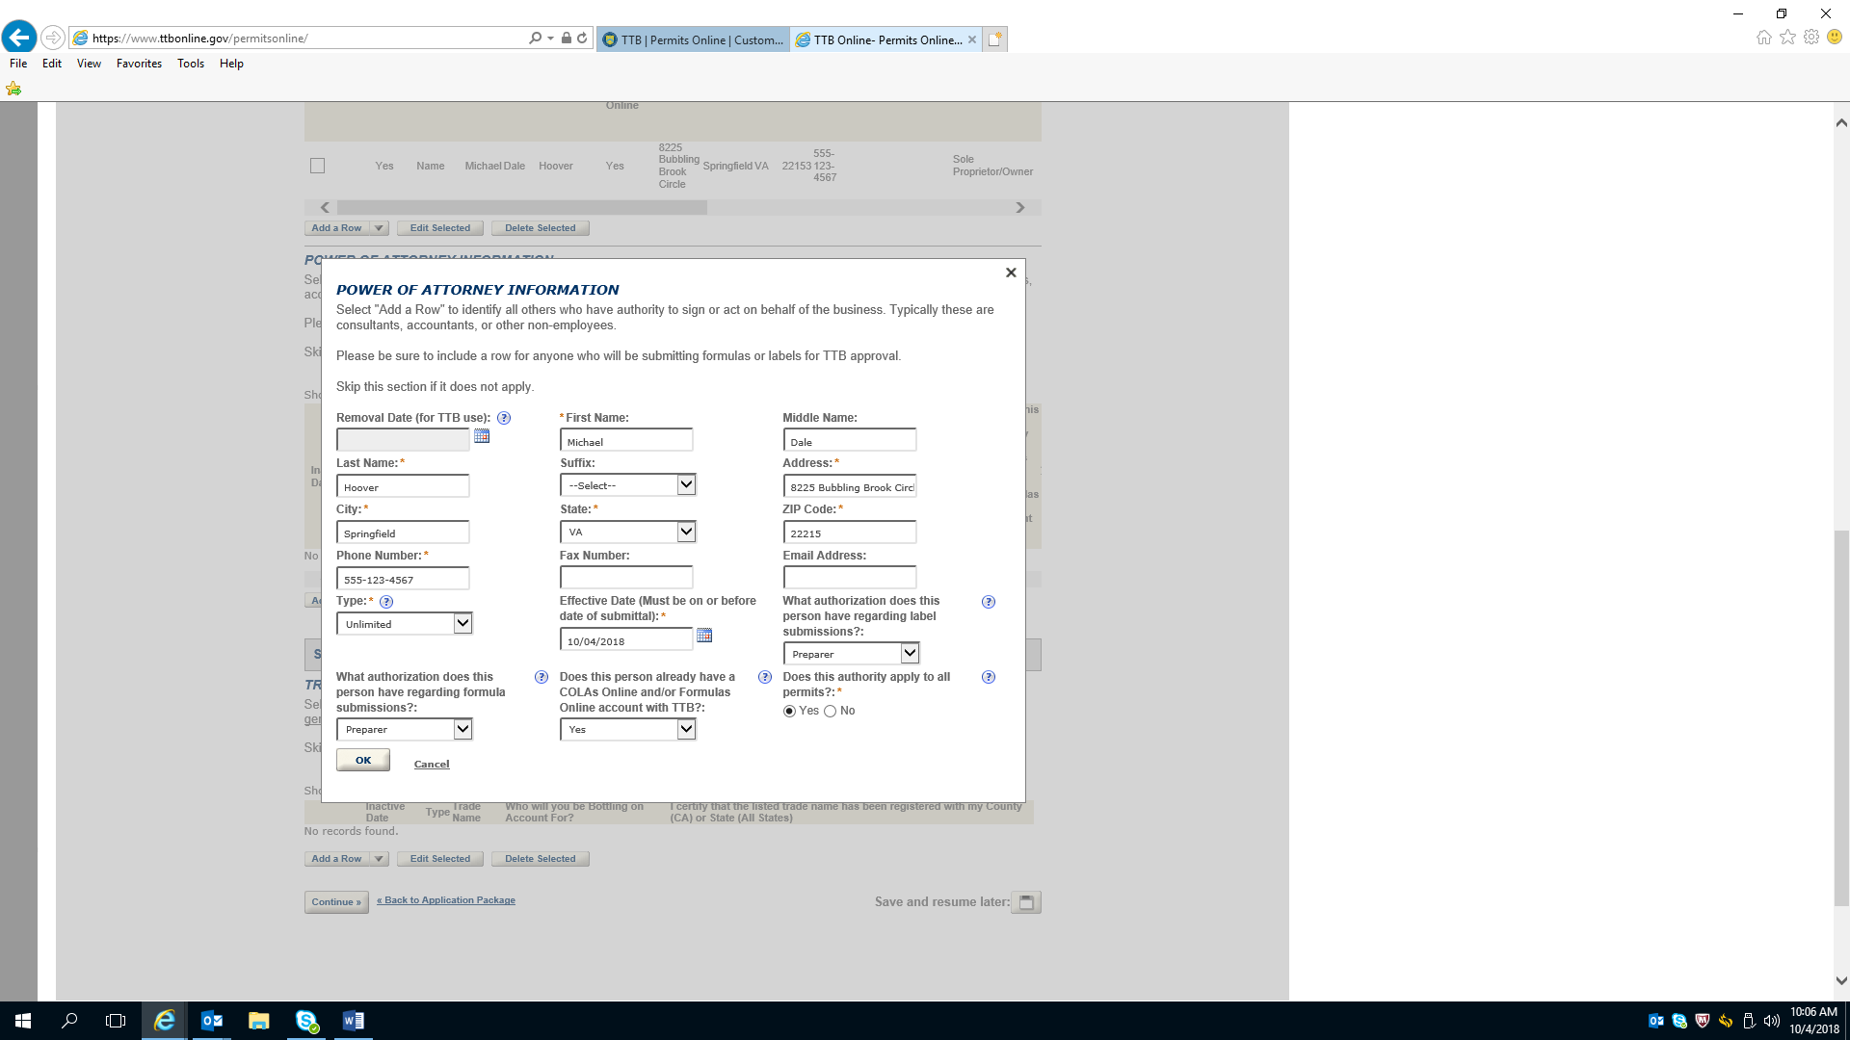

Application for Original Entity---Trade Names
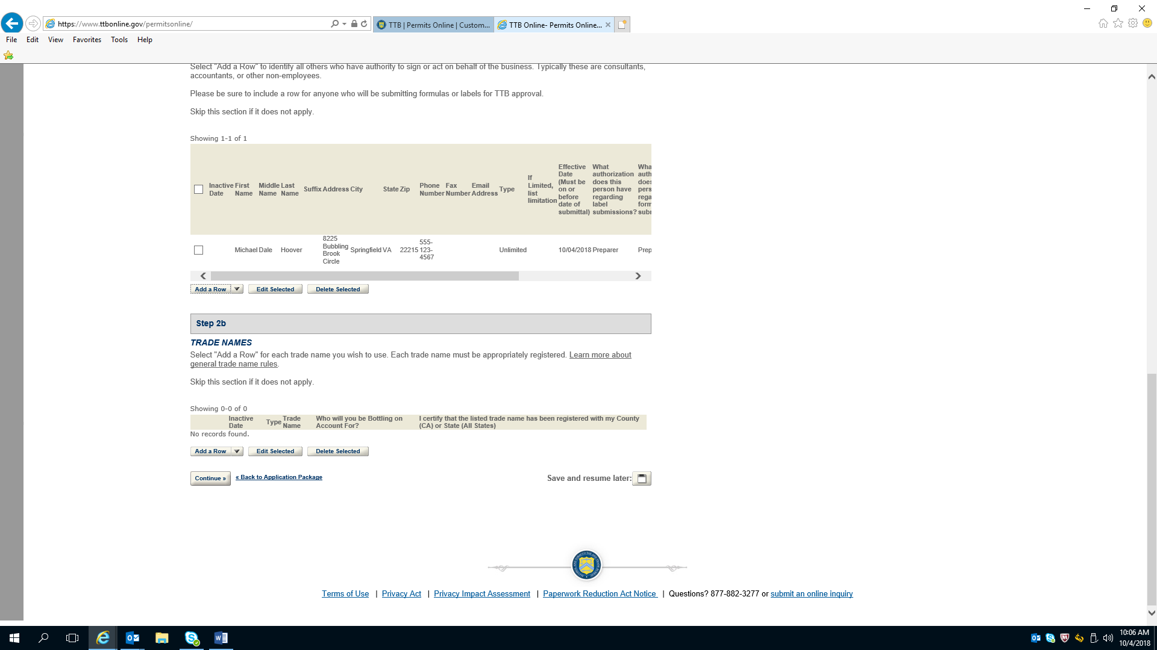

Application for Original Entity---Trade Names (continued)

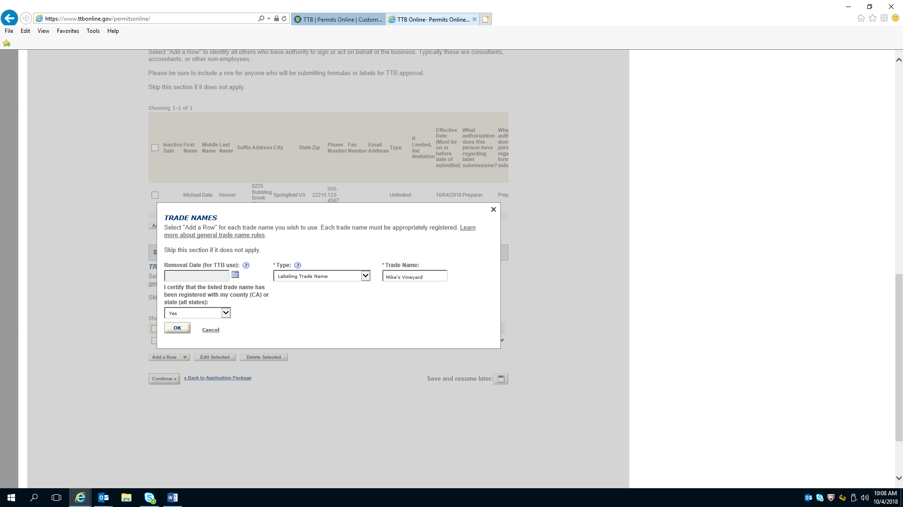

Application for Original Entity---Required Document Checklist

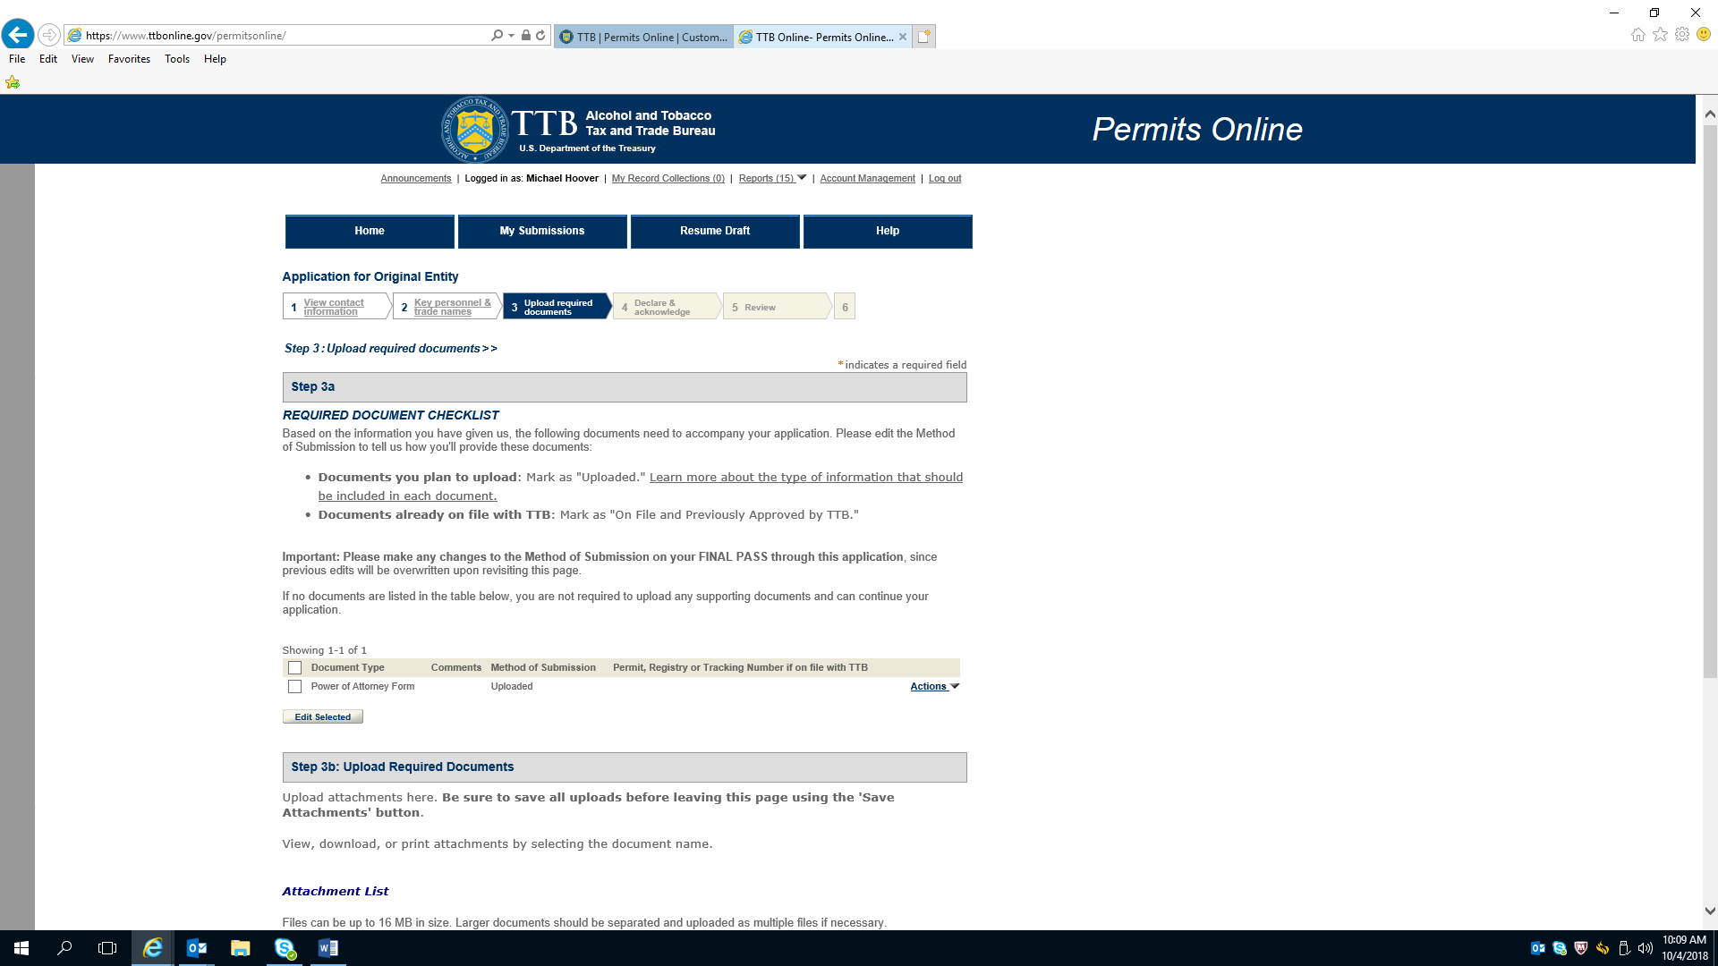

Application for Original Entity---Required Document Checklist (continued)

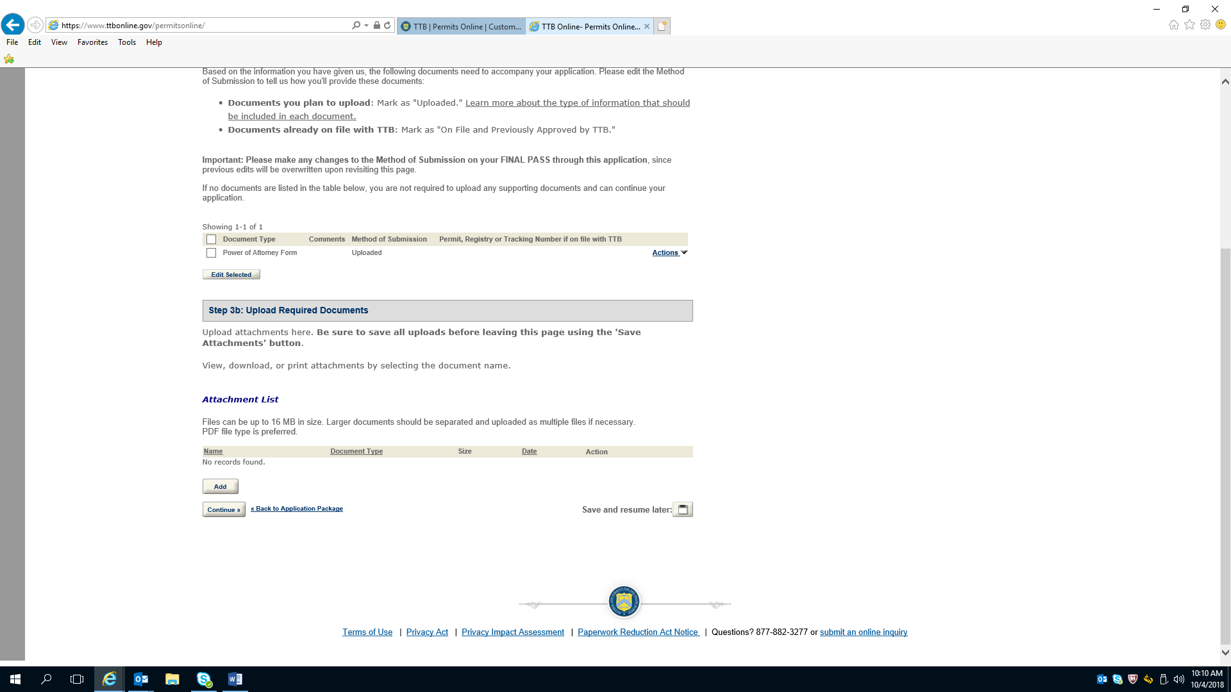

Application for Original Entity—Declare and Acknowledge
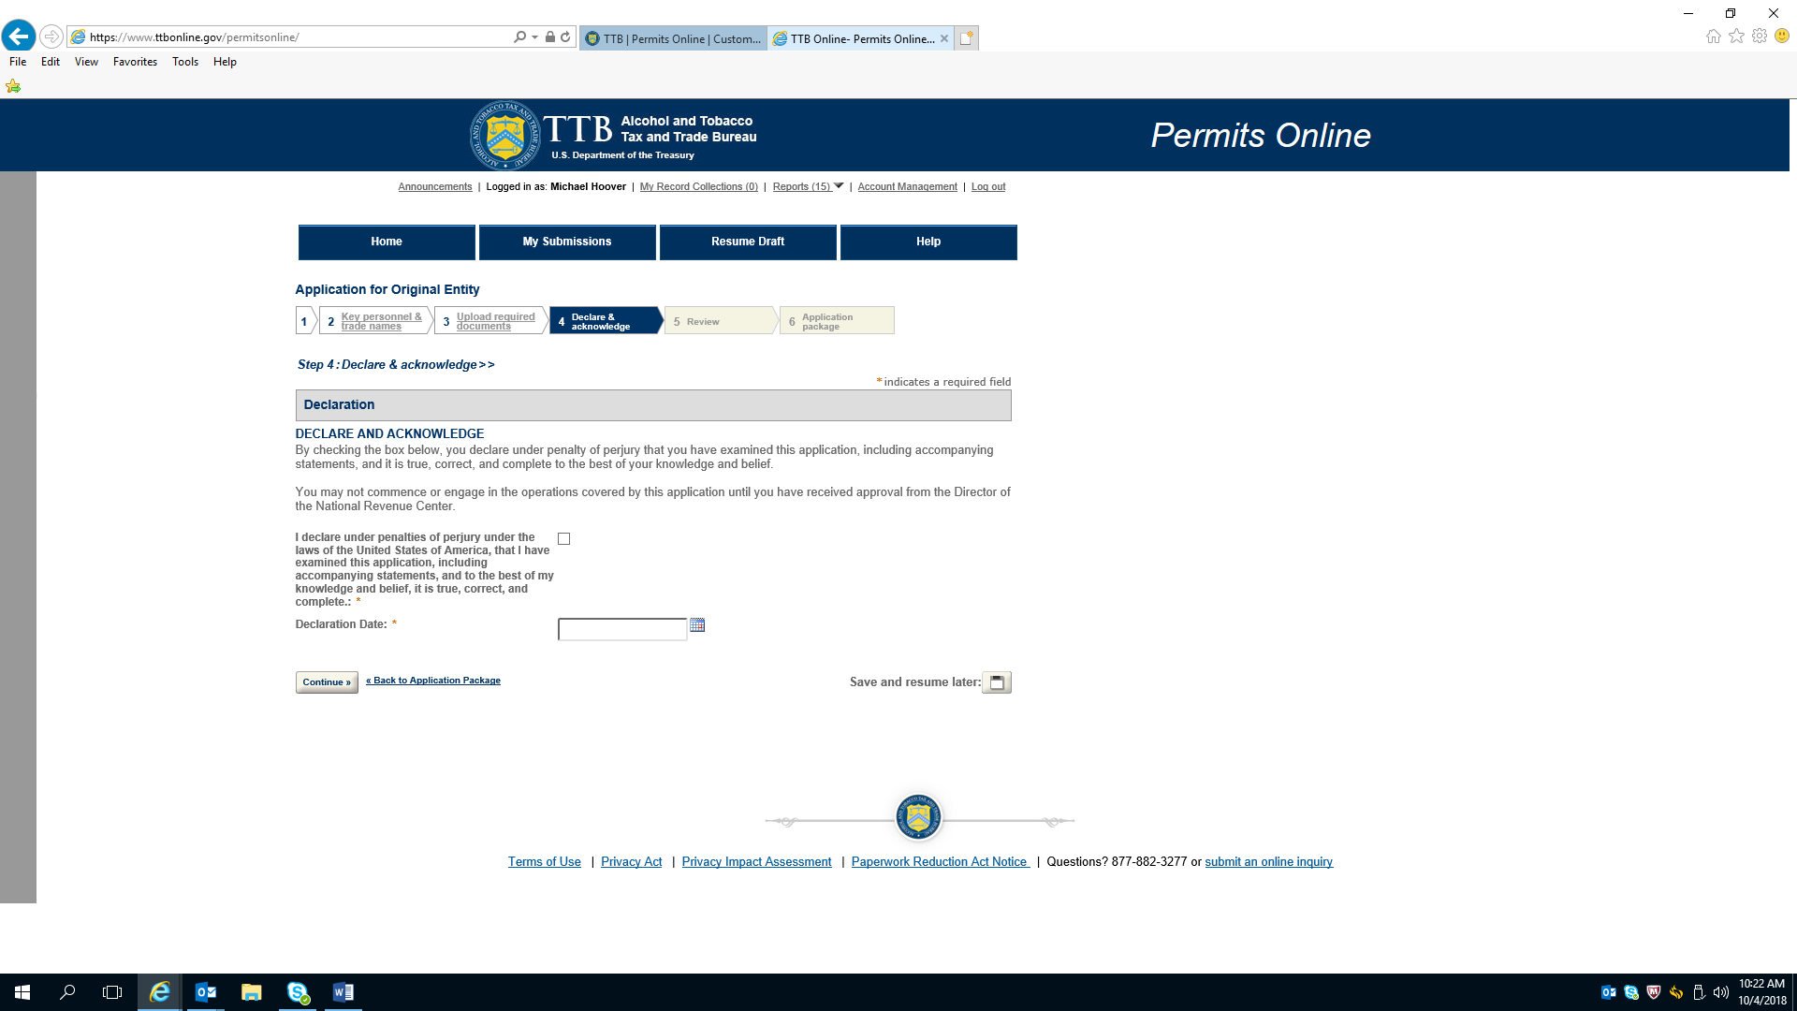

Application for Original Entity—Review

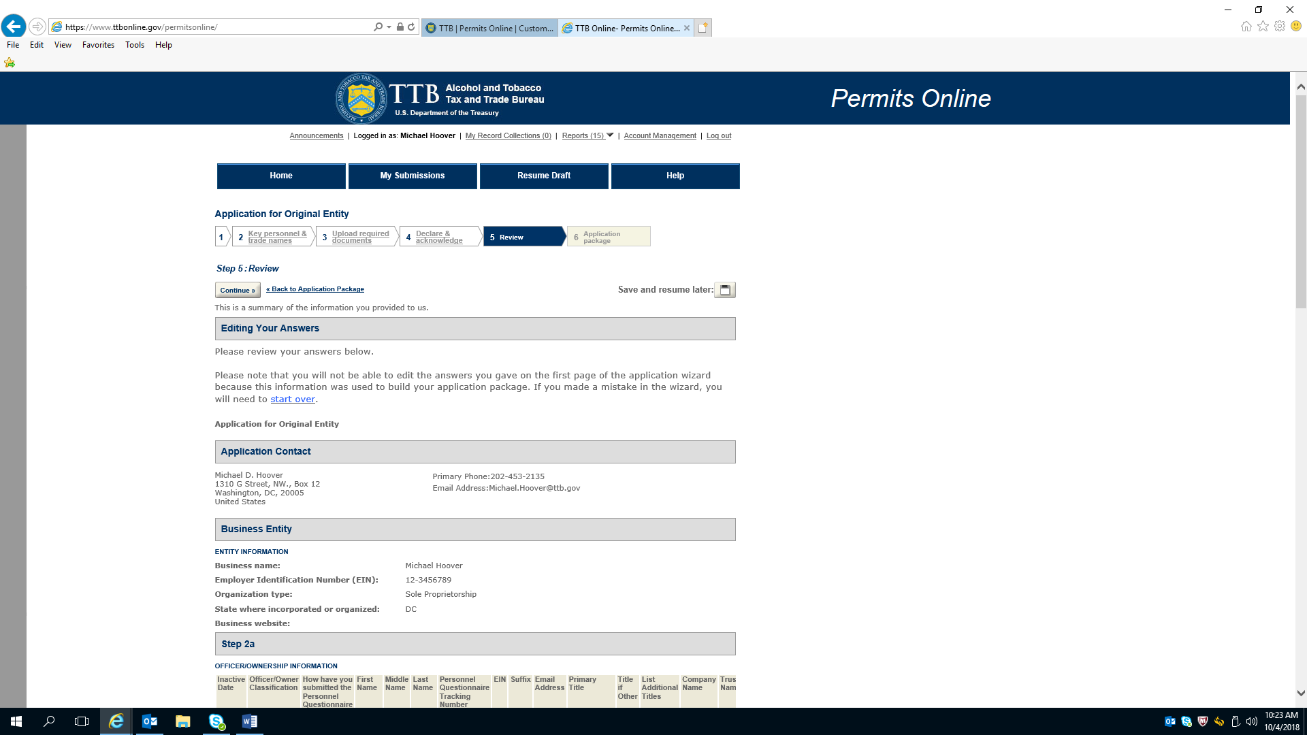

Application for Original Entity—Review (continued)

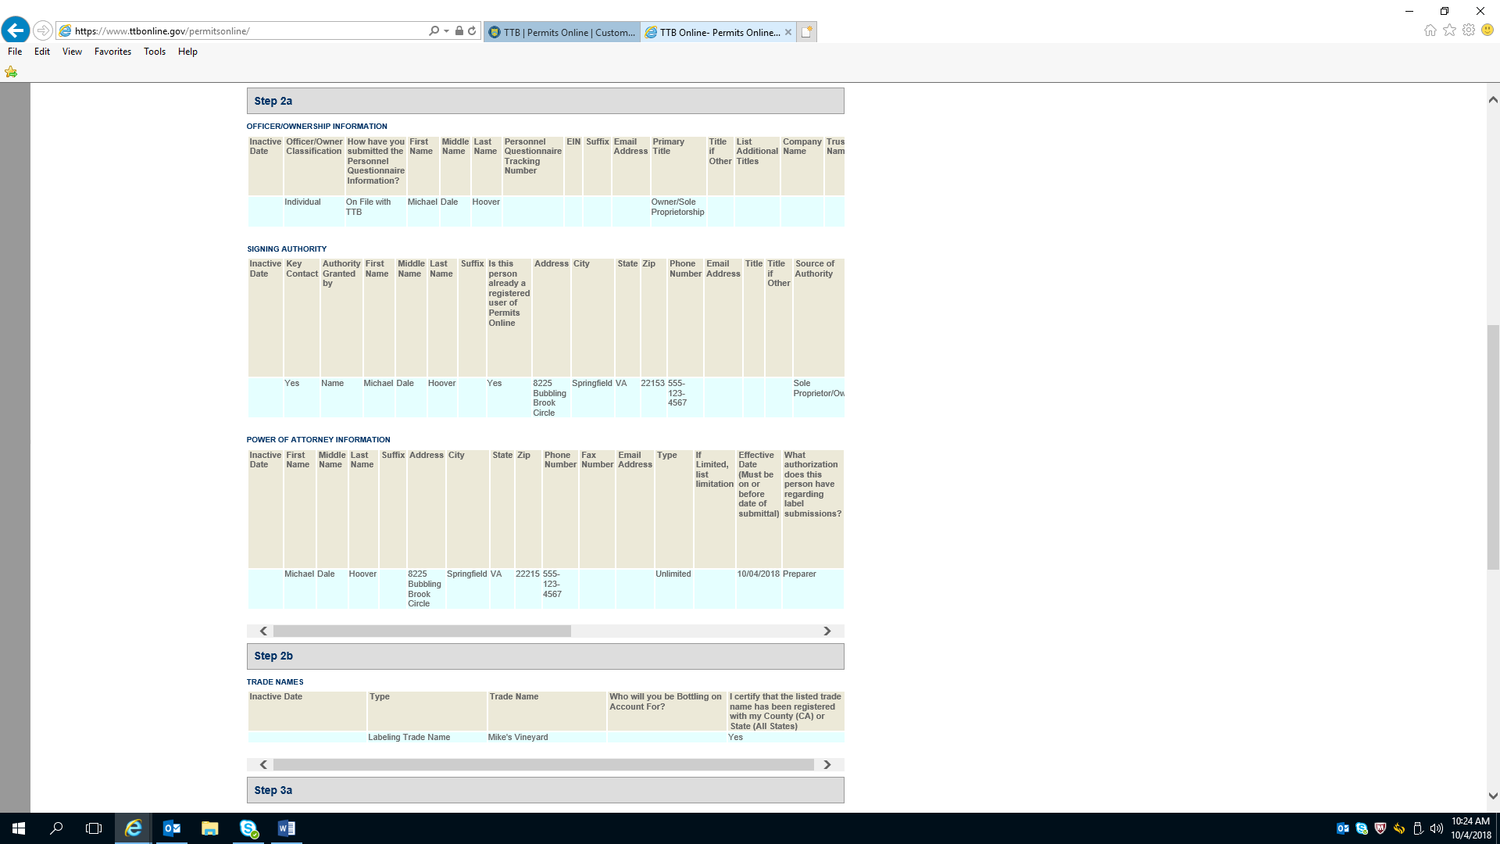

Application for Original Entity—Review (continued)

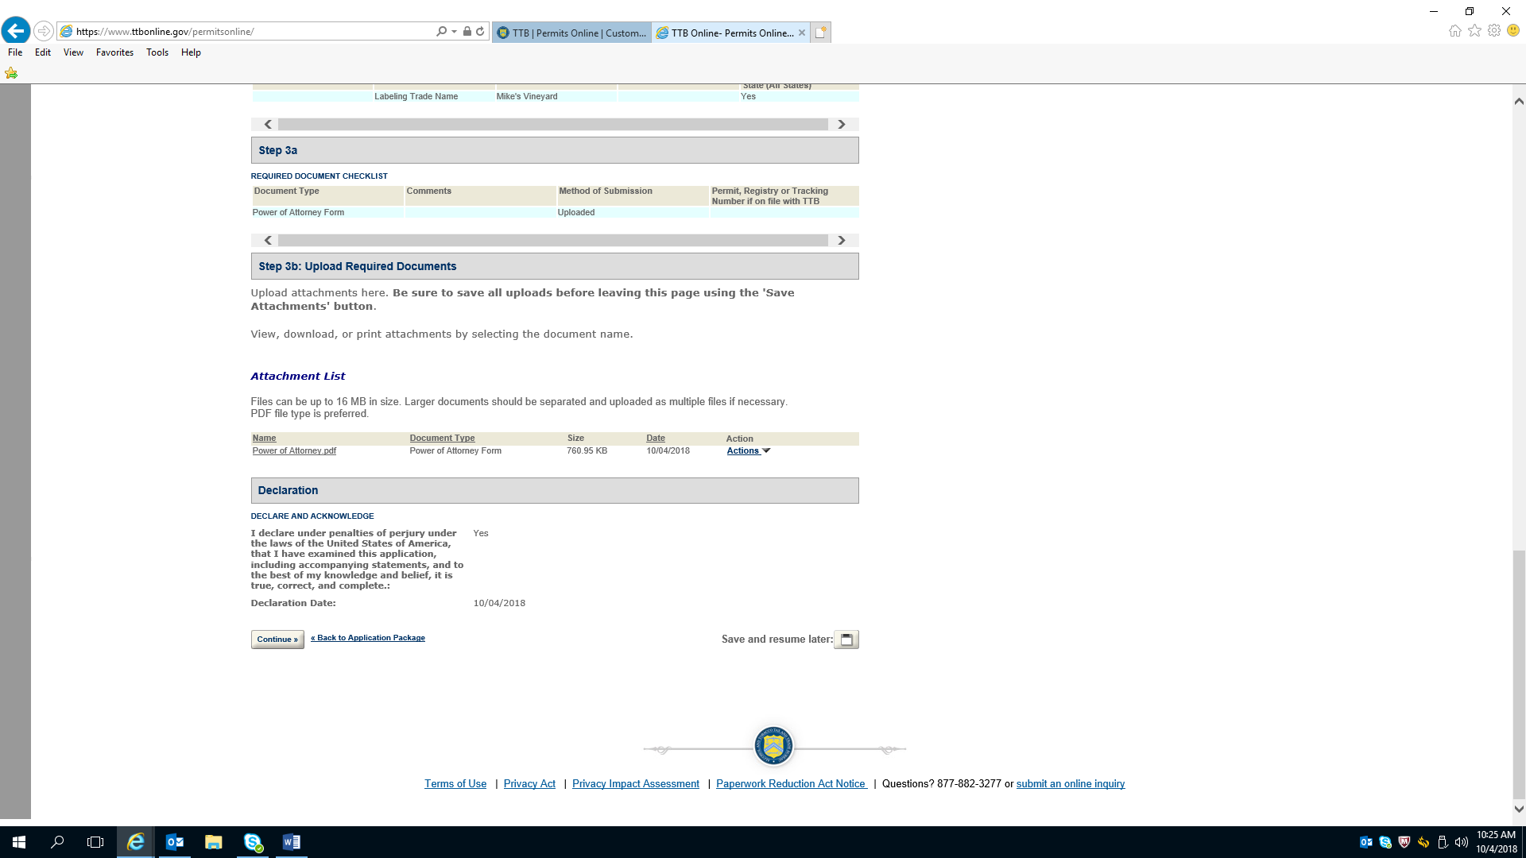

Application for Winery Operations---Initial Page

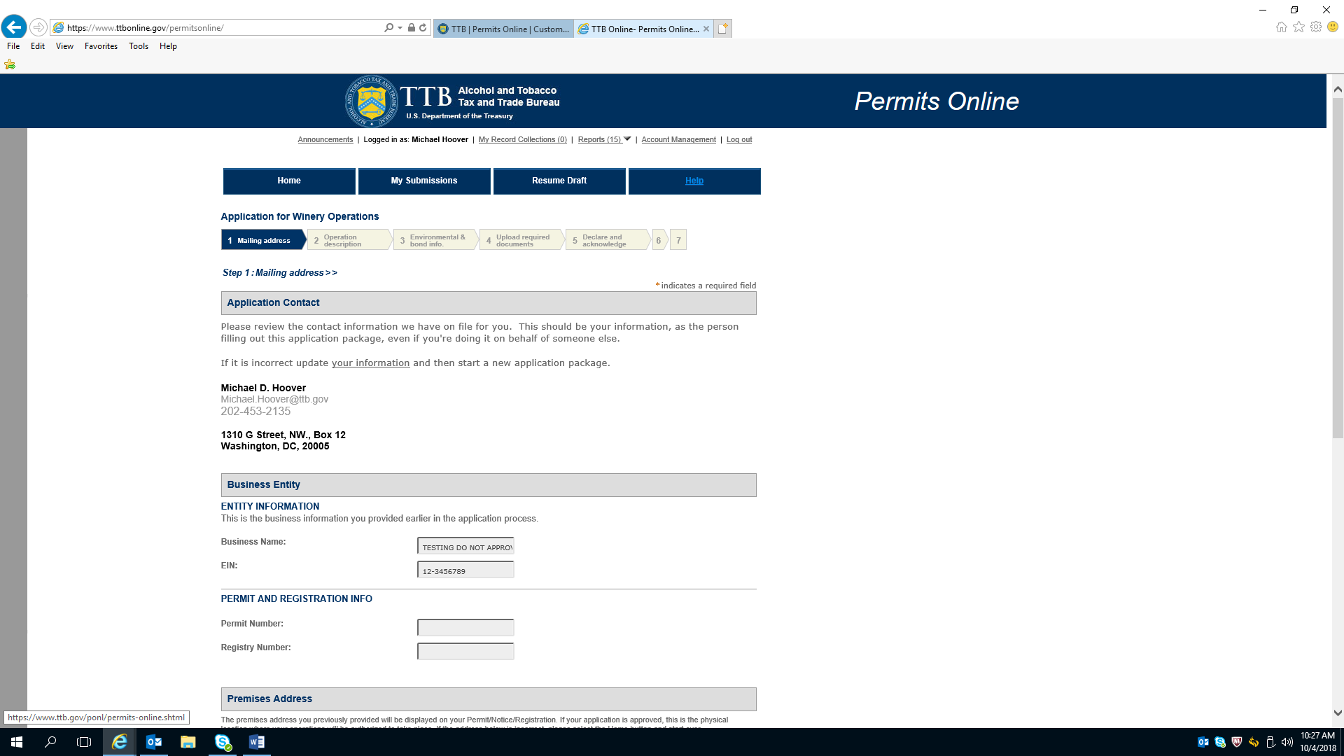

Application for Winery Operations—Initial Page (continued)

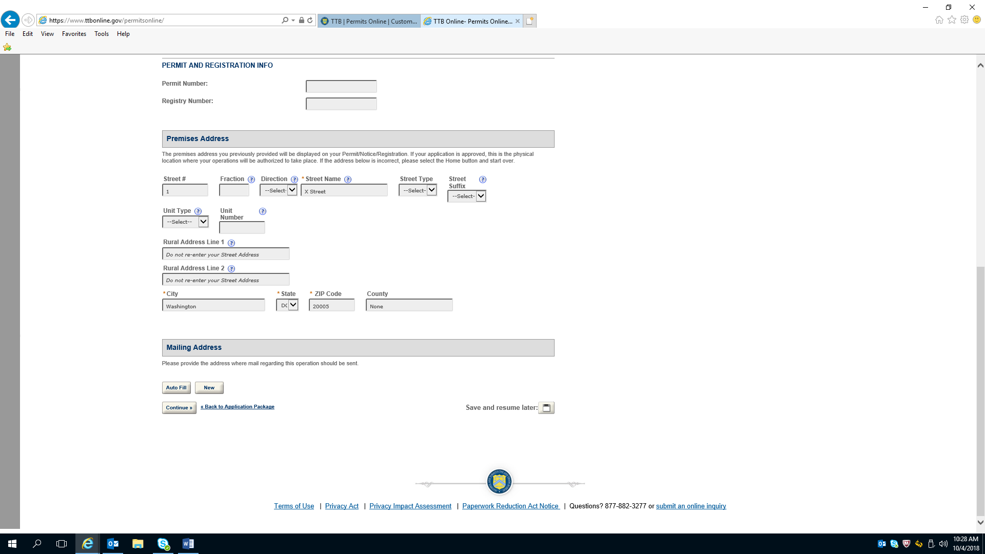

Application for Winery Operations---Operation Description

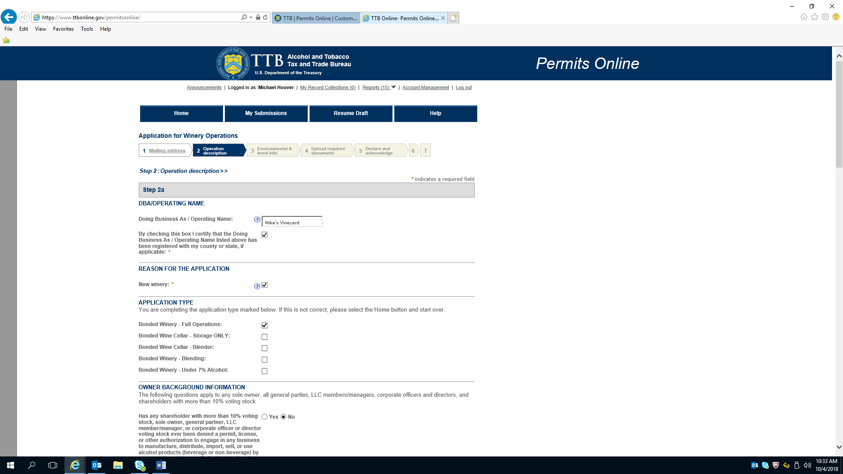

Application for Winery Operations---Operation Description (continued)

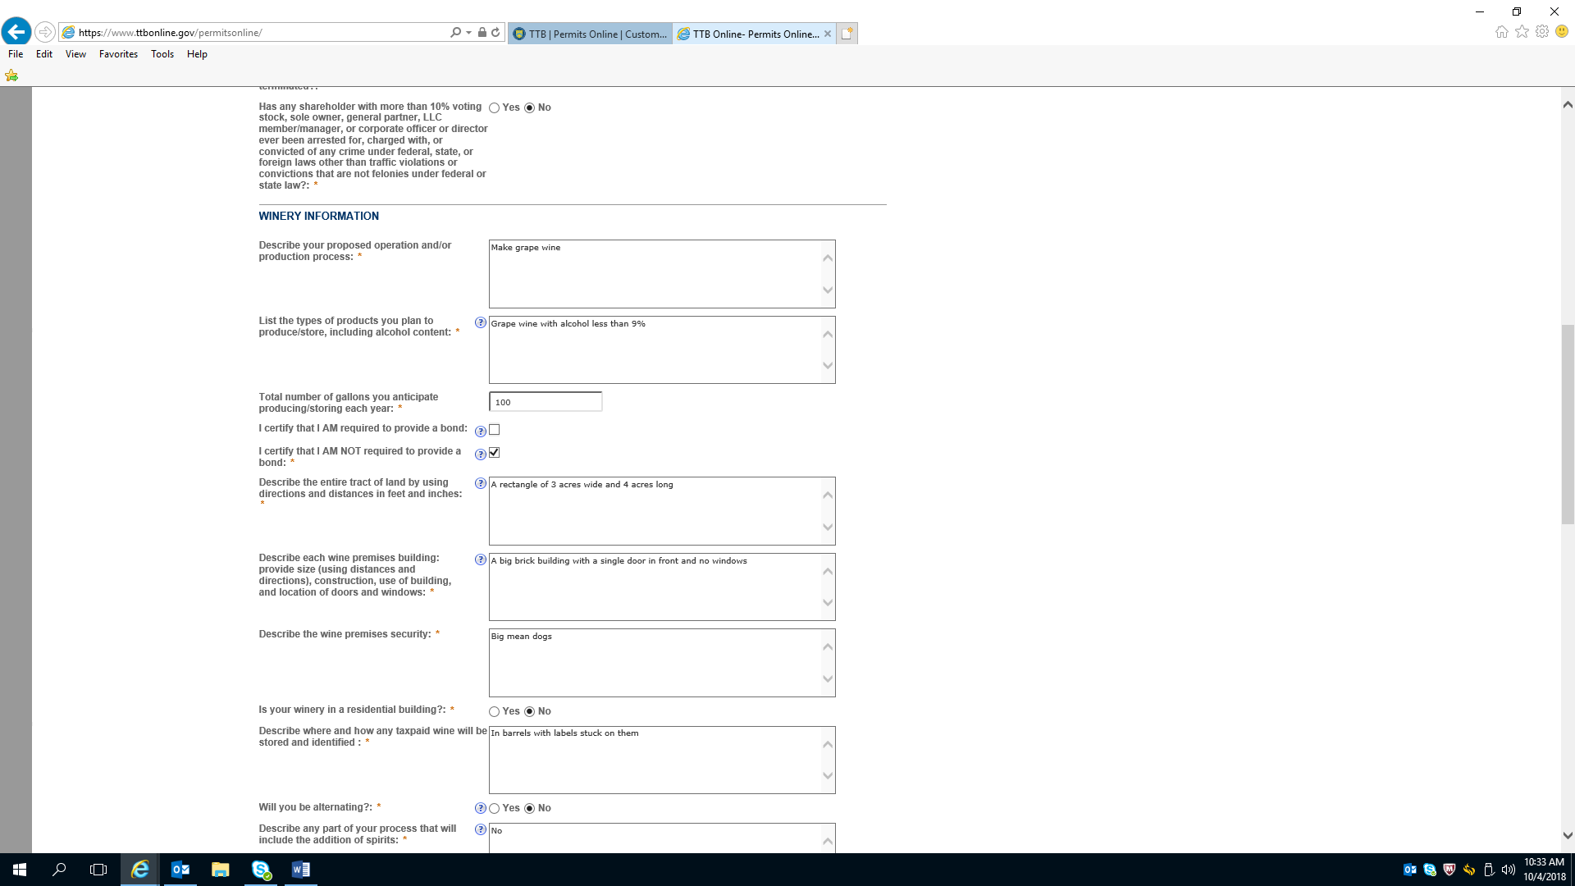

Application for Winery Operations---Operation Description (continued)

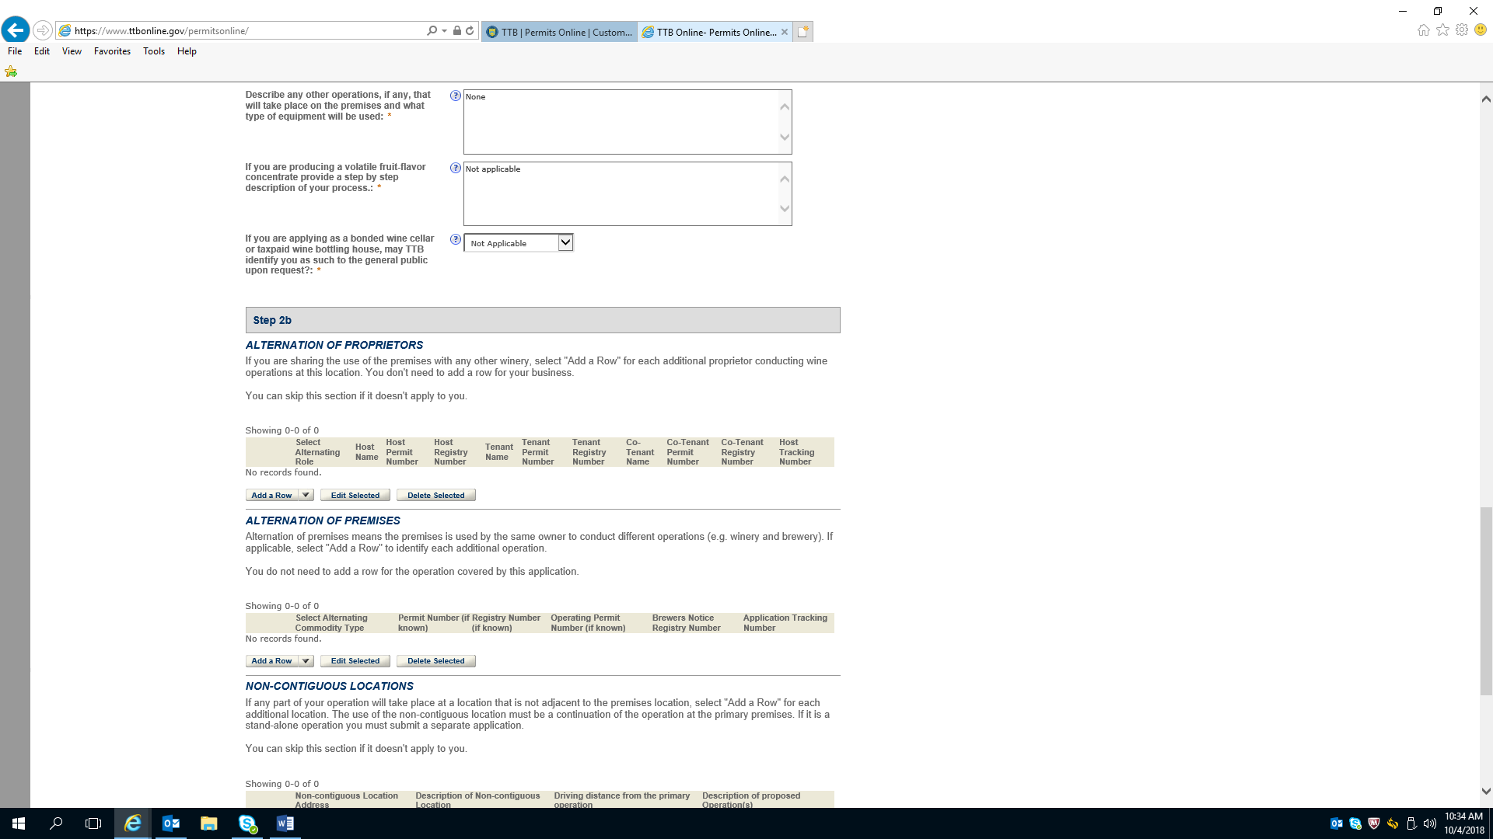

Application for Winery Operations---Operation Description (continued)

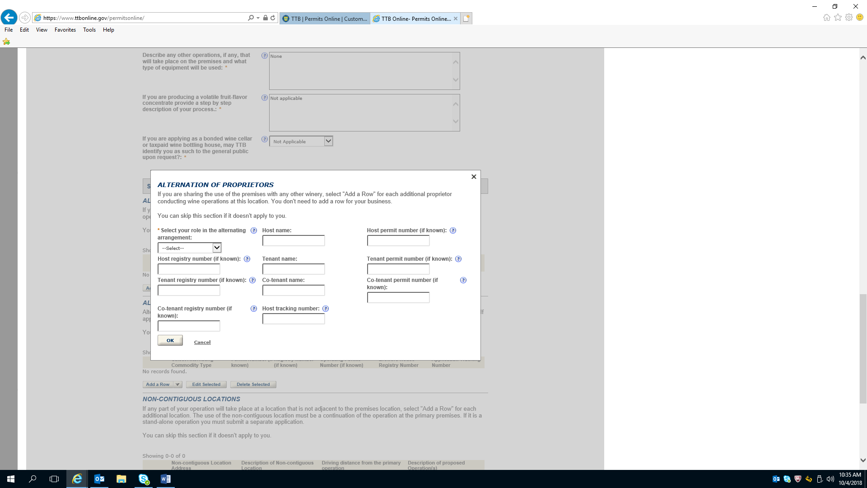

Application for Winery Operations---Operation Description (continued)

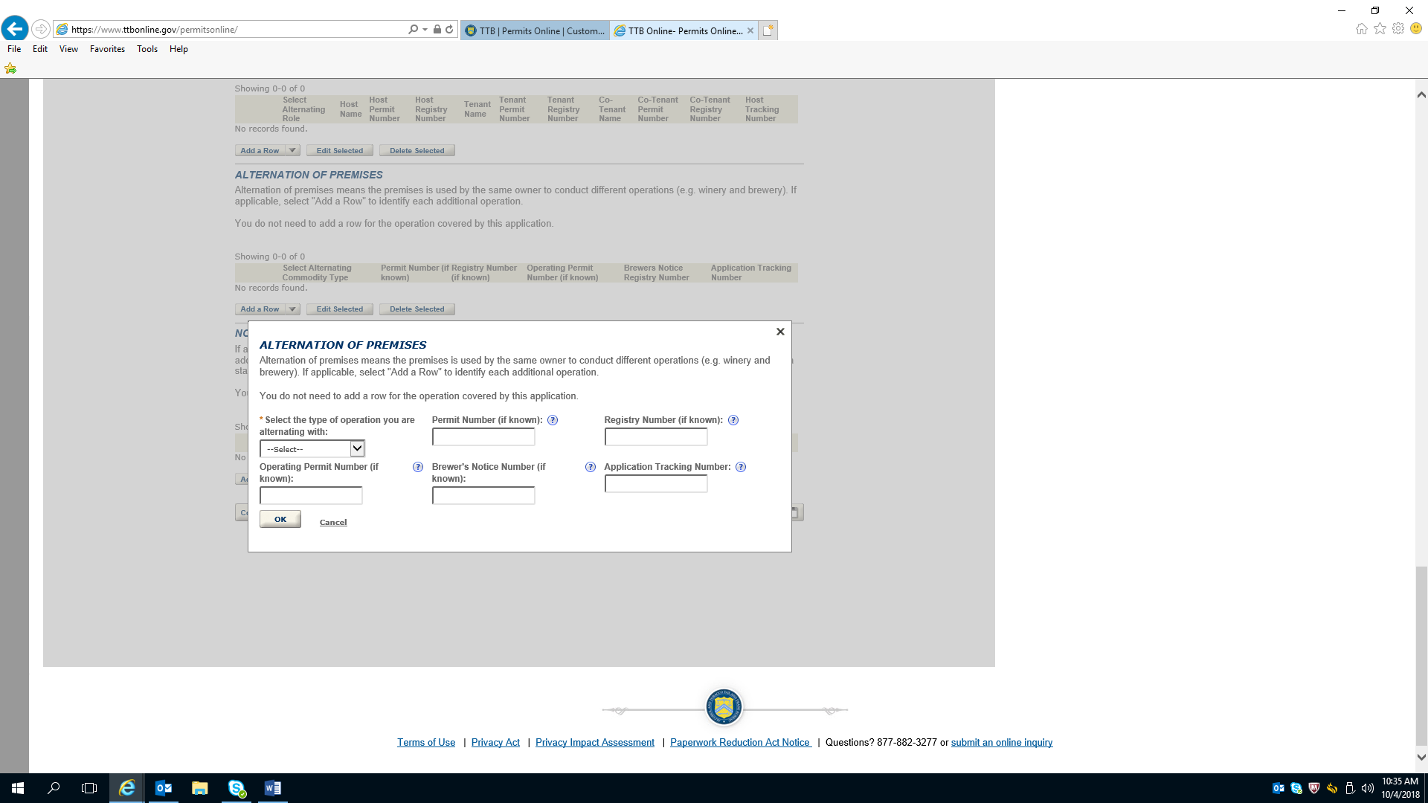

Application for Winery Operations---Operation Description (continued)

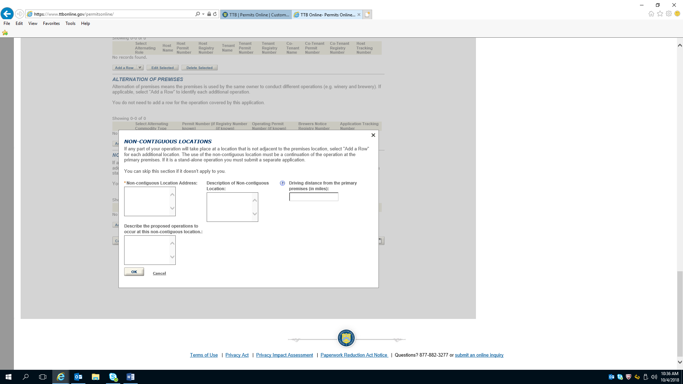

Application for Winery Operations—Environmental & Bond Info

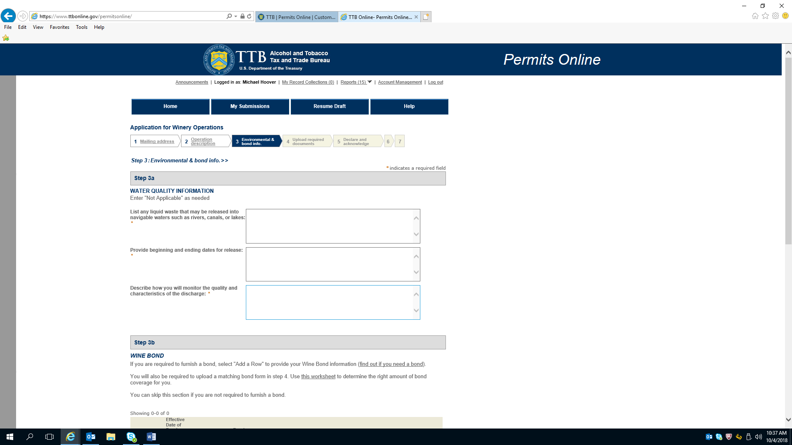

Application for Winery Operations—Environmental & Bond Info (continued)

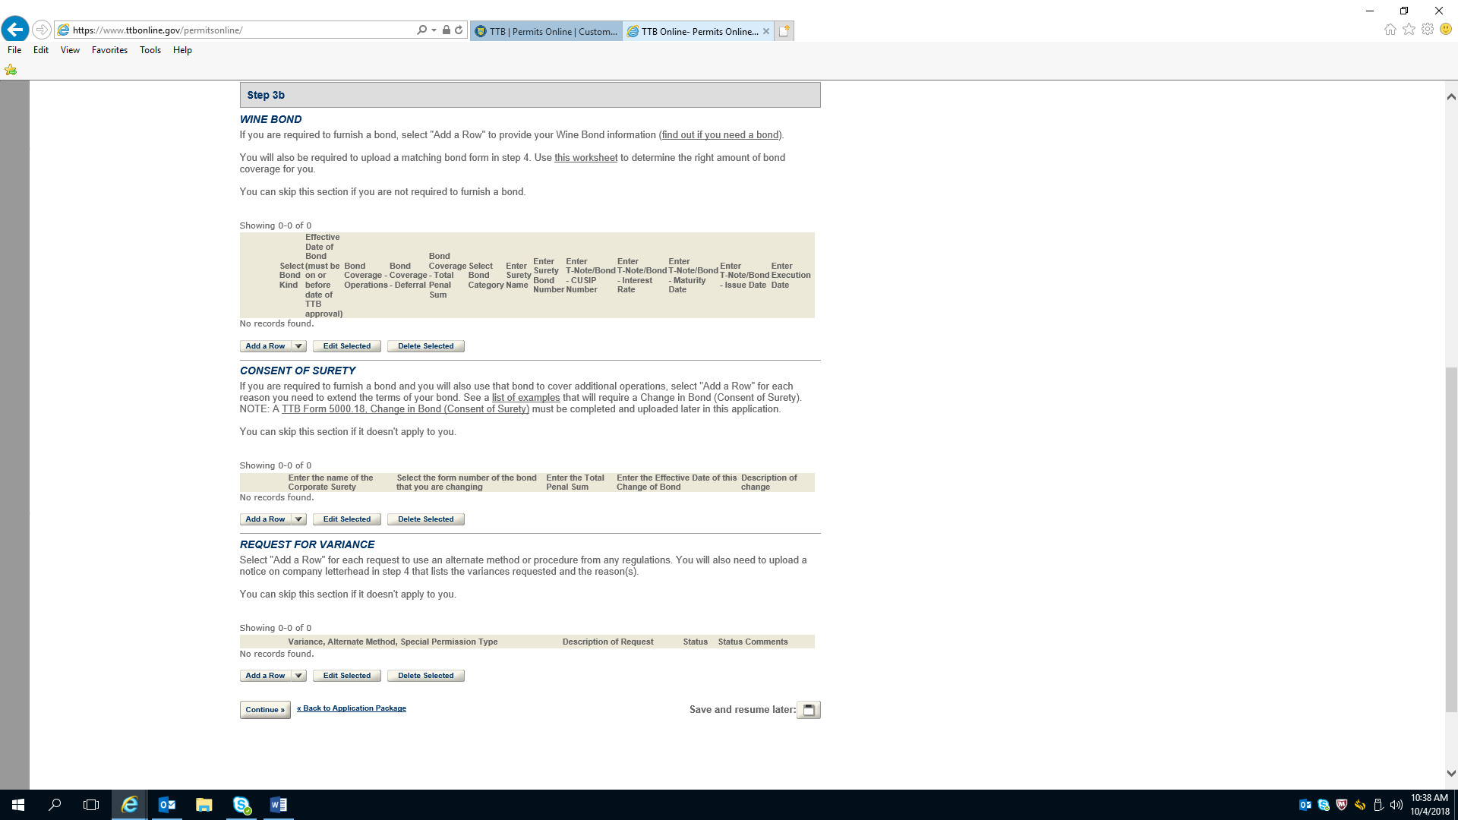

Application for Winery Operations—Environmental & Bond Info (continued)

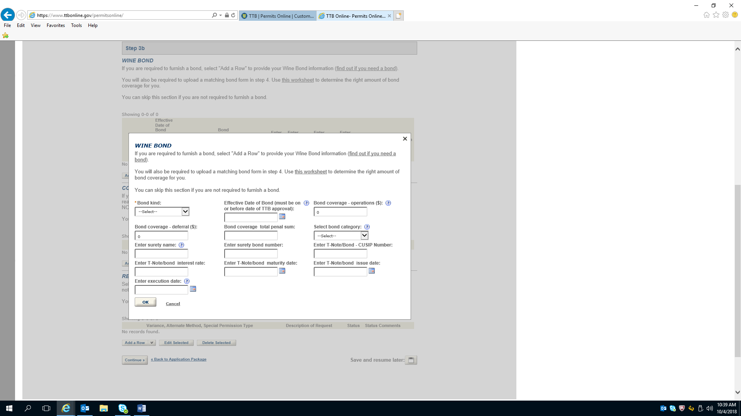

Application for Winery Operations—Environmental & Bond Info (continued)

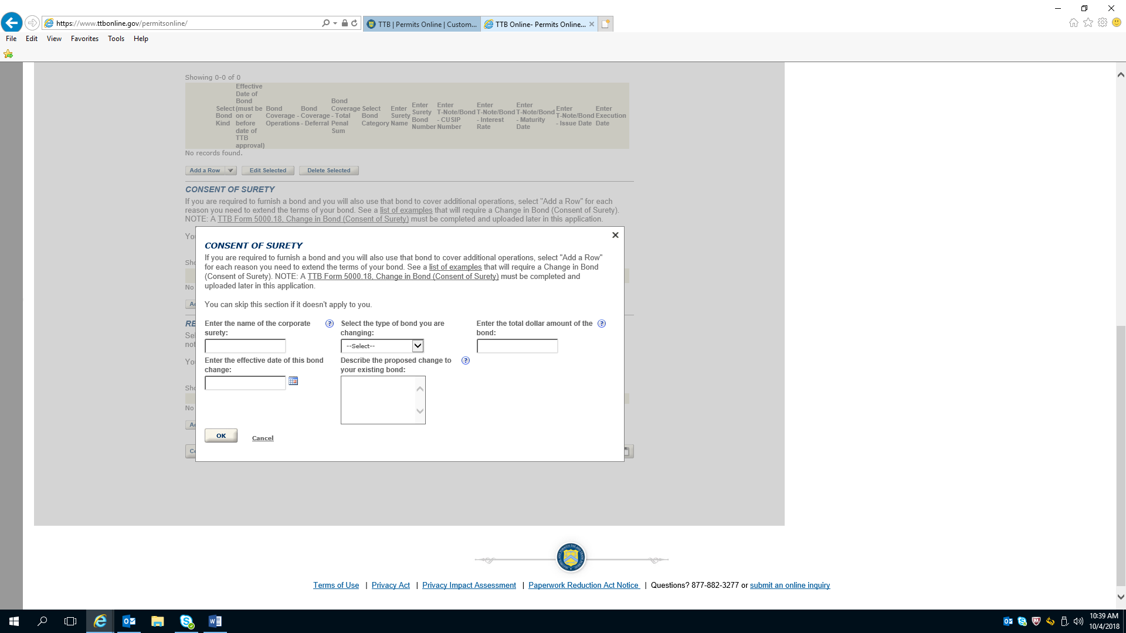

Application for Winery Operations—Environmental & Bond Info (continued)

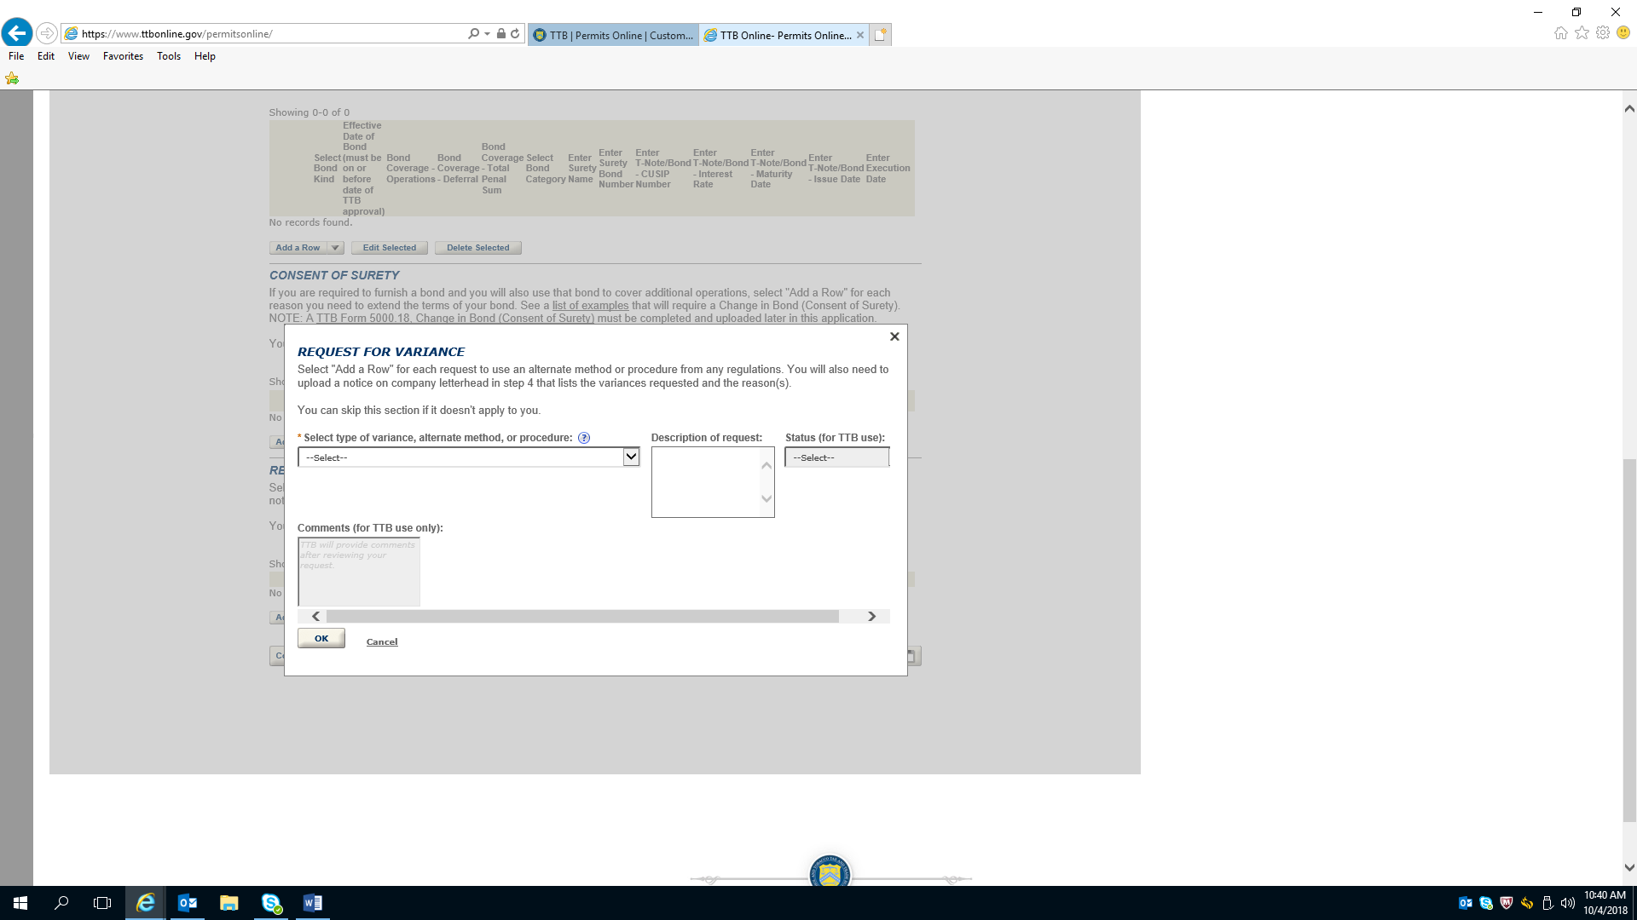

Application for Winery Operations—Upload Required Documents

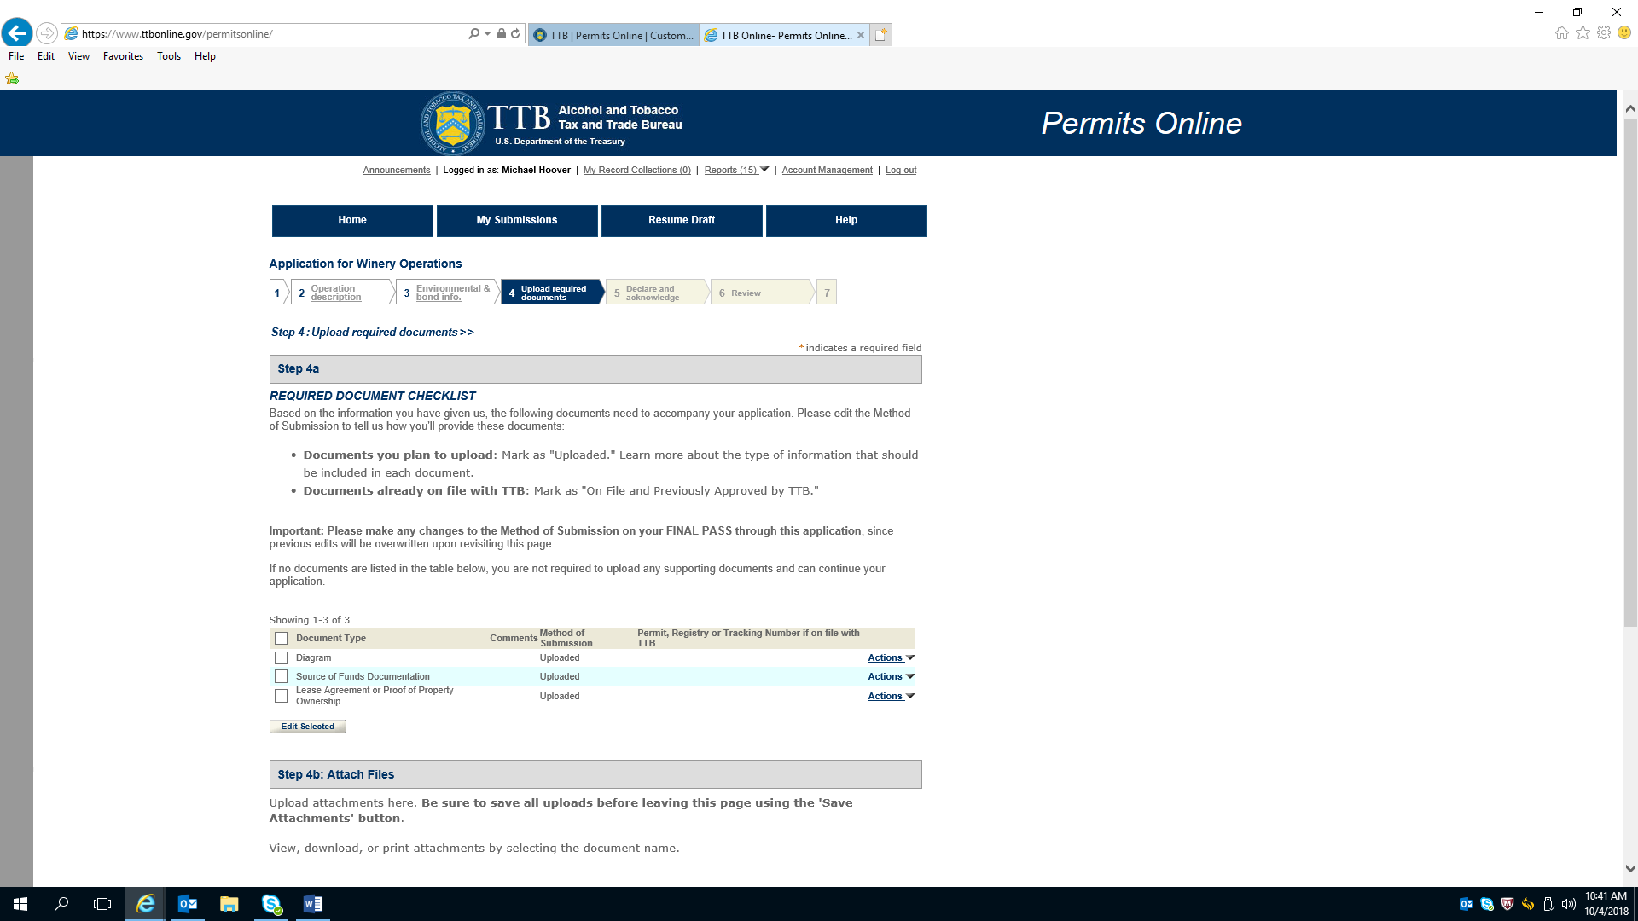

Application for Winery Operations—Upload Required Documents (continued)

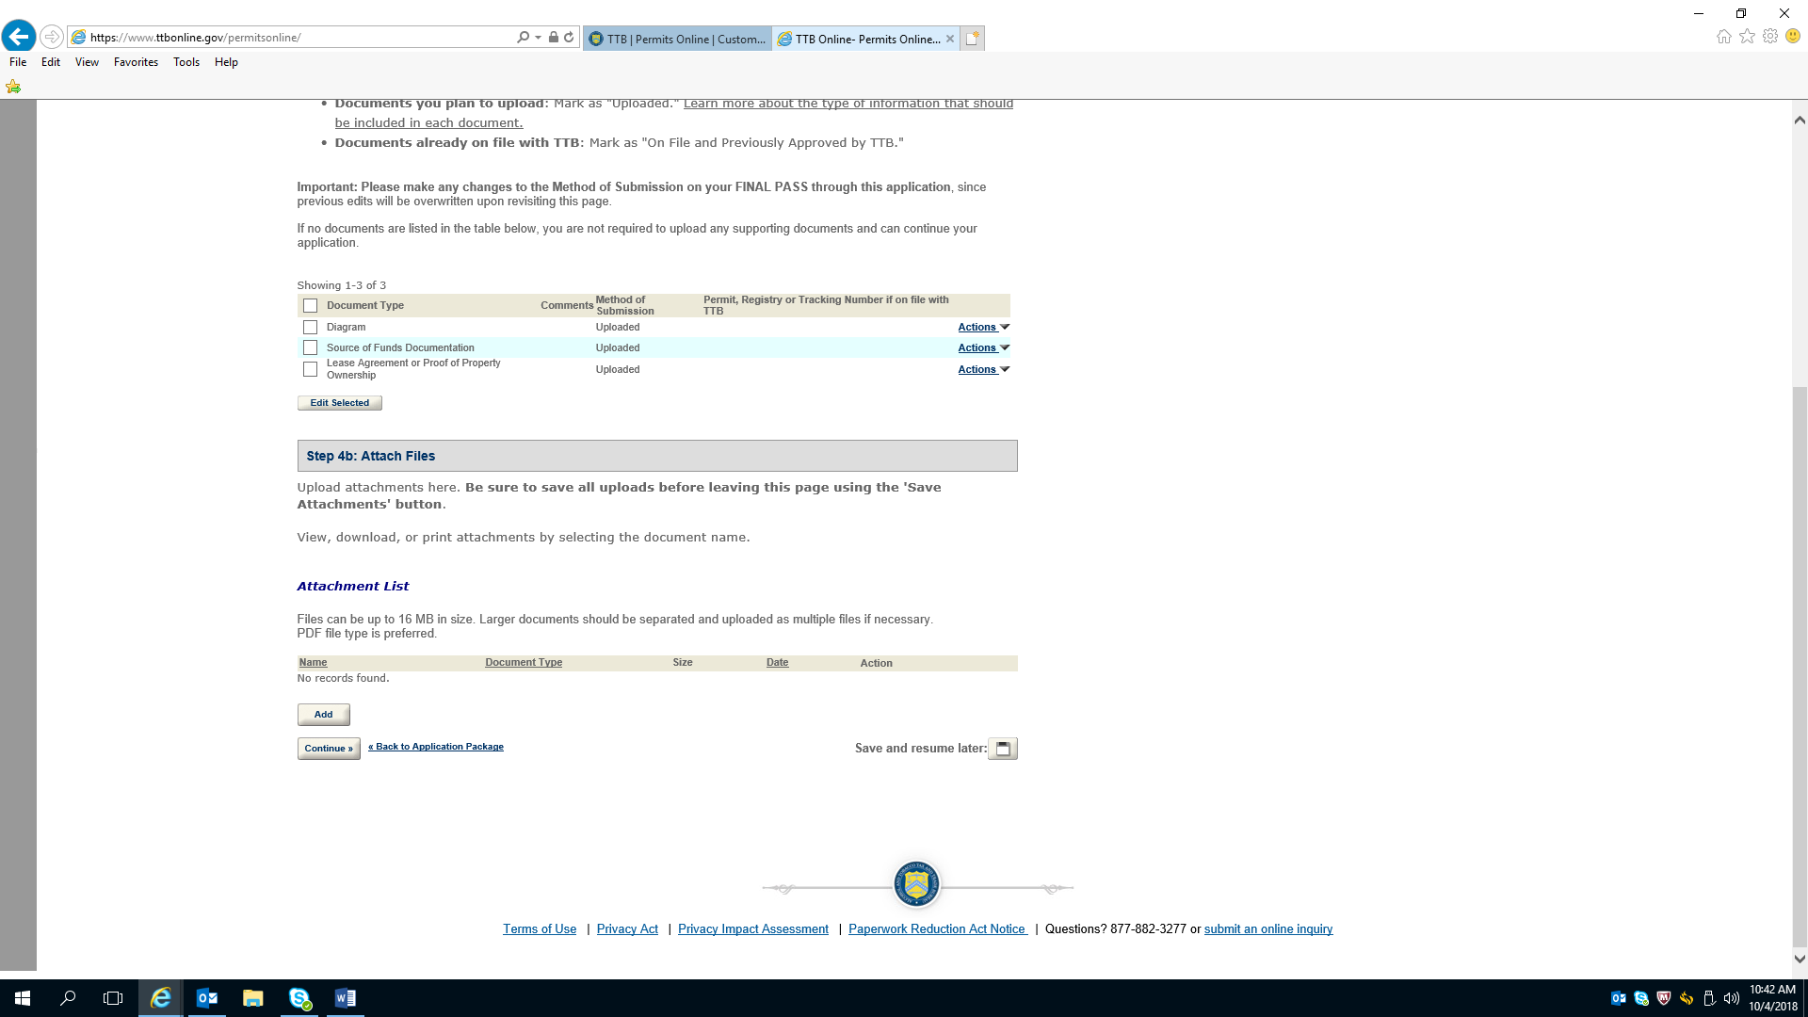

Application for Winery Operations—Declare and Acknowledge

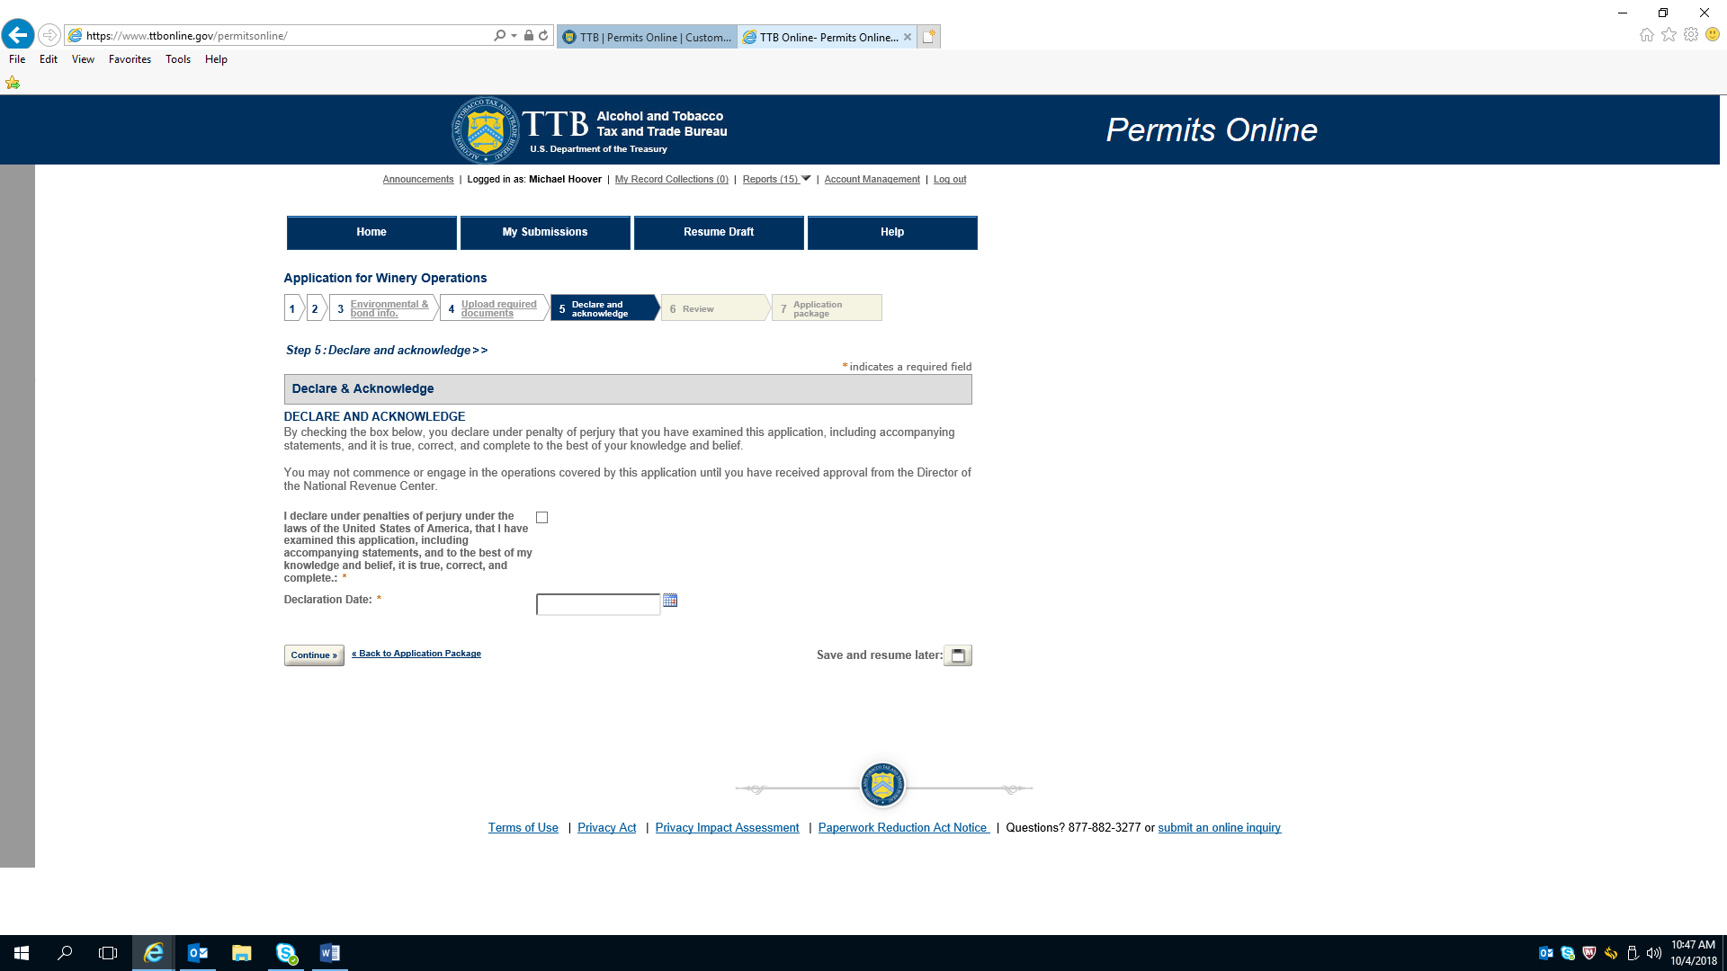

Application for Winery Operations---Review

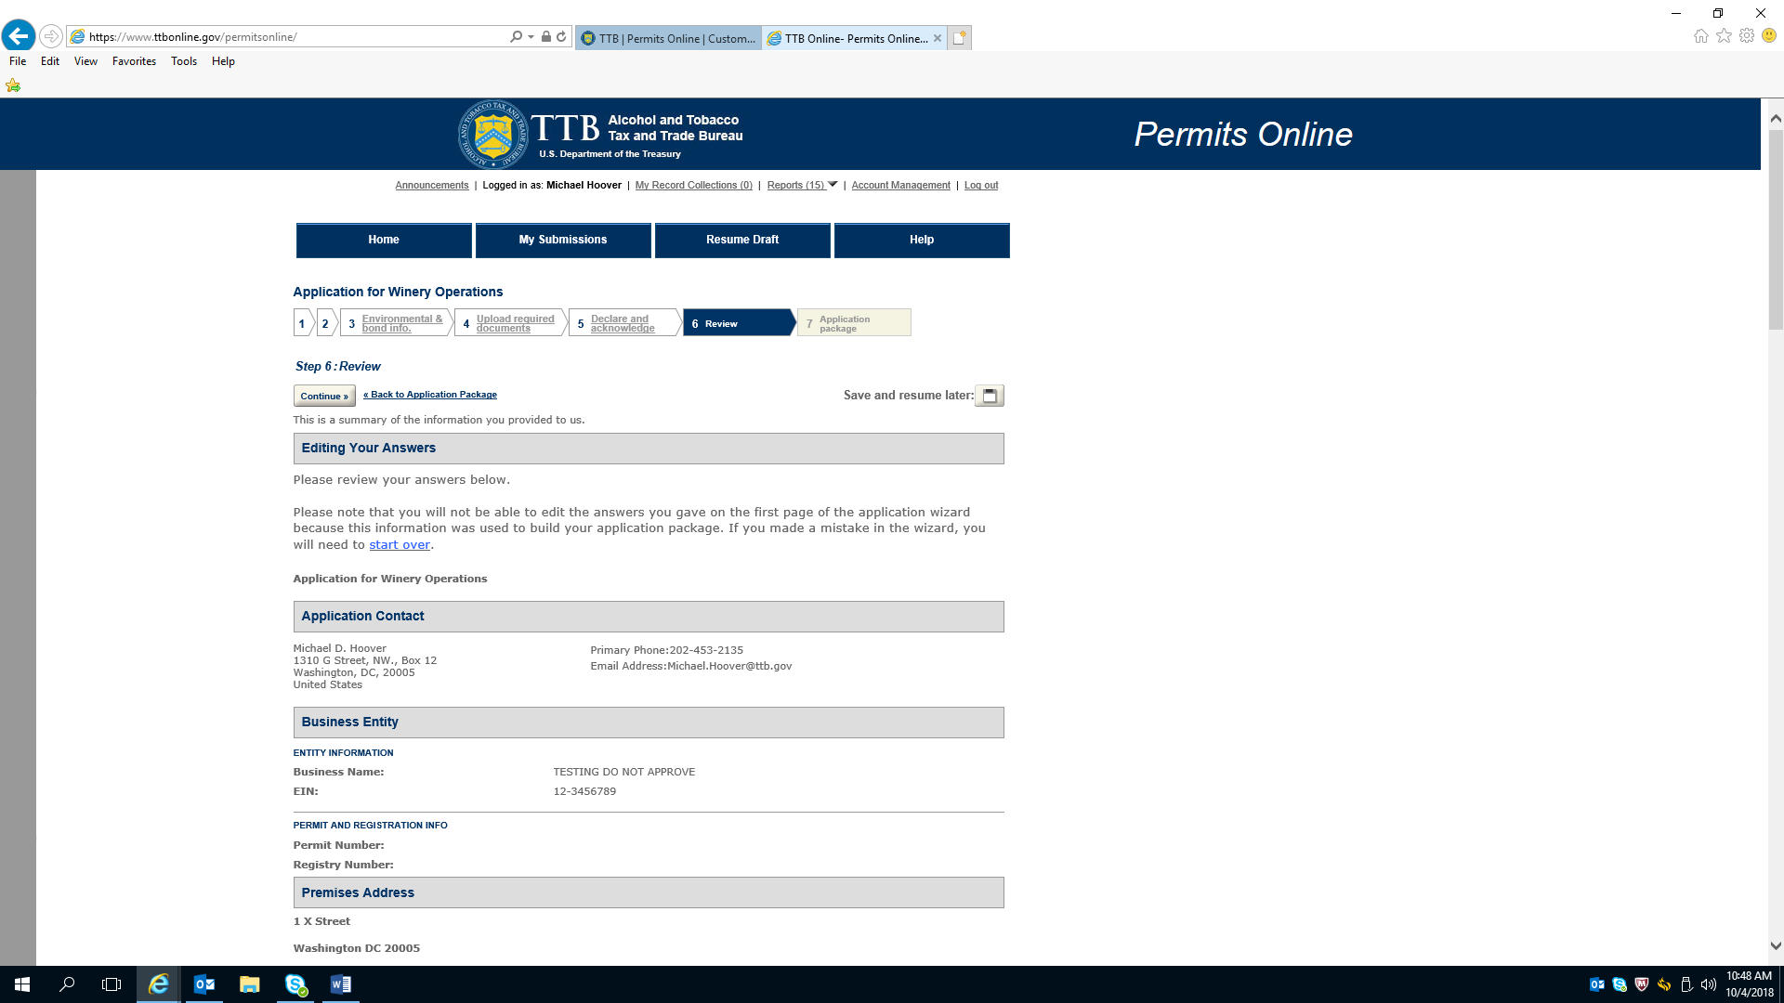

Application for Winery Operations---Review (continued)

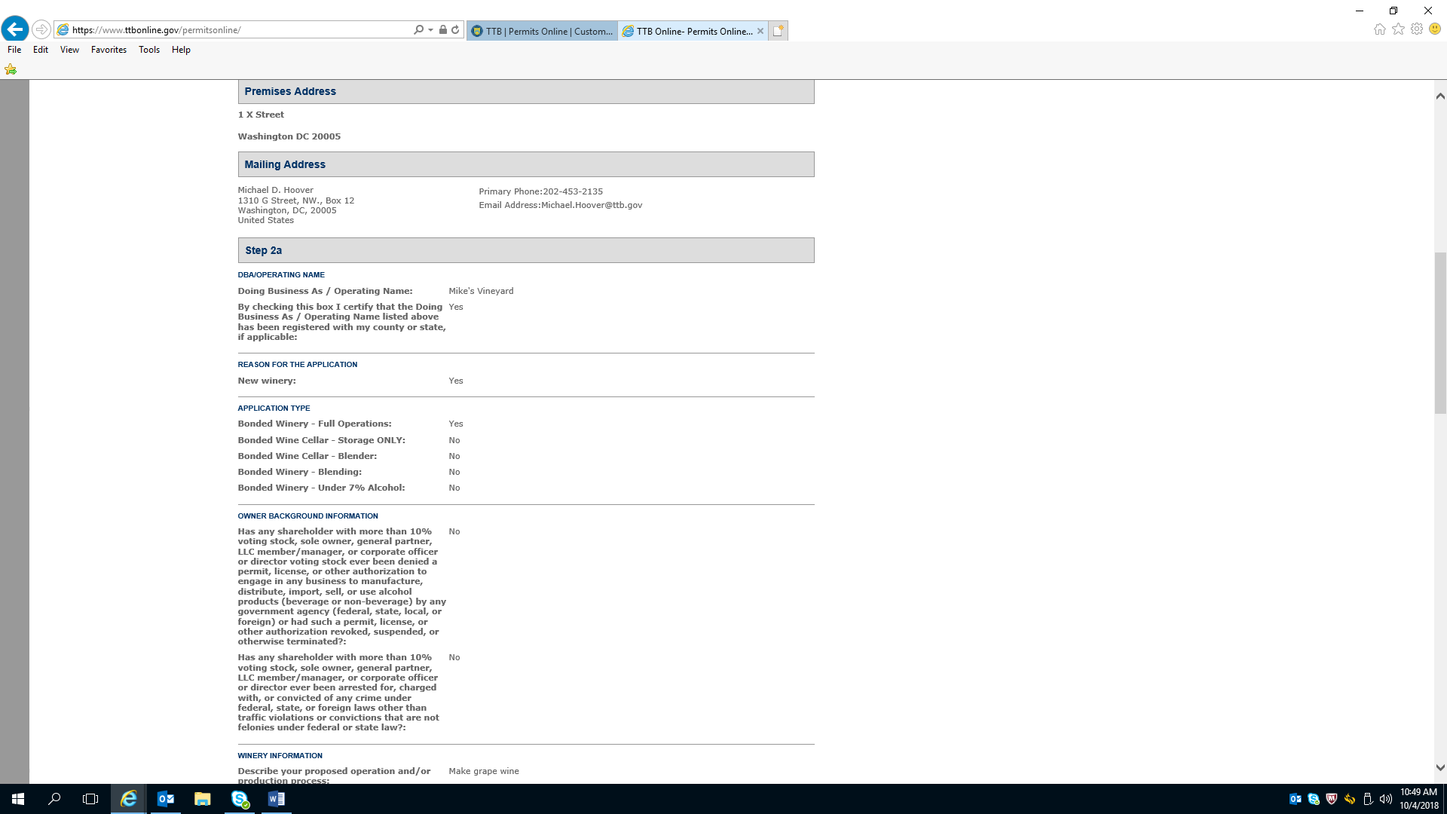

Application for Winery Operations---Review (continued)

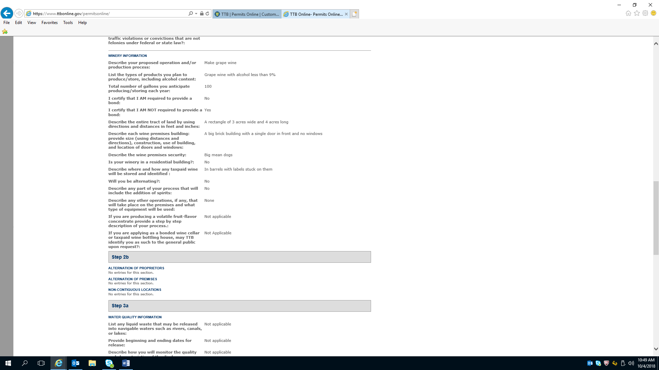

Application for Winery Operations---Review (continued)

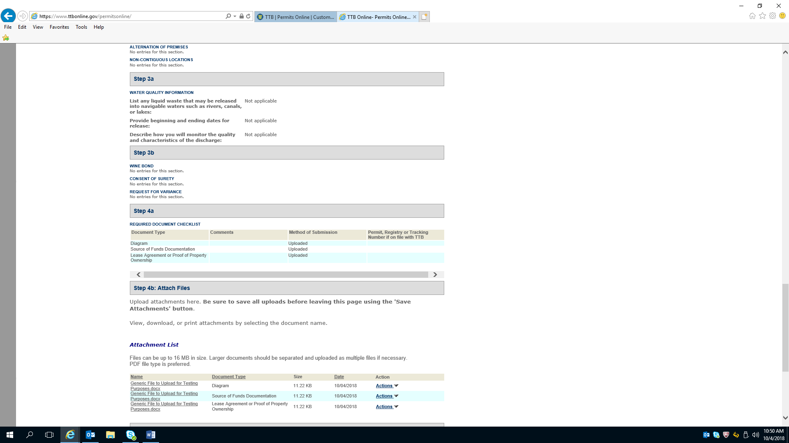

Application for Winery Operations---Review (continued)

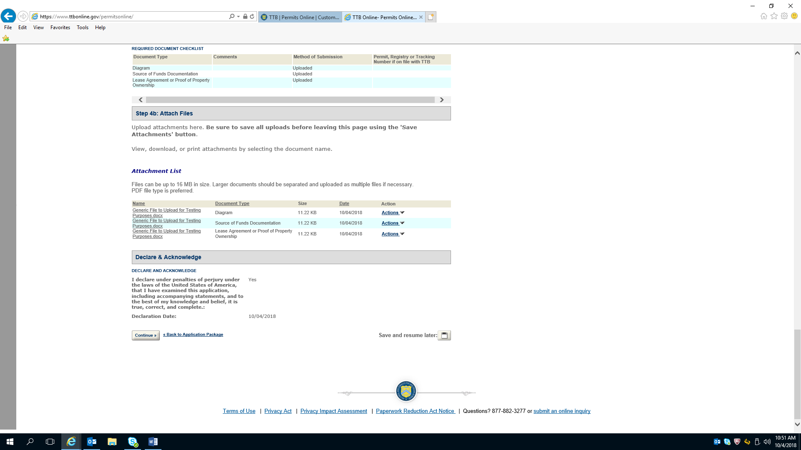

Personnel Questionnaire---Initial Page

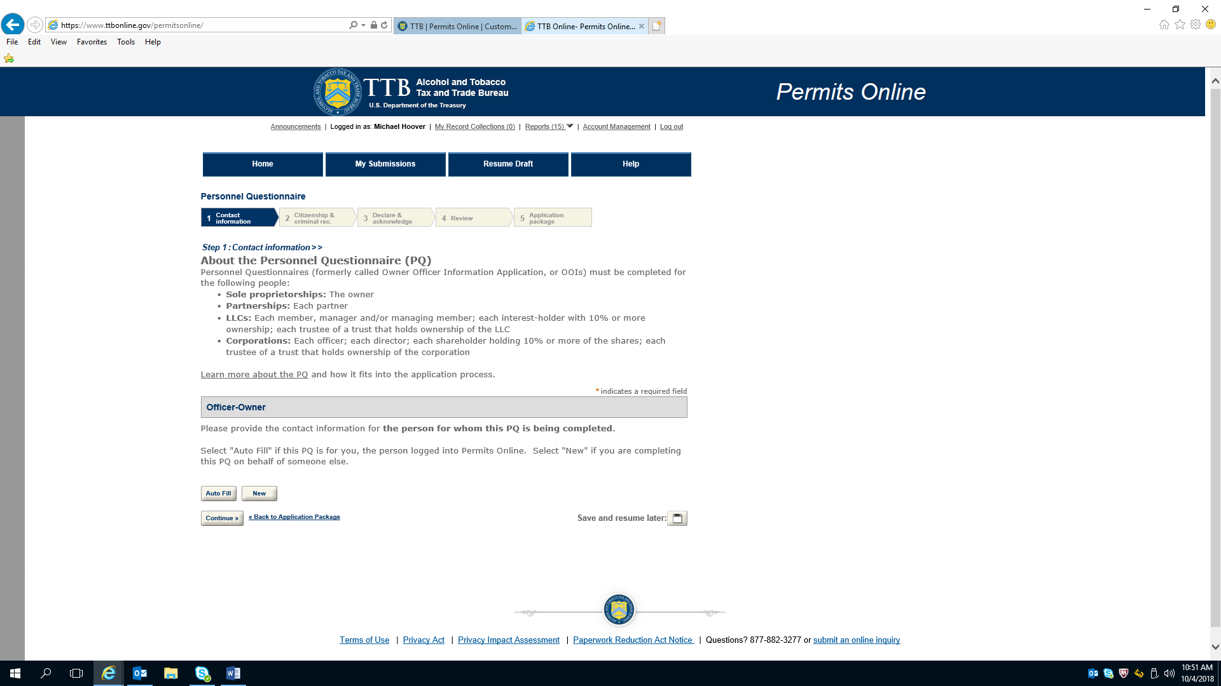

Personnel Questionnaire---Contact Information

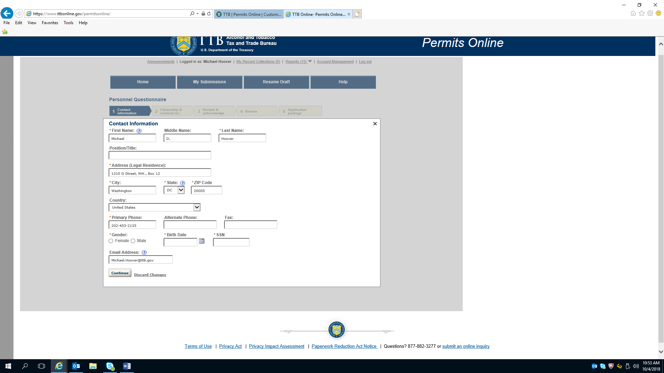

Personnel Questionnaire---Citizenship & Criminal Record

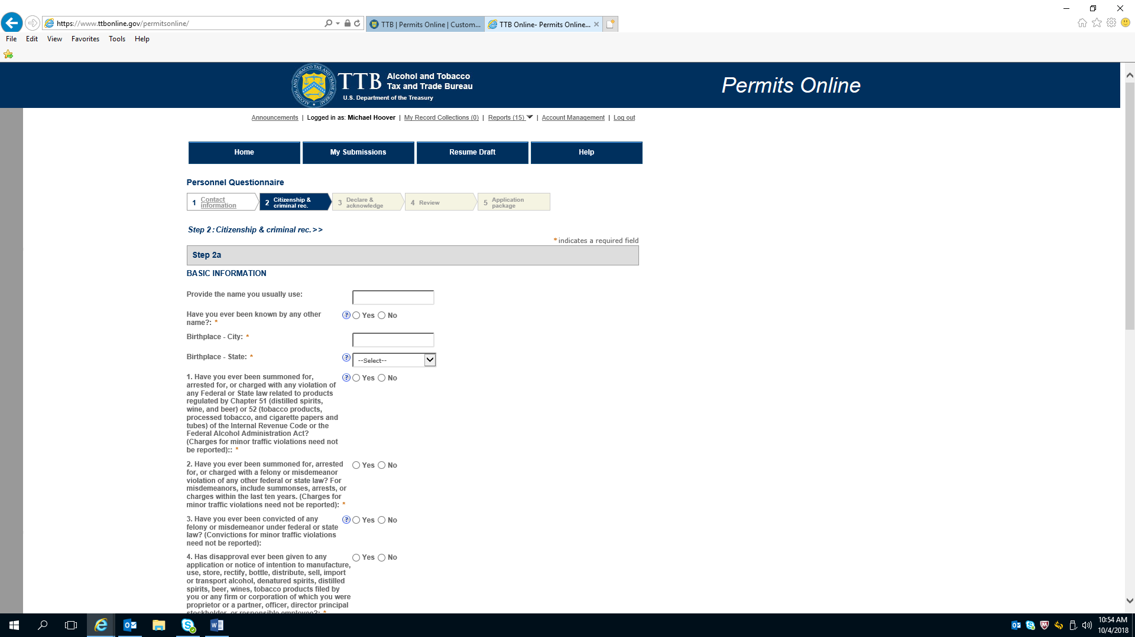

Personnel Questionnaire---Citizenship & Criminal Record (continued)

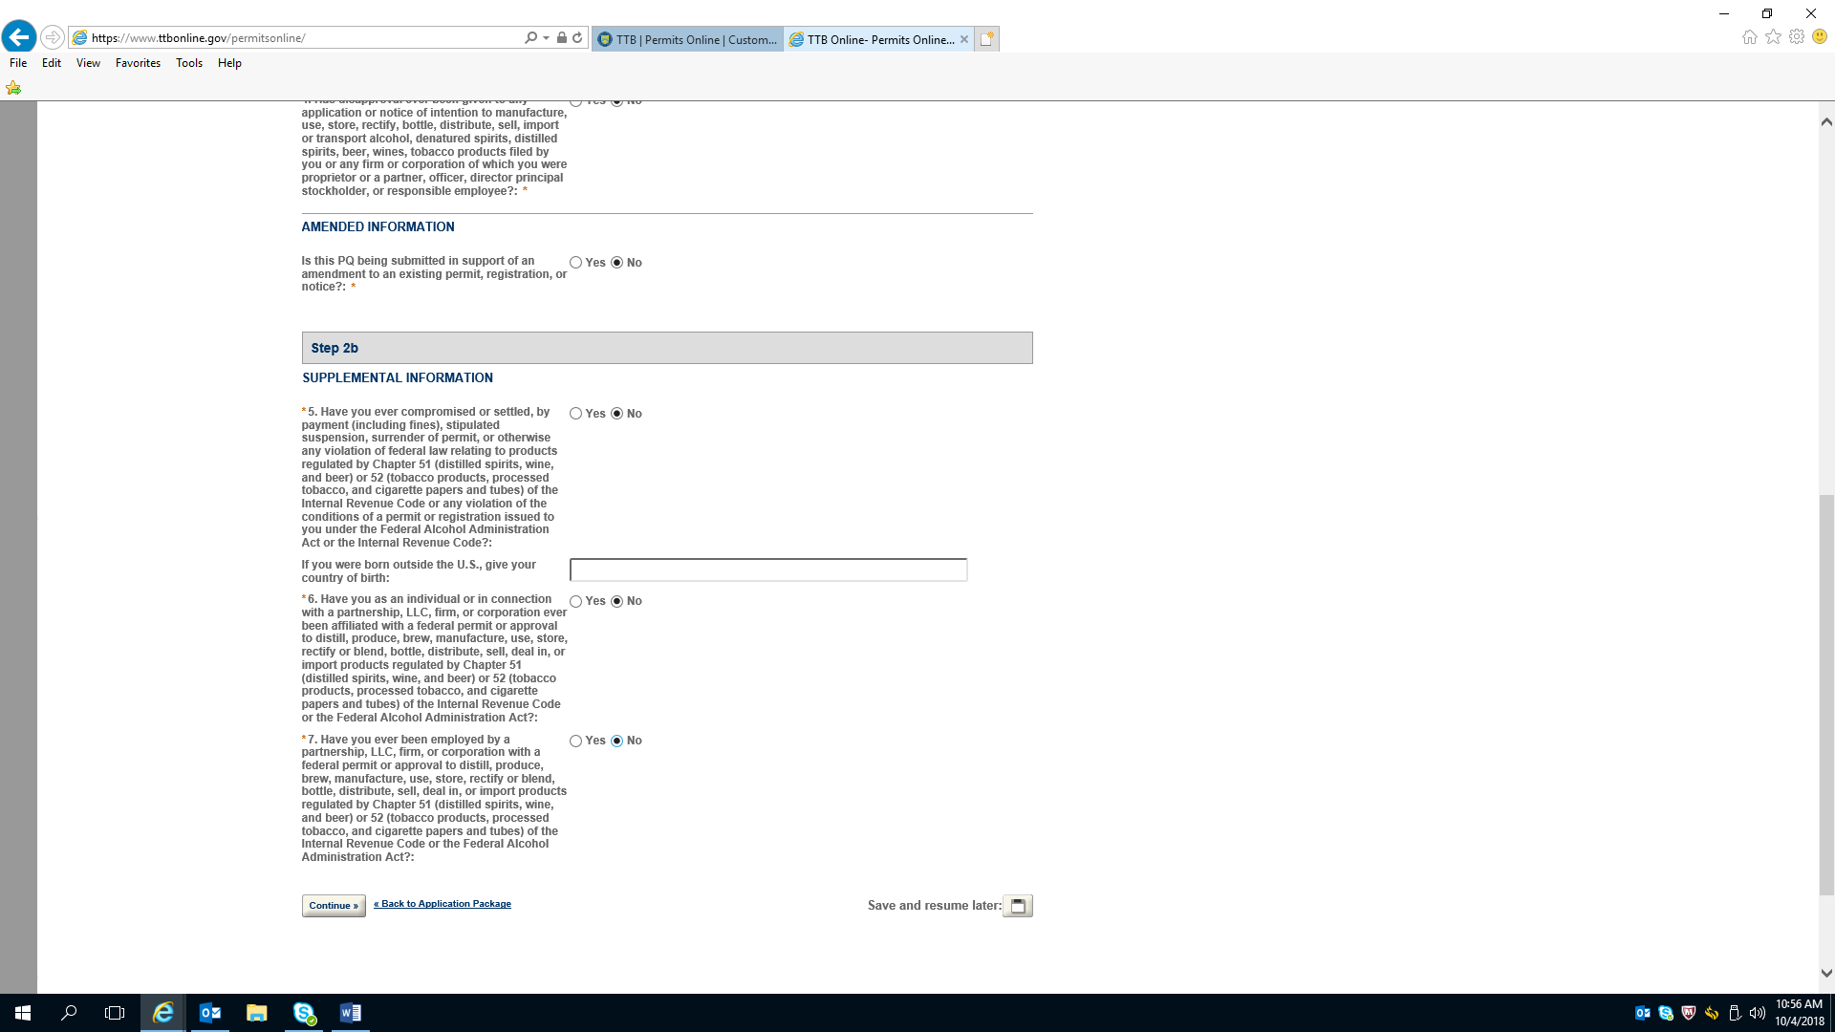

Personnel Questionnaire—Declare and Acknowledge

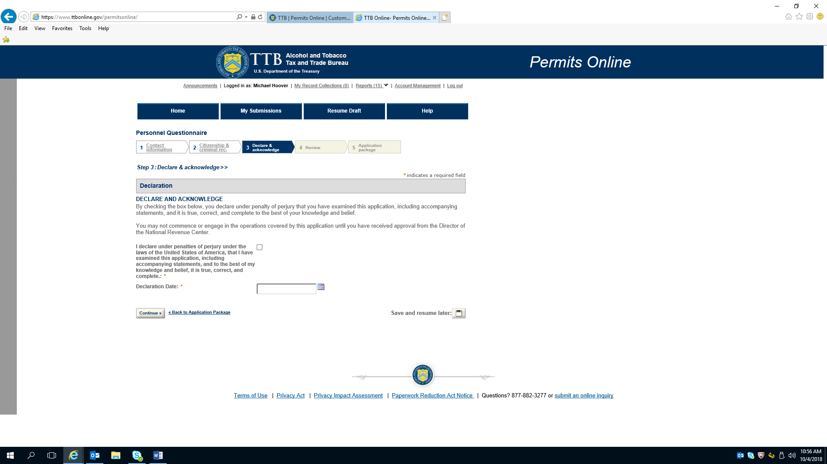

Personnel Questionnaire---Review

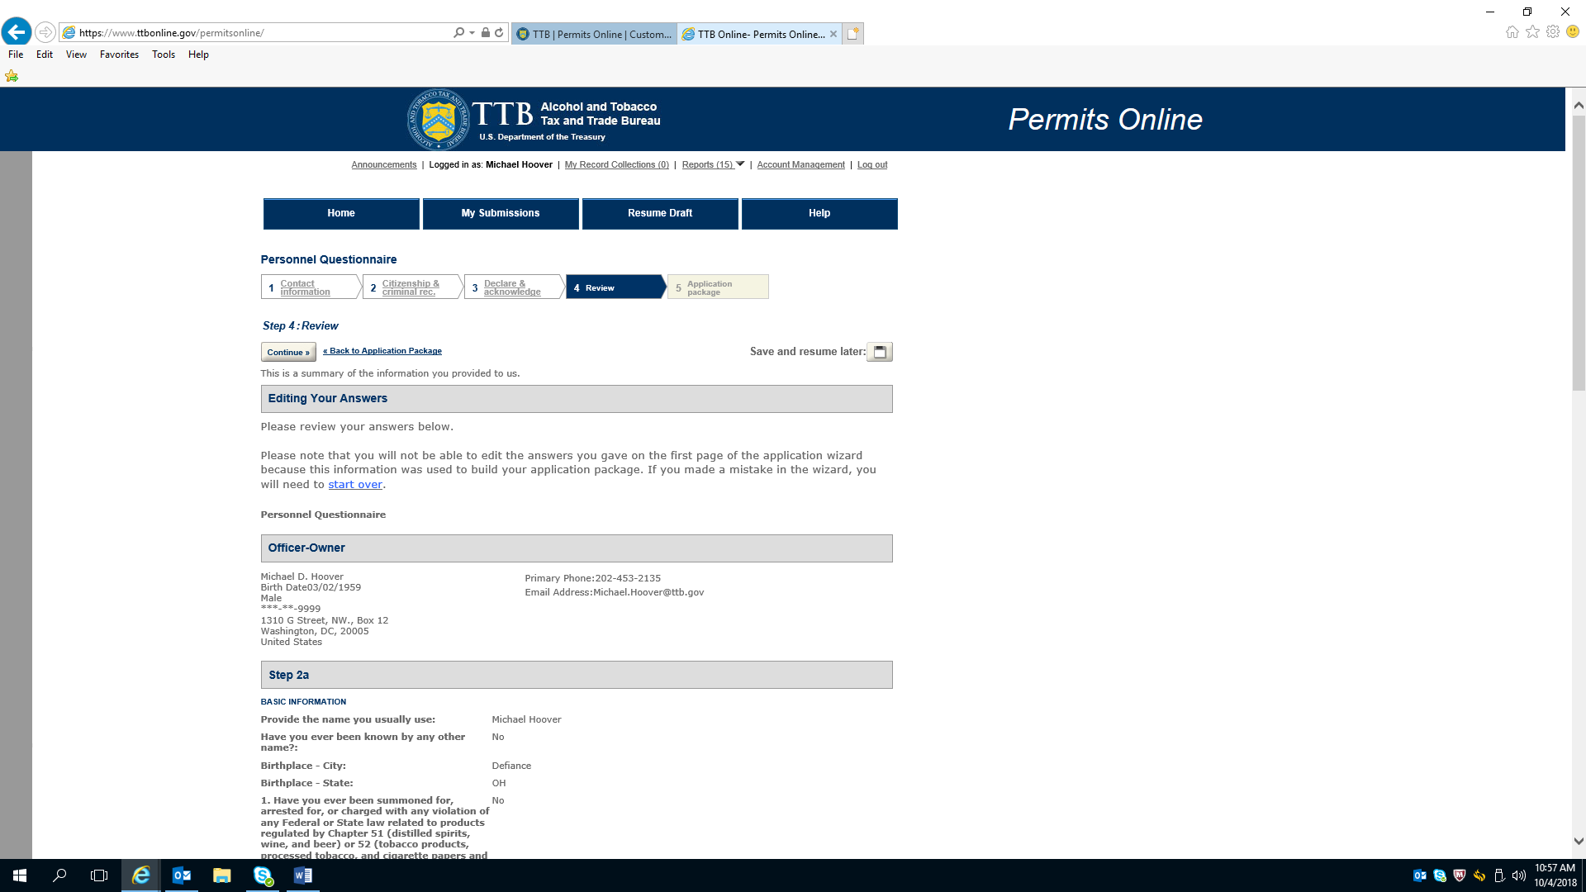

Personnel Questionnaire---Review (continued)

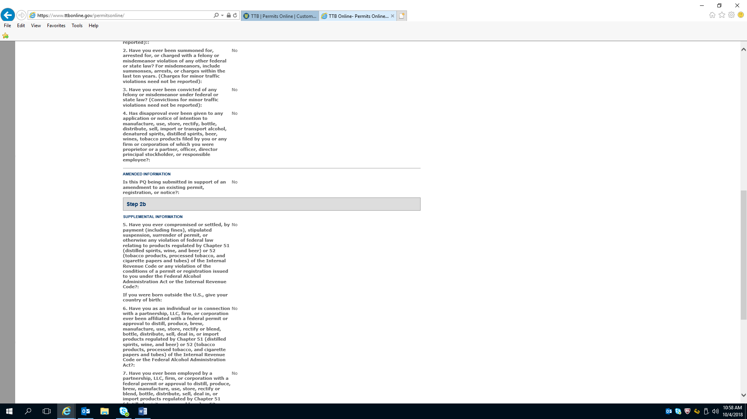

Personnel Questionnaire—Review (continued)

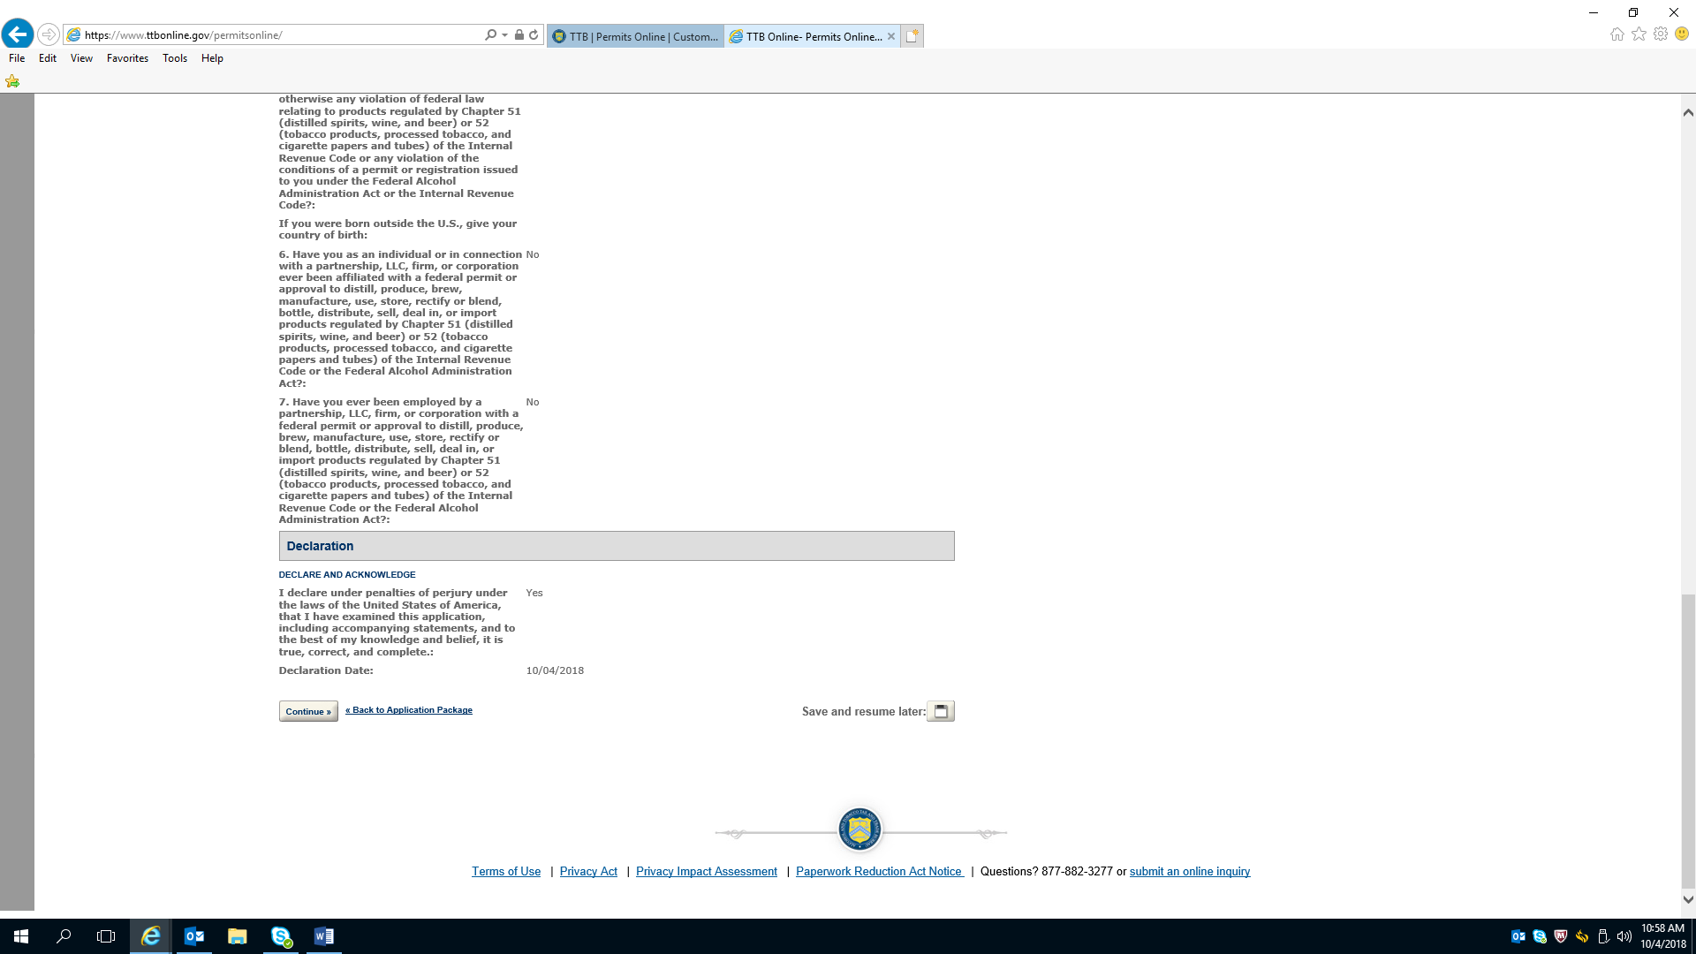

Terms of Use
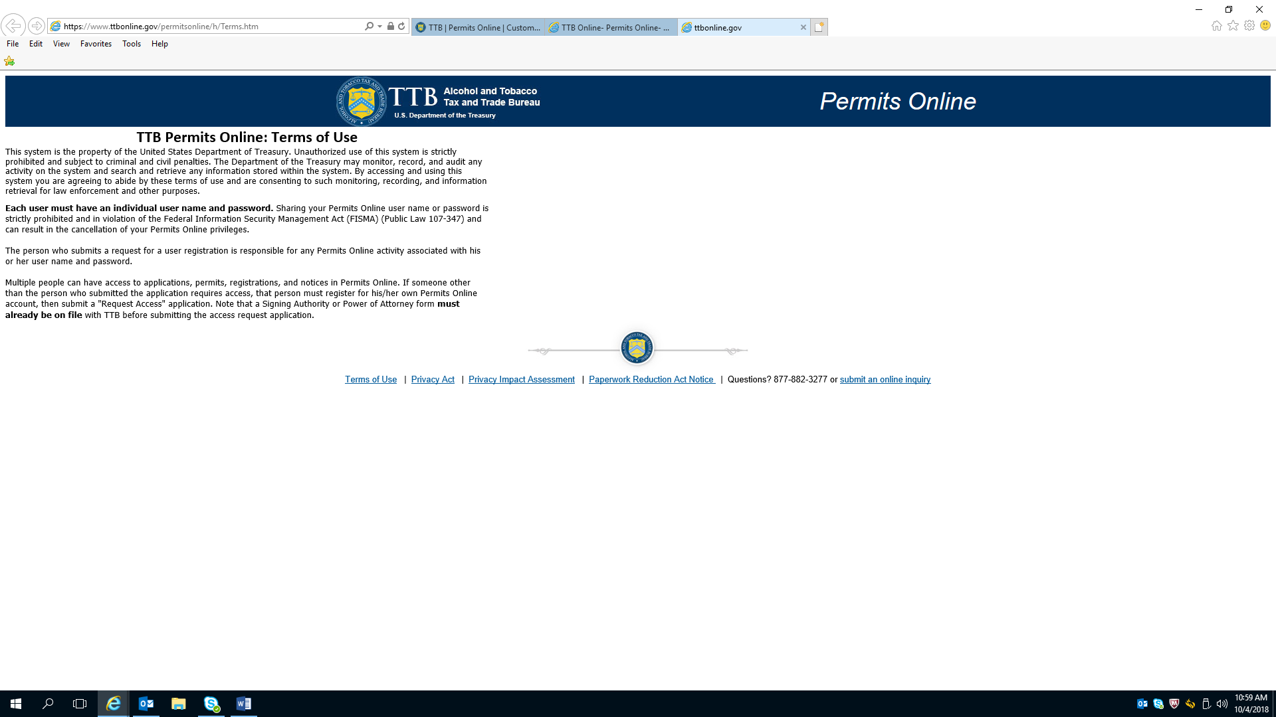

Privacy Act

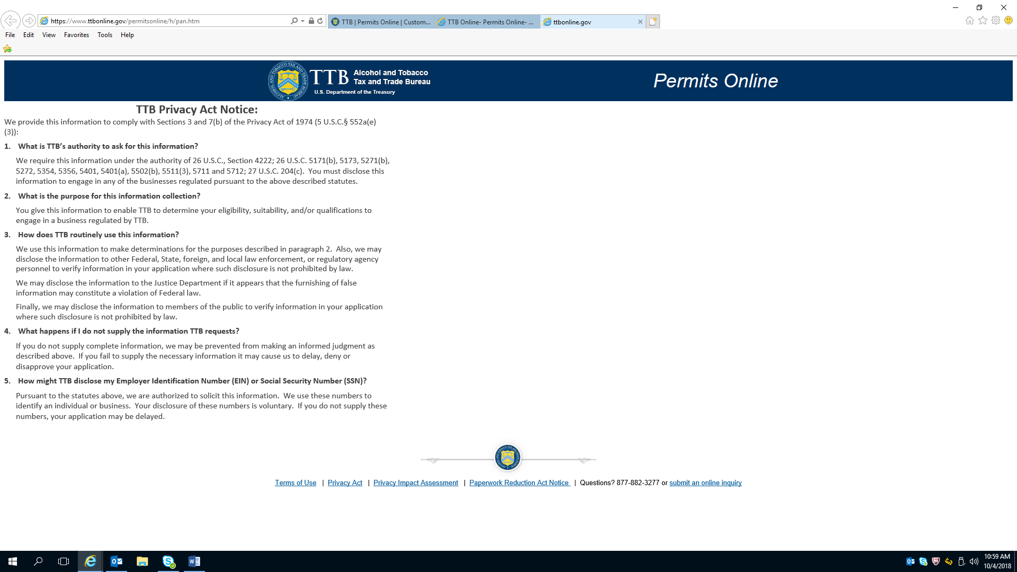

Privacy Impact Assessment

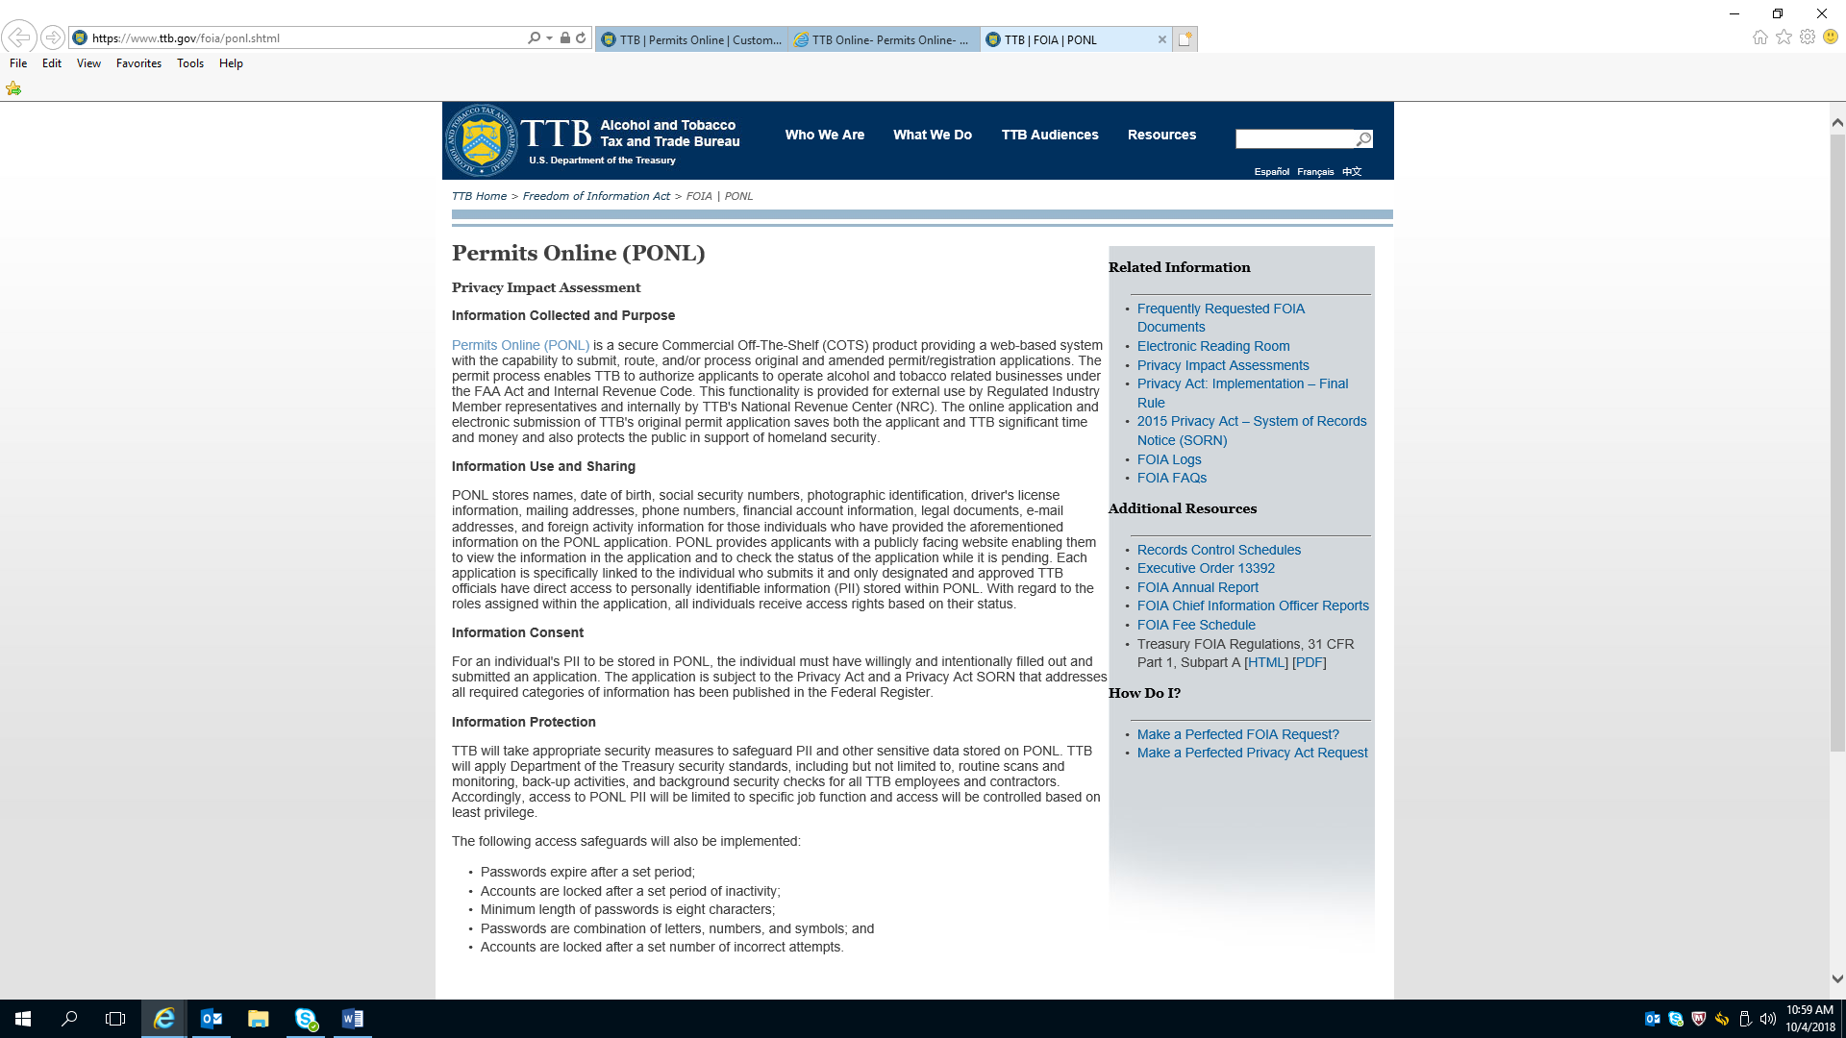

Privacy Impact Assessment (continued)

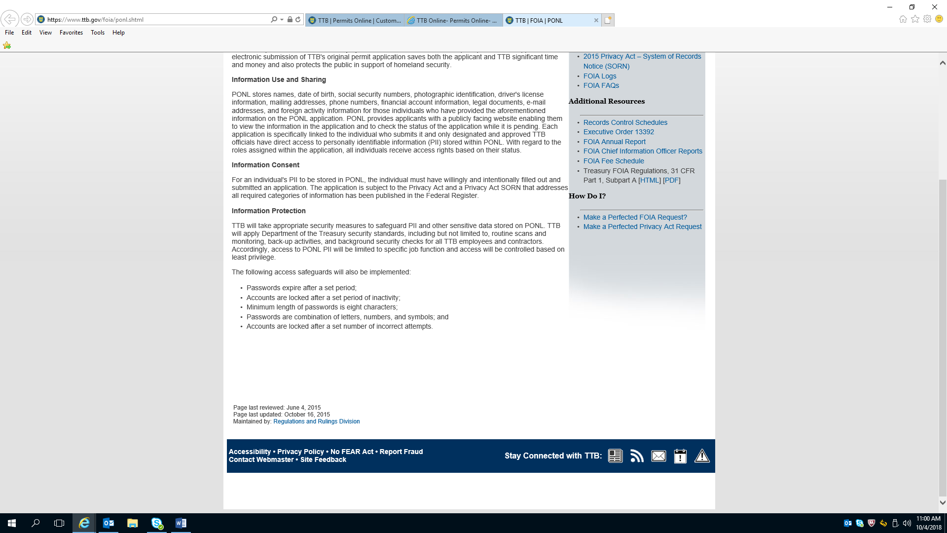

PRA Notice

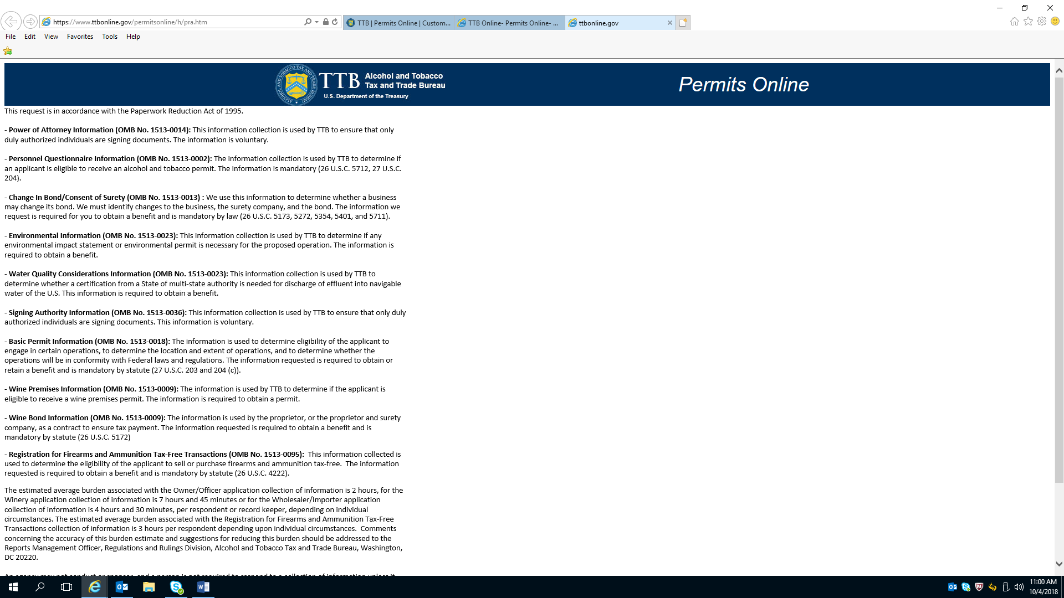

PRA Notice (Continued)

