International Early Learning Study (IELS) 2018
Main Study

OMB# 1850-0936 v.6

Appendix F
Recruitment Video Storyboards

National Center for Education Statistics (NCES)
U.S. Department of Education
Institute of Education Sciences
Washington, DC

August 2018

Table of Contents
IELS Value Video Storyboard 1
IELS Student Experience Video Storyboard 7

NCES IELS SHOOTING BOARD
Value Proposition/Piece of the Pie
Video 2 v3

Voice Over (VO): What are parents doing at home to promote their children’s learning?

Parents and children interacting at home.
VO: What do kindergarteners come to school knowing? And what do they still need to learn?

Teacher and student interacting.

5-year-olds across the country

VO: The answers to these and other questions will come as thousands of 5-year-olds...

Shapes and copy animate onto screen.
VO: ...participate in the International Early Learning Study, administered by the National Center for Education Statistics, or NCES, within the U.S. Department of Education.

IELS logo animates onto screen.

VO: The results could help set younger generations up for even greater success, and everyone has an important role to play—...

Circle enclosing video of student interacting with tablet.
VO: ...students, parents, teachers, and school staﬀ.

Each circle appears one after the other.

Teacher: As a teacher, I’m pulled in a million directions, but I’d like to be a part of any study that can help us improve our classroom activities.

Circle of teacher gets larger and ﬁlls screen.
Teacher: Especially focused on this age group. And knowing the information comes from students, parents, and teachers in several countries is meaningful.

Medium shot of teacher. Red bar swipes to the right.

Parent: This study can beneﬁt younger generations, and that means a lot to me. I would deﬁnitely let my daughter participate.

Medium shot of parent. Purple bar swipes to the right.
Parent: When she’s older, I could tell her that we helped kids who weren’t even born yet. That’s pretty inspiring.

B-roll of parent interacting with child.

VO: All parents and teachers have to do is take a short online survey. It doesn’t even have to be done all at once.

B-roll of parent on computer.
VO: Think of it this way: the child’s participation is one piece of the pie, and parent and teacher survey responses are two more pieces.

Pie chart animates on screen. Each section gets larger and video shows within pieces.

Teacher: Filling out a survey for my students sounds easy. And I talk with parents regularly, so I’d be happy to encourage them to participate too. It’s a little bit of time for a study that could have a big impact.

Medium shot of teacher. Red bar swipes to the right.
Administrator: As a principal I appreciate that we’ll have a better understanding of 5-year-olds’ language and math skills as well as their social and emotional development. Plus, we’ll be able to learn how students in other countries are developing.

Medium shot of administrator.

Administrator: I feel like our participation will really mean something. And there’s a financial incentive for being involved.

Medium shot of administrator and teacher interacting.
VO: The results of the International Early Learning Study will help parents, or anyone responsible for raising young children, learn about activities they can do at home...

Pie charts to resemble results animates on screen. Blue background swipes down.

Increase children’s knowledge and development

VO: ...to promote their children’s knowledge and development.

Shapes animate onto screen, copy comes up on screen as host reads.
Administrator: The results will help educators and policymakers make informed decisions about children’s early education, too.

Medium shot of administrator. Green bar swipes to the right.

Parent: Together we can support the learning and growth of future students, in our communities, and around the world.

Medium shot of parent. Purple bar swipes to the right.
Teacher: To everyone doing their piece to make the International Early Learning Study a success, thank you.

Medium shot of teacher. Red bar swipes to the right.

1-855-299-1398
https://nces.ed.gov/surveys/iels/
VO: Learn more by visiting: https://nces.ed.gov/surveys/iels/

IELS logo, copy, and shapes animate onto screen.

NCES IELS SHOOTING BOARD
Student Experience

Video 1 v4

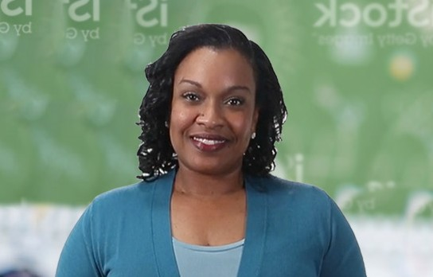

Voice Over (VO): On behalf of the U.S. Department of Education, I wanted to talk to you about an important new study...

Video opens on a tight shot of the host.
VO: ...that looks at children’s skills as they enter kindergarten. (Nods to child participating in IELS behind her). It may look like she’s playing games,...

Cut to a wide shot of the host with an IELS Administrator 1 and Student 1 in the background. Host nods to Student 1.

VO: ...but it’s so much more than that. Her interaction with the game is providing valuable information...

Cut to a close up shot of IELS Administrator 1 and Student 1 playing on tablet.
VO: ...for this new study, called the International Early Learning Study.

IELS logo animates onto screen.

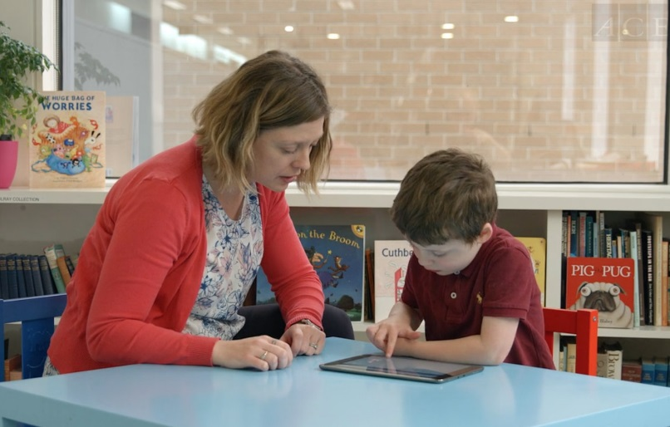

VO: The results can help set younger generations up for even greater success. Here's how it works:...

Tight shot of host.
VO: ...Children who participate in the International Early Learning Study will play fun,...

B-roll footage of Administrator 2 and Student 2 playing on tablet.

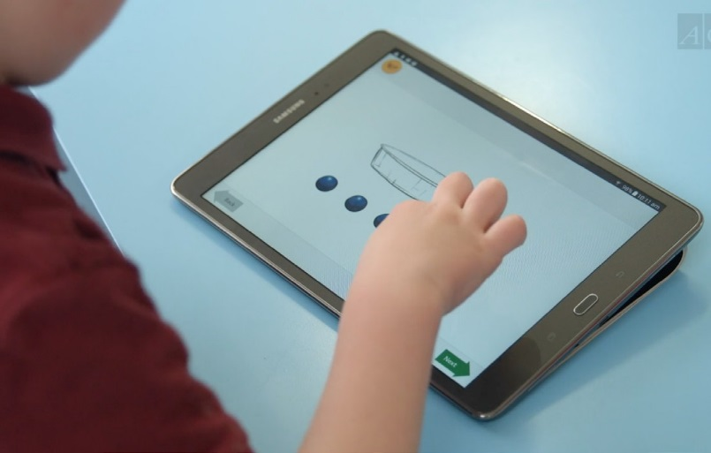

30 minutes a day 2 different days

VO: ...interactive games on a tablet, which will help us understand their developing skills in language, math, and more.

Over-the-shoulder close up shot of Student 2 taking IELS study on tablet.
VO: It takes about 30 minutes a day, on two diﬀerent days,...

Shapes animate onto screen, copy comes up on screen as host reads.

VO: ...and takes place in a comfortable and familiar spot within their own school.

B-roll footage of Administrator 2 and Student 2 playing on tablet.
VO: Here they will work one-on-one with specially trained team members...

Tight shot of host.

VO: ...who will make their experience as easy and relaxed as possible.

B-roll footage of Administrator 3 and Student 3.
VO: There is no rush, and students may take breaks...

B-roll footage of Administrator 3 and Student 3 at a diﬀerent angle.

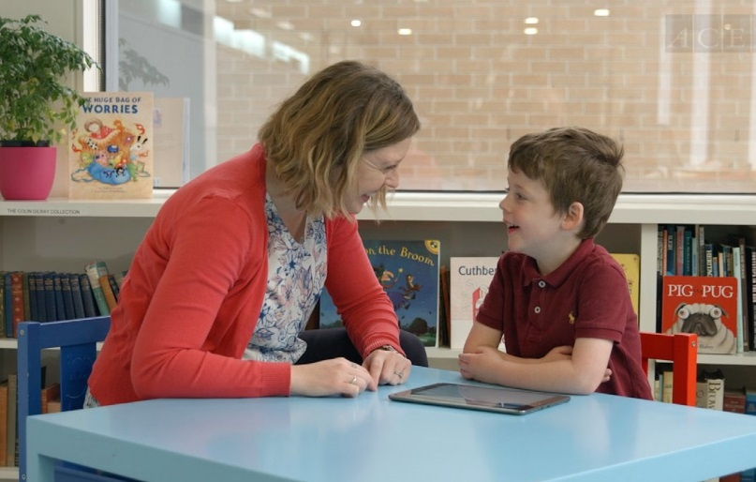

VO: ...whenever they want. Children can also choose to not answer questions at any time.

B-roll footage of Administrator 3 and Student 3. Show student putting tablet on table.
VO: Children are randomly selected to participate, and while participation is voluntary, your child's involvement is important.

B-roll footage of Administrator 2 and Student 2.

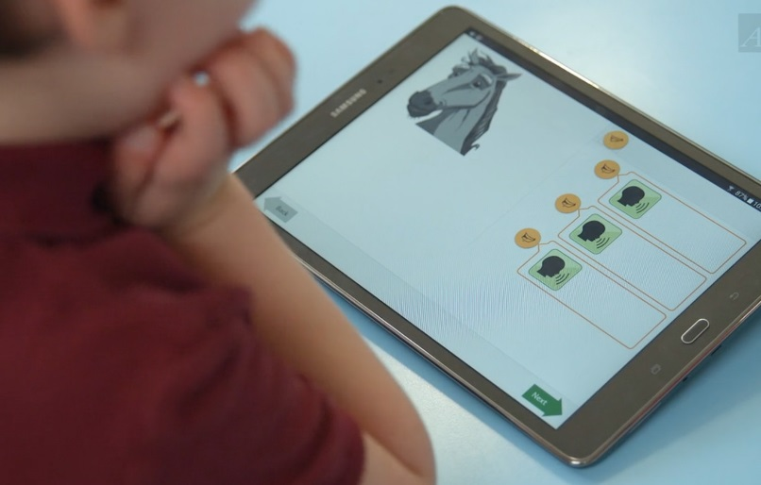

Contribute to the educational growth of future generations.

VO: It will help ensure results for the study are accurate and meaningful for parents, educators, and policymakers.

Over-the-shoulder close up shot of Student 2 taking IELS study on tablet.
VO: Your child’s time in this study will contribute to the educational growth of future generations.

Shapes animate onto screen, copy comes up on screen as host reads.

VO: If you’d like to learn more about the study, please talk to your school principal, call the IELS help line, or visit our website. We sincerely thank you for your willingness to participate.
Tight shot of host.
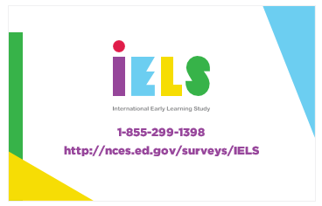IELS logo, copy, and shapes animate onto screen.

