Supporting Statement

**AGRICULTURAL LABOR SURVEY**

OMB No. 0535-0109

**B. COLLECTION OF INFORMATION EMPLOYING STATISTICAL METHODS**

**1. Describe (including a numerical estimate) the potential respondent universe and any sampling or other respondent selection method to be used. Data on the number of entities (e.g., establishments, State and local government units, households, or persons) in the universe covered by the collection and in the corresponding sample are to be provided in tabular form for the universe as a whole and for each of the strata in the proposed sample. Indicate expected response rates for the collection as a whole. If the collection has been conducted previously, include the actual response rate achieved during the last collection.**

The Agricultural Labor Survey makes use of two sampling frames: a list frame and an area frame. The combined sampling frame comprises all active operations on NASS’s list frame with at least $1,000 in Farm Value of Sales (FVS), as well as all non-overlapping (NOL) records with at least $1,000 in FVS from the area frame segments in the June Agricultural Survey (OMB No. 0535-0213).

The Agricultural Labor Survey is administered biannually (in April and October) in all States except Alaska and California. (The California Employment Development Division, in cooperation with NASS’s Pacific Regional Field Office, conducts a monthly survey in California) Survey data are used to derive national and regional estimates for numbers of agricultural workers and wage rates.

A new Agricultural Labor Survey questionnaire version was created to improve the accuracy of farm worker categorization by labor type and to collect base, incentive, and overtime wages. A bridge study will be conducted during the April 2018 Labor Survey and again in October 2018 to evaluate the new questionnaire version.

Response rates for the last two biannual surveys are shown in the table below.



The Agricultural Labor Survey List Sampling Frame is stratified by peak number of farm workers or potential to have farm workers.

**2. Describe the procedures for the collection of information including:**

**• statistical methodology for stratification and sample selection,**

**• estimation procedure,**

**• degree of accuracy needed for the purpose described in the justification,**

**• unusual problems requiring specialized sampling procedures**

The Agricultural Labor Survey list frame is stratified by peak number of farm workers. Operations that do not have a known value for peak number of farm workers are grouped into two categories - farm labor intensive and farm labor less intensive - and stratified by FVS. The sampling rate increases as the stratum number increases (from stratum 30 to stratum 98).

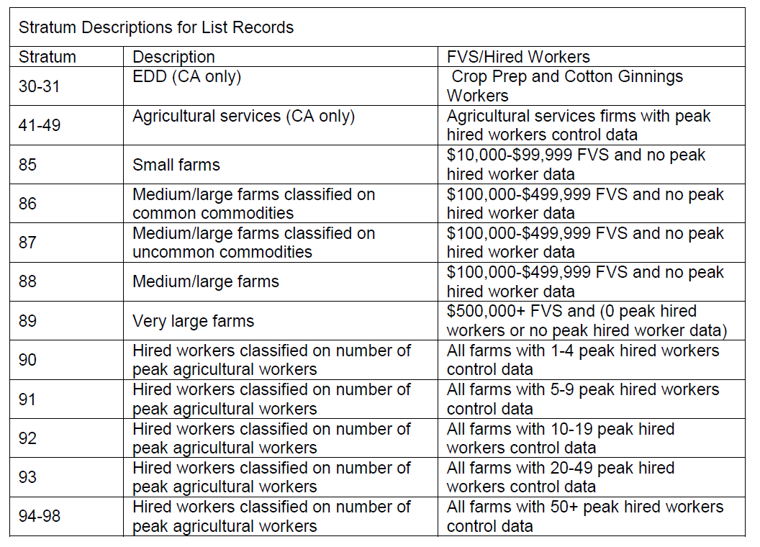

The NASS area frame is stratified by land use before Primary Sampling Units (PSUs) are delineated within each land use strata. Secondary Sampling Units (segments) are delineated within each selected PSU before segments are sampled. Tracts are delineated within each selected segment during personal enumeration.

The land use strata are:

- Heavily cultivated land

- Less heavily cultivated land

- Residential or ag-urban land with potential for agricultural use

- Pasture or grazing land

- Completely nonagricultural land

The June Area Survey records that are NOL with the list sampling frame for the Labor Survey are determined in late June. Operations with less than $1,000 of FVS are not included in the Labor Area Frame population because they do not meet USDA’s definition of a farm (having at least $1,000 of FVS).

NOL tracts from the area frame are stratified by peak number of farm workers; however, the highest two strata (21 and 22, see below) are stratified by peak number of farm workers and expansion weights.

**Area Labor**

**Stratum Description**

3 0 or missing peak workers

11 1-4 peak workers

12 5-9 peak workers

13 10-49 peak workers

14 50-99 peak workers

15 100+ peak workers

21 Labor stratum 3 records with high expansion factors

22 Labor stratum 11 records with high expansion factors

Generally, all NOL records in stratum 11 and above are included in the sample. In contrast stratum 3 is sampled at less than 100 percent.

A replicate scheme is employed to control the amount of overlap between operations that are sampled for the October and April Labor Surveys. A replicate number between one and eight is assigned to every record on the entire sample before allocating six replicates to the October Labor sample and six replicates (four overlapping and two non-overlapping replicates with the October Labor sample) to the April Labor sample.

**3. Describe methods to maximize response rates and to deal with issues of non-response. The accuracy and reliability of information collected must be shown to be adequate for intended uses. For collections based on sampling a special justification must be provided for any collection that will not yield "reliable" data that can be generalized to the universe studied.**

*Data Collection*: Generally, a cover letter and sample questionnaire are mailed to the list sample prior to each biannual survey. The letter alerts respondents that they will be contacted at a later date and encourages them to enter data on the sample questionnaire for the reference week so that it will be readily available when they are contacted by an enumerator. This procedure allows respondents to compile data at their convenience and reduces interview time when they are contacted.

Included with the cover letter, operations are also given the opportunity to respond online. They are provided a link to a website along with a personalized, secure key code that will allow them to access only their questionnaire and provide their information in a secure manner.

Regional Field Offices will attempt to contact non-internet respondents by either telephone or personal visits. Telephone data collection is done primarily through a Data Collection Center using a computer-assisted telephone interviewing (CATI) instrument which automatically displays forms and manages call-backs and appointments for the enumerators. Those operations expected to have a large number of workers or have multiple operations are typically assigned to enumerators for personal visits.

Estimates will be generated for number of workers, hours worked, and wage rates. The data will be summarized and published for 15 Farm Labor Regions along with the States of California, Florida, and Hawaii. The regions are defined in the *Farm Labor* publication attached to this OMB submission. The sample is designed to provide regional coefficients of variation of about 5 percent for wage rates and 15 percent for hired workers.

The NASS Farm Labor Survey publication will continue to include summarized data tables using the Dept. of Labor’s Employment and Training Administration (ETA) worker categories. In November 2015 NASS began to include tables with the farm labor data summarized using the Standard Occupational Classification (SOC) codes.

Survey data are subject to non-sampling errors such as omissions and mistakes in reporting and in processing the data. While these errors are not measured directly, they are minimized by NASS staff reviewing all reported data for consistency and reasonableness through an Interactive Data Analysis System (IDAS).

**4. Describe any tests of procedures or methods to be undertaken.**

There are (or have been) several qualitative and quantitative projects occurring for the Agricultural Labor Survey.

A new version of the Agricultural Labor Survey CATI instrument was developed in June 2017 to improve the accuracy of farm worker categorization by labor type (field, livestock, supervisor, and other workers). A sub-sample of the 2017 October Labor Survey sample was selected to test the instrument.

In November of 2017, OMB approved NASS to conduct up to 100 cognitive interviews (OMB # 0535-0248) with farm operators and contractors who provide farm workers to farm operations. This was in response to a request by the USDA to separate gross wages into base wages and incentive pay/overtime pay.

Iterative cognitive testing was conducted on a revised version of the Agricultural Labor Survey questionnaire from December 2017 to February 2018. A total of 26 cognitive interviews were completed with operators, with 20 of those using the initial revised version of the questionnaire that included questions for base wages. After an initial assessment of the results, the questionnaire was further revised to include questions for incentive pay/overtime pay, in addition to base wages. Additional cognitive interviews were then conducted. After assessing the results of all cognitive interviews, the final questionnaire was determined.

Although the cognitive testing focused on base wages, incentive pay/overtime pay, and gross wages paid, several other items in the questionnaire were revised. The revisions included formatting, response options given, and instruction placement and wording.

Bridge studies will be conducted during the April 2018 and October 2018 Agricultural Labor Surveys to evaluate how the new questionnaire version performs, relative to the old questionnaire. If evaluations of the bridge studies are favorable, the first publication based solely on the new questionnaire (that includes questions on base wage and incentive pay and/or overtime wages) is anticipated to occur for the April 2019 Agricultural Labor Survey.

For the bridge studies, the operational survey sample will be divided into two subsamples: one will receive the original questionnaire and another will receive the new questionnaire. Specifically, five of six sample replications will be assigned to the original questionnaire and the remaining replicate will be assigned to the new questionnaire. Analysis shows the resulting CVs from using five replicates will increase slightly, however, the resulting CVs will still meet the majority of NASS’s precision standards. To improve the precision of data collected using the new questionnaire, one non-overlapping October 2017 sample replicate will be assigned to receive the new questionnaire. Hence, two replicates will be assigned to the new questionnaire in the bridge studies (April 2018 and October 2018).

Data collection modes (CATI, internet, and face to face enumeration) and other survey procedures will be identical for the two samples to help minimize potential for bias in the data.

For the bridge studies, the power of the test of the samples allocated to the old and new questionnaire was calculated using the following formula:

$$Z_{power}=Z_{(1-β)}=\frac{∆}{se\left(∆\right)}-Z_{\left(1-α/2\right)}$$

Where:

Z is the z-score for the standard normal distribution.

α is the Type I error

β is the Type II error

Power is 1-β.

Δ, or delta, is the difference between the wage rates indications derived from the samples allocated to the original and new questionnaires, and

se(Δ) is the standard error of delta.

A 4% relative margin of error and $12.50 wage rate results in a delta value of $0.50. Using previous survey data and an alpha of 5%, the resulting power is 83%.

The bridge studies will allow NASS to evaluate the national-level performance of the historic gross wage data series as well as the additional base wage and incentive/overtime data series. The bridge studies will allow for a broad test of the new questionnaire content while maintaining a sufficient sample size with the current operational questionnaire to ensure the ability to support the current data series in the April and October 2018 publications.

After the April 2018 and October 2018 bridge studies, NASS will evaluate data quality obtained from the old versus new questionnaires. The results of these evaluations will be made available on NASS’s website. The evaluations will focus on quantitative and qualitative metrics of data quality and will include results of analyses on:

* Record-level and item-level non-response.
* Differences in reported data overall, and by domain (worker categories, geographical regions, and farm types).
* Qualitative findings from analyzing the recorded interviews using Computer Assisted Recorded Interviews (CARI).

NASS will use four data summaries for the evaluation reports. The summaries will include: one using data obtained from the current operational (old) questionnaire, one using data obtained from the new questionnaire (that includes questions on base wage and incentive pay and/or overtime wages), one using the full sample (i.e., data obtained from both the old and new questionnaires), and one using extreme operator data obtained from the new questionnaire with data from the old questionnaire. Data will be analyzed at national and regional levels.

Collectively, these summaries and evaluations will reveal whether using the new questionnaire impacts the historical gross wage data series, as well if the new questionnaire adequately collects the expanded data (base wage rates and incentive/overtime pay). Non-substantive changes and further testing of the new questionnaire may be needed if the evaluations reveal unfavorable results.

The evaluation reports for the April 2018 and October 2018 bridge studies will be made available to the public by September 30, 2018, and March 31, 2019, respectively.

After assessing the efficacy of using the new Agricultural Labor questionnaire through the bridge study evaluations, NASS will determine if the new form will be (solely) used for the April 2019 Agricultural Labor Survey. The following criteria will be used to determine whether or not the new questionnaire is used for the April 2019 Agricultural Labor Survey:

* The unit response rate for the new questionnaire will be no more than 10% less than the old questionnaire.
* Item non-response for gross wages on the new questionnaire will be no more than 10% greater than for the old questionnaire.
* Unweighted item non-response for base wages on the new questionnaire will not exceed 40%, or weighted item non-response for base wages on the new questionnaire will not exceed 25%.
* The coefficient of variation (CV) for gross wages at the national level obtained from the new questionnaire will meet NASS’s target CVs, with no more than 10% increase in sample size.

If any of the above criteria are not met, NASS will conduct additional testing on a questionnaire version that collects base wages and incentive/overtime pay.

If the new questionnaire is adopted, data users will be made aware of the change to the instrument through specific notes in the publication from the April 2019 survey. Also, as with all program changes, the Agricultural Statistics Board will issue a public notice and notify users at the USDA Data User’s Meetings in April and October 2018.

Additionally, the Department would like to collect labor data from contractors. The cognitive testing has already begun on this population. The contractor survey will be conducted for the first time in October 2018 as a pilot study. This survey is not included in this OMB docket, but will be submitted to OMB for review at a later date under a new approval request.

**5. Provide the name and telephone number of individuals consulted on statistical aspects of the design and the name of the agency unit, contractor(s), or other person(s) who will actually collect and/or analyze the information for the agency.**

The survey design and sample size for each State are determined by the Sampling, Editing, and Imputation Methodology Branch, Methodology Division; Branch Chief is Mark Apodaca, (202)720-5805.

The summary, analysis and disclosure will be handled by the Summary, Estimation and Disclosure Methodology Branch, Methodology Division; Branch Chief is Jeff Bailey, (202) 690-8141.

Data collection is carried out by NASS Field Offices. The Field Operations Director is Jay Johnson, (202) 720-3638.

The NASS survey statistician in charge of the Agricultural Labor Survey in the Environmental and Economic Surveys Section of the Survey Administration Branch, Census and Survey Division is Shareefah Williams, (202) 690-3692. She is responsible for coordination of sampling, questionnaires, data collection, training, Interviewers Manual, Survey Administration Manual, data processing, and other Field Office support. The Census and Survey Division, Survey Administration Branch Chief is Gerald Tillman, (202)720-3895.

The NASS commodity statistician in charge of the Agricultural Labor Survey in the Environmental, Economics and Demographics Section of the Environmental, Economics, and Demographics Branch, Statistics Division is responsible for national and regional summaries, analysis, and presentation of data to the Agricultural Statistics Board for final estimates, publication, and the Estimation Manual. The Statistics Division, Environmental, Economics and Demographics Branch Chief is Jody McDaniel, (202) 720-6146.

December 2017

Revised March 2018