MARINE MAMMAL PROTECTION ACT
2017 SUPPLEMENTAL DATA REPORT

SUPPORTING MATERIALS

CONTENTS:

- Fishing Area Maps
- Surface System List
- Sample Completed Table for Recording Fishing Area and Gear Configuration

Fishing Area Maps
Region | Map Number | Map
Gulf of Maine | 1 | Gulf of Maine – General/Offshore
Maine | 2 | Maine Lobster Zone A, State and Federal Waters
Maine | 3 | Maine Lobster Zones B-C, State and Federal Waters
Maine | 4 | Maine Lobster Zones D-E, State and Federal Waters
Maine | 5 | Maine Lobster Zones F-G, State and Federal Waters
New Hampshire, Massachusetts, Rhode Island | 6 | NH/MA/RI State and Federal Waters
New Hampshire, Massachusetts, Rhode Island | 7 | Northeast Offshore Waters
Connecticut, New York, New Jersey and Delaware | 8 | CT/NY/NJ/DE State and Federal Waters
Chesapeake Bay (MD, VA) | 9 | MD/VA State and Federal Waters
North Carolina | 10 | NC State and Federal Waters
Mid-Atlantic General | 11 | Mid-Atlantic Offshore Waters
South Carolina and Georgia | 12 | SC/GA State and Federal Waters
Florida | 13 | FL State and Federal Waters
Southeast General | 14 | Southeast Offshore Waters

Map 1: Gulf of Maine – General/Offshore
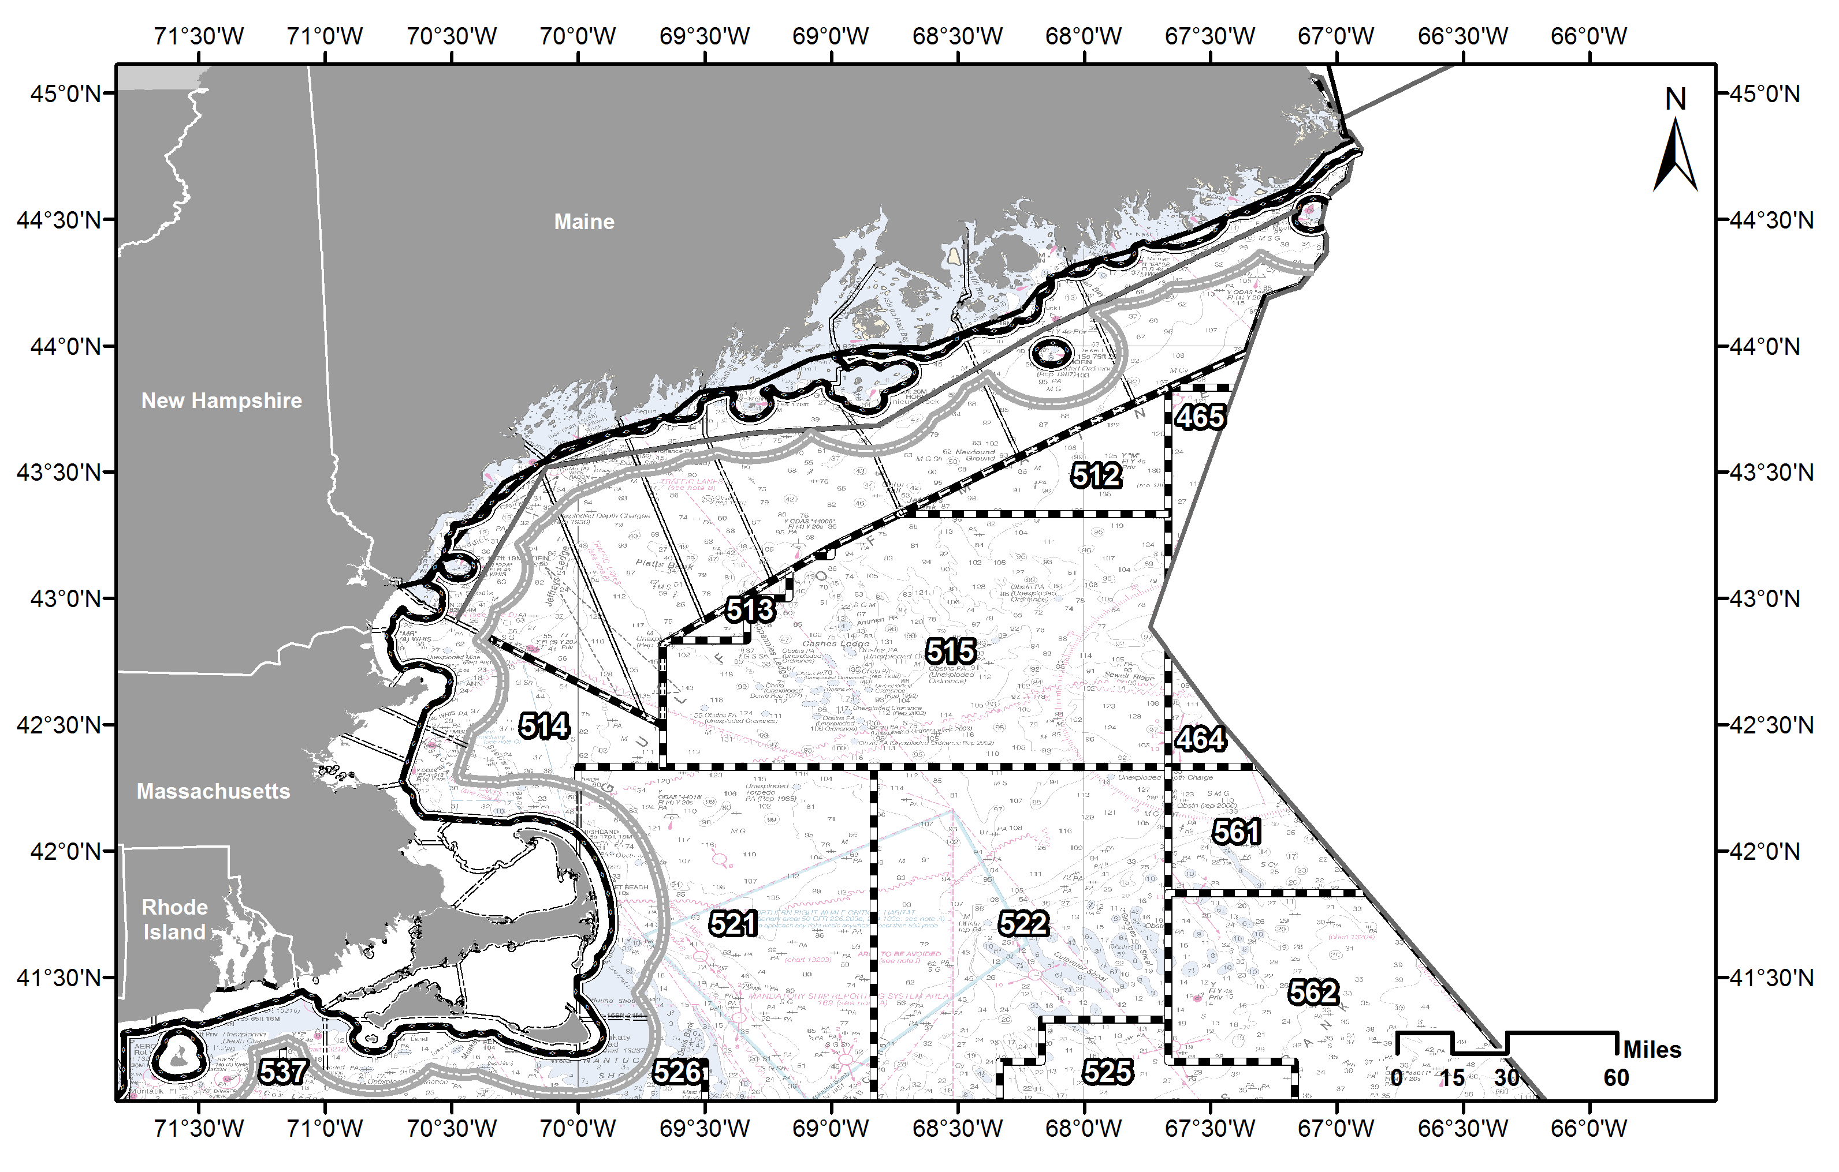
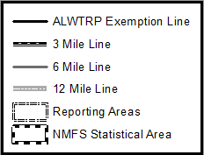
Map 2: Maine Lobster Zone A, State and Federal Waters
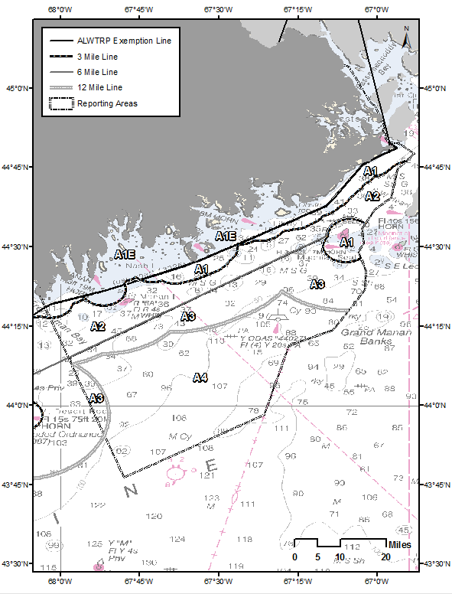
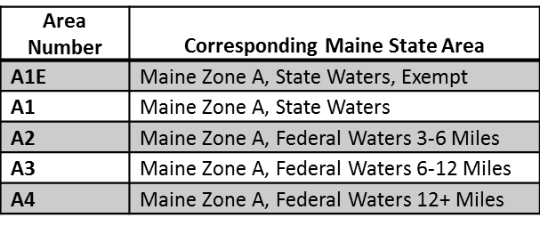
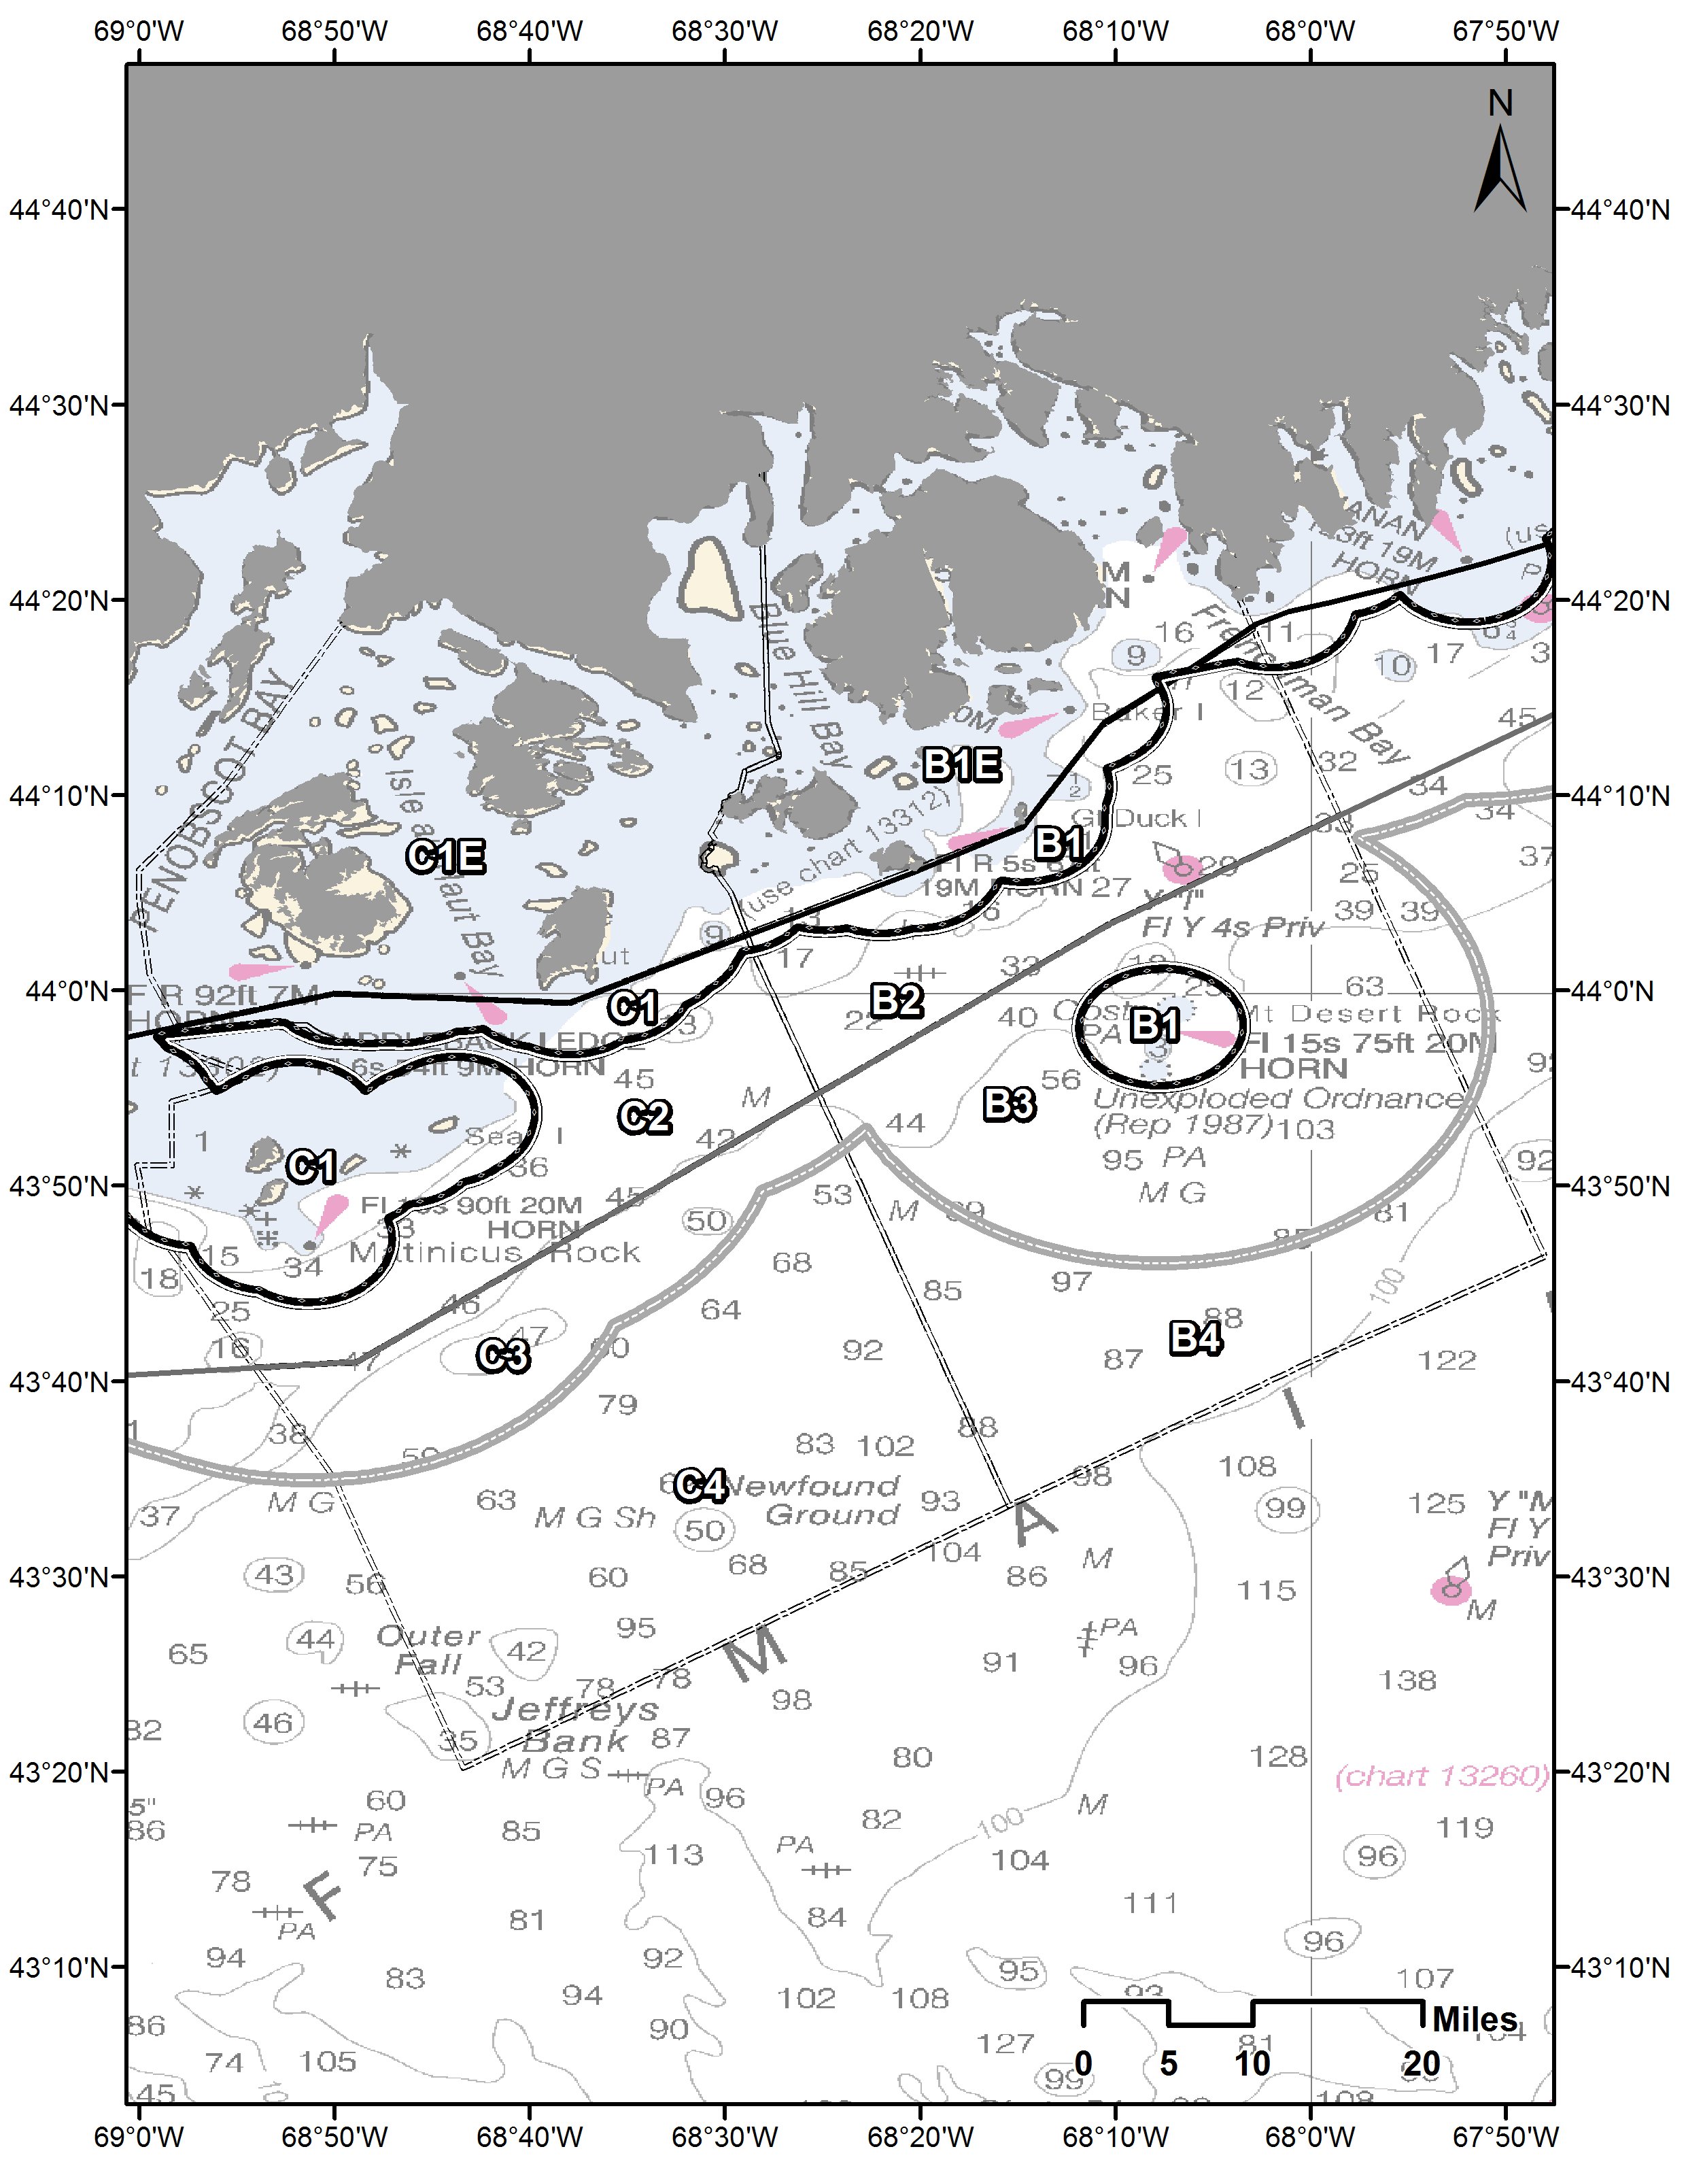
Map 3: Maine Lobster Zones B and C, State and Federal Waters
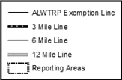
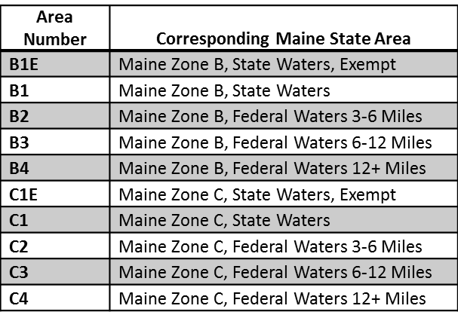

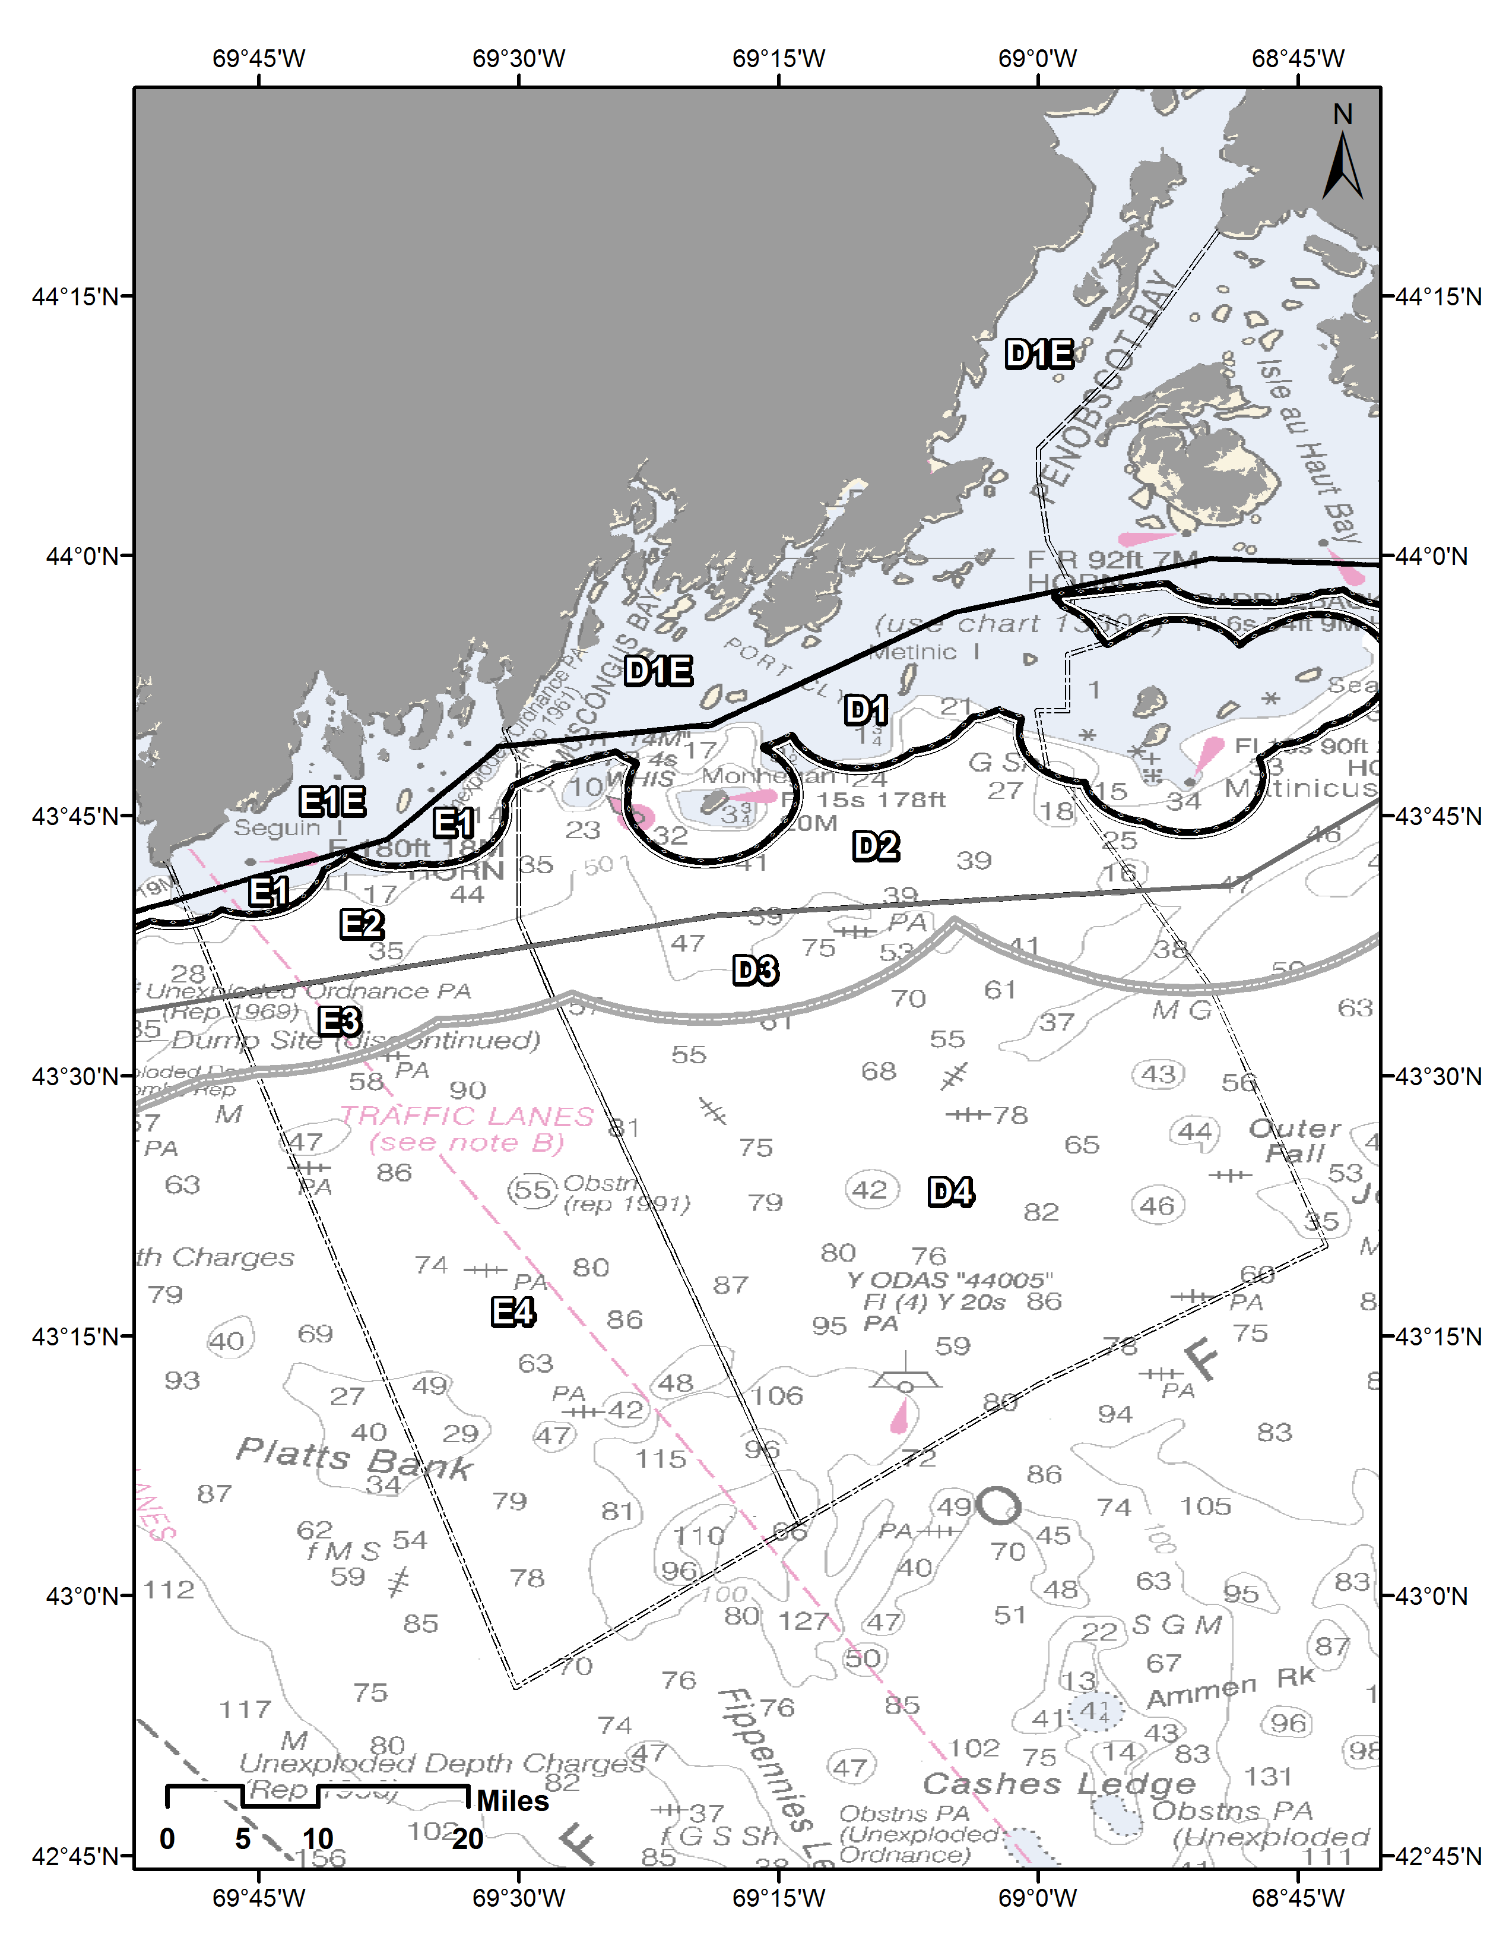
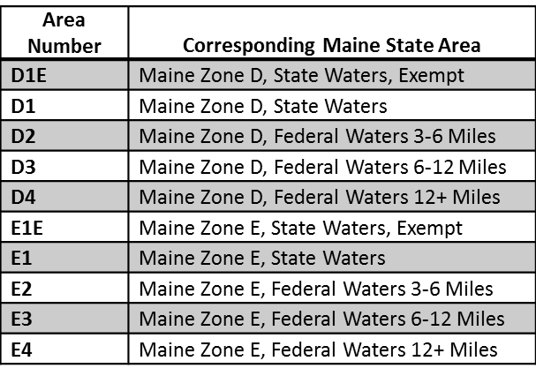
Map 4: Maine Lobster Zones D and E, State and Federal Waters
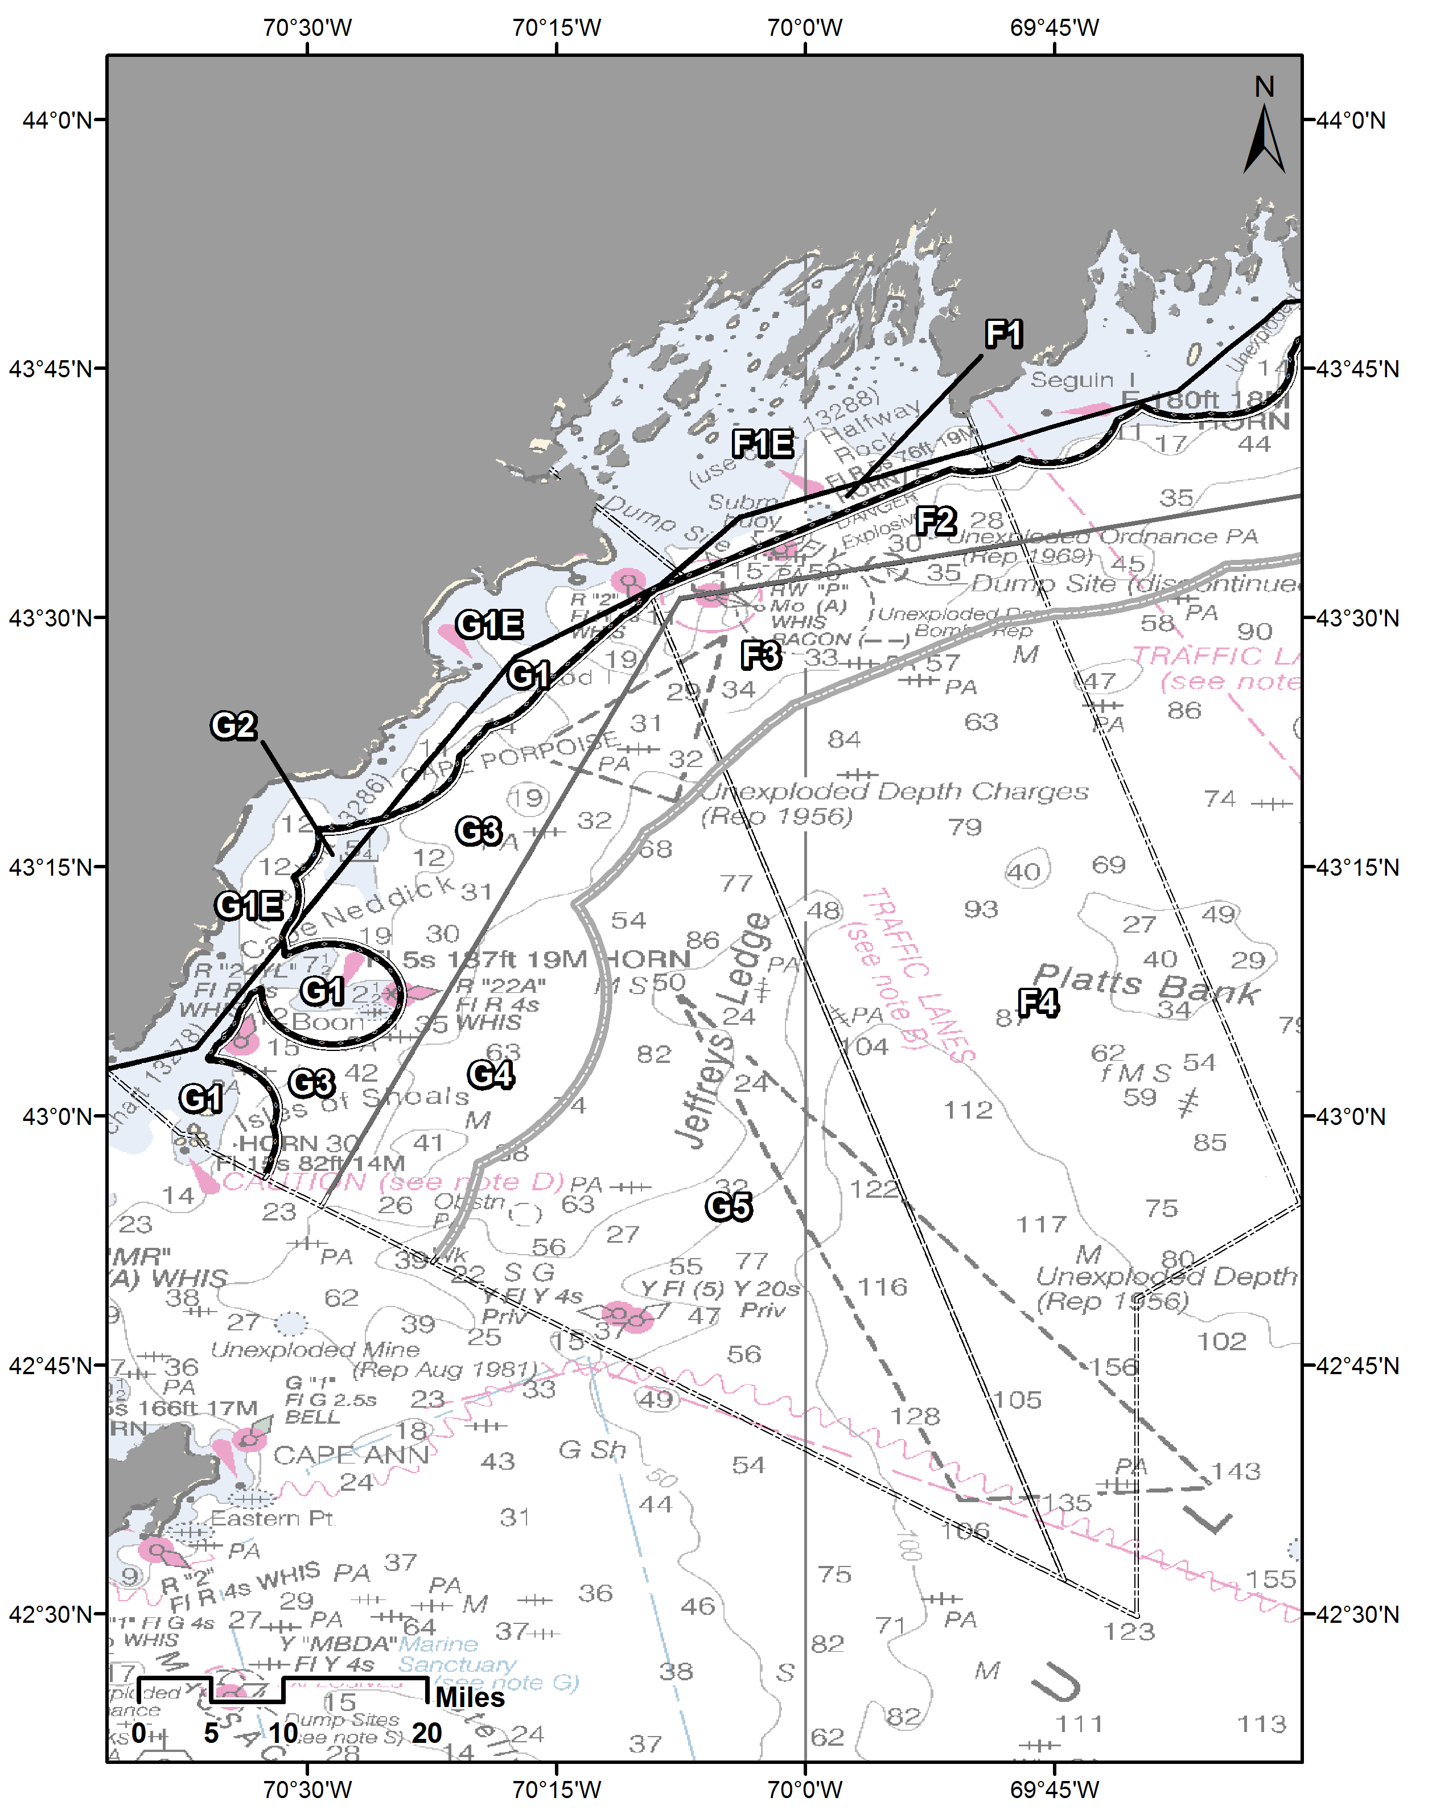
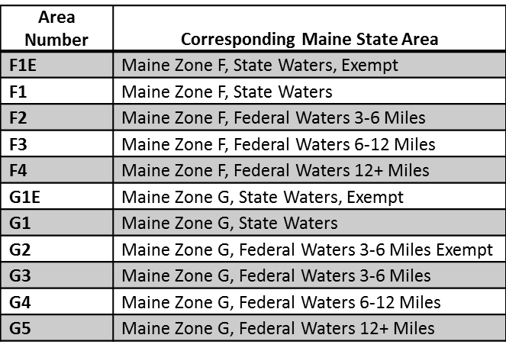
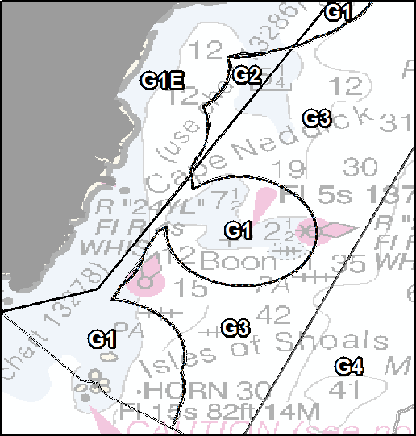
Map 5: Maine Lobster Zones F and G, State and Federal Waters
Map 6: NH/MA/RI State and Federal Waters
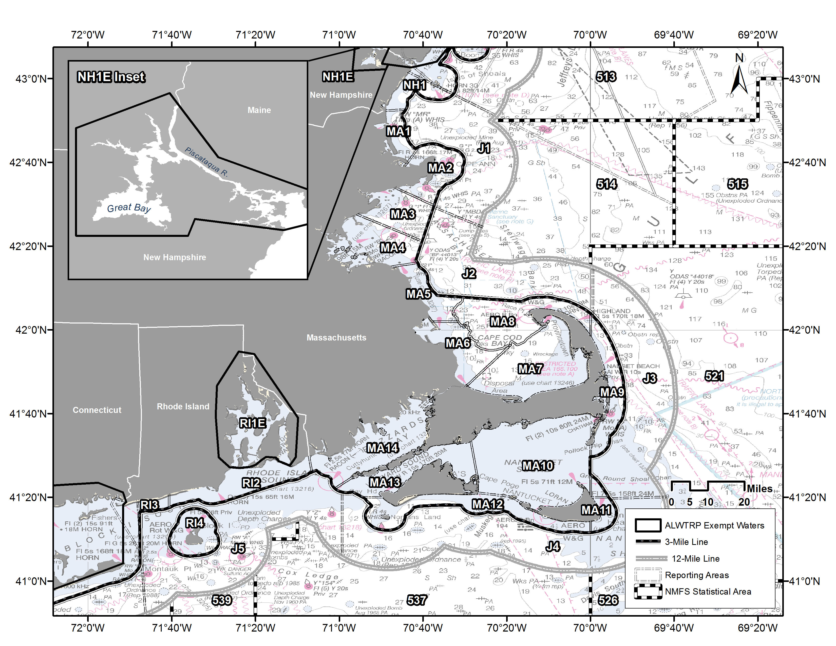

Map 7: Northeast Offshore Waters
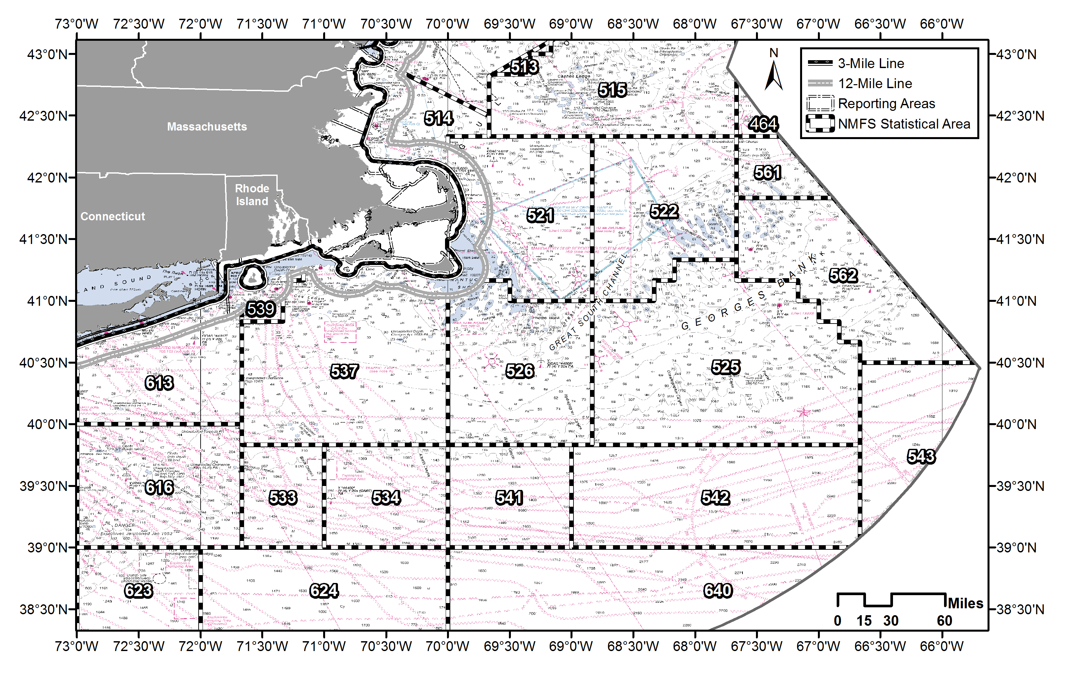

Map 8: CT/NY/NJ/DE State and Federal Waters
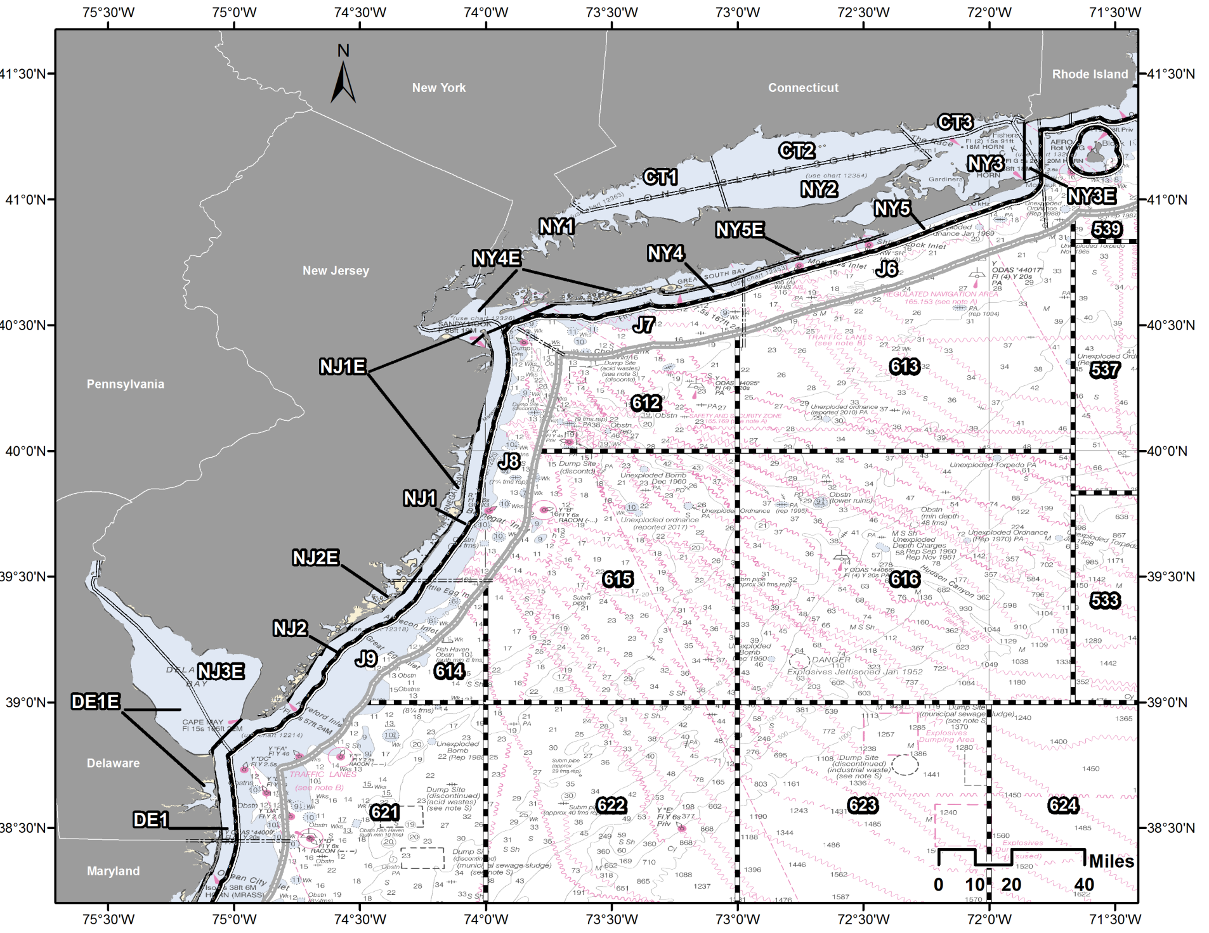
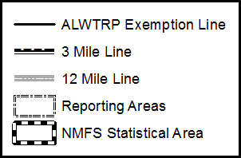

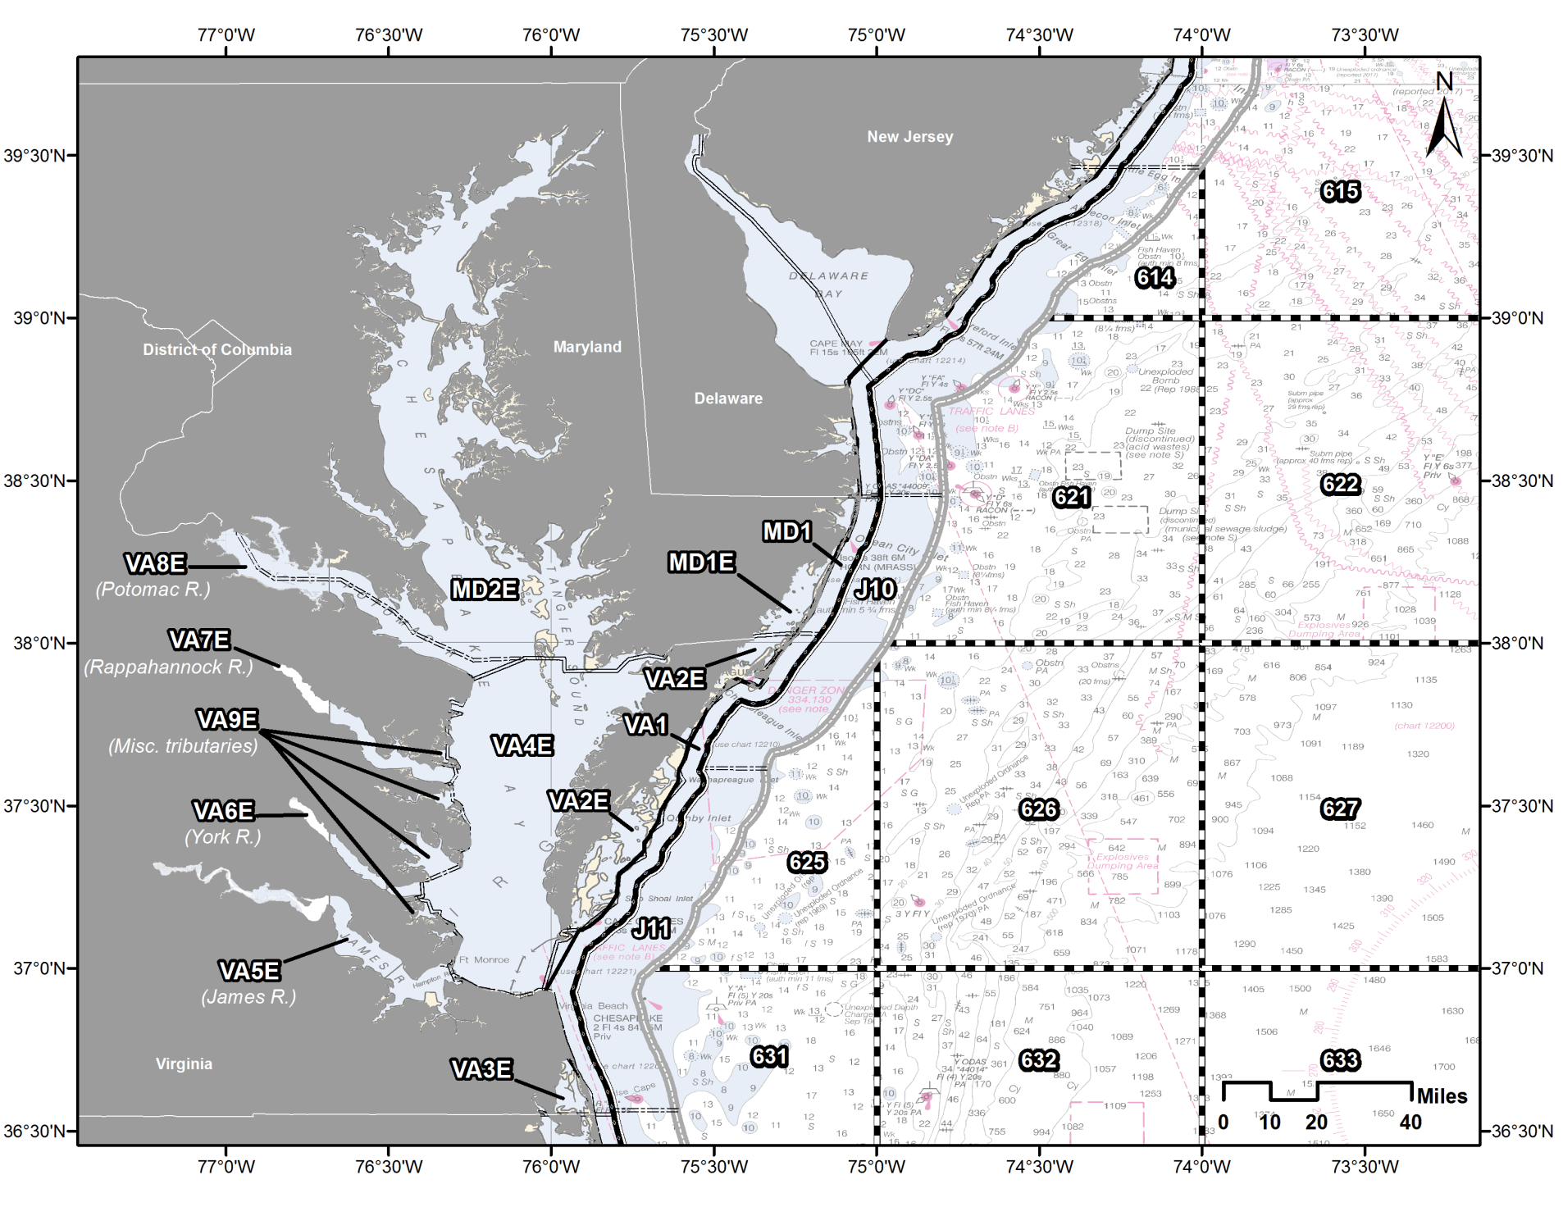
Map 9: MD/VA State and Federal Waters

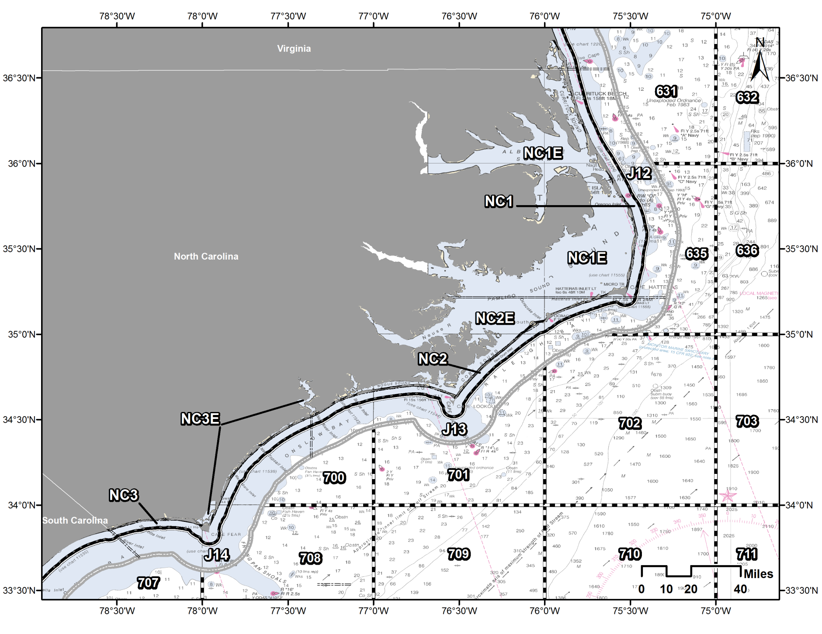
Map 10: NC State and Federal Waters
Map 11: Mid-Atlantic Offshore Waters
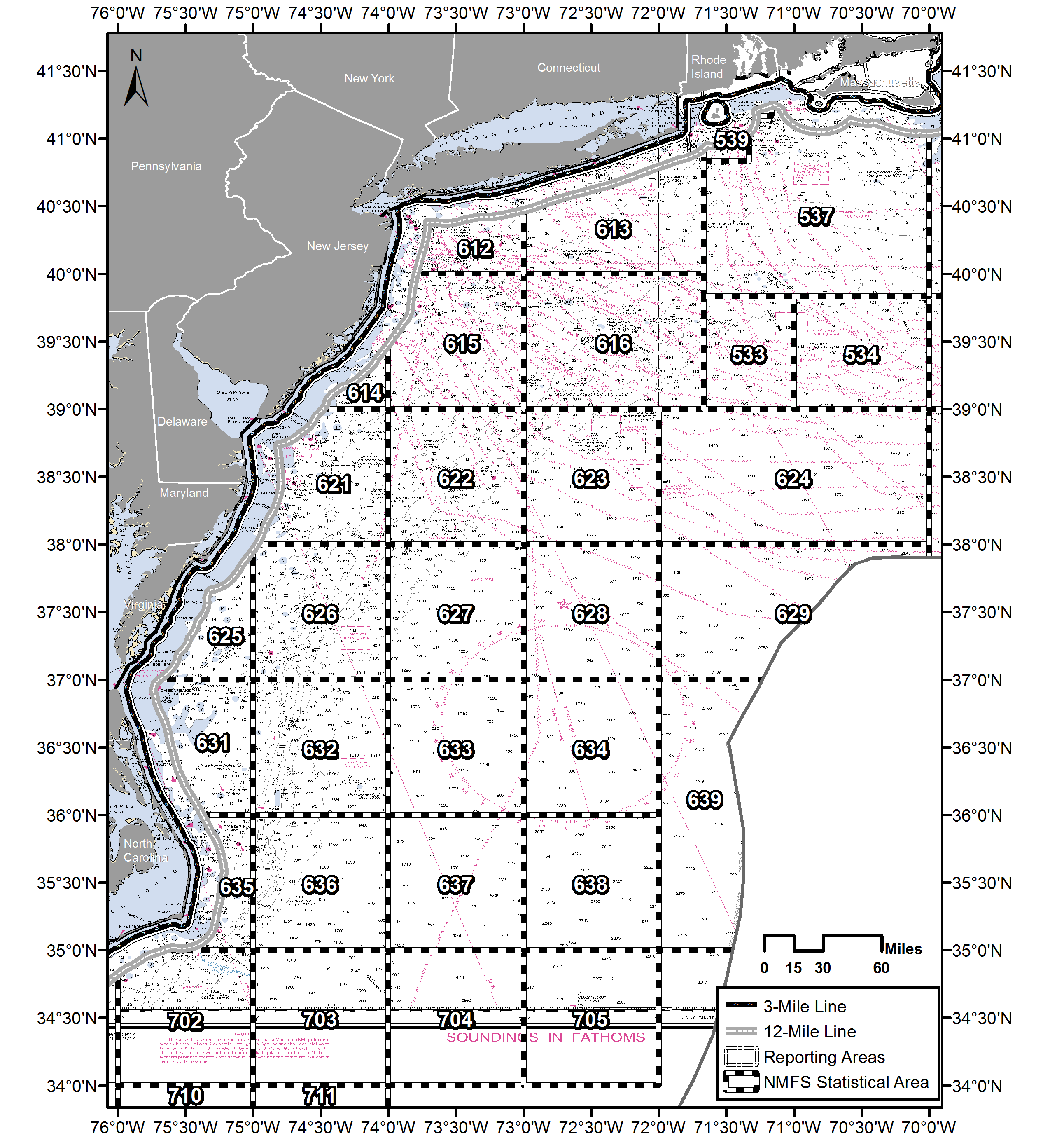

Map 12: SC/GA State and Federal Waters
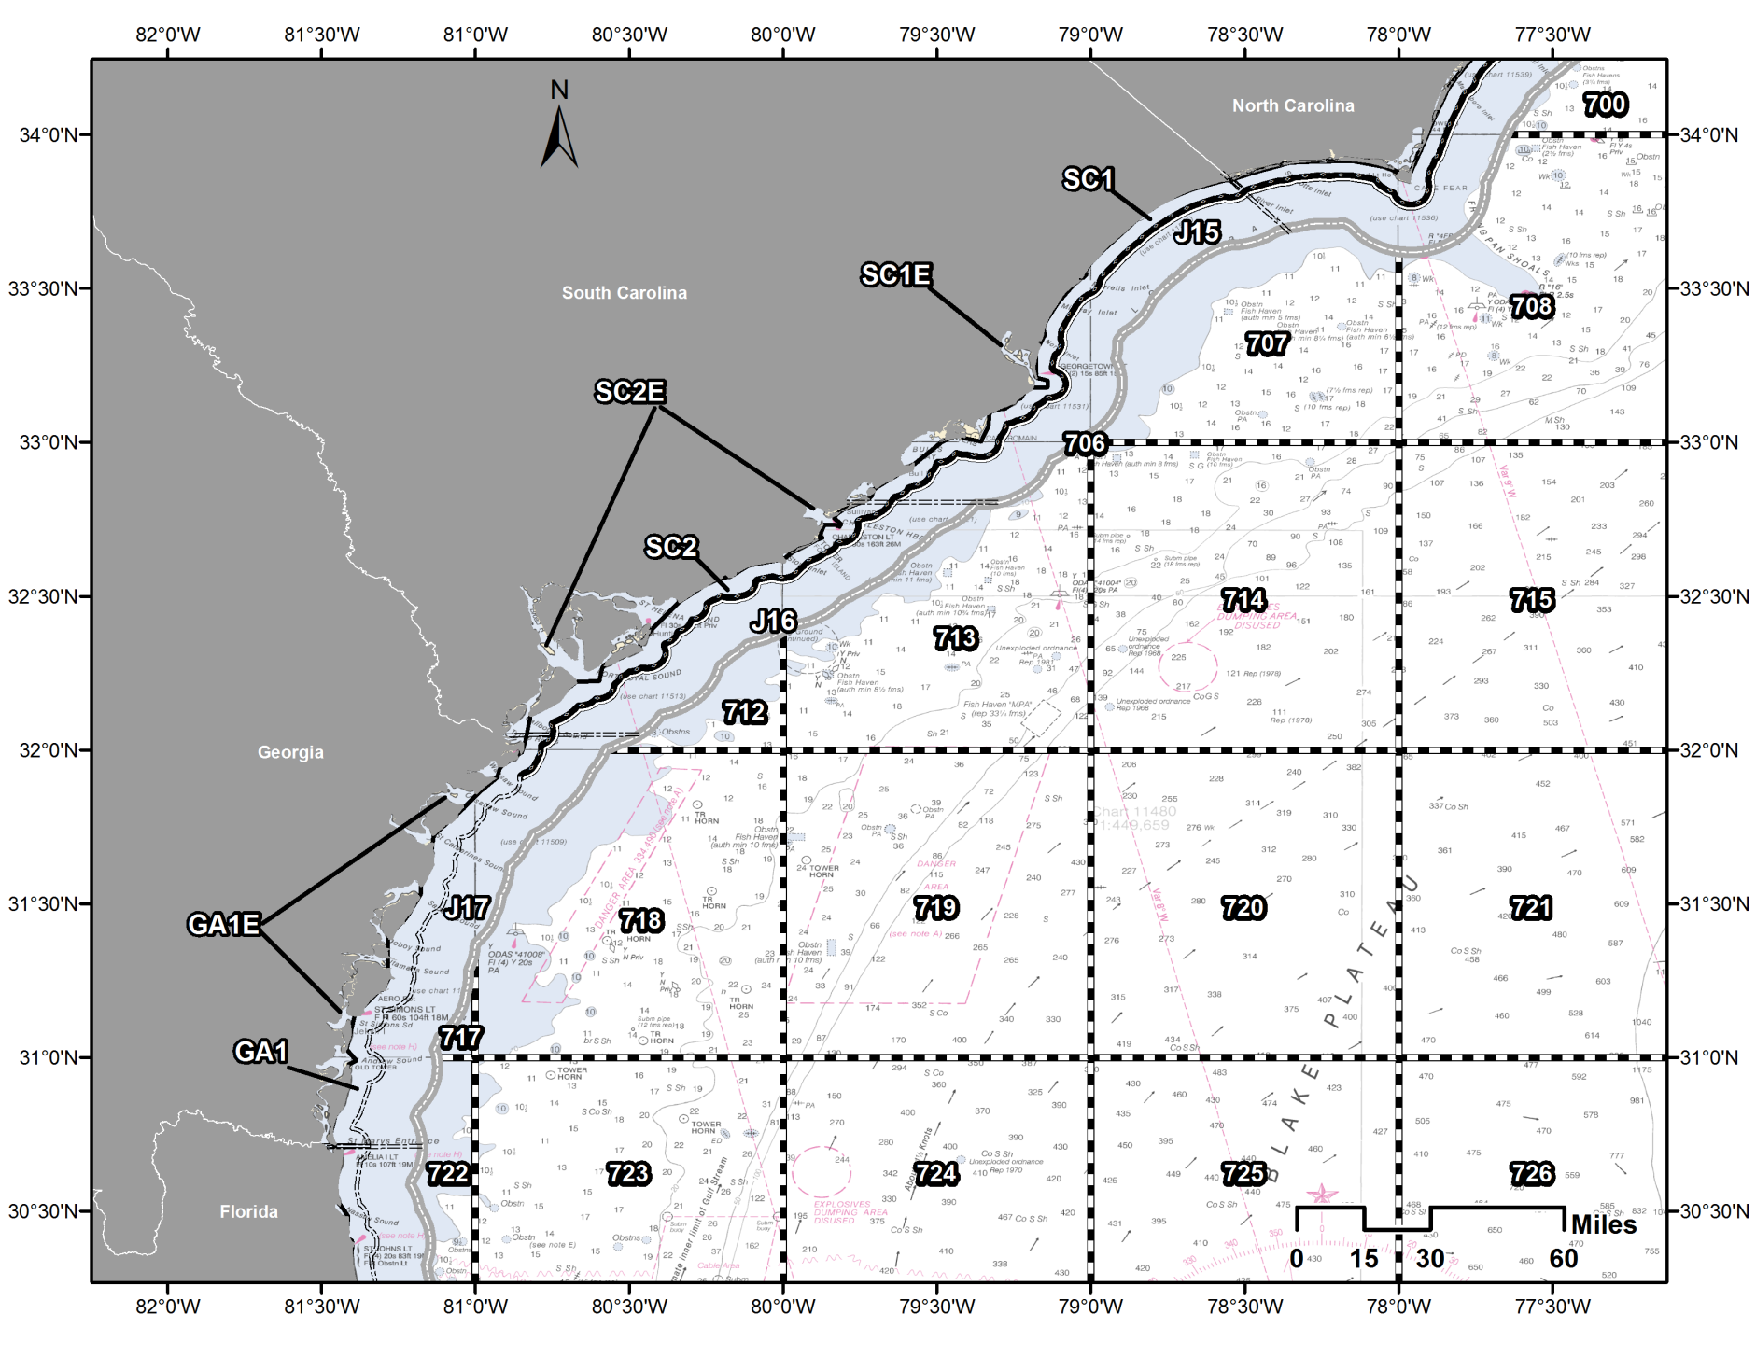
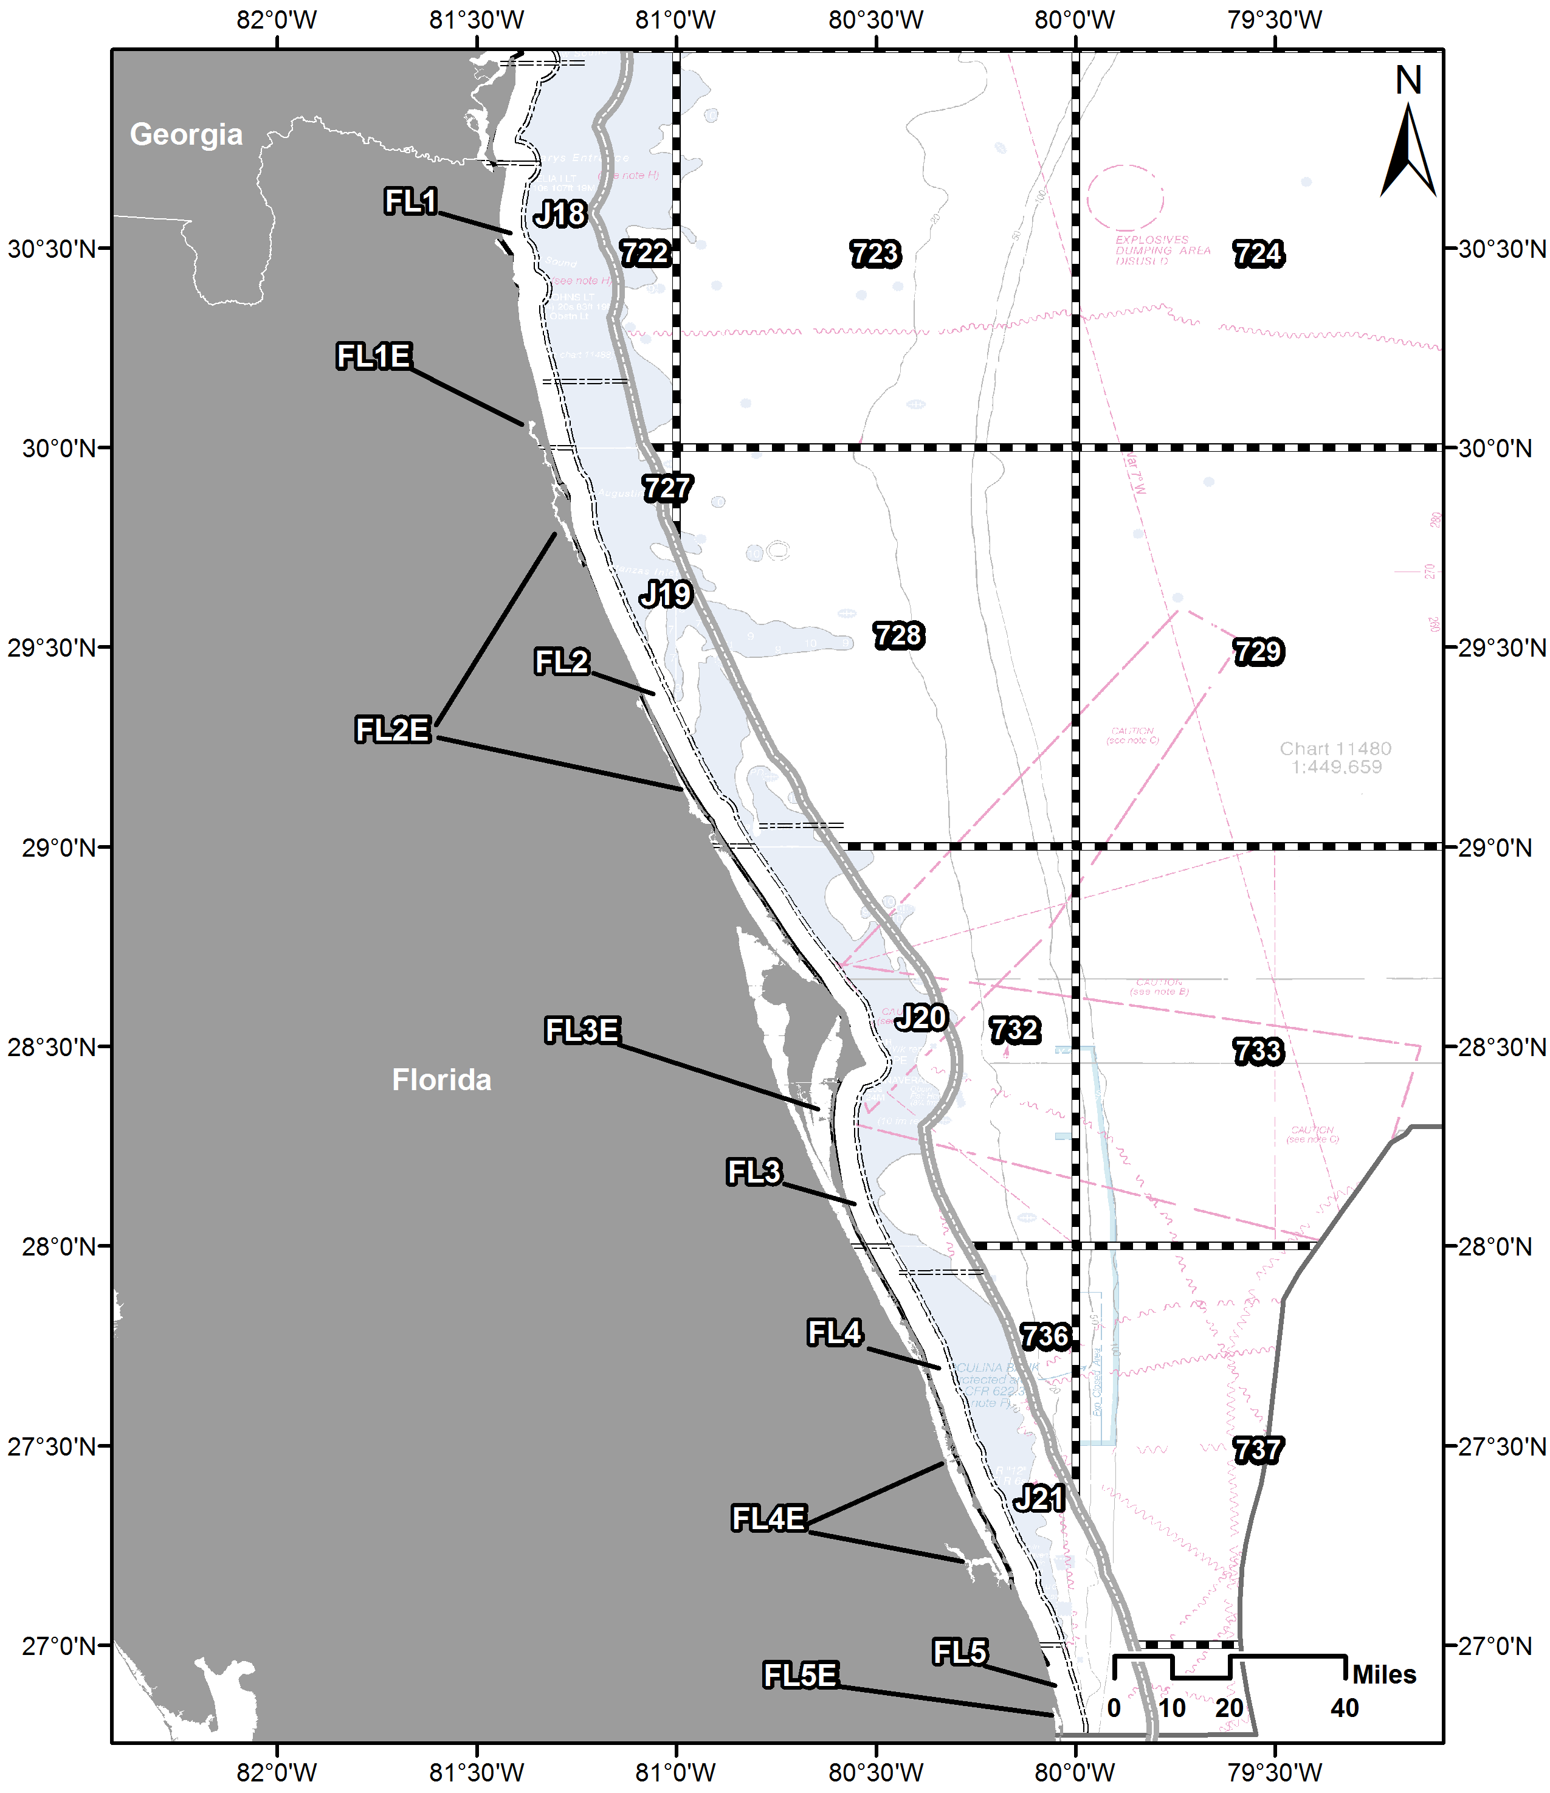
Map 13: FL State and Federal Waters

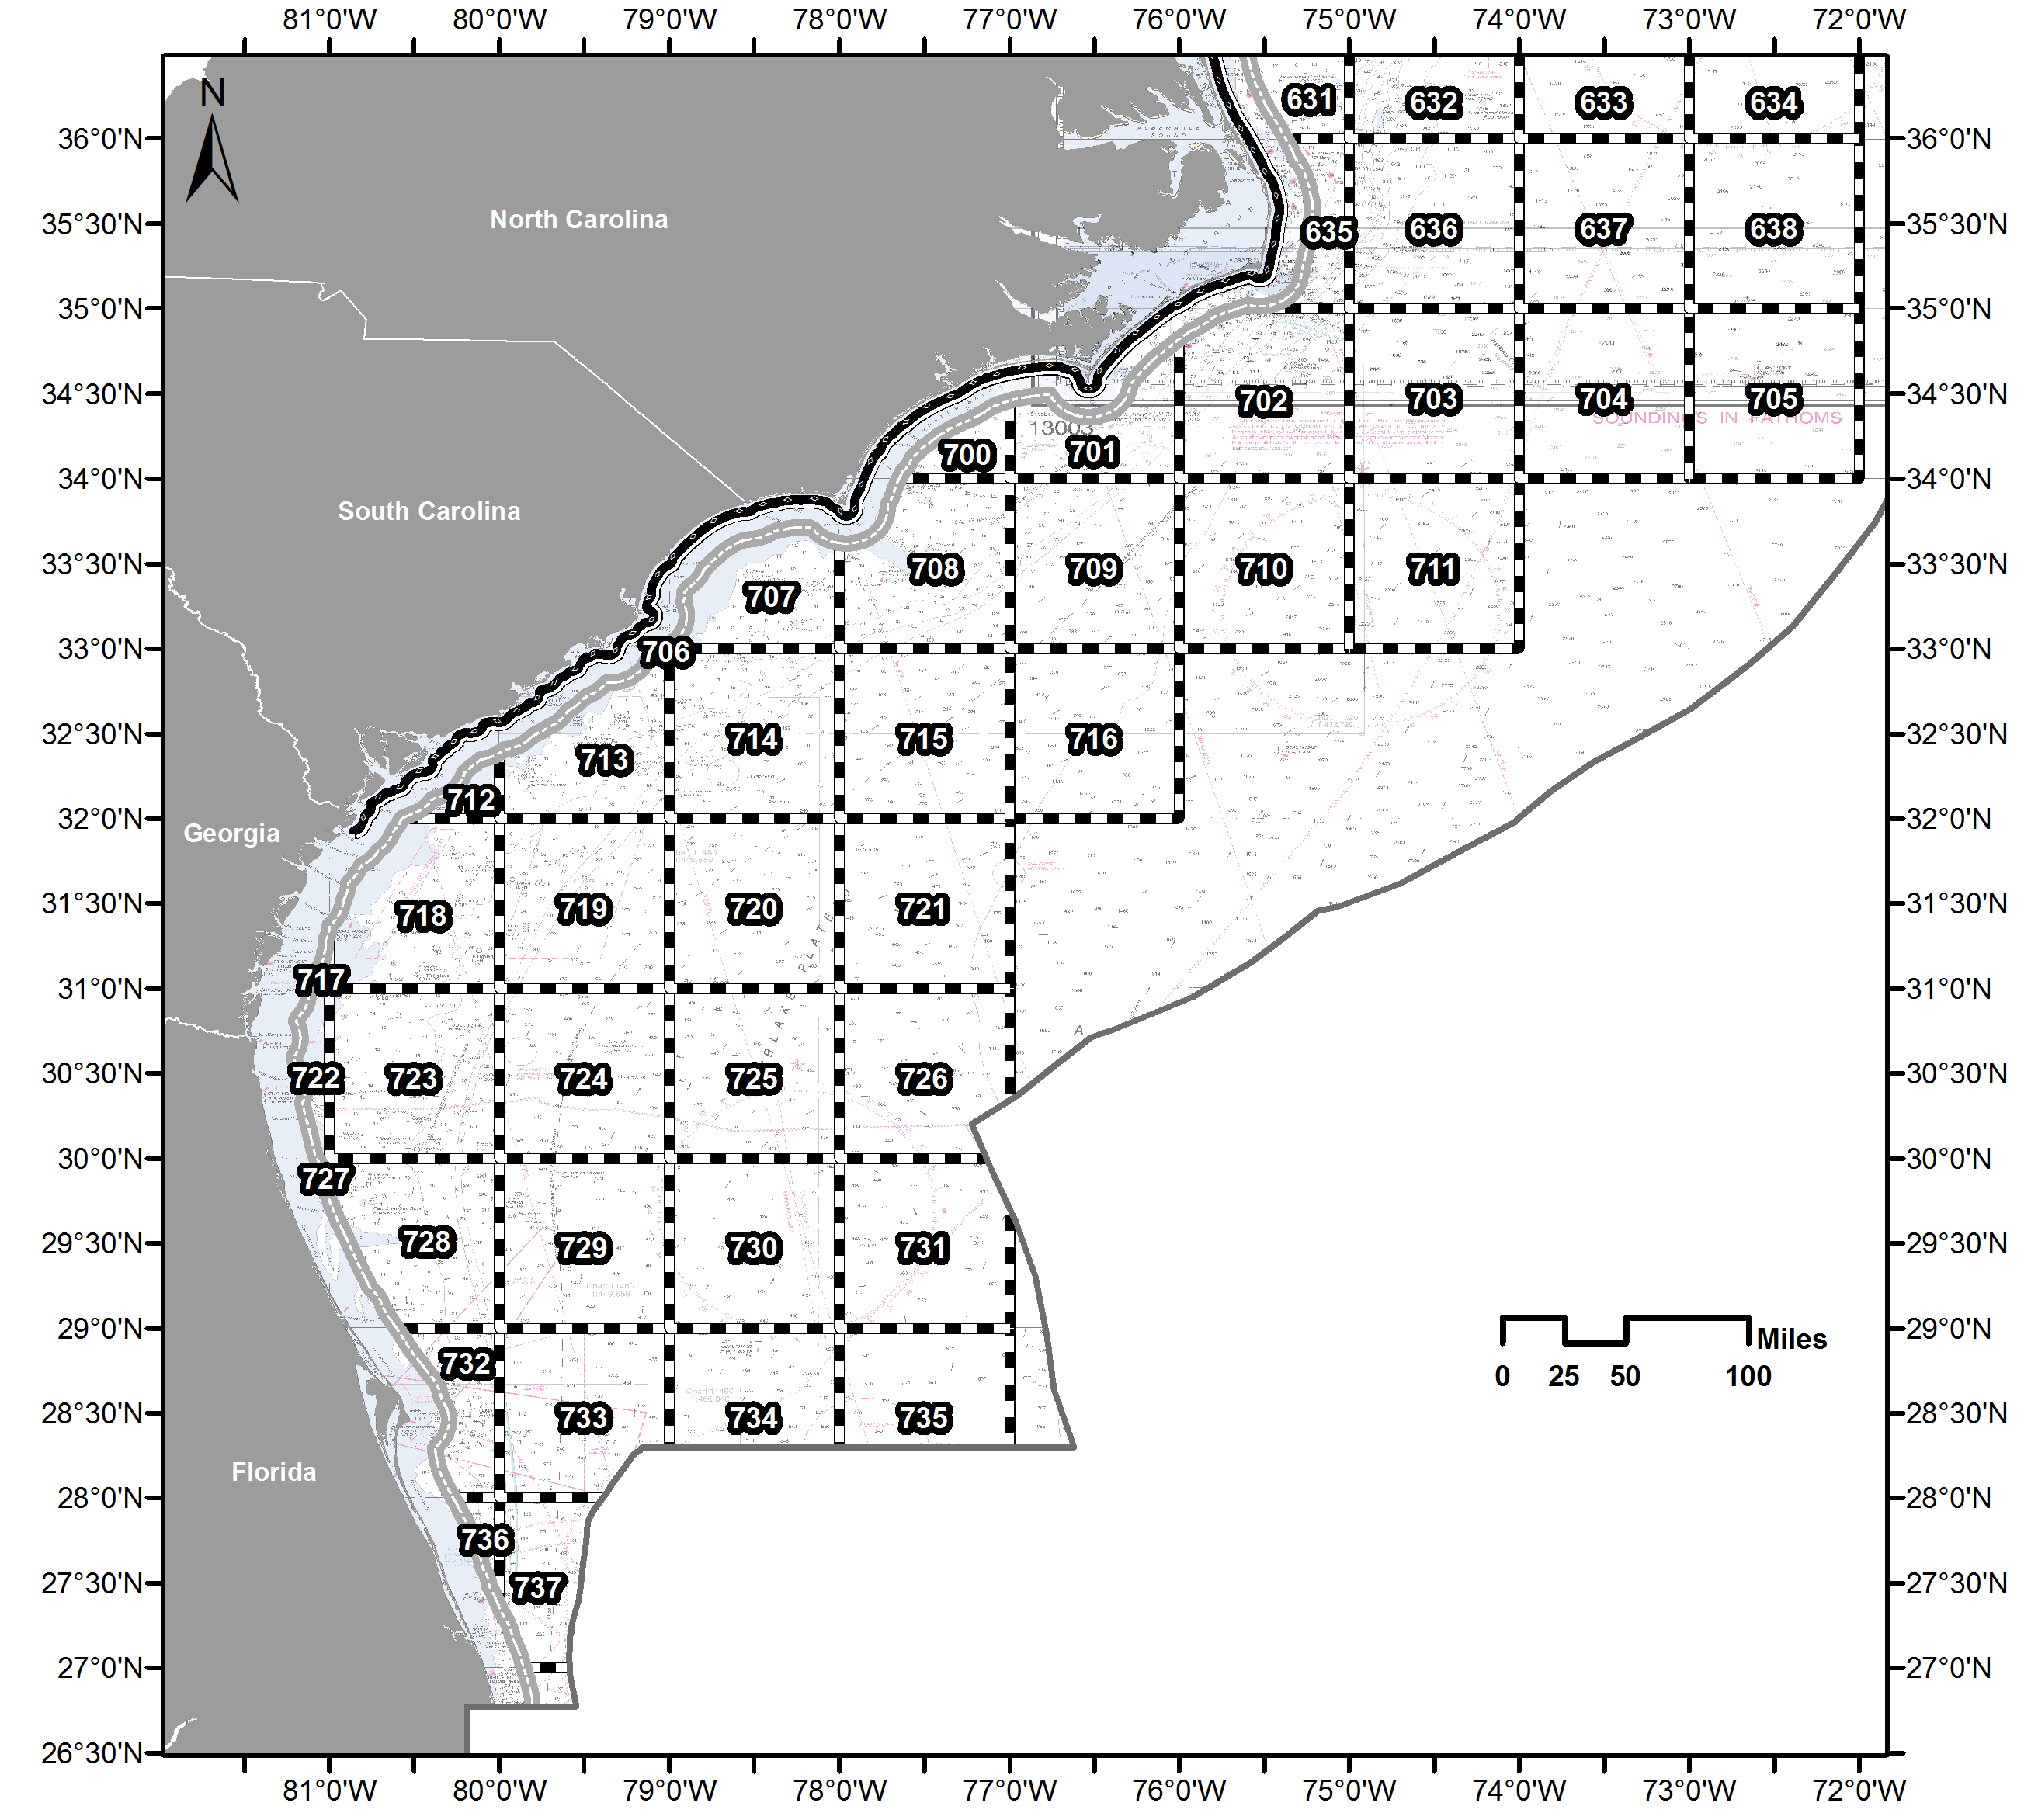
Map 14: Southeast Offshore Waters

SURFACE SYSTEM LIST
- Bullet buoy | - Bullet buoy + polyball
- Double bullet buoys | - Bullet buoy + toggle
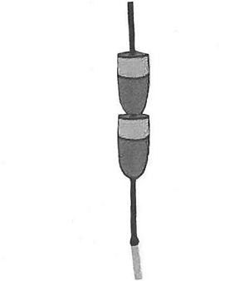 | 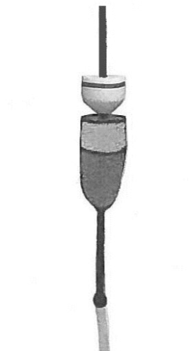
- Bullet buoys, stacked | - Bullet buoy + acorn buoy, stacked
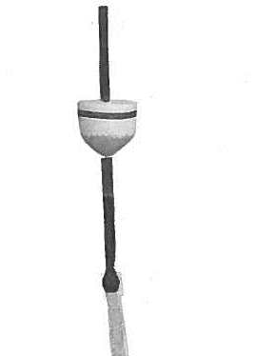 | 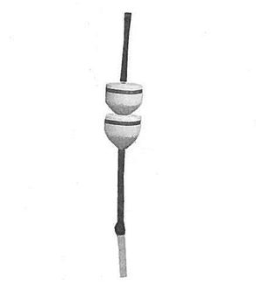
- Acorn buoy | - Acorn buoys, stacked
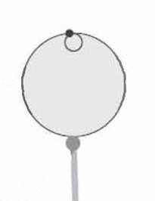
- Polyball | - High flyer + polyball

