DD-2962 (0704-0542) Personnel Security System Access Request (PSSAR) Form

Non-Substantive Revision Justification

**Background**: Defense Information System for Security (DISS) is developed to replace legacy systems for personnel security as outlined in DoD/Joint Staff SORN DMDC 24 (http://dpcld.defense.gov/Privacy/SORNsIndex/DOD-wide-SORN-Article-View/Article/799795/dmdc-24-dod/). During the upcoming transition between the current system of record for personnel security clearances and suitability determinations, Joint Personnel Adjudication System (JPAS), and DISS, DMDC must provide access request forms to new users of DISS.

**Description of changes in new DD-2962 version**: The present version of DD-2962 remains unchanged; this version allows authorized users to request access to the Joint Personnel Adjudication System (JPAS). The proposed DD-2962 Version 2 replaces JPAS with DISS, in blocks 16 and 17 for user provisioning (see Figure 1), and in the associated instructions sections on page 3 (see Figure 2).

**Impact on burden and respondents of 0704-0542**: There is no impact on the respondents by creating a second version of the DD-2962. There is no change in the number of respondents, the type of respondents, nor the estimated time per response, as outlined in 0704-0542, approved 9/14/2015. Facility Security Officers (FSO) will complete and submit either the original DD-2962 or the proposed Version 2, but not both.

**Figure 1**: Blocks 16 and 17 replace JPAS with DISS user provisioning requests. Version 1 is top two images; Version 2 is bottom image.

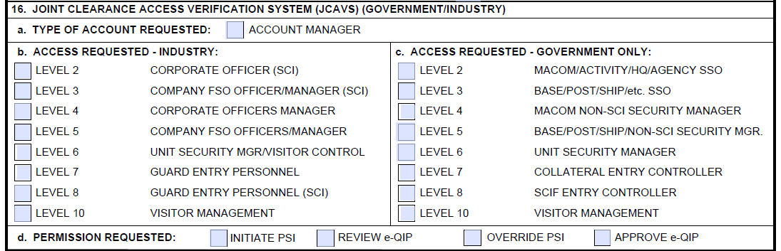

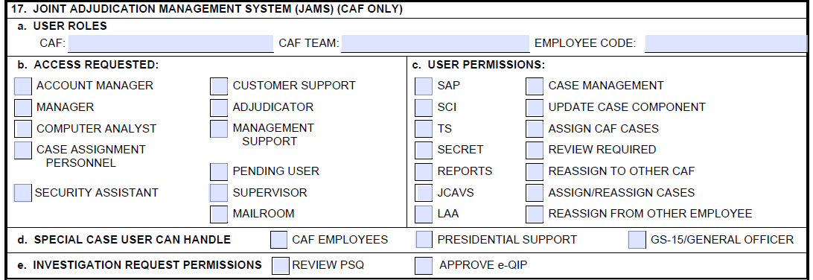

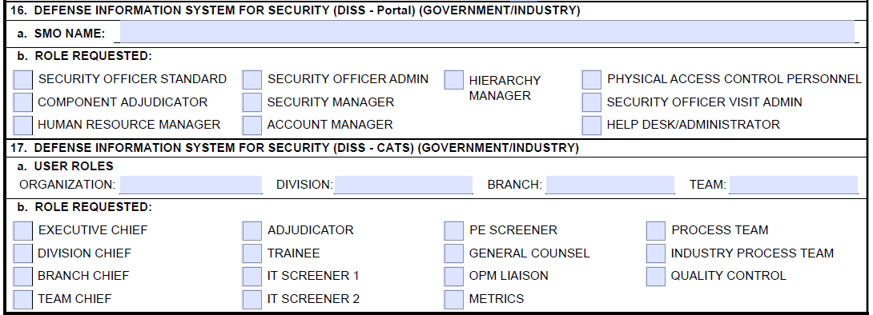

**Figure 2**: Instruction sections 16 and 17 replace JPAS with DISS user instructions for associated blocks. Version 1 is on left; Version 2 is on right.

  