**HAND CARD #1**

* **American Indian or Alaska Native**
* **Asian**

- Asian Indian

- Cambodian

- Chinese

- Filipino

- Hmong

- Japanese

- Korean

- Laotian

- Pakistani

- Thai

- Vietnamese

- Other Asian

* **Black or African American**
* **Native Hawaiian or Pacific Islander**
* Native Hawaiian
* Guamanian or Chamorro
* Samoan
* Other Pacific Islander
* **White**

**HAND CARD #2**

|  |  |
| --- | --- |
| Asian Indian | Korean |
| Bangladeshi | Laohmong |
| Bengalese | Laotian |
| Bharat | Madagascar/ Malagasy |
| Bhutanese | Malaysian |
| Burmese | Maldivian |
| Cambodian | Mong |
| Cantonese | Nepalese |
| Chinese | Nipponese |
| Dravidian | Okinawan |
| East Indian | Pakistani |
| Filipino | Siamese |
| Goanese | Singaporean |
| Hmong | Sri Lankan |
| Indochinese | Taiwanese |
| Indonesian | Thai |
| Iwo Jiman | Vietnamese |
| Japanese |  |

**HAND CARD #3**

TV

Radio

Newspaper (Print or Online)

Social Media

Other Websites

Word of mouth

Other

**HAND CARD #4**

*Note: This new hand card is for the new questions related to the NHANES social media pilot. It will have screen shots of the seven still shorts and three videos being used in the social media pilot. The materials have not yet been developed, so these are place holders for the anticipated products.*

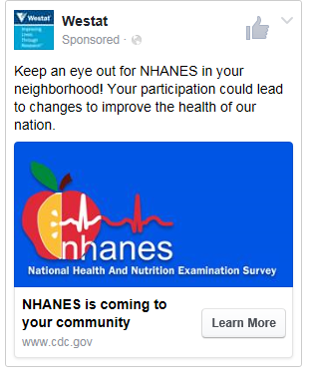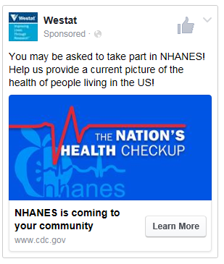

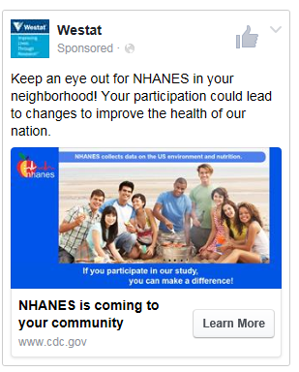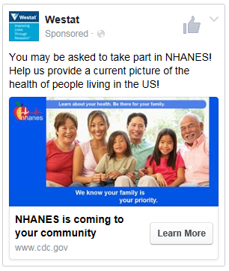

Learn more about your health at no cost to you.

*Note: Back of Hand Card #4*

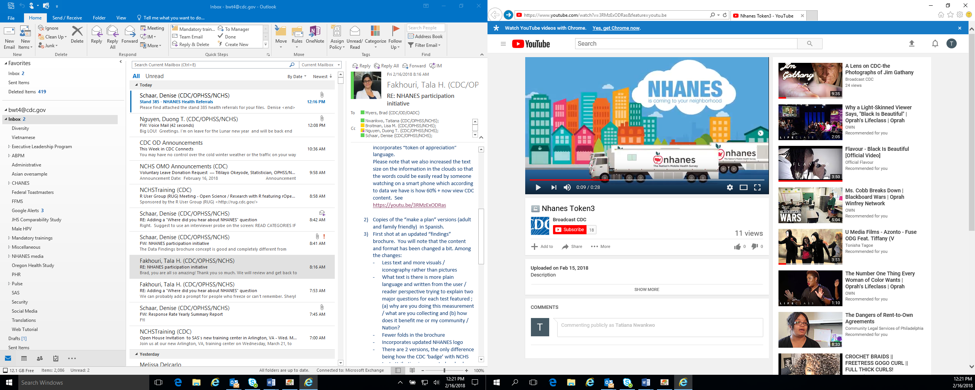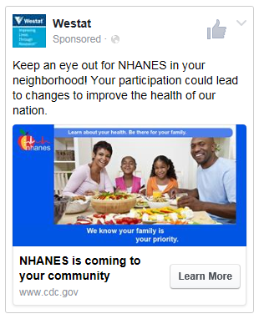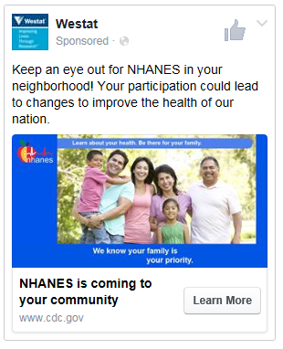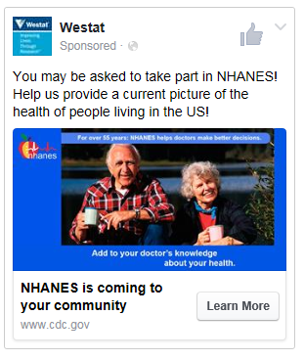

Learn more about your health at no cost to you.

Health measurements and state-of-the art tests will be provided at no cost to you.

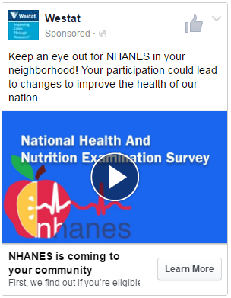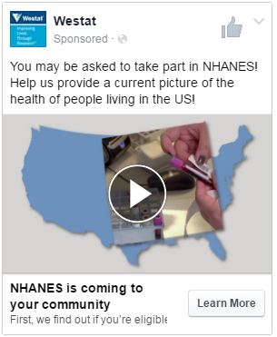

Health measurements and state-of-the art tests will be provided at no cost to you.