**Attachment 3g**

**Mobile Exam Center (MEC)**

**Computer Assisted Personal Interview (CAPI)**

**& Dietary Recall (DRQ) Hand Cards**

Table of Contents

**MEC CAPI Hand Cards3**

**Dietary Recall (DRQ) Hand Cards17**

**MEC CAPI Hand Cards**

**SXQ1**

1. Lesbian or gay
2. Straight, that is, not lesbian or gay
3. Bisexual
4. Something else
5. I don’t know the answer

**SXQ2**

1. Gay
2. Straight, that is, not gay
3. Bisexual
4. Something else

I don’t know the answer

**DPQ1**

Not at all

Several days

More than half the days

Nearly every day

*SMQ1*

|  |  |
| --- | --- |
| **Cigarette** | [http://www.dailytimes.com.pk/images/2007/09/10/20070910_b11.jpg](http://www.google.com/url?sa=i&rct=j&q=picture+hand+rolled+cigarettes&source=images&cd=&cad=rja&docid=g9DBkdI7ttMnqM&tbnid=KEvbTWI1r9g_6M:&ved=0CAUQjRw&url=http://www.dailytimes.com.pk/default.asp?page=2007\09\10\story_10-9-2007_pg6_19&ei=riRHUcOZMcip0AHNsYHoBw&bvm=bv.43828540,d.dmg&psig=AFQjCNEtm2oamrBuneUFnBbv6Nhe2EJFgA&ust=1363703335383552) |
| **Pipe** | C:\Users\Claud_S\AppData\Local\Microsoft\Windows\Temporary Internet Files\Content.Word\imagesCADJP6PY.JPG |
| **Cigar, or little cigar, or cigarillo** |  |
| **Water pipe or Hookah** |  |

*ALQ1*

|  |  |
| --- | --- |
| 12 ounces of beer |  |
|  |  |
| 5 ounces of wine |  |
|  |  |
| 1.5 ounces of hard liquor |  |

**ALQ2**

|  |  |  |
| --- | --- | --- |
| **Per Week** | **Per Month** | **Per Year** |
| Every day | 2-3 times/month | 7-11 times/last year |
| Nearly every day | Once/month | 3-6 times/last year |
| 3-4 times/week |  | 1-2 times/last year |
| 2 times/week |  |  |
| Once a week |  | Never in the last year |

*RHQ1*

|  |  |  |
| --- | --- | --- |
| **Pregnancy** | |  | | --- | |  | |
| **Breastfeeding** | C:\Users\vpp6\Desktop\can-stock-photo_csp5518094.jpg |
| **Total or Partial Hysterectomy (Surgery to Remove Uterus/Womb)** | C:\Users\vpp6\Desktop\Hysterectomy only.PNGC:\Users\vpp6\Desktop\Hysterectomy with ovaries removed.PNG |
| **Menopause / Change of Life** | C:\Users\vpp6\Desktop\Menopause.PNG  Night sweats  Loss of libido  Mood swings  Sleep issues  Hot flashes  Vaginal dryness |
| **Other** | **Medical Conditions (medical treatment, medication)**    **Excessive exercise**  **Something else?** |

RHQ.3

* 1. BIRTH CONTROL PILLS
  2. PATCH (Ortho EvraTM, XulaneTM)
  3. VAGINAL RING (NuvaRingTM)
  4. INJECTABLE (shot given every 1-3 months of Depo-ProveraTM, LunelleTM)
  5. HORMONAL IMPLANT (ImplanonTM, NexplanonTM)
  6. CONDOMS OR RUBBERS (male or female condoms)
  7. IUD (Intraueterine device, coil, loop, ParaGardTM, MirenaTM, KyleenaTM, LilettaTM, SkylaTM)
  8. DIAPHRAGM, CERVICAL CAP (FemCap) or SPONGE (TodayTM sponge)
  9. SPERMICIDE FOAM, JELLY, CREAM, SUPPOSITORY
  10. NATURAL FAMLIY PLANNING (rhythms method, StandardDays, CycleBeads, safe period by temperature or cervical mucus test)
  11. STERILIZATION (tubes tied, tubal ligation, partner’s vasectomy)
  12. WITHDRAWAL (pulling out)
  13. EMERGENCY CONTRACEPTION (pills taken within 3-5 days after sexual intercourse such as Plan BTM, PrevenTM, EllaTM, Next ChoiceTM, Morning after pills)
  14. ABSTINENCE

*RHQ2 (front)*

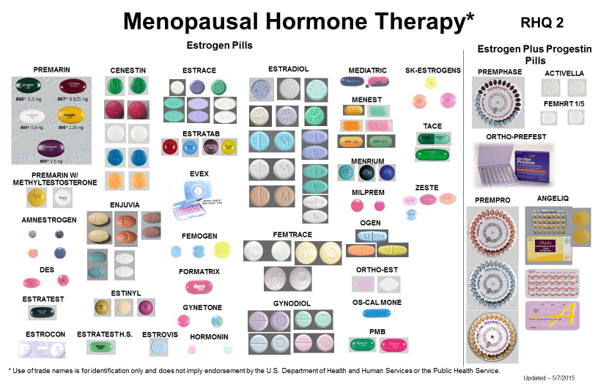

*RHQ2 (BACK)*

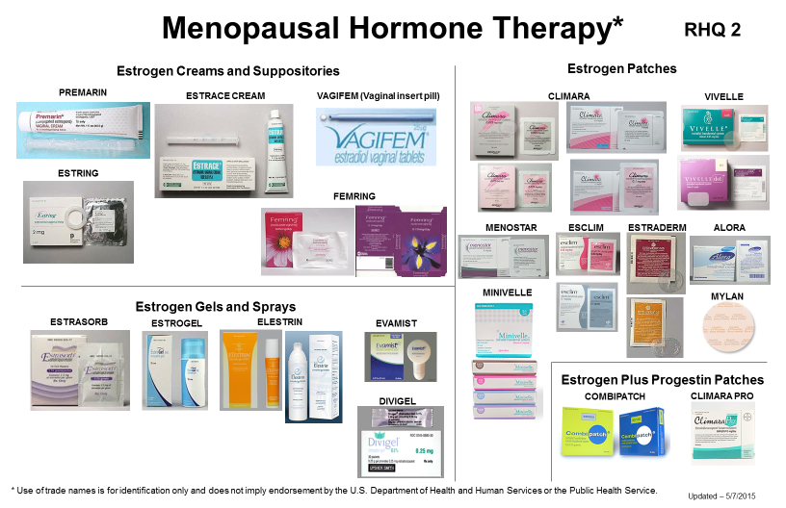

**KIQ1**

Less than once a month

A few times a month

A few times a week

Every day and/or night

WHQ2

EXAMPLES OF FROZEN MEALS AND FROZEN PIZZAS

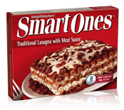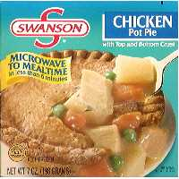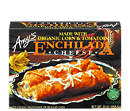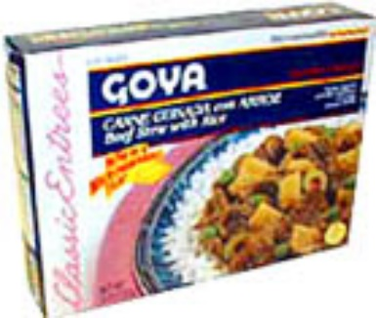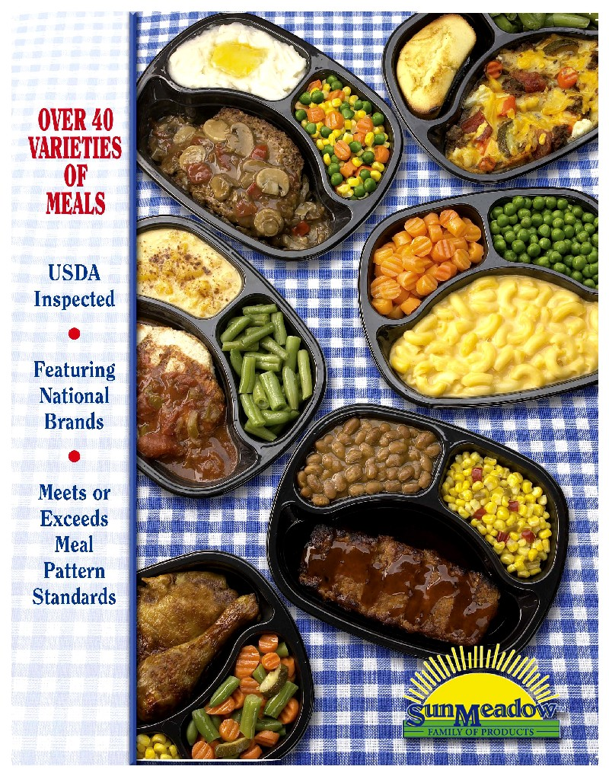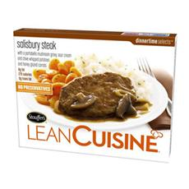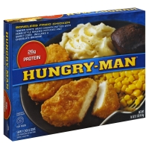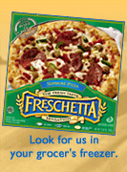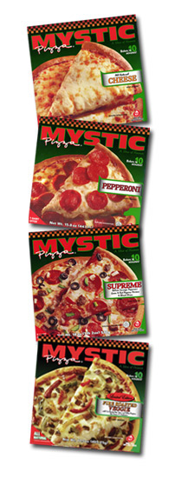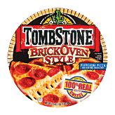

DMQ8

**Examples of what we learned when matching NHANES data to other data sources such as Medicare and Medicaid:**

* How housing environment may affect the levels of lead in children’s blood
* Higher vitamin D in the blood lowers the risk of broken bones
* Consuming high amount of sugar can increase the risk of heart diseases
* People who live or work with smokers have a higher risk of heart attack
* Adults who exercise, eat healthy diets, and do not smoke have a lower chance of dying

**Dietary Recall (DRQ) Hand Cards**

**Fish**

Breaded fish products

Tuna-canned or fresh

Bass

Catfish

Cod

Flatfish

Haddock

Mackerel

Perch

Pike

Pollock

Porgy

Salmon

Sardines

Sea Bass

Shark

Swordfish

Trout

Walleye

Other type of fish

**Shellfish**

Clams

Crab

Crayfish (crawfish)

Lobster

Mussels

Oysters

Scallops

Shrimp

Other shellfish (for example, octopus, squid)

**EXAMPLES OF AN ALCOHOLIC DRINK**

|  |  |
| --- | --- |
| *ALQ1*  12 ounces of beer |  |
|  |  |
| 5 ounces of wine |  |
|  |  |
| 1.5 ounces of hard liquor |  |