Attachment 8b Advance Letter

You or a member of your family may have a chance to take part in an important national health survey.

The National Center for Health Statistics, a part of the Centers for Disease Control and Prevention, is responsible for this survey—the National Health and Nutrition Examination Survey. This survey teaches us about the health and diet of people in the United States. Over the years, this survey has led to changes in the foods we eat and the health care we receive.

In the next few weeks, one of our health representatives may visit your home. She or he will show you official Centers for Disease Control (CDC) identification and ask some short, easy questions about you and other family members. This interview will take only a few minutes of your time. The purpose of these questions is to see if you or a member of your family will be asked to participate in the survey. Answering the questions is completely voluntary, and you may choose not to answer any questions. I assure you there will be no penalties or loss of benefits of any kind from refusing to answer.

If you or other household members are chosen, we hope you will participate in the survey. You will be among the many people in towns and cities across the country that help us increase our knowledge about the health of people in the United States.

This survey is a Federal program authorized by Section 306 of the Public Health Service Act (42 U.S.C. 242k). All of your answers will be kept in strict confidence according to Section 308(d) of the Public Health Service Act (Title 42, U.S. Code, 242m(d) and the Confidential Information Protection and Statistical Efficiency Act (Title 5 of PL 107-347). We will use your information only for statistical research and reports. Your answers will be added to others, so no one can identify which are yours.

Thank you in advance for helping.

Sincerely,

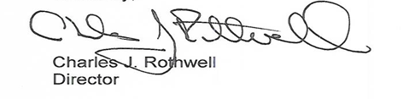

P.S. If you have questions call Mr. George Zipf of my staff at 1-800-452-6115.
The call is free, and we would be happy to answer your questions.

