Attachment 9g

MEC e-consent proposed screens: Adult SP

MEC Consent/Assent

PROVIDE MEC CONSENT BROCHURE AND REVIEW PACKET.

[Let’s take a look at a brochure as I explain the exam process to you.]

HAND RESPONDENT THE EXAMINATION CONSENT BROCHURE IN THE LANGUAGE HE/SHE READS.

REVIEW KEY POINTS FROM BROCHURE AND HEALTH MEASUREMENTS LIST, OR READ FORMS OUT LOUD.

REVIEW MEC DIAGRAM AND LAB TESTS ON BLOOD FLYERS AS NECESSARY.

REVIEW KEY POINTS FROM THE CONSENT/ASSENT AND PARENTAL PERMISSION FOR EXAM AT MEC FORM IN THE LANGUAGE HE/SHE READS, OR READ FORM OUT LOUD.

ANSWER ANY RESPONDENT QUESTIONS.

DISPLAY IMAGE OF CONSENT FORM.

LANGUAGE: ENGLISH

TURN SCREEN TO {SP/PROXY} AND EXPLAIN THAT YOU ARE REVIEWING THE SAME FORM HARDCOPY AND ELECTRONICALLY.
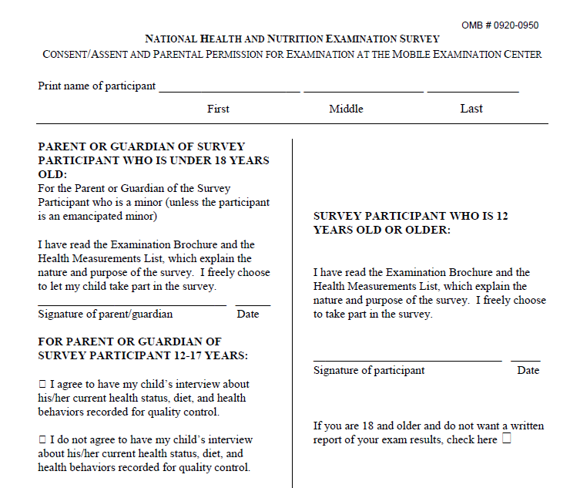

REVIEW STATEMENTS AND ALLOW RESPONDENT TO MAKE SELECTIONS.

LANGUAGE: ENGLISH

EXPLAIN THE MEC EXAM AND REPORT OF FINDINGS STATEMENTS. TURN SCREEN TO
{SP/PROXY} AND ASK HIM/HER TO RECORD HIS/HER MEC EXAM AND REPORT OF FINDINGS CHOICE BELOW.

I have read the Examination Consent Brochure and Health Measurements List. I agree to take part in the survey.
      - YES
      - NO

I would like a written report of my exam results.
      - YES
      - NO

REVIEW SELECTIONS AND ASK RESPONDENT TO SIGN.

LANGUAGE: ENGLISH

YES I agree to take part in the survey.

YES I would like a written report of my exam results.

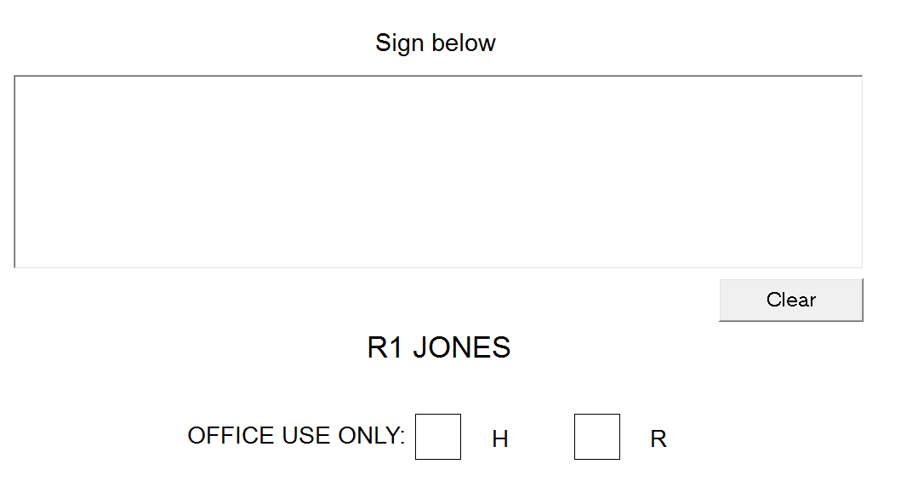

Note that if the respondent refuses the MEC exam (R), the e-consent process will not continue. The program would display the following message, “SP CANNOT BE EXAMINED WITHOUT SIGNED MEC CONSENT/ASSENT FORMS. MEC CONSENT/ASSENT FORMS SHOULD BE SIGNED BEFORE APPOINTMENT IS MADE.”

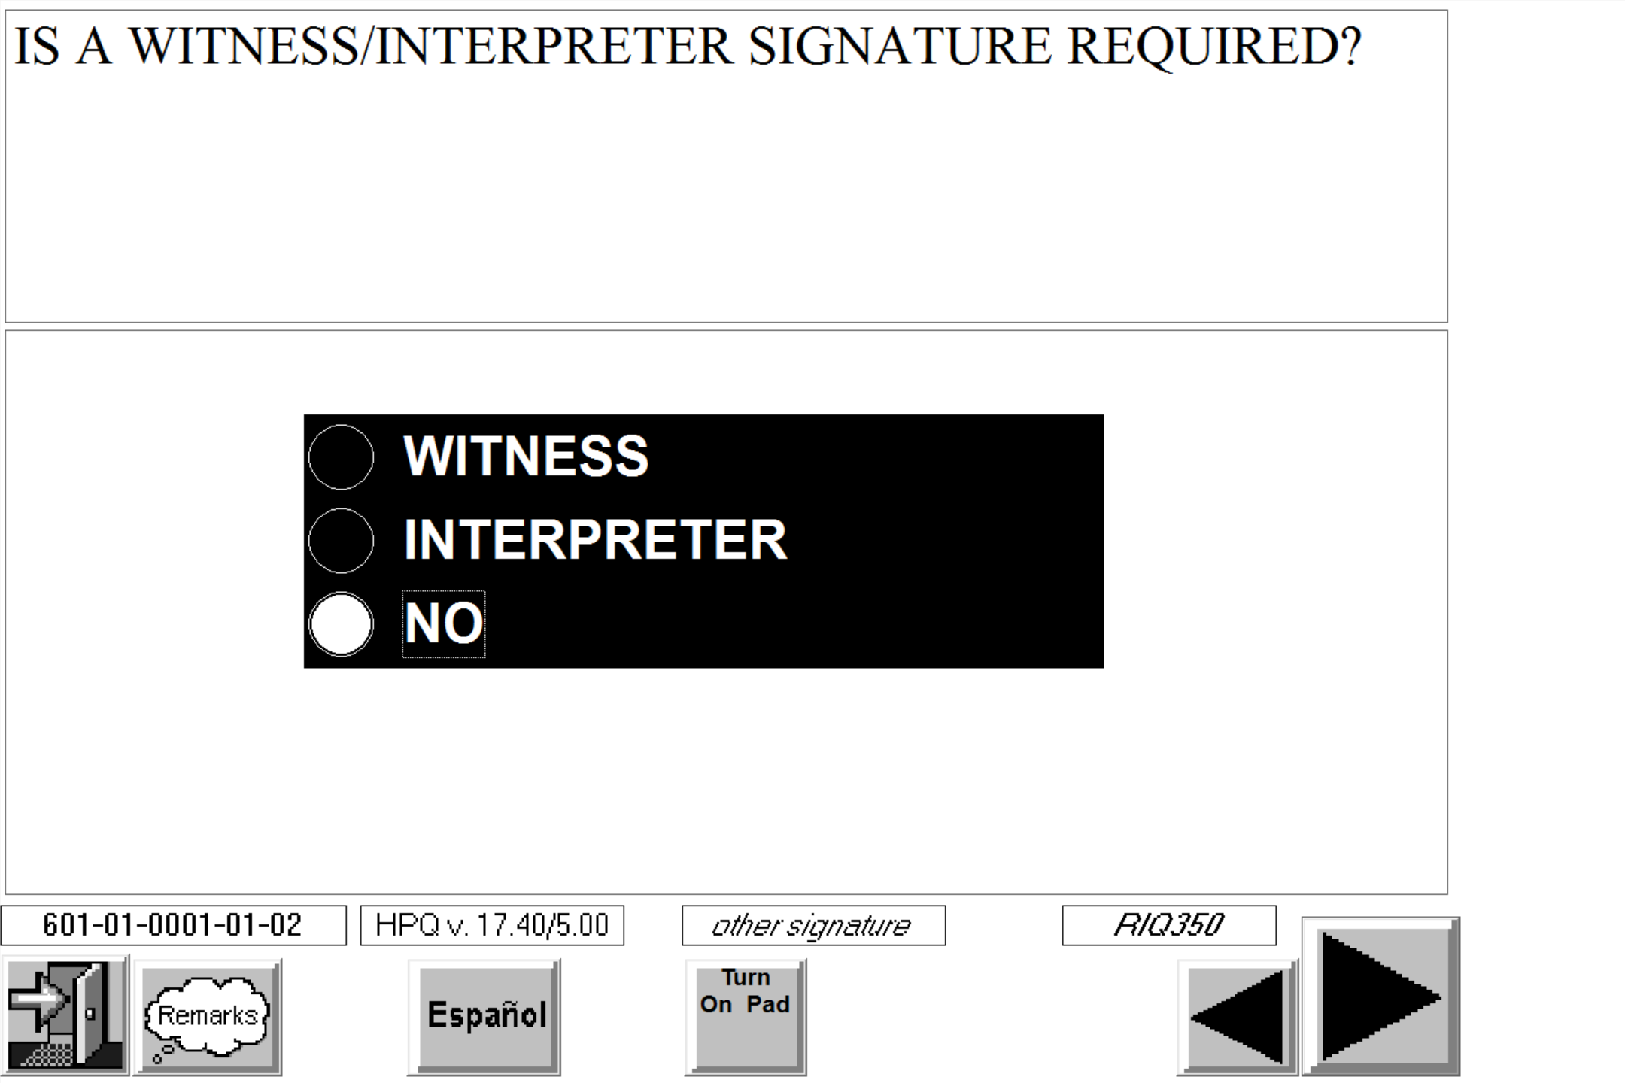

Specimen Storage

PROVIDE SPECIMENT STORAGE FORM AND REVIEW KEY POINTS.

HAND RESPONDENT THE CONSENT/ASSENT AND PARENTAL PERMISSION FOR SPECIMEN STORAGE AND CONTINUING STUDIES FORM IN THE LANGUAGE HE/SHE READS.

REVIEW KEY POINTS WITH RESPONDENT OR READ CONSENT FORM OUT LOUD.

ANSWER ANY RESPONDENT QUESTIONS.

DISPLAY IMAGE OF CONSENT FORM.

LANGUAGE: ENGLISH

TURN SCREEN TO {SP/PROXY} AND EXPLAIN THAT YOU ARE REVIEWING THE SAME FORM HARDCOPY AND ELECTRONICALLY.

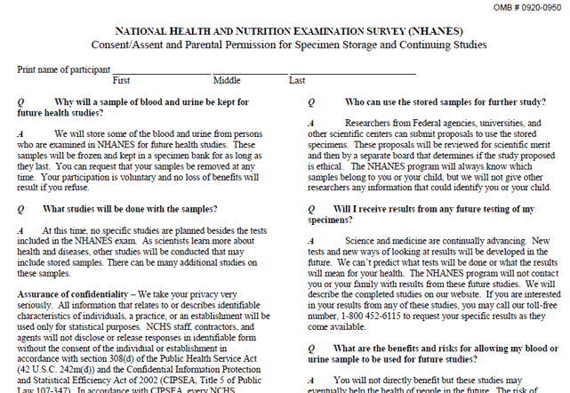

REVIEW STATEMENTS AND ALLOW RESPONDENT TO MAKE SELECTIONS.

LANGUAGE: ENGLISH

EXPLAIN SPECIMEN STORAGE FOR FUTURE HEALTH STUDIES CHECK BOXES. TURN SCREEN
TO {SP/PROXY} AND ASK HIM/HER TO RECORD HIS/HER SPECIMEN STORAGE CHOICE BELOW.

My blood and urine may be kept for future health studies, and I understand that I will not be contacted with the results from these studies.
- YES
- NO

REVIEW SELECTIONS AND ASK RESPONDENT TO SIGN.

LANGUAGE: ENGLISH

YES I permit NHANES to keep my blood and urine for future health studies, and I
understand that I will not be contacted with the results from these studies.

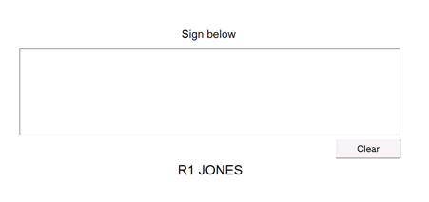

AFTER EACH SIGNITURE SCREEN, THE PROGRAM WILL ASK IF A WITNESS/INTERPRETER WAS USED.

DISPLAY SUMMARY OF RESPONDENT’S SELECTIONS. BECAUSE CONSENT WAS GIVEN ELECTRONICALLY, THE PROGRAM WILL FILL THE DROP-DOWN LISTS.

