Attachment 9e

MEC e-consent proposed screens: 7-11 yo SP

MEC Consent/Assent

PROVIDE MEC CONSENT BROCHURE AND REVIEW PACKET.

[Let’s take a look at a brochure as I explain the exam process to you.]

HAND RESPONDENT THE EXAMINATION CONSENT BROCHURE IN THE LANGUAGE HE/SHE READS.

REVIEW KEY POINTS FROM BROCHURE AND HEALTH MEASUREMENTS LIST, OR READ FORMS OUT LOUD.

REVIEW MEC DIAGRAM AND LAB TESTS ON BLOOD FLYERS AS NECESSARY.

REVIEW KEY POINTS FROM THE CONSENT/ASSENT AND PARENTAL PERMISSION FOR EXAM AT MEC FORM IN THE LANGUAGE HE/SHE READS, OR READ FORM OUT LOUD.

ANSWER ANY RESPONDENT QUESTIONS.

DISPLAY IMAGE OF CONSENT FORM.

LANGUAGE: ENGLISH

TURN SCREEN TO {PROXY} AND EXPLAIN THAT YOU ARE REVIEWING THE SAME FORM HARDCOPY AND ELECTRONICALLY.
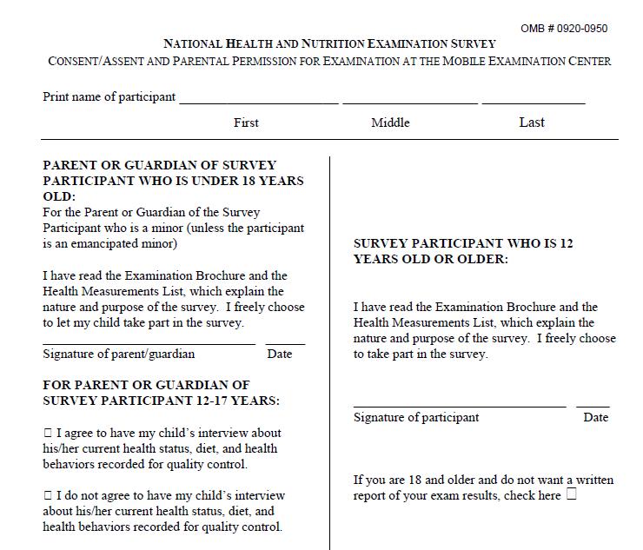

REVIEW STATEMENTS AND ALLOW RESPONDENT TO MAKE SELECTIONS.

LANGUAGE: ENGLISH

EXPLAIN THE MEC EXAM STATEMENT. TURN SCREEN TO {PROXY} AND ASK HIM/HER TO
RECORD HIS/HER MEC EXAMCHOICE BELOW.

I have read the Examination Consent Brochure and Health Measurements List. I agree to allow SP to take part in the survey.
      - YES
      - NO

REVIEW SELECTIONS AND ASK RESPONDENT TO SIGN.

LANGUAGE: ENGLISH

YES I agree to allow SP to take part in the survey.

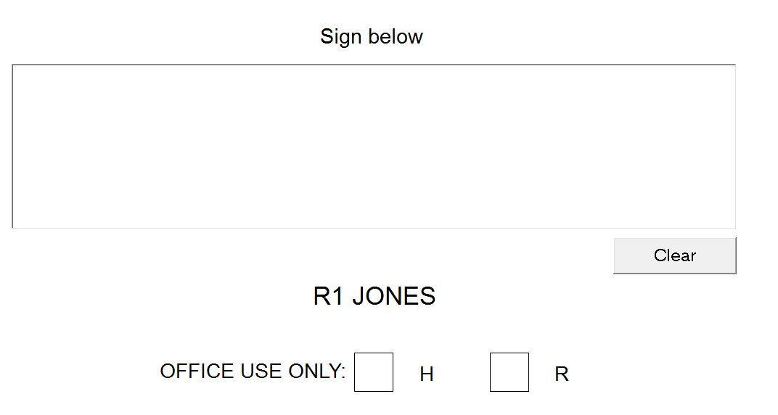

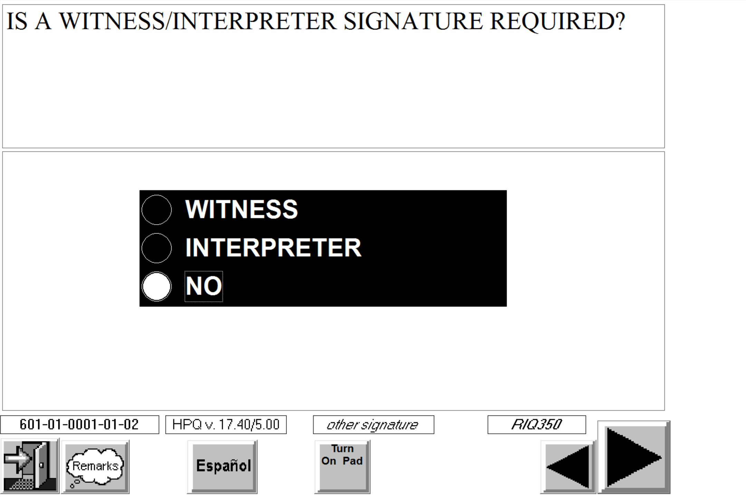

Specimen Storage

PROVIDE SPECIMEN STORAGE FORM AND REVIEW KEY POINTS.

HAND RESPONDENT THE CONSENT/ASSENT AND PARENTAL PERMISSION FOR SPECIMEN STORAGE AND CONTINUING STUDIES FORM IN THE LANGUAGE HE/SHE READS.

REVIEW KEY POINTS WITH RESPONDENT OR READ CONSENT FORM OUT LOUD.

ANSWER ANY RESPONDENT QUESTIONS.

DISPLAY IMAGE OF CONSENT FORM.

LANGUAGE: ENGLISH

TURN SCREEN TO {PROXY} AND EXPLAIN THAT YOU ARE REVIEWING THE SAME FORM HARDCOPY AND ELECTRONICALLY.

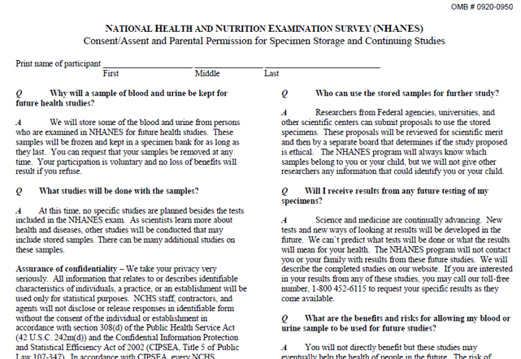

REVIEW STATEMENTS AND ALLOW RESPONDENT TO MAKE SELECTIONS.

LANGUAGE: ENGLISH

EXPLAIN SPECIMEN STORAGE FOR FUTURE HEALTH STUDIES CHECK BOXES. TURN SCREEN
TO {PROXY} AND ASK HIM/HER TO RECORD HIS/HER SPECIMEN STORAGE CHOICE BELOW.

I agree to allow SP’s blood and urine to be kept for future health studies, and I understand that I will not be contacted with the results from these studies.
- YES
- NO

REVIEW SELECTIONS AND ASK RESPONDENT TO SIGN.

LANGUAGE: ENGLISH

YES I permit NHANES to keep SP’s blood and urine for future health studies, and I
understand that I will not be contacted with the results from these studies.

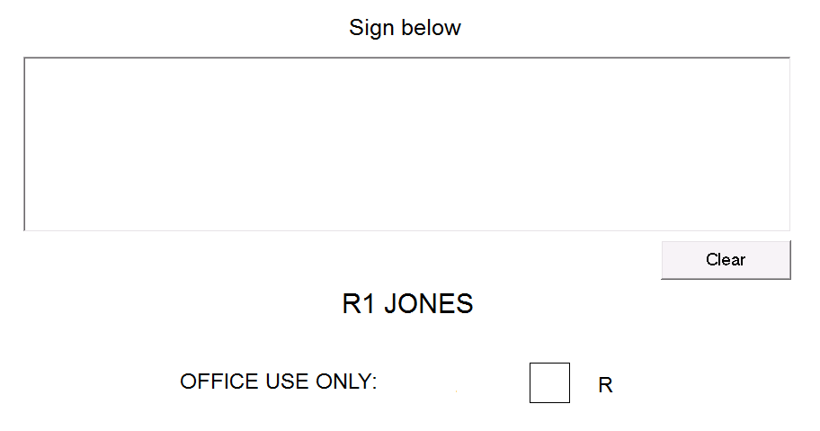

Authorization for Transportation

PROVIDE AUTHORIZATION FOR TRANSPORTATION FORM AND REVIEW KEY POINTS.

HAND RESPONDENT THE AUTHORIZATION FOR TRANSPORTATION ARRANGEMENTS FOR MINOR FORM IN THE LANGUAGE HE/SHE READS.

REVIEW KEY POINTS WITH RESPONDENT OR READ THE FORM OUT LOUD.

ANSWER ANY RESPONDENT QUESTIONS.

DISPLAY IMAGE OF CONSENT FORM.

LANGUAGE: ENGLISH

TURN SCREEN TO {PROXY NAME} AND EXPLAIN THAT YOU ARE REVIEWING THE SAME FORM HARDCOPY AND ELECTRONICALLY.

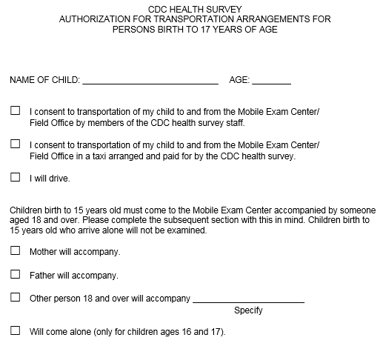

REVIEW STATEMENTS AND ALLOW RESPONDENT TO MAKE SELECTIONS.

LANGUAGE: ENGLISH

EXPLAIN THE TRANSPORTATION AND ESCORT CHECK BOXES. TURN SCREEN TO {PROXY NAME} AND ASK HIM/HER TO RECORD HIS/HER CHOICES BY TOUCHING ONE TRANSPORTATION AND ONE ESCORT STATEMENT BELOW.

TRANSPORTATION (CHOOSE ONE): I consent to transportation of {SP} to and from the Mobile Exam Center (MEC)/Field Office…

- by members of the CDC health survey staff
- in a taxi arranged and paid for by the CDC health survey
- Parent/Guardian will arrange transportation, to and from the MEC/Field Office, for {SP}

ESCORT (CHOOSE ONE): I understand that children birth to 15 years old must come to the MEC accompanied by someone aged 18 and over.

- Mother will accompany
- Father will accompany
- Other person 18 and over will accompany

REVIEW SELECTIONS AND ASK RESPONDENT TO SIGN.

LANGUAGE: ENGLISH

Parent/Guardian will arrange transportation, to and from the
Mobile Exam Center/Field Office, for {SP}.

Mother will accompany {SP} to the MEC.

Transition to minor SP as respondent

Is {SP} present and available to sign?
- YES
- NO. COME BACK LATER TO COLLECT MINOR’S SIGNATURES
- NO. COLLECT MINOR’S SIGNATURES AT MEC

Is {SP} able to give assent and sign forms?
- YES
- NO. SP HAS COGNITIVE PROBLEMS
- NO. SP HAS PHYSICAL PROBLEMS

If the SP cannot give assent and sign due to a cognitive or physical problem, the minor’s parent/guardian may sign for the child.

MEC Assent

PROVIDE MEC CONSENT BROCHURE AND REVIEW PACKET.

[Let’s take a look at a brochure as I explain the exam process to you.]

HAND SP THE EXAMINATION ASSENT BROCHURE IN THE LANGUAGE HE/SHE READS.

REVIEW KEY POINTS FROM BROCHURE OR READ BROCHURE OUT LOUD.

REVIEW KEY POINTS FROM THE MEC CHILD ASSENT FORM IN THE LANGUAGE HE/SHE READS, OR READ FORM OUT LOUD.

ANSWER ANY RESPONDENT QUESTIONS.

DISPLAY IMAGE OF CONSENT FORM.

LANGUAGE: ENGLISH

TURN SCREEN TO {SP} AND EXPLAIN THAT YOU ARE REVIEWING THE SAME FORM HARDCOPY AND ELECTRONICALLY.

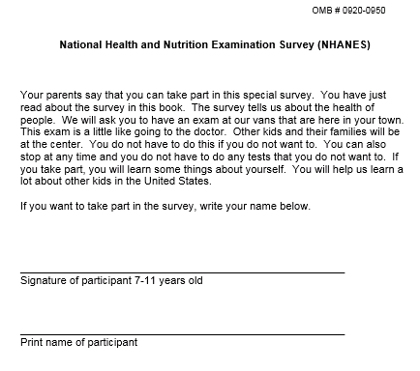

REVIEW STATEMENTS AND ALLOW RESPONDENT TO MAKE SELECTIONS.

LANGUAGE: ENGLISH

EXPLAIN THE MEC EXAM PARTICIPATION STATEMENT. TURN SCREEN TO {SP} AND ASK HIM/HER TO RECORD HIS/HER MEC EXAM PARTICIPATION CHOICE BELOW.

I have read the Examination Assent Brochure. I agree to take part in the survey.
      - YES
      - NO

REVIEW SELECTIONS AND ASK RESPONDENT TO SIGN.

LANGUAGE: ENGLISH

YES I agree to take part in the survey.

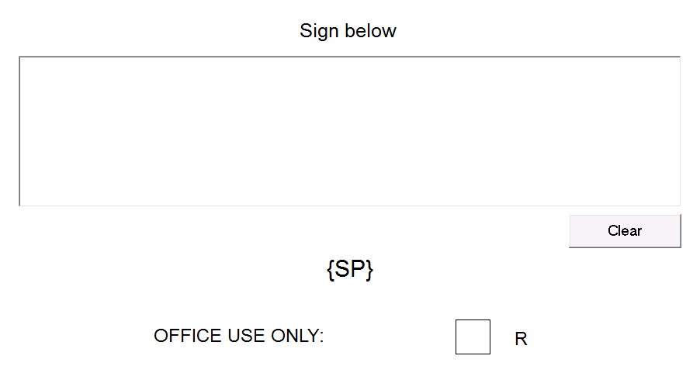

Specimen Storage

PROVIDE SPECIMEN STORAGE FORM AND REVIEW KEY POINTS.

[HAND SP THE CONSENT/ASSENT AND PARENTAL PERMISSION FOR SPECIMEN STORAGE AND CONTINUING STUDIES FORM IN THE LANGUAGE HE/SHE READS.

REVIEW KEY POINTS WITH SP OR READ CONSENT FORM OUT LOUD.

ANSWER ANY RESPONDENT QUESTIONS.]

DISPLAY IMAGE OF CONSENT FORM.

LANGUAGE: ENGLISH

TURN SCREEN TO {SP} AND EXPLAIN THAT YOU ARE REVIEWING THE SAME FORM HARDCOPY AND ELECTRONICALLY.

REVIEW STATEMENTS AND ALLOW RESPONDENT TO MAKE SELECTIONS.

LANGUAGE: ENGLISH

EXPLAIN SPECIMEN STORAGE FOR FUTURE HEALTH STUDIES CHECK BOXES. TURN SCREEN
TO {SP} AND ASK HIM/HER TO RECORD HIS/HER SPECIMEN STORAGE CHOICE BELOW.

My blood and urine to be kept for future health studies, and I understand that I will not be contacted with the results from these studies.
- YES
- NO

REVIEW SELECTIONS AND ASK RESPONDENT TO SIGN.

LANGUAGE: ENGLISH

YES I permit NHANES to keep my blood and urine for future health studies, and I
understand that I will not be contacted with the results from these studies.

PARENT/GUARDIAN agreed to allow NHANES to keep my blood and urine for future health studies.

DISPLAY SUMMARY OF RESPONDENT’S SELECTIONS. BECAUSE CONSENT WAS GIVEN ELECTRONICALLY, THE PROGRAM WILL FILL THE DROP-DOWN LISTS.

