MosquitoNET Login Page
Initially users will click “Apply for an account” and create an account. Subsequently, users will log into the system by entering username and password on this page. Note: OMB approval information appears on this page.
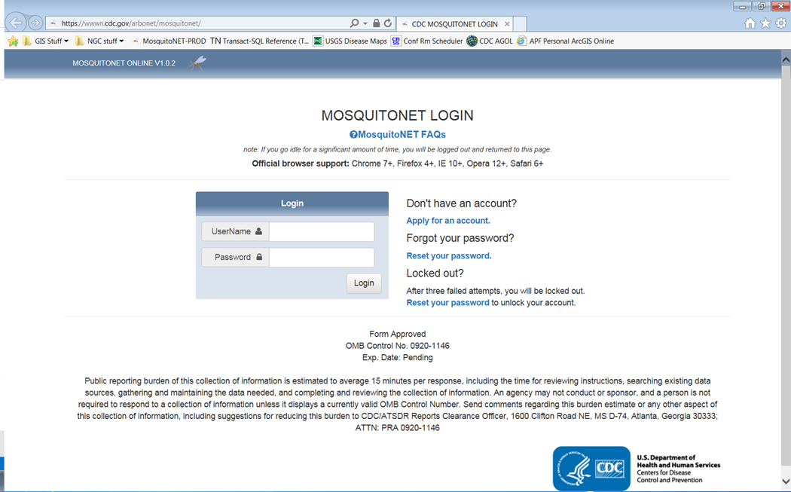

Initial User Information
One time data entry by users to create account
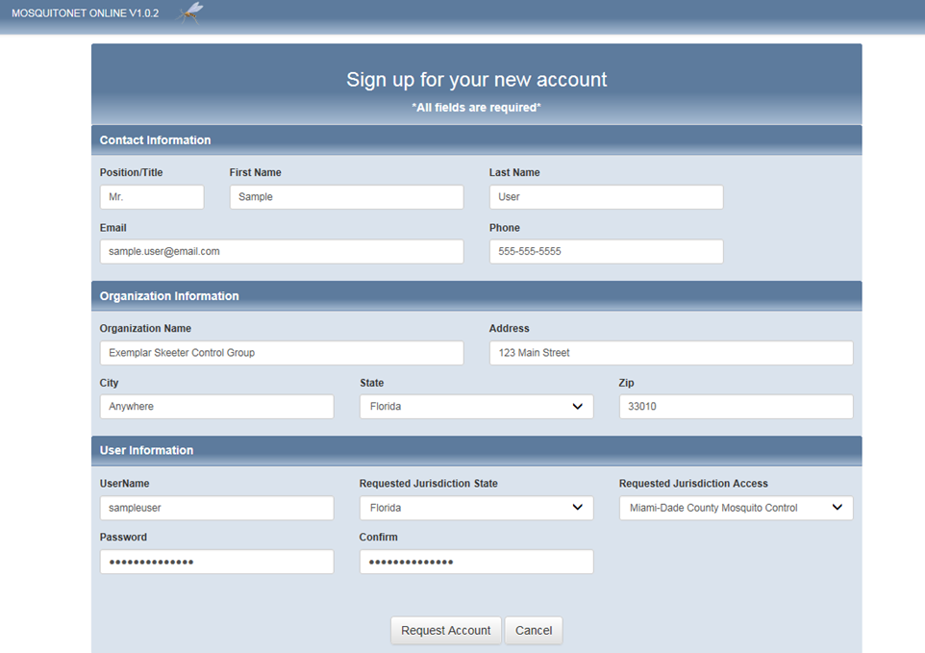

Initial Menu Page
Once accounts are established, users can log in and will see the following page
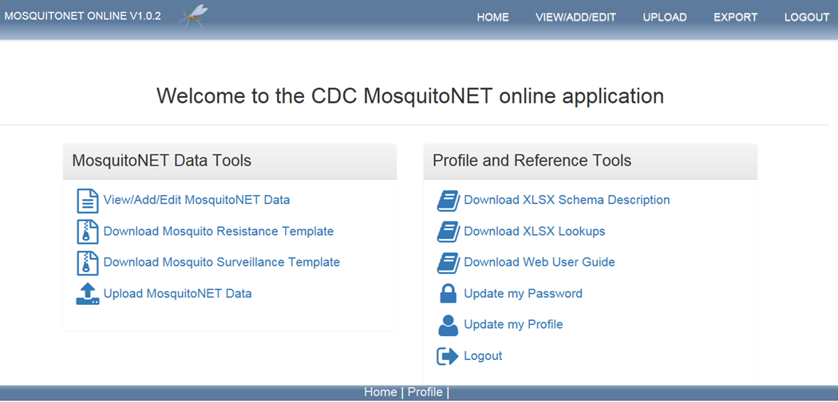

Surveillance Record Data Entry Page:
These records will be filled for each mosquito collection site each month
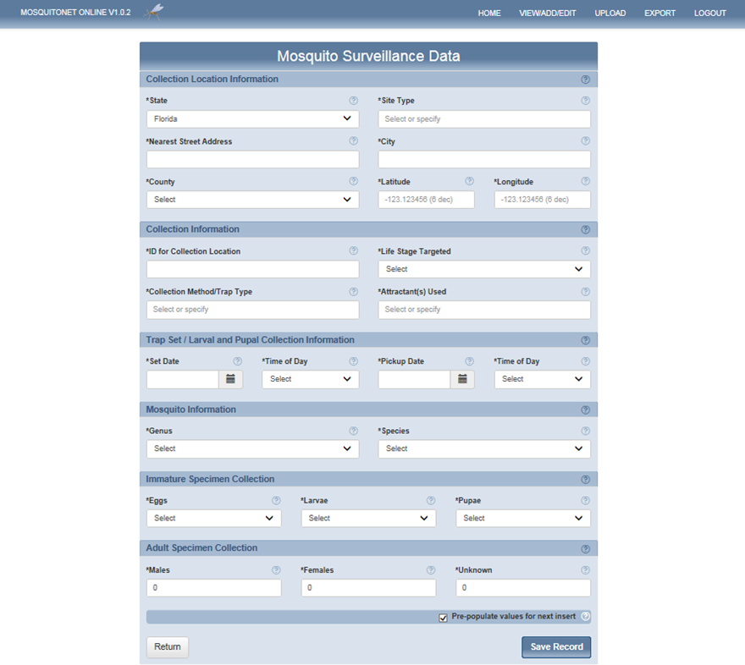

Mosquito Resistance Data Entry Page
These records will be filled for each mosquito collection site each month
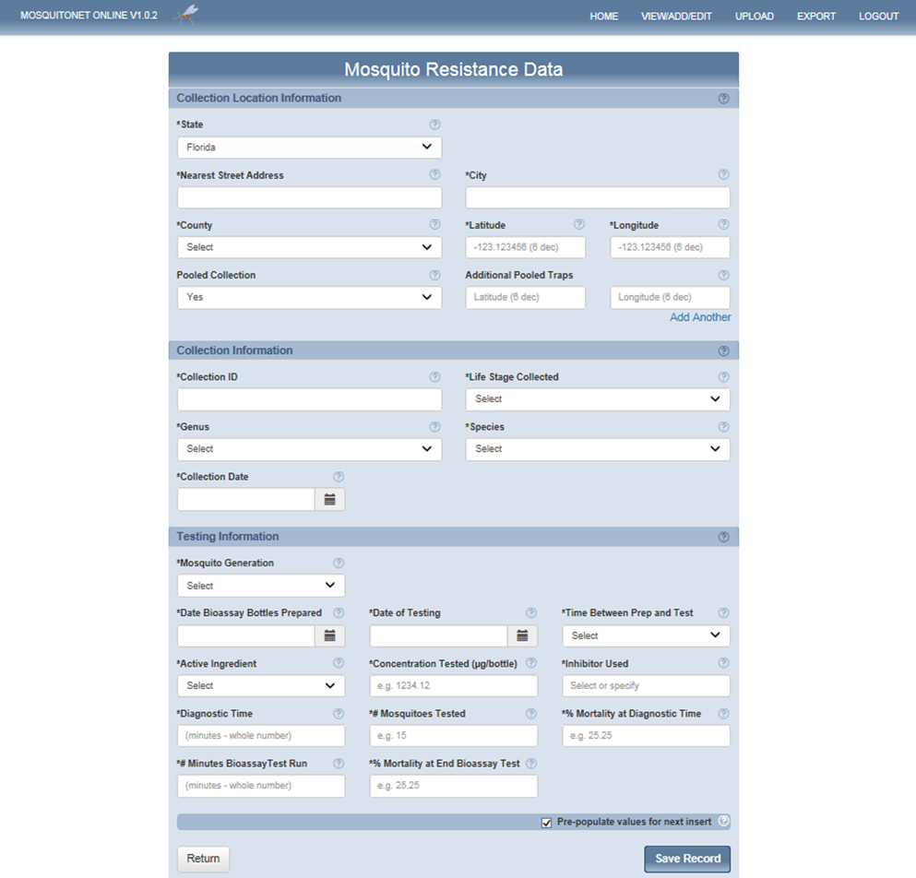

Export Records Page
If users prefer to upload Excel files in lieu of entering the data directly, they will use this page.
