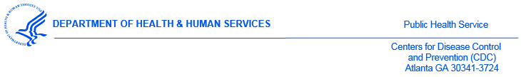
<DATE>

<Name>
<Address>
<Address>

Dear Superintendent <Name>:

The U.S. Centers for Disease Control and Prevention (CDC) will be conducting the 2017 National Youth Tobacco Survey (NYTS) during the 2017-2018 school year. The annual NYTS was designed in cooperation with federal agencies and numerous state and local departments of education and health.

The purpose of this letter is to inform you that < # > schools in < STATE > are among the 250 schools randomly selected across the United States to participate in the 2017 NYTS. This packet is for informational purposes and no action is required on your part.

As witnessed over the past few decades, youth tobacco use can increase or decrease rapidly, especially with the introduction of new tobacco products that appeal to youth. The CDC reported that from 2011 to 2015, cigarette smoking declined among middle and high school students while the use of electronic cigarettes and hookahs increased among the same population. Efforts such as the NYTS have increased our ability to measure changes in tobacco use behaviors and their influences, thereby enabling states, school districts, schools, and community organizations to adapt their tobacco prevention and control programs to combat the most prevailing issues at hand.

First conducted in 1999, the NYTS is an ongoing survey of students in grades 6 through 12 that gathers information on: (1) prevalence of use (cigarettes, smokeless tobacco, cigars, and other tobacco products), (2) knowledge and attitudes, (3) media and advertising (4) minors’ access and enforcement, (5) school curriculum, (6) secondhand smoke exposure, and (7) cessation. Each cycle has produced valuable data regarding students’ knowledge of and attitudes toward tobacco, their exposure to secondhand smoke, and their exposure to influences that promote or discourage tobacco use.

The CDC respects the educational mission of schools; for that reason, only a small number of classes in each school, one or two at each selected grade level, are chosen randomly to participate. Data collection will occur during February through May 2018. Questionnaires will be administered by specially trained field staff during one normal class period. Survey administration procedures are designed to protect student privacy and allow for anonymous participation. States, counties, cities, school districts, schools, and students will not be identified in any published reports.

As a symbol of appreciation for contributing their time and support, the CDC will provide each participating school with a monetary award. One option is to use these funds for prevention curriculum and educational materials. However, no restrictions will be placed on how schools may use these funds.

The NYTS is the most comprehensive, nationally representative source of data regarding tobacco-related behaviors and the only source of such data for middle school students (grades 6-8). In parallel to this national survey, a state-level YTS questionnaire is used independently by many state and local departments of education and health to conduct their own surveys. Results from the national survey serve as an index against which state- and local-level data can be compared and are used to support the design, implementation, and evaluation of effective tobacco use prevention and control programs.

Enclosed are a list of schools selected in your state, the 2018 NYTS questionnaire, a fact sheet, and letters of support from national health and education organizations. Within one week, a representative from <Name>, a firm contracted by CDC to conduct the NYTS, will contact you to confirm your receipt of this information and answer any questions you may have. If you have any immediate questions, please call <Name> at <#> or Dr. Sean Hu of CDC at (770) 488-5845. Thank you again for your support for this survey, which will help assess and improve efforts to reduce priority health-risk behaviors among adolescents throughout our nation.

Sincerely yours,
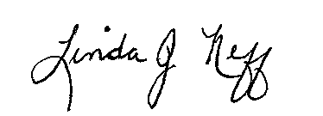

Linda J. Neff, PhD, MSPH
Chief, Epidemiology Branch, Office on Smoking and Health
National Center for Chronic Disease Prevention and Health Promotion
Centers for Disease Control and Prevention

Enclosures

cc: Sean Hu, Centers for Disease Control and Prevention

