- Establishing Ticket Assignments and Ticket Use/Ticket Assignability
Ticket Portal:
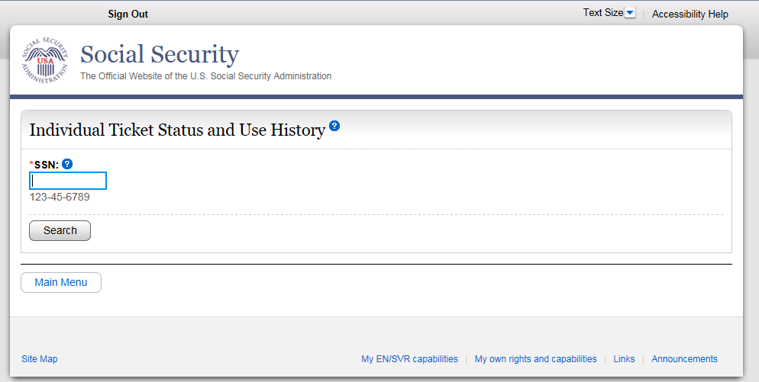
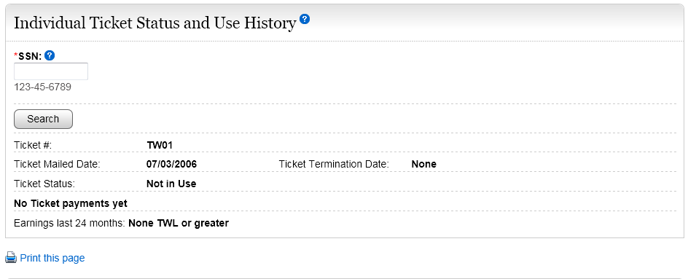
State agencies use Form SSA-1365 or the Ticket Portal
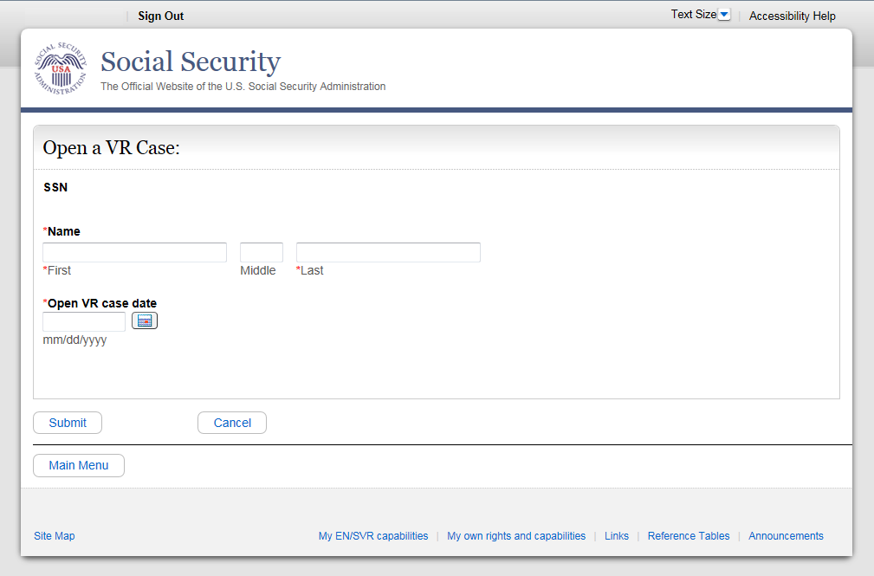
ENs in the private sector use the SSA-1370 or the Ticket Portal
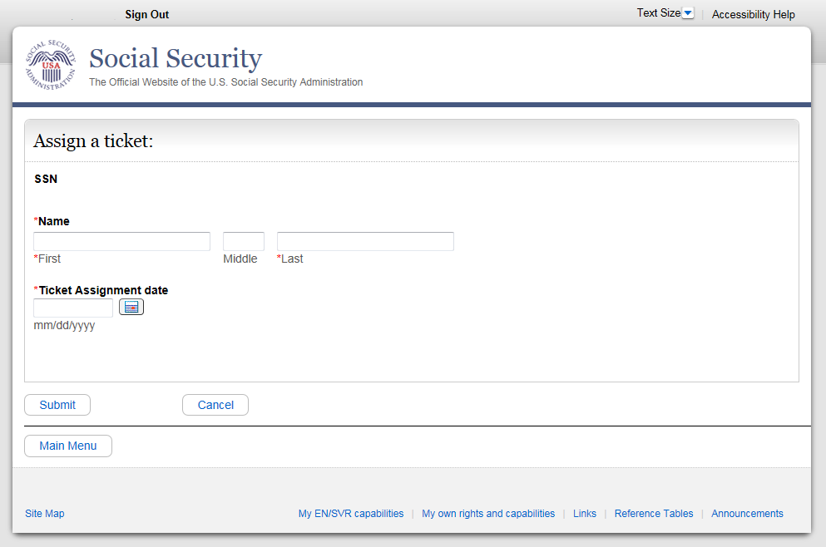
f. Requesting EN Payments

