Login Screen:
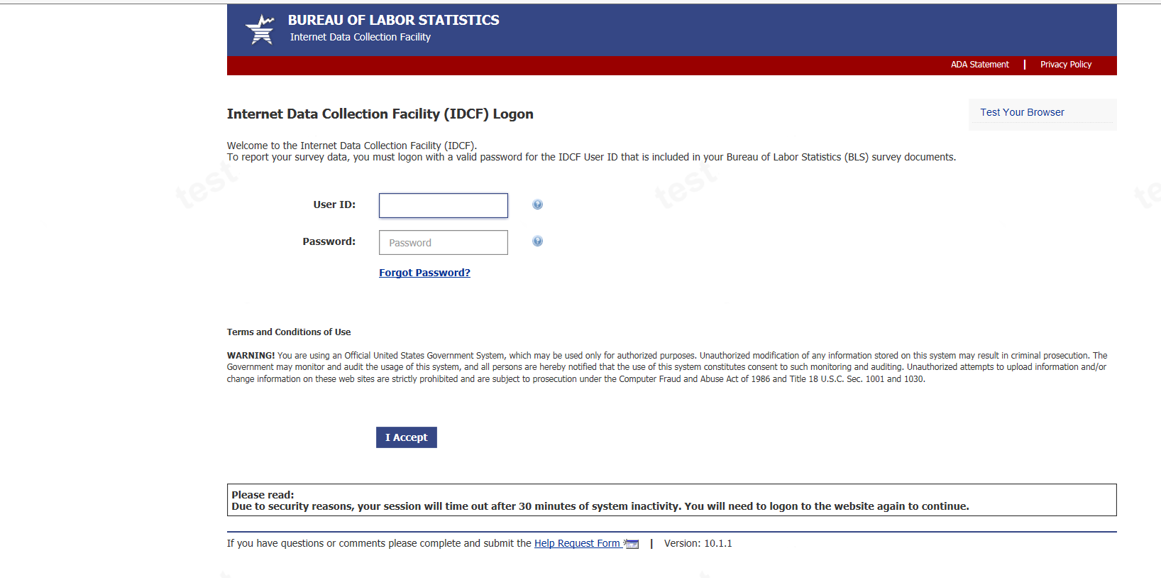

Register new account:

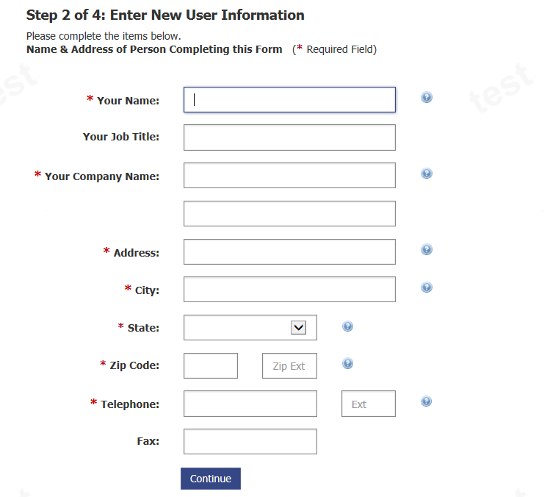
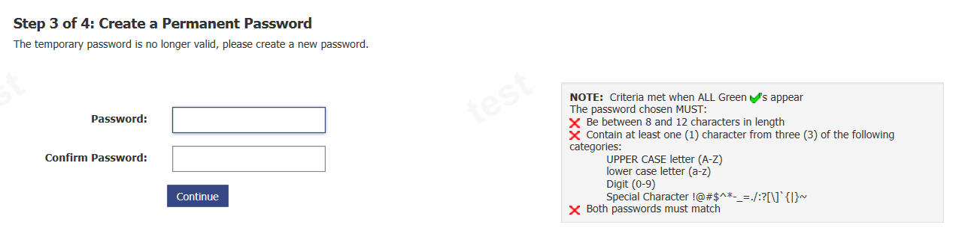
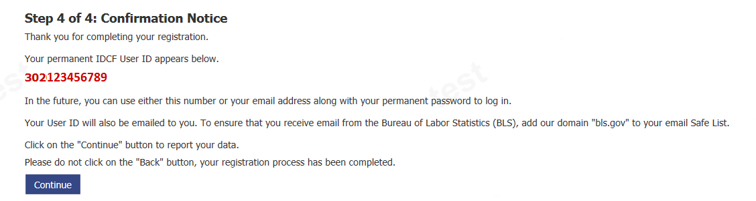
Select Survey:
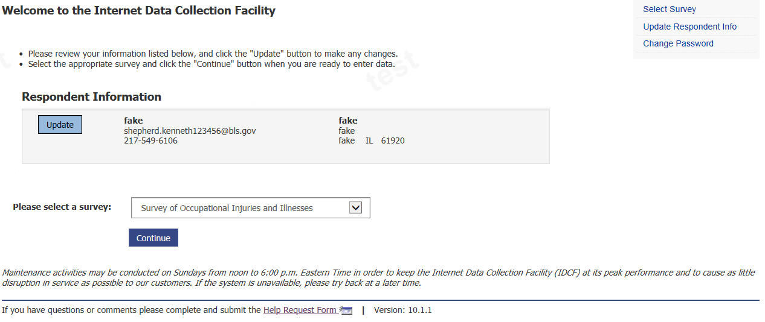

Dear Employer:
(New Cyber Security language is included at the end of the second to last paragraph)
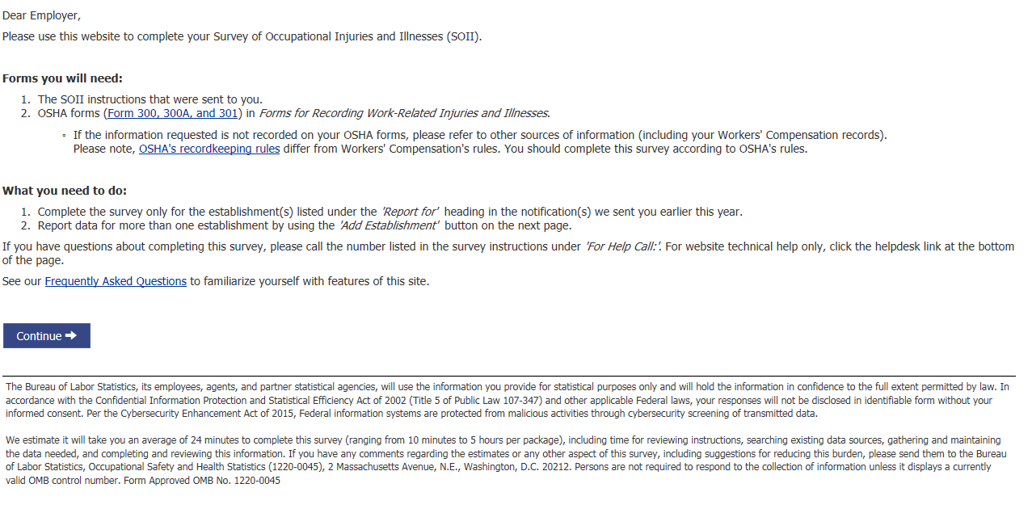
Email opt-in page:
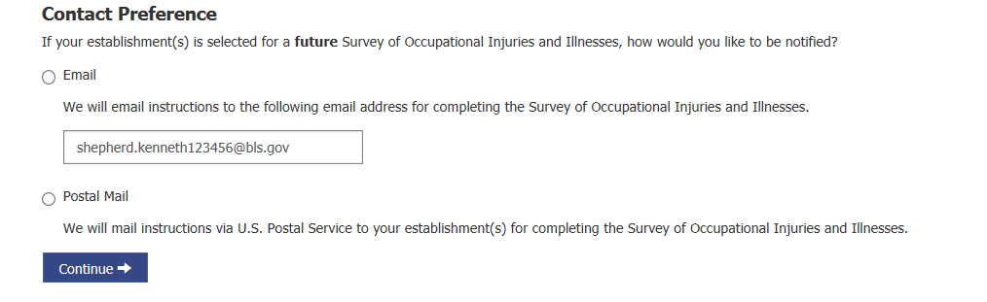
Select/Add establishment(s) page:
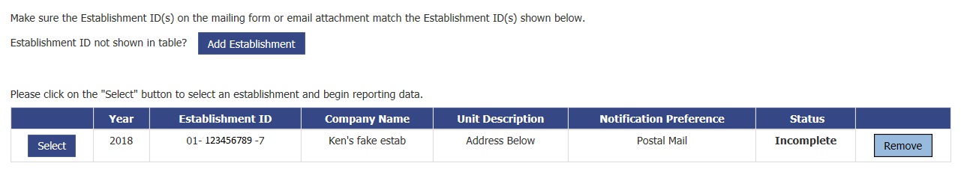

Section 1:
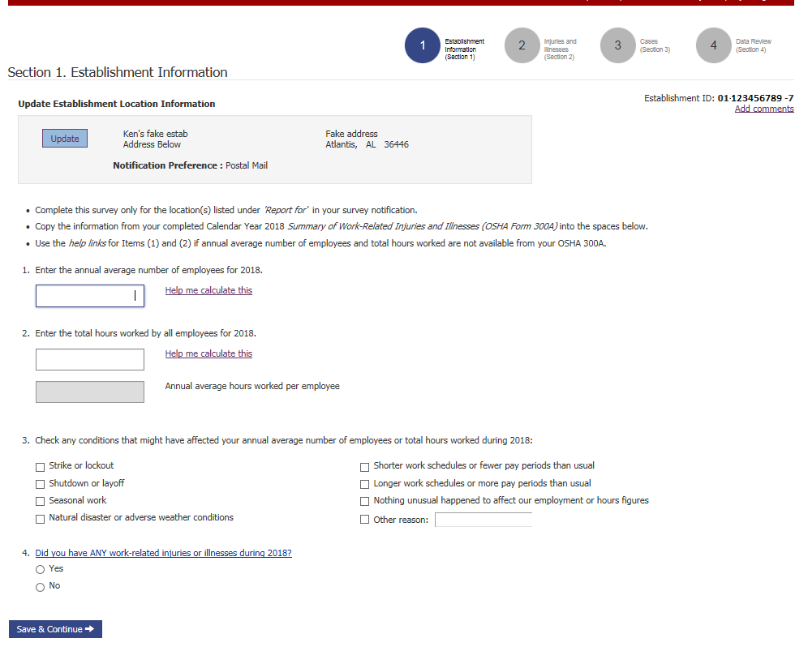

Section 2:
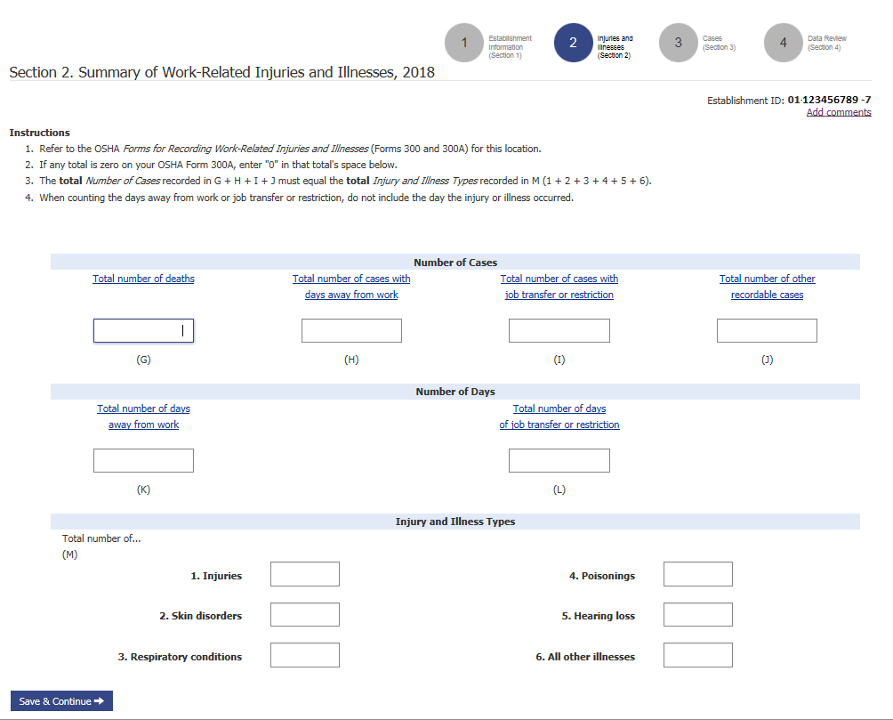
Section 3:
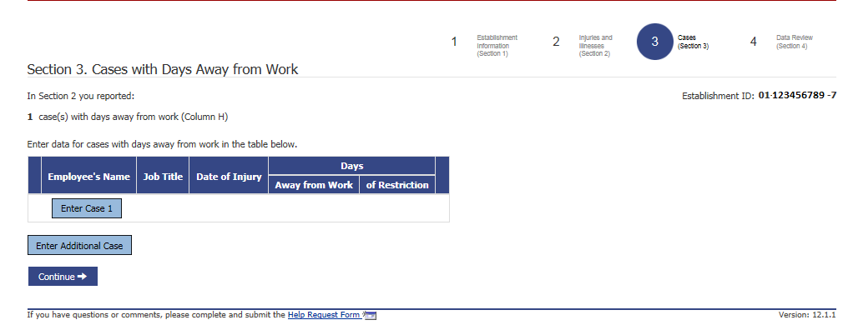

Case details:
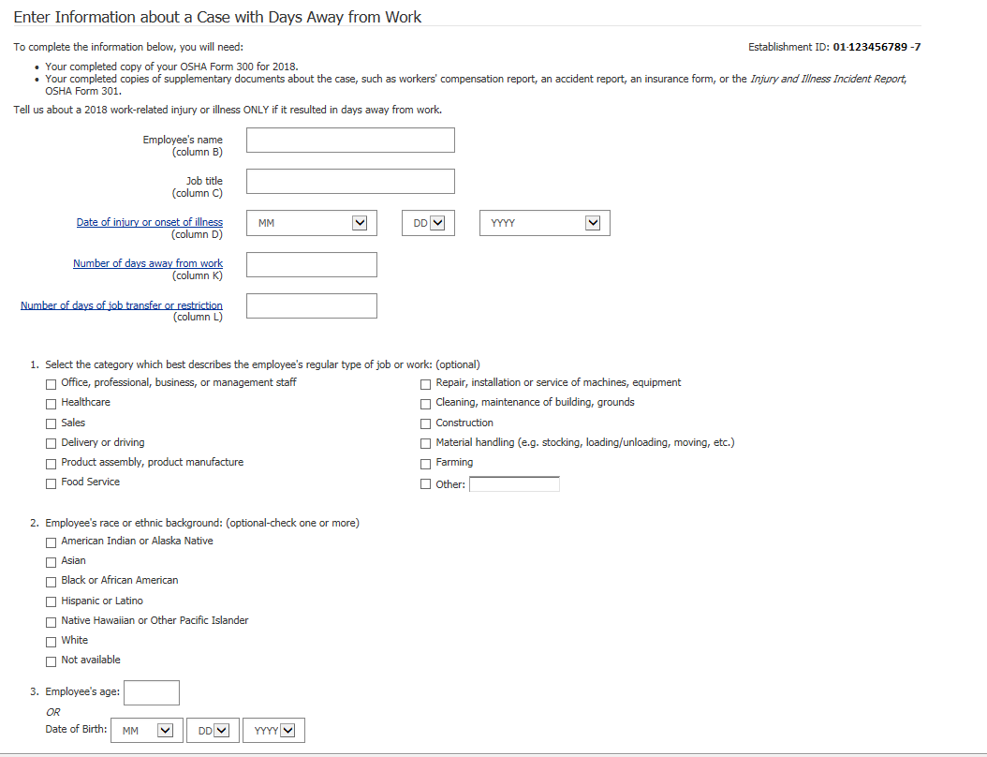
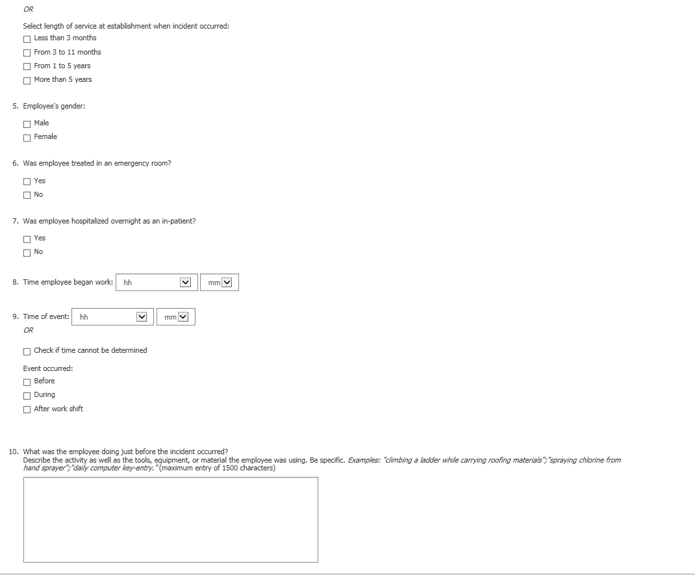

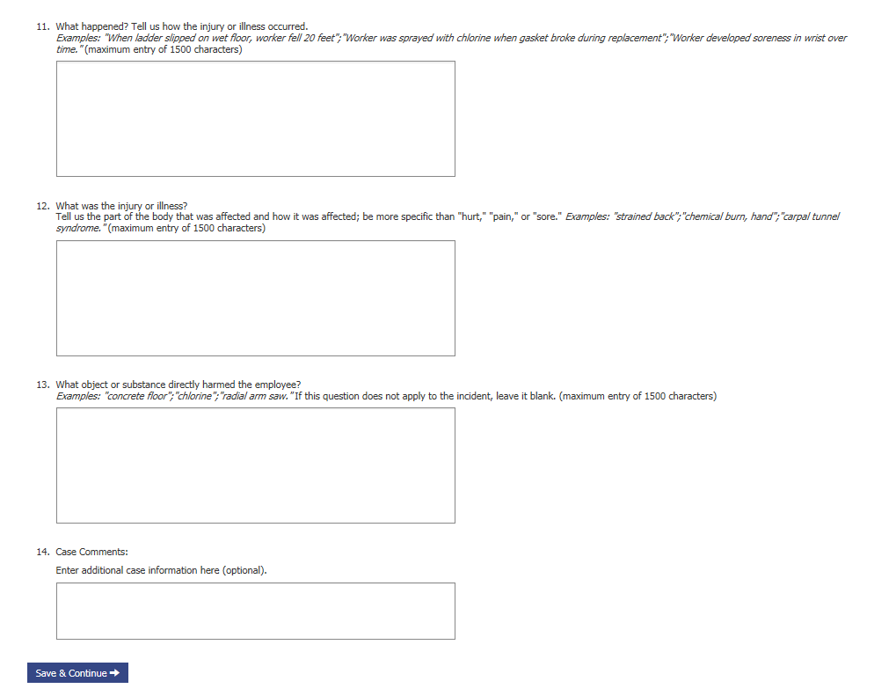

Section 4: Data Review
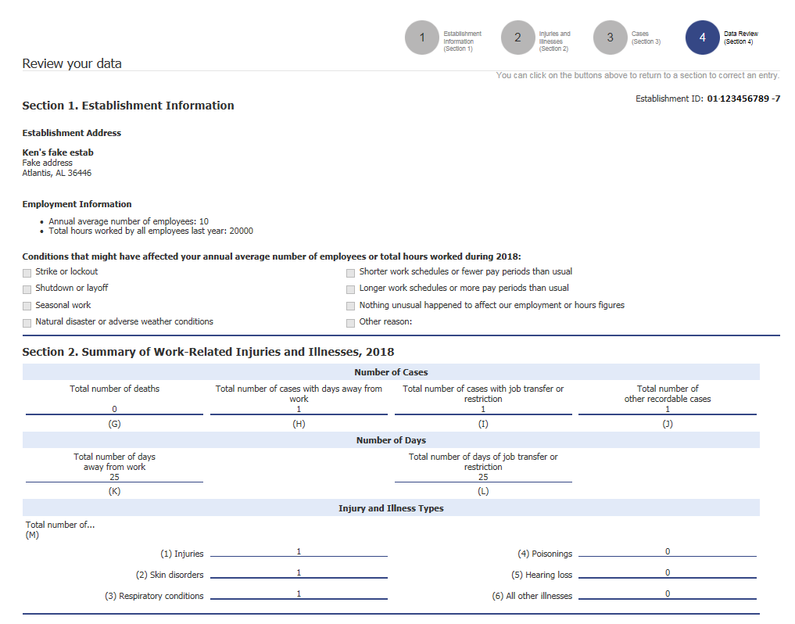
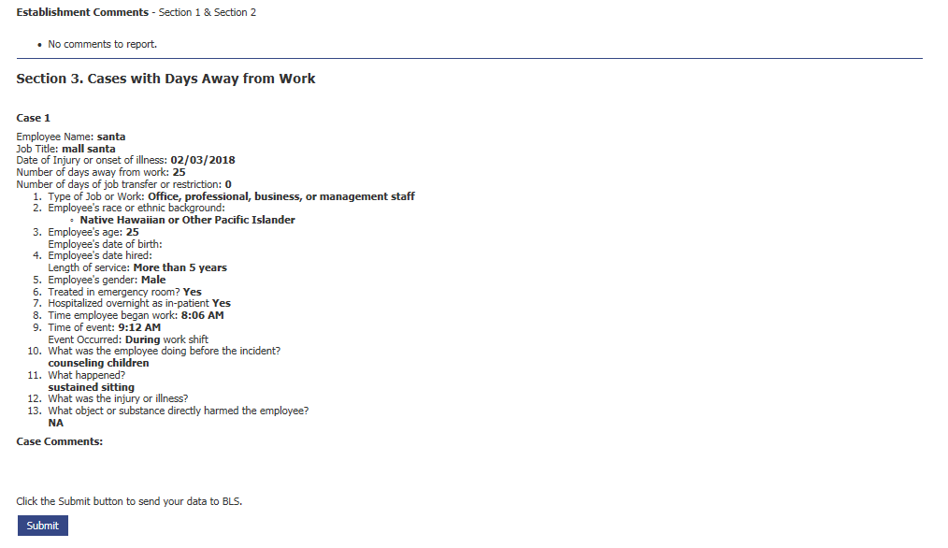
Section 4a: Additional Establishment Information
This is the section proposed to collect the OSHA ITA establishment number from respondents. It is be displayed as a pop-up and shown only to respondents that are covered by the OSHA rule. Question 2 is dynamic based on the response to question 1. Question 2 will include a soft error message if the respondent enters a digit less than 5 digits: “The OSHA ID number is typically 6 numbers long”
Thank you for submitting your Survey of Occupational Injuries and Illnesses. In 2018, the Occupational Safety and Health Administration (OSHA) required some establishments to report injury and illnesses information electronically via the Injury Tracking Application.
The Bureau of Labor Statistics and OSHA are exploring how we can work together to reduce your reporting burden. Please answer these optional question(s) below.
- Has the establishment shown above submitted injury and illness information electronically to OSHA?
  - Yes
  - No
  - Don’t know

- (shown only if Q1 = yes): What ID number did OSHA assign to the establishment? This number was provided on a confirmation email. 
_ _ _ _ _ _ (numbers only)
- Don’t know
Click continue to print your survey submission.
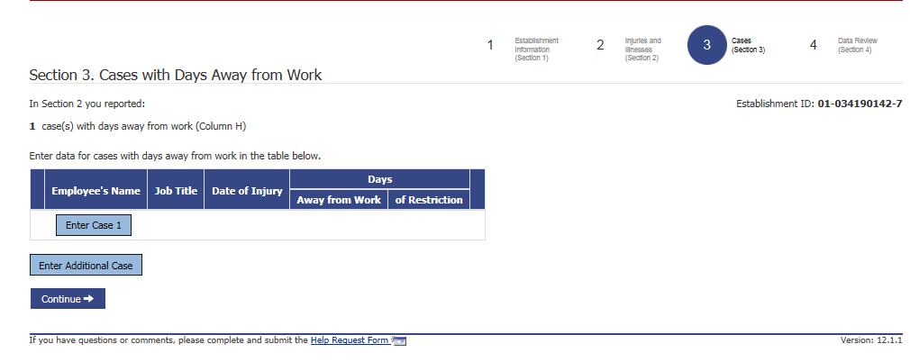
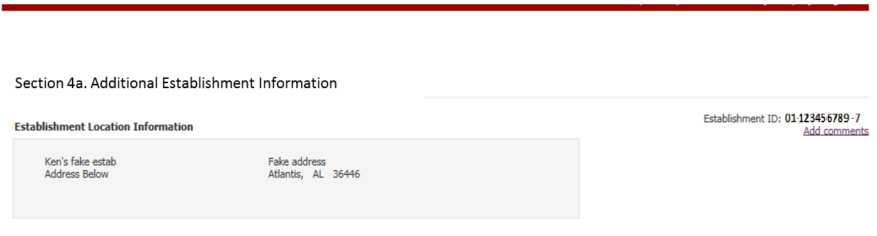

There is information provided to respondents in hover over text (by placing the cursor over the blue question mark) in question 2:
OSHA sends an email after receiving data in the Injury Tracking Application. The email contains the 6 digit ID, and looks like this:
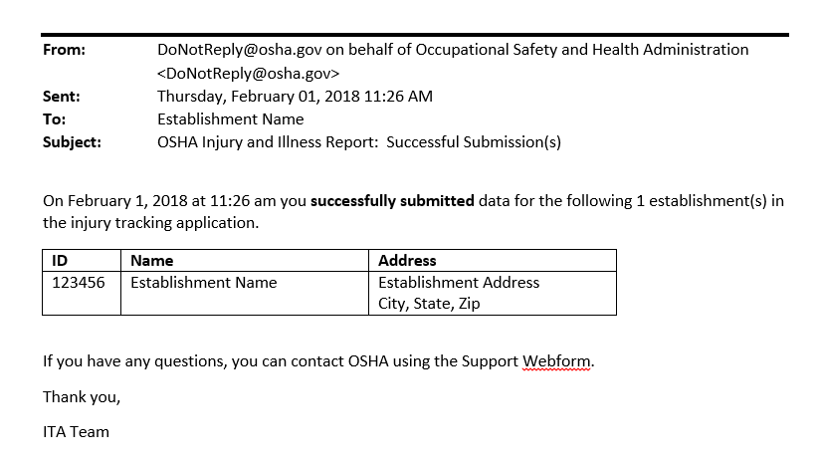

Confirmation of Submission:
